Finding full-text information using Springer Journals
First, you will need to go through the Library’s website to gain access to the full-text articles in Springer Journals. To do this, type UWTSD or http://www.uwtsd.ac.uk/ into your internet explorer. Select Quick Links, then Swansea Library and Learning Resources. Select Online Library from the left-hand side of the screen. Then select Swansea Online Library. Then under the heading A-Z Listings of Online Resources, click on the box Databases A-Z. If you hover your cursor over each title, you can view descriptions of the databases.
Scroll down the list of databases and select Springer Journals.
Type your keywords in the search box.
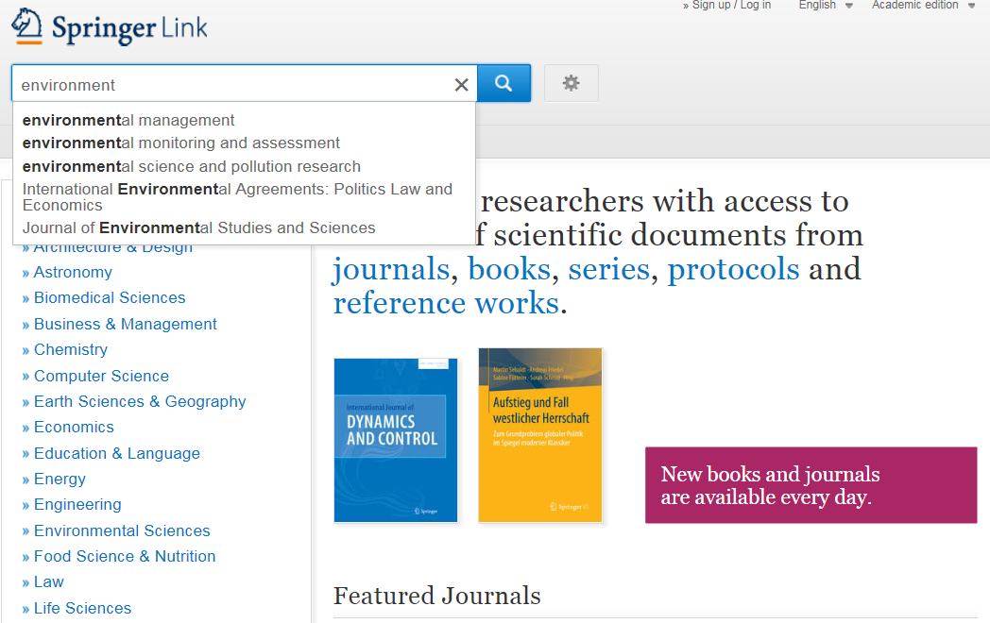

You’ll be taken to this screen:
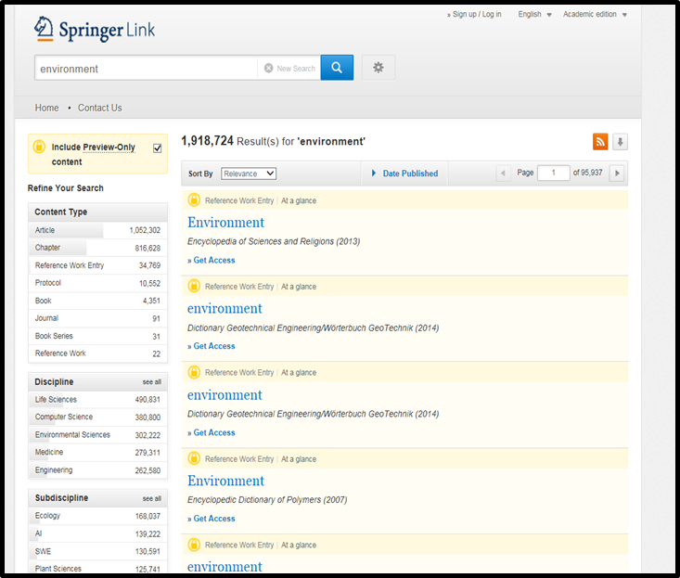
You can refine your results by unticking ‘Include Preview-Only’ content.
You can also select e.g. article or chapter in Content type, and can further refine by selecting Discipline and Sub-discipline.

You can refine the Date Published here too.

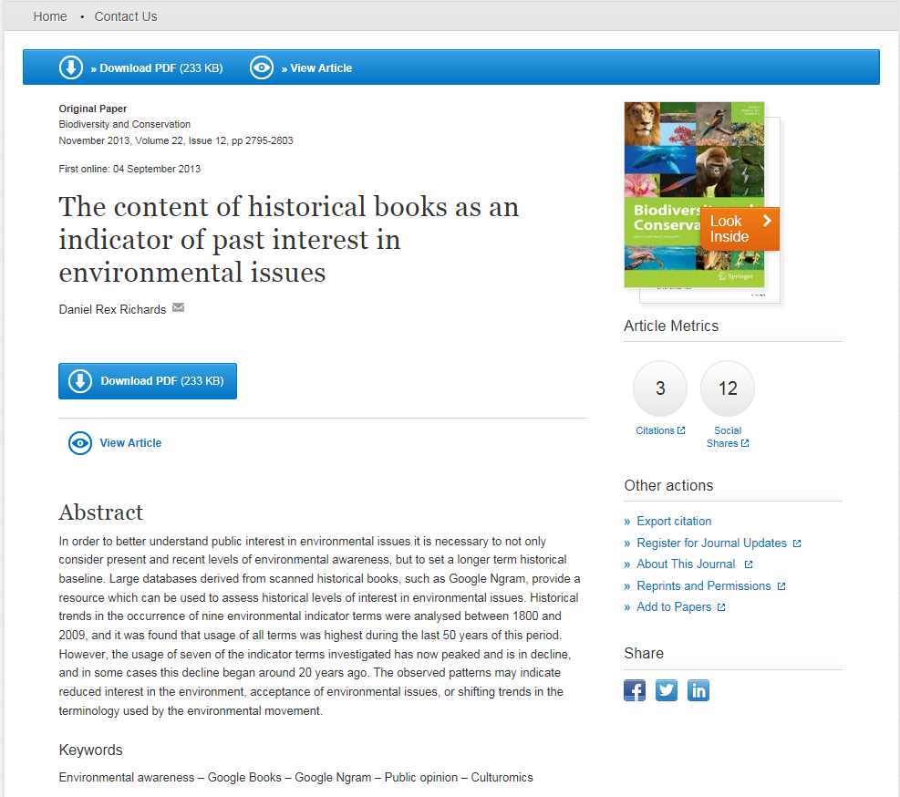
An abstract may be displayed on this page and you can download the full-text article (PDF) from here too. However, if you scroll down, you may find more information below the abstract.

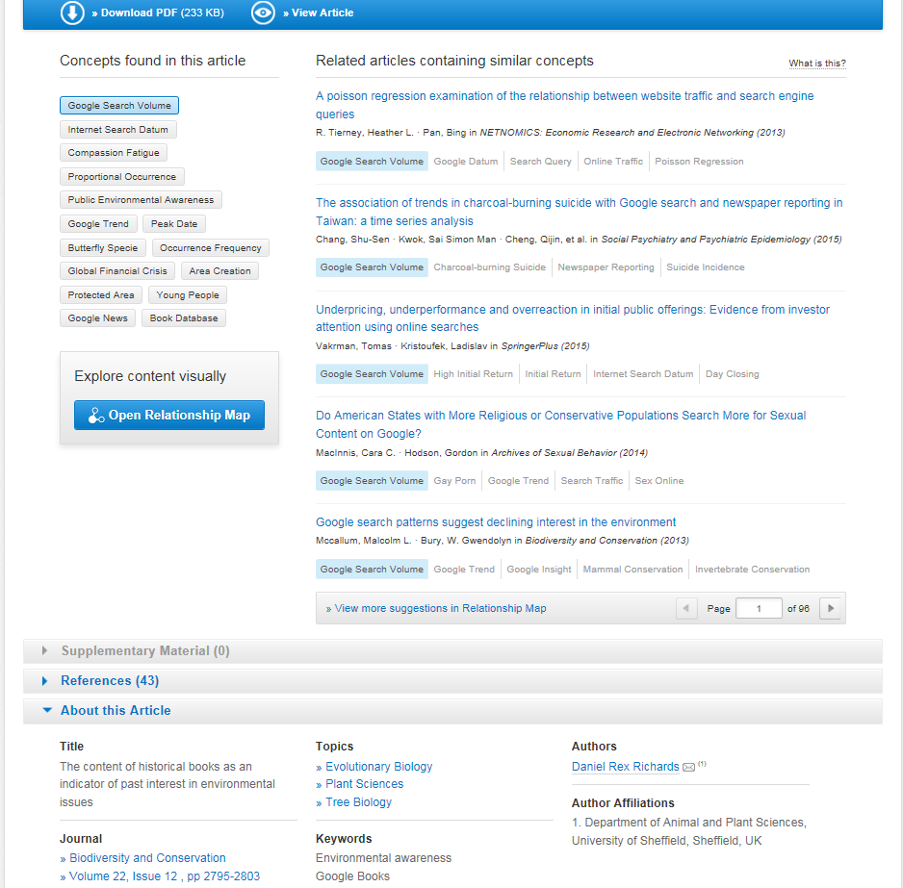
You may be presented with keywords which will be useful for your search, plus related articles which you can view by clicking on the title of the article.
The Open Relationship Map can also be very useful, as it groups the results into similar topics.
It can be helpful to look at the references to see the articles the researcher has used as they may be useful for your own research.

Please contact me if you would like help finding information for your assignments. Ask for me at counter in the Owen Library, phone (01792 481141), or email suzanne.taylor@uwtsd.ac.uk
Suzanne Taylor (Subject Librarian)

