Zahed Ahmed
1714926
Developing Relationships and Workplace Achievement

bmsk5002
Sujeewa Herath

Contents
THE POTENTIAL BENEFITS TO THE ORGANISATION OF DEVELOUPING INDIVIDUALS IN THE WORKPLACE 2
Employee Motivation 3
Types of Motivation 3
Motivation theories 4
COMMITMENT 5
IMPORTANCE OF COMMITEMENT 6
TYPES OF ORGANISATIONAL COMMITEMENT 6
TRAINING 7
TYPES OF TRAINING 8
THE MODELS OF TRAININGS 8
POTENTIAL BENEFITS FOR THE ORGANISATIONS AND INDIVIDUALS BY THE MOTIVATION VEHICLES. 10
THE TRADITIONAL INDIAN AND BENGALI CUISINES 10
Advantages and benefits of employee motivation 11
KEY BENEFITS OF ORGANIZATIONAL COMMITEMENT 12
ADVANTAGES AND BENEFITS OF TRAINING 13
PERSONAL DEVELOPMENT PLAN 13
Digital skill 13
Management skill 14
Customer service skill 14
Communication skill 14
Decision making skill 14
Team working skill 14
References. 15

THE POTENTIAL BENEFITS TO THE ORGANISATION OF DEVELOUPING INDIVIDUALS IN THE WORKPLACE

Employee development is a process where the employee with the support of their employer provides various training and support to enhance the employee’s skills and new knowledges.
According to Elena P. Antonopoulos (2000), employee development means to develop the abilities of an individual employee and organisation as a whole so; hence employee development consists of individual or employee and overall growth of the employee as when employees of the organisation would develop the organisation, organisation would be more flourished and employee performance would increase.
Employees are the important factor for any organisation also, the organisations success and failure most likely depend on the performance of the employees. The modern days organisations are researching how they can improve their service and performance to compete with their competitors. Companies are investing lots of money to develop their employees because they realised in this days service industries the friendly, motivated and well trained employees can able to provide the required level of customer care and job satisfaction and they can make the difference to the company’s success. The Human Resource Management teams main focus on to develop the work forces abilities and performance, the management arranges all the required training and also take all actions to provide the necessary structure and facilities to achieve the goal. Well-qualified, trained for the best quality and happy engaged employees are the assets for the company. Employee development is depends on the individual employee whether they willing to develop or not then again it is depends on the organisational culture if the organisational support the employees and encourage them to make the decision to and participate to develop themselves. Human Resource Managements attitude has to be in correct manor to lead the work force and guide them to achieve such quality and also, consider the organisational limitations to provide such kind of activities and the facilities. In this assignment by analyse three development vehicle and try to evaluate the importance of them and how can these influence on the organisation and make them better working environment and perform better and increase the profit margin as well.

Employee Motivation

The motivation is the driving force behind the action and the behaviour within the individual to complete the task. Motivation is the word came from a Latin word “movere” and that is mean movement. To do a task by some individual there has to be some interest or expectation for the person. Most employee need some kind of motivation to feel good about the job they doing to perform better. Some employees are motivated by the money, some are interest about their recognition and rewards. The motivation level within the organisation has a direct impact on the employee productivity. Trained motivated employees can contribute better creative culture produce more quality products. Employee motivation is all about how to engage the employee and energized them to achieve the organisational goal.

Types of Motivation
There are two types of motivation self-motivation and extrinsic motivation. Every human being are different and their need and expectations are various also the organisations need to understand the need and the demand of their employees to motivate them and full fill their needs and increase the level of their engagement and their satisfaction.
- Intrinsic motivation
- Extrinsic motivation
Intrinsic Motivation
Intrinsic motivation is the motivation comes from the individual employee. It is the own interest of the person that drives them do the jobs and that is for their own benefits. Intrinsic motivation is very vital driving force todays working environment because it plays a vital role to the performance of an individual. Also, it is a big factor for a person to stay on a job and it helps the persons stress level down.
Extrinsic motivation
Extrinsic motivation is the motivation when things are done to or for the person to motivate them from outside. To make some individual work hard and make more productive then motivate them with rewards, social recognition, fame, competition and mental achievement and all other extrinsic motivation factors.

Motivation theories
There are two most popular motivation models are Maslow’s Hierarchy of Needs and the other one is Herzberg’s two-factor model.
Maslow’s Hierarchy of needs
Abraham Maslow invented his model of motivation in (1954). On his model there are five levels of needs for the humans and every level have to fulfilled before they could be to motivate by the higher level. The four essential needs of the Maslow theory are the biological and physiological needs as food, shelter, and clothing as the basic needs for a person to survive. The safety needs are the non-threatening working environment where employees are comfortable within the workplace. The belongness can be created by good team working environment where co-workers are friendly as well as the management and Esteem the self-respect can be providing by a valid job role.

Maslow’s Hierarchy of Needs

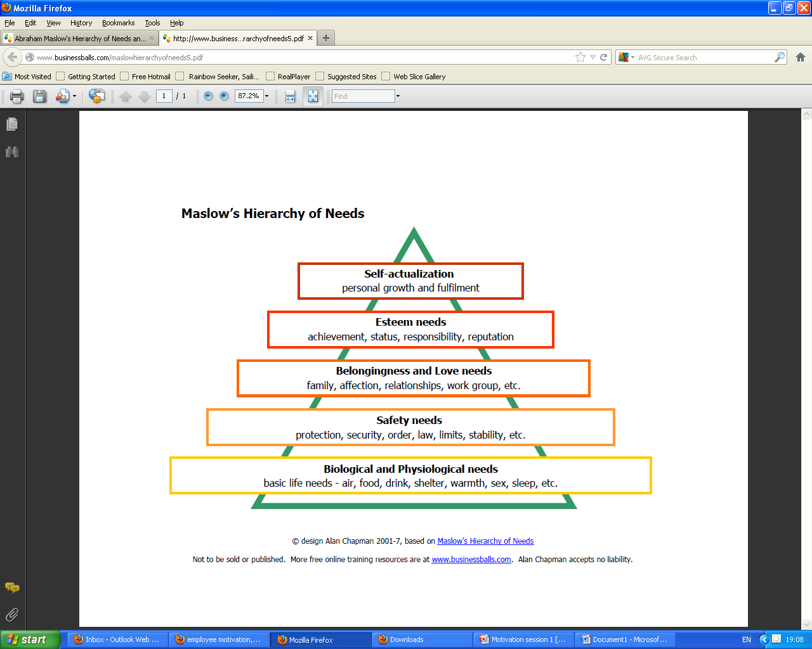

The Herzberg’s Two Factor Theory
Herzberg’s two factor theory or Herzberg’s dual-factor theory (1959) the concept of the theory is the difference between motivation factor and the hygiene factor or risk factor. On this theory hygiene factor is less important than the motivation factor. The motivation factor is the important and that lead to the job satisfaction. The motivation factor associated with the need for growth/ self-actualisation including achievement, recognition, responsibility, and advancement as well. The other one is the hygiene factor is the company policies, the administration, relation with the supervisor, working conditions, and the salary. The hygiene factor is the risk factor for the employees. If these did not meet the employees feel dissatisfied quickly and they will think to leave the organisation. Among these two factors the motivation factor led the positive approach to increase the job satisfaction.
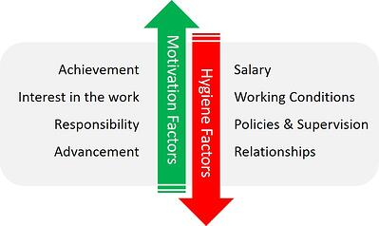
Herzberg argued that to motivate some individual successfully to do a job than need to identify the range of satisfiers and meet the needs responsibly. Also, the Maslow’s ideas are very similar to Herzberg as well.

COMMITMENT
Beer et al (1984) identified commitment is the concept of the Human Resource Management’s as a key dimension because that “can result not only in more loyalty and better performance for the organisation, but also in self-worth, dignity, psychological involvement, and identity for the individual.”
The organisational commitment represents the persons identification with and involvement in a particular organisation. Organisational commitment in the workplace is a bond between the employee with their organisation. The employee feels the connection with the organisation they feel fit in and they understand the ambition of the organisation.

IMPORTANCE OF COMMITEMENT
The importance of commitment was highlighted by Walton (1985) by saying that improve performance will result if the organisation move away from their traditional controlled oriented approach to workforce management, which relies on establishing order, exercising control and achieving efficiency. The traditional controlled oriented environment where narrowly defined jobs, and treated unwelcome necessity where employees are not very productive because they are not fully committed. On the other hand, when employees are more free and given broader responsibility, increased to contribute and helped to achieve satisfaction at their , they perform better because the jobs are designed to be broader then before and combined planning and implantation also upgrade the operations. The individual responsibility will be change as the condition change as well.

TYPES OF ORGANISATIONAL COMMITEMENT
“Organisational commitment is a multidimensional contrast that reflects a worker’s; identification with the organisation(loyalty), attachment to the organisation (intention to stay), and willingness to expand effort on the organisation’s behalf (discretionary effort) Appelbaum, et al. (2000)”.
There are three types of organisational commitments identified by Mowday et al (1982).
- Affective commitment
- Continuance commitment
- Normative commitment.

Affective commitment
Affective commitment is for a person how much he/she wants to stay within the organisation and how they feel for the organisation. They understand the company’s goals, feel they are fit in the organisation and they are satisfied. Employees who are affectively committed they act as ambassadors for their company and they are the assets for the companies.

Continuance commitment
Continuance commitment is about how the employees feel the needs to stay for the organisation. There is some underlying reason behind for the commitment that employees feel to stay with the organisation. There are lots of reason could be working for the employee to stay in the organisation, but the main reasons would be the lack of alternatives and opportunities.

Normative commitment
Normative commitment is about how much the employees feel to stay at the organisation. The employees are normatively committed and feel that they have to stay for the organisation. The employee has an emotional connection within the organisation that they feel if they leave the company there would be some consequences and they feel guilty about it. This kind of commitment concerns about the employee feeling if they leave the organisation that would create a void in knowledge or skills in the organisation and that could create a pressure on the other employees. Such feeling could have a negative effect on the performance of employees.

The commitment strategy would enable the employees to respond better and effectively when they are not tightly controlled by the management. The all three of these commitments are highly influence the employees that employees to stay within the organisation and perform well when are provided broader responsibility and encourage them to contribute and help to achieve satisfaction of their employees. The organisation should understand and recognise the importance of the commitment of the employees and encourage the employees to better committed for the organisation.

TRAINING
Employee training is to improve business productivity and make more profits also, it is a powerful tool to shaping employee attitude as well. Training motivates employees to increase discretionary behaviour and satisfaction with career development and job satisfaction. For employee development training is a major factor. Training is the use of systematic and planned instruction to promote learning. Reynolds (2004: 45) pointed out that training has a complementary role to accelerate learning; “it should be reserved for situations that justify a more directed, expert-led approach rather than viewing it as a comprehensive and all- pervasive people development solution”.

TYPES OF TRAINING

There are lots of types of training available are follows.
- Manual skills including apprenticeships.
- IT skills.
- Team leader or supervising training.
- Leadership and management training.
- Interpersonal training
- Personal skills.
- Training in organizational procedures or practice

THE MODELS OF TRAININGS

System model
This system model has of five phases and it should repeat on regularly to make sure to consist the improvement.
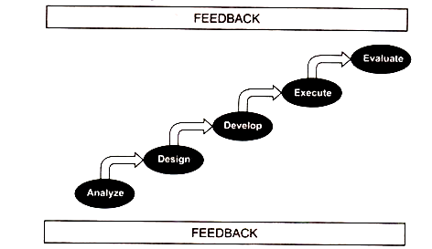

Transitional model
Transitional model mainly focuses on the organisation as a whole and the outer loop explain the vision, mission, and the values of the organisation also the inner loop to execute the goal.
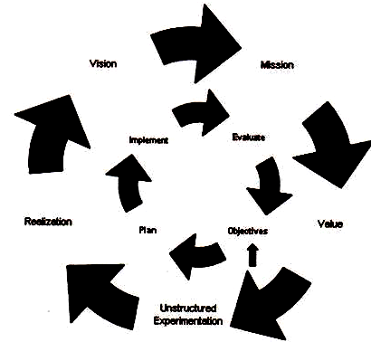

Instructional system development model
This model was been developed to answer the training problems. This model also gives the ideas to develop the strategies and the delivering media types to achieve the objectives.

POTENTIAL BENEFITS FOR THE ORGANISATIONS AND INDIVIDUALS BY THE MOTIVATION VEHICLES.

THE TRADITIONAL INDIAN AND BENGALI CUISINES

Indian cuisines in UK are common cuisine restaurant serving in the community almost in every small towns all over the United Kingdom. Eating is a necessary need for a human being and has to be fulfilled in everyday life. In this modern world time is a very important and valuable factor for every person. People try to save time by doing things in a every possible way. The effort to make food at home for working couples is so easy very time consuming often they are relied on the takeaway food or dinning outside in a restaurant or in a pub. In UK there are lots of types of food served by the different nationals. Some national foods are very popular to the British people and these foods has made their own reputation and brand in the society. In the 1784, curry and rice became specialities in some popular restaurants in London’s Piccadilly. UK celebrates the National Curry Week every October. The Curry industry became heugh in the UK market and that contributes more then £5bn to the British economy. In 2001 the British foreign secretary referred the Chicken Tikka Masala as a “true British national dish”.
According to Peter Groves, co- founder of National Curry Week 65% to 75% of the Indian restaurants in the UK run by the Bangladeshi immigrants. As worker of this industry I am the witness of these trade how it is been running by the people and the individuals are working in this industry. As a heugh contributor into the economy this industry has to be reflect better and make a better brand also can earn more respect in the community. Since the 1950’s the traditional Indian restaurants been running by the groups of people lived in a local areas and recruit’s employees from their own communities who has very little or no experience. The migrant workers came from abroad with very little or no education or practical qualifications the majority of these people work for these restaurants’ kitchen porters because of their language barrier and the ability and experience they consider this is their best option. They learn step by step to became chef without any formal training and support. They spent their whole working life as an Indian chef to serve food in this trade. Some of these people are so talented that they keep inventing dishes on their own and made the industry so big and famous as an example the famous chicken tikka masala was invented by them chefs and this very same dish doesn’t exist in India or Bangladesh or has no authentic taste too.

Some migrant workers with some English-speaking skills found their place in the front serving customers. They simply start as a bar-worker and gradually learn how to serve customer and make their career as a waiter or a restaurant manager. They have no formal or institutional education or training for their positions.
There are lots of opportunities for these individuals and the business to improve by using employee motivation vehicles to improve their abilities to provide better services to their customers and making high quality products and the services also, more profits as well. If the management understand the importance of the motivation and how these could influence the employees at work and the potential, then they will implement them at the workplace to perform better. There are lots of other competitors in this trade and a big rivalry between them also lots of modern equipment getting involved into every trade and new style of product are available in the market too. For example, people are more intended to order their food online such as Just Eat, Hungry Horse, Deliveroo etc, these kinds of internet service. People are not relying on the old traditional telephone ordering technology anymore. That is why to stay in the market and survive the traditional Indian restaurants have to motivate their employee and make them engage to be more committed also train them by the professionals as well to flow with the tide.

Advantages and benefits of employee motivation
High level of employee motivation is intrinsically link to a very high level of employee engagement and a very productive employee. There are lots of other benefits of a highly motivated employees. On these days’ organisations are pays more attention to motivates their employees. More likely these are the potential benefits.
- The motivated employee is faster and efficient. They are more productive.
- Motivated employees are more innovative they more likely to offer better and the productivity is highly focused and accurate.
- Motivated employees lead to Lower levels of absenteeism at the workplace and they are happy to be at the workplace.
- Motivated employees are more likely to stay at their respected role are make effort to make the company reputation and other hand that make the companies not spent much on training and recruitment costs.
- Motivated employees give a good reputation to attract the employees for better workplace and easier to recruit the potential leading talent for the company.

KEY BENEFITS OF ORGANIZATIONAL COMMITEMENT
There is some benefit of organisational benefits of the commitment that determine how long the employees will stay within the organisation and these committed employees are the asset for these organisations. There are some of the benefits are bellows.
- HIGHLY EMPLOYEE PRODUCTIVITY
The committed employees are more productive. They are loyal with the organisation and believe the organisational goals and the company’s vision and mission. They will make sure about to meet the organisations target also ensure that their colleagues to display the same kind of attitude.
- REDUCED ABSENTEEISM
The committed employee more likely to report lesser absenteeism and always look forward to being at the workplace on time. They are very punctual completing their job and helping out on other projects and contribute in towards organisations goals.
- EXCELLENT TEAM PLAYERS
The committed and dedicated employees are very much involved into the organisation and its success, they are great at collaborating with others and love to share with the others and working with the team.

- STRONG ADVOCATES
Dedicated, committed, and determined employees are the loyal people in the organisation and they are effective and positive advocates of their employers. They are they strong supporters of the organisations products, service, and policies.

ADVANTAGES AND BENEFITS OF TRAINING
There are lots of benefits of trained employees in the workplace and employers are more relaxed and have more confident with the quality of work and service.
- Trained employees are very effective to increase productivity and more Profit growth in the business.
- Higher trained employees can offer more quality of work and reduced faults and wastes.
- The trained employees are very competent to deal with the customers.
- Reduced employee turnover because trained employees are comfortable at the place where they are understanding the workload.
- Deeper talent succession pipelines and that is an advantage for the company as well.

PERSONAL DEVELOPMENT PLAN
A personal development plan (PDP) is a plan to improve the ability for the future improvement and learning by setting the target by finding the weakness and the strengths and the opportunities to work on it. A Personal Development Plan (PDP) is a form of portfolio assessment embedded within a larger development cycle (Evans et al., 2002).
According to the SWOT analysis I have numbers of weakness and there are lots of opportunities as well. To use the opportunities, I need to focus on my weakness to work on them to make it my strengths. The weakness I have found on my SWOT analysis that I need to improve in the future.

Digital skill
Digital skill is a vital skill to achieve in this modern working environment. Without this skill is very hard to adjust and meet the service requirement because digital equipment is taking over every little aspect of the workplaces. I will take apart a course in IT in the next academic year in my local college who offering a course that will be an afternoon course I can fit in to.

Management skill
At this current study at UWTSD I have improved already a lot by understanding and studying how to manage a business. Also working into a service providing environment helping me learn practically to enhance my knowledge by thinking critically how to manage a business.

Customer service skill
Being a student of management and leadership at UWTSD I have a great chance to understand and improve my customer service skills and that is reflecting in my current workplace.

Communication skill
It I very important for the employer to have very experienced and trained communicative person to deal with the customer for the success of the business. On my study at the university I am currently increasing my knowledge and also, learnt previously in level 4 qualification about effective communication that will improve by end of the course.

Decision making skill
By thinking critically and logically also, taking positive approach at the workplace to achieve the goal it is very important. In my current learning at my university courses are helping my understanding and improving too.

Team working skill
To work in a team there are lots of soft skills to improve and develop to play the role in a team. I have to focus on effective team working skills as I have learned from my level 4 classes from the Moodle of effective team working skills. Also, the developing relationship and workplace achievement classes are helping to enhance my team working ability.
I am fully confident and understand that by the academic year 20-21 if I can successfully complete the level- 5 & level-6 of the management and leadership course and then I will achieve these skills to be a successful candidate for the position to run and manage a business.

References.
Search-proquest-com.ezproxy.uwtsd.ac.uk. 2020. [online] Available at: <https://search-proquest-com.ezproxy.uwtsd.ac.uk/docview/229593986?accountid=130472> [Accessed 15 July 2020].
Adair, J. and Allen, M., 2003. The Concise Time Management And Personal Development. London: Thorogood.
(Employee-Organization Linkages: The Psychology of Commitment, Absenteeism, and Turnover. Richard T. Mowday , Lyman W. Porter , Richard M. Steers | American Journal of Sociology: Vol 88, No 6, 2020)
Sukhadwala, S., 2020. The Story Of London's First Indian Restaurant. [online] Londonist. Available at: <https://londonist.com/2016/06/the-story-of-london-s-first-indian-restaurant> [Accessed 15 July 2020].
bhat, a., 2020. Employee Motivation: Definition, Types, Importance, And Ways To Improve It | Questionpro. [online] QuestionPro. Available at: <https://www.questionpro.com/blog/employee-motivation/> [Accessed 29 June 2020].
chand, s., 2020. Models Of Training Employees: Steps, Transitional And Instructional System Development Model. [online] Your Article Library. Available at: <https://www.yourarticlelibrary.com/training-employees/models-of-training-employees-steps-transitional-and-instructional-system-develo> [Accessed 12 July 2020].
Coursehero.com. 2020. According To Elena P Antonacopoulou 2000 Employee Development Means To Develop | Course Hero. [online] Available at: <https://www.coursehero.com/file/p1gkqub/According-to-Elena-P-Antonacopoulou-2000-employee-development-means-to-develop/> [Accessed 30 June 2020].
GANTA, V., 2020. [online] Available at: <https://d1wqtxts1xzle7.cloudfront.net/52566956/kullll.pdf?> [Accessed 30 June 2020].
Kbmanage.com. 2020. Personal Development Plans - What Is It? Definition, Examples And More. [online] Available at: <https://www.kbmanage.com/concept/personal-development-plans> [Accessed 15 July 2020].
Gawel, J., 2020. Herzberg's Theory Of Motivation And Maslow's Hierarchy Of Needs. ERIC/AE Digest.. [online] Eric.ed.gov. Available at: <https://eric.ed.gov/?id=ED421486> [Accessed 30 June 2020].
Harvard Business Review. 2020. From Control To Commitment In The Workplace. [online] Available at: <https://hbr.org/1985/03/from-control-to-commitment-in-the-workplace> [Accessed 3 July 2020].
MUKHERJEE, D., 2020. History Of The British Curry - Historic UK. [online] Historic UK. Available at: <https://www.historic-uk.com/CultureUK/The-British-Curry/> [Accessed 14 July 2020].
Harvard Business Review. 2020. From Control To Commitment In The Workplace. [online] Available at: <https://hbr.org/1985/03/from-control-to-commitment-in-the-workplace> [Accessed 16 July 2020].
Perkbox. 2020. Why Employee Motivation Is Important & How To Improve It. [online] Available at: <https://www.perkbox.com/uk/platform/insights/why-employee-motivation-is-important-and-how-to-improve-measure-and-maintain-it> [Accessed 12 July 2020].
Ramlall, S., 2020. [online] Available at: <https://d1wqtxts1xzle7.cloudfront.net/55461861/Review_of_Employee_Motivation_Theories_-_Journal_of_American_Academy_of_Business.pdf?1515259230=&response-content-> [Accessed 2 July 2020]
UKEssays. November 2018. Meaning And Definition Of Personal Development Plan. [online]. Available from: https://www.ukessays.com/essays/management/meaning-and-definition-of-personal-development-plan-management-essay.php?vref=1 [Accessed 15 July 2020]..

