The following development appraisal will assess the viability of the conversion of an existing commercial building into 9 modern flats.

Nathan J Morris
Development Appraisal

Lace House - Luxury Apartments
Contents
Introduction 2
Executive Summary 2
History 2
Location 3
Proposed development 3
Current state of property 3
Market research 4
Identification of capital costs 4
Asset acquisition 4
Design phase and contract value 4
Market values and gross development values Luxury finish 5
Return on Investment 5
Market values and gross development values for “Good standard” finish 5
Review of similar exemplar development 6
Risks and opportunities 6
Risk register 6
Alternatives 7
Other high yielding areas within the UK 7
Flat conversion example Northern England 8
Investment within stocks and shares 8
Summary 9
Appendix 10
Appendix A – Spons development square metre costs 10
Appendix B – Risk register 0
Appendix C – Blockhouse development 1
Appendix D – Liverpool project overview 3
Appendix E – High end luxury vs good standard finish 4
Appendix F – Lace House Floor plans 7
References 9

Word count - 2662

Introduction

Executive Summary
Project Name: Lace House
Location: 39 – 40 Old Steine, Brighton, BN1 1NH
Scope: Conversion of the existing commercial building into 9 self-contained residential luxury flats, these will then be sold to make a profit.

History
Lace house is a listed 19th Century commercial building situated in the valley garden conservation area of Brighton, England. It is a former, library, post office and vehicle showroom which displayed prestige brands such as Jaguar, Rolls Royce and Bentley (HAPA, 2020). It is a grand building which is located just behind the seafront hotels and is famed for its historic black cat sculpture located on its wall. The building later became converted into offices but has recently become redundant. (logan, 2017)

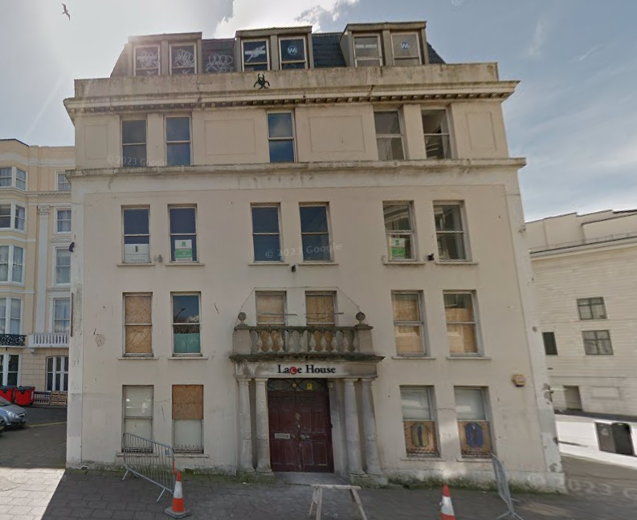
Figure 1 – Lace House, 39 Old Steine Road, Brighton. BN1 1NH. (Google, 2017)

Location
The building is made up of 6 Storeys including the basement and is located within Brighton city centre, just opposite the historic Victorian fountains and within walking distance to the famous Brighton pier and local beach.
The location of this building is central to what many regard as one of the most varied shopping, dining and cultural experiences outside of London (Lace Wilson, 2020).
The location which is near the beach is regarded as one of the best weekend getaway locations in the world, with its 8 miles of pebbled beach and plenty of bars and restaurants overlooking the sea. There are also many festivals held throughout the year as well as many cinemas, theatres galleries and museums. (Harringtons, 2020)

Proposed development
The proposed scheme includes the creation of 9 luxury flats within this unit, two of which are 2 bed flats and the other 7 are 1 bed flats. The proposed standard of refurbishment is of a high-end luxury finish and there are many other similar flats within this location to compare this development too.
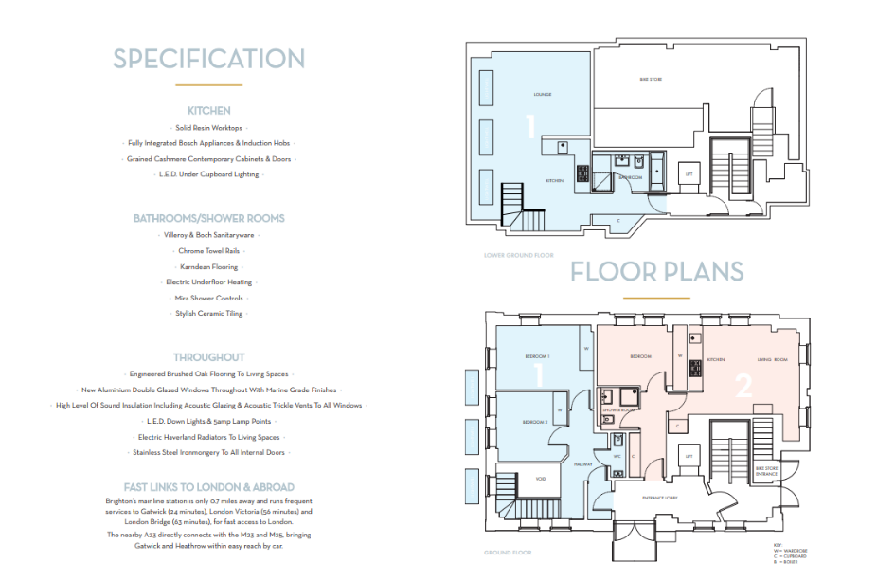
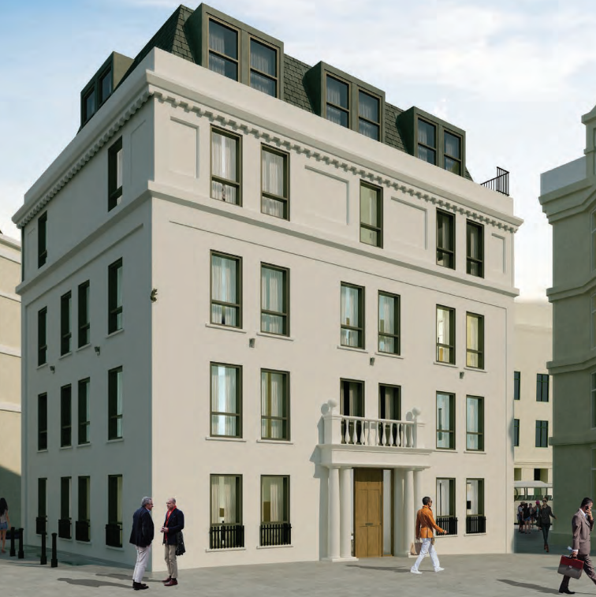
Figure 2 – Proposed exterior render and layout. (Lace Wilson, 2020)

Current state of property
The current state of the property as seen in figure 1 is very poor, with a full renovation and extensive repairs required, the building has solid concrete floors with rendered masonry blockwork and reinforced steel beams as well as an existing lift shaft and a dark confined space basement area with no natural light (Floor plans are in Appendix). The building is also of listed status with certain aspects such as the external render, balcony and window guards as well as the portico roof and columns to be restored to meet the listed status requirements, as well as restoring the historic ornamental cat on the external wall. It is extremely important for a thorough building survey to be undertaken, due to the age of the property and assume a worst-case scenario to all aspects of the project when it comes to building refurbishment, as historic buildings like these can unearth no end of issues when refurbishment begins.

Market research
Using local property websites there are many similar sized flats with high end finishings ranging in value currently from £350k -£550k with the higher end of the market being 2 bed properties (Zoopla, 2025). There is however many good standard finished properties within this price range which may mean a slight reduction in refurbishment costs depending on our analysis of our key metrics (Zoopla, 2025). We will therefore be looking to sell in 2027 and Savills have predicted a best guess of 7% increase in value over this 2-year period (Savills, 2025).

Identification of capital costs

Asset acquisition
The correct market value for the property in its current condition, based on the original £800k purchase price in 2018, with inflation added and local house prices taken into consideration is £1,316,500.00.

Design phase and contract value
For a refurbishment scheme to a luxury finish in close proximity to London, a property of this size with a total square coverage of 527.2m2, the Spons guide for refurbishment calculated costs would be £3275m2 (Aecom, 2023) . Please see appendix A).
Therefore, a refurbishment to a luxury finish would produce a contract value of (527.2*3275) =£1,726,580. (These are guide costs and should therefore be treated as such and are subject to increase or decrease, so caution should be attributed to these)
Electricity 3 phase upgrade (experts, 2023) and RIBA design fee cost of 5% estimated at £100k (RIBA, 2024).
Borrowing costs based on £3,143,080 @ 4.5% = £283,264.70 (England, 2025)
Total Development Cost including loan: £ 3,426,344.7

Market values and gross development values Luxury finish
2025 1 bed luxury flat estimates for this location are between £350k-£375k. (Zoopla, 2025)
2025 2 bed luxury flat estimates for this location are between £475k and £500k (Zoopla, 2025)
Therefore a 2027 forecast based on Savills data for this region, indicate a 7% forecasted increase over the two year period, this will therefore give us a GDV including uplifted property values for 2027 of:
Gross Development Value (GDV): Between £3,638,000 and £3,905,500 (Savills, 2025)
Based on the GDV mentioned above and the forecasted property values within the area, with the luxury finish applied to the flats we can expect a projected profit of between £211,655 and £479,156

Return on Investment
Return on Investment calculations (ROI) for 2 years: Between 6.18% and 13.98%
Initial appraisal suggests even without deducting fees for estate agents the project is non-viable due to the limited profits likely to be returned for the work required, this is based on market conditions, costs, and risks. It is therefore worth looking at the high-end luxury cost model and reduce the level of finish to a “good standard” finish rather than high end luxury as this may allow greater profits to be made. The below metrics are now re calculated with a “good standard” finish to all flats to see if this development is worth proceeding with. An example of a Luxury finish vs Good standard finish can be found in Appendix E.

Market values and gross development values for “Good standard” finish
With a cost per Square metre for a good standard finish at roughly £2475 per sqm (Aecom, 2023), we could potentially achieve the following projected profits using Spons data (this is a guide so could go up or down).
New contract value of £1,304,80 and total Development cost of £2621,320 plus the £100k fees as before and including borrowing at 4.5%. The total development cost for a standard finish would be £2,966,574.31
Estate agents fees are calculated at roughly 2% (alliance, 2025) and equate to roughly £59,331. These will be deducted from any profits.
This would then provide us with the below profits (excluding estate agent fees)

Projected Profit: Between £433,426 and £683,426
Return on Investment (ROI) 2 years: Between 22.6% and 31.6%
These new metrics are obviously much more favourable than before and worthwhile pursuing, it is therefore recommended that we go down this route of a good standard finish to the properties rather than the high-end luxury finish originally planned. Recent market analysis of the exact area within Old Steine suggests properties are selling at a lower price point with a more normalised fit and finish. This may be due to the proximity of the bus station and nightlife directly surrounding lace house, it is therefore recommended we aim for this fit and finish to achieve the best yield from the development.

Review of similar exemplar development
There are many refurbishment examples of commercial buildings being converted into residential flats, and a good similar example is “The Blockhouse”, located within the BH1 postcode (Please see figures in appendix C). A few streets inland from Lace house this previously was 6 storey Victorian school building that has been converted into 135 one, two and three bed flats with similar layouts and floor space (rent, 2025). It is obviously a larger project than the Lace house development, but the properties are finished to a good standard just like the one we are after. A two bed Flat in this area finished to a good standard achieves around the £475,000 price range (Zoopla, 2025). Photos and floor plans can be found in the appendix to this report and show the finish and layout which is similar to what we aim to achieve here.
Osbourne developments acquired the site in 2019 and secured planning permission for build to rent consent which may also be an option to our development. HNW architects designed the flats and they produce a rental income of around £2000 pcm for a 2 bed flat and £1700 pcm for a 1 bed flat. This would produce an annual return of £190,800.00 per year if we chose to go down this route for our Lace house development (Horne, 2024).

Risks and opportunities

Risk register
See Appendix B for the associated risks to the project and how these can be mitigated by using the excel risk register.

Alternatives

Other high yielding areas within the UK
Over the past two years (2023 and 2024), several UK regions have experienced significant property price growth, often outpacing the more modest increases seen in Brighton and Hove, which has only achieved an increase of 1.5%. from £417,000 - £424,000 (Plumplot, 2025)
The table below highlights alternative regions within the UK which have experienced greater property growth than Brighton.
Top UK Property Growth Areas (2023–2024)

Location | Region | 2023 Avg. Price | 2024 Avg. Price | % Growth
Stoke-on-Trent | West Midlands | £193,662 | £227,002 | 17.20%
Slough | South East | £433,194 | £497,704 | 14.90%
Oldham | North West | £218,595 | £250,546 | 14.60%
Bradford | Yorkshire and The Humber | £200,093 | £226,261 | 13.10%
Bolton | North West | £223,231 | £252,070 | 12.90%
Barnsley | Yorkshire and The Humber | £199,725 | £224,886 | 12.60%
Wolverhampton | West Midlands | £247,403 | £278,083 | 12.40%
Doncaster | Yorkshire and The Humber | £204,371 | £228,040 | 11.60%
Dunfermline | Scotland | £208,013 | £230,379 | 10.80%
Hamilton | Scotland | £208,360 | £229,835 | 10.30%

(Plumplot, 2025)

High growth areas like Stoke-on-Trent, Slough, and Oldham have seen substantial property price increases, ranging from approximately 14.6% to 17.2%, driven by factors such as affordability and increased demand.
Brighton & Hove in contrast, experienced a modest growth of 1.5% over the same period, reflecting a more stabilised market.
These trends suggest that while Brighton and Hove remain desirable, other regions have offered more significant property investment growth opportunities in the past two years as well as cheaper initial purchase prices compared to Brighton.

Flat conversion example Northern England
A similar example of a flat conversion to our project, is one in the North of England in Liverpool which was a former furniture showroom to flat conversion.
This former furniture showroom was converted into 15 residential flats. The initial purchase price was £240,000, with a total loan of £585,000 to cover refurbishment costs and a new appraisal final property valuation of £975,000 with GDV being £1.2m.
All properties were sold off plan really quickly with a total profit made of £250,000 (£337,997 in today’s money after inflation) after only 6 months of redevelopment (capital Lowry, 2016).
As you can see in this example above, £250,000 profit was made in approximately 6 months (albeit a very quick development by a large scale developer) for a lot less invested capital. Even if undertaken at a slightly slower pace than this example, if we invested in an area like this it would allow multiple projects to be completed and allow for a much greater profit to be made in a much quicker time period than our project in Brighton.

Investment within stocks and shares
Other options could even be investing in stocks and shares, for example over the past two years (2023–2024), investing in major stock indices like the S&P 500 and FTSE 100 have generally outperformed property investments in Brighton and Hove.
Stock Market Performance (2023–2024)
Investment Type | Cumulative Return (2023–2024)
S&P 500 (U.S.) | +53.2%
FTSE 100 (UK) | +10.5%
Brighton Property | +1.5%

(Curvo, 2025)
While the stock markets, particularly the S&P 500, have shown strong performance over the past two years, property prices in Brighton and Hove have experienced modest growth it is therefore worth bearing this alternative form of investment in mind.

Summary

The above development finished to a good standard, and based on forecasted sales for similar standard flats in the area could provide us with between a 22.6 – 31.6% return on investment for the 2-year period.
Based on recent property sales for flats within this area and finished to a similar standard, this refurbishment would give us a good profit and would be a good development to progress with.
However if looking to maximise our return on investment and target the greatest increase in capital yield there are other regions within the UK that would be more beneficial for this type of project, especially within the north of England as shown in the Liverpool case study above, as these are not only cheaper initially to purchase but they offer a much greater increase in future value and offer an even better ROI. These combined factors, with cheaper labour and less desire for the high end finishes, multiple developments can be undertaken within a two year period, maximising the ROI and profits for the developer.
It is important to note that with all projects like these, using best guess information regarding redevelopment costs, unforeseen problems, forecasted house prices and predicted sales, there are so many unknowns. It is therefore better to be pessimistic with ROI calculations and if the project still returns good numbers based on the ROI with all worse case factors inputted into the analysis, then you have a decent chance it will be successful.

Appendix

Appendix A – Spons development square metre costs

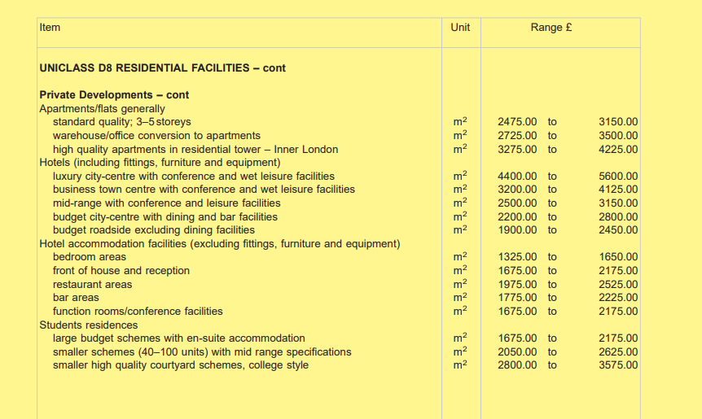
Appendix A – Sample of refurbishment costs per sqm for high quality and good standard finish (Aecom, 2023)

Blank Page

Appendix B – Risk register

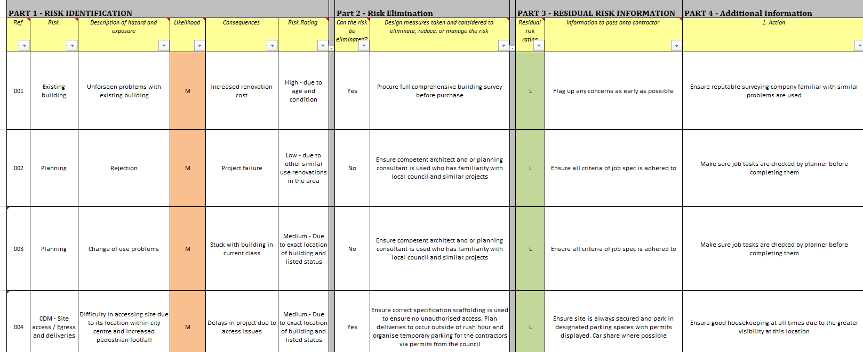

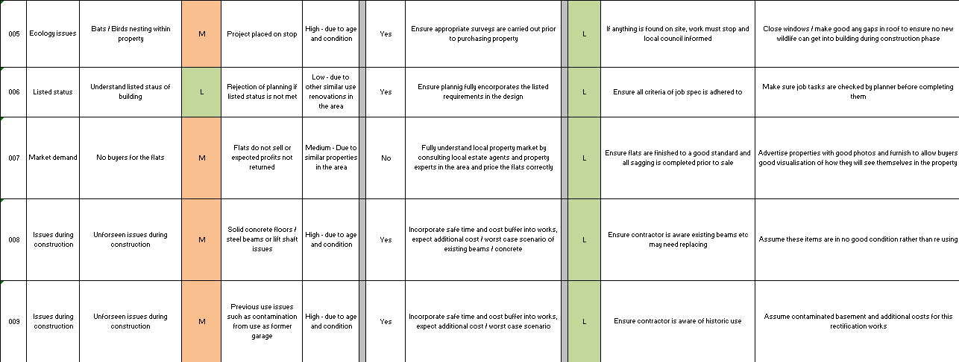

Appendix B – Risk register document

Appendix C – Blockhouse development

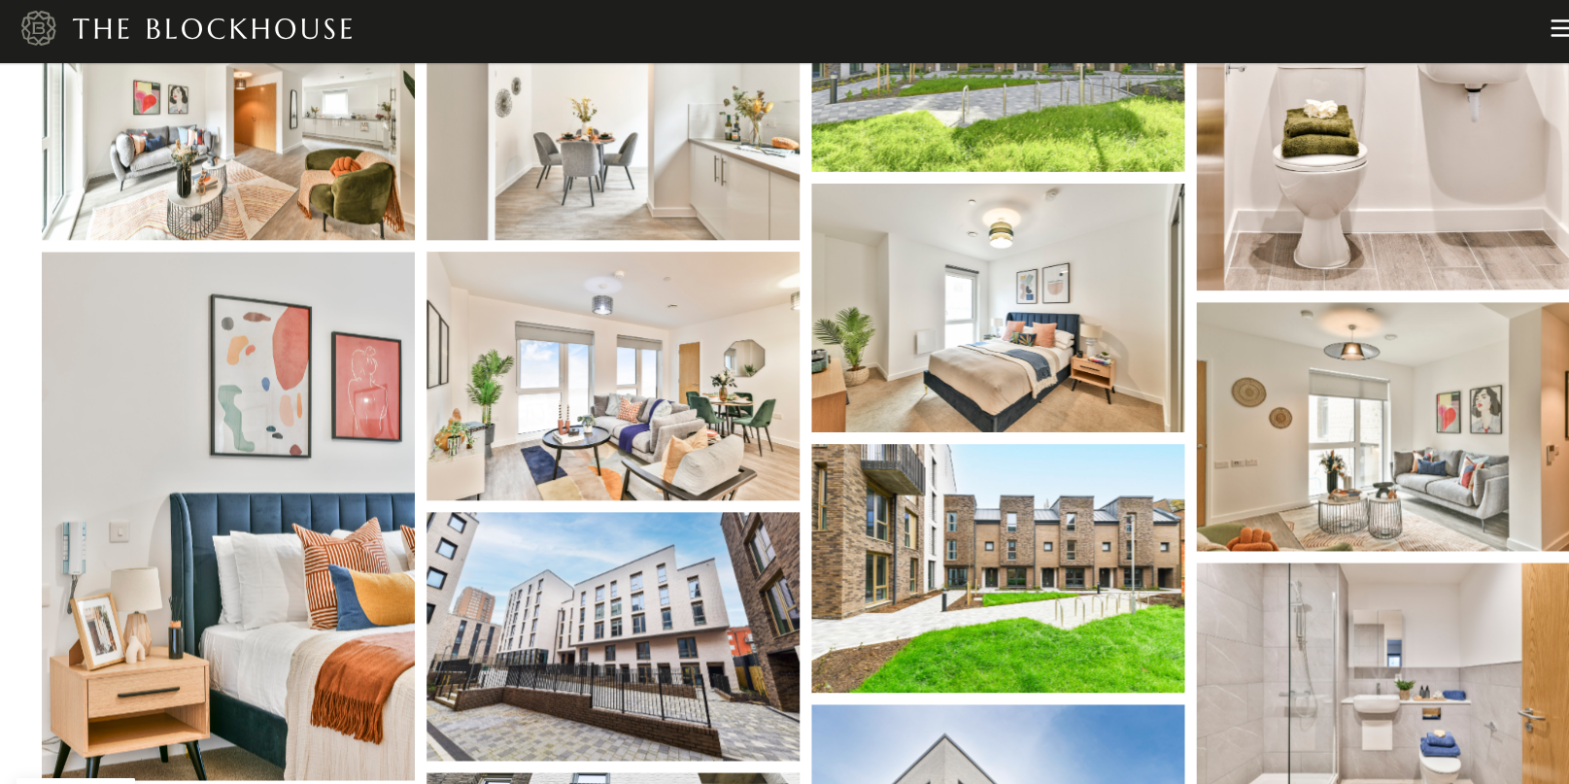

Example of fit and finish to a “good” standard of the Blockhouse development (The Blockhouse, 2025).

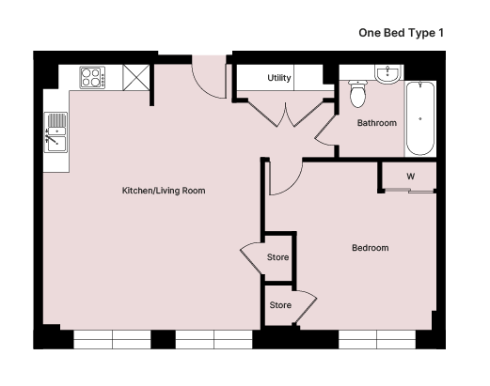

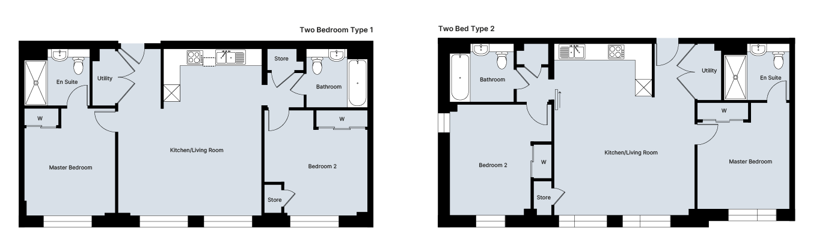

Example of layout of one and two bedroom flats at the Blockhouse development (The Blockhouse, 2025).

Appendix D – Liverpool project overview
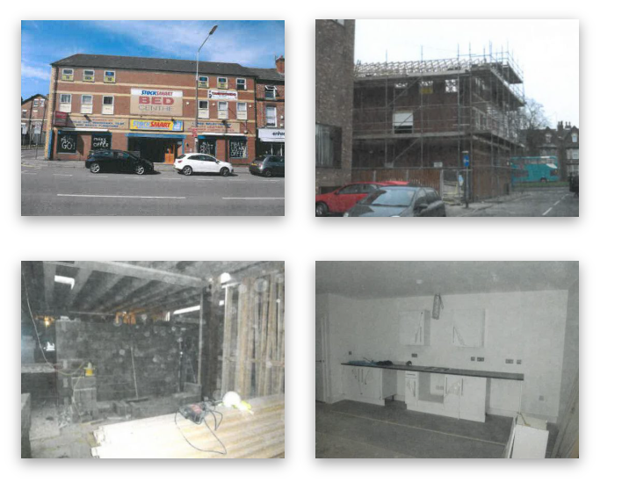
Liverpool Office conversion before and during construction, (capital Lowry, 2016)

Appendix E – High end luxury vs good standard finish

Example of key elements of the build highlighting the differences between high end luxury finishes compared to good standard finishes. Tables and photo examples to clarify key differences.

Worktops
Type | Material Example | Description
Luxury Finish | Marble (e.g., Calacatta Oro), quartzite or Dekton | Seamless, ultra-durable and visually striking; bespoke cut and polished
Good Standard | Solid quartz (e.g., Silestone) | Factory-produced, good durability, polished but less bespoke.

Flooring
Type | Material Example | Description
Luxury Finish | Wide-plank engineered oak, marble tiles, or herringbone parquet | Precision-laid, long-lasting, often underfloor heated, stylish.
Good Standard | Engineered wood or good quality LVT (e.g., Amtico, Karndean) | Durable, clean look, water-resistant, easy to install.

Kitchen Cabinets
Type | Material Example | Description
Luxury Finish | Custom-built, solid wood, matte lacquered MDF or veneered with internal LED lighting | Soft-close, seamless joinery, integrated handles.
Good Standard | Flat-pack IKEA or preassembled Howdens | Durable, modern finishes, decent fittings.

Bathroom Finishes
Type | Material Example | Description
Luxury Finish | Italian porcelain tiles, floating vanity, underfloor heating, built-in storage | Wetroom spec, seamless finishes, bespoke glass.
Good Standard | Ceramic tiles, chrome fittings, pre-made vanity unit | Functional, tidy, standard white goods.

The example below is of a Luxury finished Kitchen, with Dekton Worktops and heringbone flooring compared to a good standard Quartz worktop with good lvt flooring
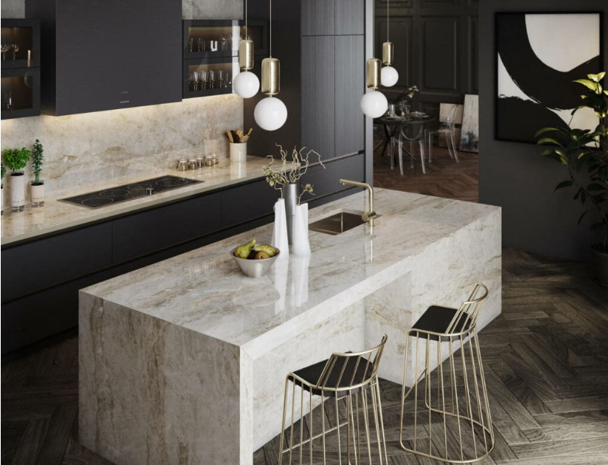
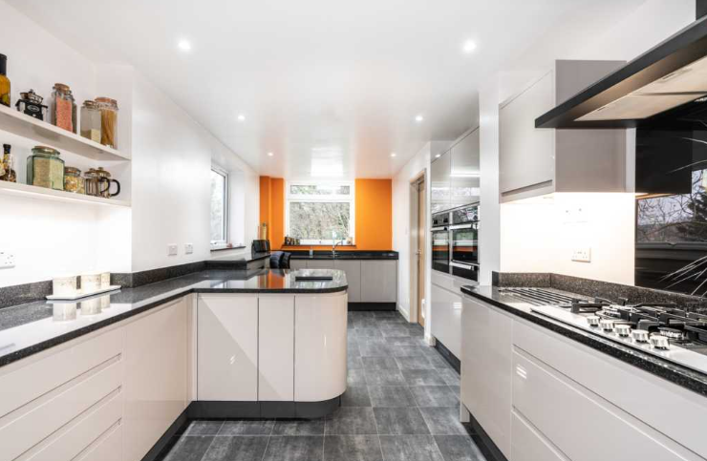
High end Luxury (Kitchens, 2025) Good standard finish (Marble, 2025)

Appendix F – Lace House Floor plans
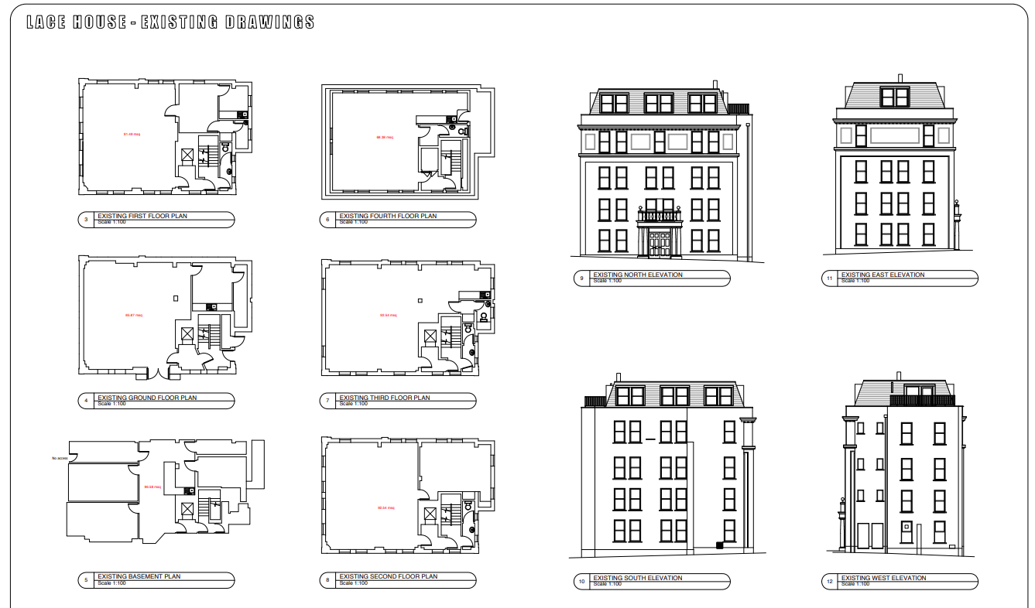
Lace house existing drawings. (Brighton-Hove, 2018)
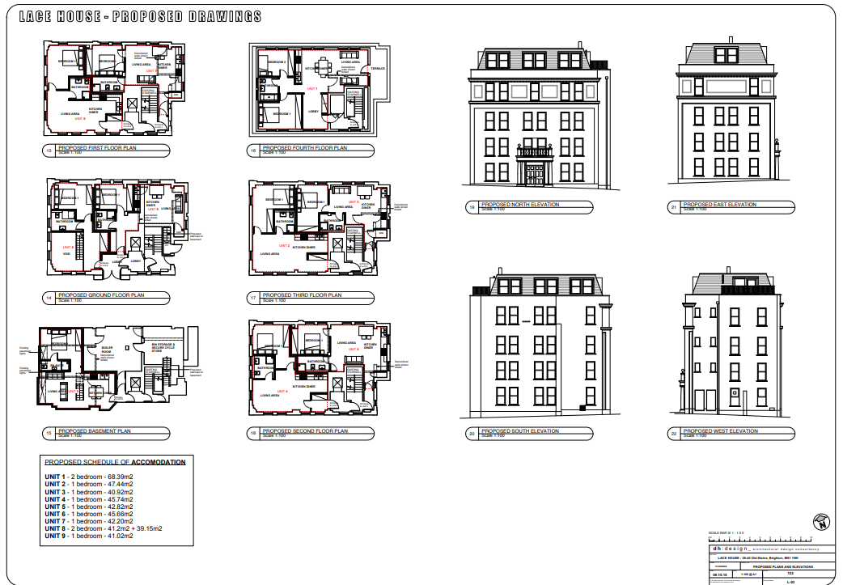
Lace house proposed layout drawings (Brighton-Hove, 2018)

References
Aecom, 2023. Spons. 148 ed. Oxford: CRC Press.
alliance, H. o., 2025. Home owners alliance,. [Online]
Available at: https://hoa.org.uk/advice/guides-for-homeowners/i-am-selling/how-much-should-i-pay-the-estate-agent/
[Accessed 20 April 2025].
Brighton-Hove, 2018. Planning portal. [Online]
Available at: https://planningapps.brighton-hove.gov.uk/online-applications/files/4FC9D908D8C52F603115E062E4D7BDB2/pdf/BH2015_03656-PROPOSED_PLANS___ELEVATIONS-3577963.pdf
[Accessed 12 05 2025].
capital Lowry, 2016. Lowry capital. [Online]
Available at: https://www.lowrycapital.co.uk/case-study/conversion-of-a-furniture-showroom-into-15-flats
[Accessed 25 April 2025].
Curvo, 2025. Curvo. [Online]
Available at: https://www.plumplot.co.uk/house-prices-by-region.html
[Accessed 15 April 2025].
England, B. o., 2025. What are interest rates,. [Online]
Available at: https://www.bankofengland.co.uk/explainers/what-are-interest-rates
[Accessed 24 April 2025].
experts, T. e., 2023. Three phase electricity,. [Online]
Available at: https://www.theecoexperts.co.uk/news/three-phase-electricity#:~:text=How%20much%20does%20it%20cost,supply%20is%20from%20your%20home.
[Accessed 24 April 2025].
Google, 2017. Lace House. [Online]
Available at: https://www.google.com/maps/@50.8200668,-0.1375742,3a,90y,194.78h,97.67t/data=!3m8!1e1!3m6!1sKepi75cyRCHjLCloBKJaTA!2e0!5s20170401T000000!6shttps:%2F%2Fstreetviewpixels-pa.googleapis.com%2Fv1%2Fthumbnail%3Fcb_client%3Dmaps_sv.tactile%26w%3D900%26h%3D600%2
[Accessed 15 April 2025].
HAPA, 2020. HAPA Architects,. [Online]
Available at: https://hapa-architects.co.uk/portfolio/lace-house/
[Accessed 24 April 2025].
Harringtons, 2020. Harringtons lettings. [Online]
Available at: https://harringtonslettings.co.uk/brighton-property-and-area-guide/
[Accessed 14 April 2025].
Horne, A., 2024. Anstey Horne. [Online]
Available at: https://www.ansteyhorne.co.uk/projects/the-blockhouse-brighton
[Accessed 14 April 2025].
Kitchens, G., 2025. German kitchens at square. [Online]
Available at: https://germankitchensatsquare.co.uk/dekton-worktops-barnsley/
[Accessed 12 05 2025].
Lace Wilson, 2020. Lace House, Brighton: Oakley.
logan, G. h., 2017. The Argus. [Online]
Available at: https://www.theargus.co.uk/homes/property/news/15630675.brighton-builders-rescue-mysterious-91-year-old-black-cat/
[Accessed 15 April 2025].
Marble, Y., 2025. Yands Marble. [Online]
Available at: https://yandsmarble.co.uk/handmade-stone/quartz-worktops/
[Accessed 12 05 2025].
Plumplot, 2025. Brighton and hove house prices,. [Online]
Available at: https://www.plumplot.co.uk/City-Brighton-and-Hove-house-prices.html
[Accessed 24 April 2025].
Plumplot, 2025. Plumplot. [Online]
Available at: https://www.plumplot.co.uk/house-prices-by-region.html
[Accessed 15 April 2025].
rent, L. t., 2025. The blockhouse,. [Online]
Available at: https://www.lovetorent.co.uk/companies/touchstone-resi/the-blockhouse/
[Accessed 25 April 2025].
RIBA, 2024. RIBA Architecture,. [Online]
Available at: https://www.architecture.com/working-with-an-architect/how-do-i-calculate-an-architects-fees?srsltid=AfmBOor2QGkC-9nyY_gdobn19U8fNuzrHzceAAjyZ5xlI0a-0npXZsMp
[Accessed 25 April 2025].
Savills, 2025. Savills. [Online]
Available at: https://www.savills.co.uk/insight-and-opinion/research-consultancy/residential-market-forecasts.aspx
[Accessed 24 April 2025].
The Blockhouse, 2025. The Blockhouse,. [Online]
Available at: https://www.theblockhouse.co.uk/two-bedroom/
[Accessed 21 April 2025].
The Blockhouse, 2025. The Blockhouse,. [Online]
Available at: https://www.theblockhouse.co.uk/gallery/
[Accessed 21 April 2025].
Zoopla, 2025. Zoopla. [Online]
Available at: https://www.zoopla.co.uk/for-sale/flats/east-sussex/brighton/old-steine/bn1-1nh/?beds_min=1&q=bn11nh&radius=0.5&search_source=for-sale
[Accessed 10 April 2025].
Zoopla, 2025. Zoopla 1 bed flat. [Online]
Available at: https://www.zoopla.co.uk/for-sale/flats/1-bedroom/bh1/?q=bh1&radius=0.25&search_source=for-sale&results_sort=highest_price&pn=1
[Accessed 20 April 2025].
Zoopla, 2025. Zoopla 2 bed flat. [Online]
Available at: https://www.zoopla.co.uk/for-sale/flats/2-bedrooms/bh1/?q=bh1&radius=0.25&search_source=for-sale&results_sort=highest_price&pn=1
[Accessed 21 April 2025].
Zoopla, 2025. Zopla. [Online]
Available at: https://www.zoopla.co.uk/for-sale/flats/2-bedrooms/bh1/?q=bh1&radius=1&search_source=for-sale&results_sort=highest_price&pn=1
[Accessed 24 April 2025].

