
University of Wales Trinity Saint David
School of Computing
Application Development
Kieran John Ayres (P149775)
04/05/2020
Application Development/ACCA5012

Contents
Introduction 1
Introduction to the Application 2
Requirements 3
Implementation 4
List of Models, Views, View Models and Controllers 5
Testing 6
Reflection 8
Conclusion 8
References 9
Bibliography 9

Introduction
The focal point of this assignment is to build a web application using the ASP.NET framework, through the use of the MVC framework. It’s a platform for developers, it’s used for assembling different types of applications including; web applications. [1]. This report will begin with a brief introduction into the application, explaining its purpose and target audience. This will also be accompanied by some intentions and plans the developer initially had. This will then be followed by the implementation section, which will include a list on the different models, view models, controllers and views that the website included. This will then show the final page designs including some explanations on some of the pages. This will be followed by a testing schedule, showing some passed and some failed testing. Some of these will be explained in more detail. The final sections of this report will include an honest evaluation of the project and an overall conclusion.

Introduction to the Application
The application that has been thought of is an application for a video rental store. The purpose of this website is to offer an online experience for the customers to rent the films they would like to watch. The target audience for this web application is anyone who likes films of any genre. This website has initially been planned to have the implementation of a rental system with a couple of features, these include; where the system can recognise if a movie has been rented and if it’s still with a customer. A ticket system has also been considered as this could be used as “Proof of Rental” to the customer.

Implementation
The next part of the report is to list the different things that have been implemented, these include; the models, views, view models and controllers that have been implemented. This will then show the completed pages.
This section of the report is to list the models, views, view models and controllers which was used.
Models
- Movie.cs
- MembershipType.cs
- MovieRent.cs
- WebApp2020DbContext.cs
- ErrorViewModel.cs
Controllers
- HomeController.cs
- MovieController.cs
- ValueController.cs
View Models

Views
- Attributes.cshtml
- Index.cshtml
- Privacy.cshtml
- Contact.cshtml
The pages are as follows;
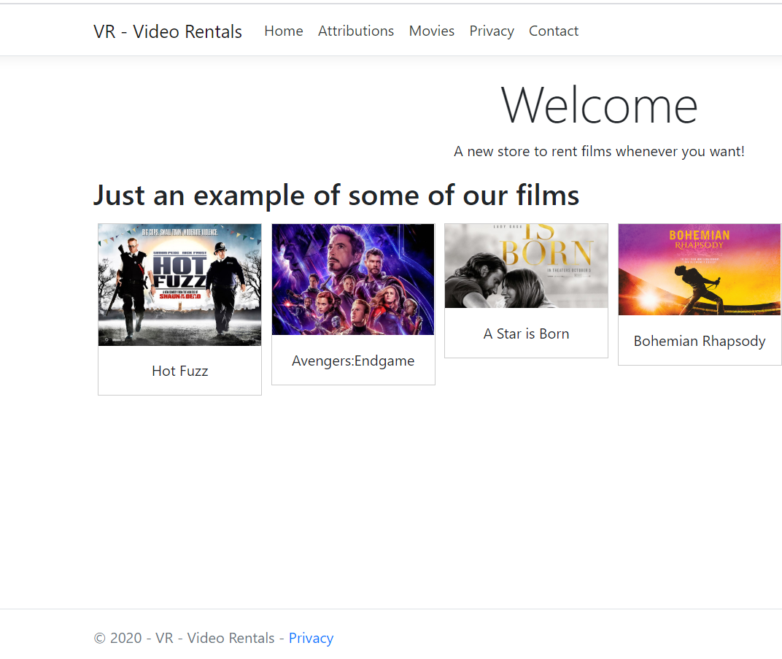
Figure 1/Index
This was a page for the home page, showing some of the films that were available page.
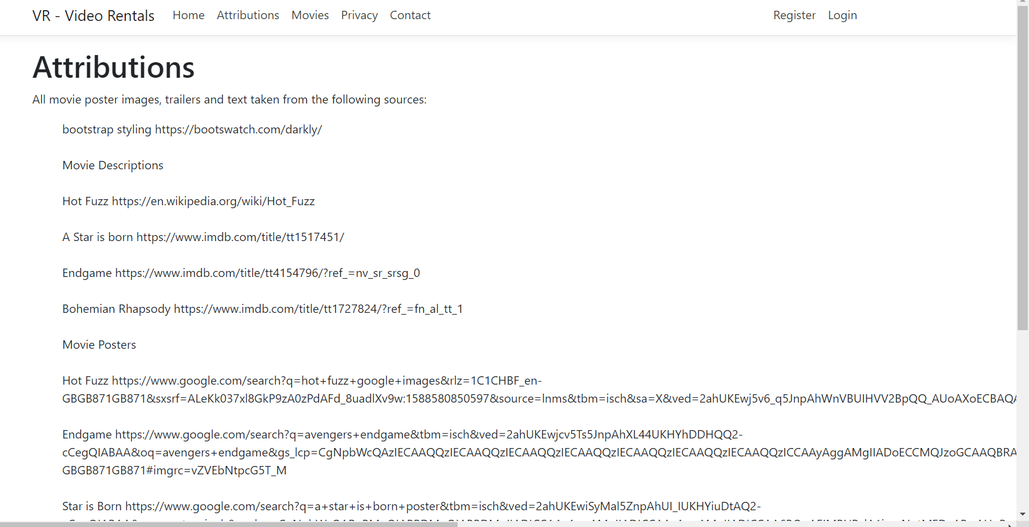
Figure 2/Attributions
It is worth mentioning that this contains the sources in which the website used.
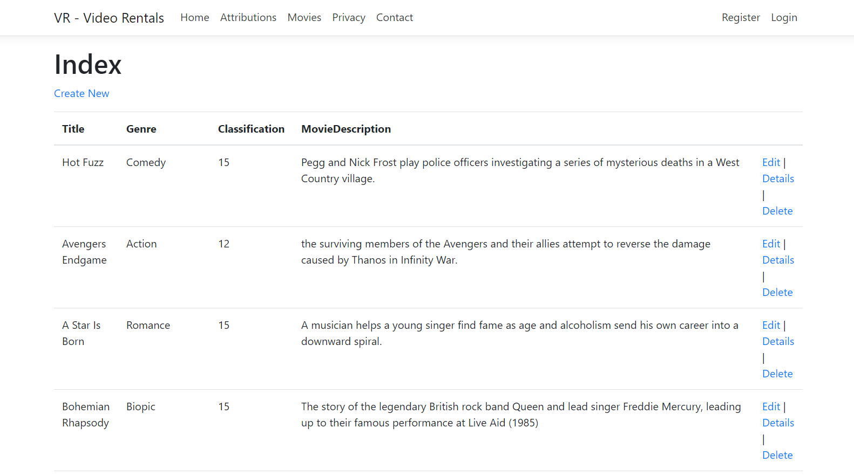
Figure 3/Movies
Although, titled index, this was viewed as an “Index of the Movies”. This is the page of the website, which uses the database to display the data, while also allowing the user to edit the list, delete entries, which would be useful in the instance of a mistype. This can also add new details, this is useful as this is an easier way to add the data in rather than using SQL to use INSERT statements as not everyone would know how to do those things. This is much more user friendly for everyday employees who don’t have a strong background in IT. This was also intended to only be viewed by the administrator of the website as if anyone can access this, anything could happen.
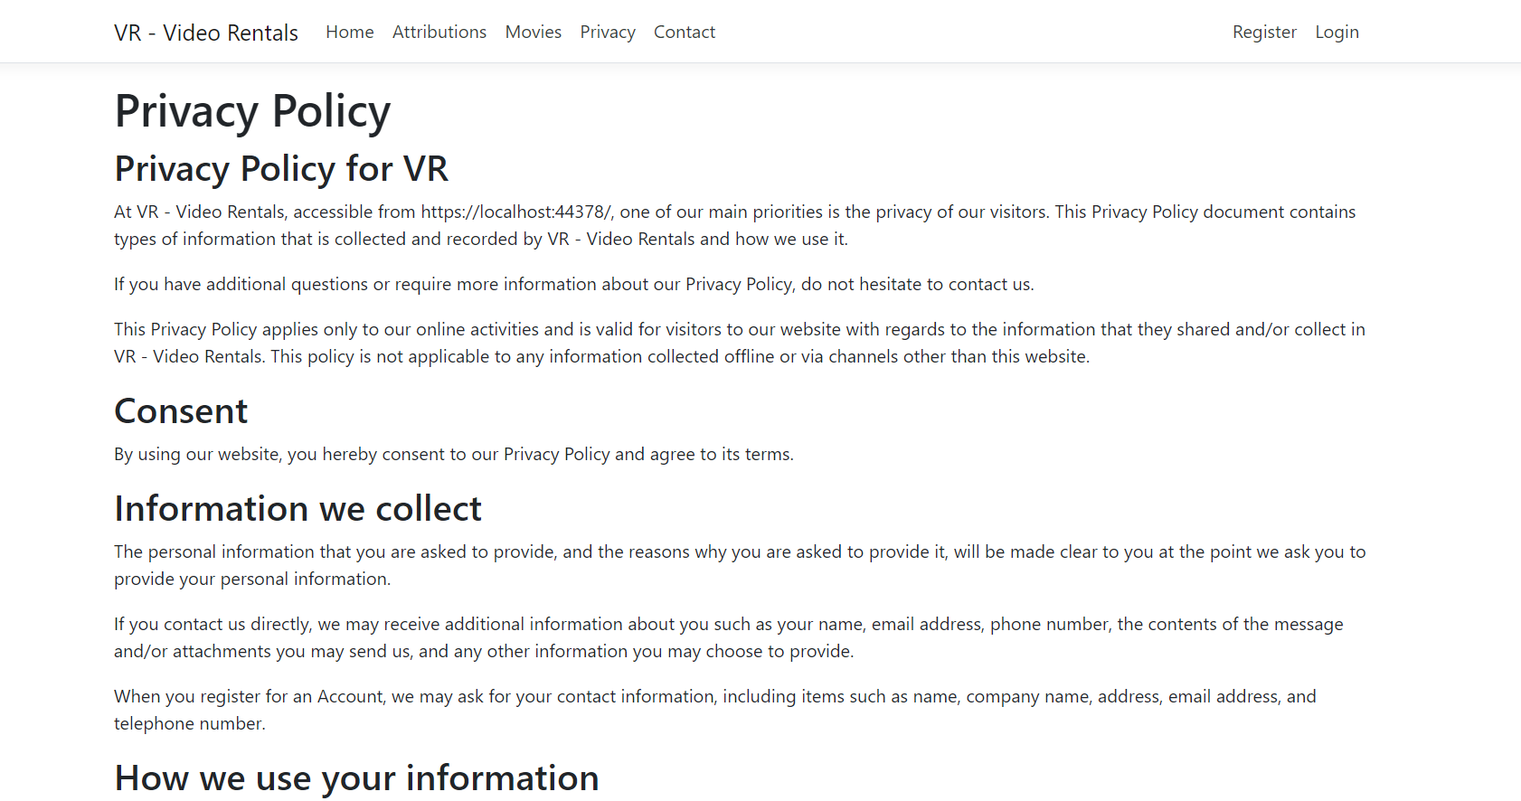
Figure 4/Privacy
This is the privacy policy of the company, this was done so users can view this to understand how exactly the company uses the data, how safe it is and what exactly information they collect.
This was generated with an internet-based generator and it can be found in the reference table.

Testing

As part of software validation, every programme should be thoroughly tested to ensure that when they are deployed there is minimal problems
Test Summary | Expected Result | Actual Result | Status (Pass/Fail)
- Application Builds | To build, with minimal problem and the application opens | Built Successful | Pass
- Bootstrap Implementation | To have a website that is styled to the preference of the student | Build was unsuccessful | Fail
- Bootstrap Implementation | Tested the bootstrap in another location | Build was unsuccessful | Fail
- Authentication | Details are Entered, allows access depending age. | Build was unsuccessful | Fail
- Testing Page Interactivity | Each link directs to the correct link. | Wouldn’t connect to Contact page,  Redirect to Privacy | Fail
- Testing Page Interactivity 2 | Each link directs to the correct link. | Can now direct correctly contact | Pass
- Testing Page Interactivity 2. | Each link directs to the correct link. | Through fixing the contact page, the Movies page got effected in the process | Fail
- Testing the Hone Page | Home Page Renders Correctly | Home Page rendered with an image not showing | Fail
- Testing the Home Page 2 | Home page builds correctly | Built Successfully | Pass

Authentication
This was a tough section, as this test failed, and the student couldn’t manage to make the application fully functional with this. The screenshot doesn’t include a “Date of Birth” section as this was something they could not get working. As shown in the screenshots below, when details were entered, it would be directed to the page detailed in the below screenshot, showing a problem within the application.
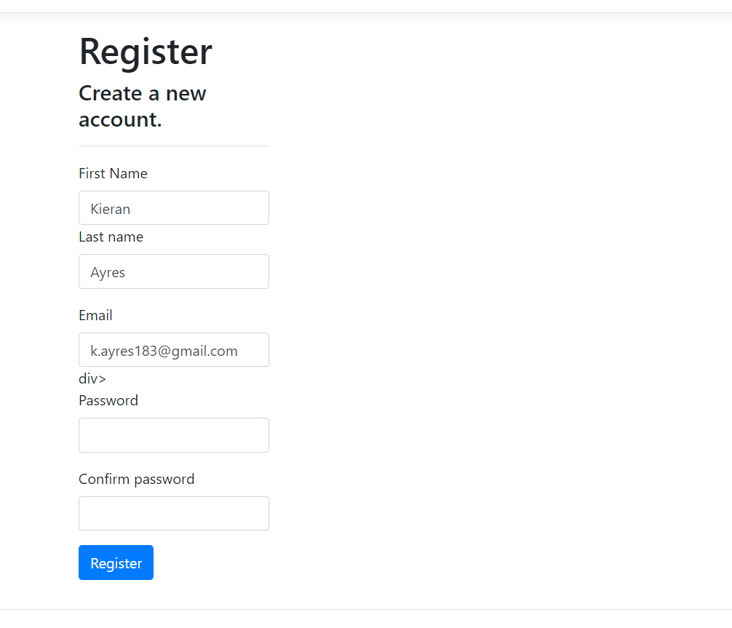
Figure 5/Test
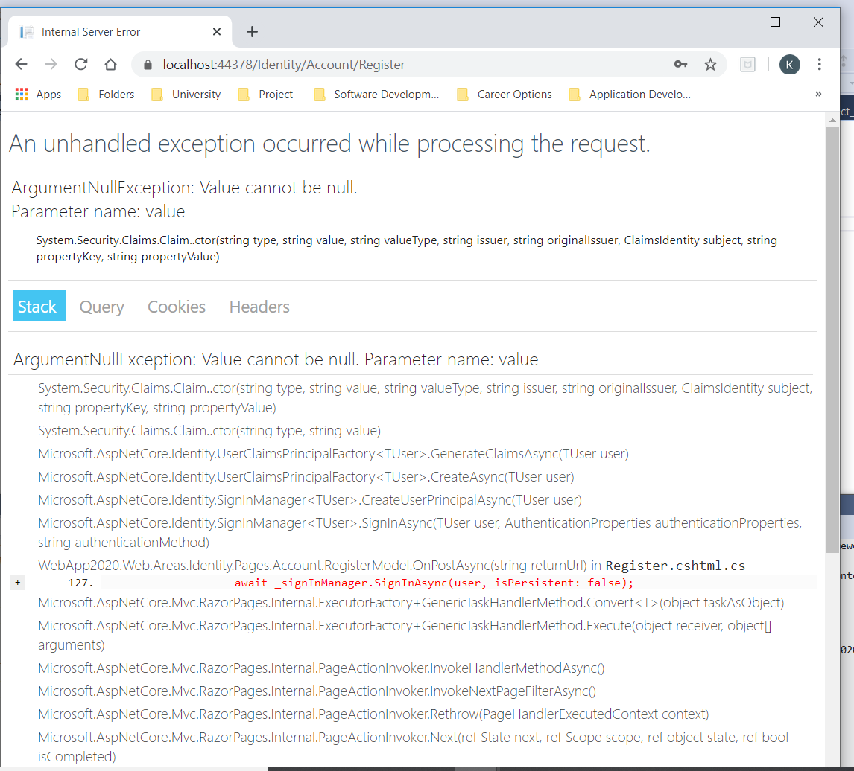
Figure 6/Test

Testing Page Interactivity
This was a test which wasn’t initially expected to fail, when they noticed this wasn’t working, they went back to the “MoviesController.cs” to amend the action results to amend to the current pages, along with, the layout page to ensure that each page went to the more specified location. Below are screenshots of what initially happened when pressing the button along with the corrected controller.
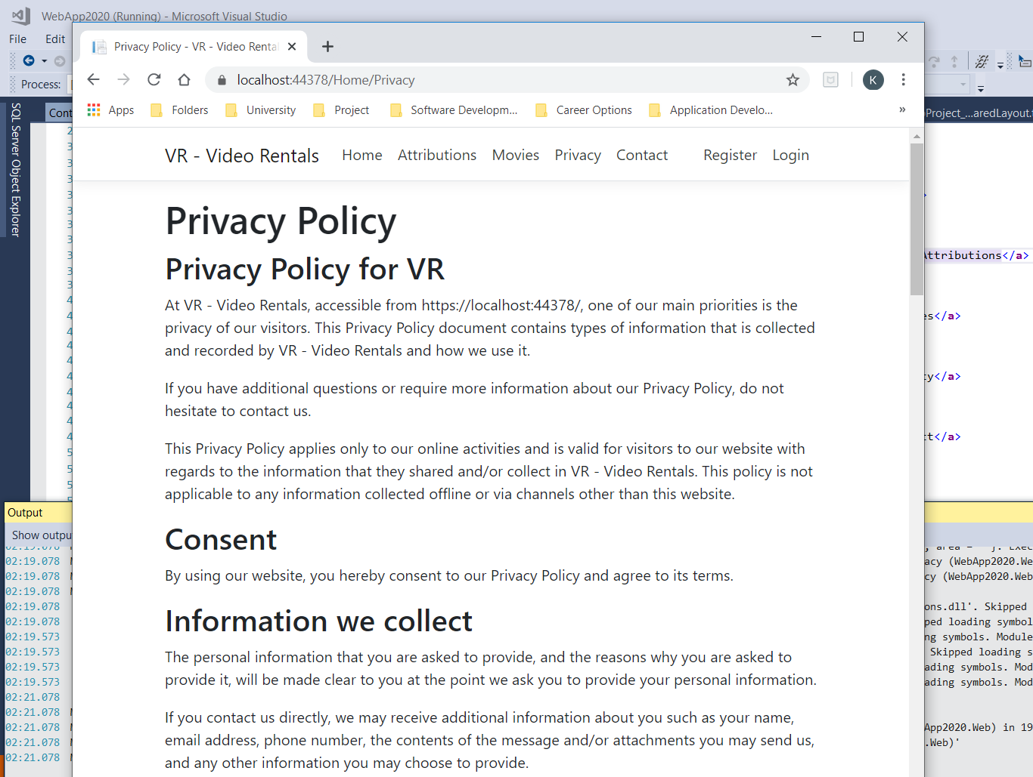
Figure 7/Testing
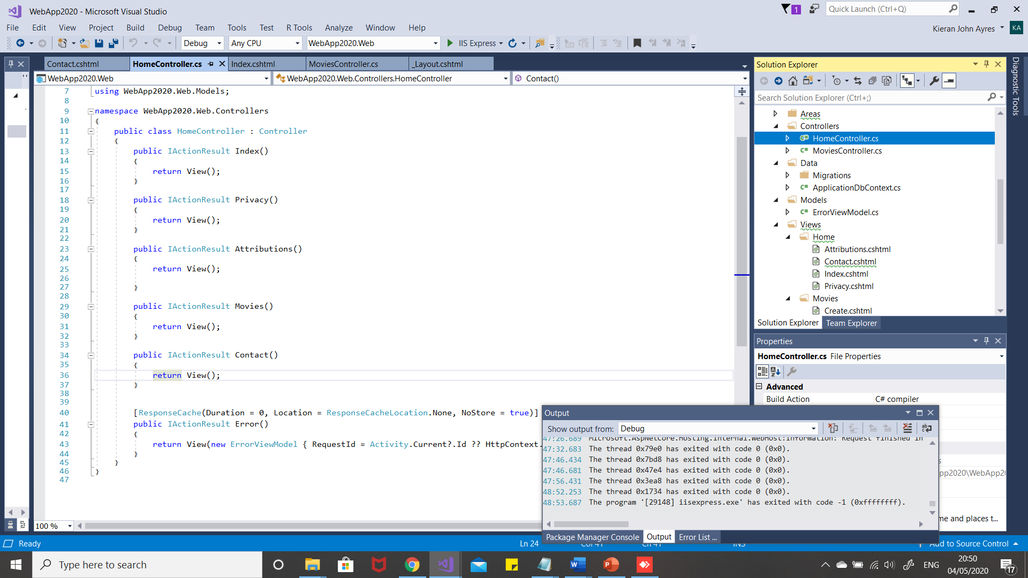
Figure 8/Testing

Home Page
Another test which wasn’t expected to fail, this was a careless mistake from the student, as they didn’t specify the full file path in the html. However, this was fixed with ease, below is a screenshot of the initial fail and then the corrected pass.
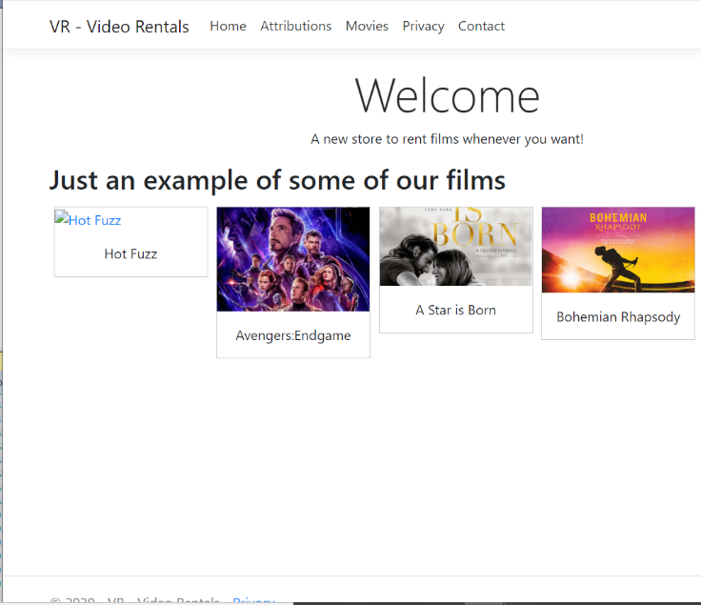
Figure 9/Testing
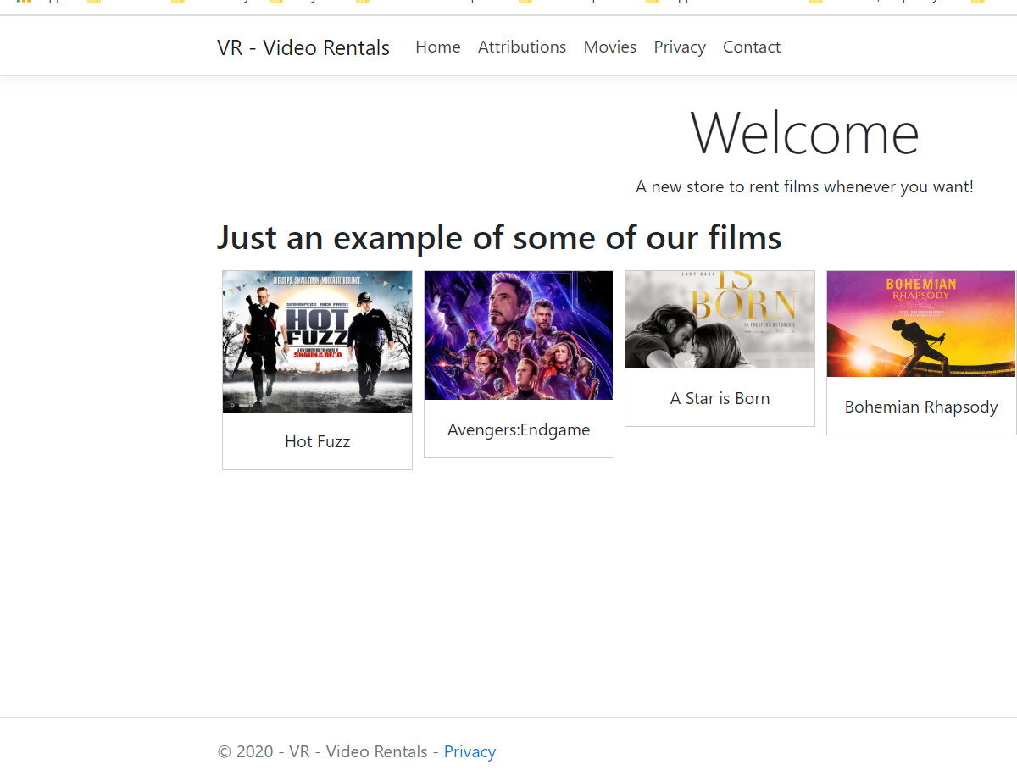
Figure 10/Testing

Reflection
This project was a tough, long process that didn’t necessarily have the outcome that the student wanted. The application that was initially thought up became a task that was too difficult and instead, was more of a prototype should the student build a broader and stronger knowledge of the ASP.NET Framework, they could revisit this. The beginning of the project, there were repeated numerous of times due to lack of knowledge or simply unintentionally missing things out in these which would result in having to restart the project quite often and this proved to be dangerous to the project in regards to time management. This was a project where the student truly felt out of their depth. The proposed project originally was planned to have a rental table which would include the movies that had been rented for example, they wanted a potential ticket system for the customer when they have rented something, so then the customer has their own proof that it worked. The student also attempted certain features but couldn’t get them completely working, some of these were selected as examples in the testing section of the report. This is a framework which the student would like to revisit and learn, where they can build their intended application. They would need to set some days aside to go back to learning these things. The usability overall is good, It can go to each page successfully, however, there are many recommendations, these include; becoming a full application with much more detailed set of features, such as sorting data, authorisation and authentication, along with a ticket system implemented. The application should also have a better look, this could have been achieved through using bootstrap, or CSS to style the website to have a better look and feel.

Conclusion
In conclusion, this was a tough learning experience, there were features that were attempted but could not be achieved due to a lack of experience in the ASP.NET framework. This is something they would like to vastly improve on as they wanted an application that was fully working rather than what they had working. They had more of a prototype when they wanted a fully functional one.

References
Please find the list of sources and references used on the application page, titled “Attributions”.

[1] | Microsoft, “What is ASP.NET?,” Microsoft , N/A N/A N/A. [Online]. Available: https://dotnet.microsoft.com/learn/aspnet/what-is-aspnet. [Accessed 4th May 2020].
[2] | N/A, “Privacy Policy Generator,” N/A N/A N/A. [Online]. Available: https://www.privacypolicygenerator.info/. [Accessed 4th May 2020].

Bibliography

[1] | Microsoft, “What is ASP.NET?,” Microsoft , N/A N/A N/A. [Online]. Available: https://dotnet.microsoft.com/learn/aspnet/what-is-aspnet. [Accessed 4th May 2020].
[2] | N/A, “Privacy Policy Generator,” N/A N/A N/A. [Online]. Available: https://www.privacypolicygenerator.info/. [Accessed 4th May 2020].

marking criteria and Student FEEDBACK

This section details the extent to which the assessment criteria are demonstrated by you, which in turn determines your mark. The marks available for each category of skill are shown. Lecturers will use the space provided to comment on the achievement of the task(s), including those areas in which you have performed well and areas that would benefit from development/improvement.

Common Assessment Criteria Applied (Assignment 2) | Marks available | Marks  awarded
1. Engagement with Literature Skills

2. Knowledge and Understanding Skills

3. Cognitive and Intellectual Skills

Overall, a good set of test cases have been developed, but the scope of the test cases needs to be expanded upon. The limitations of the application has limited what test cases you can perform. However, you have correctly identified functionality that does not work, and followed a good testing process for the tests you have demonstrated. A good reflection of the application has been provided identifying its limitations. Please note, you can contact lecturers for some assistance with your assignments. (Grade mark: 63.33%) | 30 | 19
4. Practical Application Skills

A satisfactory attempt. There is, however, room for improvement. Although, you have customised some of the static views for the Home Controller, for the views connected to the database have generally relied on the scaffolding functionality provided by VS and I would have liked to see you extend some of the functionality of the application. The database design is also limited - you have just two tables. For the Movie views, you have also simply left the default views created by VS, these views should have been customised and especially for the Index view that show the list of movies Members of the public should also not be able to edit or delete data records and you need to implement authentication and authorisation to handle this. (Grade mark: 41.67%) | 60 | 25
5. Transferable Skills for Life and Professional Practice

The report is of a good standard. (Grade mark: 60.00%) | 10 | 6

Assignment Mark (Assessment marks are subject to ratification at the Exam Board. These comments and marks are to give feedback on module work and are for guidance only until they are confirmed. ) | Late Submission Penalties (tick if appropriate) |  | 50%
 | Up to 1 week late (40% Max) |  | 50%
 | Over 1 week late (0%) |  | 50%

