Written Report
By Beatris Abazian

Student Name: Beatris Abazian

Student Number: 1809924

Module Number: ACCC4000

Module Title: Academic and Employability Skills

Assignment Title: Written reflection report upon application of the
academic and professional skills learned.

Module Lecturer: Mr. Suneth Fernando

CONTENT

1. ITRODUCTION 4

2. SKILLS EVELUATION 5

2.1. SELF EVALUATION 6

2.2. SWOT 6

2.3. LEARNING STYLES 8

3. ACTION PLAN 7

4. APPLICATION 8

4.1. LOOKING AFTER DATA 8

4.2. TIME MANAGEMENT AND ORGANIZATION 9

5. CONCLUSION 9

REFERENCES 10

APPENDIX 11

- INTRODUCTION

This written report is aiming to reflect and give evidence of application of academic, personal and professional skills learnt during the summer 2020 semester of Academic and Employability Skills module, Level 4, BCs Cloud Computing, University of Wales Trinity Saint David.
I will try to demonstrate and explain my vision of some theories, strategies and achievements in my Personal Development Plan of action. Also, I would like to share my personal experience and knowledge I already posses and one I do plan to gain, understanding of need for personal future growth, leading to effective and successful professional development and realization. Thus is based on my individual life experience, positive and negative reflective analysis, short and long-term goals, and self-evaluating and backup strategies. Establishing, finding and applying SWOT analysis on my personal capabilities, steps taken in problem solving, organizing and minimizing stress level, numeracy, communication and general abilities to understand, motivate and work under pleasure and overall broad abilities can show, explain and lead to path for a right action and give truly good opportunities for a successful performance on my chosen field of work.
This year the potential to become a Cloud Computing student present and after careful consideration I decide to take that rather wonderful and exciting opportunities and follow my teenage dream. The University of Wales Trinity Saint David, London campus is very conveniently located, easy to reach and holds a very good reputation. I always wanted to obtain a higher degree, but because the unfortunate events, health problems and family issues, I have not have the chance and possibility to take that important step towards better future earlier.
What encourage me? – I can answer that question very easy, the desire to learn, my strong will and clear wish to go ahead on adventure for discovering the amazing world of computing. My previous studies in mechanical engineering make me think how exiting is the world of numbers, innovation and creativity. Of course it involves a lot of self-discipline, aspiration and appetence to knowledge and time to study. My final project was constructing and making a mini model of real life working windmill. In two parts of the project I was assign to work in team of two other people. I do remember how pleasantly surprise I was when I discover – self monitoring that I was very organized, wrote a very detail plan including a time schedule, divide all part equal. My fellow teammates at the time observed and told me that I am very quick, logical and persistent thinker, good communicator and organizer. Receiving high grades in my casework in secondary school made me very proud and thought me a lot for my abilities – strength, weaknesses and gives an idea of some opportunities and threats. I have to admit that it was difficult at times but incredibly satisfying at the end. Unfortunately my lack of physical and practical experience it is not that great as I wish. But I can proudly say that I did improve a lot during the time. I also obtain a college degree in Financing. I did work as a private personal secretary. Then I learnt everything what I know about professionalism, communication, listening, creating good and useful working habits, people and time management, ethics, writing notes, letters, emails (latter in time), managing and joggling different tasks in order of their importance, staying calm under the pressure I did adapted that period of my life. In less words everything about how to present, approach, manner, ways of behaving, I know today. All this skills which I was able to obtain in young age were transferable and helped me a lot trough my personal and professional life and they still helping me to overcome difficult obstacle in my live, like doing assessments. They make me even stronger and determine. Motivate me to not give up and give me strength for a positive outcome at final results.
I did have fun trying to make the Power Point Presentation. There were few points I did not know about. It was quite interesting to discover that before making a presentation we need to produce a handout (usually10% more than expected people in audience) which to be distribute at the beginning or few minutes earlier. Firstly, the need to show up 10-15 minutes initial to test the equipment, dress code-appropriate and turn off the mobile phone. Second step is introduction, speech not quick, but not very slow. When presentation starts is recommended to go straight to the point, to keep it short but informative and funny at the same time (when possible). Raising voice, keeping gestures under control, try to behave calmly (do not get distracted by room noises) and go to conclusion by summarizing key concepts and ideas of the presentation, leave enough time for questions The audience needs to be kept engaged and involved and always make sure that an eye contact is in tact, never turn back to audience.
Last but not least, “Thank you” to the audience for their attention, interest and spend time.

- SKILLS EVALIATION

Getting the gob is not only about grades. Of course, there are important, but it need some other skills, too. I could be the best in my chosen field but if I cannot work amongst other people all this talent it is lost. Some of the most must have professional employability skills are:
Communication
- Leadership
- Problem-solving
- Critical thinking
- Teamwork
- Flexibility
- Resilience
- Negotiation
- Growth mindset
- Creativity
- Emotional intelligence
Trey is called soft skills and they have the same importance weight like University qualifications. And if these skills are not good or worst non existent the chances to get the specific role are very low. The soft skills are the important genuine skills, which makes a desirable employee. They are combination of lots of abilities including social skills, character trades and employment qualities. While hard skills are important in certain industries and can be obtain through education, previous experience and certification. They helps to do a specific job, they are required to actually do the work. The soft skills (people skills) are important in all of them and they are harder to evaluate. They cannot be really evaluate well of cover letter, resume or the CV. Employers do the interview or observe very carefully first few weeks on the position. Despite the differences I need both hard and soft skills. They wont just help me to land my first job, but they can give me a head start in my future employment (Apendix5).

  - SELF-EVALUATION

What is self-evaluation? This is the hardest ability of a person to observe, systematically analyze, understand and value his or his own work. This can be done by reflecting on own actions, be team playing, check if had the right attitude, meet expectations, cover the performance against the role specifications, feedback from colleagues, plan ahead by identifying areas for improvement.
“A judgment made by employee about their own work, abilities, etc., or process of doing this” (www.cambridgedictionary.com).

2.2. SWOT

SWOT is an analysis on internal factors- Strength and Opportunity and external factors – Weaknesses and Treats.
I will dare now to explore my own advantages and disadvantages by making or at least try to make a realistic self-evaluation.
My Strengths are – excellent communicational skills, problem solving and decision-making, organizing and time management, good listener, work exertions.
I am a very strong-minded person, with a quick eye and ability to understand the whole situation at a glance. Asking questions related to the specific problem and trying to keep simple conversation by staying stay calm in difficult situation is my extremely strong side. I can stay focused for a long time and try to prioritize the different problems and their impact on the issue. I have always been able to deal with particular circumstances and achieve a good result. Trying to keep all the employees as happy as possible. Seeing that I do not give up and keep alert encourages them to continue, give them strengths to believe, contribute, achieve and make all of us good team players.
My Opportunities – This course give m an opportunity to polish my academic writing as English is my third language, to perform different tasks involved in writing my assignments in order to perform better and increase quality of my work, to gain more confidence to future personal and professional growth.
My Weaknesses -unfortunately, I also do posses some of them. Limited computer practice and knowledge and lack of work experience in IT field are big obstacles in my path. For example in present studies I do have a bit difficulties using a CISCO packet tracer. I am not confident enough that I can do great at the practical exam and that’s thoughts make me panic and frustrated me. After few days of practice I do become more stable and calm. Truly can admit that I am much better than I was two month before, but it is still a bit of room for improvement left.
My Treats are young competitors, lack of training and lack of in classroom teaching and not actual experience in the field. I would not allow this treats to made impact in my future plans. I do take some self-preservation steps like starting to communicate with much younger people to try to understand their way of thinking. Delegate more time for exercising. Talking to lecturers from the University is really helping me to become more confident and continuing with my studies. I have been doing various professions and controlled at unusual situations and get a genuine perception of different problems, which are striking, and objects to reflect to successes. I get helpful abilities and knowledge in inspiration, acting and solving complicated logistics, skill to manage. Several skills I did improve, certain of them need to be improve further.
I trust that all these years of work combine with learning delegate a lot to my future and assisted me to increase several of my strengths and develop my flaws.

2.3. LEARNING STYLES

There are different styles of learning styles and theories.
Awareness of the way I study will benefit me with various connected to the carrier way and wish attain my goal faster. Everyone have a favorite way of studying known as a learning style. It is not correct or incorrect learning styles but knowing how the way I study helps to attain my full ability quicker and progress more..
What are the learning styles?
According to Honey and Mumford there are 4 different styles (www.theclassroom.com).
Activists - prefer to do the study while lesson is actually on
Reflectors –select, think and analyze before take action
Theorist – think systematically and accurately do the tasks
Pragmatists – quicker ways of solving the problem in the most effective manner. When I do become an employee I also need to figure out and understand my team’s different learning methods. It will have a huge impact to our performance and motivation.
According to my exersise(Appendix 3) I am a theorist, reflector, and pragmatist. Surprised with a result I thought that I have to believe even more into my self and my abilities to outcome different obstacle, to take the right decisions and overcome the stress
Reading, writing, and diagrams is another way of remembering things, and it is known like Visual. Auditory is listening and learning trough short movies is Kinesthetically.
According to my exercise (Appendix2) I am an auditory learner. Benefit me a lot in my area of work to avoid undesirable result. Giving devotion to what individuals wants and considerate their demands saves time and delivers healthier communication.

3. ACTION PLAN (Person Development Plan)
I will try to explain in a clear way what are my goals in short and long term (Appendix1).
As a self-thought and self-employed person I do have a lot of gained through the years experience and knowledge. Having a lecturer in my case, showing me different theoretical ways of approaching and not missing vital detail, what and how to achieve desirable goals. Thus will form my attitude, mindset and aspiration towards my preferred work field and assignments.
My short-term goals - I would like to finish and graduate successful Level 4 BCs Cloud Computing. I would like to continue further, Levels 5 and 6.
To achieve this goal I was constantly juggling my everyday responsibilities arrangement, studies. Some of in factors giving an influence in my development are – group studies, classes, exercises social media and assessment explanation and clarification. Working full time and studying put my time managing skill on a very good use.
My long - term goal is to continue and finish my degree and to find exiting and creative business where I can demonstrate and apply all useful skills, learnt and gained throughout my studies. `
Additional growing of my team working ability in mixtures with my exceptional problem solving and decision making abilities will provide me an prospect to grow into greater applicant for my selected work position. It will help me to be prominent, conceal the majority of tasks and give me a chance to become a valuable asset to the company.
I did finish Mechanical secondary school with honors and I obtain a degree of Accounting and Finance collage.
I am professionally trained personal secretary with two and a half years of experience. When I did start my professional working life I did not had much self-respect and confidence. But after finish this secretary course and find a job straight away I was given a chance from my ex employer and the other team member to work on that skills and at the end I was able to develop and maintain
those skills. With a lot of feedback from my ex colleagues and my personal friends I was able to move forward very quickly and I had a chance to start developing a new sills for the workplace.

I do posses professional certificates Level 1 and 2 for domestic and commercial cleaning, certificate in professional stenography and typewriting. Trained in Health and Safety for a cleaning industry and First Aid, Hospitality and Customer service. All these developments educated me that communication, organization, listening and team working are very significant. They confirmed some of my weaknesses, which I try to improve.

4. APPLICATION

4.1. LOOKING AFTER DATA consent the tree key elements “CIA triad” confidentiality, integrity, availability. Once they are compromised the big problems occurs. It is extremely costly – time wise, financing, accuracy and labor. Tying to avoid unfortunate situations we do use a data security and tools of proper data handle.
Data loss occurs when:
- Human error- accidental deleting
- Viruses and malware
- Physical damage
- Natural disasters flooding, overheating, etc.
- Power Outages
- Liquid damage
- Hardware clash
- Software corruption
Recovering the data is mainly done by weekly back ups, file recovery software, firewalls zero trust policies encrypting, control of the access, physically separate storage back up locations, cloud storage for remote access, disk defragmentation, partitioning on a hard drive by creating separate programs and zones.
For personal back up I do use flash, external hard drive and my file notes.
Crypto wall vires is basically a “Trojan horse” that’s encrypts files and threaten he use or organization to pay ransom in exchange of returning the data. For example: March 2020 Boots, UK, was forced to suspend loyalty card payments following an attempted cyber attack. Other example: Virgin broadband, massive data breach in March, 2020- over 900 000 people access was left open.

4.2. TIME MANAGEMENT and ORGANISATION are also one of my very strong assets. Since the beginning of my studies at UWTSD I have managed to achieve 100% attendance, which gives me, the understanding that I really do care about what my future and the fact that I did improve that skill make me believe that I will succeed in future.
What are Organizational skills? Those are “the ability to use your time, energy, resources, etc. in effective way that you achieve the things you want to achieve:”(www.dictionary.cambridge.org). In other words it means to priotiresd different task, make a schedule and time manage different tasks in right order to achieve desirable goals and have positive outcome. The good organization helps to employees to increase effectiveness, efficiency and productivity. The main point time management is smooth running the process. The parts of excellent organizational skills as follow:
- Target settings – details given
- Prioritizing-importance
- Scheduling- deadlines
- Entrusting
- Goal setting involves development of an action plan designed to guide and motivate person or group of people towards specific target

5. CONCLUSION

I trust that in this essay I was able to prove and evidently recognize my abilities and expanded knowledge, skills to replicate, actions need to be taken to obtain desirable results. To evaluate my assets and flaws in coherent manner and backing them with an accurate skilled development plan. I hope I presented appropriate interpretation and appraising of the abilities and knowledge, which add to. Inclination for a prospects established on my personal development plan, SWOT analysis, talent to communicate openly and efficiently, dealing at work place based on established employment goals and active use of social media for further opportunities (Appendix4).
I truthfully have faith in that when I graduate from UWTSD I will obtain a desirable and much more significant, resourcefully orientated job that can help me to accomplish my aspiration for a better time ahead.

REFERENCES

htpp://www.quora.com/(Accessed: 25thJuly 2020)

htpp://www.cambridgedictionary.com/(Accessed: 1st August 2020)

htpp://www.theclassroom.com/(Accessed: 2nd August 2020)

APPENDIX 1

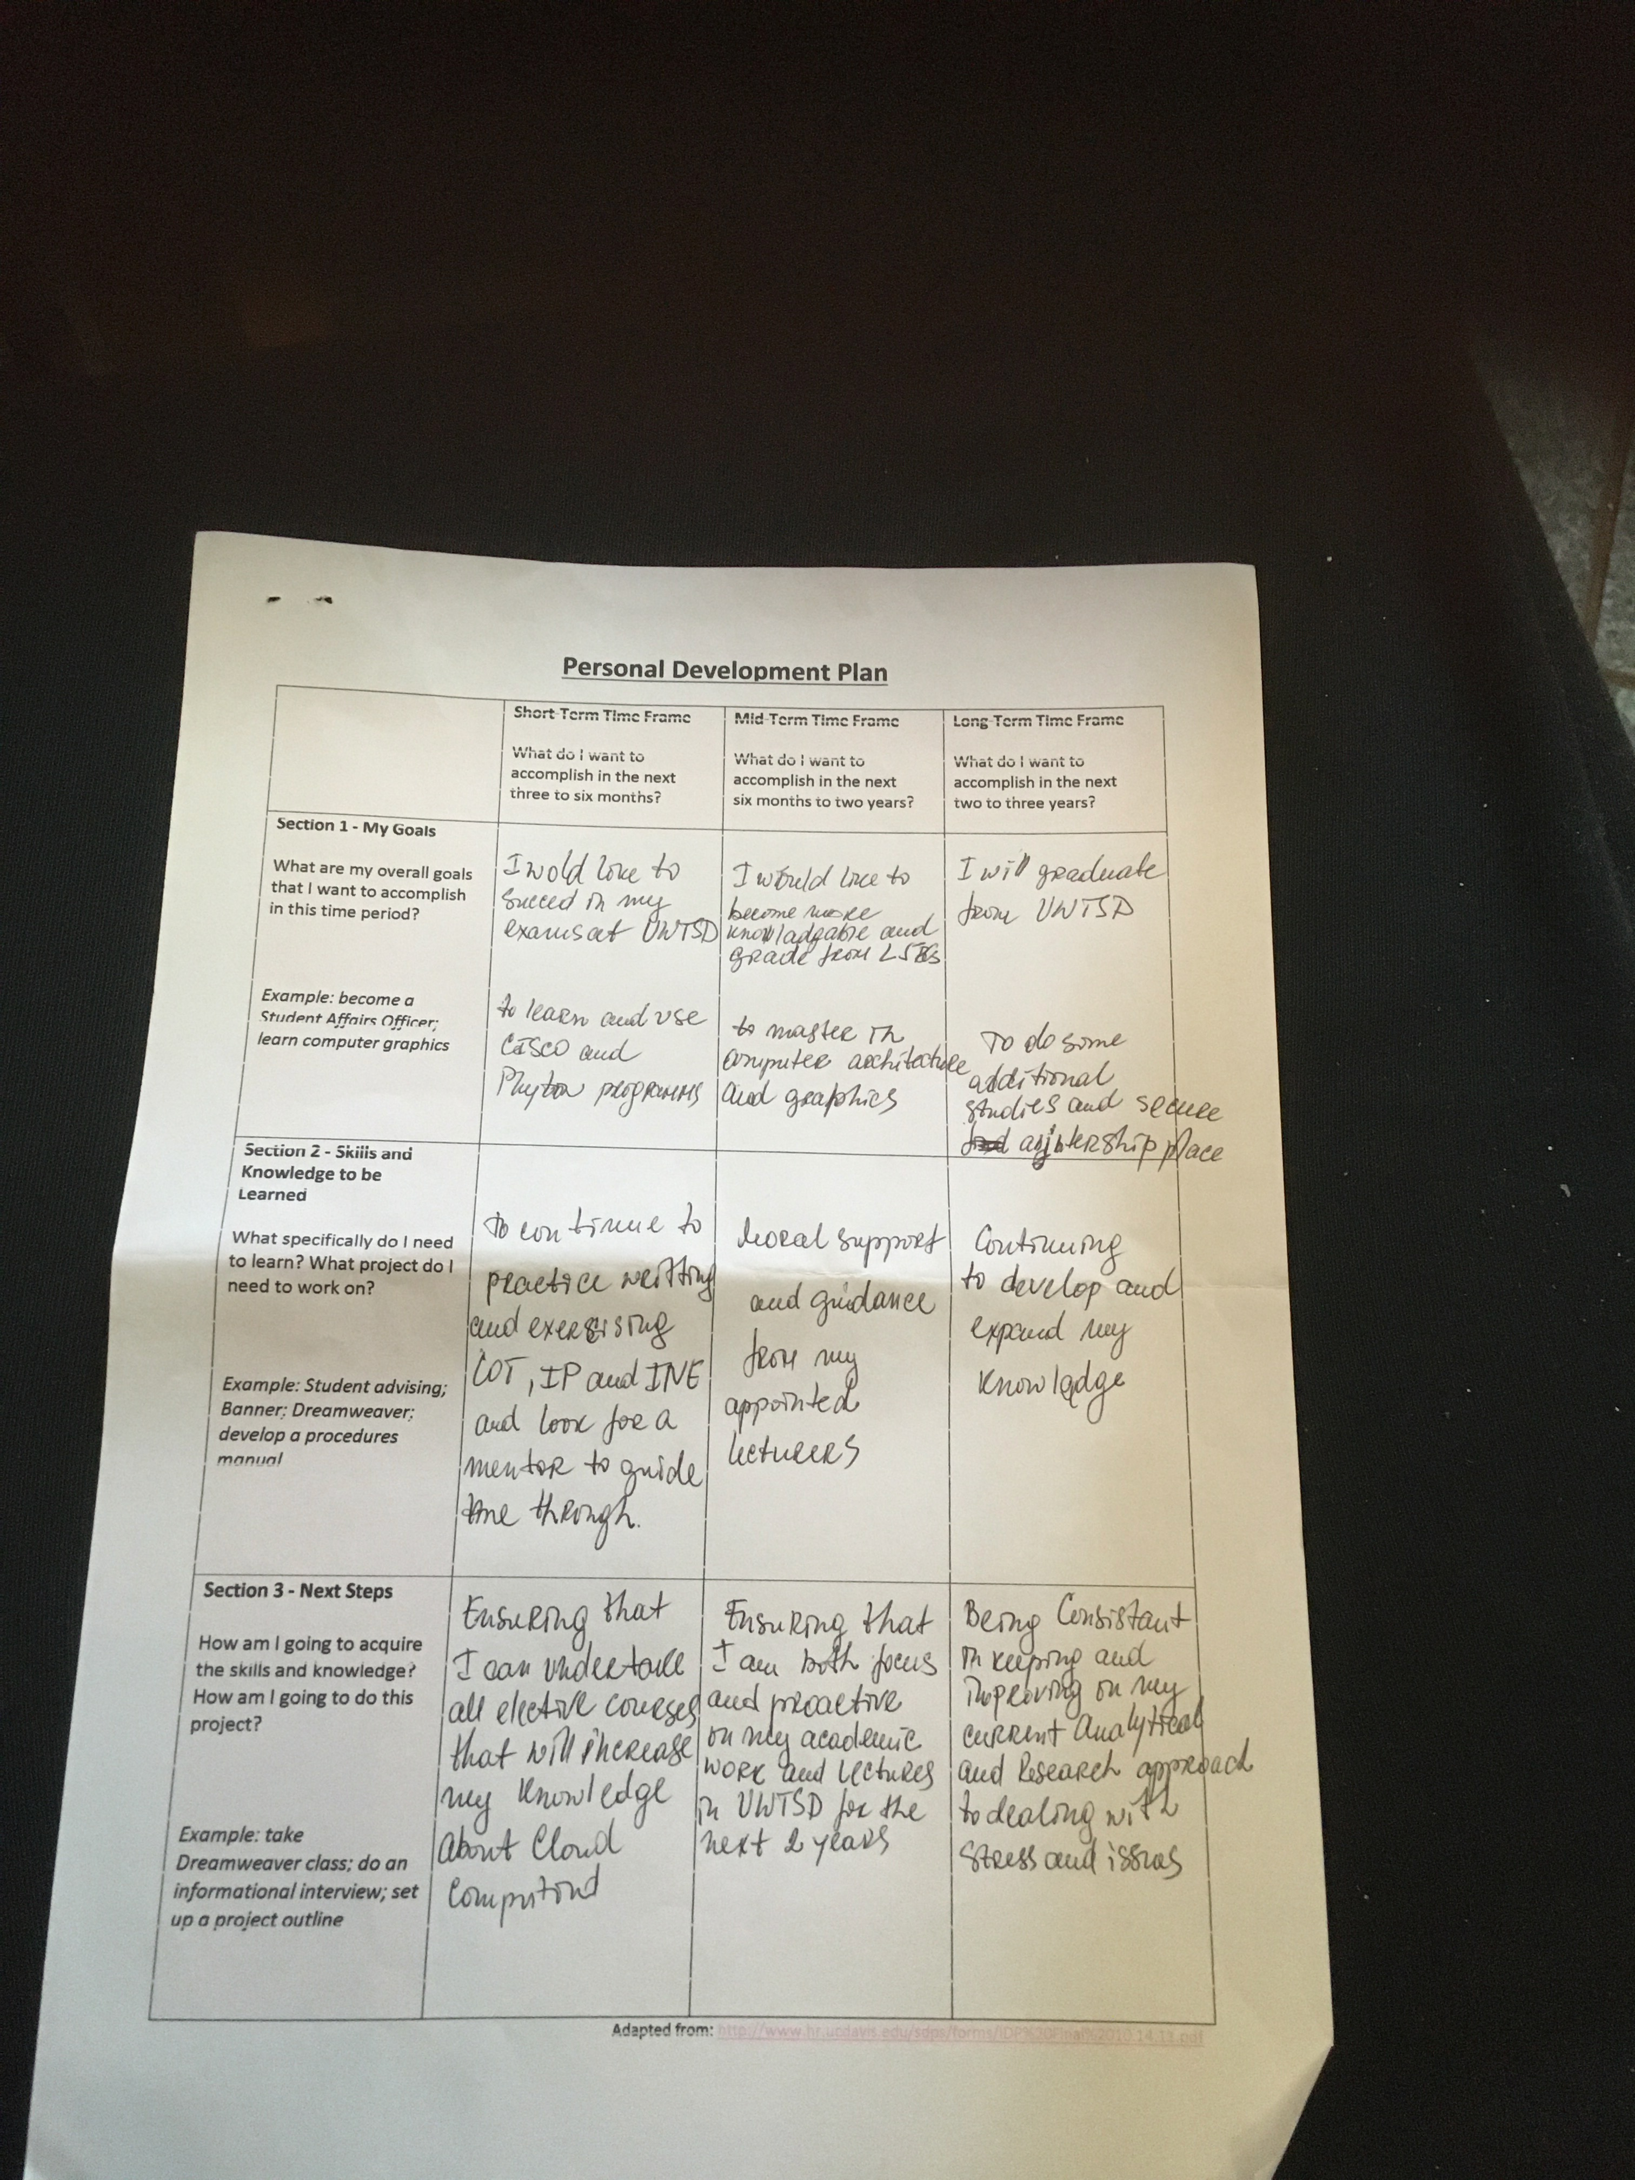

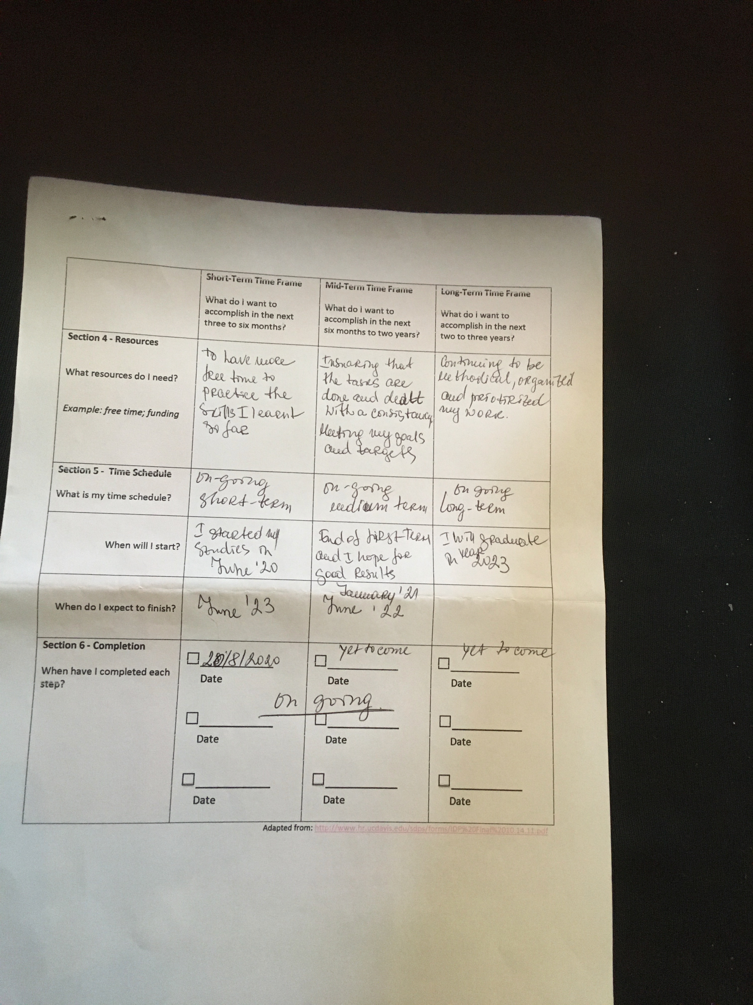

APPENDIX 2

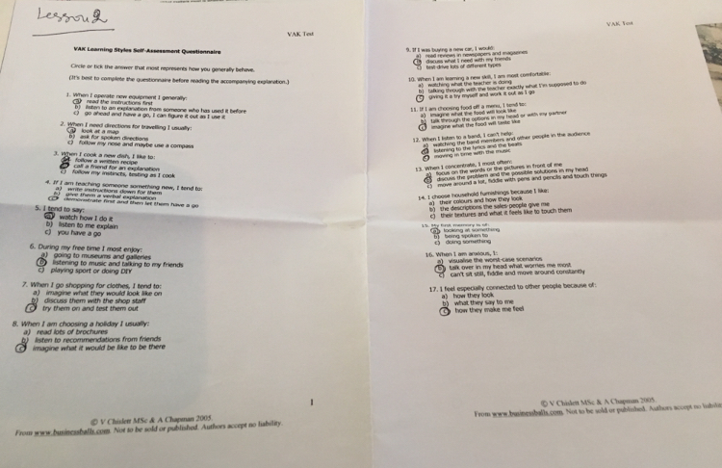

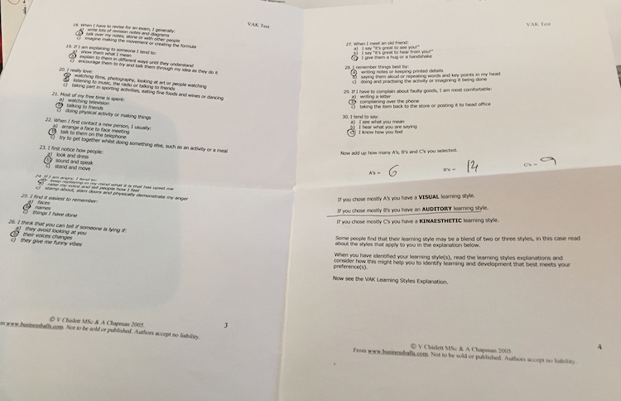

APPENDIX 3

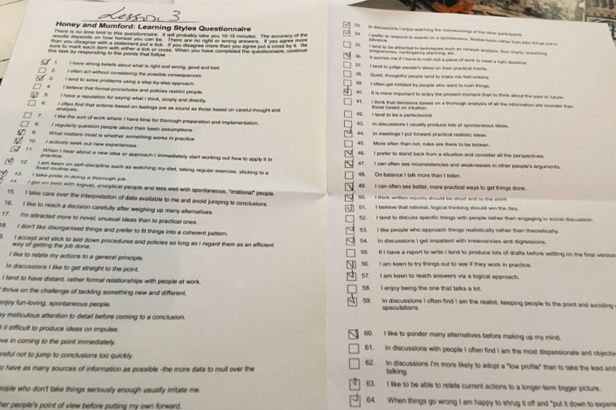

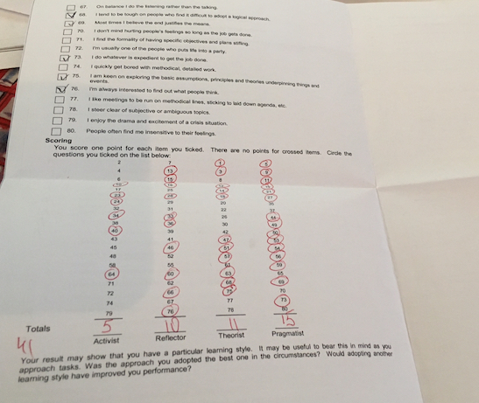

APPENDIX 4

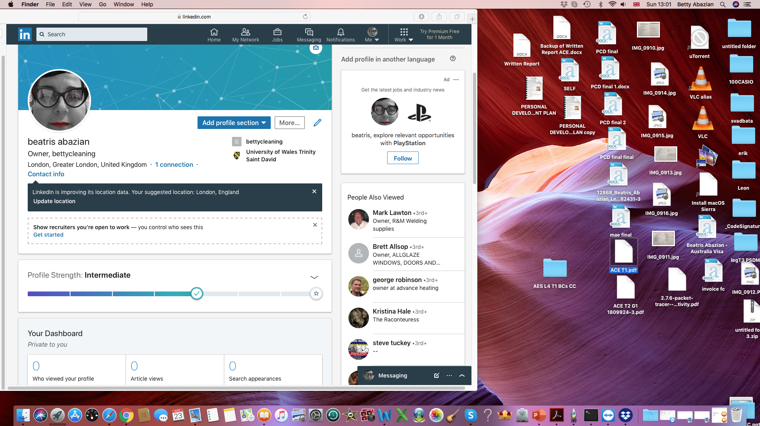

APPENDIX 5

