Combustion Emissions, Calculations and Mapping for Efficiency
  - M3X8824
  - Tristan Reed |P144117 |09/10/2018
Contents
1. Abstract 2
2. Introduction 2
3. Methodology 2
3.1. Molar Ratios of Products at Different Fuel Equivalence Ratios 2
3.2. Calculating Initial Adiabatic Flame Temperature 3
3.3. Flame Temperatures 4
3.4. NOx Production 4
4. Results and Analysis 5
4.1. Molar Ratios 5
4.2. Initial Flame Temperatures 6
4.3. Flame Temperatures 7
4.4. NOx Production 8
4.5. Effects of EGR 9
10
5. Assumptions 11
5.1. Molecular Dissociation 11
5.2. Heat Tranfer 11
5.3. Ratio of Specific Heats 11
5.4. Reversible Reactions 11
5.5. Complete Combustion 11
6. Conclusion 12
7. References 12
8. Appendix 13

Abstract
The aim of this project is to calculate NOx emissions for a 1.6 litre naturally aspirated engine over a range of lean fuel equivalence ratios. This data calculated was then used to observe the effects that exhaust gas recirculation (EGR) has on combustion temperatures and therefore NOx emissions.

Introduction
During combustion, nitrogen and oxygen in the air react to form a variety of nitrogen oxides referred to as NOx. NOx emissions contribute to acid rain as well as a variety of health issues. For a car to be legal for production the NOx emissions must meet the Euro 6 emissions of 0.06g/km and with road transport contributing to 40% of all NOx emissions in the EU, NOx reduction methods must be researched further and implemented as much as they can.

Methodology

Molar Ratios of Products at Different Fuel Equivalence Ratios
The first stage was to calculate the molar ratios of the products assuming complete combustion. This was calculated using a combustion equation for lean combustion as follows:
φC₈H₁₈ + 12.5(O₂+3.76N₂) aCO₂ + bH₂O + 47N₂ + cO₂
Where φ is the fuel equivalence ratio, a, b and c and be calculated using equations created so that the amount of carbon, hydrogen, oxygen and nitrogen and balanced on either side of the equation.
CO₂ = φ x 8
H₂O = φ x 9
N₂ = 47
O₂ = (25-(2*a)-b)/2

Calculating Initial Adiabatic Flame Temperature
The initial flame temperature can be found by calculating the available energy from the fuel for each equivalence ratio. This is calculated from the net enthalpy which is the difference in enthalpy of formation between forming the reactants and the products.

Molecule | Enthalpy of Formation (MJ/kmol)
C₈H₁₈ | -224.1
CO₂ | -393.5
H₂O | -241.8
Shown above are the enthalpies of the reactants and products during the combustion of isooctane, the enthalpy of formation of N₂ and O₂ are both 0 so they are not included.
The equation used to calculate the net enthalpy for each value of φ is as follows:
Net Enthalpy = (φ x -224.1) – ((a x -393.5) + (b x -241.8))
Using this calculated value, the initial flame temperature can be calculated using data taken from JANAF tables. The data taken from the JANAF tables are the values for $\overline{h}°\left(T\right)-{\overline{h}}_{f}°(298)$ these values represent the amount of enthalpy required to heat a specific molecule from datum zero (298K) to a certain temperature. Using the known molecules that are produced during lean combustion (CO₂, H₂O, O_{2,} N₂) a polynomial can be plotted using these values and their molar ratios for each fuel equivalence ratio. Example shown below:
f(x) = p1*x^8 + p2*x^7 + p3*x^6 + p4*x^5 + p5*x^4 + p6*x^3 + p7*x^2 + p8*x + p9
Where p(n) are constants that change with each fuel equivalence ratio and x is the enthalpy available. The net enthalpy can then be input as x in the equation to accurately calculate the initial flame temperature.
When EGR is included the enthalpy available from the fuel stays the same but there are more molecules in the combustion chamber to heat up. To compensate for this the enthalpies required to heat to a specific temperature must be multiplied by 1 + % EGR i.e. if EGR is 1% the required enthalpy much be multiplied by 1.01. Polynomials must be remade for each % of EGR.
It should be noted that the available enthalpies are normalized (shown in appendix) by a mean and standard deviation (std). This means that the enthalpy available must be manipulated in the following way before used as the x value in the polynomial:
$$Normalized Value= \frac{Avaliable Enthalpy-mean}{Std}$$

Flame Temperatures
The temperatures during combustion as the pressure increases can be modelled using the adiabatic process:
$$T_{2}=T_{2}{\left(\frac{P_{2}}{P_{1}}\right)}^{\frac{γ-1}{γ}}$$
Where T₂ is the final temperature, T₁ is the initial temperature, P₁ is the initial pressure, P₂ is the final pressure and γ the ratio of specific heats. By increasing the pressure by know increments during combustion the temperatures can be calculated throughout.
It is being assumed that φ is 1.2 throughout the combustion process.

NOx Production
From the molar ratios calculated the concentration of N₂ and O₂ can be calculated, these will be used to work out the rate of NOx production. The concentrations of these molecules are calculated as follows:
$$\left[N_{2}\right]=\frac{α47}{V{}_{b}}$$
$$\left[O_{2}\right]=\frac{αc}{V_{b}}$$
Where V_{b} is the volume of the burned zone, c is the molar ratio of O₂ and α is a multiplying constant representing the amount of air and fuel in the cylinder.
$$α=\frac{n}{molar mass of air and fuel}$$
Where $n=\frac{PV}{RuT}$ when the air enters the cylinder at ambient pressure and temperature (1 Bar, 293K) V = cylinder displacement x 0.4 = 160x10⁻⁶m³ for 40% volumetric efficiency.
The Zeldovich model for naturally aspirated engines can then be implemented to calculate the rate of NO concentration.
$$\frac{d\left[NO\right]}{dt}=4.7×{10}^{13}\left[N_{2}\right]{[O_{2}]}^{\frac{1}{2}} exp⁡\left(\frac{-67837}{T_{b}}\right)$$
Where T_{b} is the temperature in the burned zone.
To find the NOx produced in a combustion cycle the values calculated from the rate equation must be manipulated in the following way:
$$\frac{[NO]}{degree}=\frac{d\left[NO\right]}{dt}×\frac{1}{6RPM}$$
Where RPM = 1800.
$$\frac{Kmols}{degree}=\frac{\left[NO\right]}{degree}×V_{b}$$
Where V_{b} is the burn zone volume, assumed to be 40cc or 40x10⁻⁶m³.
By taking the sum of the Kmols/ degree the Kmols of NO produced during 1 combustion cycle can be calculated. This can be converted to parts per million (ppm) as follows:
$$ppm= \frac{Kmols of NO}{Kmols in Exhaust}×{10}^{6}$$

Results and Analysis

Molar Ratios

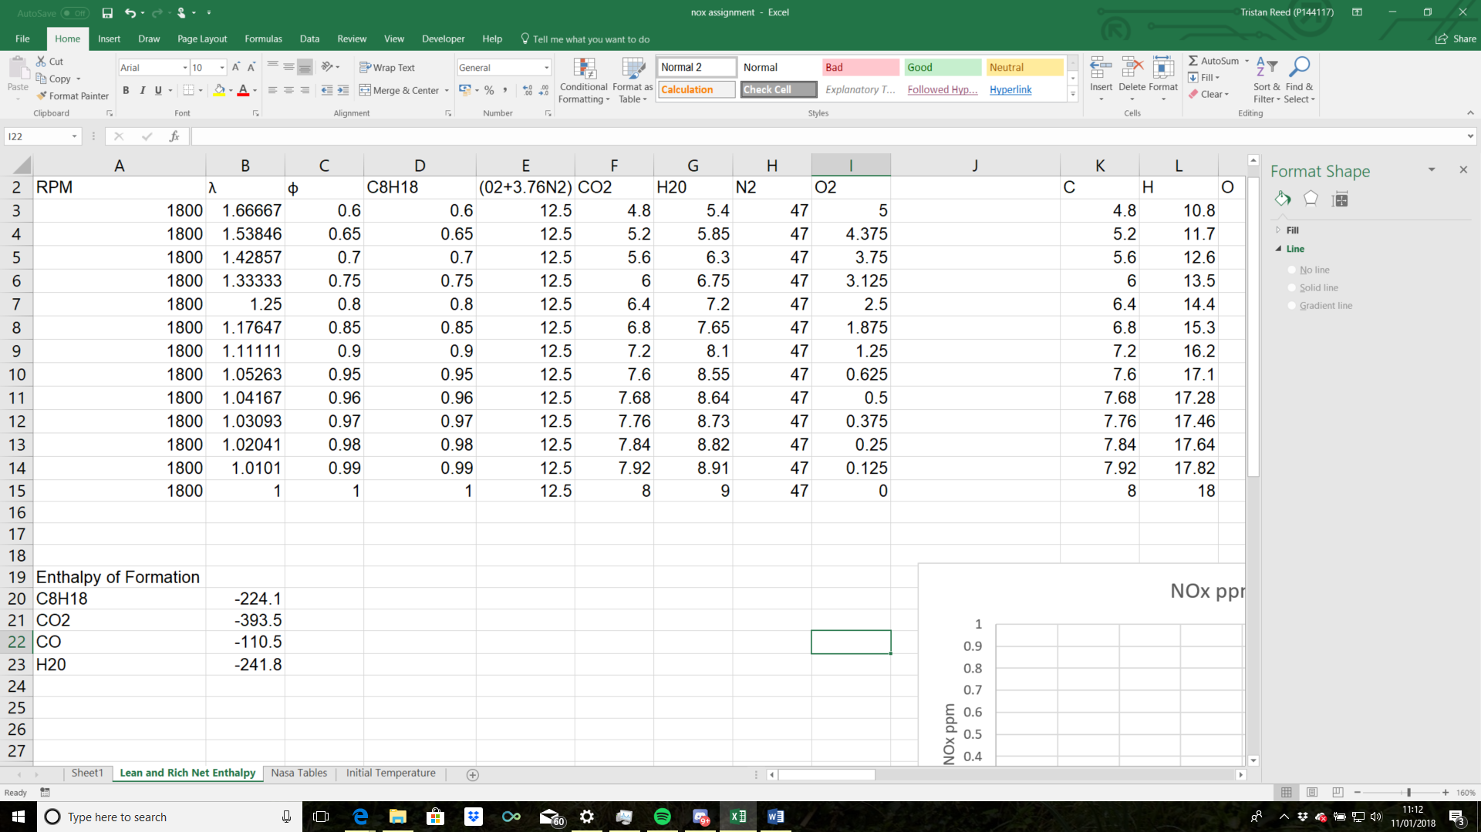
Figure 1

Figure 1 shows the molar ratios of the reactants and products for each fuel equivalence ratio; the last column shows that the amount of oxygen produced during combustion decreases as the mixture becomes richer. Figure 2 shows the net enthalpy for each fuel equivalence ratio. As expected the net enthalpy increases when more fuel is being used.
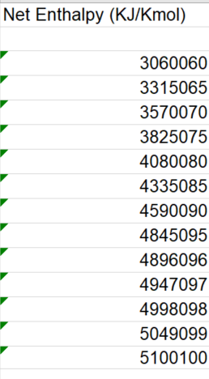
Figure 2

Initial Flame Temperatures
From the net enthalpies shown in figure 2 the initial flame temperatures in figure 3 were calculated. The initial flame temperatures increase with fuel equivalence ratio as there is more enthalpy available.
Figure 3

Flame Temperatures
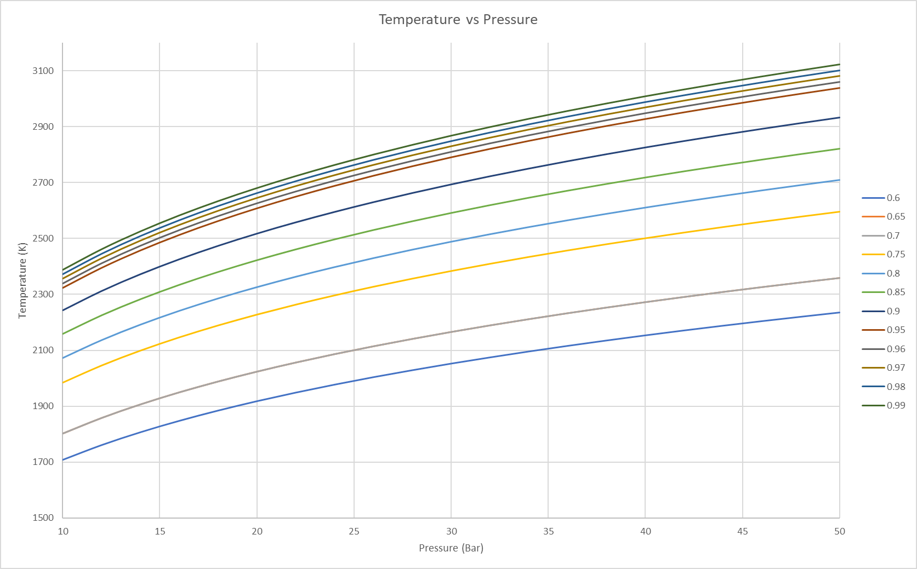
The calculated flame temperatures shown in figure 4 are completely reliant on the initial flame temperature. This can be observed as the curve for each fuel equivalence ratio is the same but has a different starting point depending on what the initial flame temperature is. From the graph we can see that the higher the fuel equivalence ratio is the higher the temperature will be at each pressure and therefore when φ = 0.99 the highest temperature is achieved of 3122K at 50 Bar.
Figure 4

NOx Production
Figures 5 and 6 shows that as φ increases the amount of NOx produced increases. We can see that in figure 1 that the amount of oxygen produced during combustion is decreasing with fuel equivalence ratio where as in figure 4 we can see that the temperature is increasing. This means that the NOx production is much more affected by combustion temperatures rather than the amount of O₂ being produced during combustion.
Figure 5
Figure 6

Effects of EGR
The figures below show how EGR effects temperatures and therefore NOx production during combustion. As EGR increases the initial temperature decreases (Figures 7,8). This decrease in initial flame temperature results in lower temperatures during the combustion cycle, which results in a lower rate of NOx production during combustion. At 10% EGR the temperature has been decreased by close to 170K and at 30% EGR the temperature has been decreased by 425K. This temperature drop massively effects the amount of NOx produced (Figures 9,10).
Figure 7

Figure 8

Figures 9 and 10 show the effects EGR has on NOx production. With just 10% EGR the NOx production has been reduced by 82% and at 30% EGR the production of NOx has been reduced by 99%.

Figure 9
Figure 10

Assumptions

Molecular Dissociation
At temperatures above 1800K molecular dissociation occurs, this is when the bonds in H₂O and CO₂ have enough energy to break forming H₂ and O and CO and O respectively. This contributes to there being more oxygen in the combustion chamber than the molecular ratios state resulting in a higher concentration of oxygen which would increase the amount of NOx produced.

Heat Tranfer
This model assumes no heat transfer during combustion where as in a real cycle heat energy in transferred through the walls and top of cylinder, this would result in lower temperatures causing the NOx production to decrease.

Ratio of Specific Heats
The ratio of specific heats, γ is assumed to be constant, this is not the case as $γ=\frac{C_{p}}{C_{v}}$ both of which are temperature dependent. While 1.2 is a decent assumption it should be noted that γ changes slightly throughout combustion.

Reversible Reactions
The Zeldovich mechanism is based on three reversible reactions:
$$O+N_{2}⇋NO+N$$
$$N+O_{2}⇋NO+O$$
$$N+OH⇋NO+H$$
When the temperature is increasing the reactions favor the products where as when the temperature is decreasing the reactants are favored. In the model produced the temperature decrease after combustion isn’t being taken into consideration. If considered this would result in a lower overall NOx production, however there isn’t a lot of time for the temperature to drop so this would have a small affect.

Complete Combustion
In this model combustion is assumed to be complete this is unrealistic, if combustion was calculated realistically not all the fuel would be burned meaning that there would be less enthalpy available and therefore lower temperatures resulting in lower NOx production.

Conclusion
Even with the assumptions being made the results clearly show that the production of NOx is affected by the combustion temperatures. The model shows that NOx production can be dramatically reduced by reduction cylinder temperatures through the means of EGR. The model however, does not show the effect that EGR has on the power of the engine, this would need to be calculated to find a balance between EGR% and power that doesn’t damage engine performance by too much.

References
European Union emission inventory report 1990–2011 under the UNECE Convention on Long-range Trans-boundary Air Pollution (LRTAP)
SMMT. (2018). UK Car Emissions Testing - SMMT. [online] Available at: https://www.smmt.co.uk/industry-topics/emissions/testing/ [Accessed 11 Jan. 2018].
Physics LibreTexts. (2018). 3.6: Adiabatic Processes for an Ideal Gas. [online] Available at: https://phys.libretexts.org/TextMaps/General_Physics_TextMaps/Map%3A_University_Physics_(OpenStax)/Map%3A_University_Physics_II_(OpenStax)/3%3A_The_First_Law_of_Thermodynamics/3.6%3A_Adiabatic_Processes_for_an_Ideal_Gas [Accessed 11 Jan. 2018].
Heywood, J. (1988). Internal combustion engine fundamentals. New York [u.a.]: McGra
Kinetics.nist.gov. (2018). Available at: http://kinetics.nist.gov/janaf/html/C-095.html [Accessed 11 Jan. 2018].w-Hill, pp.572,902-904.
Kinetics.nist.gov. (2018). Available at: http://kinetics.nist.gov/janaf/html/H-064.html [Accessed 11 Jan. 2018].
Kinetics.nist.gov. (2018). [online] Available at: http://kinetics.nist.gov/janaf/html/N-023.html [Accessed 11 Jan. 2018].
Kinetics.nist.gov. (2018). [online] Available at: http://kinetics.nist.gov/janaf/html/O-029.html [Accessed 11 Jan. 2018].

Appendix


