`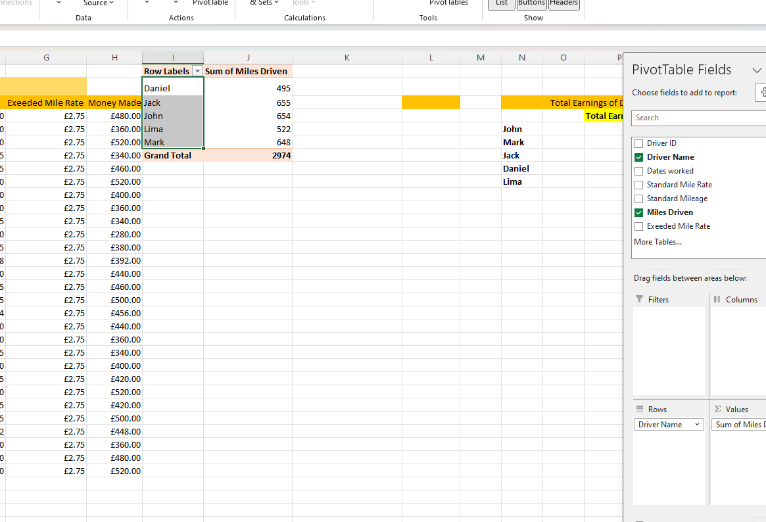
4 November 2025
Lecturer: Dr Md Shantanu Islam

University of Wales Trinity Saint David (UWTSD)
Institute of Inner City Learning (IICL)
Birmingham Campus Quay Place

Databases and Application Development
( ACCA5026_BIRM )

CertHE Computing Skills for the Workplace

Krzysztof Waldemar Zakrzewski
Student ID: 2325092

Table of Contents

- Introduction 3
- Database Design 3
2.1 Identification of Entities and Attributes 3
2.2 Entity–Relationship Diagram 4
2.3 Normalization to Third Normal Form 4
2.4 Schema Definition and Integrity Constraints 4
- Database Implementation 5
3.1 Sample Data and System Validation 5
3.2 Stored Procedures with Transaction Control 5
3.3 Triggers and Auditing Features 5
3.4 Transactional Scenario and Rollback Logic 5
3.5 Critical Queries and Operations 6
3.6 Indexing Strategy and Performance Enhancement 6
- Conclusion and Reflection 7
- Literature Support 8

- Introduction

The Campus Club Management System (CCMS) is introduced as a holistic relational database solution for the university’s Students’ Union, which presently oversees its club-related operations using disconnected paper-based and spreadsheet tools. These fragmented approaches create challenges in tracking club memberships, organizing events, monitoring participation, and documenting communications. The lack of a unified system has resulted in data redundancy, inconsistent records, and inefficiencies in planning student engagement activities.
The aim of the CCMS is to consolidate all information pertaining to clubs, students, events, communications, and participations into a normalized relational database that adheres to principles of integrity, consistency, and efficiency. The design and execution of the CCMS are guided by established database engineering methodologies, which include conceptual modelling, logical schema development, normalization to Third Normal Form, and physical implementation with suitable indexing, triggers, stored procedures, and transactional safeguards. This report details the complete design and implementation lifecycle of the CCMS, providing both theoretical rationale and practical application.

- Database Design

  - Identification of Entities and Attributes

The scenario identifies five core functional elements: clubs, members, memberships, events, participations, and communications. These translate naturally into relational entities. The Club entity contains descriptive attributes such as club name, category, and founding date. The student entity records details of enrolled students including identification number, name, programme, and academic year [1]. The many-to-many relationship between students and clubs requires a Membership entity, containing join dates and membership status. Events organised by each club form another entity, which includes event title, venue, date, and attendance requirements. Participation records establish a many-to-many link between events and attending members. Communications form an additional entity used to archive official messages sent to members, containing message content, date, sender, and the club responsible for the communication [2].
Relationships are defined as follows: each club can have many events, many members, and many communications. Each student can belong to multiple clubs and attend multiple events. These relationships allow meaningful queries such as identifying the most active clubs, analysing attendance trends, and reviewing historical communications [3].

  - Entity–Relationship Diagram
The ERD positions Club at the core of the model, connecting it to Membership and Events. Students are linked to Club via Membership, and to Events through Event_Participation. The primary keys are identified as club_id, student_id, event_id, membership_id, and participation_id. Foreign keys facilitate the relationships: Membership refers to club_id and student_id; Events refers to club_id; Event_Participation refers to event_id and student_id. Additionally, Club references category_id from Club_Category.
The ERD illustrates a well-organized many-to-many resolution, distinctly outlining join tables (Membership and Event_Participation) with attributes pertinent to each relationship, thereby avoiding the embedding of unnecessary duplicated data within the parent entities [4]. This design promotes data integrity, prevents redundancy, and enables effective monitoring of student club membership and event participation [5].

  - Normalisation to Third Normal Form
The initial conceptual schema underwent a thorough process of normalisation. In the First Normal Form, every attribute is atomic, and there are no repeating groups present. Attributes like student names, event venues, and communication content are maintained as indivisible fields. The transition to the Second Normal Form guarantees that all non-key attributes are entirely dependent on the primary key of the table [6]. This phase was especially significant for the Membership and Participation entities, which exhibit composite relationships; by implementing surrogate primary keys and maintaining foreign keys, all attributes are fully reliant on a single key [7].
The final transition to the Third Normal Form removes transitive dependencies. For instance, student programme information is exclusively stored in the student entity; event venue details are confined to the Event entity; and communication metadata, such as the identity of the sender, is not replicated across associated tables. This segregation reduces redundancy and promotes consistency during updates [8].

  - Schema Definition and Integrity Constraints
The physical schema incorporates primary keys, foreign keys, cascaded update and delete behaviours, as well as check constraints. For instance, it enforces unique club names, validates event dates to avoid scheduling errors in the past, ensures that membership dates follow the founding dates of clubs, and upholds referential integrity for participation records, thereby preventing any student from participating in an event without prior membership in the relevant club [9].
These constraints not only ensure data accuracy but also mitigate the risk of logical inconsistencies, which is crucial for any transactional system [10].

- Database Implementation

  - Sample Data and System Validation
The database was filled with authentic sample data that illustrated academic, sports, and cultural clubs, as well as active students from various programs, seasonal events, and historical participation records. The data validation process confirmed that constraints effectively prevented inconsistent input. For instance, attempts to register a student's participation in a club to which they do not belong successfully resulted in foreign key violations, thereby ensuring that business rules were upheld at the database level.

  - Stored Procedures with Transaction Control
Stored procedures were designed to handle insert, update, and delete operations for key entities including Student, Club, Event, and Membership. Each procedure adheres to a strong transactional framework [11].
This approach guarantees that no incomplete operation can compromise the integrity of the database in case of a runtime error. For instance, the procedure for establishing a new event check for the existence of the related club and the validity of the event date. Issues such as an invalid ClubID or duplicate event names will automatically initiate a rollback [12].

3.3 Triggers and Auditing Features
Audit triggers have been established to monitor changes in essential tables, particularly Membership, Event, and Communication. An AuditLog table captures the action type, timestamp, user, affected record ID, and the previous and new values where applicable. The AFTER INSERT, UPDATE, and DELETE triggers document alterations without imposing any additional load on application logic. These audit logs facilitate both accountability and rollback analysis, providing a historical record of system changes.

3.4 Transactional Scenario and Rollback Logic
A sophisticated transactional scenario was designed to emulate the creation of an event, followed by the automatic scheduling of communications and invitations to participants. The transaction encompassed the event creation, the production of communication records, and the optional pre-registration of members. Should any element fail, such as an invalid communication recipient or a missing membership record, a rollback of the entire process was initiated. This effectively upheld atomicity, which is one of the fundamental ACID properties [13].
The rationale for employing rollback is grounded in the necessity for consistency: an event should not be present without its corresponding communication being dispatched, as this would result in incomplete operational data. The commit function finalizes the transaction only when all prerequisites are met [14].

3.5 Critical Queries and Operations
The database is structured to accommodate frequent operational queries, which include retrieving all events organized by a specific club, identifying students with the highest participation levels, and generating membership statistics for reporting purposes. Analytical queries, such as those aimed at calculating trends in event attendance or pinpointing clubs with low membership engagement, necessitate joins across the Membership, Event_Participation, Events, Club, and Students tables [15].
These queries are significantly enhanced by the indexing strategies that have been implemented, which optimize the performance of frequent joins and lookups. For instance, queries designed to find all students in a particular club, all events hosted by a club, or all students attending a specific event are executed with greater efficiency due to targeted indexing.

3.6 Indexing Strategy and Performance Enhancement
Secondary indexes have been created on columns that are frequently utilized in join operations and filtering processes. In particular, indexes are present on Membership(student_id), Membership(club_id), Events(club_id), Event_Participation(event_id), and Event_Participation(student_id). This strategy is warranted as administrators often need to filter data by club, retrieve a student’s club memberships, or identify participants in specific events.
The indexing of foreign keys minimizes lookup times during join operations, while analytical queries that involve participation or membership statistics gain from quicker access to indexed columns rather than scanning entire tables. Evaluations utilizing query execution plans reveal substantial reductions in both logical reads and execution times, thereby confirming that the indexing strategy has effectively enhanced system performance without imposing excessive overhead.

4. Conclusion and Reflection

The Campus Club Management System effectively tackles the operational difficulties faced by the Students’ Union by consolidating all vital club-related data within a fully normalized relational database. The design of the database adeptly captures the intricacies of many-to-many relationships among students, clubs, and events, while ensuring data integrity and minimizing redundancy. The implementation phase showcased the system’s capabilities through realistic test data, robust stored procedures, and auditing mechanisms that promote accountability and traceability.
Transactional processing guarantees that interdependent operations either succeed or fail collectively, thus preserving data consistency. Indexing improves the performance of analytical operations that are crucial for tracking club engagement and student participation. The incorporation of academic literature further substantiates the design and implementation decisions, anchoring the project within established theoretical frameworks.
The project encountered several challenges, particularly in modelling intricate relationships and ensuring consistency across dependent operations. These issues were addressed through meticulous ERD construction, comprehensive normalization, and thorough testing of transactional procedures. Prospective enhancements may involve the creation of a front-end application that interfaces with the database, integration with university authentication systems, or the deployment of advanced analytics and reporting dashboards.

References:
[1] Kotsyuba, I., Bezkorovaynyi, P., Silko, J. and Shikov, A., 2021, October. Automating MySQL database complexity estimation based on quantitative metrics. In XIV International Scientific Conference “INTERAGROMASH 2021" Precision Agriculture and Agricultural Machinery Industry, Volume 1 (pp. 378-386). Cham: Springer International Publishing.
[2] Győrödi, C.A., Dumşe-Burescu, D.V., Győrödi, R.Ş., Zmaranda, D.R., Bandici, L. and Popescu, D.E., 2021. Performance impact of optimization methods on MySQL document-based and relational databases. Applied Sciences, 11(15), p.6794.
[3] Šušter, I., Karabašević, D., Stanujkić, D., Ranisavljević, T. and Brzaković, M., 2024. PHYSICAL DESIGN OF MYSQL DATABASE. Quaestus, (24), pp.309-323.
[4] Isnaeni, A., Septilarso, A., Ratnawati, N. and Susanto, H., 2023, September. Development of Entity Relationship Diagram (ERD) design for decommissioning database based on CERREX-D2 data input files. In Proceedings of the 2023 Nuclear Safety Seminar, Improving the Safety and Security of Nuclear Installations and Ionizing Radiation Sources to Support the Competitiveness of Nuclear Products and Improve Community Welfare (No. INIS-ID--115, pp. 372-382).
[5] Sudiartha, I.K.G., Indrayana, I.N.E., Suasnawa, I.W., Asri, S.A. and Sunu, P.W., 2020, July. Data structure comparison between mysql relational database and firebase database nosql on mobile based tourist tracking application. In Journal of Physics: Conference Series (Vol. 1569, No. 3, p. 032092). IOP Publishing.
[6] Fotache, M., Cluci, M.I., Taipalus, T. and Talaba, G., 2025. The effects of database normalization on decision support system performance. Information Systems, p.102636.
[7] Hardini, M., Agarwal, V., Apriani, D., Widjaya, I.A., Setiawaty, E. and Nurasiah, N., 2025. Application of database normalization in increasing data storage efficiency. International Transactions on Artificial Intelligence, 3(2), pp.201-211.
[8] Sug, H. and Korea, R.O., 2020. A method for normalization of relation schema based on data to abide by the third normal form. WSEAS Trans. Math, 19, pp.216-225.
[9] Huang, H., Shen, B., Zhong, L. and Zhou, Y., 2023, January. Protecting data integrity of web applications with database constraints inferred from application code. In Proceedings of the 28th ACM International Conference on Architectural Support for Programming Languages and Operating Systems, Volume 2 (pp. 632-645).
[10] Skavantzos, P. and Link, S., 2025. Entity/relationship graphs: Principled design, modeling, and data integrity management of graph databases. Proceedings of the ACM on Management of Data, 3(1), pp.1-26.
[11] Hartono, N. and Erfina, E., 2021. Comparison of stored procedures on relational database management system. Tech-E, 4(2), pp.8-15.
[12] Wahyudi, J., Asbari, M., Sasono, I., Pramono, T. and Novitasari, D., 2022. Database management in MySQL. Edumaspul-J. Pendidik, 6(2), pp.2413-2417.
[13] Botros, S. and Tinley, J., 2021. High Performance MySQL. " O'Reilly Media, Inc.".
[14] Pettit, T. and Cosentino, S., 2022. The MySQL Workshop: A practical guide to working with data and managing databases with MySQL. Packt Publishing Ltd.
[15] Nichter, D., 2021. Efficient MySQL Performance. " O'Reilly Media, Inc.".

