

Student Name: Iulian Neagu
Student ID: 2107401
LCBB6000
Proposed Research Title: ANALYSING THE STRATEGIES FOR SUCCESSFUL DIGITAL TRANSFORMATION IN SMES VS. LARGE ENTERPRISES FOR UK IT ORGANISATIONS
University of Wales Trinity Saint David (Birmingham Campus)
Date of Submission: 21 November 2025

Table of Contents
1. Introduction 4
1.1 Define Key Concepts 4
1.2 Significance of the Research 4
1.3 Purpose of the Research 4
1.3.1 Background of the Study 4
1.3.2 Problem Statement 5
1.4 Research Aim 5
1.5 Research Objectives 5
1.6 Research Questions 6
1.7 Research Hypothesis 6
2. Literature Review 7
2.1 Definition, Characteristics and Significance of Digital Transformation 7
2.2 Theories and models 7
2.3 Advantages of Digital Transformation 7
2.4 Impact of Organisational Size on Digital Success 8
2.5 Disadvantages or challenges of Digital Transformation in SMEs and Large Enterprises 8
2.6 Research Gap 9
2.7 Conceptual Framework 9
3. Research Methods and Methodology 11
3.1 Research Philosophy and Paradigm 11
3.2 Research Approach 11
3.3 Research Methodology 11
3.4 Research Strategy 11
3.5 Sampling Methods 11
3.6 Data Collection Tools 12
3.7 Data interpretation 12
3.8 Time Prospects of the Research 12
3.9 Ethical Considerations 12
4. Conclusion 13
Reference List 14

1. Introduction

1.1 Define Key Concepts
Digital transformation is the strategic implementation of technologies like cloud computing, automation, and data analytics to promote efficiency and competitiveness. It can help the SMEs and large enterprises in the UK IT sector to be innovative and adaptable, especially in the wake of COVID-19 forcing rapid technology uptake to remain resilient and grow sustainably (Thomas, 2023). Digital transformation involves not just implementation of technological advancements but it is also associated with strategic, structural as well as cultural changes within organisations. Additionally, organisations like MNCs and large enterprises have abundant sources to implement digital transformation, however SMEs have to rely more on innovation and flexibility since they sometimes face financial and skill barriers.

1.2 Significance of the Research
The research is important because it analyses the ways in which the UK IT SMEs and large enterprises can optimise digital transformation to be competitive, resilient, and innovative. It fills an obvious research gap as it compares the effect of organisational size on digital readiness, implementation success, and strategic adjustment in the post-pandemic economy.

1.3 Purpose of the Research

1.3.1 Background of the Study
As per a survey by Dell (2020), 80% of organisations accelerated their digital endeavours, 89% acknowledged the need to have scalable IT infrastructures (Thomas, 2023). Digital transformation in the UK IT industry is growing rapidly and is improving efficiency and data use, collaboration, and customer experience. Nevertheless, the strategies and the success rates of small and medium-sized enterprises (SMEs) and large enterprises are very different because of their different resources, structures, and technological capabilities.
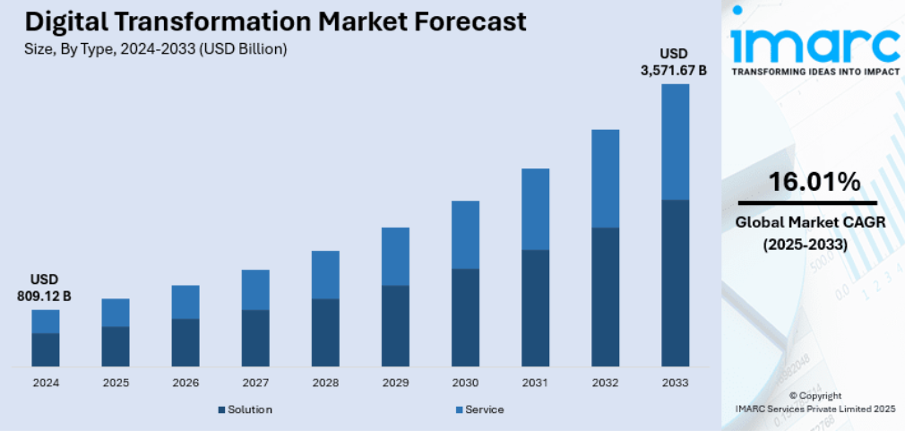

Figure 1: Digital Transformation Market Forecast
(Source: IMARC Group, 2024)
Caption: UK Digital Transformation Market Forecast

1.3.2 Problem Statement
Although there is a general understanding of the significance of digital transformation, both SMEs and big businesses have an equal measure of success in the implementation process. SMEs have problems with environmental and organisational support, compatibility with the technological aspect, and human resources, whereas big businesses usually cannot be as agile and innovative (Ta and Lin, 2023). The difference in strategic performance shows a desperate necessity to compare and analyse the determinants of effective digital transformation among organisations of various sizes in the UK IT industry.

1.4 Research Aim
The aim of the research is to review and compare strategies that help to achieve successful digital transformation in SMEs and large enterprises in the context of UK IT organisations.

1.5 Research Objectives
- To examine key drivers and barriers to implementing digital transformation in SMEs and large enterprises.
- To assess how organisational size influences digital success.
- To recommend effective digital transformation strategies for UK IT firms.

1.6 Research Questions
RQ1: What digital transformation strategies are adopted by SMEs and large IT enterprises in the UK?
RQ2: How do these strategies differ in terms of implementation and success?
RQ3: What lessons can SMEs and large enterprises learn from each other?

1.7 Research Hypothesis
H1: There is a significant difference between what digital transformation strategies are implemented by the large enterprises and by the SMEs in the IT industry in the UK. They are different in terms of implementation, resources, adaptation and outcomes.
H2: There is no such difference between what digital transformation strategies are implemented by the large enterprises and by the SMEs in the IT industry in the UK.

2. Literature Review

2.1 Definition, Characteristics and Significance of Digital Transformation
Digital transformation (DT) refers to the digital adoption of all areas of business that are redefining the operations and value creation (Kraus et al., 2021). The emerging digitalisation of economies has brought the relevance of DT in ensuring competitiveness to the fore. Besides organisational change, digital transformation affects the environmental, social and institutional systems. Kraus et al. (2021) classify the literature on DT into three categories such as technological, business and societal areas that pointing out that technology is the force behind disruption and innovation. As digitalisation continues to rise, small and large businesses face the challenge of adapting to the technologies and designing strategic models that comply with the changing market dynamics and demands of the stakeholders.

2.2 Theories and models
The Technology-Organisation-Environment (TOE) framework provides a framework through which to examine the adoption of DT in businesses. TOE framework describes digital transformation in three contexts, which are technological, organisational, and environmental (Na et al., 2022). Digital infrastructure and innovation in technological readiness and leadership, culture, and competence in employees in organisational readiness. The environmental environment encompasses the competition, government policy and external pressure. In addition to TOE, the Digital Maturity Model (DMM) and DX-Self Assessment Maturity Model (DX-SAMM) determine the digital maturity of an organisation in several dimensions to help manage gaps, areas of improvement (Haryanti et al., 2023). In the meantime, the Change Management Theory facilitates the human and structural aspects of the digital transformation. One of the most popular models that are used to direct change efforts is the Eight-Step Model by Kotter and the three-stage model by Lewin that consists of unfreezing, changing, and refreezing (Harrison et al., 2021). According to these models, communication, the involvement of leadership and the organisational culture are very vital in the successful implementation. TOE, DMM and Change Management model combination is a holistic approach of establishing the success of DT in both small and big businesses.

2.3 Advantages of Digital Transformation
The advantages of digital transformation are numerous and they can facilitate the activities of organisations and their sustainability in the long run. It allows making operations more efficient by automating processes, making better decisions with the help of data analytics, and engaging customers better by utilising digital platforms (Chen et al., 2023). In the case of SMEs, digitalisation lowers the operational expenses, enhances the market penetration, and scales the business even with scanty resources. The emerging technologies like AI and cloud computing are helpful to large enterprises since they provide better coordination among the departments, enhanced supply chain visibility, and acceleration of innovation. Besides, DT enhances organisational resilience as it enables remote work and quicker reaction to disruptions, as was the case during the COVID-19 pandemic. These are important benefits in the UK IT industry, which ensure global competitiveness and bring about continuous innovation.

2.4 Impact of Organisational Size on Digital Success
Big companies tend to have organised, multi-stage digital strategies at their disposal, which are backed by considerable financial and technological assets. Cao et al., (2023) discuss the implementation of DT in large, project-based firms based on three strategic dimensions: organisational-environment fit, proactive business transformation, and operational integration. These companies focus on governance systems, digital systems and data-intelligent decision-making to improve effectiveness. Nevertheless, change resistance, bureaucratic inertia, and divisive communication can often slow down the adoption slow. The digital strategies must be consistent with business models, and agility has to be incorporated into the hierarchical structures to transform the organisation. Effective online businesses incorporate analytics, automation, and artificial intelligence in decision-making and instil a culture of innovation. Hence, leadership congruency, strategic clarity and consistent skill building will be important in transforming digital investments into long-term competitive advantages.

2.5 Disadvantages or challenges of Digital Transformation in SMEs and Large Enterprises
The challenges that SMEs encounter in their DT journey are limited resources, a lack of digital skills, and financial capacity. According to Zhang, Xu and Ma (2022), six major factors affect the success of transformation in the SMEs, including technological, organisational and environmental factors. The mediation between the technological adoption and the successful outcomes is aided by the organisational capabilities and the employee skills strengthen this relationship. The culture of flexibility, commitment by the leader, and innovation are essential enablers which help SMEs to respond quickly to market transformations. But the strategic focus of SMEs usually is on short-term digital projects instead of overall transformation programmes since they have fewer finances. SMEs need to focus on capacity-building, capitalise on government incentives, and invest in the upskilling of their workforce to enhance the digital resilience and competitiveness of the companies in the dynamic IT setting.
Conversely, large enterprises have another set of obstacles, which are mostly associated with structural complexity, strict hierarchy, and cultural resistance to change. Although they possess more financial and technological capital, employee buy-in and convergence of large-scale systems with agile digital strategies are still lingering issues. Thus, in contrast to SMEs that cannot find a solution to the lack of resources, large enterprises have to deal with strategic and organisational inertia that slows the results of change, and a robust change management strategy and executive dedication to change are necessary to promote flexibility and innovation.

2.6 Research Gap
Although a significant amount of research focuses on digital transformation in both SMEs and large firms, there are scant comparative studies carried out in the UK IT sector. However, Zare et al., (2025) note that SMEs still face significant issues with the adoption of Industry 5.0 technologies, but little research has been done to compare the issues of these barriers and strategic enablers to larger businesses operating in the same industry.

2.7 Conceptual Framework
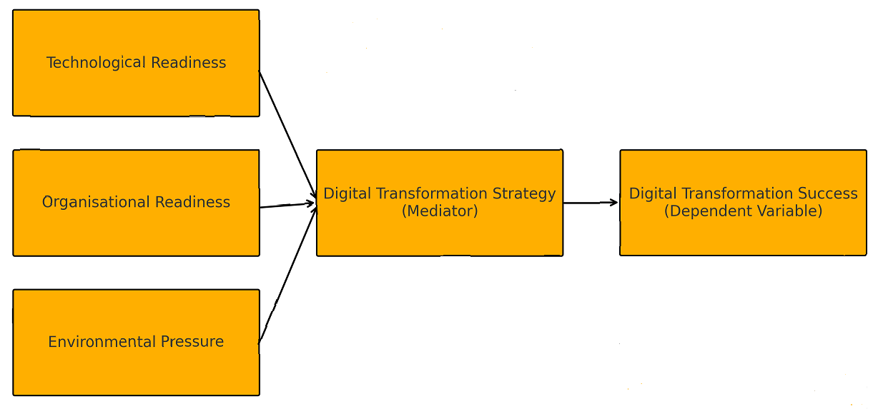

Figure 2: Conceptual Framework
(Self-developed)

3. Research Methods and Methodology

3.1 Research Philosophy and Paradigm
This study will select an interpretivist philosophy, which matches qualitative research that seeks to study meaning, understanding, and context. Interpretivism views reality as socially constructed and comprehended best through the prism of lived experiences and interactions. It will help to understand the organisational behaviours and strategies as they relate to the digital evolution of UK IT organisations.

3.2 Research Approach
An Inductive Approach will be adopted for this research. Unlike Deduction which involves testing hypotheses, Induction offers a researcher the opportunity to find patterns, concepts, and themes within data (Dudovskiy, 2025). For secondary qualitative research, this is the most suitable approach as it involves the most creative deployment of previously collected data.

3.3 Research Methodology
This research will use qualitative research methodology, which is based entirely on secondary materials. This will allow to understand the specific strategies, challenges, and contextual complexities involved in digital transformation for SMEs and large UK IT organisations.

3.4 Research Strategy
For this research, an archival research strategy will be utilized. This will gather and analyse qualitative secondary data. This will allow the researcher to conduct a study on secondary data analisyng reports about the companies, government publications, and other reliable industry data resources like IBISWorld and Statista.

3.5 Sampling Methods
The research will rely on purposive sampling to construct secondary sources that align of the study objectives. The population will be UK IT organisations that have implemented or reported on digital transformation strategies.

3.6 Data Collection Tools
The data for the present study will be only of a secondary qualitative nature and will include the following: Academic journals and books, Government reports and policy documents, Organizational case studies and certain professional publications. The provided material will be evaluated for credibility, authenticity, and relevance.

3.7 Data interpretation
Qualitative data will be analysed using thematic analysis, which will find common themes and patterns. This analysis includes the identification and interpretation of meaning from the reports and patterns within a data set (Naeem et al., 2023).

3.8 Time Prospects of the Research

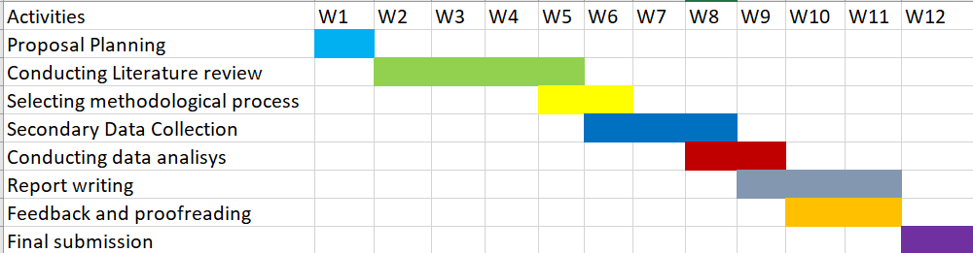

Figure 3: Research Timeline
(Self-developed)

3.9 Ethical Considerations
The Data Protection Act 2018 pertains to secondary research and ensures research is being conducted in a proper manner (Gov.uk, 2024). It usually requires personal data to be used in secondary research to be handled in accordance with the specific principles of lawful and fair processing, purpose limitation, accuracy, storage limitation, integrity, and confidentiality.

4. Conclusion
The study will be used to compare the digital transformation strategies between UK IT SMEs and large enterprises, to consider the effect of the size of the organisation on transformation success. The archival evidence enables the study to have a deep insight into technological, organisational, and environmental drivers of digital outcomes. It is believed that the findings will inform UK IT organisations on how to enhance digital maturity, agility, and competitiveness and add to the scholarly understanding of size-related variations in the effectiveness of digital transformation.

Reference List
Cao, D., Teng, X., Chen, Y., Tan, D. and Wang, G. (2023). Digital transformation strategies of project-based firms: case study of a large-scale construction company in China. Asia Pacific journal of innovation and entrepreneurship, 17(2).
Chen, A., Li, L. and Shahid, W. (2024) ‘Digital transformation as the driving force for sustainable business performance: A moderated mediation model of market-driven business model innovation and digital leadership capabilities’, Heliyon, 10(8), p. e29509.
Dudovskiy, J. (2025). Inductive Approach (Inductive Reasoning). [online] Business Research Methodology. Available at: https://research-methodology.net/research-methodology/research-approach/inductive-approach-2/.
Gov.uk (2024) Data Protection Act 2018. Available at: https://www.legislation.gov.uk/ukpga/2018/12/contents
Harrison, R., Fischer, S., Walpola, R.L., Chauhan, A., Babalola, T., Mears, S. and Le-Dao, H. (2021). Where Do Models for Change management, Improvement and Implementation meet? a Systematic Review of the Applications of Change Management Models in Healthcare. Journal of Healthcare Leadership, 13(2), pp.85–108.
Haryanti, T., Rakhmawati, N.A. and Subriadi, A.P. (2023). The Extended Digital Maturity Model. Big Data and Cognitive Computing, 7(1), p.17.
IMARC Group (2024). Digital Transformation Market Size, Growth & Report, 2033. [online] Imarcgroup.com. Available at: https://www.imarcgroup.com/digital-transformation-market [Accessed 17 Oct. 2025].
Kraus, S., Jones, P., Kailer, N., Weinmann, A., Banegas, N.C. and Tierno, N.R. (2021). Digital Transformation: an Overview of the Current State of the Art of Research. SAGE Open, 11(3), pp.1–15.
Kumar, M.D., 2023. A study on importance of Microsoft excels data analysis statistical tools in research works. Journal of Management & Educational Research Innovation, 1(3), pp.25-33.
Na, S., Heo, S., Han, S., Shin, Y. and Roh, Y. (2022). Acceptance Model of Artificial Intelligence (AI)-Based Technologies in Construction Firms: Applying the Technology Acceptance Model (TAM) in Combination with the Technology–Organisation–Environment (TOE) Framework. Buildings, 12(2), p.90.
Naeem, M., Ozuem, W., Howell, K. and Ranfagni, S. (2023). A step-by-step Process of Thematic Analysis to Develop a Conceptual Model in Qualitative Research. International Journal of Qualitative Methods, 22(1), pp.1–18. doi:https://doi.org/10.1177/16094069231205789.
Teng, X., Wu, Z. and Yang, F. (2022). Impact of the Digital Transformation of Small- and Medium-Sized Listed Companies on Performance: Based on a Cost-Benefit Analysis Framework. Journal of Mathematics, 2022(1), pp.1–14.
Thomas, H. (2023). Digital Transformation Drives Growth in Key UK Industries: Part 1 of 2. [online] Industry Insider | IBISWorld. Available at: https://www.ibisworld.com/blog/why-is-digital-transformation-so-important-to-uk-industries-part-1/44/1126/ [Accessed 17 Oct. 2025].
Zare, L., Ali, M.B., Rauch, E. and Matt, D.T. (2025). Navigating Challenges of Small and Medium-Sized Enterprises in the Era of Industry 5.0. Results in Engineering, 27, p.106457.
Zhang, X., Xu, Y. and Ma, L. (2022). Research on Successful Factors and Influencing Mechanism of the Digital Transformation in SMEs. Sustainability, 14(5), p.2549.

