Component 2 - Research Report
Student Name: Harris Mugenzi
Student Number: 2118945
Lecturer Name: Ngozi. N
BMSW4003_BIRM
Digital Skills and Research Methods.

Abstract
Is the summary of an article and it is also designed to give the reader a ‘snapshot’ of the article containing the academic formal all including the abstract is a saving time device.it summarised the study and narrowed the search. It gives a lot of feed back about the way they talk to others and help staff to innovate ideas and create a positive and collaborative workplace and to increase performance.

Contents
1. Abstract 2
2. Introduction 4
3. Research design 4
3.1. Research Question 4
3.2. Method 4
3.3. Ethical Considerations 4
4. Results 4
5. Discussion 4
6. Conclusion 4
7. Reference List 4
8. Appendix A – A blank copy questionnaire. 4

Introduction
We are faced with thousands of decisions every day of our lives, what to choose to get up in the morning what clothing we would wear. Most of the decision we make throughout the day are relatively trivial and has some consequence However some of the decision we make can carry substantial consequences, learning to understand and apply critical thinking and creating problem-solving skills can improve the quality of the decision we make, the crucial decision can shape our lives and analyse the problem facing us by considering the new different option. Most of us find decision-making. Critical thinking is a process that emphasizes a rational basis for what we believed and provides a standard and procedure for analysing and evaluating our beliefs (Rudow & Barry, 1994).

Research design
Qualitative research has an impact on the research design and overview based your research on what you see, the evident, the facts, in some weird research, they say Women smoke more than Men, it sound unbelievable, but it is a fact due to the research carried out.
Two types of research, Primary research, and Secondary research, where do you want to research.
Secondary, to base research on already collected by someone else. Research based on the citizen of Birmingham are lazy and do drugs and do not have the intention of working but want to have quality life ride expensive car without working for it.

Rational Decision.
All of us strive to make the best decision we can, but we are usually limited by certain constraints sometimes we do not have enough information or enough time. most of the time we try to be rational as we can by using what economics term or as rational decision-making process. Most of the time we would like the most reasonable, logical and objectives decision possible, but we are not able to arrive at the optimal solutions.to be able to make up a rational solution maker, most first recognise that a problem exist manager with morale problem they often denied that they are faced with problem(cowan.1986).
Cultural factors. Have also been found to influence the extent to which individual perceived, An Asian manager would not like Polk meat, but Hela meat, while Christian flow with any thing that come their way. The Asian culture are more likely to believe that the outcome is simple fate or God’ will (Adler,1997).
Citation, these provide an indication of the qualities and expert nature of a pieces of research, by showing how many times the work has been cited it can help to identify the leading Authors.
Analyzing.it seems only logical that the first step in problem solving is to describe and analyse the problem otherwise how can you solve a problem when you do not no what the problem is. Team member take time to discus problem they sheard their view and insight experiences and also sheard feedback from each other when analysing aa problem group member must look at the current condition realistically to determine the nature and the probable cause (chor&Oo,2012: gouran&hirokawa1996;kauffeld&lehmann-willenbrook,2011).

Research Question
Forms
BD4003 Tues 2-6pm
-
Saved
HM
Preview Theme Distribute
Questions
Responses
7
BMSD4003 Tues 2-6pm Group E
7
Responses
00:59
Average time to complete
Active
Status
View results
Open in Excel
1.
Would you like to take part in this questionnaire
More Details
 | Yes | 5
 | No | 0
 | Maybe | 2
2.
Are you 18 years old or above?
More Details
 | yes | 7
 | No | 0
 | Yes | 0
3.
Are you staff or a student?
More Details
 | Staff | 0
 | Student | 7
4.
Are you a male or female?
More Details
 | Male | 1
 | Female | 5
5.
Do you feel confident when using the OneDrive to collaborate with peers or colleagues? Yes or No
More Details
 | Yes | 7
 | No | 0
6.
Rank these words in order of according to how you feel about using technology to collaborate
More Details
Rank | Options
1 | Sad
2 | Happy
3 | Worried
4 | Confident
5 | Angry
First choice
Last choice
7.
Please select one option that applies to you
More Details
Strongly Agree
Agree
Disagree
Strongly Disagree
Using technology to collaborate with others improves my work

Method
THE PROPOSD METHOD.

Using MS FORM to create a questionnaire.

Closed questions. [yes or No] answers.

Rank order question.

Likert scale question.
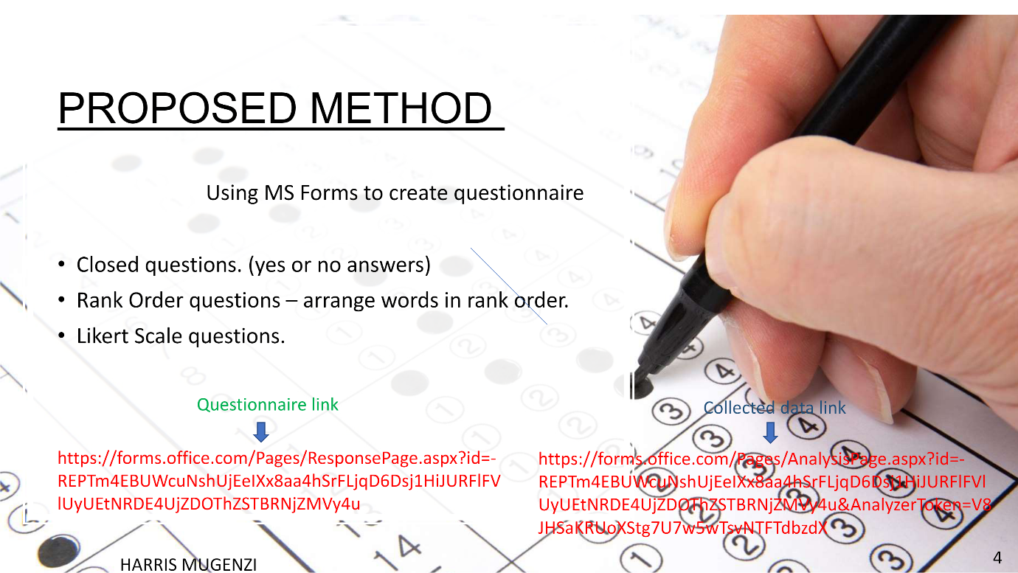

Ethical Considerations
Consent of the student are taken into Consideration whether. Yes or No.

Anonymisation of data Collected from student from UWTSD.

Data should not be link out of the organisation.

Underage student should not be interviewed, but only university student who are 18 and above years old should be interviewed.

Confidentiality of Data, like address details of identity should be private and kept between the organisation and student group members.

Moral Ethical Dilemma.

I was once asked a very tricky question during a job interview and it has not left me since, you are driving a car on a stormy day you pass by a bus stop and see three people waiting there.

The first is the perfect Woman of your dreams; The second is an old friend who once saved your life; and the third is a Lonely old lady who look really sick. If you only had one seat in your car, who would you offer ride to? Let think about it.

This is a moral and Ethical Dilemma used as part of a job applications:

Do you pick up the old woman, because she in critical condition and you should save her first? Do you take the old friend because he once saved your life, and this is the perfect opportunity for you to pay him back?

However, both choices leave you missing out on the woman of your Dreams.

The candidate hired out 200 applicants] however have no trouble answering.

He simply said, I would give the car keys to my old friend let him drive the old lady to the hospital and stay behind to wait for the bus with the woman of my Dreams.

His answer left me stunned.

It completely changed my outlook and remind me to always, Think outside the Box.

“Everyone is born with an instinct of succeed and ability to make it, but only the one who think outside the box succeed”

Remember Big ideas come from forward thinking people who challenge the Norm, thinking outside the box and invert the world they see inside rather than submitting to the limitations of current dilemma.

The limit of the possible can only be defined by going beyond them into the impossible.

Arthur. C. Clarke.
Consent of the student are taken into Consideration whether. Yes or No.

Anonymisation of data Collected from student from UWTSD.

Data should not be link out of the organisation.

Underage student should not be interviewed, but only university student who are 18 and above years old should be interviewed.

Confidentiality of Data, like address details of identity should be private and kept between the organisation and student group members.

Moral Ethical Dilemma.

I was once asked a very tricky question during a job interview and it has not left me since, you are driving a car on a stormy day you pass by a bus stop and see three people waiting there.

The first is the perfect Woman of your dreams; The second is an old friend who once saved your life; and the third is a Lonely old lady who look really sick. If you only had one seat in your car, who would you offer ride to? Let think about it.

This is a moral and Ethical Dilemma actually used as part of a job applications:

Do you pick up the old woman, because she in critical condition and you should save her first? Do you take the old friend because he once saved your life and this is the perfect opportunity for you to pay him back?

However, both choices leave you missing out on the woman of your Dreams.

The candidate hired out 200 applicants] however have no trouble answering.

He simply said, I would give the car keys to my old friend let him drive the old lady to the hospital and stay behind to wait for the bus with the woman of my Dreams.

His answer left me stunned.

It completely changed my outlook and remind me to always, Think outside the Box.

“Everyone is born with an instinct of succeed and ability to make it, but only the one who think outside the box succeed”

Remember Big ideas come from forward thinking people who challenge the Norm, thinking outside the box and invert the world they see inside rather than submitting to the limitations of current dilemma.

The limit of the possible can only be defined by going beyond them into the impossible.

Arthur. C. Clarke.

ETHICAL CONSIDERATION

ACCORDING TO JOSEPH AND EDNA INSTITUTE OF ETHICS, HE SAID THERE ARE SIX PILLARS OF CHARACTER.

1, TRUSTWORTHINES .IT MEANS ONE HAS TO BE HONEST AND BE RELIABLE, DO NOT CHEAT OR DECEIVE OTHER.

2, CITIZENSHIP, BE INFORM AND DO YOUR SHEAR, VOTE, OBEY LAWS AND RULES, RESPECT AUTHORITY, PROTECT THE ENVIRONMENT.

3, BE KIND, BE COMPASSIONATE, HELP PEOPLE IN NEED.

4, CONSENT, DO NOT BREACH CONFIDENTIALITY.

5, FAIRNESS, PLAY BY THE RULES AND DO NOT TAKE ADVANTAGES OF OTHERS.

6, RESPONSIBILITY, BE SELF DISCIPLINE, DO WHAT IS EXPECTED OF YOU.
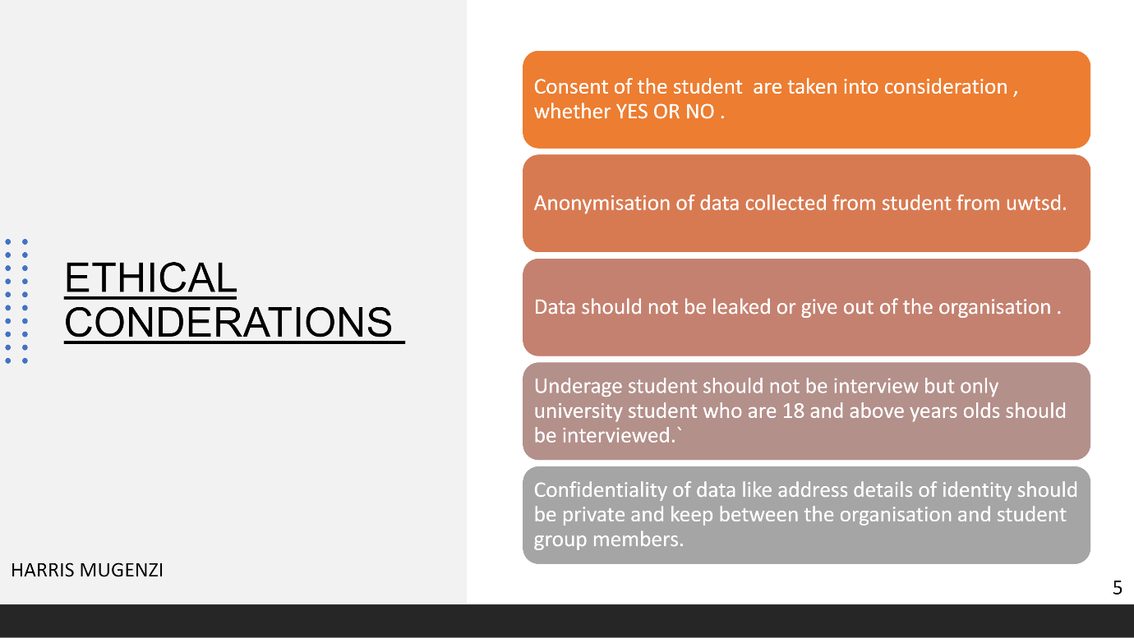
- Results

Discussion
- Forms
- BMSD4003 Tues 2-6pm GrpE
- -
- Saved
- HM
- Preview Theme Distribute
- Questions
- Responses
- 7
- BMSD4003 Tues 2-6pm Group E
- 7
- Responses
- 00:59
- Average time to complete
- Active
- Status
- View results
- Open in Excel
- 1.
- Would you like to take part in this questionnaire?
- More Details
 | Yes | 5
 | No | 0
 | Maybe | 2
- 2.
- Are you 18 years old or above?
- More Details
 | Yes | 7
 | No | 0
 | Yes | 0
- 3.
- Are you staff or a student?
- More Details
 | Staff | 0
 | Student | 7
- 4.
- Are you a male or female?
- More Details
 | Male | 1
 | Female | 5
- 5.
- Do you feel confident when using the OneDrive to collaborate with peers or colleagues? Yes or No
- More Details
 | Yes | 7
 | No | 0
- 6.
- Rank these words in order of according to how you feel about using technology to collaborate
- More Details
Rank | Options
1 | Sad
2 | Happy
3 | Worried
4 | Confident
5 | Angry
- First choice
- Last choice
- 7.
- Please select one option that applies to you
- More Details
- Strongly Agree
- Agree
- Disagree
- Strongly Disagree
- Using technology to collaborate with others improves my work

- Conclusion
The first chapter presented a description of a system and consulting approach to organization and management problem solving, we can summarised the element of the model by again using the example we consider the problem to be sociotechnical in nature to more than creating up to the information system.it is all about the literature review and Graf when undertaking your research projects it is essential that you are aware and acknowledge the existing research in your chosen area and to examine relevant sources so as to become fully conversant.

54.Reference List
- 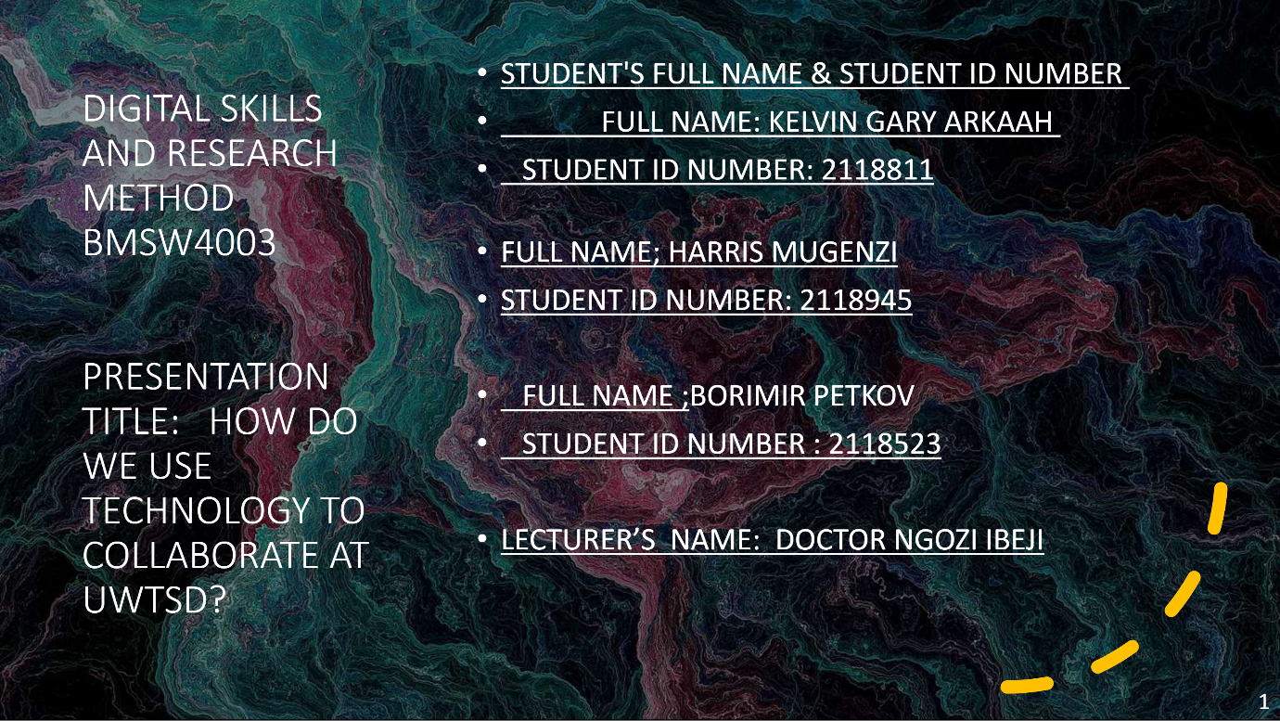

- 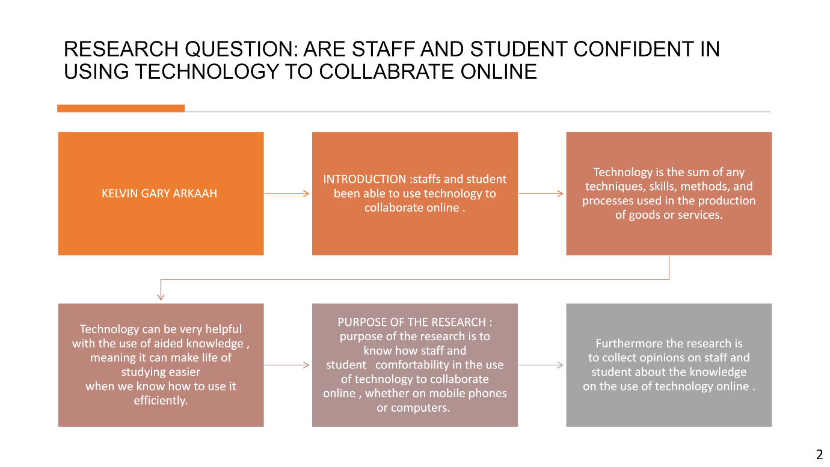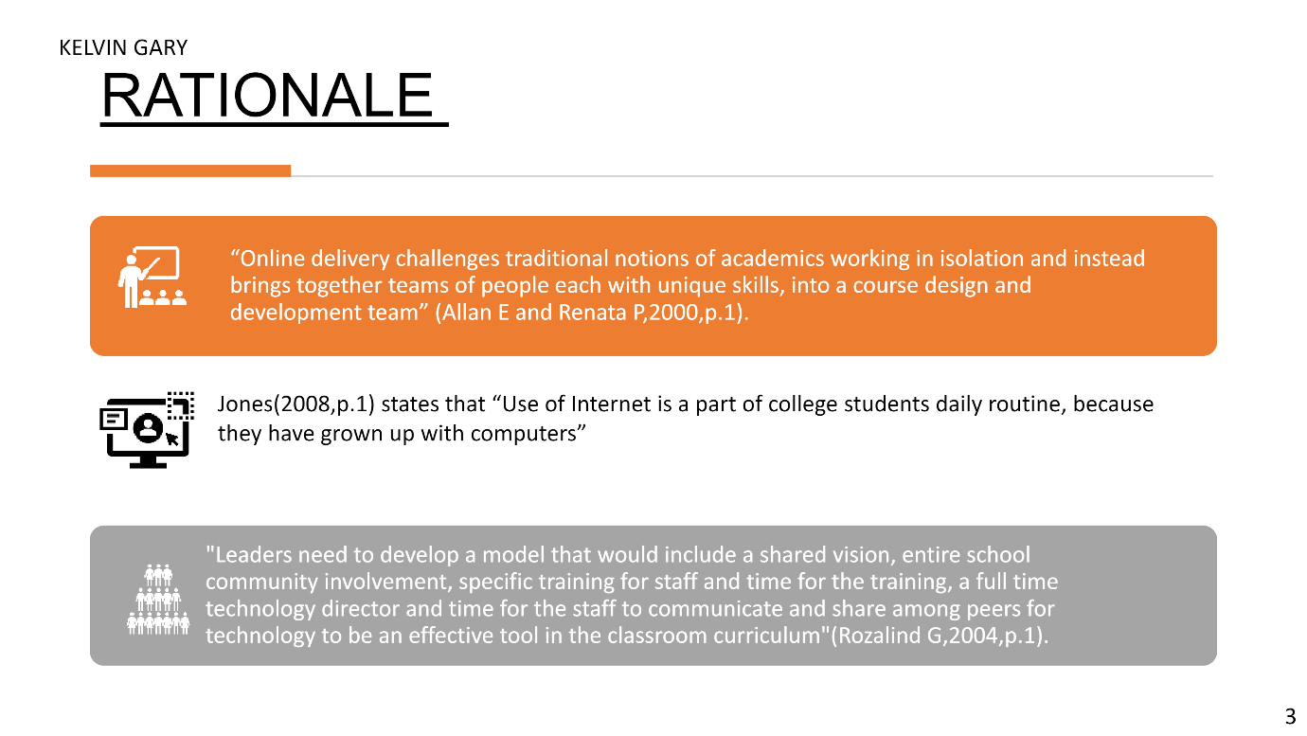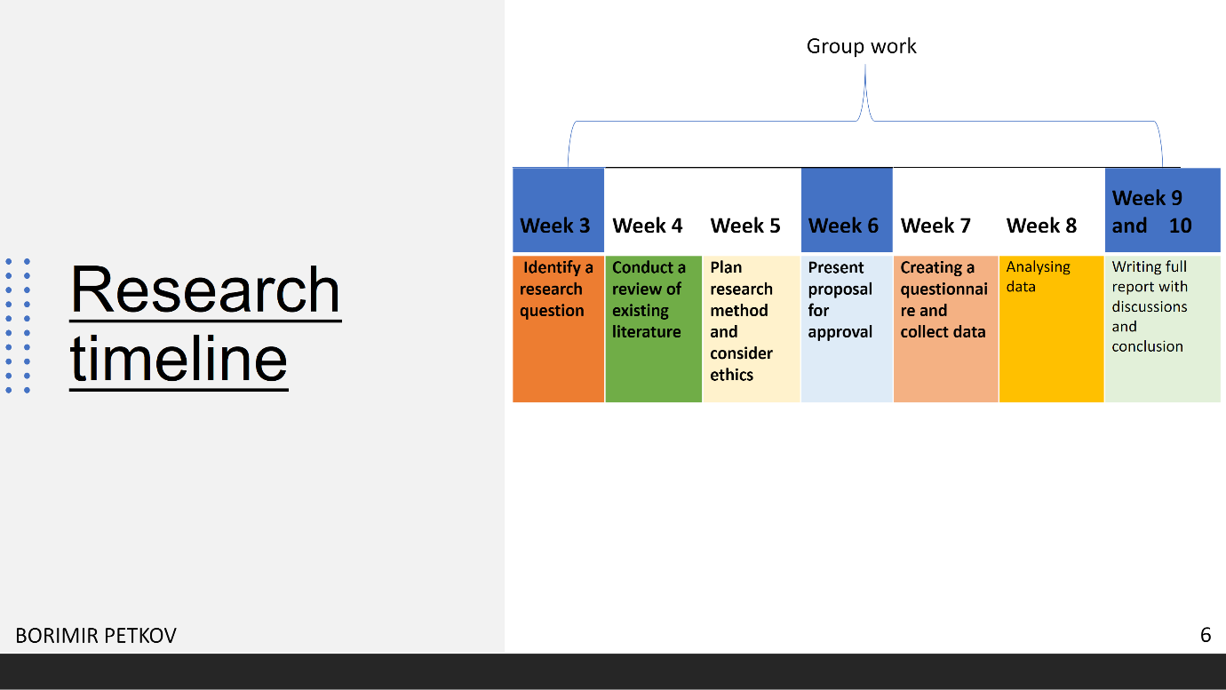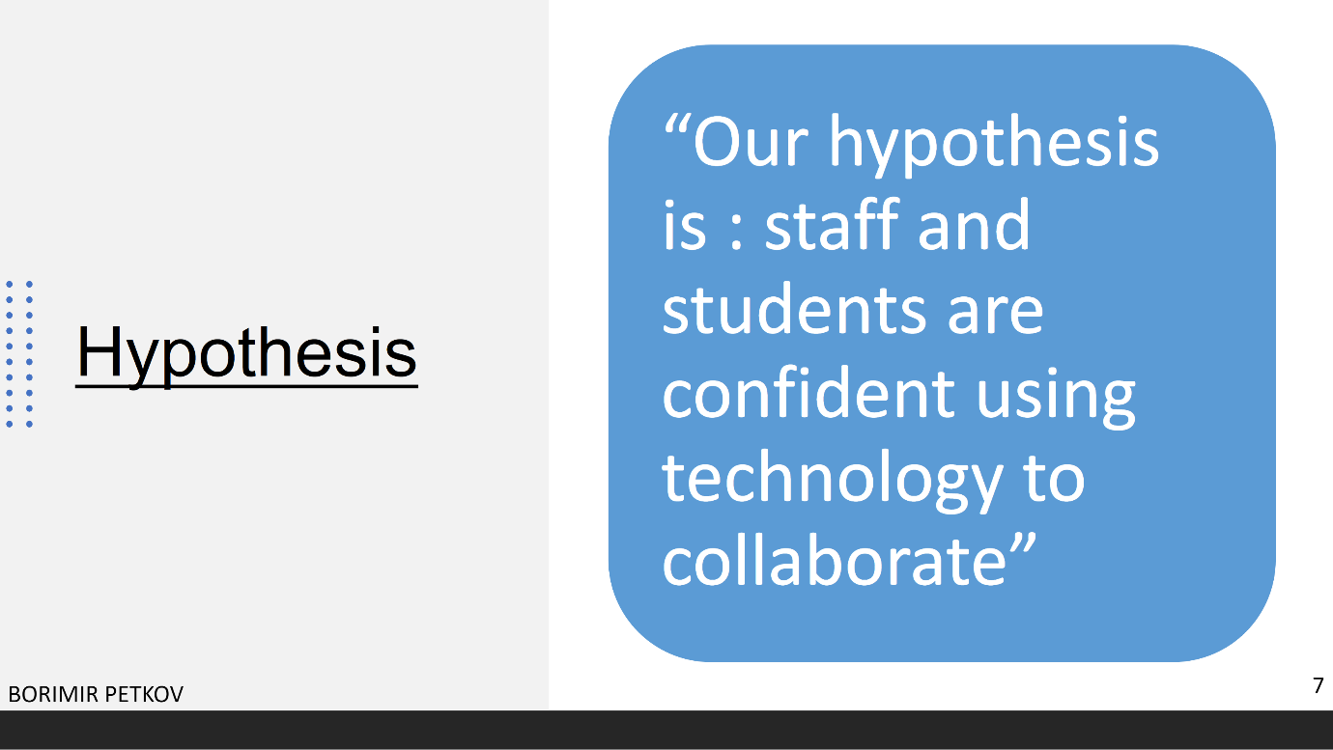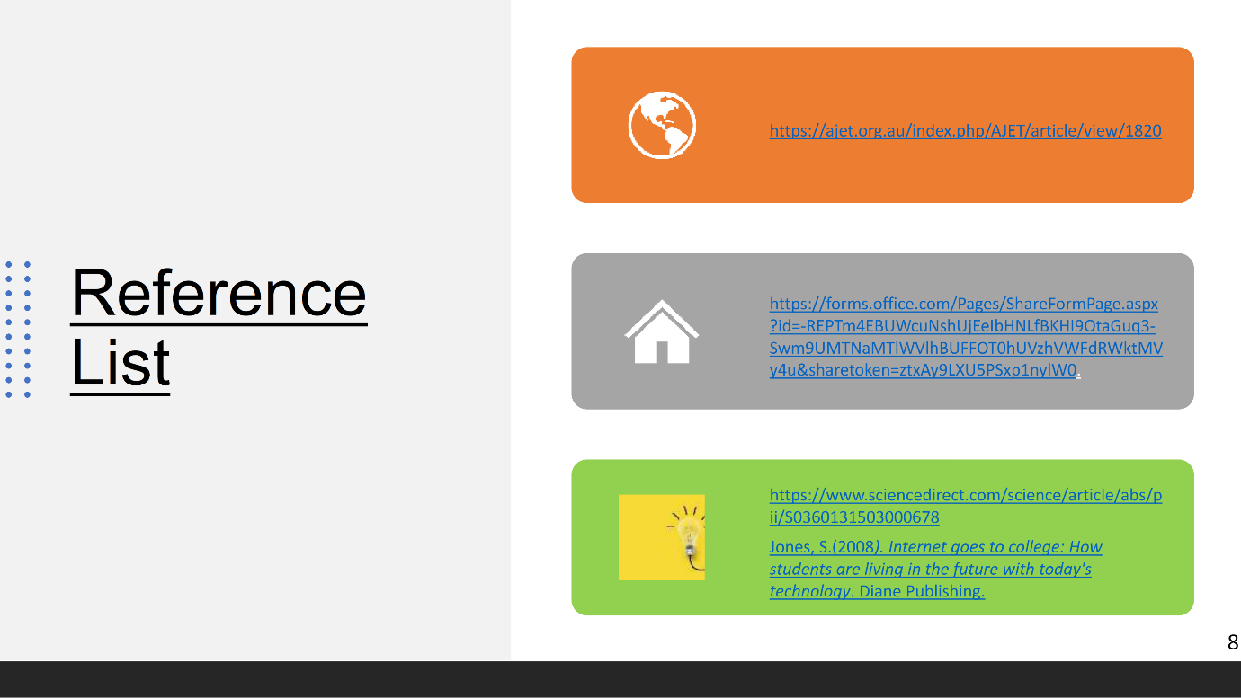

- Appendix A – A blank copy questionnaire.



