

Certificate of Higher Education in Skills for the Workplace

Task 2
Problem Solving and Decision Making

Student name: Peter Kristof
Student ID: 2113479

Module name: Problem Solving and Decision Making
Module code: (BMSW4004_LON)
Lecturer name: Saqib Shamim
Word count: 2245

Submission date: 03/09/2022
Table of Contents
Introduction 3
Defining problem 3
Root cause analysis (RCA) 4
The 5 Whys? 4
My first question: Why does the company have high staff turnover? 4
Second question: Why are employees unsatisfied? 4
Third question: Why is the job repetitive? 4
Fourth question: Why is the company not cross-training all staff for all skills and rotating employees? 5
Fifth question: Why company keep training new employees? 5
Fishbone diagram 5
Impact of the problem 6
Possible solutions 7
Cross training 7
Management focus 7
Pay raise 8
The best solution 8
Hybrid solution 8
Plan how to implement the solution 9
Monitor 9
PERT Chart 9
Conclusion 9
References: 10

Introduction

In 2013 I started to work for a market-leading retail company that employs hundreds of thousands of employees. It was a job in distribution, working in the biggest warehouse in Europe at that time. I started in the lowest position and worked up through the different skilled roles within the warehouse up to the management team. Working in different positions allowed me to meet other teams and face different challenges employees face daily. While being part of the management team It came to my attention that high staff turnover is the biggest issue our warehouse was facing since its opening. I left the company after six years of service and at the time the turnover was over forty per cent a year.

Defining problem

What is the staff turnover? Staff turnover is the number or percentage of employees leaving the company and needing replacement in set a period of time. Companies may face low, ideal or high staff turnover. It is also important to notice who is leaving the company as losing valuable and experienced employees may have a bigger impact than losing unproductive, unexperienced staff. Low employee turnover is when small numbers of employees leave a company in a set time. There are some positives about low turnover, it may indicate employees are happy and do not wish the company. The negative about low turnover is the lack of the flow of new fresh ideas into business. It is difficult to say what is ideal staff turnover as it may depend on the industry or business type. The best way to define ideal turnover is to compare the turnover with an average staff turnover within the industry. The negative side of it may be the loss of some highly productive staff. The positive is an inflow of new employees into the company and that equals to new fresh ideas, suggestions, different points of view and experience. High staff turnover is when many employees leave the company and must be replaced in a set period. There are no positives about high staff turnover, but many negatives. The main negatives are protentional loss of highly productive staff, continues high training cost, employees lack of experience in business and it is also the sign of staff unhappiness in the company. (What is Staff Turnover?, 2022)
According to edays.com the average turnover for the distribution industry in 2019 was 10.1 per cent and our warehouse had a staff turnover of over forty per cent, four times the national average so we can clearly say it caused the issue for the business.

Root cause analysis (RCA)

According to Olly Goodall, the main reasons for staff turnover are lack of personal development, too much work, lack of appreciation, the wrong role, company culture and bad bosses. (Goodall, 2019)
There are many possible causes of high staff turnover and it may be difficult to find out why are employees leaving. The easiest way could be exit interviews where you try to identify why has employee decided to leave the company. To find out possible root causes, I had to use different methods. I contacted some people that left the company in past years and some people that still work for the company.

The 5 Whys?

The first technique I used to determine the root cause is the 5 Whys. 5 Whys is a problem-solving technique that relies on asking the question “why?” five times to discover the root cause of the problem. Each time we ask “why?” the answer will become the ground for our next question. We may need to ask more than five times to identify the root cause or less than five times if we do not get any practical answers. This technique is forcing us to go deeper into the problem and find out the real root cause. Masterclass (2021)

My first question: Why does the company have high staff turnover?

All people I asked agreed on one answer: Employees are not satisfied in the company.

Second question: Why are employees unsatisfied?

I was receiving different answers to this question but most of the people said it is because the job they do is repetitive, they do not learn anything new and after a while, it becomes very boring.
This surprised me as there are different skills jobs in the warehouse so it would be possible to do something different each day for two weeks. That would avoid the job to become boring and also people would learn something new each day as they would face different challenges each day.

Third question: Why is the job repetitive?

Most answers were because of a lack of cross-training. So some people that work multiple years within the warehouse are still trained only in one or two skills.

Fourth question: Why is the company not cross-training all staff for all skills and rotating employees?

The people I asked said the company keep training new employees so they do not have enough time to train existing employees for more skills. Another fair point they raised is low performance on the skills for a few days until people get experience, which also contributes to high training costs.

Fifth question: Why company keep training new employees?

The answer was because of a lack of staff. This created a loophole, and it was clear to me that I need to take another approach to solve this problem.

Fishbone diagram

To determine the root cause of high staff turnover I decide to use another tool called the fishbone diagram developed by Kaoru Ishikawa in the 1960s. This diagram can be used to focus a conversation around the problem and categorize potential causes of the problem. (Lewis, 2020)
To create this diagram I used the same group of people but this time I asked them to give more than one answer as there are probably more issues in the workplace with so many unsatisfied employees. We decided that we can start our diagram with fish head unsatisfied employees and combine it with 5 Whys?, to be able to keep it brief we ask why only four times. Thanks to that we were able to identify sub-causes.
After brainstorming together we came up with the diagram below.

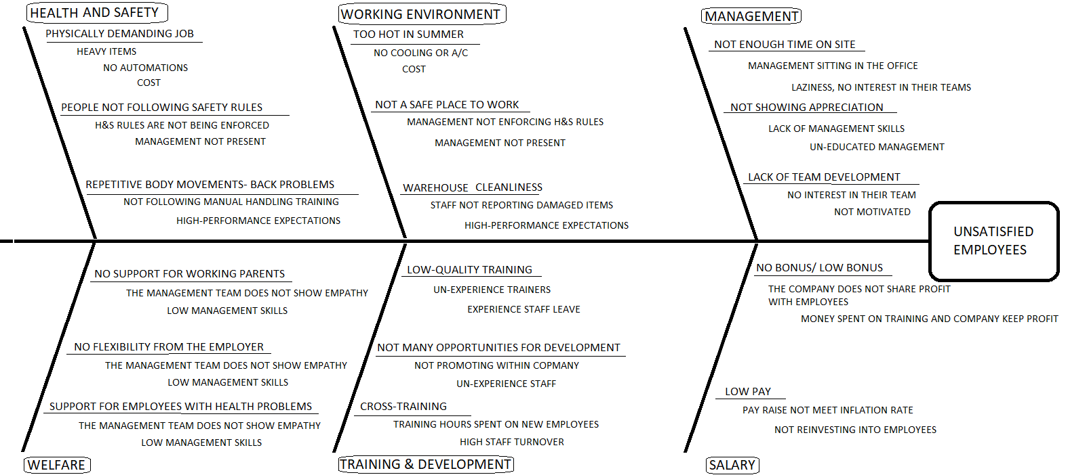

The head of the fish was unsatisfied employees and the major categories for bone of the fish were management, salary, working environment, training and development, health and safety, welfare.
After studying the fishbone diagram we created I could allocate more than one cause of high staff turnover. I realized that the lack of staff is not the root cause it is the impact of high staff turnover that causes other issues.
Low management presence in the warehouse and management’s uninterest in employees flag out multiple times on my fishbone diagram. There is not much support given to people with families or people that are in need because of the difficult situations they face such as health problems or attendance difficulties. The warehouse is also dirty and not safe because of high-performance expectations and management not being present.
The cost was the root cause of two sub-causes and we can also see the company is not spending money to improve work conditions or investing back in employees. That points out the low profit the warehouse makes, to improve the profit the company raise performance expectations and that is the cause of staff health problems and impact on the cleanliness of the warehouse.

Impact of the problem

This is a complex problem that has many impacts on the operation. The biggest impact of high staff turnover is the need to employ more people. This would be not bad at all if it would not have another impact. Employing more staff, add another cost to the business such as training cost, also new employees are not performing as good as experienced ones. That leads to a reduction in profit for the company, and if the company does not have profit big enough then is impossible to increase wages or give employees a deserved bonus. If wages do not increase enough or there is little or no bonus then the employees do not feel appreciated and become even more dissatisfied. The dissatisfaction of employees decreases their performance and that means the company need more people to do the same job. That leads to more wages the company needs to pay. This again creates a loophole as more wages means a reduction in profit.
Another impact is the company’s attempt to increase profit by raising performance expectations and that leads to a decrease in work standards. The warehouse is becoming dirtier. Some employees begin to have mental or physical health problems because of pressure at work and that is impacting the sickness rate. That is again costing the company more in long run.

Possible solutions

Cross training

My first solution to the problem is cross-training the staff in all skills within the warehouse.

Positives
The positive side of this solution is the reduction of dissatisfaction of employees and it would make the job more interesting as people would be facing different challenges each day and would learn new things each day.

Negatives
The negative side would be high training costs that could lead to even more loss. Also, I believe this would satisfy employees only for a short period as they would leave the company anyway because of the management treatment.

Management focus

The next solution is focusing on management as management failure is flagged multiple times in our fishbone diagram. We could improve in management knowledge and skills by paying for some courses such as team development, leadership or team building courses. I would also increase management presence in the warehouse by not allowing managers to stay in the office all day, instead of that they would have to spend a few hours each day in the warehouse.

Positives
Improvement in management skills. Managers would be in the warehouse building relationships with employees and listening to the challenges the employees face. That would also give them a better understanding of the process and they could potentially improve the way employees work by implementing new procedures.

Negatives
This could demotivate some employees as they could see it as an investment into management while there is no pay raise or bonuses given to people. They could potentially see it as a company that cares only about its management staff.

Pay raise

Another solution is raising wages.

Positives
Employees would feel more appreciated.

Negatives
Work conditions would not improve, the feeling of being appreciated would disappear in a few months and the job would be still boring.

The best solution

Hybrid solution

This solution combines all three solutions above. The problem is complex so we will need to focus on more areas to resolve it.
The management would take management and leadership courses. They would also need to spend more time in the warehouse to work on a relationship with people and would show empathy when employees face a difficult time by providing working hours flexibility. While present in the warehouse they would ensure people follow health and safety rules and report any damages to cleaning staff. Instead of hiring the company would promote within to ensure people have development opportunities.
The existing employees would be mixed up in training with new starters and get trained in at least three skills in the warehouse. This would ensure passing the knowledge of experienced workers to new staff.
Employees would receive small pay raises and they will be also told what targets the warehouse needs to meet to get a bonus at the end of the year.

Plan how to implement the solution

To implement the chosen solution I would need support and approval from the senior management team on site. They are fully aware of the issue so they would be more than happy to hear any solution that can improve the current state of the warehouse. I would explain to them how much continuous recruitment costs the company and introduce my plan to lower staff turnover. I am aware there is initiative cost such as courses, pay raise and cross-training but that would lower the current monthly costs such as new staff training and extras staff wages. After the full implementation of my solution, the company would save money by the end of the financial year.
Before any implementation starts management would need to present it to employees. When presenting they would need to explain what is the drive for change and why is the change needed. They will also explain when are the changes going to start and how long is going to be transmission period. It will take some time for managers to complete their courses but from day one they will be required to be more present in the warehouse.

Monitor

PERT Chart

To monitor the progress of implementation we will use PERT Chart. PERT is an acronym for Project Evaluation and Review Technique. It is a tool that helps us visually see the progress of the planned tasks. (Newell, 2022)
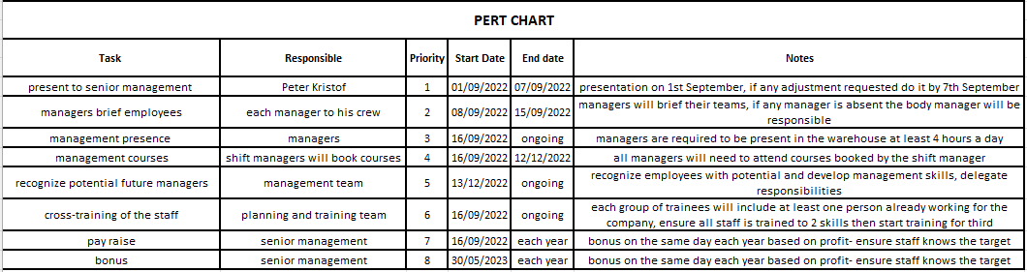
This chart is easy to follow and also provides additional notes.

Conclusion

The company would probably struggle for a short period as management and employees would try to resist the changes but if the management stick to the plan it would change the future of the warehouse. The turnover would decrease, the profit increase, employees would feel more supported and appreciated by management and the overall culture in the warehouse would improve.

References:

Brighthr.com. 2022. What is Staff Turnover?. [online] Available at: <https://www.brighthr.com/articles/culture-and-performance/staff-turnover/> [Accessed 23 August 2022].
edays. 2022. Employee Turnover Rates: An Industry Comparison. [online] Available at: <https://www.e-days.com/news/employee-turnover-rates-an-industry-comparison> [Accessed 24 August 2022].
Goodall, O., 2019. Staff turnover: How to calculate it, what causes it and how to reduce it. [online] Real Business. Available at: <https://realbusiness.co.uk/how-to-calculate-and-reduce-staff-turnover> [Accessed 24 August 2022].
Lewis, S., 2020. What is a Fishbone Diagram (Ishikawa Cause and Effect Diagram)?. [online] WhatIs.com. Available at: <https://www.techtarget.com/whatis/definition/fishbone-diagram> [Accessed 26 August 2022].
Newell, S., 2022. PERT Chart. [online] Productplan.com. Available at: <https://www.productplan.com/glossary/pert-chart/> [Accessed 28 August 2022].

