


Can FEa replace physical testing for turbine blades: a case study
Author: Sion Evans (P150600)
Advanced Stress Analysis & FEA: M6X00420
Lecturer: Kelvin Lake
School of Engineering
29/03/2020

Abstract
With continuing increase of strain on resources as the population and quality of life increases, development of simulation techniques could prove astronomically beneficial if they ae able to replace physical testing in the manufacturing industry. This paper aims to describe the FEA process and its correlation with physical testing at this date and then determine whether it is possible or should be possible. The literature reviewed in this report clearly described FEA as an extension of physical testing that has already shown to improve our understanding of physical systems as well as reduce prototyping and physical testing. However, it was found that FEA is limited to such qualities at this stage of human technological capabilities, and it is not yet possible, if ever, to replace physical testing completely.

Figure 1Turbine blade structure (Decker, 2019) 3
Figure 2. The standard FEA process (Gokhale, 2019) 5
Figure 3. 1st and 2nd order tetrahedral solid elements before and after deformation (SimScale, 2016) 6
Figure 4. Examples of element types used in FEA analysis (Rahul, 2018) 7
Figure 5. Stress distribution visuals along a turbine blade (Mourad Nachtane, 2018) 7
Figure 6. Full-scale testing apparatus of turbine blades (Bin Yang, 2013) 9
Figure 7. Schematic diagram of various non-linear analysis applications (Gokhale, 2019) 13

$Ku=P$ Equation 1. Static load equation 11

Graph 1. Graph displaying the linear and non-linear components of material behaviour (Gokhale, 2019). 12
Nomenclature
FEA = Finite Element Analysis
PDE = Partial differential equation
CAD = Computer Aided Design
𝐾 = Stiffness Matrix
𝑢 = Displacement
𝑃 = Vector of loads

Contents
Abstract 1
1. Introduction 3
2. Numerical Simulation 4
2.1 What is FEA 4
2.2 The FEA Procedure 4
2.2 i) Modelling/ Pre-processing. 5
2.2 ii) Solution. 6
2.2 iii) Post-Processing. 6
3. Why Turbine Blade Manufacturing Companies Use FEA. 7
4. Correlation Between Physical Testing and FEA of Turbine Blades. 8
4.1 Static Testing. 8
4.2 Fatigue Testing. 9
4.3 Modal Testing. 9
Non-Destructive Testing (NDT) 9
4.4 Correlation with FEA. 10
5.Limitations of FE-Simulations. 12
6. Can FEA Replace Physical Testing? 13
7. Future possibilities 13
8. References. 14
Appendix A. 16

Introduction
The size and commercial production of wind turbines has continued to grow to a point where it can compete with fossil fuels. Currently, the largest installed turbine has a capacity to generate 12MW of energy with a blade diameter of 220m (GE Renewable Energy, 2020) with 142 TWh global energy contribution coming from wind in 2018 (BP, 2019). As the magnitude of the blade size is increasing, as to is the recurring issue of blade fatigue. Turbine blades are subjected to intermittent loading conditions caused by inertial accelerating loads, gravity and turbulent wind flow. Resulting in flapwise and edgewise direction loads that deform the blade and have the potential to cause catastrophic failure (Othman Al-Khudairi, 2017). To predict failure events and mitigate solutions to the design and development of such blades physical tests and analysis takes place. Such tests may include but are not limited to static testing, modal testing, fatigue testing and none-destructive testing. This can be done physically with experimental methods, analytical methods or through numerical simulations.
Numerical techniques are mathematical models that use computers to solve governing partial differential equations otherwise extremely difficult for humans to calculate. As computers improved over the years to become the super computers currently available today, as to did the efficiency, accuracy and applicability of numerical techniques. There are four types, Boundary Element Method, Finite Volume Method, Finite Difference Method and Finite Element Method. FEM is known to outperform other numerical models for structural approximations and solving complex transient PDE’s over complex domains (Gokhale, 2019). FEA was developed by engineers in various industries to address structural mechanics problems. Earlies mathematical papers on FEA can be found as early as the analytical studies made by Schellbach [1851] with Courant [1943] being the first to introduce triangular and rectangular ‘finite elements’ (Stein, 2014). However, real life applications didn’t start till the rise of the computers with the first papers submitted by Topp, Turner, Martic and Clough (1955) with groundwork for further developments in FEA submitted by Strang & Fix (1973) (SIMSCALE, 2020). To todays date where FEA has become a well-established integrated tool for design and development manufacturing processes across a range of industry.
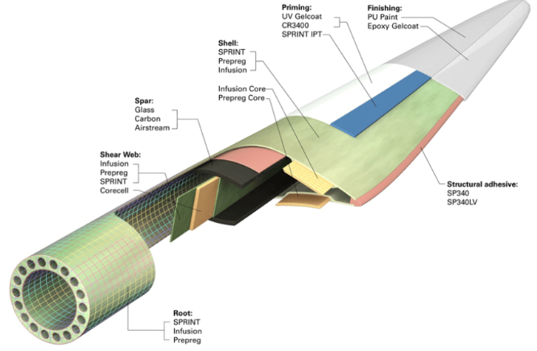
Prior to simulation engineers depended on empirical information from laboratory’s scaled up to industry level for the development of a product (Date, 2005). This paper aims to describe the FEM procedure, use published literature to address its current correlation with physical testing and finally determine whether an FEA model can completely replace physical testing for wind turbine blades. The structure of a turbine blade can be seen in [Fig. 1] with a full description in the appendix.
Figure 1Turbine blade structure (Decker, 2019)

2. Numerical Simulation

2.1 What is FEA
FEA is a name given to any simulation that uses the Finite Element Method (FEM) to quantify and understand physical phenomena, such as wave propagation, thermal transport and structural/fluid behaviour. The FEM does this by describing complicated partial differential equations (PDEs) otherwise impossible without computers. PDEs are discretized and represented by an array of nodes where unknown values are approximated, usually polynomial (SIMSCALE, 2020). Multiple computer software packages are used across industry, some include SOLIDWORKS, Auto-CAD, CATIA. There is not any clear indication that any particular software is better than another, the decision on which software to apply the model is typically down to the preference of the user (Gokhale, 2019).

2.2 The FEA Procedure
The FEA procedure takes place in three main stages, the procedure is divided into, modelling, solution and visualization as illustrated in [Fig. 1].
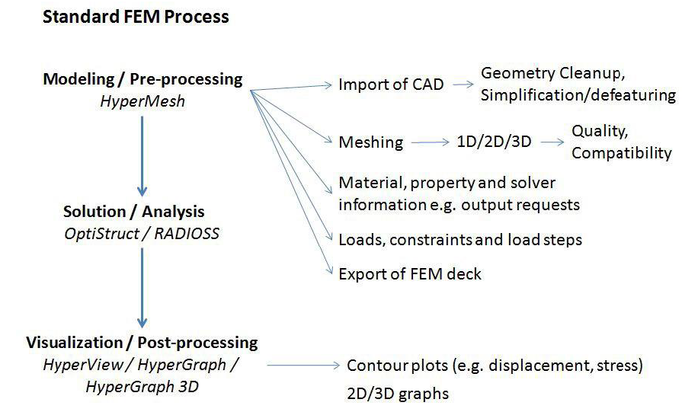
Figure 2. The standard FEA process (Gokhale, 2019)

2.2 i) Modelling/ Pre-processing.
At the beginning of FEA simulation a CAD geometry in imported into the pre-processor. This is where the geometry is cleaned up to remove issues such as broken surfaces, un-stitched surfaces, redundant surfaces and any other issues (Onwubolu, 2013). Issues such as these can cause complications in the meshing procedure further along the process, so it is crucial that everything is straightened out before moving forward with the procedure.
Once an appropriate geometry is acquired, the creation of the mesh can begin. The mesh is built up with an array of elements built up from nodes. Nodes are single points within a programme that contain material and structural data, they are connected by lines to create an element and eventually a mesh (Date, 2005). It is through this medium, approximations are made. Therefor the number and quality of the elements directly affects the accuracy of the results, and subsequently the computational time of the simulation. A mesh can consist of various elements types as illustrated in [Fig. 3], the most commonly used elements are 1D Beam elements, 2D Shell elements and 3D Solid elements (Gokhale, 2019). The mesh set-up is the most crucial part of any numerical model, if little or no time goes into element and mesh set-up, the whole simulation is compromised.
The majority of parts analysed using FEA simulations utilize a 3D, solid element model to define the boundaries surrounding the part. This is typically the industry standard as it produces more accurate results than a 1 or 2D element mesh (Gokhale, 2019). Solid elements have 3 degrees of freedom per node but can have a different number of nodes depending on which order (1st or 2nd) of the element. As shown in [Fig. 2], a first order tetrahedron has four flat faces and vertices, with 4 connecting nodes. The second-order tetrahedral has four flat faces with 10 nodes including the 4 vertices and mid-points of its edges (Onwubolu, 2013).
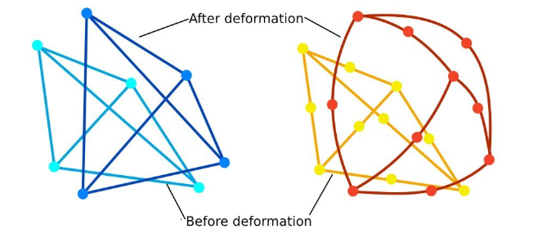
Figure 3. 1st and 2nd order tetrahedral solid elements before and after deformation (SimScale, 2016)

A shell element is a triangle consisting of 3 nodes with 6 degrees of freedom. Typically considered less accurate than a solid mesh, however in some particular cases containing thin-walled parts, i.e sheet metal parts, a shell mesh is preferred for its low computational cost and solve speed and widely used across the turbine blade manufacturing industry (Aaron Miller, 2013; F.M. Jensen, 2006; Othman Al-Khudairi, 2017). 1D beam elements are typically used to create structural members as the reduced number of nodes and elements is desirable for their minimal impact of computational cost (Onwubolu, 2013).

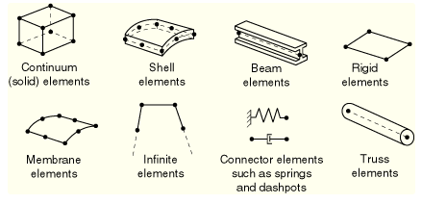
Figure 4. Examples of element types used in FEA analysis (Rahul, 2018)

Following the completion of the mesh, material and property information is assigned to the elements. Solver information, Loads and constraints are then inserted to replicate the conditions under which the product must be tested before progressing to the next stage of development.

2.2 ii) Solution.
This part of the process is where the FEA software provides a solution to the conditions set by the user, by solving the constituent governing equations. Any issues with the model will prompt the software to display an error. Some examples of errors include invalid material properties, poor element quality and insufficiently constrained model.

2.2 iii) Post-Processing.
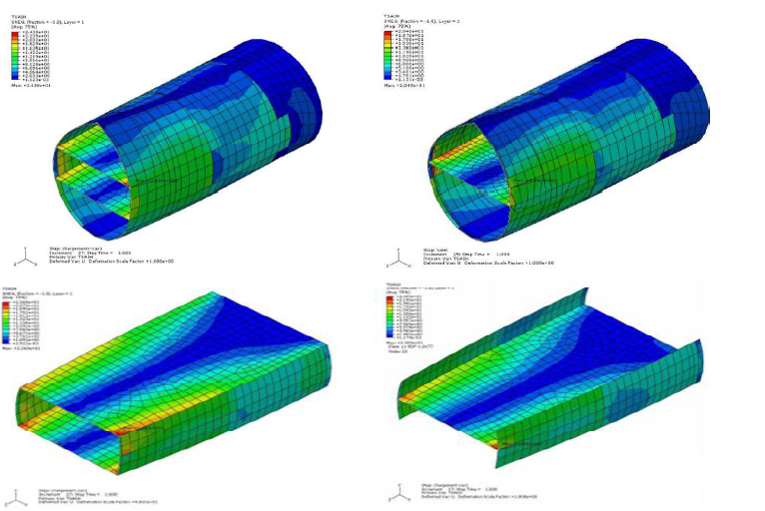
Finally following a successful solve, the post-processing package is where visualisations of the parameter being analysed, e.g stress, strain, deformation, is illustrated to the designers. Many conclusions are drawn from this process, where the behaviour of the product being tested can be visualised in ways impossible to do in real life applications, expanding the knowledge of the engineers working with a particular product (REF). An example of this can be seen in [Fig. 4]
Figure 5. Stress distribution visuals along a turbine blade (Mourad Nachtane, 2018)

3. Why Turbine Blade Manufacturing Companies Use FEA.
As wind turbine technology has developed the size of the turbines has exponentially grown to as large as the Haliade-X 12 MW offshore turbine with a turbine diameter of 220m (GE Renewable Energy, 2019). Determining the bade envelope on aerodynamic performance alone is no longer practical, there is now a requirement to consider the structure of the blade much earlier in the design process, as the structural concerns have become a more dominant design criterion (Thomas D. Ashwill, 2003). FEA is the primary numerical tool used by blade manufacturing companies to carry out structural analysis in the design and development process (Nitin Tenguria, 2011). Its proficiency is recognised worldwide as it provides a range of advantages over traditional testing methodologies, resulting in increased productivity and revenue, two desirable outcomes all companies wish to ascertain. Advantages include but may not be limited to:
Comprehensive result sets – FEA can generate a physical response of the system at any location, particularly those that cannot be captured by a physical section analysis. An example of this can be seen in full blade shell modelling, where second-order layered shell elements are used to model non-beam behaviours like cross-sectional warping (Thomas D. Ashwill, 2003).
Optimal use of a model – Once calibrated of FEA several failure modes namely critical failure, fatigue due to gravity, acceleration or cyclic loading can be done using the same model. Through numerical simulation complex load cases that represent actual wind flow can be analysed (Anon., 2011), a big advantage over full-scale tests that can only impose idealized loads. Setting up an FEA model is much more practical than setting up physical apparatus to test for each failure mode individually.
Increased Accuracy and Insight into critical design & physical testing parameters – Traditionally, ideas were sketched up, developed into prototypes and manufactured before testing could take place, only to find certain perimeters had been overlooked (REF). FEA allows for simultaneous calculations and visualization of physical parameters. As a result, designers can accurately simulate critical test conditions and gain a more advanced knowledge of where and how failures occur.
An example of this can be seen he works of (F.M. Jensen, 2006) where a 34m wind turbine blade has been tested in flapwise bending till collapse. A non-linear FEA was employed and compared with measurements taken and showed that delamination of the outer skin was the initial failure, followed by delamination buckling and a complete collapse. Without the post-processing features of FEA, the origin of the delamination buckling would be very difficult to determine.
Virtual Prototyping - FEA simulation has allowed initial designs to be virtually created and analysed in hours, compared with the days or weeks it would take for a physical prototype, saving time and money. Scholars and manufacturers FEA to virtual prototypes to investigate a fatigue analysis of various materials and designs that reduce blade weight and subsequent gravitational fatigue loads (Aaron Miller, 2013). Composite fiberglass blades cost as much as $9-11 per kg, with a typical 1.5 MW turbine blade weighing roughly 216 kg (Composite World, 2008). Without the use of FEA simulation software physical prototypes would cost so much time and money the technology would most likely not be feasible, especially whilst trying to compete with the oil and gas energy industry.

4. Correlation Between Physical Testing and FEA of Turbine Blades.
This section aims to briefly describe physical testing processes and how they correlate to FEA. During operation the blade is aerodynamically loaded in the flapwise direction and gravitationally loaded in the edgewise direction, which increase with blade size (Othman Al-Khudairi, 2017). A paper by (Mourad Nachtane, 2018) identified and studied the critical loads of a turbine blade, which can be written as:
1. Wind loading. 2. Bending loading. 3. Buckling loading. 4. Centrifugal loading. 5. Gravity loading.
The Mechanical property testing of such blades is essential for the safe-guarding and quality assurance of the technology. Such property tests are measured under individual or combinations of tensile, compressive and shear loads, this is done through static, fatigue and modal testing (Bin Yang, 2013). This can be done through full-scale testing where idealised conditions are set and strain gauges sensors and accelerometers collect relevant data, as seen in [Fig. 4]. This section aims to briefly describe physical testing process and identify the correlation with FEA.
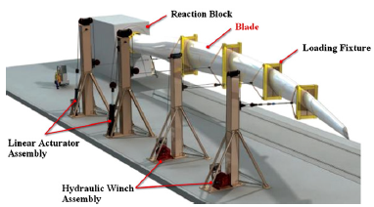

Figure 6. Full-scale testing apparatus of turbine blades (Bin Yang, 2013)

4.1 Static Testing.
In experimental static testing loads are unidirectionally applied to the blade to determine the ultimate strength. This is done to ensure blade and tower collisions to not take place and determine a blades ability to withstand excessive cyclic loads caused by transient storm conditions. The test methodology being a choice of destructive or none-destructive testing. Such test can take form in many ways depending on the size of the blade, multiple techniques can be seen in a review of turbine testing technologies reported in (Bin Yang, 2013).

4.2 Fatigue Testing.
Blades are subjected to highly irregular loading conditions caused by gravity, turbulent wind flow and inertial loading during acceleration of the turbine. Fatigue testing is open to determine failure mode and fatigue strength of the blade, in particular fatigue at attachment regions, such as the root attachment of the blades and rotor. The technique of doing such a test is down to inhouse industry standards with variation between one company an another (Thomas D. Ashwill, 2003) There are multiple laboratories worldwide that have developed their own methods for fatigue testing as can be seen in the work of (P.R. Greaves, 2012).

4.3 Modal Testing.
Modal analysis is carried out to determine the dynamic characteristics of structural element at resonance (TARTIBU, 2015). Turbine blades have become more flexible as they have grown, creating potential instability problems. Determining the modal parameters is crucial for determining the blades reliability as the resonant properties of the blades are influenced by the physical geometry properties.
The modal analysis is accomplished through a number of experimental techniques where the dynamic properties are characterised into the following modal parameters:
- Modal frequency.
- Damping factor.
- Mode shape
Modal frequency analysis is performed by exciting the blade at a fixed point in a fixed direction, using an impact hammer and electrodynamical shaker. Accelerations are measured at various cross-sections along the blade using accelerometers.

Non-Destructive Testing (NDT)
The field of NDT is also used on turbine blades, typically used inspection rather than full-scale structural analysis. Some techniques include vibration analysis, thermography, X-ray imaging, in acoustic emission testing and ultrasonic techniques. Although it is typically used for inspection, some techniques can cross over to the development and design stages of blade manufacturing. A comprehensive description of the following techniques has been published in the works of (R. Raišutis, 2008; Bin Yang, 2013).

4.4 Correlation with FEA.
At today’s date in FEA is used as an extension of physical testing the gain comprehensive understanding of the governing physical principles. When referring to the correlation between FEA and physical testing, it is the types of analysis used in FEA and the application within the wind industry that is of interest. This section aims to briefly describe certain analysis types that are associated with the physical tests above. As submitted in the FEA Altair Guidelines (Gokhale, 2019), the FEA model has a range of analysis capability including:
- Linear static analysis 6. Fatigue analysis
- Nonlinear analysis 7. Optimization
- Dynamic analysis 8. CFD analysis
- Buckling analysis 9. Crash analysis
- Thermal analysis 10. NVH analysis
The following analysis capabilities are practically applied in the manufacturing industry, particularly in product design and existing product development. Allowing engineers to accurately simulate and approximate solutions cheaper than traditional methods and with more visualisation of theoretical internal stresses (Onwubolu, 2013). It is used as a tool to ensure that new and existing products meet economic and physical specifications and determine allowable modifications required to overcome any problems permitting it from.

Linear static analysis is the most popular analysis type used in an FE-simulation, where the elastic modulus is taken to be constant and the material behaviour is represented by a straight line through the origin, later broken into solid pieces as it succeeds the ultimate stress (Gokhale, 2019). It is typically used as an extension of static and fatigue testing for wind turbine blades, examples of its correlation are published in the works of (Aaron Miller, 2013; Othman Al-Khudairi, 2017). FE models are typical to be built of simple 2D shell elements where the static load is solved using [Eq. 1] following the static force and equilibrium conditions that applies to static analysis.
$Ku=P$ Equation 1. Static load equation
$K$ = Stiffness Matrix $u$ =Displacement $P$ = Vector of loads
Non-linear analysis is also used in fatigue testing, it Is associated with non-linear elastic, viscoelastic and elastoplatic material behaviour where the force vs displacement curve in polynomial [Graph. 1]. It is used to deal with true stress and strain where stiffness is a function of displacement (Gokhale, 2019). Its applications can be seen in [Fig. 5], although its typical function is to analyse local deformations with a more complex sophisticated mesh made up of solid 3D elements, in place of the global shell elements system that fails to accurately simulate this phenomena. As discussed in the works of (Nitin Tenguria, 2011; F.M. Jensen, 2006).

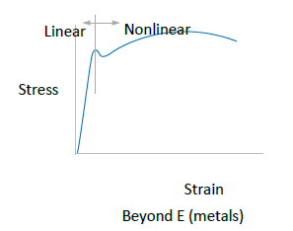

Graph 1. Graph displaying the linear and non-linear components of material behaviour (Gokhale, 2019).

Non-linear analysis typically correlates to critical loading analysis due to its accurate prediction of material properties after succeeding ultimate stress. This FEA is used to discuss significant damage behaviour and knowledge of complex structural behaviour and can be seen in the critical load analysis work submitted by (Mourad Nachtane, 2018). A comprehensive description of other non-linear applications can be found in the work of (Altair REF).
Other analysis types such as fatigue, dynamic, acoustic, thermal and response spectrum also apply to static and fatigue testing also to modal testing. In all cases FE-simulation is used as an extension of the physical test to gain otherwise unavailable insight to phenomena that takes places during cyclic, transient, shear and compressive loads that a blade is subjected to. An officially validated modal can take the place of most of the physical test, especially in the early development stages with regards to modal testing for blade material and geometry selection. NVH analysis capabilities of FEA are typically used in the design process of turbine blades as noise pollution from wind turbine is an old age issue with negative public perception potentially damaging the development of the wind energy industry.

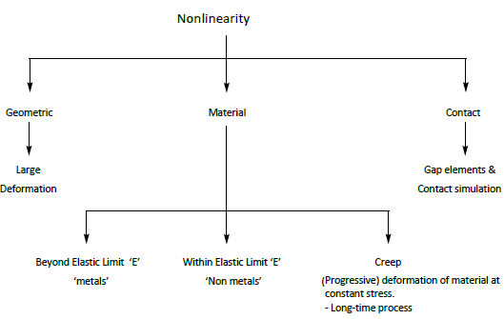

Figure 7. Schematic diagram of various non-linear analysis applications (Gokhale, 2019)

5.Limitations of FE-Simulations.
FE-simulation is not without its limits and is subjected to a range of errors and uncertainties holding it back. The uncertainty in FEA and all numerical simulations can be categorised into numerical uncertainty and physical uncertainty.
Difficulties arise when applying an FE-model to a full-scale test. In the case of a full scale turbine blade test, high tolerances in the manufacturing process creates empty spaces and variation in geometrical details that validated models do not recognise, thus creating errors and uncertainties in the numerical results (F.M. Jensen, 2006). Difficulties also arise in attempting to predict local deformations with globalised 2D shell mesh where inaccuracies leave uncertainty of results. A solid 3D mesh can be used to simulate such local deformation however, little work has been done on the integration of both mesh types so actual test data is required for identifying localised deformations that require a more sophisticated 3D solid mesh (Nitin Tenguria, 2011).
Additionally, physical uncertainties can be found in boundary and initial conditions, geometry details, loads and material properties (Dascotte, 2004). Variables such as temperature, load level and frequency can affect each of these physical properties through changing how the material is affected, making it difficult to realistically simulate this change. The numerical uncertainties can be accumulated by several variables, such as:
- Lack of system understanding, and vague physical process data can lead to conceptual modelling uncertainties.
- The choice of element type, level of geometrical detail and mesh density can lead to discretization uncertainties. Additionally, errors accumulated in the discretization process occur leading to differences in result sets found using the same FE-model (Dascotte, 2004). Tolerances, convergence, integration step and rounding number also lead to solution errors and uncertainties. A paper submitted by the centre for predictive engineering and computing sciences presents a method for estimating the previously discussed errors, it can be found in the work of (Todd A. Oliver, 2014).
- The wrong utilization of the software and input programming errors are examples of human errors leading to numerical simulations.

6. Can FEA Replace Physical Testing?
The aim of this paper was to discuss the FEA process, the correlation this has with physical testing and to determine whether FE-simulation could, or should, completely replace physical testing. It is clear across all literature that numerical modelling, including FEA, has continued to improve to a point today where design, meshing, analysis, and postprocessing comes highly integrated and automated alongside physical testing. It continues to be used across industry as a reliable tool to improve the accuracy, efficiency, cost and analysis of not only turbine blade, but all manufacturing processes.
This world is of finite resources, with exponentially growing population and need for raw materials, the longevity of humankind is at risk and the sustainability of our processes are of great importance. Through the creation of a simulated world capable of realistically representing underlying physical properties, the limitations of a finite world would be no more and new the possibilities of an infinite simulated world would be revealed and serve a great purpose for mankind. However, as perfect as that sounds it is currently more of a science-fiction fantasy than it is a possibility. Numerical simulation has dramatically reduced the need for a range of physical testing apparatus and processes, reducing the use of materials and subsequently reducing cost. Unfortunately, that is all it is limited to with current technological capabilities. Without the validation of numerical models through imperial measurement and physical testing as they are currently based on nominal values for input.
It is clear from the works of scholars and engineers surrounding FEM that it is not yet at a stage where it can completely replace physical testing for turbine blade manufacturing. In some cases physical testing is even required by law where national standards for German certification body requires a full scale static and fatigue testing before being certified for use (Thomas D. Ashwill, 2003). Contradictory to replacing physical testing, some scholars suggest more testing is needed to improve the efficiency and accuracy of FE-modelling through the analysis of test data to determine probability distribution function and their properties (Dascotte, 2004). This work highlights an important point as validating a single simulation from a single test only reveals a small picture if the scatter of the input test data is not considered.

7. Future possibilities
This paper is limited only to the FEA capabilities with regards to turbine blade manufacturing. Further investigation into whether certain niche products have the capability of being physically tested and manufactured completely through simulation. The shear size and health risk of wind turbines make it much more difficult for this to be possible. Additionally, more physical testing is desirable to build up a vast range of physical data to improve the probabilistic nature of numerical modelling by improving the accuracy of inputted data obtained by collecting more physical test results.

8. References.
Aaron Miller, B. C. R. I. G. C., 2013. Review of Computer-Aided Numerical Simulation in Wind Energy. Renewable and Sustainable Energy Reviews, Volume 25, pp. 122-134.
Anon., 2011. Asian J, Volume 4.
Bin Yang, D. S., 2013. Testing, Inspecting and Monitoring Technologies for Wind Turbine Blades: A survey. Rnewable and Sustainable Energy Reviews, Volume 22, pp. 515-526.
BP, 2019. BP Statistical Review of World Energy. 68 ed. s.l.:BP.
Chazly, N. E., 1993. Static and Dynamic Analysis of Wind Turbine Blades Using the Finite Element Method. Renewable Energy, 3(6-7), pp. 705-724.
Composite World, 2008. Wind turbine blades: Big and getting bigger. [Online]
Available at: https://www.compositesworld.com/articles/wind-turbine-blades-big-and-getting-bigger
Dascotte, E., 2004. Linking FEA with Test. Sound And Vibration, pp. 12-16.
Date, A. W., 2005. Introduction to Computational Fluid Dynamics. 1 ed. New York: Cambridge University Press.
Decker, K. D., 2019. How to Mkae wind Power Sustainable Again, s.l.: Low-Tech Magazine.
F.M. Jensen, B. F. J. A. H. S., 2006. Structural testing and numerical simulation of a 34 m compositewind turbine blade. Composite Structures, Volume 76, pp. 52-61.
GE Renewable Energy, 2019. Haliade-X 12 MW offshore. [Online]
Available at: https://www.ge.com/renewableenergy/wind-energy/offshore-wind/haliade-x-offshore-turbine
[Accessed 3 03 2020].
GE Renewable Energy, 2020. Haliade-X 12 MW Offshore Wind Turbine Platform. [Online]
Available at: https://www.ge.com/renewableenergy/wind-energy/offshore-wind/haliade-x-offshore-turbine
[Accessed 23 03 20].
Gokhale, N. S., 2019. Practical Aspects of Finite Element Simulation - A Study Guide. 5th ed. s.l.:Altair Engineering, inc..
M Davies, S. Z. M. A., 2001. Improving The Efficiency of The Numerical Modelling of Built Environment earth-Contact Heat Transfers. Applied Energy, 68(1), pp. 31-42.
Mourad Nachtane, A. E. M. M. T. D. S., 2018. Finite Element Analysis of Composite Wind Turbine Blade Under the Critical Loads. Eleven International Conference on Thermal Engineering: Theory and Applications, pp. 1-3.
Nitin Tenguria, N. M. a. S. A., 2011. Modal Analysis for Blade of Horizontal Axis Wind Turbine. Asian Journal of Scientific Research, Volume 4, pp. 326-334.
Onwubolu, G., 2013. Computer-Aided Engineerin Design with SOLIDWORKS. London: Imperial College Press.
Othman Al-Khudairi, H. H. C. L. G. G. P. G. K. D., 2017. Full-Scale Fatigue Testing of a Wind Turbine Blade in Flapwise Direction and Examining the Effect of Crack Propagation on the Blade Performance. Materials, Volume 10, pp. 1-22.
P.R. Greaves, R. D. G. I. H. L. a. R. C., 2012. Evaluation of dual-axis fatigue testing of large wind turbine blades. In: Proceedings of the institution of mechanical engineers. Journal of Mechanical Engineering Science, Volume 226, pp. 1693-1704.
R. Raišutis, E. J. R. Š., 2008. The review of non-destructive testing techniques suitable for inspection of the wind turbine blades. ULTRAGARSAS (ULTRASOUND), 68(1), pp. 1392-2114.
Rahul, 2018. How to I select the type of elements in FEA. [Online]
Available at: https://www.quora.com/How-do-I-select-the-type-of-elements-in-FEA
[Accessed 26 03 2020].
SimScale, 2016. When should I use a second order mesh?. [Online]
Available at: https://www.simscale.com/forum/t/when-should-i-use-a-second-order-mesh/25899
SIMSCALE, 2020. What is FEA: Finite Element Analysis?. [Online]
Available at: https://www.simscale.com/docs/content/simwiki/fea/whatisfea.html
[Accessed 21 03 2020].
Stein, E., 2014. History of the Finite Element Method – Mathematics Meets Mechanics – Part I: Engineering Developments. 1 ed. Switzerland: Springer, Berlin, Heidelberg.
TARTIBU, L. ,. K. M. ,. V. D. M. A., 2015. MODAL TESTING OF A SIMPLIFIED WIND TURBINE BLADE. International Journal of Advances in Engineering & Technology, pp. 2231-1963.
Thomas D. Ashwill, D. A. G. J. F. M., 2003. Trends in the Design Manufacture and Evaluation of Wind Turbine Blades. Wind Energy, Volume 6, pp. 245-259.
Todd A. Oliver, N. M. R. U. R. D. M., 2014. Estimating Uncertainties in Sattistics Computed from Direct Numerical Simulation. Physics of Fluids, Volume 26, pp. 35101 - 35127.

Appendix A.
Wind turbine blades are the component used to harvest kinetic energy in the prevailing wind and transfer it to the rotor to generate mechanical torque which is later used to generate electricity. The blades function by harvesting the lift-component of the wind through using aerofoil technology. Through using such technology wind velocity is encouraged to accelerate over the top of the aerofoil creating low velocity below the profile and generating lift. The blade is generally tapered from a thick profile near the joint to the rotor to a narrow profile near the blade tip to increase the tip speed ratio and maximise lifting capacity. Typical structural architecture for wind turbine blades. The spar cap is a relatively thick laminate with primarily unidirectional fibres to carry the flapwise bending loads. Blade skins are typically double-bias or triaxial fibreglass, with balsa or foam core used as needed for buckling resistance. Historically, wind turbine blades have been constructed using either all-fibreglass laminate or, in a few cases, fibreglass construction with selective use of carbon for local reinforcement. For blade sizes up to 30 m the most common manufacturing approach has been an open mould with wet lay-up. The most notable exception to that approach is Vestas Wind Systems, which has a long history of using prepreg fibreglass in its blade manufacturing process as described by (Thomas D. Ashwill, 2003).



