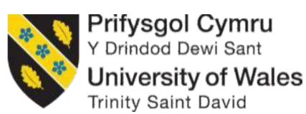

Programme: BA International Hotel Management

Module: Hotel Placement Research Project
Module code: BMIH6008
Assignment Title: Hotel Research Project

Topic: To investigate the guest satisfaction strategy in the hotel industry for ensuring customer service excellence- A case study of Delta Hotel Tudor Park by Marriott.

Student Name: Marius Hurmuzache
Student ID: 2125248
Tutor Name: Ernest Wavei

AI Acknowledgement
I acknowledge that I have not used any AI during the work. I have used several articles, books, journals and websites which are not connected with this type of tool. The entire part was conducted by myself and I used some external sources to understand the topic properly.

Abstract
The quality of service, the amenities in the hotel, experiences, and satisfaction in the hotel industry all reflect on the hotel’s overall performance. The research project has been based on customer satisfaction practices in the hotel sector with special emphasis on the placement hotel, "Delta Hotel Tudor Park by Marriott". An overview of the case study organisation along with the background of the research has been presented here. Aim and objectives have been made for the comprehension of the overall criteria and desires. The report has presented a detailed literature review part which has discussed the three objectives of the work effectively. Multiple articles, books and journals have been used in this section to analyse pre-existing data from these sources. Herzberg’s two-factor model has been applied in this work to evaluate the topic properly. A SWOT analysis has been included in the case study to evaluate the internal environment of the company. With this, a netnography has also been incorporated to investigate the opinions of the customers available online. The project has also provided a detailed overview of the methodology that was used to gather and analyse the information. This has stated the integration of the research onion in the procedure to ensure effective implementation of the plan. Thematic analysis has been done where based on each objective, relevant themes have been chosen. With the use of online resources, the challenges faced by businesses including Delta Hotel have been found out. Solutions of dealing with the challenges and also improving the guest experiences have then been discussed. The guest satisfaction practices of Delta Hotel Tudor Park by Marriott have been examined in this research project. It found that the improved customer experience came about by implementing factors such as personalised customer service, digital engagement, and high-quality amenities among others. Enabling AI-powered chatbots, mobile check-ins and CRM systems have been made to increase service efficiency. Service improvements have been affected by a lack of financial constraints and digital engagement has also required a large investment. Studies in the past have influenced the prioritising of improvements by the hospitality organisation in terms of personalising services, sustainability, and digital transformation. A discussion has also been determined here through analysing the findings of case study and review of literature on the basis of the research objectives.
A conclusion and recommendations section has been included in the project, which summarises the findings of thematic analysis. Various strategies were also suggested that can be incorporated by the hotel to enhance their operations.

Table of Contents
Introduction 8
Background of the research project 8
Aim and objectives 8
Research questions 9
Overview of the case study 9
Rationale of the research 10
Literature review 11
Introduction 11
Key guest satisfaction practices adopted by the hospitality sector to improve its customer experiences 11
Various challenges that hotels experienced during the implementation of customer satisfaction strategies to enhance their guest services 12
Practices that the hospitality sector can incorporate to address the barriers and provide excellent guest services 14
Literature gaps 15
Summary 15
Research Methodology 16
Introduction 16
Research Onion 16
Research Philosophy 17
Research Approach 17
Research Design 17
Research Strategy 17
Research Method 18
Data Collection Tools 18
Data Analysis 18
Time Horizon 19
Ethical considerations 19
Conclusions 19
Case Study Hotel Overview and Findings 20
Overview of the Hotel 20
SWOT analysis 22
PEST Analysis 24
Competitor analysis of Delta Hotel Tudor Park by Marriott 28
Netnography 29
Reflective Account 32
Discussion 34
Thematic Analysis 34
Objective 1: Key guest satisfaction practices adopted by Delta Hotel Tudor Park by Marriott for improving its customer experiences 34
Objective 2: Challenges the hotel has experienced while implementing customer satisfaction strategies 37
Objective 3: Practices that Delta Hotel Tudor Park can incorporate to address the barriers and provide excellent guest services 40
Discussion 44
Conclusion and Recommendation 50
Conclusion 50
Recommendations 51
References 54
Appendix 65
Gantt Chart 65

Introduction

Background of the research project
Guest satisfaction holds notable importance in the hotel industry as a key contributor to customer loyalty, social posting and a pathway for long-lasting business success (Manolitzas et al., 2022). The UK hotel industry will generate £16.60 billion in revenue in 2024 and employs 1.85 million people (statista, 2025). Personalised guest experience and feedback, efficient reception of the booking process and reactions to it, free services, and embedded devices are effective strategies. Despite that, these strategies are not easy to implement into practice due to continuously increasing operational costs, technological integration issues and changes to the expectations of guests (Hill, 2025). This research project will thus endeavour to look into the ways that Delta Hotel Tudor Park by Marriott employs to ensure guest satisfaction to the level of customer service excellence. The study will examine the existing practices of hotels, scrutinise the problems faced during the implementation and suggest possible solutions to the problems faced.

Aim and objectives
Aim
To identify the guest satisfaction strategies in ensuring customer service excellence within Delta Hotel Tudor Park by Marriott.
Objectives
To assess the key guest satisfaction practices adopted by Delta Hotel Tudor Park by Marriott for improving its customer experiences.
To analyse the challenges that the hotel has experienced while implementing customer satisfaction strategies for enhancing its guest services.
To evaluate the practices that Delta Hotel Tudor Park can incorporate to address the barriers and provide excellent guest services.

Research questions
1. What key guest satisfaction practices has Delta Hotel Tudor Park adopted to enhance customer experiences?
2. What challenges has the hotel encountered while implementing customer satisfaction strategies to improve guest services?
3. What practices can Delta Hotel Tudor Park incorporate to overcome barriers and achieve excellence in gusset services?

Overview of the case study
Delta Hotel Tudor Park by Marriott is a famous hotel brand which can be relied upon for the quality of its hospitality. It was built during the 17th century by a member of the Ramsey family who served as an ambassador to France and sought to provide pleasure for London city officials and especially its doctors (marriott, 2025). The hotel provides premium accommodations, dining facilities, and leisure activities for both business and leisure travellers. It is part of the globally recognised Marriott brand and this brand has of very high standard of service excellence, however, “Delta Hotel Tudor Park” is adapting to new changes within the industry (POPȘA, 2021). The case study will explain the strategies of guest satisfaction for the hotel to attain customer service excellence. It will focus on key guest satisfaction practices of the hotel, analyse the challenges of implementing strategy, and review how the hotel can improve services in overcoming these barriers. Featuring rich fibre, free Wi-Fi, air conditioning, a TV and free newspapers, the hotel offers 120 premium rooms (marriott, 2025).

Rationale of the research
Guest satisfaction is of prime importance in the hotel business, as it reflects on customers' loyalty, reputation, and revenue. In 2022, the sector brought in £5.86 billion of business investment, £20 billion of exports and in tax receipts £54 billion (parliament.uk, 2023). Customers who are receiving personalised service, having good quality amenities and are generally satisfied with their stay, tend to pay higher prices for their stays. However, there is a big research gap regarding specific problems and the means of handling them faced by hotels implementing guest satisfaction strategies (Cruz et al., 2024). In order to fill the gap, this research will focus on Delta Hotel Tudor Park's case study in addressing customer satisfaction issues encountered during implementation and other possible solutions to improve service excellence (Cottrell, 2014).

Literature review

Introduction
A literature review is a useful practice of investigation which analyses pre-existing data on a particular topic through the usage of various journals and articles. Google Scholar also plays a significant role in this sector as it provides multiple genuine articles by authors. Three objectives of this work will be evaluated properly in this section to generate a proper outcome for the topic. Hence, these factors are created based on the aim of this study which focuses on guest satisfaction strategies in the hospitality sector. A literature gap will be presented in this part which will indicate its limitations properly.

Key guest satisfaction practices adopted by the hospitality sector to improve its customer experiences
Collins (2023) has described that guest satisfaction is an important factor for the hospitality sector. This industry also rapidly adopts innovative strategies to enhance this factor and improve customer experiences significantly in the market. There are various methods which are utilised by firms the most.
Personalised services
As per Campione (2021), personalised service offerings have a significant role in guest satisfaction in this sector. Various hotels also use AI-driven data analytics to tailor experiences and it offers customised room preferences to users in the market. Positive brand image can also be achieved with this factor. Hence, for this reason, this approach is utilised by a maximum number of organisations.
Digital integration
Buhalis and Moldavska (2022) depicted that technology is an effective factor which can enhance the convenience and efficiency of the hospitality industry properly. The current generations are also very passionate about advanced tools and equipment which has driven its demand for technology integration in various industries. Many hotels implement mobile check-ins, keyless entry and AI chatbots for instant customer support. Thus, the utilisation of robotics and automation also plays a significant role in this sector.
Sustainability initiatives
The current market has a huge demand for eco-preservation and sustainability which forces companies to implement various initiatives regarding this aspect in the workplace. Joseph Marcello and Theresa Rogovin (2024) evaluated that hotels use various activities such as energy-efficient lighting, reduced plastic use and sustainable sourcing to increase overall guest satisfaction in the workplace. Green certification and goals for some sustainability efforts are also some major key elements which are utilised by this industry to substantiate its plan properly.
Loyalty programme
According to Moenga and Rotich (2023), loyalty programmes are some vital strategies in this aspect and a huge number of companies use this factor in their workplaces. Various initiatives such as free upgradation of membership, lounge access and discounts emphasise this factor significantly.

Various challenges that hotels experienced during the implementation of customer satisfaction strategies to enhance their guest services
Cordero et al. (2022) explained that the hospitality industry constantly seeks to enhance guest experiences, however, these strategies come with various risks. These factors negatively affect hotels which is a major issue for this industry. Operational cost, technological factors and staff shortage are some major approaches in this practice.
High operational costs
As per Thomas (2024), guest satisfaction strategies need various types of training and technology upgrades. These areas require a huge investment which can create a financial crisis in companies. Personalised service is also a significant part of this strategy which needs various expenses. Hence, this factor prevents firms from establishing their strategies in the workplace.
Technological adaptation issue
Marques and Marques (2023) analysed that the hospitality sector highly struggles with the complex nature of technology. Various equipment also comes with various modules and regulations which create difficulties for hotels. Additionally, this practice has high initial costs and for this factor, small businesses can face a lack the budget in this sector.
Labour shortage
As per Scott (2024), the global market has seen a huge labour shortage after the COVID-19 pandemic which affects all industries significantly. The hospitality sector also struggles with this factor the most which prevents it from adapting various strategies for guest experience. Women are playing a crucial role in mitigating this issue in several markets, however, they need various trainings to handle the entire factors properly. Hence, this practice is a vital challenge for the hotel businesses.
Maintenance of consistency across locations
Torres (2024) evaluated that the maintenance of consistency in various locations creates many difficulties. Every region has different regulations and laws which affect hotels the most during the implementation of guest satisfaction strategies in the workplace.

Practices that the hospitality sector can incorporate to address the barriers and provide excellent guest services
Opined by Segovia-Pérez et al. (2021), the hospitality sector faces multiple challenges during its offering of exceptional guest services, however, the adaptation of strategic practices can help firms address these barriers. Galanakis and Peramatzis (2022) express that Herzberg’s Two-Factor Theory is an effective framework which can evaluate this factor easily. There are two main elements in this model which are motivators and hygiene factors.
Investment in employee training and retention
Carlbäck et al. (2024) pointed out that proper employee training plays a useful role in the workplace to mitigate various issues properly. As per the above-mentioned theory, this approach is both a hygiene and motivator factor which can allow hotels to engage their experienced staff effectively. Hence, the hospitality sector must utilise it to solve its challenges and offer an extreme service to customers.
Adaptation of smart technology
According to Pergelova et al. (2024), hotels should strongly focus on smart technology which is a vital hygiene factor and can allow this industry to offer an exclusive service to users. Various digital solutions such as AI chatbots, mobile check-ins and contactless payments are some major elements in this area. Hence, with this factor, companies will boost their operational efficiency properly.
Maintenance of country regulations
Poullas and Kakoulli, (2023) also indicate the importance of various regulations in the hospitality sector. Hotels can also use this strategy to avoid various political issues and offer better services to users. Additionally, with this factor, they may get various types of funds from the government which are useful for companies.

Literature gaps
This section has mentioned the topic in detail with the utilisation of multiple pre-existing data. However, there are many limitations in this part which may differ the outcome of the study significantly. Collins (2023) has mentioned various strategies such as service personalisation and digitalisation which are used by hotels to offer better guest service. However, the integration process of these practices is not mentioned in this observation which creates a major gap. Several challenges during the integration of these techniques in organisations have been identified by Cordero et al. (2022). Thus, the lack of the reasons behind the rising of these elements is also a limitation of the section.

Summary
The literature review part has analysed the main topic of the study properly with the utilisation of multiple articles, books and journals. Google Scholar has been selected in this section to get access to various genuine articles. Three objectives of the study have been evaluated so individuals can gather knowledge from it easily. Herzberg’s two-factor theory has also been applied in this work to conduct the practice properly. Hence, this analysis has generated a proper outcome with the topic. A literature gap has been presented in this work to examine the limitations of this aspect.

Research Methodology

Introduction
This is a constructive strategy that is utilised for gathering, and the interpretation of data to foster work questions or solve issues. It involves different techniques such as surveys, experiments, and observations that assist individuals in collecting appropriate insights. This draws significant conclusions and also makes clarified decisions in the work.

Research Onion
This provides a significant structure that instructs individuals to perform work through different stages such as philosophy, approach, and more. It assures a significant decision-making procedure that adheres to the individual stages (Saunders et al., 2012).

Figure: Research Onion
Source: (BBC, 2025)

Research Philosophy
Research philosophy states the underpinning beliefs about knowledge and practicality of the inspection. It also depicts procedure through which the work should be performed and comprehended (Mbanso et al., 2023). Here, the interpretivism method has been utilised as it assists individuals in comprehending complicated problems through generalised experiences that encompass various perspectives during qualitative research.

Research Approach
This is the critical plan or process for performing a complete work, and it also instructs effective data gathering with assessment (Bergmann, 2023). The inductive method has been utilised in this work as it permits researchers to improve theories from various observations. There is also fostering of new information and the procedure is highly significant for assessing a complicated method. It also promotes scalable direct enquiry to create explained comprehension (Mulisa, 2022).

Research Design
This is the complete plan that structures the procedure to gather, assess, and interpret data systematically. Exploratory design has been used here as it assists the investigator in inspecting new or non-clarified topics and also creates significant insights. This promotes scalability and also permits researchers to foster questions by creating fundamental comprehension (Collis and Hussey, 2014).

Research Strategy
This is a constructive approach that instructs the procedure through which work objectives are attained effectively (Veal, 2006). Here, a case study has been used as it offers a clarified comprehension of actual-time contexts. It assists in exploring complicated incidents, encompasses detailed information, and also regulates data.

Research Method
Research method refers to the various techniques that are utilised to evaluate, assess, and interpret data constructively. There has been usage of the mono method in this work as it assures prioritisation and simplicity. Utilisation of an individual data-gathering process assists individuals to sustain consistency. This makes assessment of information more straightforward and the outcomes which are convenient to execute (Flick, 2022).

Data Collection Tools
Data gathering is the procedure for the acquisition of insights from different sources which also addresses work questions significantly. Secondary data collection tools have been used here as it consumes less time and resources. This also offers admittance to present or appropriate insights and also assists individuals with varying findings. It has been performed through the usage of various industry reports, journals, and company papers (Bergmann, 2023).

Data Analysis
This is the method of arranging with effective interpretation of data to receive significant conclusions. A qualitative data analysis procedure has been used here as it encompasses rich, explained insights into human experiences. It also assists investigators in seeking out complex incidents, recognising trends, and comprehending the explained significance behind interactions (Bergmann, 2023).

Time Horizon
This states the effective time schedule that helps researchers to perform and potentially complete a work (Castro et al., 2025). The cross-sectional method has been utilised here as it encompasses data at an individual point and also offers a detailed picture of patterns.

Ethical considerations
This is a highly vital factor for securing individual rights which also assures integrity with effective maintenance of work credibility and trust. Here, the Data Protection Act of 2018 has been implemented for accomplishment of the inspection. It also assures an explained approval with confidentiality that represents honesty throughout the work (Castro et al., 2025).

Conclusions
The above-mentioned portion has been highly significant as it describes various stages of the work. This offers a constructive framework for performing the inspection which also assures precision. It also instructs individuals in selecting suitable procedures that provide appropriate outcomes.

Case Study Hotel Overview and Findings

Overview of the Hotel
Hotel Description
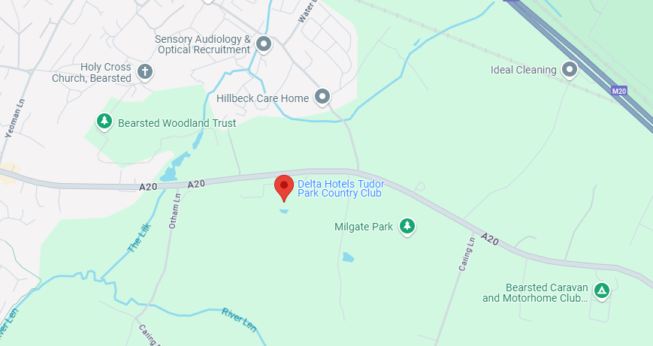
Figure: Location of Delta Hotel Tudor Park by Marriott
Source: (Google Maps, 2025)
Situated in the heart of Kent, Delta Hotels by Marriott Tudor Park is a fine four-star establishment. This hotel is about 30 miles southeast of London and is situated within the tranquil English countryside. It also has a rejuvenating spa, indoor swimming pool, 18-hole PGA championship golf course, and versatile event spaces good for business and social meetings (Delta Hotels, 2025). Located within the hotel are the Cast Iron Grill, with local British dishes, and the Zest Bar, where guests can enjoy watching and betting on major sporting events.
Brand Information
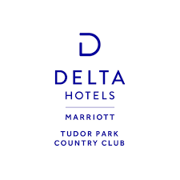
Figure: Logo of Delta Hotel Tudor Park by Marriott
Source: (Delta Hotels, 2024)
Marriott International has a premium hotel brand, Delta Hotels by Marriott, which focuses on delivering a seamless and streamlined experience for travellers. Delta Hotels’ origins trace back to Canada in 1962 (Carlino, 2022). Marriott International acquired the chain in 2015 and integrated it into its assortment of hospitality brands (Gruber, 2023). In 2020, Delta Hotels maintained over 90 locations with a total of approximately 28,400 rooms. The firm has effectively generated revenue worth £2.25 billion per year through offering effective hospitality services to its potential clients (growjo, 2024).
Location and Cultural Context
The Delta Hotel Tudor Park by Marriott is situated in the village of Bearsted just outside of Maidstone, Kent. It is an area also known as the “Garden of England” for various reasons, as it is blessed with beautiful landscapes, and historical sites and is home to charming villages. Adjacent to nearby attractions such as Leeds Castle, recognised as the “loveliest castle in the world” and the “medieval town of Maidstone”, this features shopping and dining, as well as theatres, museums, and galleries, those guests can explore the surroundings (Crowhurst, 2023). For those people who are looking to relax and get a good night’s sleep in a central location, the hotel’s location close to London makes it an excellent base.
Facilities and Services
The Delta Hotel Tudor Park by Marriott, besides boasting a professional golf course and spa facilities, provides comfortable rooms with modern amenities such as flat-screen TVs and complimentary Wi-Fi. The hotel offers loads of event spaces as well as a team dedicated to events to make sure they run smoothly for weddings, conferences, and many more (Delta Hotels, 2024). The fully equipped gym within the hotel is also useful for fitness enthusiasts and nature enthusiasts who can walk the surroundings for the purpose of witnessing Kent's natural beauty.

SWOT analysis
A SWOT (strengths, weaknesses, opportunities and threats) analysis is a strategic framework that helps a business firm to evaluate its internal environment (Puyt et al., 2023). In this section, this module will be implemented to evaluate the practices of Delta Hotel Tudor Park by Marriott.
strengths | Weaknesses
Brand reputation  The hotel is operational in the country for a very long time, which has helped them to build a legacy. This has also provided them with a strong brand image which is beneficial for them to ensure growth of the company. Many individuals book their service with the hotel for the brand reputation, which is an advantage in ensuring stable sales.  Location  Delta Hotel Tudor Park by Marriott is available in prime locations across the UK, which increases the reachability of the company. This is beneficial for the firm to attract a major section of the tourists who are visiting the country (Maté-Sánchez-Val and Teruel-Gutierrez, 2022). The prime location is also beneficial for the firm to operate efficiently, which is directly connected with their performance. | Operational costs  The firm is operational in the travel sector, where the industry demands high operational costs to maintain consistency. This is a drawback for the company as their investment is high, which limits their actions. In the hotel business, infrastructure plays a vital role, which demands a company to have monetary funds.  Differentiation  The service provided by the hotel industry does not have much factor of differentiation, which decreases the uniqueness of the company (Schwartz and Webb, 2022). Delta Hotel Tudor Park by Marriott facesa challenge in scaling their business as companies providing similar offerings exist in the market.
Opportunities | Threats
Growth of sustainable tourism  The rise of global warming is also demanding organisations to integrate sustainable practices in their operations. These open up an opportunity for the hotel companies to provide options for sustainable tourism (Miller and Torres-Delgado, 2023). This can be a separate segment for the company to attract the consumers towards the offered services. The consumers who are aware of the environmental problems will choose the firm for its ethical approach.  High sales and revenue  The advantages of prime location and brand reputation will be beneficial for the company to ensure high sales and revenue (Parris and Guzmán, 2023). This will be beneficial for the organisation to sustain its consumer base, which is directly connected with the number of bookings. Therefore, the organisation has an evident opportunity for high sales and revenue considering its strengths. | Economic uncertainty  The hospitality industry is highly dependent on the seasonality factor as tourism is directly connected with the external environment. This suggests a problem of economic uncertainty for the company as it is not necessary that they will have equal sales in every season. However, the firm has to maintain its infrastructure and operations to sustain in the market.  High competition  A lack of differentiation is directly connected with the level of competition a company would face in the market (Rossidis et al., 2021). This is another threat that Delta Hotel Tudor Park by Marriott can encounter due to the availability of similar products. The disadavatage will demand the organisation to put in extra effort to have stable operations which will create a pressure on the management.

PEST Analysis
Evaluating the Political, Economic, Social, and Technology fundamentals is highly vital for comprehending the operational culture of Delta Hotel Tudor Park by Marriott in the UK market. These elements impact strategic decisions with the organisation’s capability to improve.
Political factors
The hospitality industry of the UK has encountered potential issues due to contemporary administrative regulations. During the month of October, there was an announcement of 25 billion British Pounds leverage in employers’ national insurance functions by the Chancellor. (Michael, 2025). This affects worker costs in various industries, and the norm has resulted in a prolonged time of work reductions. It also affects service businesses by minimising the number of employees for five gradual months, which is the longest from 2011. Moreover, the initiation of higher national functions and a hike in the living wage have increased operational prices for accommodation. This type of action is expected to leverage expenditures by 3.4 billion British Pounds yearly in the hospitality sector. (Statista, 2025).
Economic factors
Economy of the UK has encountered potential fluctuations that impact the hospitality market. During the month of February, the S&P Global Purchasing Manager’s Index for services increased to 51.0 from 50.8, which was in January. (Michael, 2025). This shows a significant marginal development, although the employment index decreased to 43.9, which is the lowest from November 2020. It demonstrates that increased work cuts and the leveraging of input costs with restrained business anticipations have functioned to these net employment losses. Additionally, the hospitality sector is facing shortages of workers, especially in the UK. It is caused due to the changes in the pre-Brexit immigration rules. It is highly challenging to hire international employees which results in operational concerns with decreased hours.
Social factors
The hospitality industry is a potential work provider in the UK that offers work to nearly 2.5 million individuals (Statista, 2025). This is responsible for approximately 7.1% of the total employment rate of the UK. The market follows an increased proportion of younger employees, staff from temporary and minority backgrounds. It is highly competitive with other industries, however, worker shortages remain a significant problem with vacancies in 2024 (Statista, 2025). Moreover, the industry has been advocating administrative endorsement to decrease financial pressures. Leveraged employment prices and significant extra taxes could create difficulties in financing work development. Delta Hotel Tudor Park by Marriott runs its business operations within a complicated landscape constructed by political decisions, and social progressiveness.
Technological factors
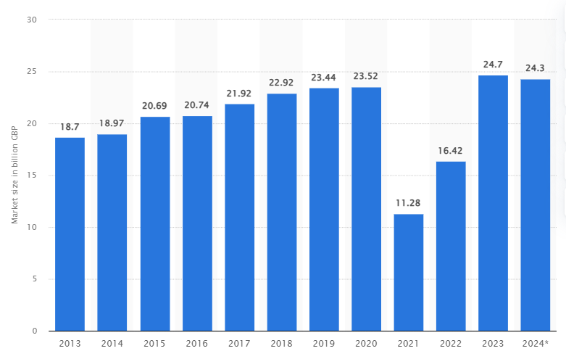
Figure: Market size of UK hotel industry
Source: (Statista, 2024)
The operations of Delta Hotel Tudor Park by Marriott are greatly influenced by the advanced technological landscape in the United Kingdom. High-speed internet is widely available to make online booking easier and to improve guest services that directly affect customer satisfaction. Technological integrations continue to be essential to the competitive environment of the UK hospitality industry which maintains a £24.3 billion market size in 2024 (Statista, 2024). Artificial intelligence (AI) and automation are the new ways of the hospitality sector. Chatbots and virtual concierge are AI-powered tools to simplify operations and provide a personalised experience for the guests. Firms can use data analytics to do personalisation of guest experience and also the best way to price (Lindecrantz, 2022). Nowadays, technology is integrated into the hospitality sector as much as in the booking apps to use them like the technological appearance of smart room controls making such a guest experience more convenient, personalised and efficient.

Competitor analysis of Delta Hotel Tudor Park by Marriott
Porter’s five forces
Porter’s five forces is a useful model which can evaluate the power of competitors and other stakeholders properly. This theory has five elements which are the threat of new entrants, industry rivalry, the threat of substitutes, the bargaining power of buyers and the bargaining power of suppliers (Asana, 2025).
The threat of new entrants
The hotel industry requires substantial capital investment and integration with strict regulations which creates significant entry barriers. Hence with this factor, the threat of these new entrants becomes moderate. However, established brands such as Marriott have been expanding their market presence rapidly which prevents them from taking entry into the market. For example, between October 2022 and summer 2023, Marriott rebranded 23 UK regional properties under the Delta brand (Caswell, 2022).
Bargaining power of suppliers
This factor is low for the hotel as this industry has access to numerous suppliers for essentials such as linens, food and beverages. Additionally, Delta Hotel operates its business in high margin which has increased its bargaining power with this stakeholder.
Bargaining power of buyers
Delta Hotel Tudor Park by Marriott faces a high power from buyers which is a vital problem for it. Guests have a wide range of accommodation options where they can choose any section from luxury hotels to budget-friendly establishments. This factor has reduced the power of the company among these stakeholders.
Threat of substitutes
Alternative lodging options such as Airbnb and serviced apartments present substitutes for traditional hotel stays. Additionally, the demand for luxury and mid-market hotel stays has impacted the budget chains significantly. This factor makes the power of substitutes moderate in the market.
Industry rivalry
Industry rivalry is very high for Delta Hotel Tudor Park by Marriott. The current UK hotel industry has numerous players such as Travelodge which have intensified the competition in the market. The company can also suffer from this issue in society significantly (Travelodge, 2025).

Netnography
Netnography is a method of research where online sources are utilised to evaluate the perception of customers and investigate business activities (Kozinets and Gretzel, 2024). This evaluation technique will be implemented in this section to understand the opinions of the guests of Delta Hotel Tudor Park by Marriott.
Evaluation of guest feedback
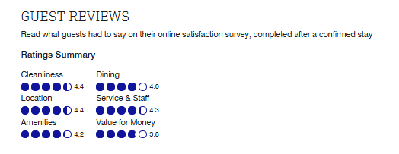
Figure: Summary of the customer feedback
Source: (Marriott, 2025)
The above picture is a summary of the guest feedback given on the official website of Marriott. This has been presented in the form of ratings where the highest is five and the lowest is 1. Here, it is evident that most of the customers are satisfied with the operations of the company as none of the points has less than three ratings. Delta Hotel Tudor Park by Marriott has been rated 4.4 for its cleanliness and 4.2 for its offered amenities. With this, it is clear that the hotel provides high-quality services to its consumers, which is a positive sign for the long-term growth. Staff service has been rated as 4,3, which indicates satisfaction of the consumers. The lowest rated factor here is value for money which is 3.8.
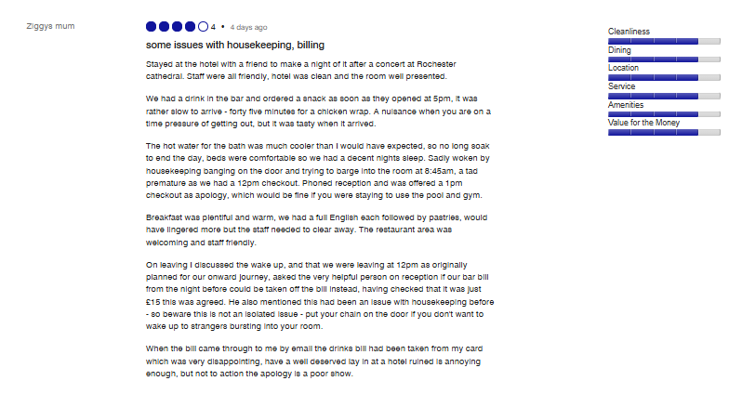
Figure: Customer review
Source: (Marriott, 2025)
The above picture highlights the review of a consumer who has stayed in the hotel previously. In this feedback, the guest has rated the overall service of the company with 4, which is a positive rating for the firm. However, the customer has a few complaints with the housekeeping staff as the service took more time than expected. Here the consumer mentions that the efficiency of the employees was not according to their expectations, which has led to evident problems with the services. However, the rooms were of high standard and the food was also tasty due to which their overall experience was positive.

Reflective Account
Reflection through the usage of Gibb’s Reflective Cycle has been described in various stages.
Description
Working on Delta Hotel Tudor Park’s client satisfaction approach provides me with significant insight into the hospitality market. I seek different hotels’ procedures for optimising consumer experiences with issues encountered during the application of strategy and significant enhancements. I also gained knowledge about the procedure Marriott’s brand standards impact client responses from individualised services to management of issues.
Feelings
During the introductory stage of work, I felt excited to learn about the process a famous brand effectively sustains excellent service standards. Although I was submerged by the complexities of stabilising client anticipations with operational constraints, particularly during the time of the increased requirements period. There is an increased appreciation for the hotel’s initiatives, however, there is still a problem with the changing worker shortages and leveraging prices.
Evaluation
The work encompasses various strengths such as proactive review gathering and employee training. It optimises client satisfaction, although, I recognised some limitations such as constraints in sustaining service consistency during high times. Comprehending these restrictions has assisted me in appreciating the initiative necessitated to transmit particular services during external pressures (Bassot, 2024).
Analysis
This procedure has helped to clarify my knowledge about standard service excellence. I realised that constant enhancement and significant adaptability are primary to retaining client satisfaction. Again, increasing technology or rapid check-ins with the implementation of employee welfare programs can reduce the strain and also optimise service quality.
Conclusion
I gained knowledge about the fact that client experience in the hospitality sector is a progressive method that necessitates critical management. Hence, effective stabilisation of this is necessary to stabilise client anticipations with real-time competencies. This is highly vital for retaining the extended-term effectiveness of the business.
Action plan
There is a suggestion for more frequent staff review programs by me, which can effectively help to comprehend front-end issues. I would also seek different client loyalty campaigns that provide individualised perks and also cater to extended-term connections.

Discussion

Thematic Analysis

Objective 1: Key guest satisfaction practices adopted by Delta Hotel Tudor Park by Marriott for improving its customer experiences
Theme 1: Personalised customer service and digital customer engagement.
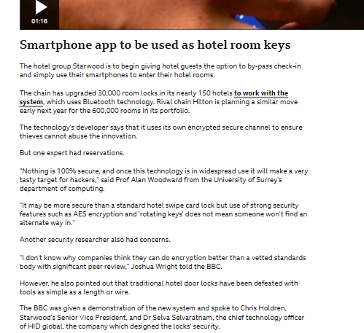
Figure: Personalisation for digital customer engagement strategy
Source: (BBC, 2024)
There is an important role played by personalised customer service as well as digital engagement in improving the satisfaction of guests in the hospitality field. Digital tools are used in modern hotels to offer a customised experience to the customers, streamline the operations and meet the changing consumer expectations. Around 72% of consumers prefer interactions with brands that are personalised based on their preferences (McKinsey, 2021). Some means of personalization in hotels include tailored room settings, customised meal recommendations, as well as exclusive loyalty program benefits. Artificial Intelligence (AI) and data analytics help hotels understand their past behaviours as they can predict these needs from the customer's side. Real-time customer service is provided by AI-powered chatbots, mobile check-ins shorten waiting time, and CRM systems help hotels with targeted promotions and discounts (BBC, 2024). In Delta Hotel Tudor Park by Marriott, several digital engagement strategies are used which enhance customer experience. Mobile check-in and keyless entry mitigates the necessity for interaction with the front desk. Routine inquiries such as room service, restaurant reservations and local travel recommendations are as a matter of course taken care of by AI chatbots and virtual assistants. Under the Marriott Bonvoy loyalty program, the hotel uses a customer relationship management (CRM) system to gather guest data to give guests room upgrades, preferred dining, and customized wellness experiences (Marriott Bonvoy, 2025). This shows the effectiveness of loyalty-driven engagement in the hospitality industry as Marriott Bonvoy has over 196 million members worldwide (Statista, 2024). Additionally, Delta Hotel Tudor Park also provides smart room technologies such as automatic lighting, temperature controlling and voice-activated assistants for the guests to personalise their stay.
Theme 2: Quality of amenities and hospitality standards
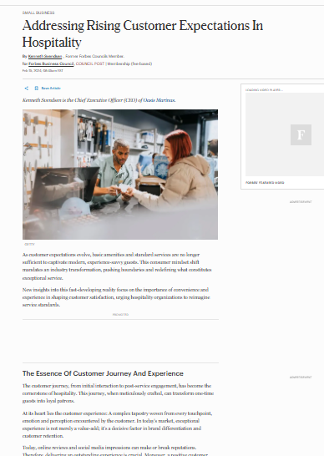
Figure: Rising customer expectation through better amenities
Source: (Svendsen, 2024)
Amenities and high hospitality standards affect guest satisfaction to a large extent, as these things affect the overall quality of amenities. It has been recorded that around 86% of hotel guests take cleanliness, comfort and the availability of premium facilities as the primary factors that play a role in the giving of the overall experience (Svendsen, 2024). Top hotels that provide high-end services have well-maintained accommodations with wellness facilities and top-class dining to ensure that the comfort of the guests is at par. Thus, approximately 76% of travellers would put hotels that have high cleanliness ratings and a green approach as their top priority (Bennett, 2023). With modern hotels' expectations of what eco-friendly should entail, including energy-efficient lighting, use of biodegradable toiletries, and water conservation measures, they are actually investing in eco-friendly initiatives. Also, luxury properties provide superior services such as spa treatments, fitness centres and gourmet dining to make memories. Premium amenities are provided by such a standard high hotel as is maintained by Delta Hotel Tudor Park by Marriott. Additional wellness includes massages, facials and hydrotherapy from the on-site spa. For health-conscious guests, the hotel has a fully equipped fitness centre and indoor swimming pool. These facilities add comfort and satisfaction to the guest experience. Other dining experiences at the hotel help boost guests’ satisfaction at the hotel. Marriott’s Global Cleanliness Standards are followed by the hotel; it has rigorous hygiene protocols, and contactless service options, and employs frequent sanitization of public space (Marriott International, 2020). Delta Hotel Tudor Park also prides itself as a sustainable hotel. Marriott's 360 initiative includes cutting carbon emissions, reducing plastic waste and helping to support the community of which they are affiliated.

Objective 2: Challenges the hotel has experienced while implementing customer satisfaction strategies
Theme 3: Challenges Related to Guest Satisfaction Strategy Implementation
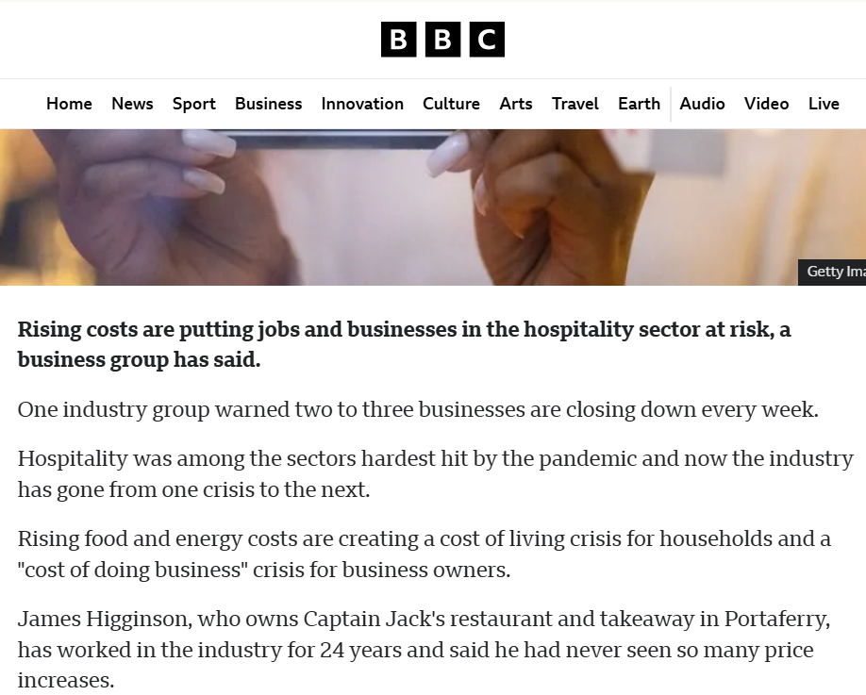
Figure: Impact of Rising Living Costs in Hospitality Sector
Source: (Rice, 2022)
The implementation of guest satisfaction strategies in the hospitality industry is a problem which lacks to some degree. The cost of living crisis is one of the great difficulties with the cost of doing business that has become a great challenge for hotel operators. With rising food and energy costs, businesses are finding rising prices hard to stop and keep up high service standards. As an outcome, managing costs in hotels is a difficult situation where they do not have control over any costs (Rice, 2022). The rise of the national living wage and much-reduced rates of VAT have also hit budgets harder, making it difficult without cutting standards to remain competitive on price. Another significant challenge is to overcome the operational constraints, in particular with respect to staffing and resource management. After the pandemic, many businesses including Delta Hotel are struggling to find labour to provide seamless guest services (Walker, 2022). It was reported by hotels that their ability to recruit and retain skilled workers has been hampered, hence placing a greater burden on existing staff. As a result, service times can be slower, personalisation decreases and overall guest satisfaction decreases. Additionally, the repayment of loans in the time of the pandemic has generated more financial pressure, stopping it from investing in staff training and service improvements. Efficiency of guest satisfaction strategies is negatively affected by technological and digital integration challenges (mckinsey, 2022). Despite the increasingly digital world, implementation of these modern solutions can be complex, costly and time-consuming.
Theme 4: Impact of the poor guest satisfaction strategy employment on customer services
Improper implementation of tactics for guest satisfaction in hotels such as Delta Hotel Tudor Park can erode customer service and result in bad experiences for guests along the reputation of the hotel will be hampered (Gautier, 2022). The poor service strategies may result in slow response time, inconsistency of service quality and not addressing guests' concerns which might lead to marginalisation of customer trust and loyalty. Frontline staff may struggle to fulfil guests' expectations when the strategies used to enhance guest satisfaction are not well executed and may result in additional complaints and dissatisfaction. This can be especially detrimental when operations in the hospitality industry are not effective. Inadequate investment in the training and development of staff, can also seriously affect the standards of customer service (deloitte, 2025). It results in employee as well as guest frustration if they are not properly equipped with the ways to resolve the guest's issues or how to make sure the guest's experience is seamless. Understaffing due to budget constraints results in overworked employees which in turn does not encourage them being able to furnish quality service and a personalised interaction with the customers. There are also technological challenges in the poor employment of guest satisfaction strategies. Guests can be inconvenienced negatively, if digital booking systems, self-check-in kiosks or customer feedback channels are not integrated or properly maintained (Dempsey, 2023). Thus, poor strategy implementation at Delta Hotel Tudor Park will have a negative impact on guest retention, online reviews, and overall, business sustainability in the increasingly competitive hospitality market.

Objective 3: Practices that Delta Hotel Tudor Park can incorporate to address the barriers and provide excellent guest services
Theme 5: Strategies to overcome the barriers that occur during guest satisfaction strategy adaptation

Source: Delta Hotel’s Championship Course for Nature Preservation
Source: (marriott, 2025)
A versatile approach is vital to overcome the barriers involved in guest satisfaction strategy adaptation at “Delta Hotel Tudor Park”. Effective cost management is one key strategy and is an effective optimisation of operation costs, without threatening service quality (bbc, 2025). The hotel can do this by negotiating better supplier contracts, implementing energy-efficient solutions to reduce utility costs, and adjusting pricing models to balance affordability and profitability. Furthermore, investments in sustainable practices can also reduce future costs and attract guests who are environmentally friendly. Another important strategy for Delta Hotel is to improve staff training and development. Comprehensive training programs give employees the capacity to operate guest inquiries, deal with complaints appropriately and offer personalised services (Straus, 2024). Also, to prevent the impact of labour shortages and keep the service appropriate, the retention of competent staff through competitive salaries, internal career path opportunities and employee engagement programs must be achieved. With some technology, the hotel can even further improve the guest experience through streamlining operations. Reducing waiting times and improving efficiency can be achieved by implementing factors such as a user-friendly digital booking system, self-check-in option and AI-driven customer support. Proactive guest feedback management also allows the hotel to constantly refine its service strategies. Delta Hotel has implemented a "par-70 championship programme" to save the natural features of a deer park that satisfies the sustainability demand of guests (marriott, 2025).
Theme 6: Ways to provide excellent guest services
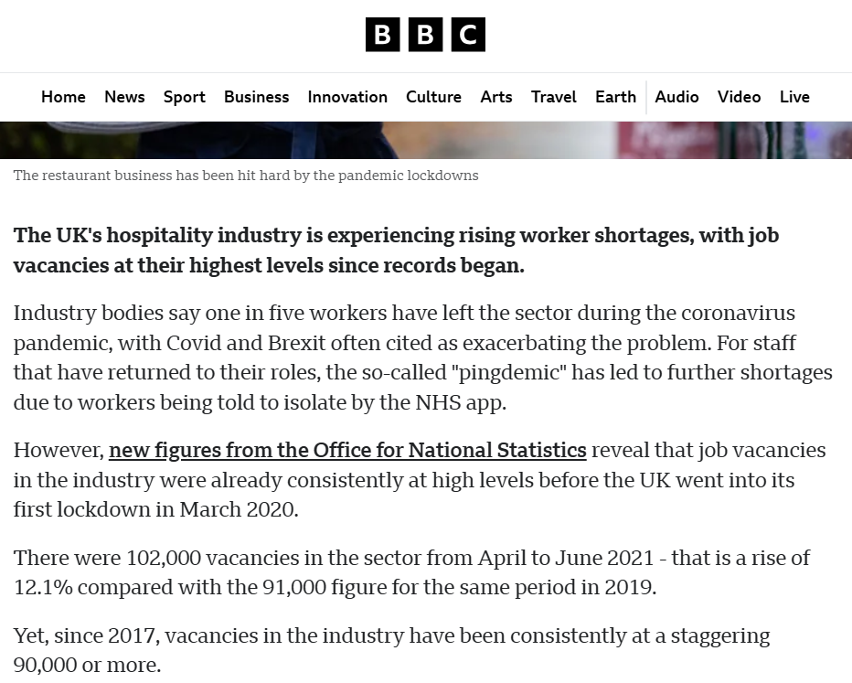
Figure: Reducing Staff Shortage Issues in Hotels
Source: (Race, 2021)
Personal experience and operation, as well as a solid culture and customer focus all are necessary for the improvement of guest services within Delta Hotel. This can be achieved in one of the most effective ways by ensuring seamless and personalised guest interactions. The staff should be trained to anticipate the guest's needs, make personalised recommendations and create a warm and welcoming environment for the guests. Fair working times and proper payment are indispensable for staff retention and high performance (Race, 2021). Guest preferences with respect to, for example, room choices or dining habits, can be memorised to improve the guest stay and increase long-term loyalty. Another key factor is operational efficiency in order to provide outstanding service. This key communication consists of check-in and check-out processes that are ensured to be smooth. Digital systems have built space for convenience, thus, the use of mobile check-ins combined with process automation through AI-powered chatbots can optimise convenience. For customer service excellence, policy solving and conflict resolution, training programs should be carried out continuously (Ramirez, 2023). Recognition programs and career development programs can also be used to create a motivated workforce which can drive up service delivery. Guest feedback management is about being proactive to continuously improve service quality. Gaining reviews, responding quickly to complaints, and actually making the required changes according to the feedback all point to a desire to satisfy customers (Mayfield, 2023). Delta Hotel Tudor Park can create a culture that encourages attentiveness, efficiency and innovation.

Discussion
Addressing the research topic
Within the context of the UK hospitality sector, the research has investigated the operational challenge and opportunity of Delta Hotel Tudor Park by Marriott in the aspect of guest satisfaction. This fits with existing literature that brands need to draw upon the brand reputation, location and technological developments to keep a competitive edge in the market. In the case study, Delta Hotel Tudor Park has been indicated as having the advantage of being in the market for a long, in that, its existence has consistently attracted customers conversely as a result of its legacy and brand image. Consequently, as noted by Campione (2021) location is important in determining whether a hospitality business would be successful. This is confirmed by the case study, as the prime locations of the hotel increase accessibility and increase the attractiveness of the hotel to arriving visitors. Furthermore, differentiation is a problem as the hotel cannot differentiate itself from the rest as it is highly competitive and labour shortage. The research also highlights opportunities such as sustainable tourism. Technological growth potential is also growing in the same way. According to Pergelova et al. (2024), the combination of AI featuring chatbots and smart room controls helps in digital transformation and improves the guest experience, as well as operational efficiency. Based on the case study, technological integration can help to improve customer satisfaction while diminishing hotel operations. While it offers such opportunities, external threats, including economic uncertainty and labour shortages, are very strong. Economic instability has been proven to have an impact on the financial performance of the hospitality business by Thomas (2024). Achieving the research objectives
The findings of the research are presented and are useful in providing insights into guest satisfaction practices in Delta Hotel Tudor Park by Marriott. The literature also emphasises the importance of personal services, high-quality amenities, and digital experiences for improving customer experiences. The research findings may be crucial to realise that Delta Hotel Tudor Park approached individual visitor support and that electronic interruption adds up to visitor contentment. AI-powered chatbots, mobile check-in, and keyless entry eliminate customer waiting time and make customer interactions much easier. Buhalis and Moldavska (2022) suggest that digital transformation in the hospitality industry has been very important in improving how service delivery and personalisation is done. The study has also confirmed that the hotel makes use of CRM systems to collect customer data and use it to provide room settings, dining preferences and loyalty program benefits according to each of its customers. This supports the importance of hospitality in the case of personalised services. Campione (2021) also relates those customised experiences play a substantial role in acquiring guest satisfaction as well as loyalty. This perspective seems to be validated by the findings from the Delta Hotel Tudor Park, wherein the Marriott Bonvoy loyalty program strengthens the sense of engagement as it leverages exclusive upgrades, dining preferences, and others. It has been found from the case study findings that Delta Hotel Tudor Park follows Marriott's Global Cleanliness Standard and Marriott 360 sustainability program. This is associated with how Joseph Marcello and Theresa Rogovin (2024) assert that sustainability practices help achieve customer perceptions and improve brand reputation. It is found that Delta Hotel Tudor Park has faced multiple challenges in implementing guest satisfaction strategies such as economic, operational and technological limitations. High operational expenses have resulted from rising food and energy costs, thus the hotel is not able to deliver high service standards. Thomas (2024) mentioned that such financial constraints in the hospitality sector often restrict the usage of funds for service improvements. This issue is confirmed by the findings as Delta Hotel Tudor Park has not been able to find the balance between service excellence and cost management. It has had a slower service time and a diminished personalisation of its guests due to staffing issues. As with technological challenges, it has also been difficult to implement guest satisfaction strategies. Digital engagement also requires large investments and expertise for the integration of modern technologies. According to Marques and Marques (2023), the high cost and complexity of the systems make it difficult for hotels to adopt new digital solutions. The findings also confirm that Delta Hotel Tudor Park has not maintained self-check-in kiosks or customer feedback systems as there have been service disruptions periodically. However, these findings would suggest some of the routes that could be taken to overcome barriers to the implementation of a guest satisfaction strategy. The findings of the case study have also verified that Delta Hotel Tudor Park has implemented training initiatives as well as competitive salary packages to retain skilled employees.
Research Implications
The significance of the research is to show the reason for the use of guest satisfaction strategies to guarantee customer service quality in “Delta Hotel Tudor Park”. The study reflects on how the hotel is evaluating key guest satisfaction to cater to its customers based on superior service quality, personalisation and responsiveness. From a higher level, issues that are experienced in implementing these strategies have been analysed and the operational and technology barriers that make the actual delivery of the service difficult have been identified. Thus, the research makes practical recommendations for the hotel to refine its guest satisfaction strategies through the evaluation of best practices to overcome these challenges. Additional enhancement of the study findings includes the use of PEST, SWOT, netnography, and competitor analysis that provide more understanding of external influences, internal capabilities and positioning in the competitive space. The secondary research and literature review form the theoretical foundation of the hotel's strategies, all of which are aligned with the trend in the hotel industry and customer's expectations. The insights are useful for managerial decision-making, and the hotel can improve service innovation, operational efficiency and customer engagement. The findings of this study conceptualise the vital need for strategic guest satisfaction practices to ensure longer-term success in the hospitality industry.
Acknowledging Limitations
The limitations of the research need to be acknowledged though it has provided valuable insights into Delta Hotel Tudor Park’s customer service aspect through analysing the impact of guest satisfaction strategy. The study is limited to one hotel brand is one of the foremost limitations. Hospitality businesses have various strategies and challenges depending on location, target audience and business model. However, as the research only considers Delta Hotel Tudor Park, the findings may not fully reflect UK hospitality on the whole. The study would be better when it compares market dynamics with multiple hotel brands. The limitation also involves dependence on secondary data. Secondary research has a first-hand perspective which claims to be missing from this study and may prevent the presence of a depth of analysis. The case study does not include primary data such as surveys and interviews of hotel management and customers. It limits the capacity to determine real-time customer satisfaction, employee experiences and operational issues. Thus, to enhance the findings, the research methods should include primary research methods that would incorporate direct inputs from the key stakeholders. Furthermore, the research makes an attempt to explore the strategies that can be utilised by hospitality firms to mitigate the challenges and improve the guest satisfaction approach to business growth in a long-term perspective. As stated by Carlbäck et al. (2024), investing in staff training is needed with technology as it increases operational efficiency through which a positive guest satisfaction rate can be achieved. According to Cordero et al. (2022), the hospitality industry is very vulnerable to changes in external factors. The findings of the research show that it is financially unstable and costly for operations though does not represent the probable trends of the future that can be obtained by the firm. Although these limitations are a reason to be cautious about the conclusions of this study, nevertheless, it offers a solid foundation for analysing the problems and opportunities in the UK hospitality industry. These findings could be further studied further in future research that uses comparative study, primary data, and testing long-term strategic response to industry changes.
Valuable Areas Critical to the Hotel Operation
Research on the determination of customer satisfaction at “Delta Hotel Tudor Park” has a notable value on its operations as various important information has been gathered. Paramount to their strength is the hotel’s long standing in the industry giving rise to a brand reputation of trust and loyalty among customers. The prime location of the theme park also contributes to the increasing number of tourists. Despite that, high operational costs such as maintaining infrastructure, service quality and others are still a challenge. Also, differentiation in service offerings is very small, thus, it is tough for the hotel to differentiate from the rest of the market. It is an opportunity for the hotel to be connected with the changing preferences of the consumers, with hospitality to the environmentally aware guests. Beyond that, technological advancements, including AI-based customer interactions and smart room controls, could heighten the guest experience and support operational efficiency. However, economic uncertainty, political regulations and a shortage of labourers contribute to instability, adding to costs and restricting workforce availability. Overall satisfaction of guest feedback has been analysed, the ratings that are high are for cleanliness, amenities, and staff service. However, efficiency in housekeeping needs to be increased along with value for money. Through improving these areas, the hotel will be able to further position itself from a competitive perspective for continuous growth and customer satisfaction.

Conclusion and Recommendation

Conclusion
The above-mentioned study has been dependent on three significant objectives and the front-end one is connected to key client satisfaction methods. This has been controlled by Delta Hotel Tudor Park for optimising its positive customer experiences. It has stated that the establishment enhances customer satisfaction through various personalised services such as AI-steered chatbots, app-based check-ins, and loyalty perks related to CRM. The hotel also prioritises excellent quality amenities with viable practices that are emphasised in Marriott’s global actions. Various issues arising apart from these strengths display financial fundamentals with the leveraged cost of regulating new technologies. There are initiatives such as employee training, and sustainability that potentially decrease these issues. Various issues that the brand has encountered while applying positive customer experience approaches are related to the second objective. This work has described challenges such as leveraging costs, worker shortages, and economic pressures. It is causing issues in the successful implementation of positive customer experience strategies. Increased operational expenditures and worker gaps result in reduced service that damages guest satisfaction. Poorly implemented approaches can cause a non-continuous service standard that decreases client trust. These issues can harm the brand’s image and also decrease client retention with the threat of long-term business viability. The third objective has been based on practices that Delta Hotel Tudor Park can integrate to address the issues. It has described that regulating viable procedures, and investment in employee training has been a significant strategy. They enhance activities with technology such as AI chatbots, and individual check-ins. Individualised services and a worker identification program also assist in sustaining the service standard that caters to extended-term customer loyalty.

Recommendations
The future development of a firm is highly dependent on the decisions they take, which need to be strategic. Therefore, in this section various recommendations will be suggested to Delta Hotel Tudor Park by Marriott that can help them to enhance the satisfaction of the consumers.
Employee training and development
A workforce plays a vital role in the hospitality sector as they come in direct contact with the customers. Their personality and actions directly impact the mindset of the individuals as it provides an overview of a company’s practices (Michael and Fotiadis, 2022). Delta Hotel Tudor Park by Marriott needs to have a plan for its human resource management to ensure high performance of them. Here, a plan regarding future training and development has to be created, which will be beneficial for the organisation to solve future problems and implement strategic plans. This will help the company to align the actions of the employees with the objectives of the organisation, which will help the company to ensure customer satisfaction.
Technological integration
The digital transformation has bound the companies to plan about the integration of technology in the operations. This will be done by crafting a plan that provides a support of a framework which can be utilised to add technological inventions. The advantages of automation are beneficial to analyse the performance of the company, which is essential for further plans and actions (Wynn and Jones, 2022). In the hospitality sector, it is essential to evaluate the market trends and current practices to develop strategies accordingly. With the help of artificial intelligence, this investigation will be automated, which is beneficial for the firm to save their time and resources.
Emphasis on sustainable practices
The rise of global warming is creating an evident pressure on the companies to work towards their sustainable practices. This demand is also amongst the people who are aware of the reaction of a particular business practice. Around 25% of the global carbon emissions are emitted by the travel sector, which reflects an evident problem in the operations (Statista, 2024). The figures suggest an urgent need for finding sustainable alternatives that can provide a solution for the environmental issues. Hence, it is suggested to Delta Hotel Tudor Park by Marriott to find out sustainable alternatives for its current operational activities to ensure stability in the market. Avoiding the aspect of sustainability can create regulatory challenges for the company (Pereira-Moliner et al., 2021). Therefore, to avoid this problem, the organisation needs to build a strong plan related to sustainability.
Comprehensive research
The Delta Hotel Tudor Park by Marriott has to implement an efficient strategy to conduct research for the market demands, including an evolution of consumer preferences and choices. This research needs to be completed with the real-time information of the industry, which is efficient to predict practical solutions (Veloso and Gomez-Suarez, 2023). Here, the functions of AI can be used to understand recurring patterns and themes, which will suggest about the choices of the customers. This identification needs to be utilised by the company to develop a strategy for product development or marketing. With this, the organisation will be able to align its actions with the demands of the guests, which is beneficial for positive customer experience.
Enhancing service-quality
The hotel industry is highly dependent on the service quality and safety of the guests. A consumer spends their valuable time during the stay, and it is a responsibility of the hotel to ensure that they are provided with clean rooms and basic amenities. An assurance of these factors ensures a positive influence of the offered services, which is directly connected with their overall satisfaction. In the hospitality sector, practical experience of the consumers plays a vital role in developing a mindset of the customers. While staying, a consumer expects hygiene and safety from its host. This demand of the guests needs to be taken care of by the company to make sure that the practice of the firm helps it to achieve its organisational goals (Dimitriou, 2022).
Loyalty programs
The overall experience of the consumers is dependent on the mindset and approach of the company. It is essential for the hotel to prioritise its loyal customers by providing them with privileges. This will create a positive impact on the consumers as they will be valued by the company. Therefore, it is suggested to the Delta Hotel Tudor Park by Marriott to implement a plan for the loyalty programs, which offers special discounts to long-term consumers (Bravo et al., 2023). Here, personalised discounts and offers need to be communicated with the loyal customers, which will draw their attention towards the operations of the firm.

References
Asana, (2025). 7 strategic planning models, plus 8 frameworks to help you get started. [Online]Available at: https://asana.com/resources/strategic-planning-models [Accessed 2 March 2025].
Bassot, B., (2024). The reflective journal. Bloomsbury Publishing.
BBC, (2024). Smartphone app to be used as hotel room keys. [Online] Available at: https://www.bbc.com/news/av/technology-29869249 [Accessed 04 March 2025].
BBC, (2025). Conducting research - methodology. [Online]Available at: https://www.bbc.co.uk/bitesize/guides/z9rn3k7/revision/3 [Accessed 2 March 2025].
bbc, (2025). Dealing with complaints. [Online] Available at: https://www.bbc.co.uk/bitesize/guides/znnb6v4/revision/3 [Accessed 02 March 2025].
Bennett, P., (2023). Survey of travellers finds 76% want more sustainable options. [Online] Available at: https://www.weforum.org/stories/2023/04/survey-of-travelers-finds-76-want-more-sustainable-options/ [Accessed 04 March 2025].
Bergmann, J., (2023). Research philosophy, methodological implications, and research design. In At Risk of Deprivation: The Multidimensional Well-Being Impacts of Climate Migration and Immobility in Peru (pp. 57-89). Wiesbaden: Springer Fachmedien Wiesbaden.
Bravo, R., Catalán, S. and Pina, J. M. (2023). The impact of gamified loyalty programmes on customer engagement behaviours. A hotel industry application. Journal of Hospitality and Tourism Technology, 14(5), 925-940.
Buhalis, D. and Moldavska, I., (2022). Voice assistants in hospitality: using artificial intelligence for customer service. Journal of Hospitality and Tourism Technology, 13(3), pp.386-403.
Cabral, B.P., Braga, L.A.M., Conte Filho, C.G., Penteado, B., Freire de Castro Silva, S.L., Castro, L., Fornazin, M. and Mota, F., (2025). Future Use of AI in Diagnostic Medicine: 2-Wave Cross-Sectional Survey Study. Journal of Medical Internet Research, 27, p.e53892.
Campione, R., (2021). How digitalization is revolutionizing relationships between customers and service providers in the hospitality industry: Personalization and gamification. International Journal of Information, Business and Management, 13(1), pp.35-52.
Carlbäck, M., Nygren, T. and Hägglund, P., (2024). Human resource development in restaurants in Western Sweden–a human capital theory perspective. Journal of Human Resources in Hospitality & Tourism, 23(2), pp.289-314.
Carlino, N., (2022). Delta Hotels believes hospitality should be ‘simple made perfect’. [Online] Available at: https://togo.hotelbusiness.com/article/delta-hotels-believes-hospitality-should-be-simple-made-perfect/ [Accessed 02 March 2025].
Caswell, M., (2022). Marriott to reflag 23 UK regional properties under Delta brand. [Online]Available at: https://www.businesstraveller.com/business-travel/2022/08/22/marriott-to-reflag-23-uk-regional-properties-under-delta-brand/ [Accessed 2 March 2025].
Collins, G., (2023). Impact of Digitalization on Customer Experience Management in the Hospitality Industry. Hospitality and Tourism Journal, 1(1), pp.12-23.
Collis, J & Hussey, R., (2014). Business Research, A Practical Guide for Undergraduate and Post Graduate Students, Palgrave, London
Cordero, J., Barba-Guaman, L. and Guamán, F., (2022). Use of chatbots for customer service in MSMEs. Applied Computing and Informatics.
Cottrell, S. (2014). Dissertations and project reports: a step-by-step guide. New York: Pallgrave.
Crowhurst, R., (2023). Leeds Castle: The Loveliest Castle in the World?. [Online] Available at: https://www.timetravel-britain.com/articles/castles/leeds.shtml [Accessed 02 March 2025].
Cruz, M., Hodari, D. and Raub, S., (2024). The impact of management structure on guest satisfaction in chain-affiliated hotels and the moderating influence of chain scale. International Journal of Hospitality Management, 117, p.103651.
deloitte, (2025). Next-gen hotel guests have checked in. [Online] Available at: https://www2.deloitte.com/us/en/pages/consumer-business/articles/hotel-guest-experience-strategy.html [Accessed 02 March 2055].
Delta Hotels, (2024). Focus on What Matters. [Online] Available at: https://delta-hotels.marriott.com/about-delta-hotels/ [Accessed 02 March 2025].
Delta Hotels, (2025). Delta Hotels Tudor Park Country Club. [Online] Available at: https://www.marriott.com/en-gb/hotels/lontp-delta-hotels-tudor-park-country-club/overview/ [Accessed 02 March 2025].
Dempsey, J., (2023). Hospitality sector 'anxious' over summer staffing. [Online] Available at: https://www.bbc.com/news/business-66021588 [Accessed 02 March 2025].
Dimitriou, C. K. (2022). The critical role that national culture and ethical leadership play in fostering employee commitment to service quality in the hotel industry. Research in Hospitality Management, 12(3), 255-271.
Flick, U., (2022). The SAGE handbook of qualitative research design.
Galanakis, M. and Peramatzis, G., (2022). Herzberg’s motivation theory in workplace. Journal of Psychology Research, 12(12), pp.971-978.
Gautier, K., (2022). Research: How Employee Experience Impacts Your Bottom Line. [Online] Available at: https://hbr.org/2022/03/research-how-employee-experience-impacts-your-bottom-line [Accessed 02 March 2025].
Google Maps, (2025). Delta Hotel Tudor Park. [Online] Available at: https://www.google.com/maps/place/Delta+Hotels+Tudor+Park+Country+Club/@51.2666358,0.5831856,15.17z/data=!3m1!5s0x47df2ea3f2ceb40d:0x14594ed1c23f4283!4m9!3m8!1s0x47df2ddf60cd8ebd:0xeb036fcade7a373f!5m2!4m1!1i2!8m2!3d51.2665376!4d0.5873948!16s%2Fg%2F1ty73k [Accessed 02 March 2025].
growjo, (2024). Delta Hotels by Marriott Revenue and Competitors. [Online] Available at: https://growjo.com/company/Delta_Hotels_by_Marriott [Accessed 02 March 2025].
Gruber, B. F., (2023). Marriott acquires Delta Hotels and Resorts. [Online] Available at: https://hotelsmag.com/news/marriott-acquires-delta-hotels-and-resorts/#:~:text=Marriott%20International%20has%20signed%20a,million%20(US%24135%20million). [Accessed 02 March 2025].
Hill, B., (2025). The Most Important Ways to Achieve Customer Satisfaction. [Online] Available at: https://smallbusiness.chron.com/important-ways-achieve-customer-satisfaction-81379.html [Accessed 28 February 2025].
Joseph Marcello, M.B.A. and Theresa Rogovin, M.B.A., (2024). Sustainability and Cost Containment in the Hotel Industry: A Review of the Literature. THE CONSORTIUM, p.33.
Kozinets, R. V. and Gretzel, U. (2024). Netnography evolved: New contexts, scope, procedures and sensibilities. Annals of Tourism Research, 104, 103693.
Lindecrantz, E., (2022). Personalizing the customer experience: Driving differentiation in retail. [Online] Available at: https://www.mckinsey.com/industries/retail/our-insights/personalizing-the-customer-experience-driving-differentiation-in-retail [Accessed 03 March 2025].
Manolitzas, P., Glaveli, N., Palamas, S., Talias, M. and Grigoroudis, E., (2022). Hotel guests’ demanding level and importance of attribute satisfaction ratings: An application of multiple criteria Satisfaction Analysis on TripAdvisor’s hotel guests ratings. Current Issues in Tourism, 25(8), pp.1203-1208.
Marques, J. and Marques, R.P., (2023). Digital transformation of the hotel industry: Theories, practices, and global challenges. Springer Nature.
Marriott Bonvoy, (2025). About Marriott Bonvoy. [Online] Available at: https://www.marriott.com/loyalty.mi [Accessed 04 March 2025].
Marriott International, (2020). Marriott International Launches Global Cleanliness Council to Promote Even Higher Standards of Cleanliness in the Age of COVID-19. [Online] Available at: https://news.marriott.com/news/2020/04/21/marriott-international-launches-global-cleanliness-council-to-promote-even-higher-standards-of-cleanliness-in-the-age-of-covid-19 [Accessed 04 March 2025].
Marriott, (2025). Delta Hotels Tudor Park Country Club. [Online] Available at: https://www.marriott.com/en-gb/hotels/lontp-delta-hotels-tudor-park-country-club/reviews/ [Accessed 3 March 2025].
marriott, (2025). Discover the Garden of England at our country hotel in Kent. [Online] Available at: https://www.marriott.com/en-us/hotels/lontp-delta-hotels-tudor-park-country-club/overview/ [Accessed 02 March 2025].
marriott, (2025). Reserve your stay in our hotel rooms & suites. [Online] Available at: https://www.marriott.com/en-us/hotels/lontp-delta-hotels-tudor-park-country-club/rooms/ [Accessed 28 February 2025].
Maté-Sánchez-Val, M. and Teruel-Gutierrez, R. (2022). Evaluating the effects of hotel location on the adoption of green management strategies and hotel performance. Journal of Sustainable Tourism, 30(8), 2029-2052.
Mayfield, N., (2023). Mastering Guest Engagement: Four Essential Strategies For Meaningful Interactions. [Online] Available at: https://www.forbes.com/councils/forbesbusinesscouncil/2023/05/23/mastering-guest-engagement-four-essential-strategies-for-meaningful-interactions/ [Accessed 03 March 2025].
Mbanaso, U.M., Abrahams, L. and Okafor, K.C., (2023). Research philosophy, design and methodology. In Research Techniques for Computer Science, Information Systems and Cybersecurity (pp. 81-113). Cham: Springer Nature Switzerland.
McKinsey, (2021). The value of getting personalization right—or wrong—is multiplying. [Online] Available at: https://www.mckinsey.com/capabilities/growth-marketing-and-sales/our-insights/the-value-of-getting-personalization-right-or-wrong-is-multiplying [Accessed 04 March 2025].
mckinsey, (2022). The state of customer care in 2022. [Online] Available at: https://www.mckinsey.com/capabilities/operations/our-insights/the-state-of-customer-care-in-2022 [Accessed 01 March 2025].
Michael, A., (2025). National Insurance Contributions: What Are They, And How Can You Check Yours?. [Online]Available at: https://www.forbes.com/uk/advisor/personal-finance/national-insurance-explained/ [Accessed 2 March 2025].
Michael, N. and Fotiadis, A. (2022). Employee turnover: The hotel industry perspective. Journal of Tourism, Heritage & Services Marketing, 8(1), 38-47.
Miller, G. and Torres-Delgado, A. (2023). Measuring sustainable tourism: A state of the art review of sustainable tourism indicators. Journal of Sustainable Tourism, 31(7), 1483-1496.
Moenga, A. and Rotich, D., (2023). Influence Of Technology And ICT Policies On Hotel Guest Satisfaction In The Hotel Industry: A Case Of 4 And 5 Star Rated Hotels In Nairobi City County. Journal of Hospitality and Tourism Management, 6(2), pp.42-59.
Mulisa, F., (2022). When does a researcher choose a quantitative, qualitative, or mixed research approach?. Interchange, 53(1), pp.113-131.
parliament.uk, (2023). THE ECONOMIC CONTRIBUTION OF THE UK HOSPITALITY INDUSTRY. [Online] Available at: https://committees.parliament.uk/publications/42327/documents/210436/default/ [Accessed 28 February 2025].
Parris, D. L. and Guzmán, F. (2023). Evolving brand boundaries and expectations: looking back on brand equity, brand loyalty, and brand image research to move forward. Journal of Product & Brand Management, 32(2), 191-234.
Pereira-Moliner, J., López-Gamero, M. D., Molina-Azorín, J. F., Tarí, J. J. and Pertusa-Ortega, E. M. (2021). Sustainability, competitive advantages and performance in the hotel industry: A synergistic relationship.
Pergelova, A., Beck, S., Zwiegelaar, J. and Stylos, N., (2024). Smart Technologies Use by SMEs in the Hospitality Industry: Implications for Customer Interactions and Organizational Resilience. In Contemporary Marketing Management for Tourism and Hospitality: How New Tech and Gen Z Drive Sustainable Business Transformation (pp. 67-97). Cham: Springer International Publishing.
POPȘA, R.E., (2021). HOTEL INDUSTRY-TRENDS AND PERSPECTIVE IN THE CONTEXT OF COVID-19 PANDEMIC [online]
Poullas, M.S. and Kakoulli, E., (2023, June). IoT for Sustainable Hospitality: A Systematic Review of Opportunities and Challenges for the Hospitality Industry Revolution. In 2023 19th International Conference on Distributed Computing in Smart Systems and the Internet of Things (DCOSS-IoT) (pp. 740-747). IEEE.
Puyt, R. W., Lie, F. B. and Wilderom, C. P. (2023). The origins of SWOT analysis. Long range planning, 56(3), 102304.
Race, M., (2021). Is there a solution to the hospitality staff crisis?. [Online] Available at: https://www.bbc.com/news/business-57817775 [Accessed 03 March 2025].
Ramirez, E., (2023). Three innovations to solve hotel staffing shortages. [Online] Available at: https://www.mckinsey.com/industries/travel/our-insights/three-innovations-to-solve-hotel-staffing-shortages [Accessed 03 March 2025].
Rice, C., (2022). Cost of living: Hospitality sector at risk as costs soar. [Online] Available at: https://www.bbc.com/news/uk-northern-ireland-62324925 [Accessed 01 March 2025].
Rossidis, I., Belias, D. and Vasiliadis, L. (2021, June). Strategic hotel management in the “hostile” international environment. In Culture and Tourism in a Smart, Globalized, and Sustainable World: 7th International Conference of IACuDiT, Hydra, Greece, 2020 (pp. 325-336). Cham: Springer International Publishing.
Saunders, M., Lewis, P. and Thornhill, A., (2012). Research Methods for Business Students, FT/Prentice Hall: Harlow
Schwartz, Z. and Webb, T. (2022). Resource similarity, market commonality, and spatial distribution of hotel competitive sets. Journal of Hospitality & Tourism Research, 46(4), 724-741.
Scott, K., (2024). Women in Canada’s changing post-pandemic labour market: Bumpy Ride series, spring 2024 update. WORK.
Segovia-Pérez, M., Rubio-Andrada, L., Figueroa-Domecq, C. and De la Fuente-Cabrero, C., (2021). Facilitators and barriers to women’s access to top management positions in the hospitality industry. Journal of Human Resources in Hospitality & Tourism, 20(3), pp.442-471.
Statista, (2024). Carbon footprint of tourism-related transport worldwide 2005-2030. [Online] Available at: https://www.statista.com/statistics/1222798/carbon-footprint-of-tourism-related-transport-worldwide/ [Accessed 3 March 2025].
Statista, (2024). Market size of the hotel industry in the United Kingdom from 2013 to 2023, with a forecast for 2024. [Online] Available at: https://www.statista.com/statistics/1364712/hotel-industry-market-size-uk/ [Accessed 03 March 2025].
Statista, (2024). Number of Marriott International loyalty program Marriott Bonvoy members worldwide from 2020 to 2023. [Online] Available at: https://www.statista.com/statistics/1477211/marriott-bonvoy-members/ [Accessed 04 March 2025].
Statista, (2025). Hospitality and tourism workforce in the United Kingdom (UK). [Online]Available at: https://www.statista.com/study/22285/the-hospitality-and-tourism-workforce-in-the-uk-statista-dossier/ [Accessed 2 March 2025].
Statista, (2025). Hotel industry in the UK - statistics & facts. [Online]Available at: https://www.statista.com/topics/3146/hotel-industry-in-the-united-kingdom-uk/ [Accessed 2 March 2025].
statista, (2025). Hotels - United Kingdom. [Online] Available at: https://www.statista.com/outlook/mmo/travel-tourism/hotels/united-kingdom [Accessed 28 February 2025].
Straus, M., (2024). How the world’s best hotels deliver exceptional customer experience. [Online] Available at: https://www.mckinsey.com/industries/travel/our-insights/how-the-worlds-best-hotels-deliver-exceptional-customer-experience [Accessed 02 March 2025].
Svendsen, K., (2024). Addressing Rising Customer Expectations In Hospitality. [Online] Available at: https://www.forbes.com/councils/forbesbusinesscouncil/2024/02/15/addressing-rising-customer-expectations-in-hospitality/ [Accessed 04 March 2025].
Thomas, G., (2024). Challenges and trends of digital innovation in the tourism sector: Contemporary literature review. Open Journal of Business and Management, 12(01), pp.179-190.
Torres, E.N., (2024). Why great service is difficult to achieve: insights from theory and practice. International Journal of Contemporary Hospitality Management, 36(1), pp.41-70.
Travelodge, (2025). Company Overview. [Online]Available at: https://www.travelodge.co.uk/our-business/about-us/company-overview/ [Accessed 2 March 2025].
Veal, A J., (2006). Research Methods for Leisure and Tourism, 3rd Ed, Financial Times/ Prentice Hall
Veloso, M. and Gomez-Suarez, M. (2023). Customer experience in the hotel industry: a systematic literature review and research agenda. International Journal of Contemporary Hospitality Management, 35(8), 3006-3028.
Walker, D. D., (2022). Encouraging Good Behavior from Your Customers. [Online] Available at: https://hbr.org/2022/11/encouraging-good-behavior-from-your-customers [Accessed 01 March 2025].
Wynn, M. and Jones, P. (2022). IT strategy in the hotel industry in the digital era. Sustainability, 14(17), 10705.

Appendix

Gantt Chart
Features | January | February | March | April | May | June | July | August | September | October
Selection of research topic
Setting aim
Setting Objectives
Setting Questionnaire
Choosing and conducting the secondary research methods
Doing the primary research
Communicating the findings
Conclusion
Justification and recommendation

