Initial Exercises for Functions 2 (SOLUTIONS)

1a Write a program in main() that allows the user to enter three marks. Use variables int mark1, mark2, mark3 to store these.

Sample output:

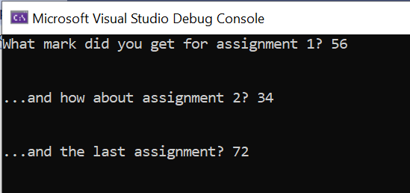

Solution:

#define _CRT_SECURE_NO_WARNINGS
#include <stdio.h>

void main()
{
int mark1,mark2,mark3;
printf("What mark did you get for assignment 1? ");
scanf("%d", &mark1);

printf("\n\n...and how about assignment 2? ");
scanf("%d", &mark2);

printf("\n\n...and the last assignment? ");
scanf("%d", &mark3);

printf("\n\n");
}

1b Add a function to the above program comment on the mark achieved:

Sample output:

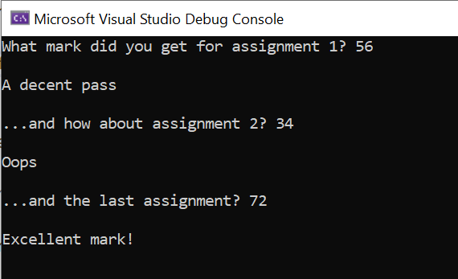

Solution:

#define _CRT_SECURE_NO_WARNINGS
#include <stdio.h>
void comment(int);

void main()
{
int mark1,mark2,mark3;
printf("What mark did you get for assignment 1? ");
scanf("%d", &mark1);
comment(mark1);

printf("\n\n...and how about assignment 2? ");
scanf("%d", &mark2);
comment(mark2);

printf("\n\n...and the last assignment? ");
scanf("%d", &mark3);
comment(mark3);

printf("\n\n");
}

void comment(int theMark)
{
if (theMark >= 70)
{
printf("\nExcellent mark!");
}
else if(theMark >= 55)
{
printf("\nA decent pass");
}
else if (theMark >= 40)
{
printf("\nPass");
}
else
{
printf("\nOops");
}

}

2a. In my shop, I am having a sale today, with 15 per cent off everything. Write a program to allow the user to check the sale price or a couple of items. Ask the user for the original price in main() and then use a function to calculate the sale price and print it on the screen.

Sample output

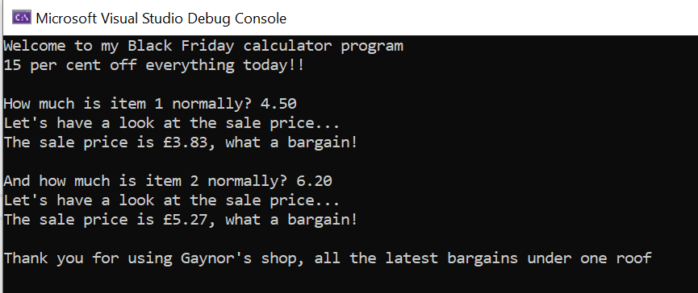

Solution:
#define _CRT_SECURE_NO_WARNINGS
#include <stdio.h>

void saleprice(float, float);

void main()
{
float itemdiscount = 0.15, item1, item2;
printf("Welcome to my Black Friday calculator program\n");
printf("15 per cent off everything today!!\n\n");

printf("How much is item 1 normally? ");
scanf("%f", &item1);
saleprice(item1, itemdiscount);

printf("And how much is item 2 normally? ");
scanf("%f", &item2);
saleprice(item2, itemdiscount);

printf("Thank you for using Gaynor's shop, all the latest bargains under one roof\n\n");
}

void saleprice(float theCost, float theDiscount)
{
float total;
theDiscount = 1 - theDiscount;
total = theCost * theDiscount;
printf("Let's have a look at the sale price...\n");
printf("The sale price is \x9c%.2f, what a bargain!\n\n", total);
}

2b In 2a, we allowed the user to check the price of 2 sale items. Re-write the program so that they can check as many items as they want (hint: use a loop in main() )

Sample output:

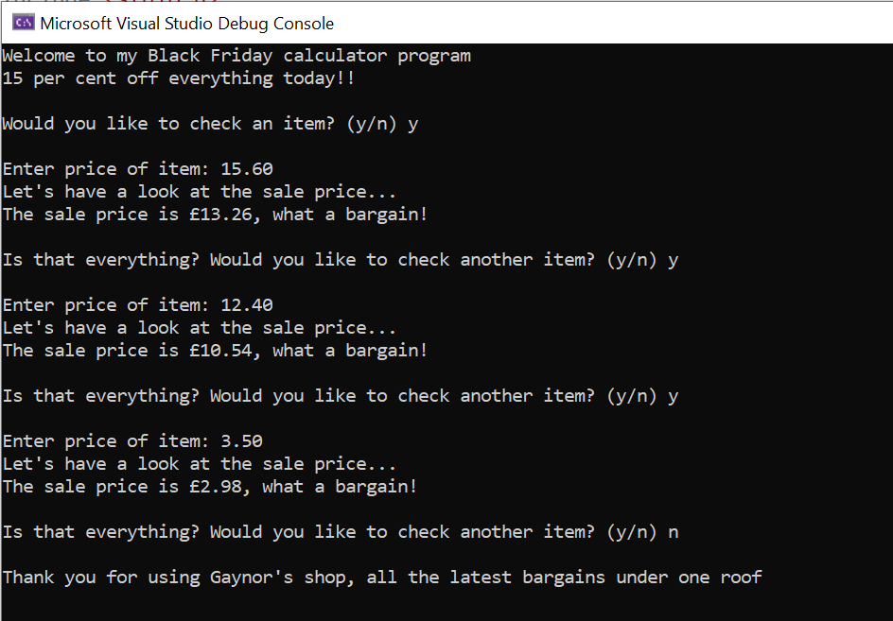

Solution:

#define _CRT_SECURE_NO_WARNINGS
#include <stdio.h>

void saleprice(float, float);

void main()
{
float itemdiscount = 0.15, item;
char choice;
printf("Welcome to my Black Friday calculator program\n");
printf("15 per cent off everything today!!\n\n");

printf("Would you like to check an item? (y/n) ");
scanf(" %c", &choice);

while (choice == 'y')
{
printf("\nEnter price of item: ");
scanf("%f", &item);
saleprice(item, itemdiscount);
printf("Is that everything? Would you like to check another item? (y/n) ");
scanf(" %c", &choice);
}

printf("\nThank you for using Gaynor's shop, all the latest bargains under one roof\n\n");

}

void saleprice(float theCost, float theDiscount)
{
float total;
theDiscount = 1 - theDiscount;
total = theCost * theDiscount;
printf("Let's have a look at the sale price...\n");
printf("The sale price is \x9c%.2f, what a bargain!\n\n", total);
}

