Rationale ECIE5004 KW

Wales is one of the smallest countries that forms the United Kingdom (Jones, 2018). The Welsh language evolved from the Brittonic Roman Empires and is over 1500 years old, it is thought to be the oldest language (Welsh Government, 2024). The Welsh language was undoubtedly suppressed by the Industrial Revolution (Welsh Government, 2024) which brought a surge of industrial growth, particularly in the coal, steel and slate industries of the South Wales areas. Large-scale migration from other regions of the United Kingdom proved another spike in the English language as many employees did not speak Welsh which increased the English language to be the more dominant language in Welsh industrial towns such as Cardiff, Merthyr Tydfil and Swansea (Davies, 2014). Baker (1992) suggests the Welsh language was deemed ‘old fashioned and difficult’. Religion played a pivotal role in the promotion of the Welsh language, as the Welsh Trust (founded in 1699) was known for publishing and distributing 545 books in Welsh consisting of 11editions of the bible. The circulation of the Bibles grew year after year around local schools and is a vital element in the history of the Welsh language and culture (Davies, 2014). The ‘Welsh Not’ was introduced in Welsh schools through the 19th century which involved children being punished for speaking their native Welsh language and wearing the ‘Welsh Not’ sign (see Appendix 1) around their neck for punishment (Jeffers, 2014 as cited in, Evans, 2020). The Welsh Language Act of 1967 was a major turning point for Wales and its traditional language as the Act gave Welsh citizens the same status as English in law courts (Welsh Government, 2020) and offered support, guidance and strategies for public schemes and sectors. In 1993 the Welsh Language Board and the Welsh Language Act (1993) (2011) was established and responsible for administering the Welsh Language Act (1967) in Wales which was awarded an annual grant of £13 million to ‘promote and facilitate the use of the Welsh Language’. The Welsh Language Board was abolished in 2012 and replaced with what is now known as the Welsh Language Service. The Welsh Language Commissioner is responsible for overseeing compliance with these standards (The Welsh Language Standards, 2015) in the public domain.
Under the Education Reform Act (1988) and religious studies Welsh became compulsory in some areas of Wales, yet it was not taught in all Welsh regions (Davies, 2014). Wales and England shared a national curriculum however, community campaigning proved to be a catalyst for the newly formed National Assembly for Wales in 1999 (Jones and Roderick, 2003) which gave Welsh citizens more scope to collectively encourage and develop the Welsh language and culture of Wales (Jones, 2019).
After 600 years of subjugation and attempted assimilation Welsh language has since become an important aspect of Welsh education, with the reform of the New Curriculum for Wales (2022) being an integral component of Welsh children’s education and the Welsh Government recent pledge to reach one million Welsh speakers by the year 2050 (Welsh Government, 2023b) will ensure children are proud of their identity and culture. The Welsh Government has set targets to ensure their vision is met by 2050 including, increasing Welsh provision within Early years and increasing the number of teachers that can teach through the medium of Welsh to ensure 70percent of children can speak Welsh by the time they leave secondary school (Welsh Government, 2017). Welsh is not only taught in lessons but also utilised incidentally daily within other elements of the curriculum such (School A, 2015; Welsh Government, 2019; Cummins, 2013).

The Welsh government's ethos towards the Welsh language in schools is supported by Siarter Iaith Framework (The Welsh Language Charter) with their overall aim being to inspire and encourage all to use the Welsh language in all aspects of life (Welsh Government, 2019). Children learn to speak because they need to interact with adults around them in their daily lives (Baker, 2014). Cummins, (2013) explains a second language (‘conversational fluency’) can be acquired within 2years with the implementation of Basic Interpersonal Communication Skills (BICS) infusing repetition and consistency through the school environment can develop BICS in most children. Research suggests for children to be regarded as bilingual they need to be exposed to their target language simultaneously with their native language between 10-25percent of the time (Byers-Heinlein, under review; Place & Hoff, 2011; Marchman et al., 2010; Marchman, Martnez-Sussmann, & Dale, 2004, as cited in, Byers-Heinlein, and Lew-Williams, 2013). Additionally, Cognitive Academic Language Proficiency (CALP) can take between 5 to 7 years to develop into a native speaker (Cummins, 2000; 2013, as cited in, Aleksi, 2022). CALP is a crucial concept in bilingual education and language acquisition and its focus is on the advanced language skills necessary for academic success (Cummins, 2021), understanding CALP allows educators to better support children. Furthermore, Bialystok (2009) suggests “Bilingualism is one of the experiences capable of influencing cognitive function and to some extent, cognitive structure” (P.9 as cited in, Mohr et al., 2016: Vygotsky, 1980). Bilingual children can have greater cultural assimilation (Ransdell et al., 2001) and increase “density of grey in the left inferior parietal cortex” (Bialysok, 2009, p. 3, as cited in, Mohr et al, 2016) which can increase overall learning efficiency (Nayek et al., 1990).

Activities
School A, a small Primary, Category 1 school (Welsh Government, 2021) in rural Wales, currently working towards the silver award under the Welsh Language Charter (Welsh Government, 2023a). Progression step 3 children are taught 90 mins of Welsh per week (Welsh Government, 2017) following the “Y Gromlech, Sir Benfro” Framework (Y Gromlech, n,d) employing videos, stories and games to encompass their fluency. Also, utilised daily via commands, greetings, feelings, and responses (School A, 2015). Children expand on linguistic skills, knowledge and understanding acquired during Nursery, Progression step 1 and 2 to develop through progression steps 3 and 4 (these are regularly monitored and assessed) to ensure children develop in the four strands of the new Welsh curriculum (School A, 2015; Welsh Government, 2020; Bruner, 2009). It is important to note that research suggests the appropriate age for children to learn an additional language is between 6 and 12 years (Special Eurobarometer, 2006 as cited in, Mohr et al., 2016). However, some critics argue for equality and say children should be taught both languages from the age of 3 years (Welsh Government, 2011; Welsh Government, 2021; Unicef, 2024). Teachers have attended Welsh sabbatical courses and approximately 10 Support staff have attended a Second Language course provided by the Local Authority and funded by the Welsh Government (2022) to improve their working knowledge and proficiencies of the Welsh language. Nevertheless, Estyn indicates to release staff to attend available training proves to be a continuous challenge (as cited in, Morgan et al., 2022; Welsh Government, 2022). There is predominantly no other Welsh input within the children's daily linguistics other than opportunities created in School A (School A, 2015; The Welsh Language Board, 2015; Welsh Government, 2019). All children are aware of the targets of “Cymraeg Campus” they are displayed on a display board in the main hall and discussed regularly in class and Welsh assemblies (see Appendix 2) so children can see exactly what goals they are working towards as a school to gain the silver award (Welsh Government, 2023a). Other Welsh prominence is visible throughout the school via wall displays, bilingual posters and advertisements, and signs around the school building including “prifathro” [headteacher], “toiledau” [toilet]. Any correspondence sent home to parents/carers and on social media is produced in a bilingual format (Welsh Language Standards, 2015).
School A daily discusses a weather chart (see Appendix 3) through the medium of Welsh as a comprehensive, holistic approach. This enables children to discuss the weather, days and months of the year using visual manipulatives with a More Knowledgeable Other (MKO) to push children through the Zone of Proximal Development (Vygotsky, 1978) to facilitate their understanding and proficiency in Welsh (Welsh Government, 2020). Vygotsky suggests “What is the zone of proximal development today will be the actual develop-mental level tomorrow” (Vygotsky, 1978, P. 87, as cited in, Harland, 2003). Children also write these sentences in Welsh about the weather down sometimes using sentence starters (Vygotsky, 1980; School A, 2015; Welsh Government, 2023a) depending on the age and abilities of the children to accommodate any new vocabulary and add to existing schemas and enhance cognitive equilibrium (Piaget, 1970 as cited in, Block 1982; Welsh Government, 2019). Metacognitive linguistic skills of the bilingual child can also increase and develop their executive functioning skills (Bialystok, 2017, as cited in, Gunnerud, et al., 2000). Conversely, according to Paap et al., 2014; Dunabeitia et al., 2014; Gathercole, et al., 2014; Morton and Harper, 2007, as cited in, Folke et al., 2016) there is no evidence to support the idea that bilingualism can benefit executive function attributes. A deeper understanding of the child's first language (“mother tongue”) can aid and developing proficiency in the second language (Mohr et al, 2016). Moreover, the teacher's methodologies, enthusiasm and positive attitude towards the target language can impact the ability to learn a second language. If the teacher displays a love and enthusiasm for the target language this will inevitably transfer to their learners (Bandura 1977). In contrast, a teacher with poor pedagogy and a lack of motivation can lead to negative cognitive functioning and retaining information (Abdullaev, 2021). Critics also suggest children's learning may suffer as delivery of the new curriculum which is inadequately defined and too reliant on teachers' expertise and talents (Lewis, 2019).
Upper Progression Step 3 children at School A are invited to LLangranog (local Urdd Centre) for a 2-night residential trip, for a fee children can endure various activities including horse riding, dancing, and swimming with their friends and peers. Llangranog offers children the opportunity to fully immerse in Welsh linguistics as fluent Welsh and trained staff implement basic Welsh speaking to encourage children to communicate through the medium of Welsh (School A, 2015; Welsh Government, 2015; Welsh Government, 2020). “Speaking two languages on a daily basis has consequences for how higher cognitive processes operate and results in more precocious development of inhibition and attentional abilities” (Barec et al., p. 701 as cited in Mohr et al., 2016). This trip is a fun and enjoyable way to learn Welsh linguistics through real-life experiences (Kolb, 2014; School A, 2015; Welsh Government, 2023a) and learn about Welsh culture which can support and promote a positive ethos towards the Welsh language and identities (Welsh Government, 2021; School A, 2015). Llangranog allows children to communicate and develop their personal proficiency and fluency acquisition in Welsh language in a non-biased, safe, secure environment (Maslow, 2013; Cummins, 2013) and become (1) ‘ambitious, capable learners who are ready to learn throughout their lives’; (2) ‘healthy, confident individuals who are ready to lead fulfilling lives as valued members of society’; (3) ‘enterprising, creative contributors who are ready to play a full part in life and work’; and (4) ‘ethical, informed citizens who are ready to be citizens of Wales and the world’ (Donaldson, 2015, p. 31 as cited in Gatley, 2020; Welsh Government, 2015; Welsh Government 2020). However, a quarter of the population of Wales is deemed to be impoverished (Evans et al., 2021) therefore unfortunately, not all parents/carers can afford this trip which can lead to children missing such meaningful experiences (Naven et al, 2019).

“Criw Cymraeg” [Welsh Crew] consists of elected children from each class from Years 2 to Year 6 at school A. These children discuss ideas and games for supporting and assisting the development of speaking Welsh around the classrooms and playground. The children meet every week with the Welsh Co-Ordinator and are responsible for introducing and encouraging new Welsh sentences that can be used incidentally throughout the school day such as “alla I gael help os gwelwch yn dda?” [can I have help please?] (Welsh Government, 2022; Welsh Government, 2019; Cummins, 2013). The teacher from each class selects a child who has spoken the target sentences the most that week to receive a certificate (Appendix 4) presented by “Criw Cymraeg” in assembly (Skinner, 2012; Baker,1992) to promote reinforcement. “Criw Cymraeg” lead an assembly once a month involving fun games and Welsh songs to sing (School A, 2015; Welsh Government, 2015). Welsh music and hymns are sung regularly in classrooms and assemblies. All children sing ‘Happy Birthday’ [Penblwydd Hapus] and many songs in English and Welsh tied in with celebrations depending on the time of year, for example at Christmas time children will sing “Dymunwn Nadolig Llawen” [Merry Christmas Everyone] and St Davids Day celebrations all children will sing “Sosban Fach”[little saucepan] and “Yma O Hyd” [Still here] by composer Dafydd Iwan. Children are made aware that “Yma O Hyd” is an important part of the history of Wales and emphasises that the Welsh language has survived many challenges over centuries and is still prevalent globally today (‘still here’). In more recent years it has become a popular Welsh football anthem (Cânsing, n.d; Cummins, 2013). Singing enriches children's knowledge of their country's struggles and promotes the 7 well-being goals of the Future Generations Act (2015) (see Appendix 5) (Welsh Government, 2015). Singing is led by a teacher with lyrics on an electronic board, the teacher explains the meaning of the words in English and the pronunciation of words in Welsh before they sing (Vygotsky, 1978; Welsh Government, 1993: Welsh Government, 2020; Baker, 2014). Teachers modelling positive behaviours towards the Welsh language will encourage children to develop the same positive attitudes (Bandura, 1977). Children thoroughly enjoy singing traditional Welsh songs which enables a sense of belonging and pride in Wales and can enhance fluency (Welsh Government, 2015). A meta-analysis of 62 studies involving 6,022 participants indicated that bilingualism is reliably associated with various executive function outcomes including, increased memory attention control, working memory, metalinguistic awareness, and abstract and symbolic representation skill (Andesope et al., 2010) compared to monolingual children (Craik and Freedman, 2010; and can potentially “delay Alzheimer's disease (Amal, 2024).

Evaluation
School A are significantly sustaining the Welsh language, cultural, historical and geographical features in line with the Welsh Government, ‘Cymraeg 2050’ vision (Welsh Government, 2023b). Welsh Language is fully implemented as a holistic approach across all areas of the curriculum through fun, engaging games and songs regularly using manipulatives to deepen the child's understanding and develop proficiency knowledge and understanding of Welsh cultures (School A, 2015; Welsh Government, 2015; Cummins, 2013; Vygotsky, 1980). School A’s ethos is to provide all children (School A, 2023; Unicef, 2022, UNCRC, 2024) with knowledge of the Welsh language, cultural and historical characteristics of Wales concurrent with balanced, unique opportunities to become bilingual. Children can take their linguistic foundations through to adulthood and secure future jobs in Wales and contribute to the Welsh economy as bilingualism has become an essential skill in many job applications (Evans 2020; Welsh Government, 2015; Welsh Government, 2020), create opportunities to further develop and apply to faster and more effective learning of other world languages and become multilingual (Cummins, 2013; School A, 2015). Conversely, some children particularly Additional Learner Needs (ALN) children struggle with linguistics in their ‘mother tongue language’ and therefore can deplete their attitudes towards learning a new language. Furthermore, a lack of confidence and low self-esteem can also have a negative effect on children speaking Welsh in a classroom environment (Williams and Evas, 1997; 1998, as cited in, Thomas and Williams, 2013). Finally, exposure to incidental Welsh phrases may be reduced with a Pastoral Support Plan (PSP) in place (Davies, 2023).

Rationale ECIE5004 KW

Appendices

Appendix 1
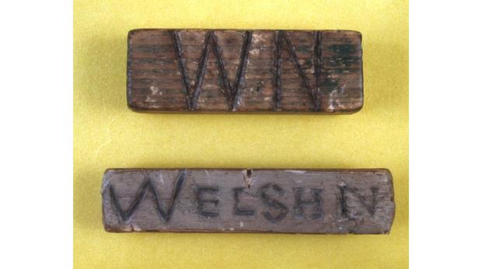
(BBC, 2014).

Appendix 2
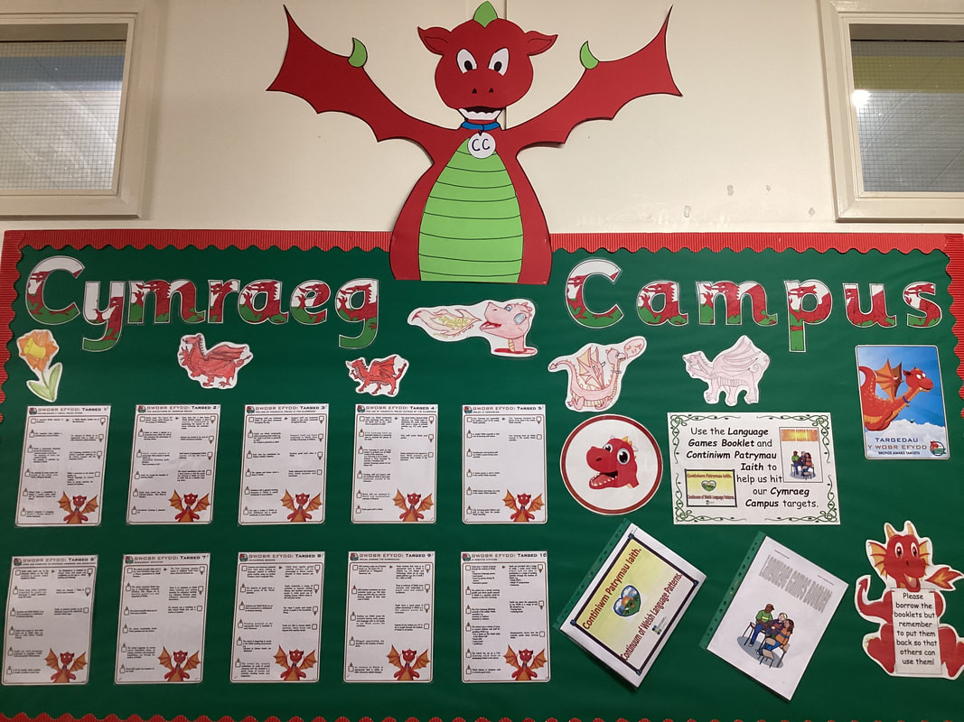
(School A, 2024).

Appendice 3

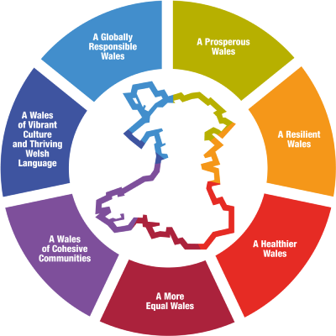
(Welsh Goverment, 2015).

