Student Name: Jordan Danielle Davies
P Number: 1701078
Programme of Study: 3D Computer Animation
Module: M4X01558

Production Analysis
In the beginnings of a new project setting out the path of roles and dates is crucial before kicking off into creating the piece itself. Coming together as a group we decided to share out the roles evenly through each stage;
- Pre-production
- Modelling
- Texturing
- Animating
- Rendering
These were listed down and from that I could create a rough Gantt chart, laying out the roles of everyone and the beginnings of the dates in creating the individual piece that has been given to the person.
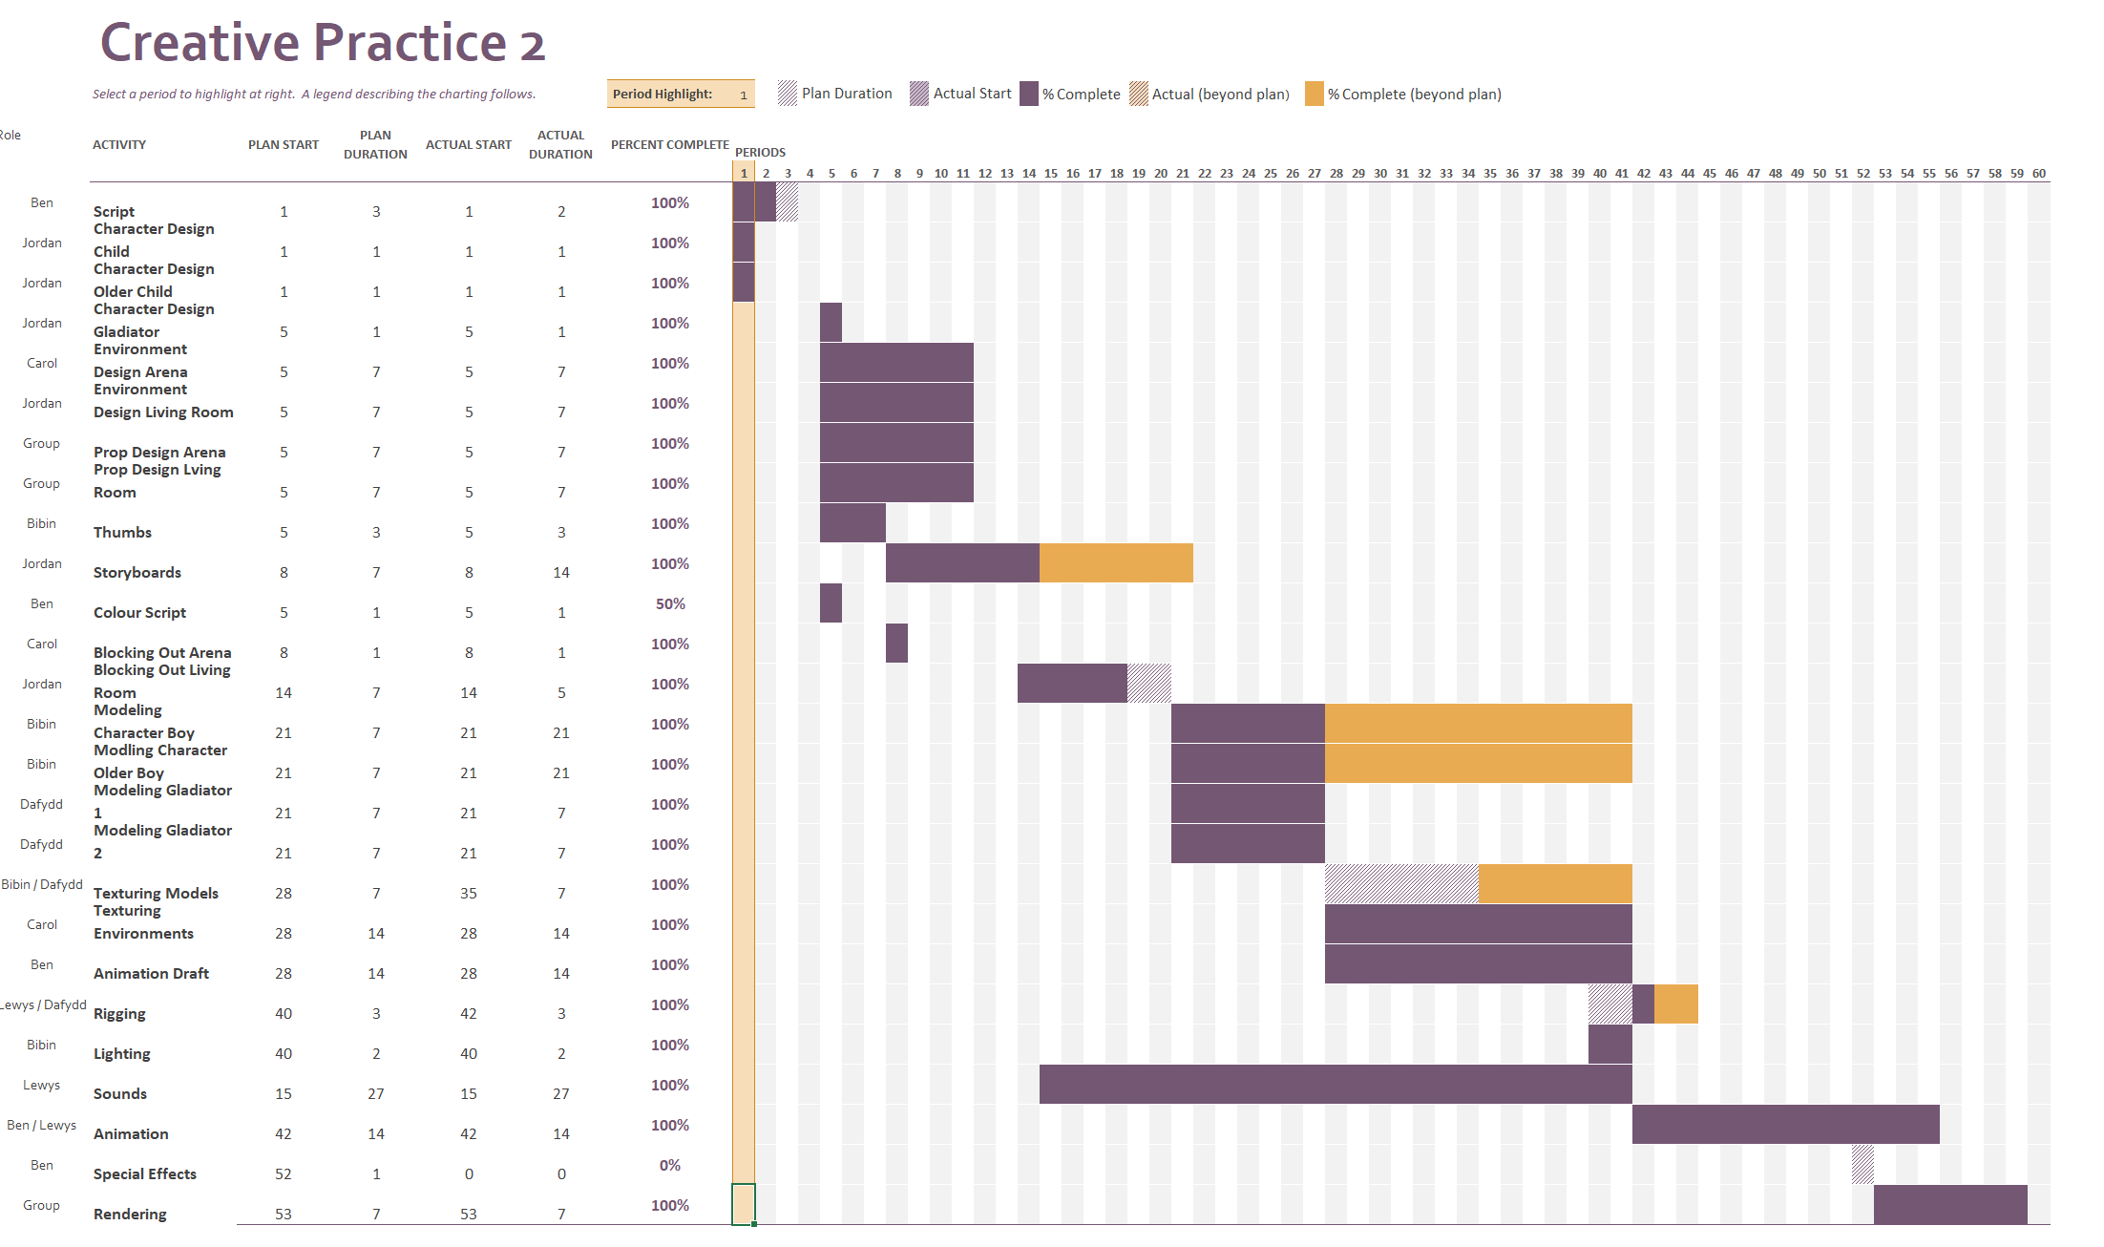
One of my roles was designing the characters in the story, after discussing with my group on certain characteristics of the characters I was able to draw up some facial expressions with different hairstyles, these alone helped to decide how the older and younger brother would look. With the considerations of the rest of the group we decided on how the two young boys will look. 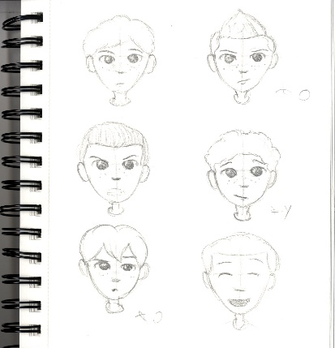
Another character I designed was the gladiator, to create this I considered a body type that would be fit enough to fight against another man and be able to win. A muscular figure that doesn’t go too far into looking like a bodybuilder but still strong enough for their muscles to be defined.
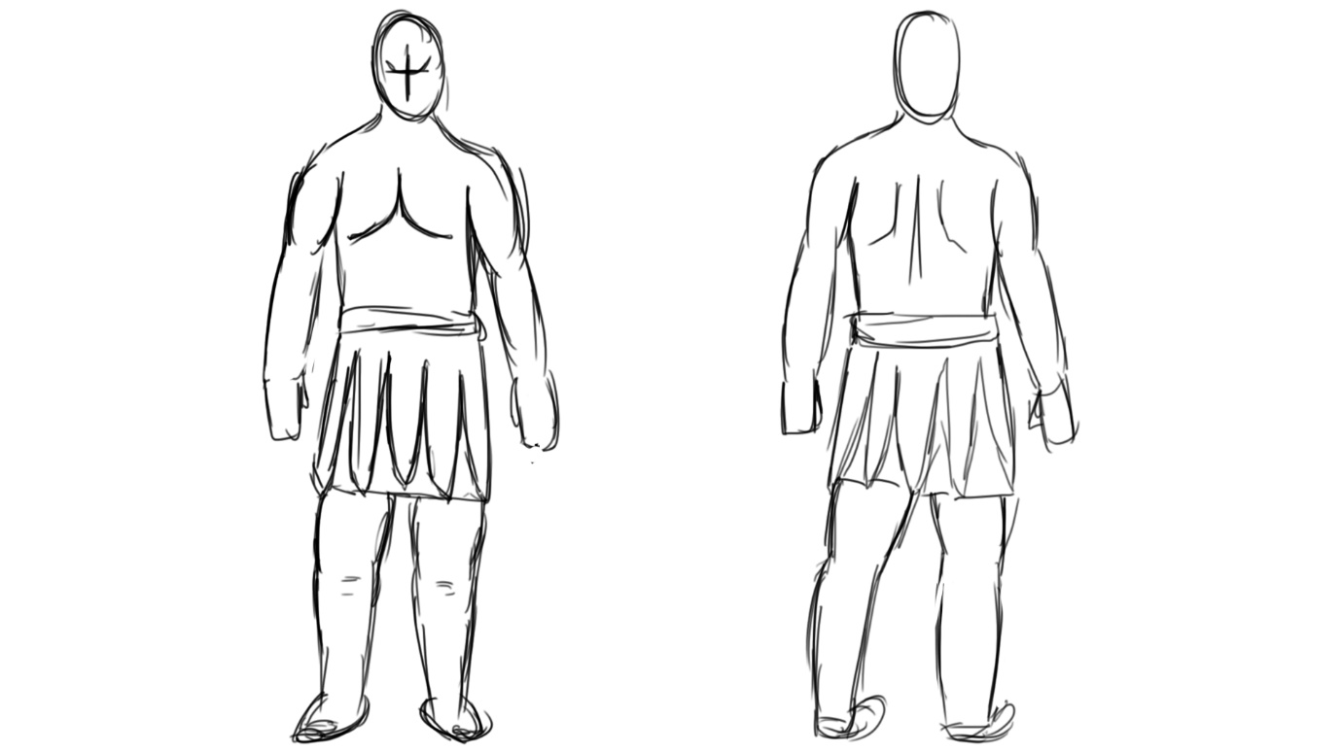
To further develop the story, I used the thumbs made by Bibin to create the storyboard, ensuring that the fight scene would be shown clearly every move was drawn showing exactly what they would be doing whether that was running, hitting or pushing. This would help when given to the animator when creating this in 3D. My role as the storyboarder was to also bring more detail into each drawing from the thumbs, showing where the gladiators would be placed in the stadium and what would be surrounding them. Including things such as the table and the array of weapons that would be placed on top for the fighters to choose.

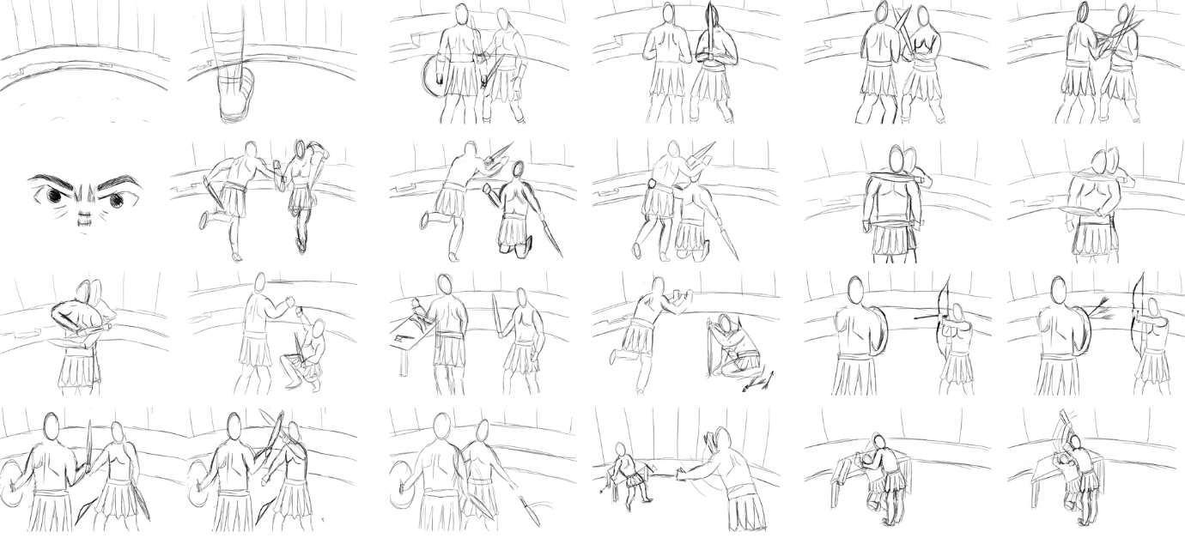
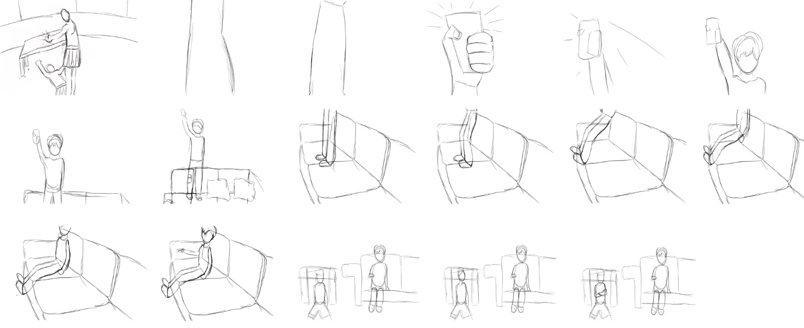
To gain some research on the living room that the children would be playing in, mood boards would be an efficient way to get different ideas together and figure out which elements would go better with others. One of them consisted of the living room itself, seeing the floor plan and how the furniture was placed throughout. This helped me develop my own floor plan and put together a room that looks cosy and put together for a family with children. Another mood board that I created put together miscellaneous objects that are commonly seen in a family room, I thought that this would help when creating the different elements other than the main pieces of furniture.

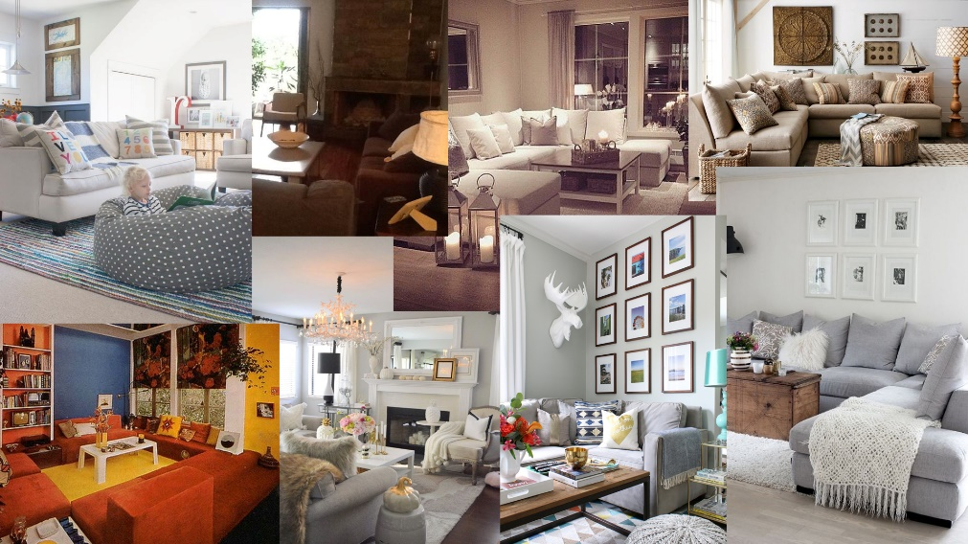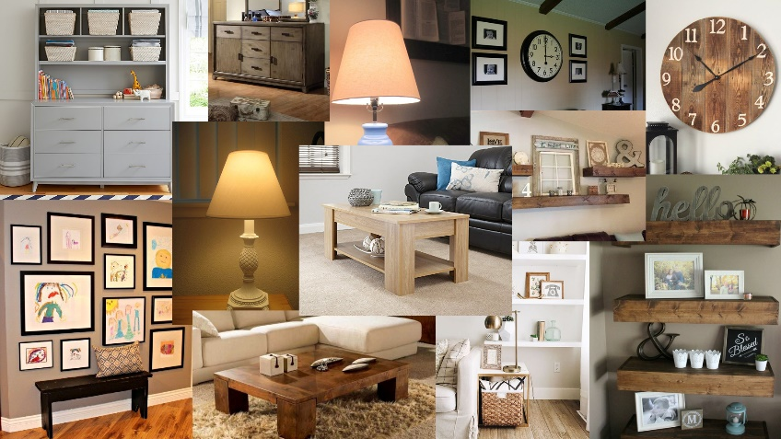
Developing the characters was to add colour and decide on the clothing that they would wear as this would help with showing their different ages. When colouring the older brother, I decided on him wearing baggy sweatpants would be more comfortable to wear over being more practical also having his hair being that little bit too long over his eyes.
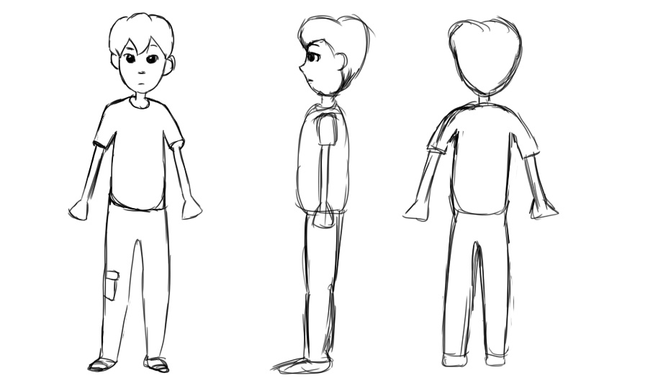
For the younger brother his clothing is based on more of a play outfit that is still smart. Wearing the shorts that is more playful as well as using brighter colours than what his brother wears. His hair is more well-kept in blonde curls, something that the parent would still tend to.
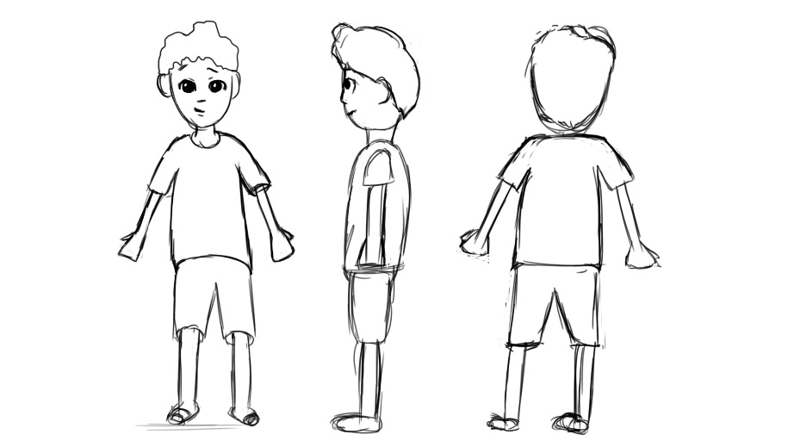
I felt that you can clearly see the children’s personalities by how they look and dress. I like this feature of the characters and how they can portray the children that may watch this piece. Giving a sense of relation to the audience when they watch this.
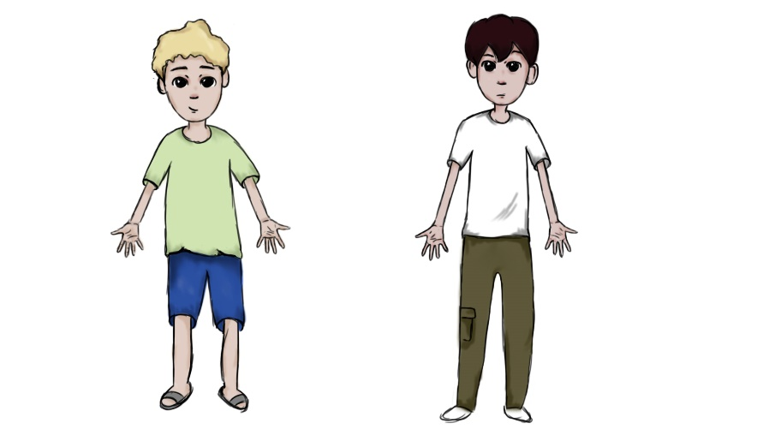
Here is some research I conducted on designing children, this demonstrates the proportions that are needed when designing children of this age.
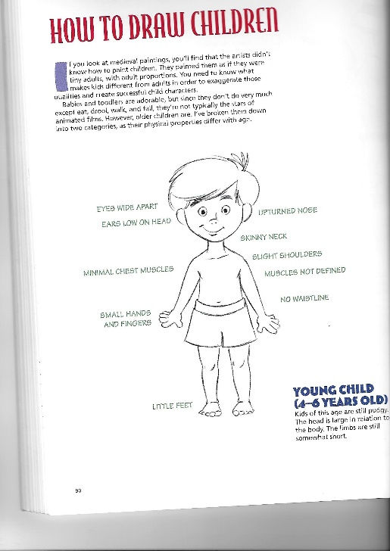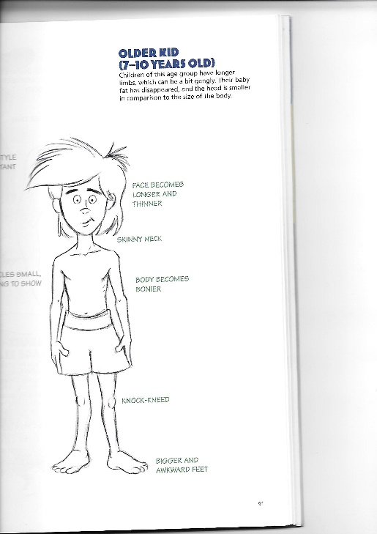
(1997:90)
Another development I made was with the living room, turning it from a 2D design to a full 3D piece. Firstly, creating a simple block out of the room, putting shapes together that will then become the finished piece of furniture. When creating this I found it hard to picture the room as whole as the shapes were all too similar so I had the idea to take an image of the room and creating a sketch over that, that can then give more of a resemblance of the finished room. I feel that using this step can help the rest of my group gain a better idea into what the living will look like before I add any detail to it. I like how even using simple blocks I can still create a clear vision into what the room will look like further down in the process.
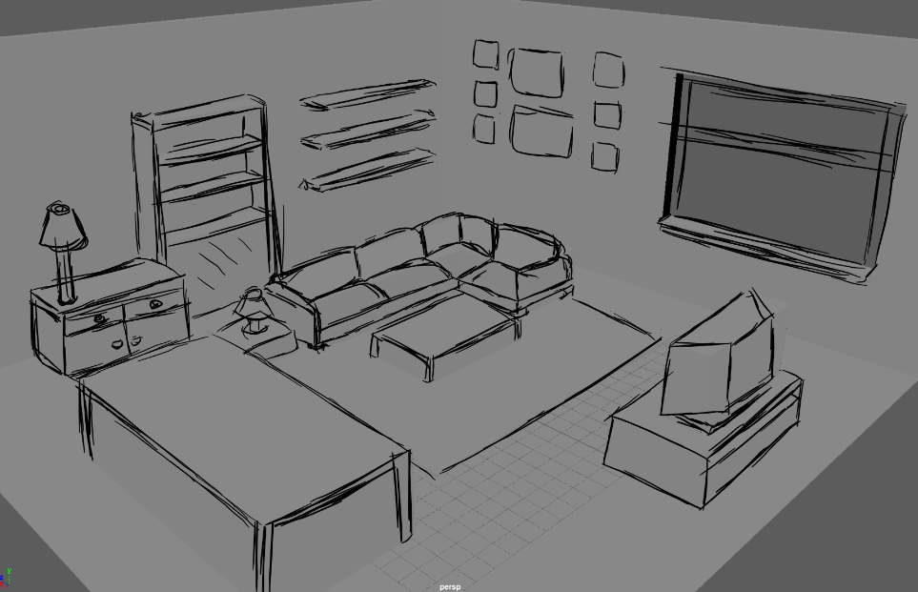

From the block out and sketches with it, I moved on to creating the more detailed pieces of furniture, also making them all have a more used look was important to ensure that the audience knew that this is a family room that the children do play in more often, creating that familiar memory that the audience may have experienced themselves as Bachelard explain, “..memories of other places we have lived in come back to us, we travel to the land of motionless childhood.” This is the feeling that I want to give when the audience views the animation and my living room specifically.

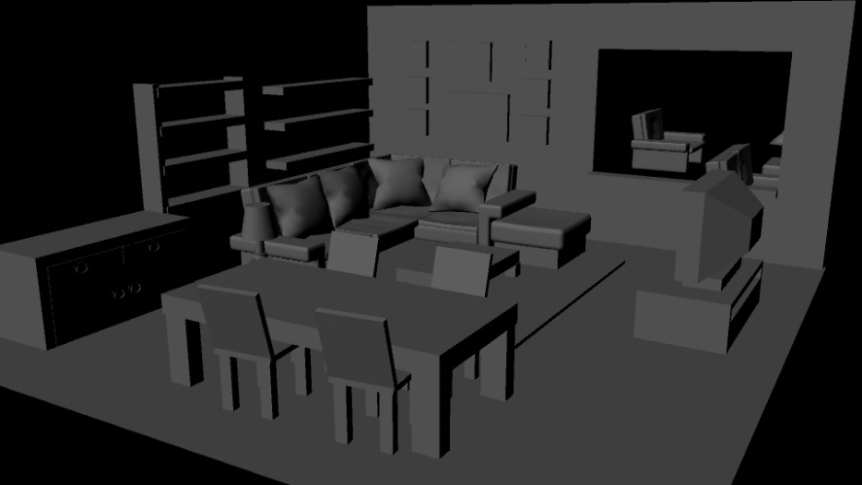

Overall, working in a group ensured that if we were to face problems we could come together and come up with solutions. Changing roles when needed, such as when running into problems with the production of sounds we decided as a group to contribute to have enough to add to the finished animation. Keeping absent members updated by keeping notes on the changes that needed to be made. We found that we had to keep communication to know exactly where everyone is in terms of their roles, the Gantt chart helped in knowing where everyone should be also. In the aspects in which the entire group was involved such as the rendering, we would always check on those who were animating to keep with the timing needed to accomplish this as well as we could. In a future project I would possibly try doing more animation to build up skill and try a new skill, showing that I can then contribute through many aspects in production.

Bibliography
Bachelard, G. (1969) The Poetics of Space. Boston: Beacon Press
Hart, C. (1997) How to Draw Animation New York: Watson-Guptill Publications

