M5X01926

Entrepreneurship

Create a written Business Plan

Student Name: Saful Muhammad Islam
Student ID: 1818532

Contents
Introduction 1
Legal aspects of the business proposal 2
Marketing Aspects of the business proposal 3
Financial Aspects of the business proposal 6
Conclusion 9
Appendices 10
References 13

Introduction
The previous owners haven’t been running good and had sold the business. The name of the business is Exotic Cuisine to show what the takeaway will sell. The business was put to sale because the property is freehold and the owner is offering a new lease of 20 years to sell the business. The previous business was only selling Indian food only as an Indian takeaway but we feel it it better to have new meals for different type people. The report will discuss the marketing mix and include finance details for the takeaway with research to back up plan.

Legal aspects of the business proposal
The legal status of the business is a sole trader. There is no liability available for a sole trader. It has unlimited liability that is defined as if the debt is not paid the owner will lose all his/her personal possessions such as their house to pay off the debt. The business will have to set the trading terms and conditions or the customers will make their own. These need to be agreed by the customers. Licences are needed to run a restaurant and takeaway. A hygiene certificate from the Food Standards Agency is needed to prove customers that food is safe and healthy. Cleanliness, hygiene and good service is very important for customers due to this report from the 2014 Food and You Survey (Prior et al, 2014).

When recruiting people for the business there need to have experience in working in a takeaway and work really good. There need to be checks to see if the employees are legal to work in the workplace and are eligible to work in the UK. If the immigration officers find out an illegal immigrant is working in the workplace, there will be fine of £10,000 per immigrant. Taxes need to be paid such as income tax. There needs to be checks that all the employees have national insurance and should be taxed. If part-time employees are employed, they will not be taxed but yet they still have to pay for the national insurance. I will have to pay my employees the minimum wage of £8.72 per hour for 25 and over. Ages 21 to 24 will be paid £8.20 per hour and £6.45 for 18 to 20 years old. If my business has a sales turnover over £67,000 per year I have to register with HMRC for VAT. I will need to keep records of the employees VAT, National Insurance and any voluntary charity contributions they make from their wages. But my employees have a right and trust me that their personal information is kept safe and handled in a proper and private manner. The employees’ information is protected under the Data Protection Act. Also the business documents need to be kept such as assets, purchases, expenses, and gross receipts.

Certain laws need to be followed by my business. These laws include discrimination of age, sex, race, disability, religion, trade unions and other laws such as equal pay act and employment. I will have to be responsible if any health and safety problems happen with a visitor or one of my employees. There has to be public liability and employee liability in my business. There will be fire exits and safety equipment if a fire is let out. The owner has duties and responsibilities as a business owner such as making sure that the employees do their work and that they do it safely. There are other business owners who have experience can help with advice. I could visit HM revenue and customs workshops where their trained Advisers can aid me to understand my responsibilities as an entrepreneur and give me the confidence I need to get it right immediately.

Marketing Aspects of the business proposal

The business will sell kebabs, Chinese food like chow mein and pizzas. The takeaway also sells fish and chips. The takeaway has A3 use so the business can allow customers to eat inside like a restaurant. The annual turnover of the business is approximately £78,000. But by changing the business to make a big impression on customers and providing chinese food, kebabs, burgers and pizzas, the business turnover will increase alot.

The business will offer good quality service in high standard and showing customers how important quality is for us. Customers will be provided with quality foods and dishes meeting their needs. There are different meals including Indian curry meals such as chicken tikka masala, lamb korma. Kebabs and burger meal such as doner kebabs, sheek kebabs, and beef burger will also be included. Selling pizzas from medium to large would be great to have different types of food available in takeaway. Also selling chow mein and yangzhou fried rice as more example. There will be free drinks on some meal deals to attract customers from competition. If our customers want a dish or a specialised pizza, our chef will try his utmost to fulfil the customer's need. The Business will provide deliveries within a 3-mile radius so the customers can order their meals and curries through phone. A card machine that accept certain cards will be available and customers can pay cash if they want.

The marketing mix will need to include all the P’s including online marketing (Hughes and Fill, 2007). My average price for the meals is £10.00 and also providing meal deals, kids meals to attract the customers to the takeaway. The prices for the meals and curries will vary depending on the customer’s choice. We aim to compete against the competitors to get customers from them. The business will be unique and provides a wide selection of foods aiming at a variety of market segments. Market research will be carried out. To be successful, we also have to be knowledgeable in relation to what the customer wants. This must be acknowledged by market research. We will have to look at the market research information and we must try to know what customers might want.

We will carry out 2 types of market research, field and desk research. By using questionnaires that is the field research we could find out is there a demand for the business. According to McQuarrie (2015) carrying out a lot of research will give accurate results. We received customer feedback about how important quality is and the meal should be good value for money. The customers don't mind if they have to pay a bit more only if the food is good value and is made in high quality standard. We will use promotional pricing by using buy one get one free and discounts to gain customers from the competitors. According to Smith (2012) pricing strategy will have to be competitive to make a profit because other competitors will try to attract customers with offers and good pricing.

Marketing usually means going out and finding out what customers would want because if the takeaway does not meet the customers' needs and wants, as a result the takeaway will be unlikely to sell the meal deal. Marketing is one of the methods used to find out what customers want and give them (Kotler and Armstrong, 2005). The customers of my business will buy the food in my takeaway because there is a high demand in Indian food. In the takeaway market, the Indian and Chinese are at the top of the market varying in positions first and second place. People have accepted Indian food in their food routine and lifestyle. According to Mintel (2020) found that Indian food sales beat Chinese because people prefer Indian food more.

The survey from valued opinions from 24-7 press release (2010) shows that Chinese takeaway is very popular with 38% followed by Indian 22% and Italian pizza 18%. Also Indian foods have some cures and prevent illnesses.

The groups the business is aiming at are business people, couples, students, children and residents. We have researched that older people often go out less but spend a lot of money because most of them are rich. But the main target is the age group 18 to 40 years old. The kebabs and burger will attract customers who go out and eat in fast food outlets. The recession has an effect on businesses as customers will have less disposable income. The unemployment levels will increase because people were being made redundant by businesses. The coronavirus pandemic has affected a lot of businesses and people’s jobs. People will have less income and some people will work part time. Since people will be at home, we will need to use Deliveroo and Ubereats to attract a lot of people to order from the business. The business will need to know who their customers are and use the methods to attract them with the right method (Kotler and Armstrong, 2010).

Promotion is another of the four P's of the marketing mix. We will advertise by producing menus and post them to each house in areas near by. Also we will on advertise on TV that can attract customers to order through phone for delivery only within a 3-mile radius. This will cost me £100 to advertise both ways so the customers are aware that one of the decent takeaways with wide range of choices is waiting for their call and also to eat in.

Choosing the right location is important for the business because the product should be sold where the customers find it suitable and a perfect place to be purchased. The location of the existing business is in Swansea. The business has some benefits because the residential area near the town centre situated it. The business is located near its suppliers so transport costs will be less. The takeaway is a bulk-decreasing business that would mean we would buy in bulks and produce less products. Exotic spice will be near its customers, suppliers, employees, and competitors. The employees are the main force to drive the business forward.

Financial Aspects of the business proposal

At least £200 to £250 per week will be needed to survive each week in a personal survival budget. But there will be loss first because start up cost is high. The place where the business will located the premises will cost £28,000. The equipment needed are tables, chairs, cutlery, takeaway bags, chips bag, papadum hot machine.

The supplies needed are bottles of soft drinks, lamb meat, chicken, papadums, rice, mixed curry powders, coriander, okra (ladies fingers), garlic, ginger, onion, 10 slices of cheese, bag of flower powders, sugar, salt, vinegar, green chillies, bottles of milk, cream, frozen fish and chips, beans, kebabs, buns, sliced chicken and meat keema, noodles, chicken wings and pizzas. A tray of mushrooms, green peppers and tomatoes will need to be bought. 3 employees will be employed that consist of a chef, tandoori chef and delivery driver is my son. The chef will get £280 per week; the tandoori chef will get £240 per week. Driver gets per delivery cost.

The welsh government will provide grants to help the takeaway with the start up costs. Also get business start up loans with lower APR of 6.2% and repay within 5 years (Business Wales, 2020). The good news would be there is no need to pay the grants back to the government and the loans can be paid back when the business will start to do well and the business start to make a profit.

Expect to sell around 5200 units

Break-even = Fixed Cost = £18550.00 = 6183 units

Selling price – Variable cost £10 – £7

Fixed Costs (year) | Cost
Rent | £7200.00
Business rates | £850.00
Loan, Repayment | £9000.00
Gas (Tank) | £900.00
Insurance Premium | £600.00
Total Fixed Costs | £18550.00

Variable Costs (year) | Cost
Electricity | £3000.00
Gas (Tank) | £900.00
Wages | £29760.00
Water | £100.00
Stock | £6000.00
Total variable Costs | £39760.00

Setting up cost | Cost
Leasing per annum for the takeaway | £28,000.00
Cooker | £39.99
Tables and chairs | £699.99
Cutlery | £34.99
Fridge and Freezer | £229.99
Telephone | £19.99
Dish washer | £169.99
Plates | £99.99
Pan set | £39.99
Fryer | £23.99
Total Setting up cost | £29358.91

We will need to sell 6183 meals in order to break-even as a business. We will take an overdraft of £9,000 from Islamic bank of Britain and pay them back £750 per month. An accountant will be hired who will produce four financial documents and they are the profit and loss account, balance sheet, variances and cash flow forecast. By producing these financial statements, we can plan the business ahead and use problem solving key skill to stop financial problems from occurring. Also the accountant will do the financial issues that can remove stress off me and therefore we can focus on other problems that might occur.

Records of transaction in the filing cabinet in the house and will be kept for 6 years. The transactions include bills, receipts, and bill from suppliers, checks will keep safe in the house. Copies will go to the accountant in order to deal with the financial issue and give advice of what should be done to move business forward. Since the landlord is leasing the building, £600 per month will be paid on rent.

Conclusion
This proposal is well thought with the right marketing strategies to target the right people. The previous owners haven’t been running good and had sold the business. The business was put to sale because the property is freehold and the owner is offering a new lease of 20 years to sell the business. The previous business was only selling Indian food only as an Indian takeaway but we feel it it better to have new meals for different type people. A lot of people favour Chinese. Italian as well as Indian and believe we should satisfy customer wants.

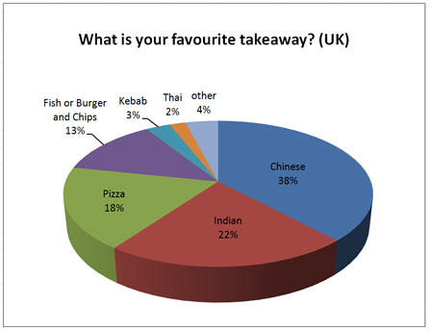
Appendices

Valued opinions survey, 2010

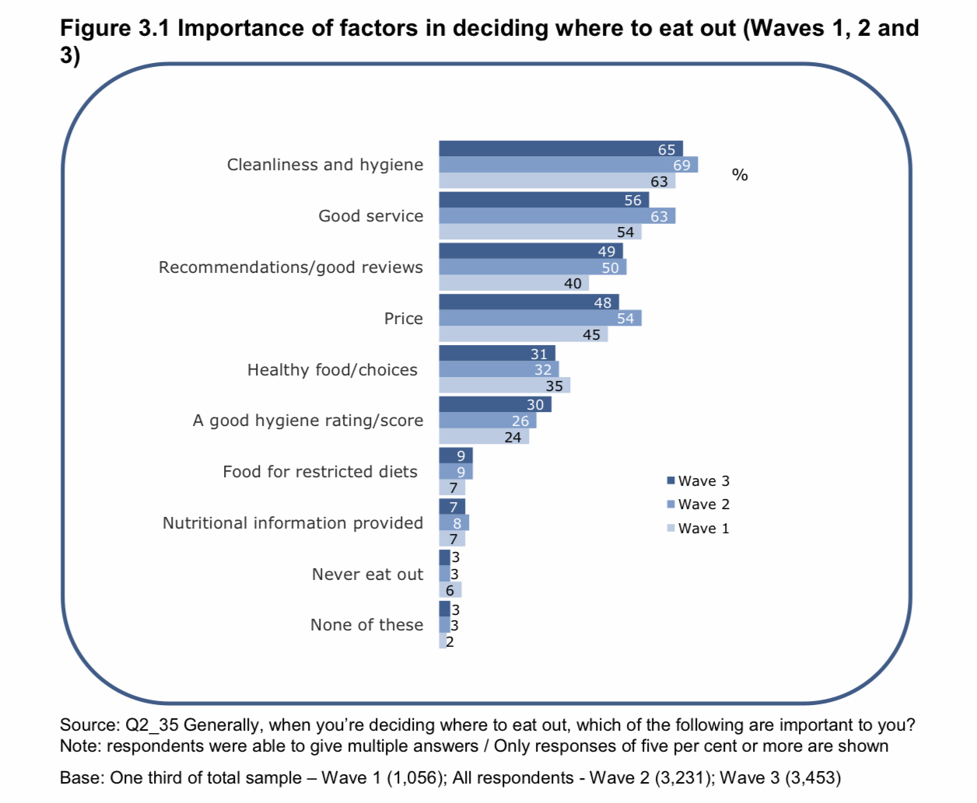
2014 Food and You Survey
Questionnaire

The purpose of this questionnaire is that it is a useful way of gathering information. Your opinions are important to us. Please complete this form beneath. There are some boxes, please tick only one box.

1. What is your occupation?

Home student Business owner

International student Employee

Housewife Other

2. What is your age?

Under 20 21 – 25 26 – 30

31 – 35 36 – 40 Over 41

3. Do you order takeaways or go restaurant ?

Takeaway Restaurants Both

4. How many times a week do you order takeaway to eat?

Once a week Twice a week Thrice a week

5. What is your favourite type of food?

6. How much do you normally spend on meals in takeaways?

£5 – £10 £11 – £15 £16 – £20

£21 – £25 £26 – £35 £36 – £40 £41⁺

7. Have you tasted Chinese food?

Yes No

Which types of food?

8. Have you tasted Indian food?

Yes No

Which types of food?

9. Would you like to eat meals that have fused with different cuisines?

Yes No

10. Would you be willing to be part of the membership to get discounts?

Yes No

That is the end of the questionnaire.
Thank you for taking time to complete it.

References

Armstrong G, Kotler P, (2010), Principles of Marketing, Pearson education.

Armstrong G, Kotler P, (2005), Marketing: An introduction, Pearson education/ Prentice Hall.

https://www.gov.uk/national-minimum-wage-rates

https://store.mintel.com/world-cuisines-uk-march-2020?_ga=2.73014483.1777277275.1593768861-1271301759.1593768861

https://www.24-7pressrelease.com/press-release/188502/valued-opinions-survey-shows-chinese-food-is-firm-favourite-in-take-away-britain

https://www.travelchinaguide.com/top-10-chinese-dishes.htm

https://goodcalculators.com/break-even-calculator/

https://businesswales.gov.wales/businessfinance/types-finance-and-how-apply/grants

https://businesswales.gov.wales/start-loans

https://developmentbank.wales/get-business-finance/starting-business

https://www.alrayanbank.co.uk/useful-info-tools/islamic-finance

Hughes G, Fill C. (2007), Redefining the nature and format of the marketing communications mix, The Marketing Review, 7(1).

McQuarrie E, (2015), The Market Research Toolbox: A Concise Guide for Beginners, Sage Publications

Prior G, Phillips R, O’Driscoll C, The 2014 Food and You Survey, Food Standards Agency, Government Statistical Service, October 2014.
Link: https://www.food.gov.uk/sites/default/files/media/document/food-and-you-2014-uk-bulletin-3_0.pdf

Smith T, (2012), Pricing Strategy: Setting Price Levels, Managing Price Discounts and Establishing Price Structures, Cengage Learning.

