LCLM6003
LEADING AND IMPLEMENTING CHANGE
A STRATEGIC CHANGE PLAN

Student: Florin Marian Bariz
Student ID: 2221353
Lecturer: Nadeem Mirza

Executive Summary
JLR focuses on the implementation of both transformational and democratic leadership style to ensure the change management process. The implementation of these leadership approaches helps this organisation to address the digital disruption within the market. A change management plan has been proposed to help this organisation in the integration of the latest technology like cloud computing and AI. The initial stage of Jaguar Land Rover's (JLR) transformation involves the critical assessment of legacy practices deemed unsustainable. By identifying the shortcomings of these processes, the company aims to pave the way for innovative and efficient methods that enhance overall performance and sustainability. This strategic move signifies JLR's commitment to modernizing its operations while aligning with evolving industry standards and consumer expectations, ultimately fostering long-term growth and competitiveness.

Table of Contents
Introduction 4
Introduction of Chosen Organisation 4
Analysis of Recent History of the Organisation and Transformation in its Internal and External Environment 5
Evaluation of Change Management Models of the Organisation 11
Evaluating the Changes Managed within the Organisation through Leadership Style or Approach 14
Development of Change Management Plan 17
Conclusion 20
References 22

Introduction
Technological advancement and the changing needs of customers are transforming trends in the automobile sector, which indicates a need for the development of a strategic change plan. In this study, a strategic change plan for Jaguar Land Rover (JLR) is to be developed through the analysis of its organisational history and its internal and external business environment. In this respect, the change management models like Kotter’s 8-Step and Lewin’s 2-Stage force field framework are to be analyses to identify the issues related to strategic change within this organisation. Furthermore, a suitable change management plan is to be proposed for this organisation to address the diverse issues of this organisation, which are happening due to changing market trends.

Introduction of Chosen Organisation
Jaguar Land Rover Automotive PLC (JLR) is one of the largest and most premium automotive manufacturing organisations in the UK. Therefore, this organisation’s subsidiary totally owned by Tata Motors Ltd since the year 2008, and its headquarters are located in Coventry, West Midlands (JLR, 2025). JLR mainly achieved success through its extensive industrial footprint that includes some effective vehicle manufacturing plants such as Halewood, Castle Bromwich, and Solihull. Most importantly, JLR effectively operates under a unique “House of Brands” structure, which represents four global luxury brands such as Jaguar, Discovery, Range Rover, and Defender (JLR, 2026).
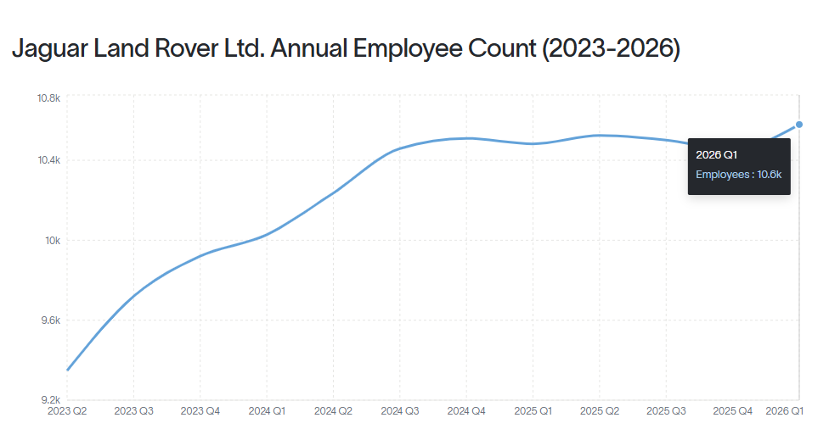
Figure 1: JLR Annual Employee Count
(Source: Revelio Labs, 2026)
From the above figure 1, it is easier to understand that in the UK, JLR's annual employee count was 10.6k in the quarter of 2026 (Revelio Labs, 2026). This significant employee number of JLR helps the organisation to provide services to consumers in 120 countries. However, currently JLR also experiences increasing volatile macroeconomic climate due to excessive trade barriers, supply chain issues, strict environmental regulations, etc. In addition, to creatively avoid these issues JLR has currently launched the "Reimagine" strategy because this organisation believes that through this corporate framework the organisation can ensure digital disruption, advance digital connectivity, and outline the definitive transformation towards vehicle electrification (JLR, 2026). In the consideration of a strategic transformation plan, a significant analysis of JLR’s structural setup and market presence is essential to evaluate its ongoing organisational transformation.

Analysis of Recent History of the Organisation and Transformation in its Internal and External Environment
Recent History and Financial Context
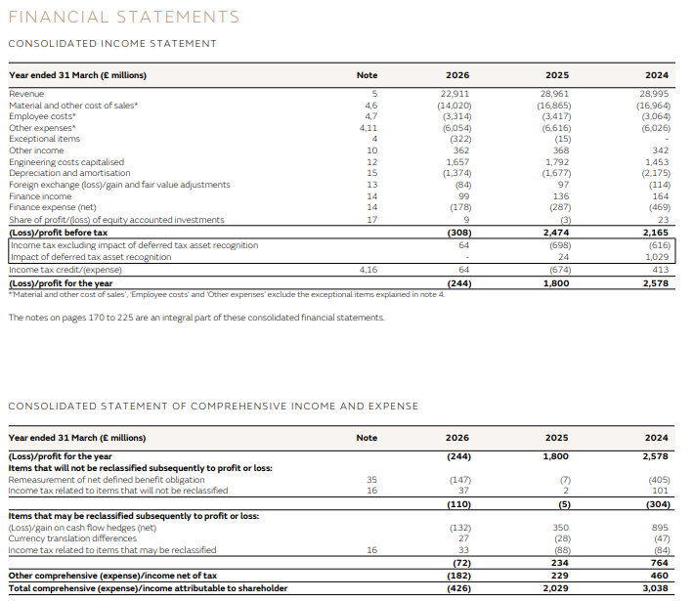
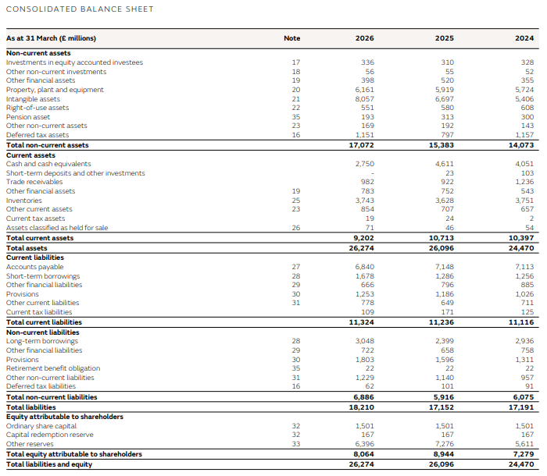
Figure 2: Financial Statement of JLR 2025 and 2026
(Source: JLR, 2026)
The significant operational trajectory is currently defined through its structural volatility, supply-chain stock, and luxury pivot. Through the above-represented financial statement of JLR, it has been easier to understand that from the year 2025 to 2026 the organisation has experienced considerable financial pressure. The major reason behind this consideration is the above figure 2 of JLR’s financial statement; it is easier to highlight that in the year 2026 the revenue of the organisation dropped around 20.9% because in this year the organisation earned around 22,911 million (JLR, 2026). On the other hand, the wholesale volume of the organisation also dropped around 23.2%, meaning around 307,900 units declined. The major reasons behind these losses of JLR are effectively associated with the increasing cyberattacks, the planned wind-down of legacy Jaguar models, and the newly launched U.S traffic. Moreover, the above financial statement also highlights that JLR’s adjusted EBIT margin also sharply decreased by around 0.7% from 0.8% the previous year (JLR, 2026). However, the changes that are visible in JLR’s external and internal environment due to the current financial transformation have been discussed below.
Transformation in the External Environment (PESTLE)
Digital Disruption and AI
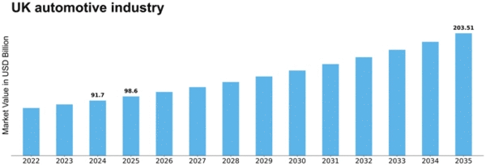
Figure 3: Market Size of Automobile Industry in the UK
(Source: marketresearchfuture.com, 2026)
From the above figure 3, it is easier to understand that from the year 2022 to 2025 the market size of the automobile industry was significantly increasing, and in 2025 the industry achieved around 98.6 billion (marketresearchfuture.com, 2026). The major reason behind the year-by-year market size increase of the automobile industry is that in the UK, around 56% of automobile business leaders have incorporated AI within their vision projects (themanufacturer.com, 2023). Therefore, the automobile industry is also forecast to achieve around 203.51 billion in market size by 2035, which creates investment pressure on JLR to compute AI infrastructure within its organisational culture (marketresearchfuture.com, 2026). Through this information, it has been easier to understand that key competitors have quickly incorporated machine learning into autonomous driving, which creates obstacles for JLR to maintain its comparative position.
Economic and Trade Pressures
The significant transformation within macroeconomic conditions has effectively created regional imbalance. In the consideration of economic transformation, recently JLR has experienced a car sales decline of around 29.8% in China because the Chinese market has effectively shifted towards EV consumption and discounting policies (autonews.com, 2026). On the other hand, currently JLR has also experienced 69% of profit decline due to the Middle East conflict, supplier fire, and ongoing U.S trade tariffs (autonews.com, 2026).
Geopolitical and Supply Chain Shocks
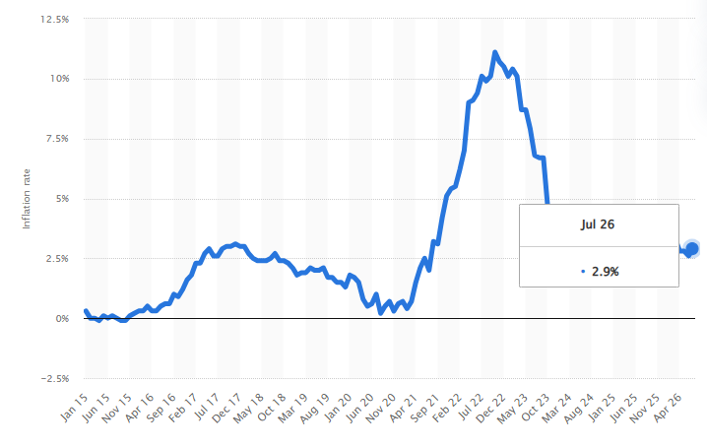
Figure 4: UK Inflation Rate
(Source: statista.com, 2026)
From the above figure 4, it has been easier to understand that from the year 2015 to 2025 the inflation rate of the UK was significantly increasing. However, in the year 2026 it stood at around 2.9%, which is higher than the previous year, while due to this higher inflation rate the geopolitical risk for JLR also increased, where the organisation can experience higher costs in product exportation. (statista.com, 2026) In addition, the intense geopolitical friction can generate a direct negative impact on organisational sales and logistics. On the other hand, the significant conflict within the Middle East creates a challenge in "market disruption” for JLR, which also directly generates a negative impact on the sales volume of this organisation (Qamar et al., 2023).
Transformation in the Internal Environment
The "Reimagine" Strategy
The internal landscape of JLR effectively operates through its newly launched Reimagine strategy, which helps the organisation to be focused within a "House of Brands" organisational structure (Górska, 2024). This framework or strategy also guides the organisation to ensure its electric transition and flexible utilisation of mixed powertrain options, for example, BEV, PHEV, or MHEV. Moreover, in recent times, various consumers are demanding luxury electric vehicles; for this reason, currently JLR focuses on re-engineering its luxury electric vehicles by launching a 4-door GT-type 01 vehicle (Padovan, 2020).
Cybersecurity Posture
In the year 2025, JLR experienced a major internal crisis because, within this financial year, JLR experienced a massive cyberattack that breached its confidential network. Due to the cyberattack, JLR lost around £500m, as well as the organisation's car production was also stopped after the breach, where it lost around £398 million in profit (theguardian.com, 2026). The major reason behind the massive cyberattack and profit loss of JLR is significantly driven by its failure within data privacy protocols and risk assessment system establishment. However, in the future, to avoid the risk of massive cyberattacks and data breaches regarding issues, not only JLR but also other automobile organisations are required to adopt UK GDPR & Data Protection Act 2018, Computer Misuse Act 1990, and Telecoms Security Act 2021 policies (Antczak, 2026).
Human Capital and Future Skills
In recent times, JLR has effectively focused on incorporating AI technology within its product manufacturing and operational decision-making process. However, during the incorporation of digital infrastructure, JLR has experienced a significant skill gap among employees. The skill gaps among employees have effectively restricted JLR from developing digital infrastructure, which can help the organisation to ensure automotive product manufacturing (Khan and Islam, 2024). Moreover, by adopting digital infrastructure, JLR can also strengthen its external and internal risk assessment process. However, each year JLR effectively focuses on investing over £20 million in employee upskilling programmes and future skills programmes (JLR, 2026). Therefore, the main aim of these employee upskilling programmes is to provide employees clear knowledge about data analytics, autonomous software design, and digital technology operation or management processes. These programmes are also help JLR to extend its employee retention rate, increasing legacy.
Throughout the overall analysis, it has been easier to understand that external issues such as geopolitical pressure and economic volatility directly generate a negative impact on JLR’s sales volume as well as profitability (Fernández, 2025). On the other hand, internal issues, for example, cyberattacks and a massive technical skill gap among employees, restrict JLR from developing digital infrastructure within its organisational culture and generate a negative impact on the organisational reputation along with its comparative position.

Evaluation of Change Management Models of the Organisation
Currently, JLR effectively focuses on implementing or following its newly launched "Reimagine" strategy to creatively avoid the negative operational disruptions, for example, a damaging cyberattack and total electrification of Jaguar’s luxury brands. In this section, two different types of change management frameworks or models have been utilised for example, Kotter’s 8-Step Change Model and Lewin’s 3-Stage Force-Field Model, to assess the theoretical validation and limitations of implementing the Reimagine strategy and digital infrastructure development.
Kotter’s 8-Step Change Model: Application and Critique
John Kotter’s linear framework is a highly effective change management model because it helps in critically breaking down the organisational inertia to justify the strategic transformation that the organisation plans to conduct (Carreño, 2024).
Create Urgency
JLR now focuses on effectively implementing both strict net-zero logistics as well as cyberattack prevention policies within its organisational culture (CAVANAGH, 2025). The major reason behind this consideration is that by implementing both of these strategies, the organisation will be able to regain the consumer trust that it lost during the 2025 cyberattack. On the other hand, by implementing a sustainability strategy, the organisation will be able to showcase its environmental commitments, which can generate a direct positive impact on the organisation’s industrial reputation.
Form a Powerful Guiding Coalition
JLR can effectively operationalise this strategy by aligning its executive board with digital transformation experts of Tata Communications as well as advanced software engineers.
Create Strategic Vision
New Reimagine strategy of JLR can serve as a significant or clear strategic guideline that helps the organisation to focus on creating its marketing products under the House of Brands structure (Li et al., 2024). However, to ensure the implication of the Reimagine strategy, JLR is required to focus on ensuring an association between its luxury brands and electrified platforms such as EMA or MLA.
Communication Vision
Under the communication vision, JLR is required to implement its organisational strategies through maintaining transparency as well as a multi-channel internal communication process because it can help the organisation to avoid strategic conflict among corporate employees and line teams (Pimpa, 2026).
Empower Action/Remove Obstacles
Currently, JLR experiences technical skill gaps among employees, which restrict the organisation from developing digital infrastructure. However, to avoid these potential skill gap issues, JLR is required to organise multiple future skills programmes where employees can gain clear knowledge about data analytics, machine learning, etc. On the other hand, by focusing on sufficient employee training, JLR will also be able to reduce its increasing employee turnover rate regarding these issues.
Create Short-term Wins
Under this strategy, JLR can focus on successfully launching the Jaguar Type 01 GT electric vehicle because it is considered as a tangible proof of concept. By following this milestone, JLR will be able to build commercial credibility within its operating industry in a systematic way.
Sustain Acceleration
In the context of this strategy, JLR can creatively utilised the early momentum in the electric vehicle manufacturing process (Sjunnesson et al., 2025). The major reason behind this consideration is that it can help the organisation to expand its Enterprise Missions program, which can drive towards ensuring future vehicle manufacturing efficiency.
Anchor Changes in Culture
Under this strategy, JLR is required to ensure the implementation of a cloud-first security mindset as well as a data-driven approach within its standard operational routines.
Lewin’s 3-Stage Force-Field Framework: Application and Critique
Kurt Lewin’s change management model primarily helps organisations to simplify their strategic transformation focuses and their dynamics in a systematic way. However, the three stages of Lewin’s change management model have been discussed below.
Stage 1: Unfreezing (Disrupting Equilibrium)
Under the first stage, JLR was required to exclude its legacy practices by highlighting why those processes are unsustainable for new organisational culture (Fitzgibbons, 2025). Therefore, by focusing on this strategy, JLR can avoid the financial issues that it experienced during 2025’s cyberattack and the Chinese automobile market transformation.
Stage 2: Changing (Transitioning to New States)
Under this phase, JLR will be able to launch new product manufacturing systems, working styles, etc., by transforming its production process towards Electrified Modular Architecture (EMA).
Stage 3: Refreezing (Locking in the New Equilibrium): In the context of this strategy, JLR is required to incorporate a new digital workflow into a formal corporate policy. The main reason behind this consideration is that it can help the organisation to ensure the avoidance of cybersecurity compliance and the maintenance of sustainability targets.

Evaluating the Changes Managed within the Organisation through Leadership Style or Approach
Applying the leadership approaches
Leaders play a significant role in influencing employees related to diverse business operations like supply chain processes to meet the organisational goals. Their role is vital in this context as they motivate the employees to give their significant contribution to the growth of organisations, which helps to build their confidence in a positive way. Due to the advancement of technologies, the leaders within JLR are focusing on adopting the latest technologies like AI to meet the diverse demands of their customers in the current market dynamics. After the COVID-19 pandemic, this organisation in the automotive sector has gone through a significant crisis of semi-conductor due the disruption in the automotive supply chain. However, the leaders within this organisation have collaborated with Everstream Analytics to include AI technology within its supply chain system in order to address the disruptions significantly (jaguarlandrover.com, 2023). This technology supports their organisation to monitor its supply chain on a real-\time process, so that it can respond to supply chain disruptions on an early basis. In this respect, it uses a combination of AI, machine learning, predictive analytics to predict incidents like data breaches, natural disasters, along with export issues, which might put a negative influence on JLR’s supply chain system.
This organisation is using a combination of transformational and democratic leadership styles to manage the changes within its diverse business operations to maintain a good position in the current competitive market. Based on the transformational leadership style, leaders mainly inspire their employees to fulfil the vision of the organisation, and they also focus on the development of the innovative thought process within them for addressing the market changes (Payton, 2022). The leaders within this organisation are planning to expand the usage of its digital capabilities through opening new tech hubs in the European region. In this process, leaders within this organisation are focusing on adapting to the trend of the market, which is mainly based on the use of AI technology.
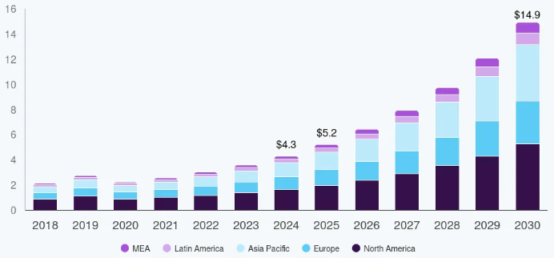
Figure 5: AI in the automotive sector
(Source: grandviewresearch.com, 2026)
Figure 5 indicates that the market size of the AI automotive sector is expected to reach $14.9 billion by 2030, which suggests tremendous growth in recent years (grandviewresearch.com, 2026). The drivers of this significant growth are mainly the changing perception of customers and the use of technologies like machine learning to address the changing demands of the market for the development of modern cars.
In 2021, JLR launched its electrification strategy, which is referred to as the “Reimagine Strategy”, to make changes to its cars to develop itself as an electric car brand from 2025. During the launch of its strategy, this organisation aimed to achieve 100% Jaguar sales and 60% Land Rover sales to ensure a good position in the market of automotive market (Sjunnesson et al., 2025). The main purpose of selling cars in such a manner is to achieve net-zero tailpipe emissions by 2030, with the aim of making hybrid Land Rover models. This shows the application of the democratic leadership style to make change in its business operations to gain relevant outcomes in the future. Based on this leadership style, leaders mainly maintain open communication, a thoughtful decision-making process and even focus on developing the relevant potential of their team members (Daud et al., 2025). As a result, it helps the leaders to encourage their team members to participate in the decision-making process within the business operations of organisations. This type of leadership style is mainly relevant in a complex business environment like JLR’s working environment, where a significant use of both digital and multi-cultural aspects is observed. As a result, through the application of this approach, JLR provide a significant response to the changes in the market, which are happening due to the emerging trade pressure because of the geopolitical factors along with the evolution of legislative and environmental regulations.
Impact of organisational culture on the change management program
The automotive sector mainly follows a traditional manufacturing process in order to develop its product, which was also a significant part of JLR’s organisational culture. Due to the digital disruption, this organisation is making a significant change within its manufacturing process through the integration of modern technology to speed up the process of developing the latest electric vehicles (EV).
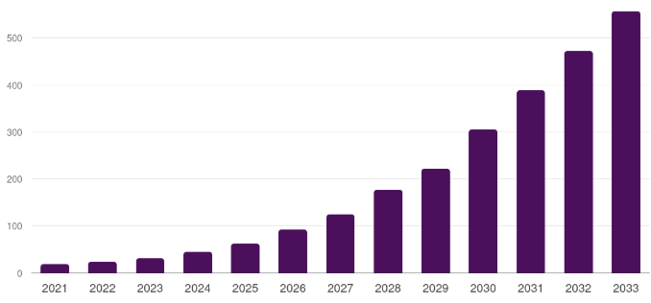
Figure 6: Electric Vehicles market size
(Source: grandviewresearch.com, 2026)
Figure 6 indicates that the market size of EVs in the UK is expected to reach $556.8 billion by 2033, which suggests significant market growth in recent times (grandviewresearch.com, 2026). This significant market growth is mainly driven by the country's target to achieve net-zero emissions and the integration of the latest technology for developing modern cars. In this respect, this organisation is focusing on making changes in its management structure to build relevant tech hubs in the international context. These significant changes in the market are also creating relevant pressure on the employees to increase their revenue margin to maintain a significant position in the current competitive market (Agustian et al., 2023). Employees showed resistance to the adoption of such technology in the market, so this organisation is focusing on the adoption of a significant strategy, like providing relevant training programs to its employees to increase their engagement for its growth in the current market dynamics. For example, JLR is providing a large-scale apprentice program to its employees through the Multiverse Data Fellowship Apprenticeship, in which almost 600 employees were enrolled in the year 2023 (jlr.com, 2023). Due to the implementation of such a training program, this organisation is significantly responding to the digital disruption within the current market. Alternatively, to align with the needs of the customers, it is focusing on the development of EVs to stay relevant within the current competitive market.

Development of Change Management Plan
Proposed plan
In order to provide a response towards the digital disruption in the market, this organisation can integrate the latest technology, such as cloud systems, within its business operations to attract a wide range of customers around the world.
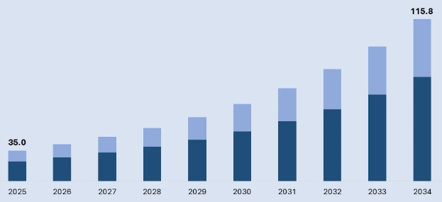
Figure 7: Automotive cloud market size
(Source: imarcgroup.com, 2026)
Figure 7 indicates that the automotive cloud market is expected to reach $115.8 billion by 2034, which suggests a relevant growth in the upcoming years (imarcgroup.com, 2026). This growth is mainly influenced by the changing demands of the customers for the EVs, increment in the adoption of the connected vehicle technologies and a significant advancement in the 5G infrastructure. In this process, it can focus also on collaborating with diverse organisations for the integration of AI-based risk-monitoring tools and upgrade its legacy system to manufacture luxurious EVs for the customers in the context. Therefore, the integration of such technologies within its supply chain, manufacturing process along with the legacy system can help this organisation to deal with the diverse disruptions in the current competitive market.
Objectives
- To increase the growth of its revenue by making changes in its business operations for attracting a wide range of customers. .
- To launch hybrid and electric vehicles with the integration of the ML and cloud based technology
- To provide training to the employees related to future upskilling in the automotive market due to the integration of the latest technologies like AI in the product development process.
- To achieve a net zero emission in the upcoming years through transitioning its cars into EV and hybrid models.
Financial Plan
The implementation of the change management process within the organisational structure of JLR cannot be done without the development of a relevant financial plan. This is because it helps to identify the areas which are need to be observed significantly to manage the expenses (Li et al., 2024).
Elements | Expenses
Hardware cost | £10,0000
Server and software | £15,0000
SaaS subscription | £5,0000
Training and development | £7,0000
Table 1: Costing structure for initiating the changes
(Source: Self-Developed)
Table 1 indicates the costing structure for the implementation of the change management programme within this organisation to provide responses to the digital disruption in the market. The total estimated cost for conducting the change management programme will be £27,0000, which requires a relevant investment in SaaS subscription, training of the employees, hardware, server and software.
Funding and sourcing of the resources: The accomplishment of this financial plan can be done through obtaining the funding from diverse stakeholders like investors to integrate the latest technology within its business operations. On the other hand, the utilisation of the debts can be done for providing for buying the relevant servers and the software to initiate the changes in a significant way.
Communication Plan
The most important element in bringing changes in the business operations is to develop a relevant communication plan, to ensure the smooth maintenance of all work within organisations. JLR can follow a significant approach to maintain its communication with its employees and ensure the development of a positive environment in the workplace. In this process, this organisation needs to evaluate the situation within the workplace to implement a relevant communication style that can help it to achieve a relevant outcome. In this process, it can follow the stakeholder mapping framework to understand the circumstances of its diverse stakeholders like customers, investors, and employees (Styk and Bogacz, 2022). In this process, it can also address the resistance of the employees in the current market dynamics due to the implementation of the change management programme.
The development of scheduled milestones can help this organisation to communicate with its investors related to the integration of the latest technologies like cloud infrastructure and AI. This can help to inform the shareholders; banking partners and investors related to the cost-cutting strategies of this organization to initiate the changes and maintain the revenue in a structured way.
Evaluation Plan
Conducting the changes in the business operations is not enough to ensure the benefits of this proposed change management plan. This is because it is very important to evaluate the change through a constant monitoring plan to identify any type of challenges as early as possible. In this respect, the KPIs (key performance indicators) are to be developed to monitor this change management plan (Aithal and Aithal, 2023). For example, the percentage of the completion of the employees training programme can help to understand their perception for accepting this technology in a significant way. On the other hand, monitoring the reduction of the carbon emission within the supply chain process can also help to monitor the progress of this plan. The development of relevant milestones like tracking the delivery of the profit margin, cash flow metrics and checking the sales volume is important to evaluate this change management plan.

Conclusion
In conclusion, this study has analysed the both internal and external environment of JLR in order to identify the factors that are responsible for the development of its change management plan. It has been found that the geopolitical factors like inflation rate of the UK along with an economic and trade pressure from the external environment has put influence on its automotive business operations. However, this organisation has provided a significant response to such factors through the development of the Reimagine strategy, which involves the inclusion of the digital technologies for establishing its popularity in the EV market. A relevant change management plan has been proposed for this organisation, which can help it to ensure address the digital disruption in the current competitive market.

References
Agustian, K., Mubarok, E.S., Zen, A., Wiwin, W. and Malik, A.J., (2023). The impact of digital transformation on business models and competitive advantage. Technology and Society Perspectives (TACIT), 1(2), pp.79-93.
Aithal, P.S. and Aithal, S., (2023). Key performance indicators (KPI) for researchers at different levels & strategies to achieve it. International Journal of Management, Technology, and Social Sciences (IJMTS), 8(3), pp.294-325.
Antczak, J. (2026). THE IMPACT OF CYBER THREAT EVOLUTION ON ENTERPRISE MANAGEMENT. Scientific Papers of Silesian University of Technology. Organization & Management/Zeszyty Naukowe Politechniki Slaskiej. Seria Organizacji i Zarzadzanie, (243), 9.
autonews.com, (2026). Jaguar Land Rover focuses China sales on Range Rovers amid luxury market downturn. Available at: https://www.autonews.com/jaguar-land-rover/ane-jlr-china-profit-range-rover-luxury/ [Accessed on: 17-08-2026]
autonews.com, (2026). JLR profit falls 69% as supplier fire, Middle East conflict hit quarterly sales. Available at: https://www.autonews.com/jaguar-land-rover/ane-jlr-results-revenue-slump-0813/ [Accessed on: 17-08-2026]
Carreño, A. M. (2024). An analytical review of John Kotter's change leadership framework: A modern approach to sustainable organizational transformation. Available at SSRN 5044428.
CAVANAGH, R. (2025). The Role of Business Management in the Net Zero Transition.
Daud, F., Ibrahim, A.I., Adam, S., Duhi, P.A. and Sibula, K., (2025). Literature Review: Analysis of Democratic Leadership Styles. International Journal of Health, Economics, and Social Sciences (IJHESS), 7(4), pp.2083-2089.
Fernández Serrano, C. (2025). Financial and strategic impact of mergers and acquisitions in the automotive industry: a multi-case study.
Fitzgibbons, D. S. (2025). Systems Thinking and Leadership Architecture: How Complexity, Purpose, and Behaviour Shape Executive Judgement. Purpose, and Behaviour Shape Executive Judgement (November 28, 2025).
Górska-Warsewicz, H. (2024). Trust and Brand Management: The Role of Brand Heritage. Taylor & Francis.
grandviewresearch.com, (2026). Automotive AI Market Summary. Available at: https://www.grandviewresearch.com/industry-analysis/automotive-artificial-intelligence-market-report [accessed on: 17-08-2026]
grandviewresearch.com, (2026). UK electric vehicle market highlights. Available at: https://www.grandviewresearch.com/horizon/outlook/electric-vehicle-market/uk accessed on: 17-08-2026]
imarcgroup.com, (2026). Automotive Cloud Market Size and Share. Available at: https://www.imarcgroup.com/automotive-cloud-market [accessed on: 17-08-2026]
jaguarlandrover.com, (2023). JLR HARNESSES THE POWER OF AI TO PROTECT AND STRENGTHEN SUPPLY CHAIN. Available at: https://media.jaguarlandrover.com/news/2023/06/jlr-harnesses-power-ai-protect-and-strengthen-supply-chain [accessed on: 17-08-2026]
JLR, (2025). Annual Report 2025. Available at: https://www.jlr.com/annual-report-2025 [Accessed on: 17-08-2026]
JLR, (2026). Jaguar Land Rover Automotive PLC. Available at: https://www.jlr.com/ [Accessed on: 17-08-2026]
JLR, (2026). Jaguar Land Rover unveils Future Skills Programme to train 29,000 for modern luxury, all-electric future. Available at: https://media.jaguarlandrover.com/news/2022/09/jaguar-land-rover-unveils-future-skills-programme-train-29000-modern-luxury-all [Accessed on: 17-08-2026]
JLR, (2026). JLR_AnnualReport_1305_lo_FINAL 1.pdf. Available at: https://www.jlr.com/annual-report-2026 [Accessed on: 17-08-2026]
jlr.com, (2023). JLR TRAINS HUNDREDS IN NEW DATA SKILLS – HELPING TO DRIVE GREATER RANGE ROVER PRODUCTION. Available at: https://www.jlr.com/news/2023/06/jlr-trains-hundreds-new-data-skills-helping-drive-greater-range-rover-production [accessed on: 17-08-2026]
Khan, R., and Islam, T. (2024). Closing the productivity gap in electric vehicle manufacturing: Challenges and solutions. Innovatech Engineering Journal, 1(01), 223-243.
Li, L., Ismai, N. A., Zeng, J., and Chong, C. W. (2024). What Are JLR Trying To Achieve With Their Current Global Strategies? Using the Module Content, Wider Reading and Your Own Re-search, Critically Evaluate the JLR Global Strat-egy Potential and Advise JLR on Improvements. Economics & Management, 5(3).
Li, L., Ismai, N.A., Zeng, J. and Chong, C.W., (2024). What Are JLR Trying To Achieve With Their Current Global Strategies? Using the Module Content, Wider Reading and Your Own Re-search, Critically Evaluate the JLR Global Strat-egy Potential and Advise JLR on Improvements. Economics & Management, 5(3).
marketresearchfuture.com, (2026). UK Automotive Industry. Available at: https://www.marketresearchfuture.com/reports/uk-automotive-industry-47036 [Accessed on: 17-08-2026]
Padovan, D. (2020). Knowledge sourcing in the automotive industry: a patent-based analysis of industry 4.0 and related technologies.
Payton, S., (2022). A correlation study of job performance, transformational leadership style, and employee turnover intention in the automotive sector. South University.
Pimpa, N. (2026). Sustainable management: business and human rights issues in Thailand. Frontiers in Sustainability, 7, 1909590.
Qamar, A., Collinson, S., and Green, A. (2023). Covid-19 disruption, resilience and industrial policy: the automotive sector in the West Midlands. Regional Studies, 57(6), 1156-1170.
Revelio Labs, (2026). How many employees work at Jaguar Land Rover Ltd.? Available at: https://www.reveliolabs.com/companies/jaguar-land-rover-ltd/employees [Accessed on: 17-08-2026]
Sjunnesson, L., Gamal Abbas Helmy Elsayed, M. and Hemmatkhah, G., (2025). Repositioning on the roads: How Automotive Brands’ current customers are reacting to Rebranding Towards Electric Vehicles. LBMG Strategic Brand Management-Masters Paper Series.
Sjunnesson, L., Gamal Abbas Helmy Elsayed, M., and Hemmatkhah, G. (2025). Repositioning on the roads: How Automotive Brands’ current customers are reacting to Rebranding Towards Electric Vehicles. LBMG Strategic Brand Management-Masters Paper Series.
statista.com, (2026). Inflation rate for the Consumer Price Index (CPI) in the United Kingdom from January 2015 to July 2026. Available at: https://www.statista.com/statistics/306648/inflation-rate-consumer-price-index-cpi-united-kingdom-uk/?srsltid=AfmBOops733tJvfr7tKZNKQZHjbVFvLE9NhK9uwNjcerl-6Q80Q2iEg5 [Accessed on: 17-08-2026]
Styk, K. and Bogacz, P., (2022). A method for stakeholder mapping in connection with the implementation of a development project. Energies, 15(4), p.1592.
theguardian.com, (2026). Jaguar Land Rover slides to loss of almost £500m after cyber-attack. Available at: https://www.theguardian.com/business/2025/nov/14/jaguar-land-rover-loss-cyber-attack [Accessed on: 17-08-2026]
themanufacturer.com, (2023). Over half of UK automotive industry companies now using AI for machine vision. Available at: https://www.themanufacturer.com/articles/over-half-of-uk-automotive-industry-companies-now-using-ai-for-machine-vision/ [Accessed on: 17-08-2026]

