

Changemakers: Creativity and Value Creation
Professions (BMHP5014)

Component 2: Poster and Pitch

Student name: Marcelina Musteata
Student number: 2415793
Lecturer’s name: Laila Surani

Table of Contents
Introduction 2
Background 2
Innovation Description 3
Impact on Health and Social Care 4
Public and Stakeholder Involvement 5
Policies, Services and Professional Links 5
Conclusion 6
Poster 7
References 8

Poster
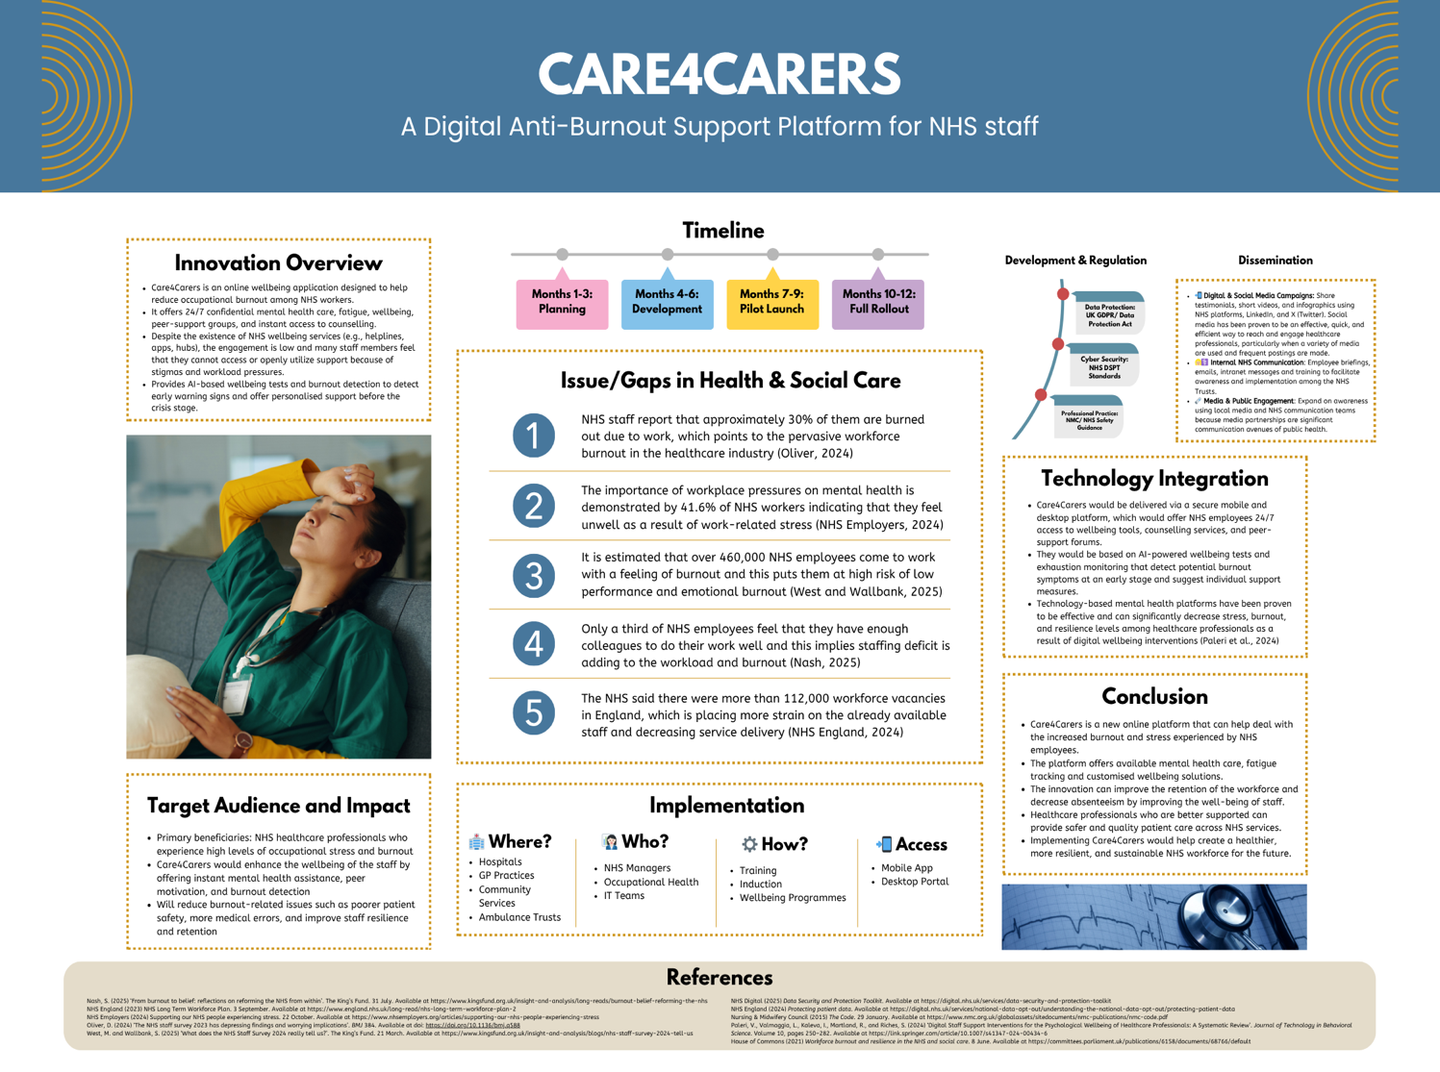

Introduction
Care4Carers is an online anti-burnout service aimed at helping NHS employees with mental health care, which is convenient and confidential. It addresses a vital gap: approximately 30% of NHS employees report burnout, and more than 41% experience work-related stress, underscoring the inadequacy of existing support mechanisms (Oliver, 2024; NHS Employers, 2024). Emotionally tired staff persist in their work, negatively affecting wellbeing and patient care (West and Willbink, 2025). The innovation has a positive impact on healthcare workers in NHS facilities by offering early intervention, personalised support, and unlimited access to resources. Staff wellbeing is vital in workforce retention, quality care delivery, and a resilient healthcare system (Cohen et al., 2023).

Background
NHS employees have developed burnout and poor mental health as a major issue of public concern, not only in terms of workforce sustainability but also patient care. The latest NHS Staff Survey data indicates that more than four in ten workers say they have felt unwell because of work stress, and almost one out of every three report burnouts because of work stress (NHS Employers, 2026). Besides that, over three-quarters (76%) of NHS workers said that they had a mental health condition in the last year, such as anxiety, low mood, and emotional exhaustion (NHS Charities Together, 2024). These results draw attention to a workforce that is experiencing chronic mental stress.
Burnout is a multifactorial problem caused by shortages of staff, excessive workloads, and emotional pressures. It is only approximately one-third of the staff who believe that they have enough colleagues to perform their duties well, thus leading to fatigue and poor quality of care (Oliver, 2024). This is in line with the research made by the Care Quality Commission (2025), which underlines the role of stress and fatigue on the well-being and safety of staff in health and social care systems.
The NHS England (2023) Long Term Workforce Plan, as well as other policy frameworks, acknowledge that staff wellbeing must be enhanced urgently to continue delivering safe and high-quality care. Nevertheless, even with the current wellbeing programs, there is evidence to indicate that the current support mechanisms are not enough to address the status of high levels of stress and mental health-related absences in the NHS workforce.

Innovation Description
Care4Carers is an online wellbeing hub that is specifically created and aimed at helping NHS personnel who are stressed, burnout, and emotionally exhausted. It is an app that is both mobile and web-based and offers confidential 24/7 access to mental health support that includes self-assessment tools, peer support networks, and access to professional counselling. The platform is based on AI-inspired wellbeing tracking (e.g., mood check-ins, stress levels) to detect the early indicators of burnout and trigger interventions in a timely and personalised way.
This innovation will enhance the current NHS support by changing the reactive services into proactive, preventative services. Existing mechanisms have the problem of relying on employees requesting assistance when they are in crisis mode, as not all of them do so because of stigma, time limitations, or ignorance (NHS Employers, 2024). Care4Carers tackles this by providing anonymous access and by being on demand and flexible, which makes it easier for staff to seek help early and regularly by the staff (Jangid, 2024).
The platform explicitly addresses the current problem of high stress and burnout in NHS workers, with more than 40% of them reporting work-related stress and many of them working despite their poor mental health (Oliver, 2024; West and Wallbank, 2025). Care4Carers offers sustained monitoring, customized resources, and combined support, which can decrease emotional exhaustion, enhance coping strategies, and wellbeing (Sedaghati et al., 2026).
This innovation will eventually benefit staff and patients through the enhancement of workforce resilience, a decrease in absenteeism, and a better quality and safety of care delivery (Sedaghati et al., 2026).

Impact on Health and Social Care
Care4Carers has a diverse range of beneficiaries in health and social care, with frontline NHS workers (nurses, junior doctors, and ambulance workers) being the most affected by burnout. It is also beneficial to newly qualified staff members, as they usually have more stress, and underrepresented populations (e.g., ethnic minority staff), who might have an even further disadvantage in accessing mental health assistance. The platform enhances equity and inclusion by offering confidential and flexible access, maintaining the ability of all staff to access support, irrespective of their position or background, without stigma.
Staff wellbeing leads to a direct effect on the quality of care and patient safety. It is found that low staff wellbeing and burnout are closely linked with more medical errors, decreased patient satisfaction, and care quality loss (Li et al., 2024). On the other hand, investment in the mental health of staff enhances patient outcomes and safety since healthier staff members are more active, more alert, and capable of providing compassionate care (Daniels et al., 2022).
The innovation also improves access to the support, providing 24/7 digital services that break the barriers of time limitations, stigma, and workforce shortage. This will minimize absenteeism and staff turnover, which have been known to affect service delivery and prolong waiting time adversely (Nicodemo, 2025).
Care4Carers, in general, can help the common good through enhancing the well-being of the workforce, the quality of care, and a more sustainable and equitable healthcare system in which the staff and the patients will be able to flourish.

Public and Stakeholder Involvement
Care4Carers will take a co-production strategy, which will extensively engage NHS employees, carers, and stakeholders in the process of designing, delivering, and evaluating the platform. Co-production means that individuals with lived experience collaborate on an equal basis with professionals to enhance the relevance and efficacy of services (NHS England, n.d.).

Engagement with the public will consist of surveys, focus groups, and pilot testing, which will enable staff to provide feedback and influence features. Online conversations will be facilitated by social media and forums to facilitate continuous discussions and broader engagement.
Through joint workshops and advisory panels, the stakeholders of the NHS Trusts, professional bodies, and staff unions will be engaged in making sure that the innovation meets the needs of the workforce and policy priorities.
Such an inclusive method fosters a culture of shared decision-making, equity and empowerment, resulting in more effective, user-centred solutions and better adoption in health and social care systems.

Policies, Services and Professional Links
Care4Carers complies with the major legislations in the UK, the Care Act 2014, which fosters the well-being and obliges organisations to promote the physical and mental well-being of individuals and the Equality Act 2010, which demands equal and fair access to services, especially to vulnerable populations. The platform is useful in alleviating disparities in mental health care access through the provision of confidential and accessible digital support (legislation.gov.uk, 2014; GEO and EHRC, 2015).
The innovation is an addition to the already available services like General Practitioners (GPs), occupational health teams, and voluntary organisations such as Mind to facilitate timely referral and integrated care.
It also facilitates professional roles such as nurses, social workers and allied health professionals by enhancing wellbeing, decreasing burnout, and assisting them in providing safe, high-quality care in accordance with the professional standards.

Conclusion
Care4Carers is a necessary innovation that responds to the growing crisis of burnout and mental ill-health among NHS staff, where existing support systems remain insufficient (NHS Employers, 2024; Oliver, 2024). By providing accessible, confidential, and proactive digital support, it offers a realistic and scalable solution that fits within current NHS structures. The platform has the potential to significantly improve staff wellbeing, enhance patient care, and strengthen workforce sustainability. Ultimately, Care4Carers supports a more resilient, equitable healthcare system, benefiting both professionals and the wider community (Cohen et al., 2023).

References
Care Quality Commission (2025) What was health care and adult social care like in England in 2024 and 2025? Available at https://www.cqc.org.uk/sites/default/files/2025-10/20251024_stateofcare2425_easyread.pdf (Accessed date 18th April 2026)
Cohen, C., Pignata, S., Bezak, E., Tie, M., and Childs, J. (2023) ‘Workplace interventions to improve well-being and reduce burnout for nurses, physicians and allied healthcare professionals: a systematic review’. BMJ Open. 13(6):e071203. doi: 10.1136/bmjopen-2022-071203. Available at https://pmc.ncbi.nlm.nih.gov/articles/PMC10314589/ (Accessed date 18th April 2026)
Daniels, K., Connolly, S., Woodard, R., van Stolk, C., Patey, J., Fong, K., France, R., Vigurs, C., and Herd, M. (2022) ‘NHS staff wellbeing: Why investing in organisational and management practices makes business sense: A rapid evidence review and economic analysis’. IPPO. https://eppi.ioe.ac.uk/cms/Portals/0/IPPO%20NHS%20Staff%20Wellbeing%20report_LO160622-1849.pdf (Accessed date 20th April 2026)
Government Equalities Office and Equality and Human Rights Commission (2015) ‘Equality Act 2010: guidance’. Gov.UK. 27 February. Available at https://www.gov.uk/guidance/equality-act-2010-guidance#overview (Accessed date 24th April 2026)
Jangid, A. (2024) ‘AI AND EMPLOYEE WELLBEING: HOW ARTIFICIAL INTELLIGENCE CAN MONITOR AND IMPROVE MENTAL HEALTH IN THE WORKPLACE’. International Journal of Advanced Research. 12(10), 743-764. ISSN: 2320-5407. DOI:10.21474/IJAR01/19693. Available at https://www.researchgate.net/publication/385707875_AI_AND_EMPLOYEE_WELLBEING_HOW_ARTIFICIAL_INTELLIGENCE_CAN_MONITOR_AND_IMPROVE_MENTAL_HEALTH_IN_THE_WORKPLACE (Accessed date 18th April 2026)
Legislation.gov.uk (2014) Care Act 2014. Available at https://www.legislation.gov.uk/ukpga/2014/23/contents (Accessed date 18th April 2026)
Li, L. Z., Yang, P., Singer, S. J., Pfeffer, J., Mathur, M. B., and Shanafelt, T. (2024) ‘Nurse Burnout and Patient Safety, Satisfaction, and Quality of Care’. Jama Network Open. Vol. 7, No. 11. Available at https://jamanetwork.com/journals/jamanetworkopen/fullarticle/2825639 (Accessed date 24th April 2026)
NHS Charities Together (2024) Three in four NHS staff struggled with their mental health in the past year. 17 April. Available at https://nhscharitiestogether.co.uk/news/research/three-in-four-nhs-staff-struggled-with-their-mental-health-in-the-past-year (Accessed date 20th April 2026)
NHS Employers (2026) NHS Staff Survey results 2025. 12 March. Available at https://www.nhsemployers.org/news/nhs-staff-survey-results-2025 (Accessed date 24th April 2026)
NHS England (n.d.) Co-production. Available at https://www.england.nhs.uk/always-events/co-production (Accessed date 18th April 2026)
NHS England (2023) NHS Long Term Workforce Plan. 3 September. Available at https://www.england.nhs.uk/long-read/nhs-long-term-workforce-plan-2 (Accessed date 18th April 2026)
Nicodemo, C. (2025) ‘Investing in NHS staff wellbeing could produce economic benefits the UK desperately needs’. Brunel University of London. 19 June. Available at https://www.brunel.ac.uk/news-and-events/news/articles/Investing-in-NHS-staff-wellbeing-could-produce-economic-benefits-the-UK-desperately-needs (Accessed date 24th April 2026)
Oliver, D. (2024) ‘The NHS staff survey 2023 has depressing findings and worrying implications’. BMJ 384. Available at doi: https://doi.org/10.1136/bmj.q588 (Accessed date 20th April 2026)
Sedaghati, F., Stetsenko, A., MacMillan, I. O., Nagra, H., and Dana, Z. (2025) ‘Use of Digital Peer Support for Employee Well-Being: Retrospective Analysis Across Five Large Employers’. JMIR Publications Vol. 13. Available at https://humanfactors.jmir.org/2026/1/e90431 (Accessed date 24th April 2026)
West, M. and Wallbank, S. (2025) ‘What does the NHS Staff Survey 2024 really tell us?’. The King’s Fund. 21 March. Available at https://www.kingsfund.org.uk/insight-and-analysis/blogs/nhs-staff-survey-2024-tell-us (Accessed date 24th April 2026)

