
BA Applied Leadership and Management in the Workplace
Module Assignment Submission
Student Name: | Lyssa Muir
Student Number: | 1917752
Module No: | BMSK5013
Module Title: | Knowledge and Information Management Skills for the Workplace

Date submitted: | 19th May 2024
Time submitted: | 16:30 PM

Statement of Confirmation of Authenticity
By the act of making this submission, the student declares that this is the work of the student named above. The work has not, in whole or in part, been knowingly presented elsewhere for assessment, or where assessment has been built on a previous assessment, this has been identified. Where materials have been used from other sources it has been properly acknowledged. If this statement is untrue, the student acknowledges that an assessment offence has been committed.
Attention is drawn to the plagiarism and unfair practice policies of both the University and of ILM.

Contents

- Introduction
- Knowledge, Data and Informartion
- The relationship between Knowledge, data, and Information
- Individual Knowledge and Organisational Knowledge
- SWOT and PESTEL analysis in identifying Knowledge assets.
- Evaluation of actual and potential knowledge assets in my workplace
- What is required to create, store, apply and integrate knowledge?
- The contribution knowledge assets have on an organisation.
- Evaluation of Workplace framework for knowledge sharing
- Organisational improvements for knowledge sharing
- Conclusion
- References

Introduction
This report will take a closer and more in depth look at knowledge and information management, particularly for the workplace. The report will explore and include what is knowledge, Tacit and Explicit Knowledge, Implicit knowledge, and knowledge management. It will include the definition for each knowledge, information and data and the link between each and how my workplace implements and utilises these. SWOT and PEST analysis tools were used to identify the strengths and weaknesses of the knowledge assets that are used in the health board, before moving on to discuss the contribution knowledge assets have on the organisation. Then to finalise the report a personal evaluation was completed to evaluate the methods the health board uses when it comes to knowledge sharing and recommendations on what areas are needed to improve. This report will highlight more about the processes and methods of which the health board use when use when it comes to knowledge management and knowledge sharing.

What is knowledge, Data and Information?
Knowledge, Knowledge is having the understanding or an awareness of a certain subject or topic. Knowledge is typically acquired through education, experiences or being told some information by someone. There are different types of knowledge, those being Tacit, which is also known as implicit knowledge and then Explicit knowledge. Tacit or implicit knowledge is more likely developed through experiences such as work experiences and life experiences that have occurred over a period, intuition- an example being is having a gut instinct that you know something is/ isn’t right, typically knowledge that is stored in our heads, knowledge we don’t even think about. Explicit knowledge is the knowledge that is more commonly found and passed on through individuals or through books, text, emails, leaflets, manuals, articles, how- to videos, documentation, and files. Explicit knowledge is formed through data and information that can be readily available and easily interpreted for everyone who has access to understand. Explicit knowledge is used daily in large organisations especially those of NHS to share important knowledge/ information with colleagues, Staff, and patients etc. Next, we look at knowledge management, what is it? Knowledge management is the process in which an organisation identifies, stores, organizes, utilizes, and shares information with its employees, shareholders, customers, external agencies etc. It’s vital that large organizations have effective knowledge management strategies to ensure the smooth running of their organisations. If effective knowledge management are implemented in organisations, then it can be beneficial for the organisation in areas such as decision making, team collaboration, enhances effective communication, develop better processes and strategies, improved organisational efficiency and performance, aids in the growth and development of staff and sharing valuable expertise with new staff, the benefits are endless. As with every positive there do come some challenges of knowledge management of which can be motivating staff to engage, share, apply and reuse knowledge consistently, signposting and making resources easier to find, choosing and applying a method of knowledge management technology, integrating knowledge management into current organisation processes.

"The single greatest challenge facing managers in the developed countries of the word is to raise the productivity of knowledge and service works"
Peter F. Drucker 1909-2005, American management guru, in Harvard Business Review Nov-Dec 1991

- Famous quotes on Knowledge Management. (n.d.-a). https://www.12manage.com/quotes_ki.html- Accessed- 10/05/2024
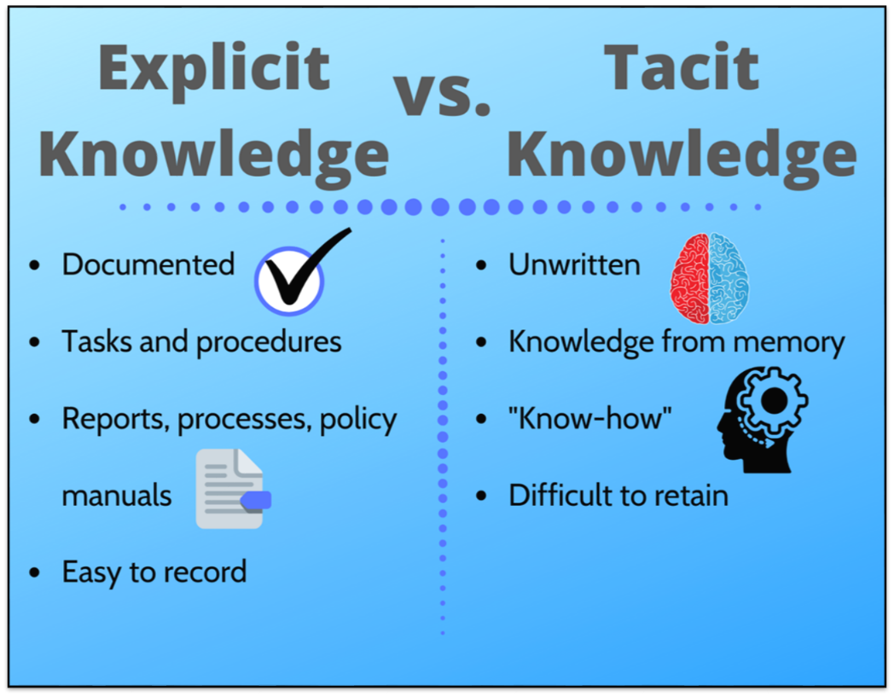

- The Human Capital Hub. (2020, October 23). Knowledge management: Everything you need to know. Human Capital Hub. https://www.thehumancapitalhub.com/articles/Knowledge-Management---Everything-You-Need-To-Know

Data- Data is a piece or a set of information used to as a collective to help find an answer or solution to something when decision making. Data is also used to help form statistics such as the statistics used in the consensus comes from data that has been gathered. In the health board data is gathered many different ways through the medium of surveys and questionnaires etc. Within my organization most of the data held is confidential personal data on our patients. Confidential personal data is usually name, address, date of birth, medical history etc. This information is highly confidential and only can be shared between staff working with the patient and in certain cases if there are safeguarding concerns. If this personal data is shared without consent, incorrectly or without following protocols then it could result in disciplinary actions, suspension from post, court case and even resulting being issued a high value fine. The breaching of GDPR within my organisation are taken very seriously as you can be dealing with highly confidential data. The data protection act was developed in 1998 to control the way data is held and used. It gives individuals legal rights when it comes to their personal data. The data protection act amended in 2018 to incorporate GDPR.
Information- Information is facts or something that someone has been told or learnt which can be from sources such as reading a book, watching a video, or watching someone do something etc. Information is also the facts we have collected from data. We as individuals encounter new information and learn new things daily. Information sharing plays a huge part in organisations, it enables innovative ideas, skills and knowledge enhancements, effective communication, job satisfaction, better outcomes. We use many modes of information sharing within the health board of which include verbally, emails, documenting at the end of each shift, hand over after each shift, policies and procedures, leaflets, staff shadowing, training sessions, appointments, Microsoft teams and completing assessments, the list is endless within such a large organisation. Moving with the times most large organisations share their information within their organisation and externally digitally, this has progressed more so since the global covid-19 pandemic, when most organisations were remote working at home digitally.

“Know where to find the information and how to use it – That’s the secret of success.”
— Albert Einstein
- Albert Einstein quote: “know where to find the information and how to use it – that’s the secret of success.” Quotefancy. (n.d.). https://quotefancy.com/quote/763398/Albert-Einstein-Know-where-to-find-the-information-and-how-to-use-it-That-s-the-secret-of Accessed 15/05/2024

The relationship between knowledge, data, and information
Knowledge, data, and information are integral in the workplace and larger organisations. On occasions some organisations can get confused between the differences of Knowledge, data, and information. Many organisations, particularly new and inexperienced ones, implement the running, routines, and procedures of their organisation with the data and information they hold, without considering how reliable and sustainable their knowledge sources are. This can have negative impacts on the organisation’s success. Many often link the relationship between knowledge, information, and data with the pyramid, this is known as the knowledge hierarchy, I have included a diagram below. Data being at the bottom and knowledge being at the top, aiming to highlight the process that data, turns into information, which in return turns into knowledge which then can be applied in the workplace.

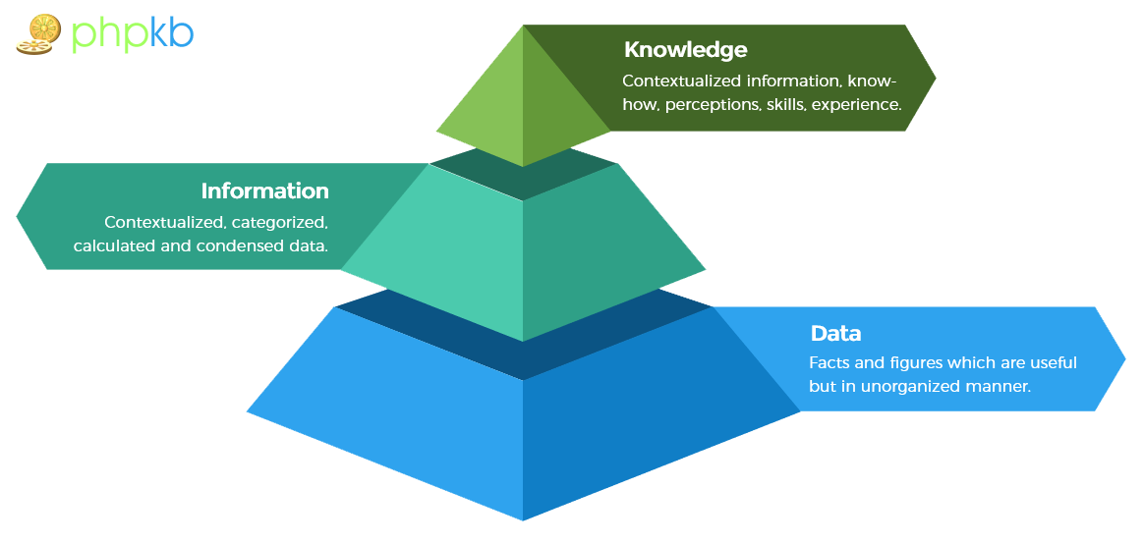

- Chadha, A. (2021, October 9). Defining knowledge, information, data. PHPKB. https://www.phpkb.com/kb/article/defining-knowledge-information-data-239.html Accessed- 10/05/2024

Individual knowledge and Organisational knowledge
Individual knowledge is knowledge a person holds as individuals usually developed through individual experiences, lessons, and skills they possess. Whereas organisational knowledge is all the knowledge an organisation holds. Usually collective knowledge, knowledge that is developed through the collective organisation, processes, policies, procedures, and experience.
“Organizational Knowledge is the specific knowledge of the organization, coming either from its collective experience or from the individual experience of its persons. In an explicit or implicit way this knowledge is, or can be, used to attain the organization’s objectives.”
Auditing Practices Group Guidance on: Organisational Knowledge, ISO & IAF (2016)
Individual and organisational knowledge are vital in the successful running and productivity of workplaces and organisations. The knowledge is used to meet the organisations objectives and vision, improve communication, enhances growth and development, increases employee satisfaction and wellbeing, mitigates risks, aids, and enhances learning and development of employees and increases innovation and creativity.
There are many different sources of knowledge in the organisation that I am employed, these include structural sources such as routines, IT systems, workplace/ organisation culture, team meetings, processes, training, desktop portals/ programmes, emails, Microsoft teams. Structural knowledge can be referred to tacit or implicit knowledge it is the things we do routinely in the workplace without even thinking. Another source of knowledge in the NHS is organisational, this is the knowledge that is held in the organisational policies, procedures, guidelines, regulations, reports, staff surveys etc.

Analysis- Identifying knowledge assets-
Most knowledge assets within the health board are digital. A SWOT analysis and a PESTLE analysis has been created to identify the pros and cons of such Knowledge assets within a large organisation. With the successful use of SWOT and PESTLE analysis enables organisations to have a clearer view, evaluate and mitigate risks within their organisation. The SWOT and PESTLE analysis has been completed and applied to the knowledge assets that are in place by the health board (my organisation/ workplace).
SWOT Analysis
STRENGTHS  - Modern- Moving with the times.  - Easily Transferrable  - Regular feedback- know areas in which need to improve and what areas are doing well. | WEAKNESSES  - Not everyone finds it easy accessing these sources of information digitally/ using technology.  - Computer not readily available in certain job roles.  - Lack of time.  - Too many sources of knowledge assets- can be confusing.  - Too many staff to train/ inform.
OPPORTUNITIES  - Can Increase staff understanding, efficiency and productivity.  - Potential growth/ profit for organisation  - Staff satisfaction  - Good organisational reputation | THREATS  - IT Issues- Unable to access systems and relevant documents.  - Errors being made- due to large organisation and having high levels of staff, maybe not all have the knowledge or have been informed.

PESTLE Analysis
POLITICAL  - Follows organisation guidelines.  - Policies and procedures.  - Increase in political media issues in regards to nhs. | ECONOMIC  - Costly to the organisation to implement new programmes/ procedures- potential risk they may not work well.  - Costly to organisation employing and training new staff- especially if they end up leaving organisation. | SOCIAL  - Large organisation with a diverse multi-cultural workforce, potential language barriers which can cause misunderstanding about certain knowledge assets.  - Cultural issues/ beliefs.  - Media/ Press/ social media
TECHNOLOGICAL  - IT Issues  - Staff training on how to use new technology and new programmes. | ENVIRONMENTAL  - High staff intake and turn over- loads of new staff train.  - Busy work environments- things can be missed, potential for misunderstanding errors. | LEGAL  - Accidental breaches of confidentially.  - Information not documented thorough or clear enough- errors will be made due to lack of understanding.  - Policies, procedures, legislations.

- Both SWOT analysis and PESTLE analysis have been used to evaluate and identify the potential risks that the knowledge assets have within my organisation. There are risks every organisation must take for them to see what methods and processes work best for their business. A lot of the knowledge assets within the health board are technological and more risks come with technology more so than other potential knowledge assets, we all know how reliable IT is. IT systems fail, they require down time for routine maintenance, software viruses and hackers- all of which are huge risk to the organisations knowledge and their profits. But it is the 21st century and things are moving more digitally as a whole, and organisations must move with that to keep up. With these risks, I do think they have minimal affect because they don’t occur and happen frequently. The positive of the use of the technological knowledge assets override the risks as a whole. Being such a large organisation, there are many processes in place if any of the potential risk were to occur.
Evaluation of actual and potential knowledge assets in my workplace
Actual Asset | Evaluation Method | Potential Asset | Evaluation Method
Intellectual asset | - Monitoring organisations profits or losses. | Technological asset | - Regular IT system updates, maintenance and checks to ensure smooth running.  - Regular Training for staff to be competent and efficient in using technology in organisation.  - Staff survey to see how they feel using technology.  - Risk assessments- will confidential be securely and safely stored on desktop.
Human asset | - Regular training sessions.  - Promotion/ career progression  - Questionnaires | Learning/ Training | - Regularly monitor/ review staff training compliance percentage.  - Regular performance appraisal reviews/ personal development reviews.
Intangible asset | - Regularly review, monitor and update things if needed.  - Questionnaires.  - Audits | Policies, Procedures and Guidelines | - Monitor that they are being followed.  - Signpost to staff where they are kept.  - Training  - Update if and when needed.
Physical Assets | - Completing Reports  - Audits

What is required to create, store, apply and integrate knowledge?

In the NHS information is stored in many different platforms, depending on the information being stored and whether it is confidential or not. Organisational information for staff such as policies, procedures, guidelines, forms, board meeting minutes and certain programmes can be easily accessible to staff on the health boards intranet page. If policies, procedures, guidelines and forms have been changed then the updated version will be available on the health boards intranet page. Non confidential information can also be found on health board desktop drive, booklets, regular emails, daily global emails, that get sent to staff. When it comes to confidential information such as patient details and in particularly in my workplace information is kept in an individual personal file on the drive, which is password protected and only those who work in the workplace or those who are authorised have access to these details if needed when they are working with the patient/ if the patient is open on their caseload. Patient information is also stored on WPAS (Welsh patient administration system), WNCR (Welsh Nursing Care Record)- for nursing staff to complete inpatient documentation and Care Partners, which is used by staff across all health boards to document on patients who are under mental health or learning disability teams. Information can also be shared by staff through the medium of share point, password protected emails, Microsoft teams and attend anywhere which are often used daily now in the NHS. On some occasions if needed there are also printed copies of confidential patient information, these are stored in a personal file in a locked cupboard/ unit and disposed of correctly when no longer required. Once Confidential Information records within the health board have reached their lifecycle then they must be disposed of in the correct manner adhering to the guidelines, once records have been destroyed/ disposed of they will be marked as destroyed on the Welsh patient administration system. Although all these confidential files are securely stored to maintain GDPR, there are risks especially with the unpredictability of IT issues in large organizations, there’s the risk, although rare of files going missing, staff not storing them correctly, staff accidentally sharing confidential information, temporarily not having access to them due to IT issues. In a busy and demanding work environment, mistakes can be made, human error. There are processes in place within the health board if staff were to accidentally make an error, for instance sending information about the wrong patient to someone else. Firstly, if this were to happen, they would have to report it to their line manager and they would be supported through the process.
In this age many large organisations have intellectual property, what is intellectual property? It is the creations, assets, trademarks, copyrights that have been created by an individual or organisation. Intellectual Property (IP) is protected by law which prevents any unauthorised use or plagiarising of an organisation’s intellectual property. IP Also enables organisations to expand, gain profits and appeal to wider public. Intellectual Property encourages innovative and unique designs.

The contribution knowledge assets have on an organisation.
There are numerous knowledge assets within the health board, these can be used to improve the way a specific department or the organisation operates. Annually within the organisation staff are sent employee surveys to complete, which asks questions such as around job satisfaction, feeling valued and supported, staffing issues, training/ career progression opportunities, what can be done to improve the workplace etc and recommend working for the health board to friends or family. The information gathered from staff completing these surveys can be used to make positive changes within the workplace. Through experience and my own knowledge that I have, very few staff who work within the organisation complete these surveys annually because they feel as nothing ever comes from the feedback that they have given. There is also a relatively new service within the last couple of years in the health board and that is the patient liaison service. This service was put into place to help patients have a more comfortable, satisfied stay whilst at hospital and help in responding to patients’ queries, concerns, and complaints. The PALS team also on occasions complete patient feedback surveys, to help in enabling smoother, better patient experiences within the health board. Feedback from the patient surveys is usually acted upon and changes are made when needed more frequently than the feedback from staff surveys.

Evaluation of workplace framework for knowledge sharing
The health board have of platforms which are used when it comes to knowledge sharing. Within the health board there are many different methods of information and knowledge sharing. Regular day to examples being having regular MDT meetings, relaying information via emails or Microsoft teams, attend anywhere, regular training sessions on different topics from a variety of different disciplines, ESR training, Health board intranet, Patient liaison service, WNCR, WPAS and Care partners. These methods of knowledge sharing within the organisation I feel very beneficial not only to the organisation but to the staff as it creates more awareness, general and mutual understanding, effective communication, new individual knowledge, increased productivity, increased accuracy and efficiency and it helps create better personal and organisational outcomes. When it comes to the accessibility and sharing of the organisations policies, procedures, and guidelines because they are located on the health boards intranet, they can be a little more difficult to locate unless you know exactly what policy, procedure, guidelines or forms you are looking for. This can prove to be especially difficult for those staff members who aren’t savvy with technology or those who don’t have access to a computer or are not in an administrative role. Overall, the use and implementation of these methods of knowledge sharing within my organisation are very beneficial to the staff individually and the organisation. Although minor inconveniences can occur from time to time, such as IT issues which can prevent the knowledge sharing, they are usually resolved promptly.
Organisational Improvements for knowledge sharing
Being a large organisation, I do feel that the knowledge sharing methods and platforms work well. Although generally good, there could be some slight improvement that the organisation could implement when it comes to knowledge sharing. Access to policies, procedures and forms should be more readily available and each department should have printed copies for those who don’t and can’t access the online versions, this will enable more efficiency and understanding to those individuals. On occasions due to the department, I work for in my organisation office being in an external organisation premises we have ongoing IT issues which make it difficult to access the files and things we need when these issues are ongoing. Some of the programmes and portals we use daily are regularly being updated or the systems are down which can cause disruptions to workflow and being able to attain the things needed to be able to complete our jobs. New electronic patient documentation systems have been put in place of recent in place of the old hand written paper documentation, initially this caused many teething problems as staff were struggling to gain access, not everyone was trained to use it in a timely manner, temporarily faulty systems which then resorts in staff having to go back to handwritten documenting when on shift which is very time consuming in a role where there isn’t enough time.

Conclusion
To conclude this report, it has been identified throughout and is clear that the importance of effectively creating, storing, using, sharing information and knowledge management is vital in the successful operation of any organisation. The report has covered and looked closely at everything from the relationship between information, knowledge, and data to how it is used, stored, and shared in the organisation I work for. To finalise the report, we looked at and evaluated the current methods and processes my organisation currently implements, and identified the strengths and areas in which they could improve when it comes to information sharing and knowledge management. It was identified after evaluation that overall the knowledge management system within the health board generally works well, but as with anything there are areas for improvement as stated above.
References
- Knowledge | definition in the Cambridge english dictionary. (n.d.). https://dictionary.cambridge.org/us/dictionary/english/knowledge Accessed- 7/05/2024
- Tacit knowledge | english meaning - cambridge dictionary. (n.d.-b). https://dictionary.cambridge.org/dictionary/english/tacit-knowledge Accessed- 7/05/2024
- Freedman, M. (2024, February 6). Tacit knowledge: Significance, advantages, and examples. Fellow.app. https://fellow.app/blog/productivity/tacit-knowledge/ Accessed- 8/05/2024
- Tacit and explicit knowledge. (n.d.). https://www.hrmguide.co.uk/learning/explicit_tacit.htm Accessed- 8/05/2024
- What is knowledge management?. IBM. (2024, April 8). https://www.ibm.com/topics/knowledge-management Accessed- 9/05/2024
- Knowledge management and business growth. Advantages and disadvantages of knowledge management. (n.d.). https://www.nibusinessinfo.co.uk/content/advantages-and-disadvantages-knowledge-management Accessed- 9/05/2024
- Famous quotes on Knowledge Management. (n.d.-a). https://www.12manage.com/quotes_ki.html Accessed- 10/05/2024
- Data | English meaning - cambridge dictionary. (n.d.-a). https://dictionary.cambridge.org/dictionary/english/data Accessed- 10/05/2024
- Chadha, A. (2021, October 9). Defining knowledge, information, data. PHPKB. https://www.phpkb.com/kb/article/defining-knowledge-information-data-239.html Accessed- 10/05/2024
- What is organisational knowledge and why is it important? - wynleigh international certification services. Wynleigh International Certification Services - Leaders in ISO Certification. (2023, May 4). https://www.wynleigh.com/quality-management/what-is-organisational-knowledge-and-why-is-it-important/ Accessed- 11/05/2024
- Hajric, E., Benjamin, K. A., Carsen, J., Matton, A., & Grensing-Pophal, L. (2019, May 28). What is organizational knowledge, and where can I find it?. HR Daily Advisor. https://hrdailyadvisor.blr.com/2019/05/30/what-is-organizational-knowledge-and-where-can-i-find-it/ Accessed- 12/05/2024
- What is intellectual property (IP)?. WIPO. (n.d.). https://www.wipo.int/about-ip/en/ Accessed- 12/05/2024
- How your organization’s experts can share their knowledge. Harvard Business Review. (2021, August 6). https://hbr.org/2019/12/how-your-organizations-experts-can-share-their-knowledge Accessed- 13/05/2024
- Information | english meaning - cambridge dictionary. (n.d.-c). https://d ictionary.cambridge.org/dictionary/english/information Accessed- 13/05/2024
- Albert Einstein quote: “know where to find the information and how to use it – that’s the secret of success.” Quotefancy. (n.d.). https://quotefancy.com/quote/763398/Albert-Einstein-Know-where-to-find-the-information-and-how-to-use-it-That-s-the-secret-of Accessed- 15/05/2024
- The Human Capital Hub. (2020, October 23). Knowledge management: Everything you need to know. Human Capital Hub. https://www.thehumancapitalhub.com/articles/Knowledge-Management---Everything-You-Need-To-Know Accessed- 15/05/2024
- Seismic. (2022, October 21). Data, information, and knowledge: What’s the difference? https://seismic.com/blog/data-information-and-knowledge-whats-the-difference/ Accessed- 16/05/2024
- Data protection. (2011, November 15). GOV.UK. https://www.gov.uk/data-protection Accessed- 16/05/2024
- Just a moment... (n.d.). Just a moment... https://www.indeed.com/career-advice/career-development/knowledge-assets Accessed- 17/05/2024
- (n.d.). Forbes. https://www.forbes.com/sites/forbestechcouncil/2023/10/27/data-ecosystems-how-information-sharing-improves-businesses/ Accessed- 18/05/2024
- PESTLE analysis: A key risk management tool. (2023, June 25). WuDo Solutions. https://www.wudo.solutions/pestle-analysis-a-key-risk-management-tool/ Accessed- 19/05/2024

