Report on Moodle
Digital skills
Sakara Lauren campbell
1908201
Lecturer Balan Kandasamy

Table of contents
Executive summary
Introduction
Literature review
Primary research
Methodology
Ethical considerations
Results
Limitations of the study
Conclusion
References
Appendix

Executive summary
Moodle is Modular Object-Oriented Dynamic Learning Environment
Moodle is an acronym for "Modular Object-Oriented Dynamic Learning Environment." It is an online educational platform that provides custom learning environments for students. Educators can use Moodle to create lessons, manage courses, and interact with teachers and students.3 Mar 2018
For me Moodle means that I have access to my learning material at all times meaning I have a more greater chance of success because I can always go back to the lesson and go back over anything the lecturer has discussed in class getting greater understanding of the modules, I believe Moodle also helps with remaining in contact with other students and lectures at all times.
The purpose of the study I have done is to asses the impact of Moodle on students, I done this by asking a series of question to my fellow students which made my survey a convenient survey, I made sure that I kept everyone’s information confidential by not asking anyone to leave any person details. I wanted everyone to be honest with their answers so I made sure not to put any pressure of asking them to leave any contact details.

Introduction
In this report I am going to talk about Moodle. Moodle is an online learning platform which helps provide educators, administrators and learners with a secure and integrated system to create personalised learning environments (martin dougiamas). Moodle is a sufficient way to continue learning in any environment even after the lecture has finish you can go back on Moodle to recap over the lessons you have been taught. Moodle has many different functions working within the program, students can access their emails and look over lesson plans to be well prepared for the lesson ahead and go back over lesson to continue studies. Students can also submit work through Moodle and speak to anybody within the university on Moodle.
My main aim and objective is to find out how useful other university students find Moodle. I want to find out if students even access Moodle at all to stay connected with the university, or what anybody would recommend improving about Moodle.
I personally think Moodle can do with some improvements, as sometimes I cannot access my emails as it doesn’t gain me access and I found it very difficult the first time I had to upload my assignment through Turnitin. As I do studies and research I will find out if many or any students feel the same way.
Literature review
I have done some secondary research on some other university students review on Moodle. I found that a lot of university use Moodle as a way of e learning (Umek, Kerzic, Aristonik and Tomazevic 2015) reading a report from these guys they say that by doing there research on Moodle they found that some institutes use e- learning completely taking away the old way of learning face to face. The student did their studies in a university in Ljubljana they “analysed the relationship between the proportion of the course implemented in the Moodle e learning platform to work out satisfaction ad performance”. Their findings were that Moodle was a positive correlation for performance and satisfaction, finding that it can enhance student’s success. The results that the students collected showed them that by added Moodle to learning increased the student’s effectiveness and improved grades.
Primary research
Methodology
I did a convenient sampling survey; I did this by asking all my classmates to fill in a questionnaire that I formed on Microsoft forms. I asked them a series of 10 question and waited for a response once I got all responses, I collected my results and charted them in a frequency table and bar chart.
The questions I asked:
- What is your gender?
- What is your age?
- Do you find Moodle helpful?
- If yes, please explain why?
- How often would you access Moodle?
- How would you rate Moodle for effective home learning?
- Do you find it easy to find assignments and deadlines on Moodle?
- Do you find it easy to submit your work on Moodle?
- If you do not find it easy to submit your work, please explain why?
- Would you recommend Moodle to others?
Ethical considerations
To protect everyone’s identity and privacy I did not asked anybody any personal details for example I didn’t require them to leave an email address or use their personal id numbers, when filling out my survey they will be anonymous so there is no way to trace anybody back.
Results
Question 1: this is a qualitative nominal as the answers with be personal to each person.

- What is your gender | Male  Female  Non-binary  Prefer not to say | ☐  ☐  ☐  ☐

Frequency table

Types of gender | count of respondent
Male | 3
Female | 8
Non-binary | 0
Prefer not to say | 0
Grand total | 11

N.B this pie chart shows the percentage of people who answered my question.

Question 2
This question is a qualitative nominal
What is your age? | 18-24  25-34  35-44  45-54  55-64  65 and above
Frequency chart
What is your age? | Counts of respondent
18-24 | 3
25-34 | 3
35-44 | 2
45-54 | 2
55-64 | 1
65 and over | 0
Grand total | 11

NB this bar chart shows the age range of everyone that I asked my questionnaire.
Question 3
This question is a qualitative binary
Do you find Moodle helpful?
Yes
No
maybe
Frequency table
do you find Moodle helpful? | Counts of respondents
Yes | 10
No | 0
Maybe | 1
Grand total | 11

NB this bar chart shows the number of respondents to say if they find Moodle useful or not.
Question 4
If yes, please explain why? This question is a quantitative discrete
Reponses
1 | anonymous | Good learning materials
2 | anonymous | Because help me to understand the topic better and study when when I want.
3 | anonymous | If I miss a class, I can check what I missed
4 | anonymous | I go on moodle prior lecture
5 | anonymous | I can study at home
6 | anonymous | Good learning platform
7 | anonymous | Is a platform that helps us with the continuous learning of the university different modules.
8 | anonymous | It clarifies many doubts for me
9 | anonymous | If you miss a class, you can see the slides on Moodle
NB this shows the response to the question asked in a form of each person’s opinion.
Question 5
This is a qualitative continuous
Question 5  How often do you use Moodle | answers | Please tick one
 | Daily | ☐
 | Weekly | ☐
 | Monthly | ☐
 | Seasonal | ☐
 | Yearly | ☐
 | never | ☐
Frequency table
How often do you use Moodle? | Counts of respondents
Daily | 2
Weekly | 8
Monthly | 0
Seasonal | 0
Yearly | 0
Never | 0
Grand total | 10

NB this bar chart shows that people use Moodle on a weekly and daily basis
Question 6
This is a quantitative discrete
How would you rate Moodle for effective home learning?
I asked all respondents to rate their home learning experience out of 5.
The results I got from this was a rating of 4.5 for their overall experience of home learning when it came onto using Moodle.
Question 7
This is a qualitative binary question
Question 7  Do you find it easy to find assignments and deadlines on Moodle? | Answers | Please tick one
 | Yes | ☐
 | No | ☐
 | Maybe | ☐
Frequency table
Do you find it easy to find assignments and deadlines on Moodle? | Counts of respondents
yes | 8
No | 0
Maybe | 3
Grand total | 11

NB this bar chart shows most people find it easy to find work and deadlines on Moodle with a small number suggesting maybe.

Question 8
This is a qualitative binary question
Question 8  Do you find it easy to submit your work on Moodle? | Answers | Please tick one
 | Yes | ☐
 | No | ☐
 | Maybe | ☐
Frequency table
Do you find it easy to submit your work on Moodle? | Count of respondents
Yes | 11
No | 0
Maybe | 0
Grand total | 11

NB this bar chart shows that everyone I asked finds it easy to submit work on Moodle

Question 9
This is a quantitative discrete question
Question 9
If you do not find it easy to submit your work, please explain why?
The result I got for this question was no response as my frequency table shows you from the previous question everybody found it easy to submit their work on Moodle, so nobody had anything more to add.
Question 10
This is a qualitative binary question
Question 10  Would you recommend Moodle to other students? | Answers | Please tick one
 | Yes
 | No
 | Maybe
Frequency table
Would you recommend Moodle to other students? | Counts of respondents
Yes | 10
No | 0
Maybe | 1
Grand total | 11

NB this bar chart shows majority of people would recommend Moodle
Limitation of studies
I had a limitation to my studies as I was not able to connect with a lot of students to get a broader response. I manage to do a convenient method to ask people to fill in my questionnaire, in total I asked 12 students as I only had access to the 12 student in my what app group we created in class. Another major limitation was that university had to be closed early because the world is experiencing a pandemic limiting me to the number of students, I can give my questionnaire too. I know if I were able to connect to more students, I would have got much more clearer results to analyse and come to an understanding if students find Moodle a useful overall.
Conclusion
My conclusion in a whole is that I found that because I didn’t question the amount of people I wanted to, I was expected to give my survey to 30 people but instead I only managed 12 which I believe impacted in my quality of getting a effective results, the result I got is I manage to analyse and came to a steady conclusion that most of the students feel Moodle is very useful as it helps with assignments and learning material that you can always have access to whenever needed, it also gives you the opportunity to email the lectures directly meaning you can have contact and support throughout your studies.
What I would improve on Moodle is add more services on there for example it would improve learning and have an better impact on your Moodle learning experience, if we was able to talk to lectures through live chats specially now because of the times we are living in and not being able to have face to face learning , which is completely new to some studies and could be very challenging for them. Moodle is a great learning tool because it gives you everything you need to know about your studies, giving you access to online material and lecture plans and assignment details at all times you can access this information allowing for greater understanding of your module. Moodle has become an essential part of the way we learn now because of this pandemic we are living in. I believe Moodle has been put to the test, with all student having to continue studies at home without Moodle I think being able to complete our studies would have been much harder but by having access to learning material and the lesson plans to be able to look over made the experience much more easier to get through. Overall I think Moodle is very effective interactive learning material from my results its clear all students find it very useful even though I didn’t get to question many students it shows that Moodle has a great impact towards learning with everyone having a positive attitude towards the interactive learning experience on Moodle.
Reference

Moodle Definition - TechTerms.com
techterms.com › definition › moodle

Appendix A
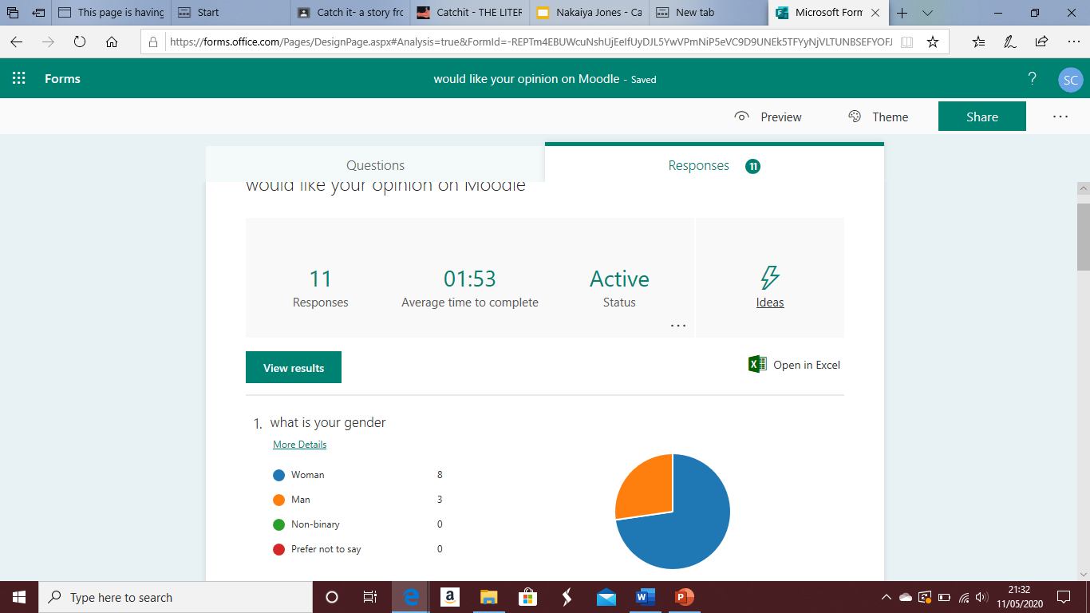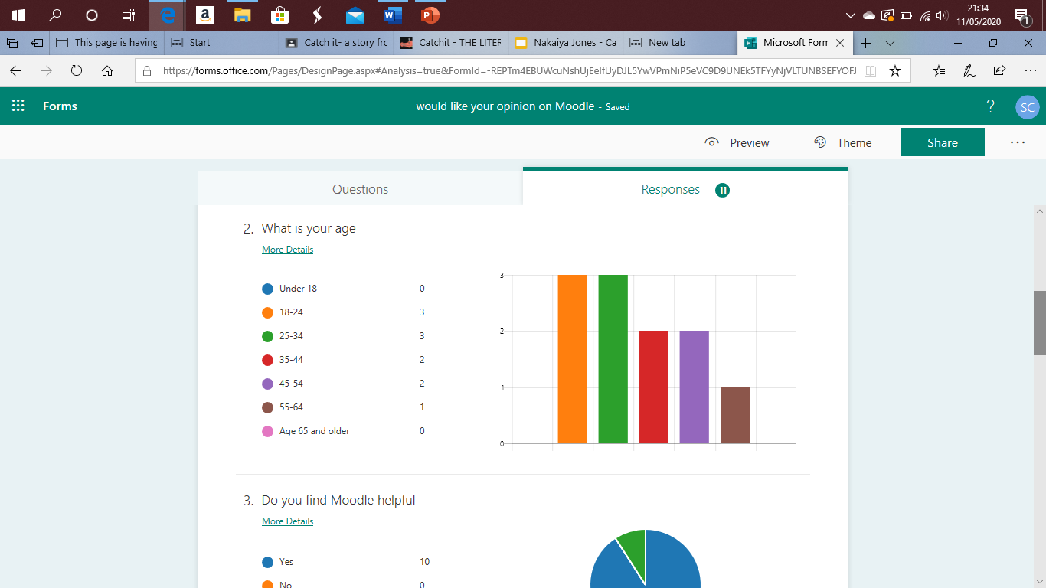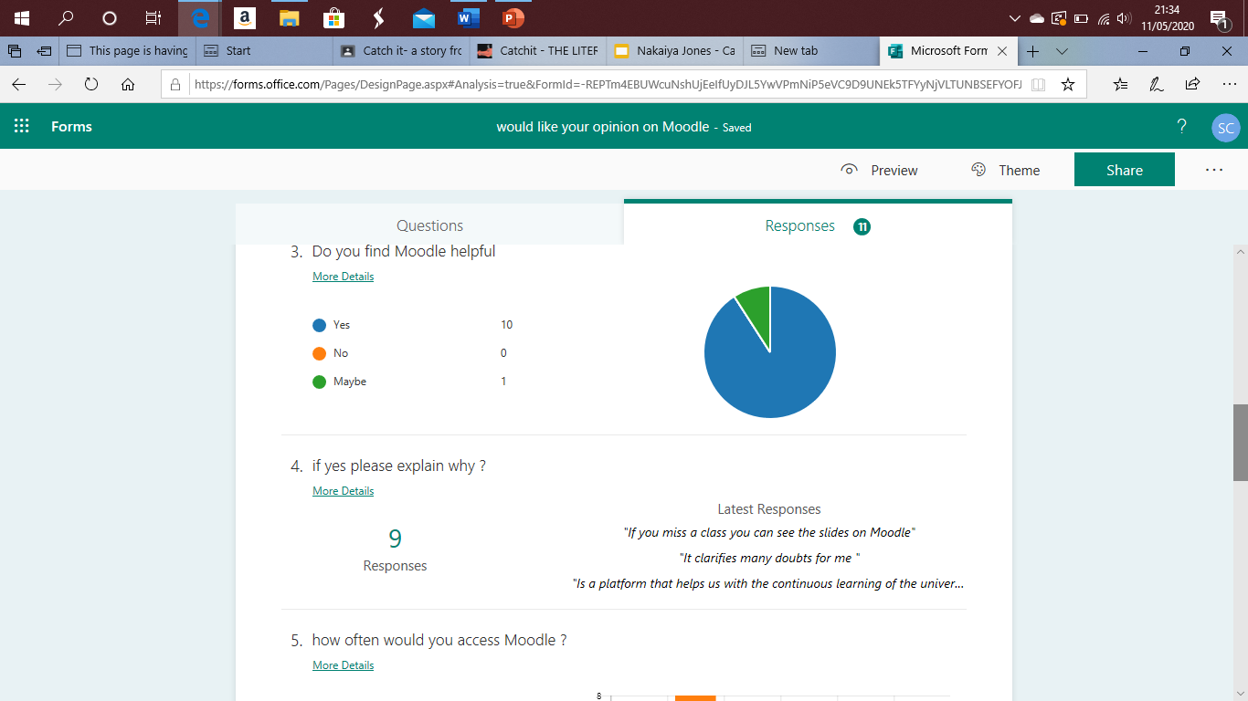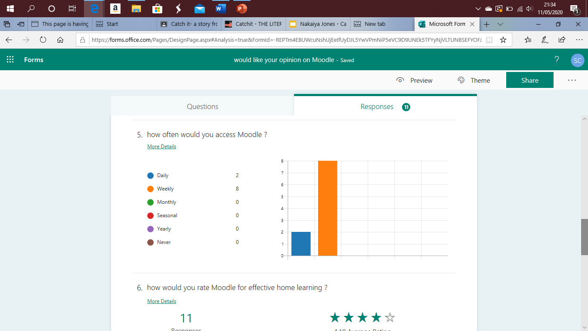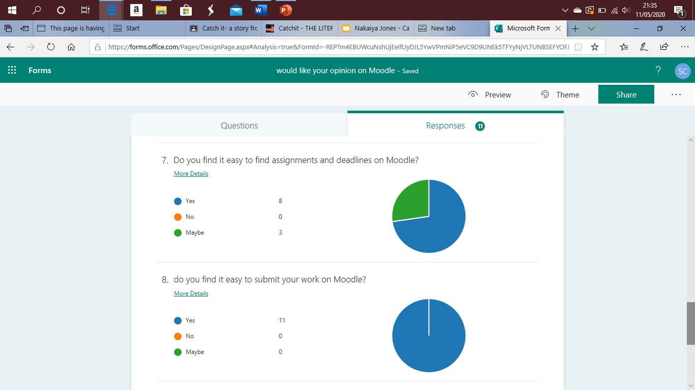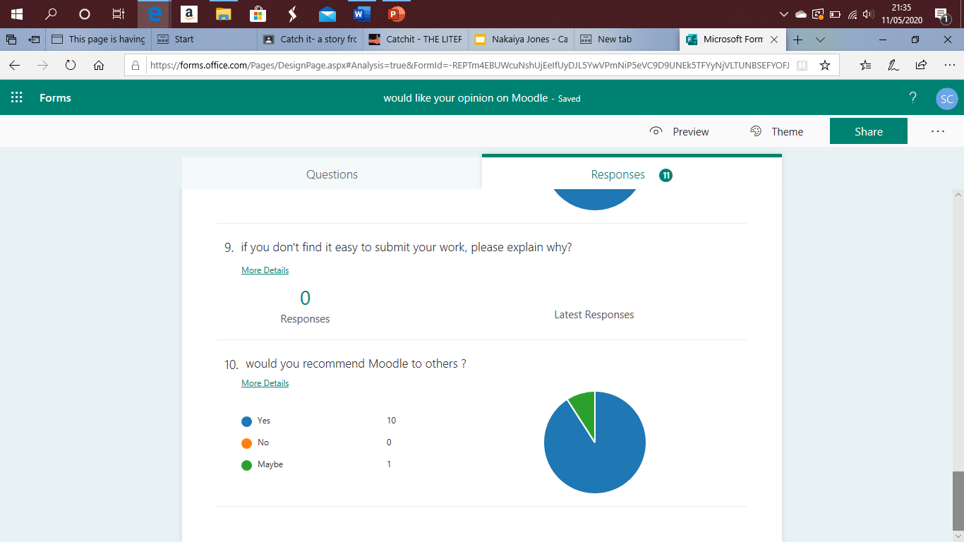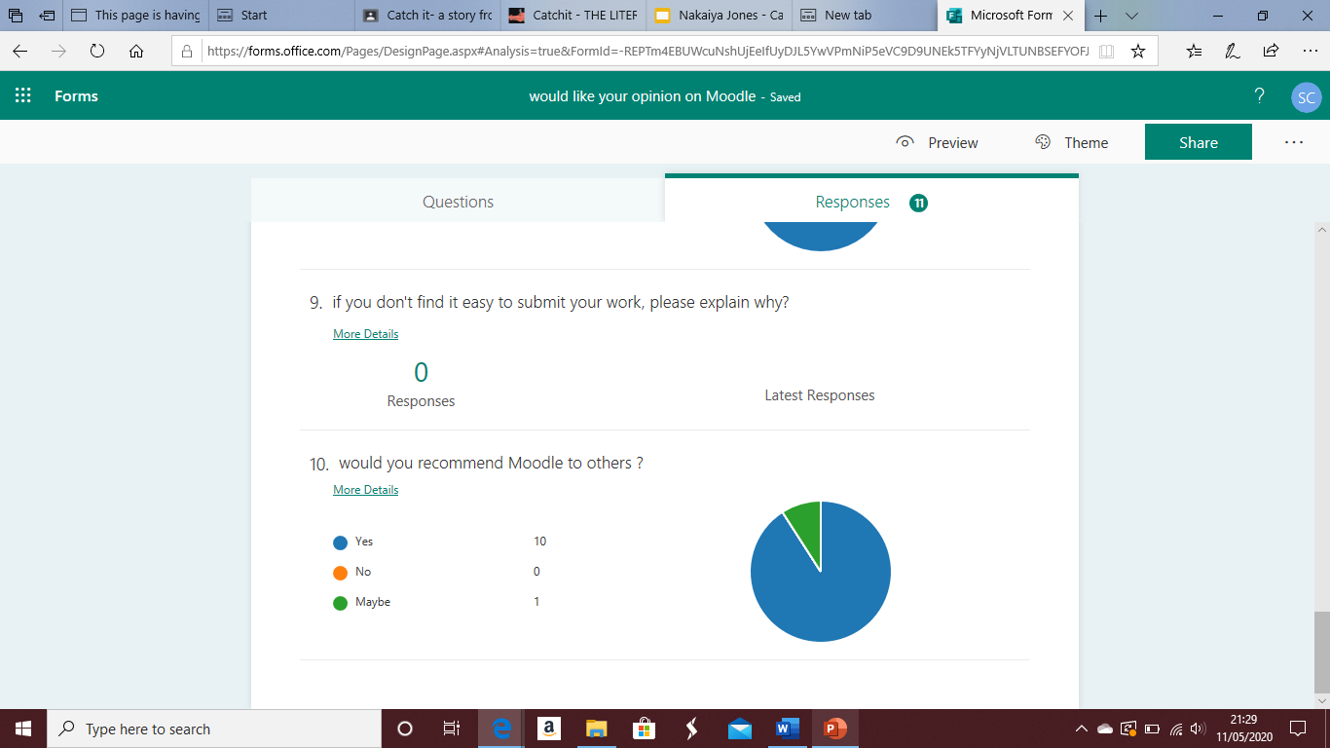
Appendix B


