

LEVEL 4 ASSESSMENT

Student name: | Dylan Williams | Student ID number: | 2514117
Programme: | Construction Portfolio
Module: | Construction Materials
Module code: | ACBA4016
Lecturer: | Allan Nantel
Assignment Title: | Properties of Framing Materials

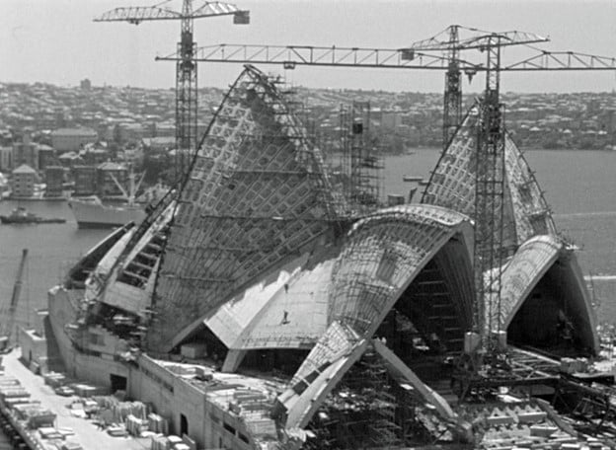
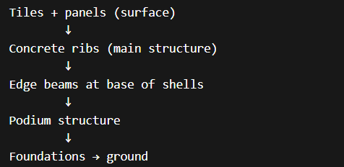
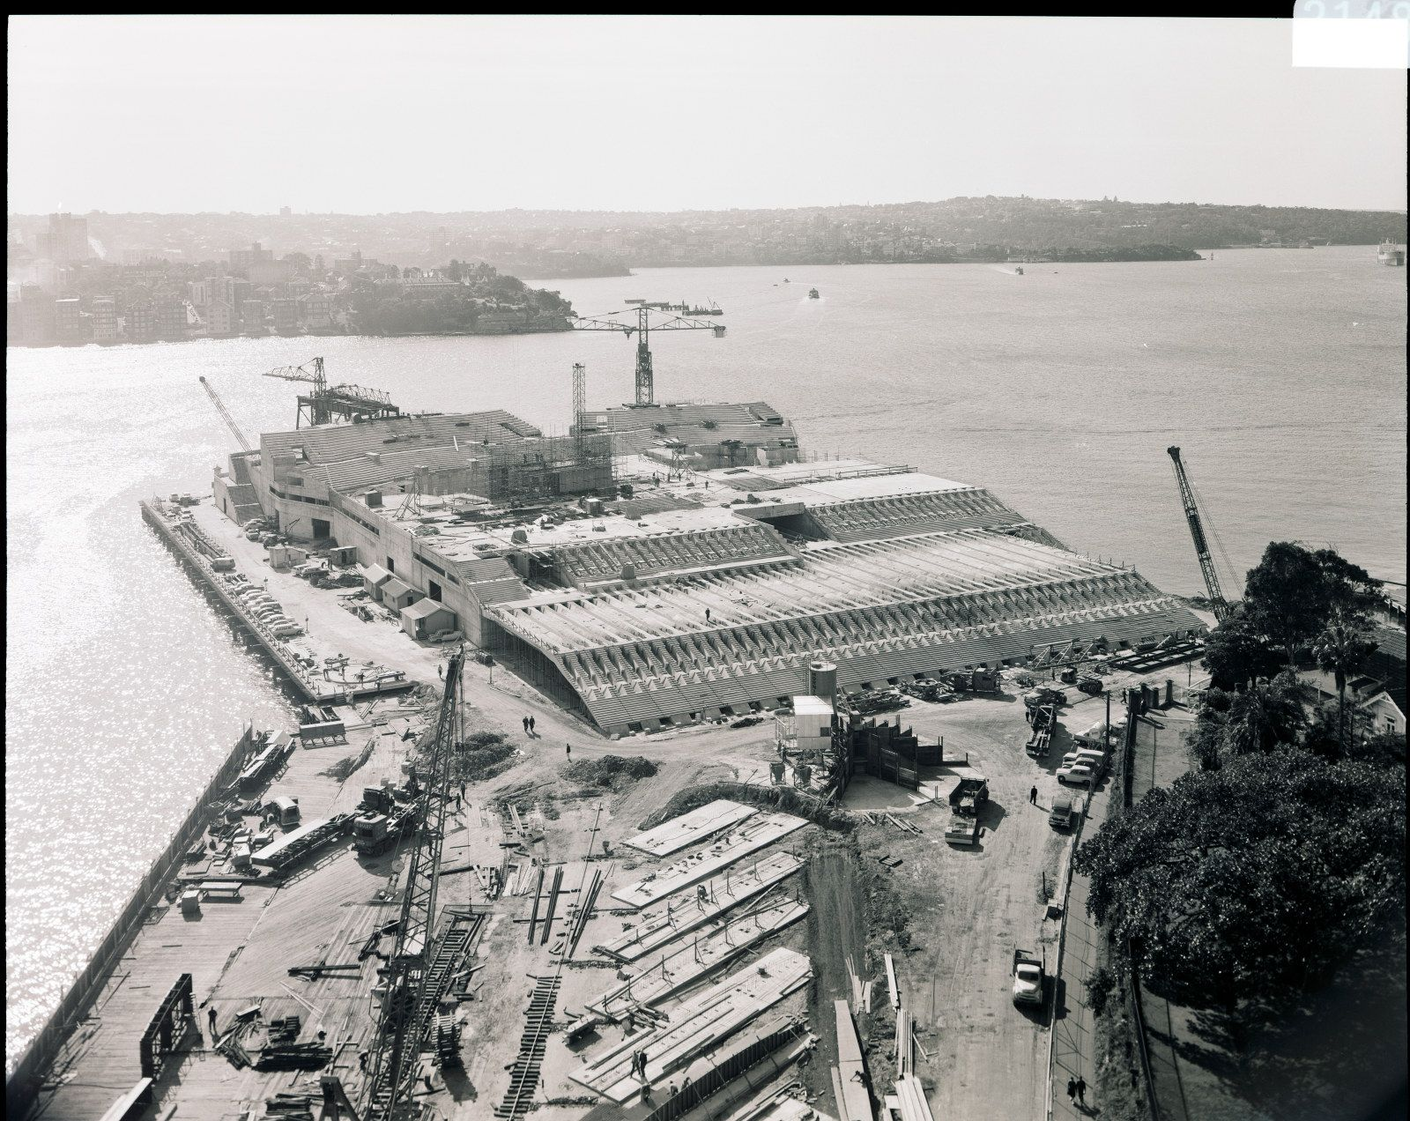
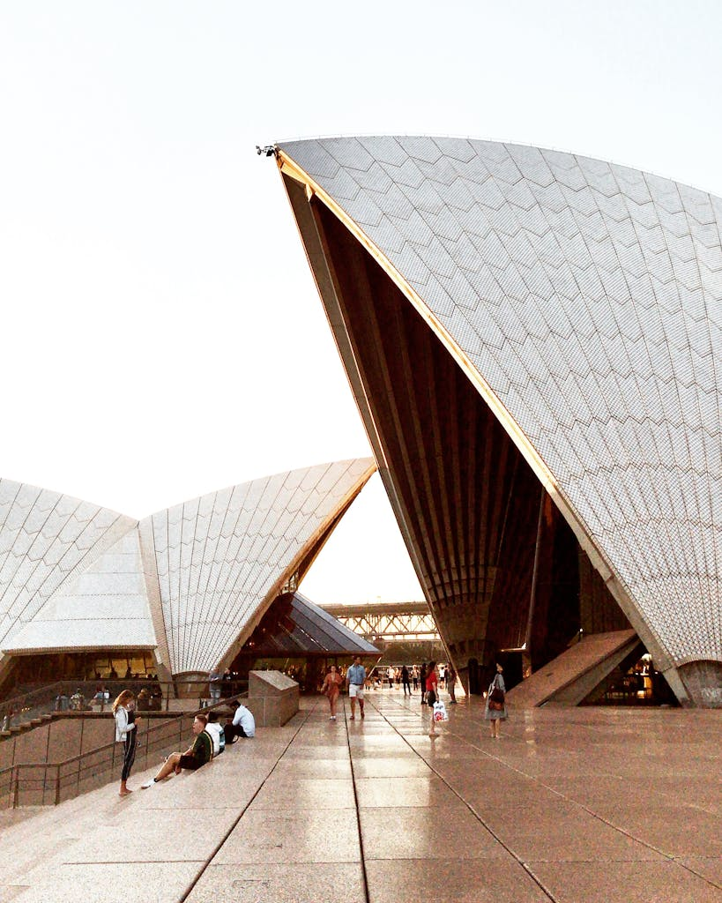
There are many different concrete frame builds which have been constructed over the years, concrete is considered one of the most influential building materials to be introduced to construction with buildings dating to around 300 B.C with more advanced reinforced concrete introduced in the mid 19th century, a building which I find intriguing is the Sydney Opera House, the project which was originally concepted in 1957 by architect Jorn Utzon and began construction in 1959 and 14 years later it opened, now one of the most recognisable buildings in the world with other 5,000 visitors a day and over 8 million a year. The method in which the contractor chose for this project was 3 separate stages: Stage 1: Podium, Stage 2: Roof and Stage 3: Interior and exterior finishes, the initial podium stage saw issues due to its location on the Sydney harbour and therefore the area where the structure was to be built was considered unsuitable for bearing the weight needed. The method which was used to get around this was over 700 cased concrete shafts 1m in diameter placed to create a more stable foundation for the works, the podium design alone made it one of the largest concrete structures in the southern hemisphere at the time. The podium consisted of in-situ reinforced concrete base, allowing for the separation of public circulation and performance halls, the design used the stepped elements to portray an anchor the building visually and physically sits on. The structural engineering required on the original design, particularly for the podium element was crucial due to the mass weight involved, the podium was clad in granite panels, all these are crucial due to the design of the arches which created large outward thrusting force as the shells are constantly trying to force themselves apart via down the curves of the building and then the podium design acted as a clamp to counteract the forces. The most distinguishable aspect of this building would be its roof, the architect based this design on ship sails due to its harbour side location, the construction method used to create this was the inclusion of precast concrete ribs with lighter concrete panels between these ribs to from the unique shape, this was considered groundbreaking at the time of construction. The inclusion of these ribs and panels were crucial to form the spherical shape which it’s known for, the panels were all cast on-site in re-usable moulds and once set then craned up into position on a unique conveyor style crane, while majority concrete steel cables were installed and tightened allowing all elements to connect and create the self supported arch/sail design. While the roof design was made out of precast panels there are further elements and materials that were utilised to create the affects in which the architect envisioned during design stages, on the external façade the concrete panels are finished with a ceramic gloss chevron tile, over 1,000 were installed. These were designed to help with the integration with the surroundings, as well as the sail design, Utzon used the gloss effect to reduce the glare of the building while enhancing the texture of the building under sunlight, the design also is understood to reflect light differently throughout the day. Stage 3 of the project was regarding the interior and exterior finishes, this aspect of the project was originally an oversight by the architect and when it came to this stage there were issues with both design and acoustics, this resulted in the resignation of Utzon as the project architect. Due to this the original design is almost lost internally as rooms had to be altered such as the original opera hall being converted to a concert hall. The use of concrete however maintained throughout the interior structural design, reinforced concrete was used for all floors, beams and supporting structures throughout the process these can be seen in the large auditorium as concrete allowed to maintain the flexibility in design while having the structural integrity benefits not possible with other materials.
Load Path and how the weight travels down the build.
Strength, Durability and Climatic Resistance
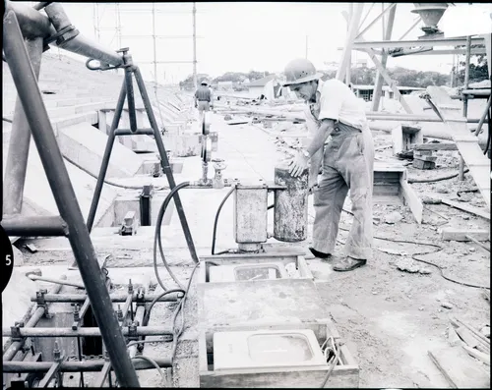
The use of reinforced concrete throughout the building design is clearly intentional for it’s structural properties as well as it’s flexibility in terms of architectural design. The harbour-side location of this build comes with the added environmental conditions such as high winds and salt exposure, the inclusion of concrete allows enough mass in these foundations for stiffness and stability to mitigate the lateral forces from any wind conditions. The concrete would also be affected in the high heats in which is expected in the Southern hemisphere, this could result in it curing too fast and the cement will dry out too fast losing all it’s desired strength from the designed mix. If the concrete was properly maintained and best practise was taken during it’s curing process and a designed mix was assigned then any coastal conditions should not impact it’s strength or durability, these conditions could lead to corrosion to the steel reinforcement from over salt exposure, freeze thaw is also a common trait of seaside located buildings, however the climate in Australia as mentioned would be too high in most seasons.

Could steel have been seen as an alternative to concrete?
When comparing the feasibility of steel framing rather than the use of concrete in regards to this build would not be possible due to many mitigating factors of construction during this time. The properties in which steel is known to be advantageous for such as reaching long spans, use in lightweight structures and prefabricated builds expresses that in theory would be a viable alternative for this build, however due to the complexity of the design and the use a spherical features within the roof this becomes a lot more difficult. The in-situ concrete panels are easily made with moulds where-as a steel alternative would need to be manufactured and then manipulated to suit which would have been extremely difficult and expensive in the 1960’s showing a gain not only on cost but time and programme also.

The ease of erection and dismantling the build and it’s ease of adaption during it’s life cycle.
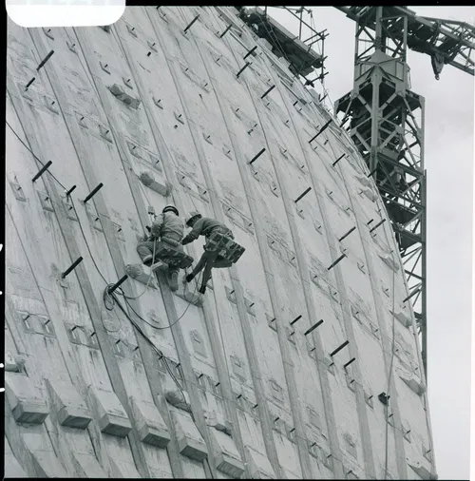
The Sydney Opera House didn’t utilise a standard concrete frame but a rather complex panelling system that was made on site into in-situ moulds and then transported via a uniquely manufactured crane like system which allowed workers to fit these panels simultaneously to create the sail feature shape, as well as these panels there was concrete infills which were filled on site to create a bind between the panels. High tension steel rods were inserted into the panels when installed to allow for a more precise and smooth finish. In the unlikely event that this building would need to be demolished, the panelling system would allow a more efficient dismantling of the external façade as you could remove similar to how it would be erected so a low volatile process could be followed. When panels are removed the adaption of these would be not possible as you cannot manipulate cured concrete, however you would be able to re-use these as they could be re-cycled via crushing and used as aggregate in the concrete production process. The larger spans of concrete such as columns and beams would not be dismantled as such but could be re-used in the same way suggested. The element of the build which could be adapted for further use to another build would be the extensive foundations and podium area, this is due to the high levels of structural engineering thought out in the design stages to mitigate any loose grounds due to it’s location on the harbour. You’d assume that the removal and demolition of this element would not be beneficial due to cost and location, in which any damage could cause major issues to the port when these foundations could be re-used for further use.
Integration of Services and how these were overcome
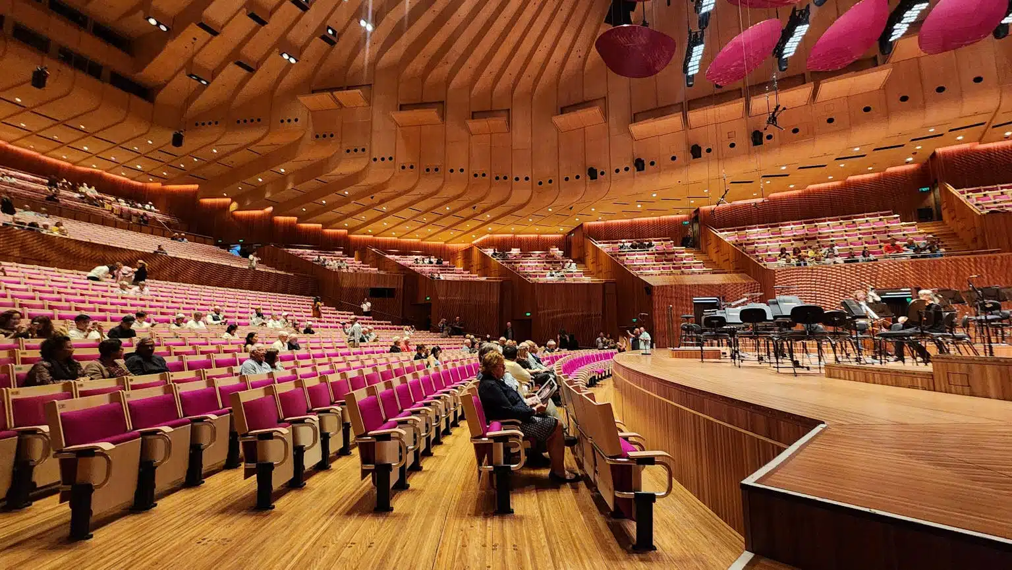
The Sydney Opera House had many issues when fitting services like ventilation, lighting, acoustics, and stage equipment. This was mainly because the design by Utzon focused first on the building’s outside shape, and not enough on the inside spaces. The roof sails were built before the interior layout was fully planned, so there was little room for ducts, cables, and machinery. The curved shape of the building also made it hard to control sound, causing acoustic problems. Large spaces needed air conditioning, but there was not enough space for big ducts. Lighting and electrical systems were also difficult to install because there were no standard ceiling heights due to the abstract design. After Utzon, a new team led by Peter Hall had to redesign the interiors, which caused further challenges. These problems were resolved by changing the interior layout and making compromises. For example, the main hall was changed to a concert hall to help meet acoustic standards. Engineers used under-seat air systems and special acoustic panels to improve sound and airflow. Services were split into smaller systems to fit the space, Hall attempted to retrofit holes and service routes through walls to adapt to the poor design without reducing the structural integrity of the beams, walls and columns.
Negative Impacts of the concrete production process on the environment and community.
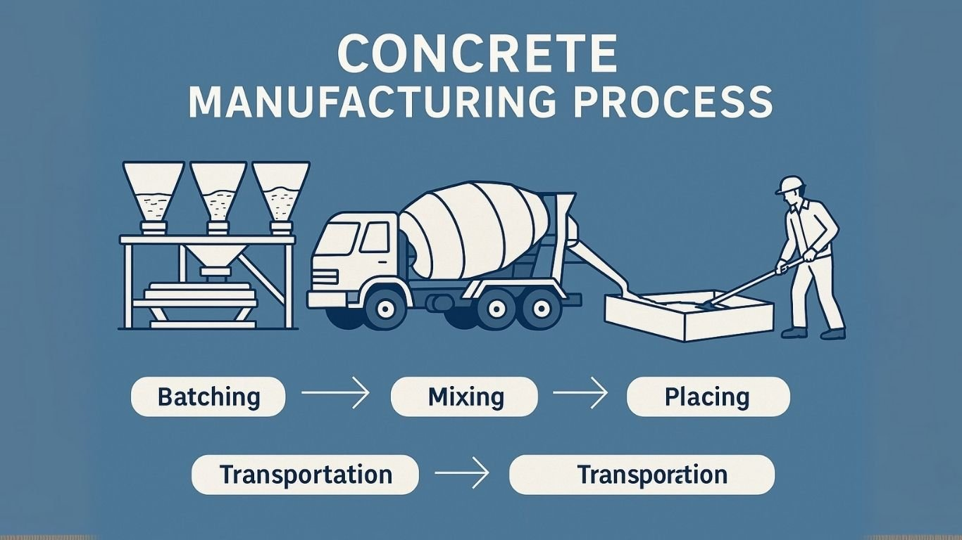
While concrete is regarded as one of the most used construction materials and considered a big positive in the industry, the impact it has on the wider environment is almost the opposite. One of these would be it’s industrial production process, this process consists of excavating large amounts of naturally occurring materials (aggregates) from quarries with industrial machinery producing high CO₂ emissions, this aspect of the process can sometimes be overlooked due to other aspects which produce similar gasses. As well as the machinery, the production aspect of concrete is far from perfect, the process required to heat up the limestone via kilns releases dangerous CO₂ gasses as part of the chemical reaction, moreover large quantities of fossil fuels are burnt during this process with all this considered it is estimated that almost 7-8% of the worlds carbon emissions is from concrete alone.

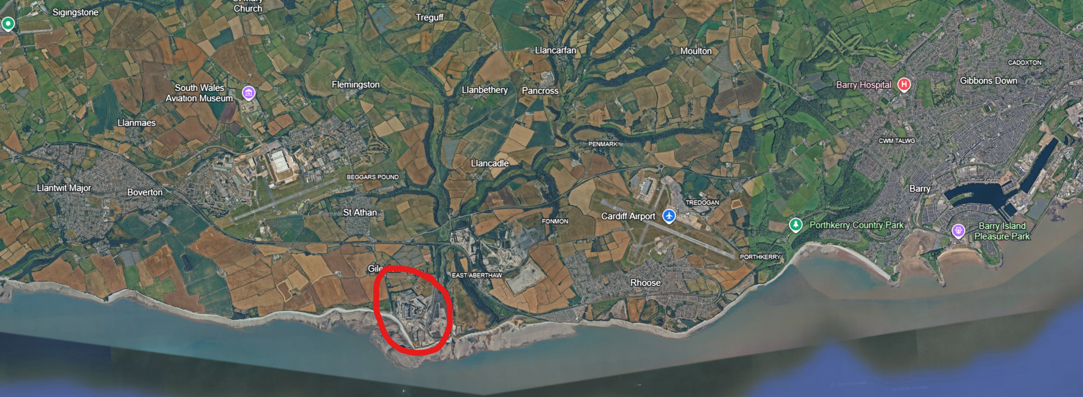
Even though the environmental impacts of this process can be considered detrimental to the general climate, there are further local impacts which are caused not only by the emissions but the safety of the works. A local example of this is the Aberthaw works, this is located in Barry that has subsequently undergoing major redevelopment works to become a renewable energy park. In recent years, this park has been making progressing in becoming a much more sustainable practice and has been using alternative fuels such as old tires and waste oil which has resulted in CO₂ emissions per ton reducing by 10%. But prior to these changes and still today they face major issues, as pictured this site is located near a prime walking path along the coast which produces large amounts of foot traffic per year, this results in not only possible health issues for thousands of walkers but there’s a considerable amount of noise pollution being emitted from the site. There are small communities who live nearby that are effected by this from the extensive noise the machinery is making from early hours to the late night shifts which are frequent in this industry. As well as this, there are water sources nearby being polluted from fumes, debris and general traffic in and out of the site which can lead to wildlife dying effecting plots of land as seen from image surrounding this site.

Reference list
- Standard Materials Group. (2024). A Guide to How Concrete is Made - Standard Materials Group. Available at: https://standardmaterials.com/insights/a-guide-to-how-concrete-is-made/. Accessed on: 13/03/26
- Bandera, G. (2024). Why is Concrete so Damaging to the Environment? [online] FairPlanet. Available at: https://www.fairplanet.org/story/concrete-climate-change-environmental-injustice/. Accessed on: 13/03/26
- Bob (2025). Discover Aberthaw Cement Works: A Leader In Sustainable Cement Production And Innovation - ConcreteCaptain.com. [online] ConcreteCaptain.com. Available at: https://concretecaptain.com/aberthaw-cement-works/ [Accessed 26 Mar. 2026]. Accessed on: 16/03/26
- Science Museum (2021). Building the modern world: Concrete and our environment. [online] Science Museum. Available at: https://www.sciencemuseum.org.uk/objects-and-stories/everyday-wonders/building-modern-world-concrete-and-our-environment. Accessed on: 13/03/26
- Museums of History NSW. (n.d.). Sydney Opera House construction. [online] Available at: https://mhnsw.au/sydney-opera-house-construction/. Accessed on: 14/03/26
- jonnyhough (2025). Concrete history | Concrete Society. [online] Concrete Society. Available at: https://www.concrete.org.uk/fingertips/concrete-history/. Accessed on: 13/03/26
- Sydney Opera House (2025). Construction begins. [online] Sydney Opera House. Available at: https://www.sydneyoperahouse.com/our-story/construction-begins. Accessed on: 14/03/26
- Team, M. (2025). Sydney Opera House Engineering Solving the Unbuildable Icon: Triumph and Tragedy ArchUp Architecture. [online] ArchUp. Available at: https://archup.net/sydney-opera-house-engineering-spherical-solution-tragedy/. Accessed on: 14/03/26
‌

Sample Size: 1250g
Sieve Size (mm) | Mass(g) | % on sieve | % Passing
125 | 0 | 0 | 100
75 | 0 | 0 | 100
63 | 0 | 0 | 100
37.5 | 120 | 9.6 | 90.4
20 | 137 | 10.96 | 79.44
10 | 143 | 11.44 | 68
6.3 | 105 | 8.4 | 59.6
3.35 | 45 | 3.6 | 56
2 | 130 | 10.4 | 45.6
1.18 | 63 | 5.04 | 40.56
0.6 | 105 | 8.4 | 32.16
0.3 | 102 | 8.16 | 24
0.212 | 109 | 8.72 | 15.28
0.15 | 98 | 7.84 | 7.44
0.063 | 55 | 4.4 | 3.04

Within this mix there are 40.6% Coarse aggregates, this is specified as any size above 4.7mm, then there are 56.56% fine aggregates which is specified by any size smaller than the 4.7mm but not below as this is then considered clay and then finally circa 3.04% is considered by mass.
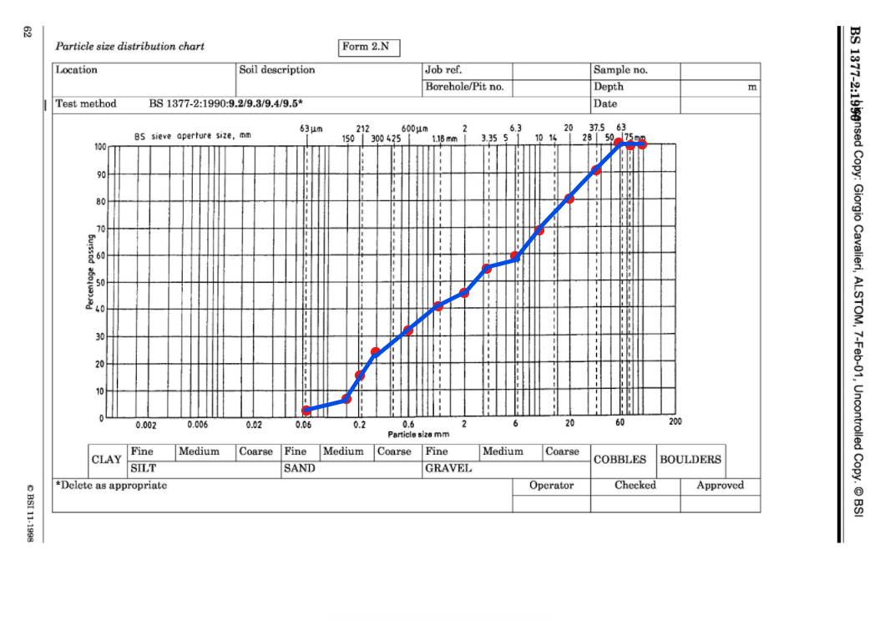
Over 20% of the sample lies between 37.5mm and 10mm in size, these are larger aggregates which are required in the ‘all-in’ mix which has been . This is similar between samples 3.35mm and 2mm which is above 10%, these percentages show that there is a clear mix of fines and coarse aggregates throughout the mix for concrete with larger coarse to help with bind of the cement and smaller to fill the gaps in between these larger size aggregates.

