Application Development (Web)
  - Lecture 9a Lab Tutorial Exercise

Authentication and Authorisation

Objectives
The aim of this lab exercise is to add authentication and authorisation functionality to the application.
We will be using the ASP.NET Core Identity API to add this functionality.
This exercise focuses on creating the registration views and adding new users.

Customising Identity Views

Examining the Default Views
- Run your application.
- You should have a Login and a Register link in your main menu (top right corner).
- Click on both links (do not register just yet ). You will notice that the views are quite basic.
- Stop your application.

Scaffolding the Views
To customise the default views, you need to add the views and models to your application (I am not going to make you write any code just yet ).
- Go the GoMovies2020.Web project.
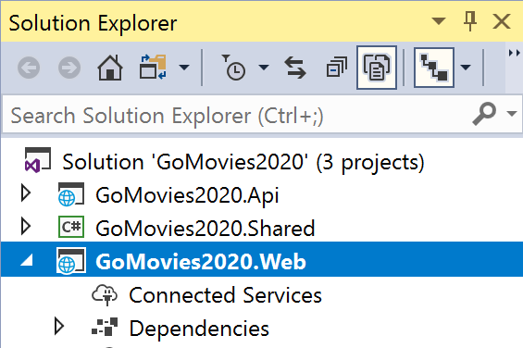

- Right-click on the project node. Select Add New Scaffolded Item…
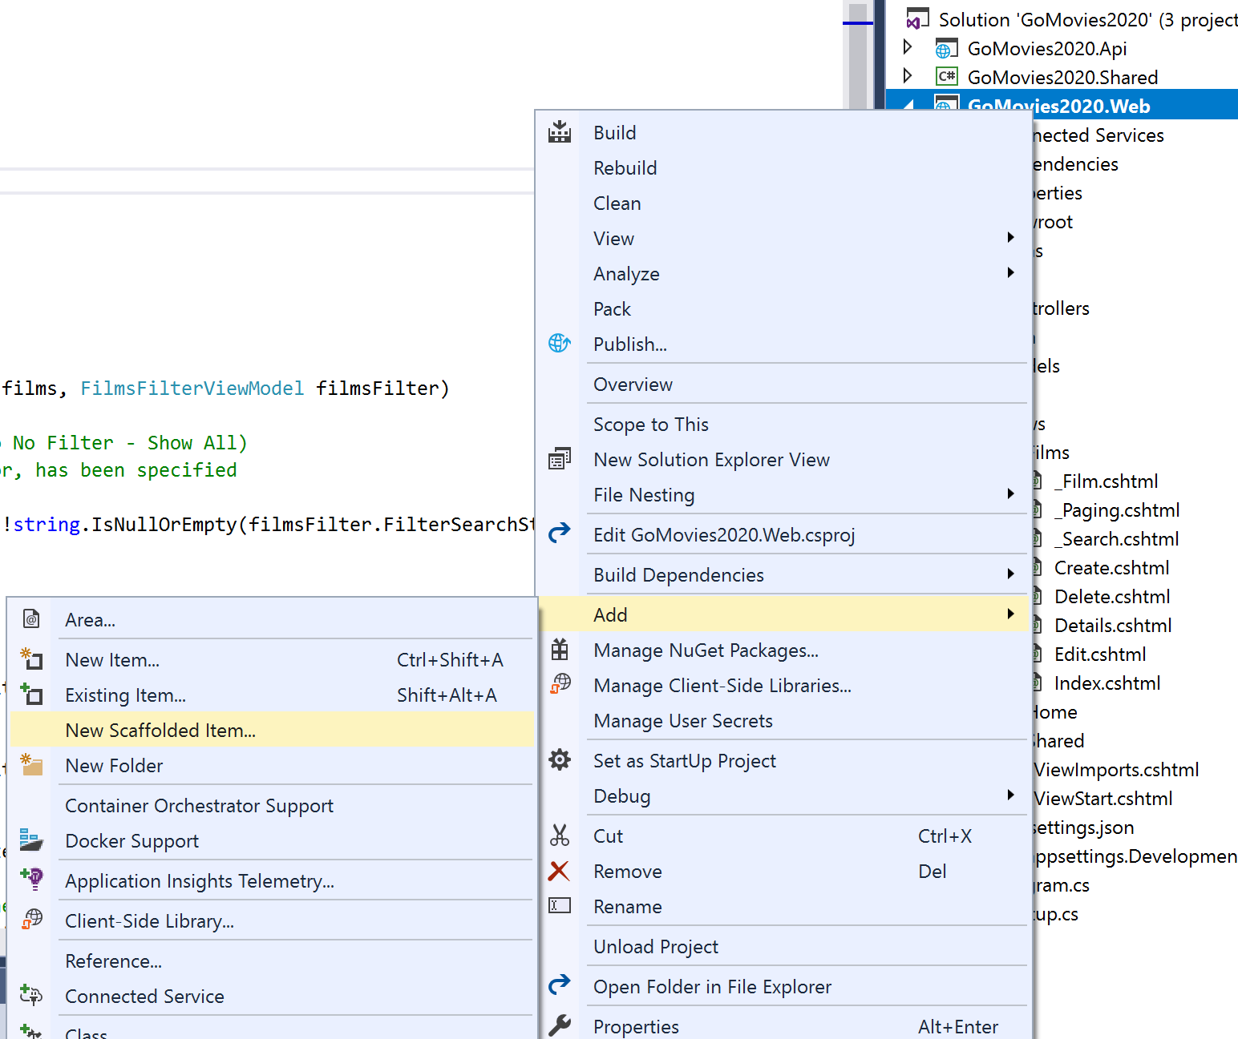
- Select Identity in the window that displays (see screenshot) and click the Add button.
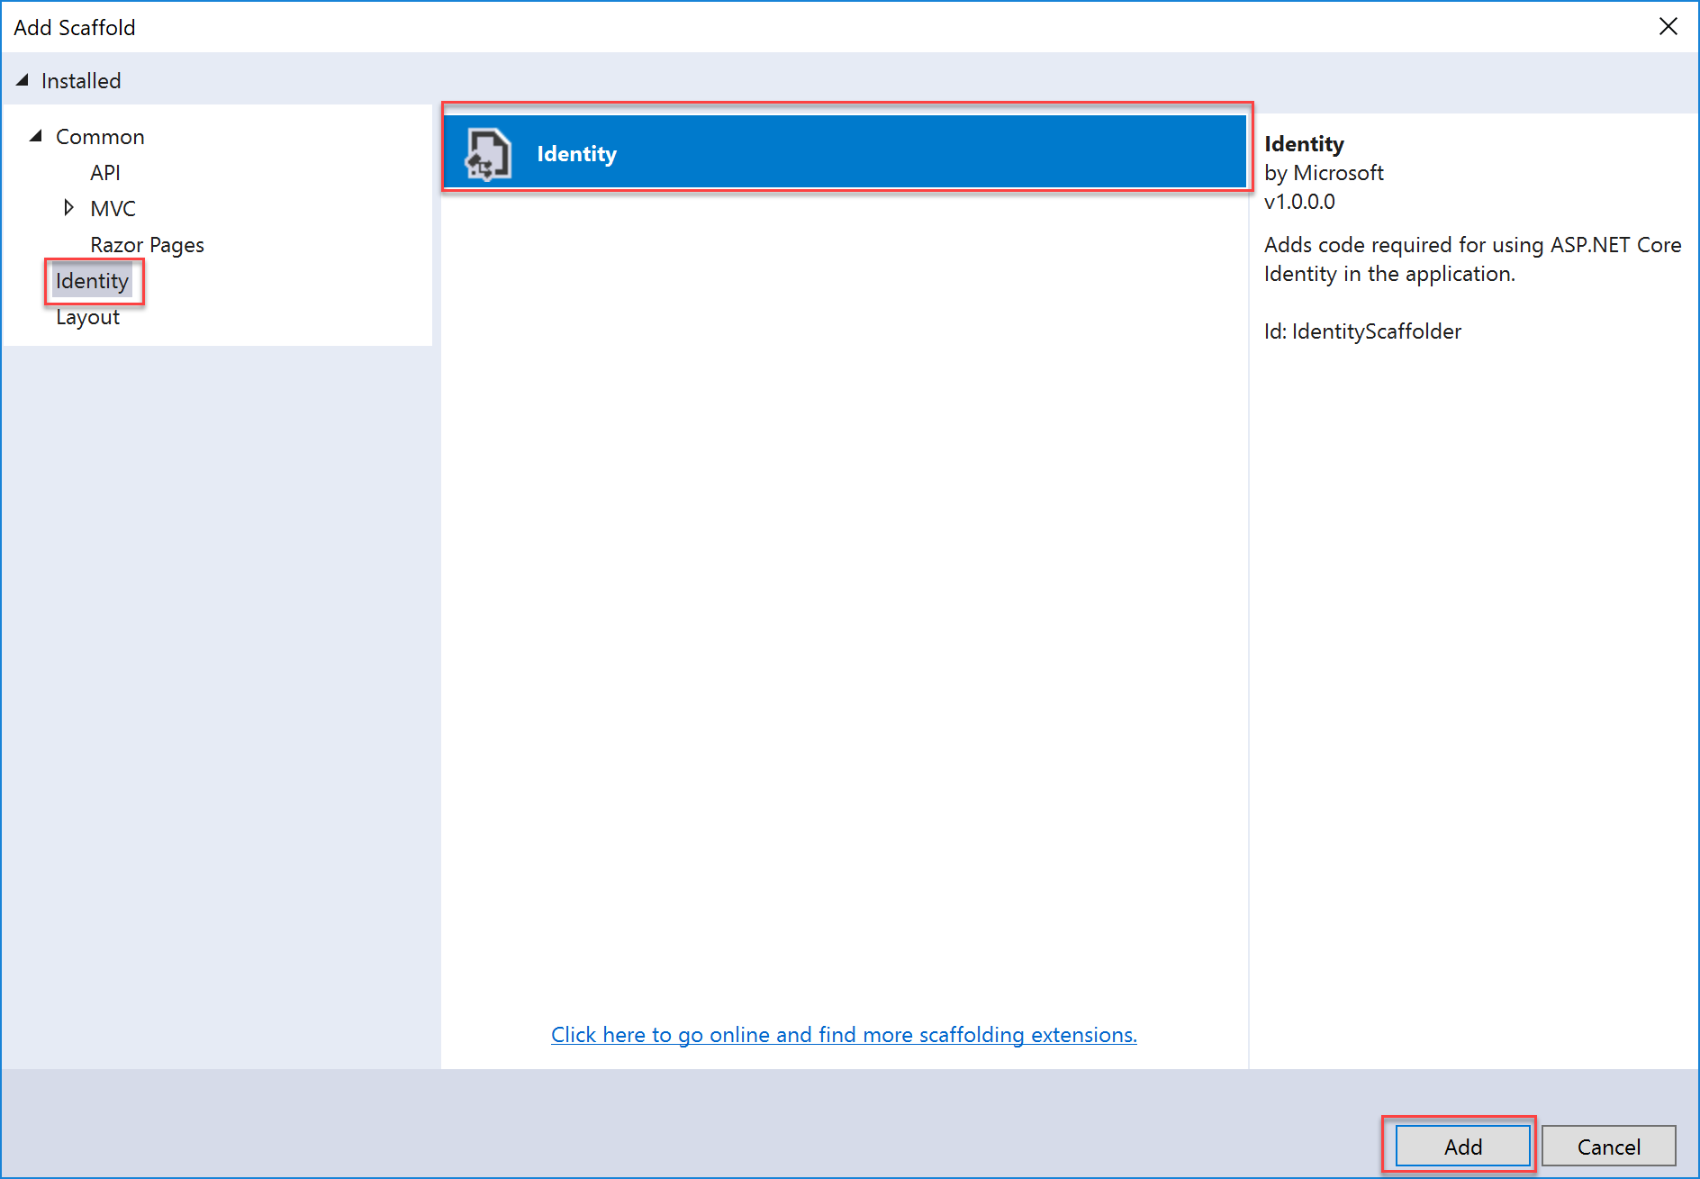
- In the next window:
  - Specify the shared layout page (click the button with the three dots to select the page – see below).
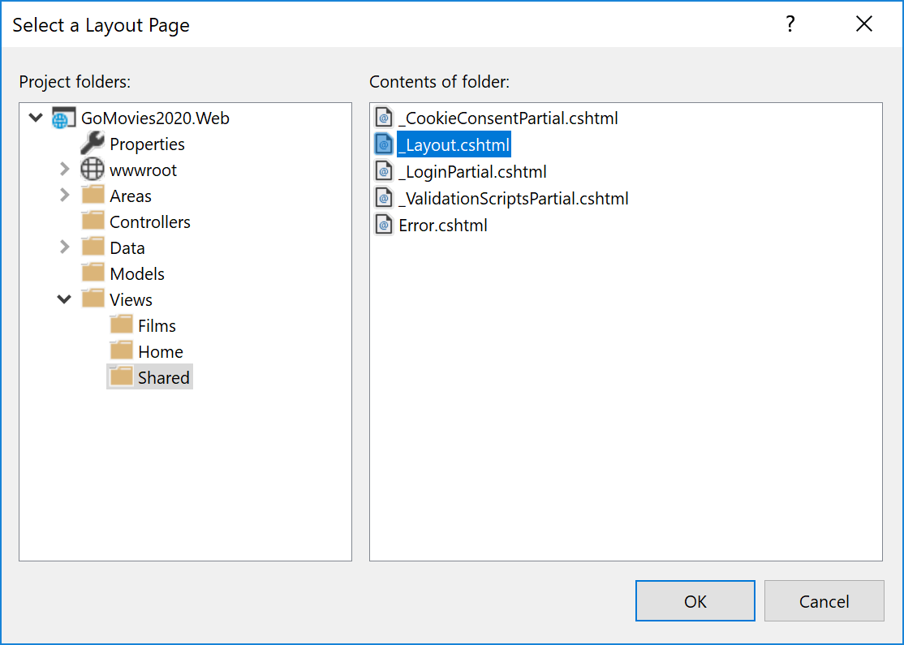
  - Select the Identity files that you wish to customise (for the purpose of this exercise the ones shown are okay, but you can choose more if you wish).
  - Specify the Database context class as shown.
  - Click the Add button.
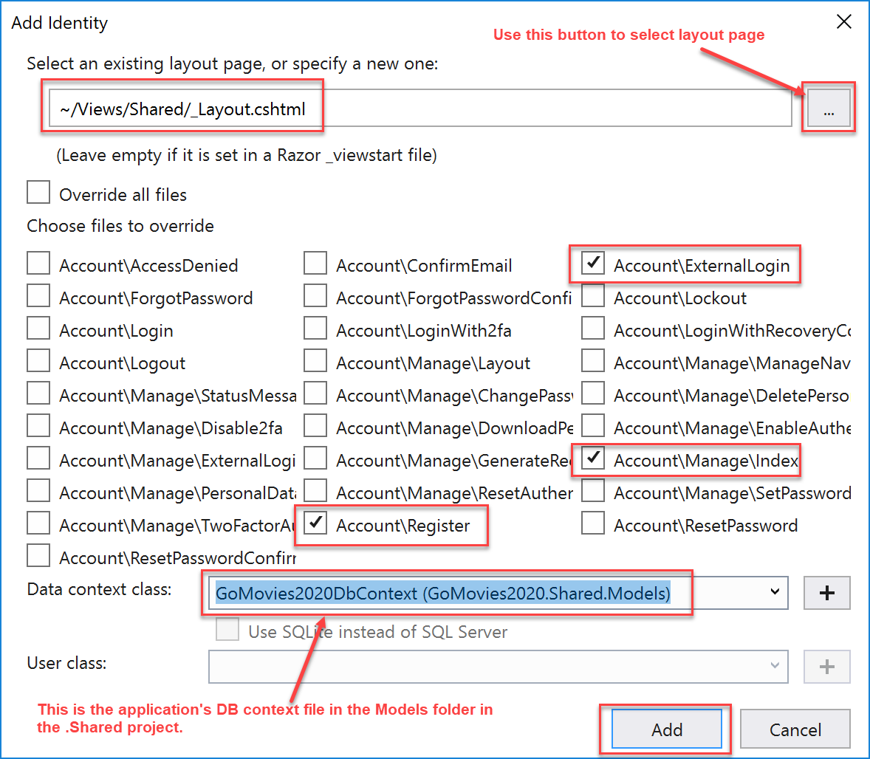

- You should now have the following pages in your project. The ones of interest have been highlighted.
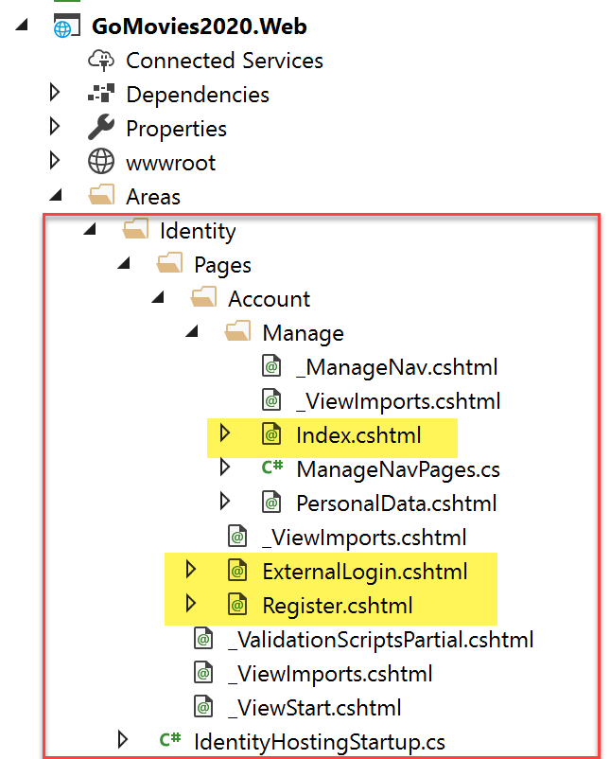

Updating AppSettings
You will add some new settings to app settings.
- Go the GoMovies2020.Web project.
- Open up appsettings.json.
- Add the following code to specify the admin and customer roles, don’t forget the comma to separate the value from the previous setting. (you can change the values if you wish).
"ApplicationUsers": {
"Roles": {
"AdminRole": "Admin",
"CustomerRole": "Customer"
}
}
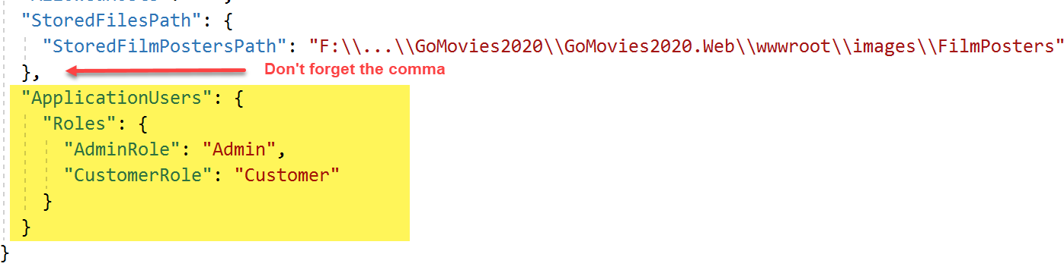
- Save your changes.

Customising the Register Pages
- The pages are split into:
  - The client-side HTML view (.cshtml file)
  - The back-end code-behind (cshtml.cs file).
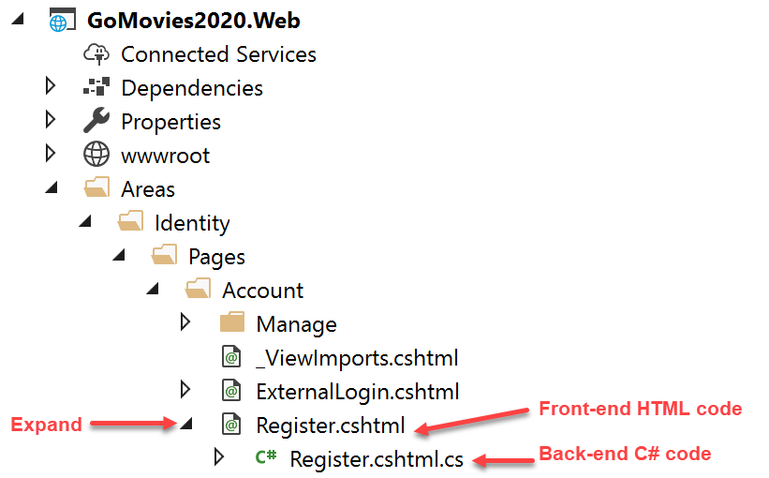

Adding Variable to Read Config File
- Open up the Register.cshtml.cs (back-end code) file.
- Import the following two libraries:
using System.Security.Claims;
using Microsoft.Extensions.Configuration;
- Next add the following highlighted variable declaration that will store the access to the configuration settings:
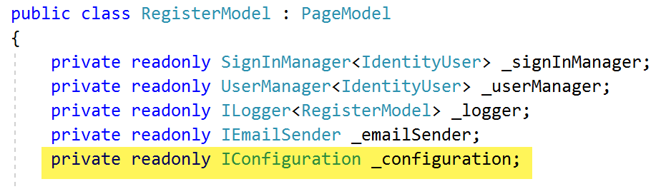
- Next, inject the configuration settings into the constructor and save in the variable created in the last step as shown below (don’t forget the comma to separate the parameter).
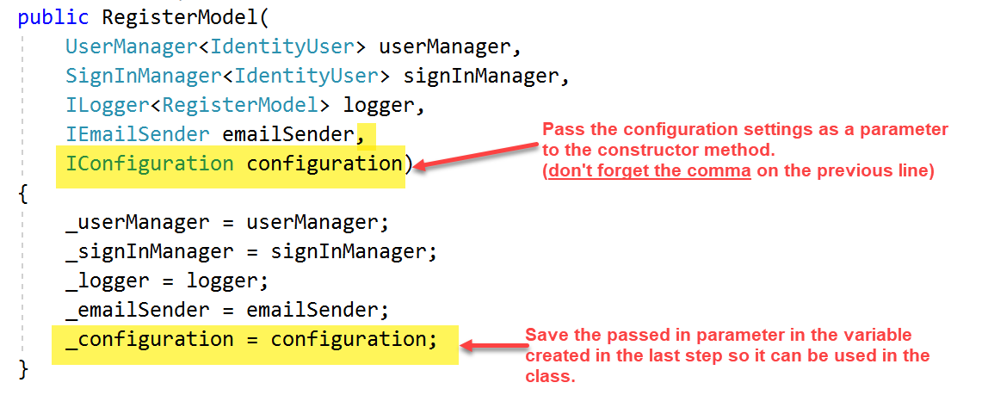

Extending the Default Model
- The model class for the Register view is defined in a class called InputModel. Scroll down and locate the InputModel class.
- As you can see it currently has only three properties: Email, Password and ConfirmPassword.

Adding First Name
- Copy and paste the following code to add a new property for the view to include the First Name (see screenshot below). You can modify the data annotations as you wish.
[Required]
[StringLength(30, ErrorMessage = "The {0} must be at least {2} and at max {1} characters long.", MinimumLength = 1)]
[DataType(DataType.Text)]
[Display(Name = "First Name")]
public string FirstName { get; set; }

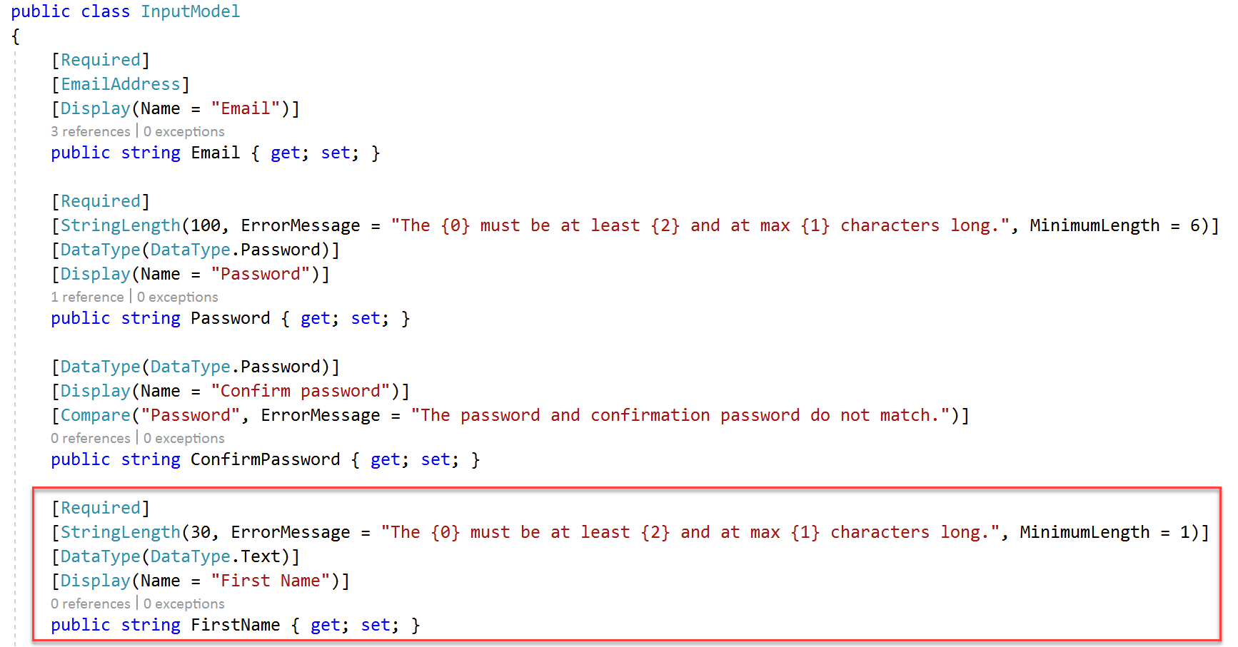

Adding Surname: Challenge Exercise
- Now try adding a new property for the view to include the Surname.
- Add appropriate data annotations (Hint: see what you did for first name).
  - Required
  - String length as you wish.
  - Data type: text
  - Display name

Adding Phone Number: Challenge Exercise
- Now try adding a new property for the view to include the Phone number.
- Add appropriate data annotations (Hint: see what you did for first name).
  - String length as you wish.
  - Data type: phone number
  - Display name
  - Regular Expression – copy code below
[RegularExpression(@"^[+]*[(]{0,1}[0-9]{1,4}[)]{0,1}[-\s\./0-9]*$", ErrorMessage = "The {0} must be a valid phone number.")]

Adding Date of Birth (DOB): Challenge Exercise
- Now try adding a new property for the view to include the Date of Birth (DOB).
- Add appropriate data annotations (Hint: see what you did for first name).
  - Required
  - Data type: date
  - Display name

Updating the Logic
- The logic to add the new user registering to the database is in the OnPostAsync method. Locate the OnPostAsync method.

Adding the Phone Number
The phone number is part of the information stored in the AspNetUsers table, but you only want to add it one has been specified.
- Add the following highlighted code to save the phone number.
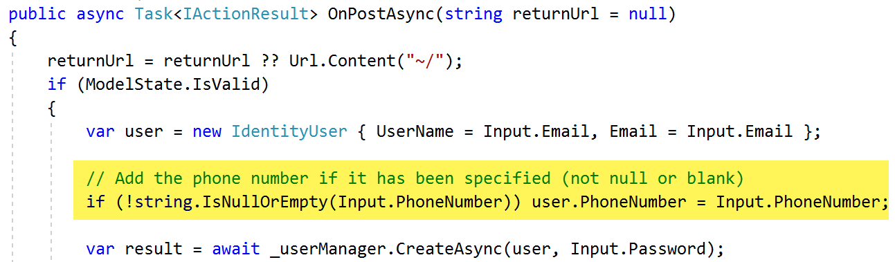

Adding the Other Property Values
The other values (first name, surname, and DOB) are extra information that are stored as user claims.
- Add the code to add these values as claims as shown below (remember to complete the code for surname). The first bit of the code has been provided for you to copy and paste.
// Add user claims for additional properties firstname, surname, and dob
var claims = new List<Claim>();
// ... Complete the code
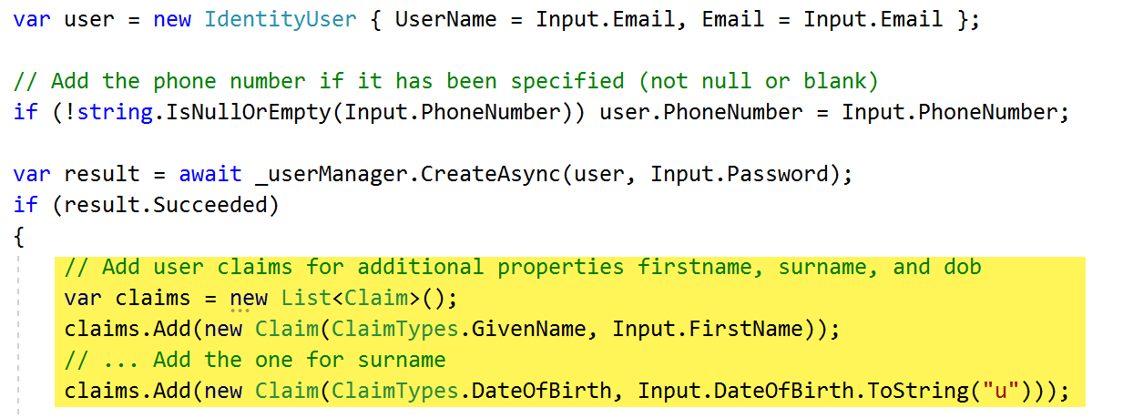
- Add the following code after the DOB claim to indicate that the user is a customer (the customer role is read from appsettings – you specified this earlier).
claims.Add(new Claim(ClaimTypes.Role, _configuration["ApplicationUsers:Roles:CustomerRole"]));
- Add the following code after the last line to save all the added claims in the database.
// Save the claims in the database
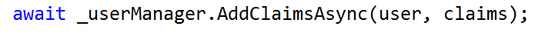

Commenting out the Email Confirmation Code
As we do not have email setup, you have to comment out the code below. If you do want to set up your application to send emails, you will need to sign up for an email provider account (SendGrid) and follow the instructions here: Account confirmation and password recovery.
- Comment out the following block of code. If you do set up an email provider, you can uncomment it.
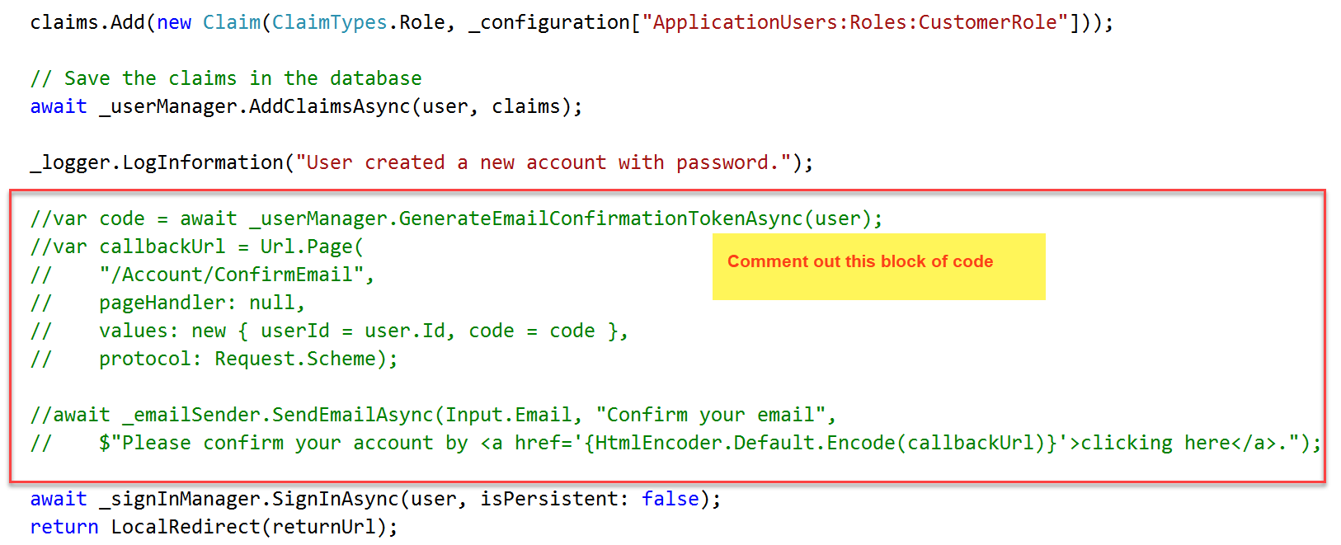
- Save your changes.

Extending the View
Finally, you need to extend the view to include input fields for the additional properties, first name, surname, and DOB.
- Open up the Register.cshtml (front-end HTML) file.

Adding Input field for First Name
- Add the following code (before the input field for Email see screenshot below) to add an input field for the first name. The model properties need to be set to specify what property this field is for - see highlighted values.
<div class="form-group">
<label asp-for="Input.FirstName"></label>
<input asp-for="Input.FirstName" class="form-control" />
<span asp-validation-for="Input.FirstName" class="text-danger"></span>
</div>
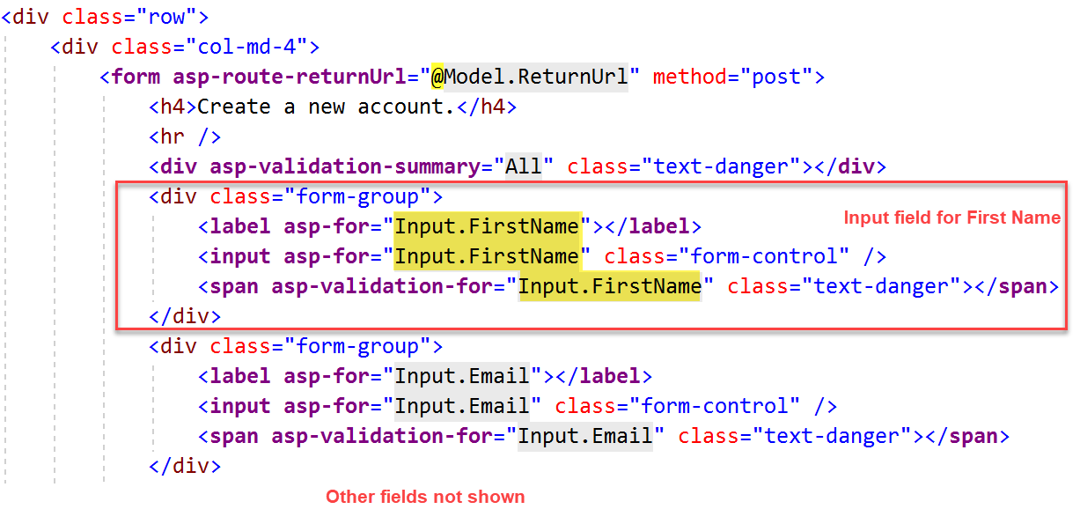

Adding Input field for Surname: Challenge Exercise
- Now try adding the input field in the view for the Surname.
  - Don’t forget to set the model properties.

Adding Input field for Date of Birth (DOB): Challenge Exercise
- First add the following code (just after the block for Surname) to add some basic client-side validation for the DOB. Ideally, you also want to add server-side validation, but we do not have enough time.
  - Customers must be at least 18 to register
  - Complete the code for the minimum DOB.
@{
// Must be 18 years old to register
string maxDOB = DateTime.Now.AddYears(-18).ToString("yyyy-MM-dd");

// Registered users must not be older than 100 when registering
string minDOB = ...;
}
- Now try adding the input field in the view for the Date of Birth.
  - Set the input type attribute to date i.e. add a type attribute to the <input /> field.
  - Set the input max attribute as shown below and do the same for min attribute.
  - Don’t forget to set the model properties.

Adding Input field for Phone Number: Challenge Exercise
- Now try adding the input field in the view for the Phone Number.
  - Don’t forget to set the model properties.
- Save your changes.

Testing
- Run your application.
- Click on the register link and try registering a new user account.
  - You could first try specifying invalid values to see if you get the error messages.
- Once the registration is successful, you will notice that you are signed in to the application.
- You can check the values in the database by running the following SQL commands:
SELECT * FROM AspNetUsers

SELECT * FROM AspNetUserClaims

Adding an Admin User

Adding Code to Seed Users
No, I am not going to make you write a lot of code. It is a copy and paste job
- Go the GoMovies2020.Shared project.
- Right-click and add a new folder called DataSeeder.
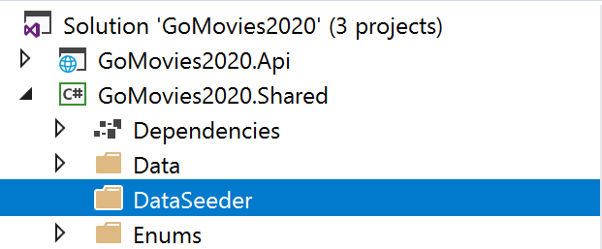
- Add a new class called SeedUsers.
- Import the following libraries (you can copy and paste).
using System.Threading.Tasks;
using GoMovies2020.Shared.Models;
using Microsoft.AspNetCore.Identity;
using System.Security.Claims;
using Microsoft.Extensions.Configuration;
- Make the class public and static as shown below.
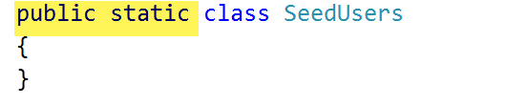
- Go to Moodle, locate the SeedUsers.txt file - copy and paste the code in the file into the class.
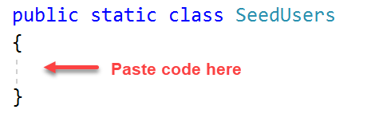
- Locate the SeedAdminUser method.
- Make the following changes (see screenshot).
  - Change the Admin password to your preferred password – something you will remember. The password must:
    - Have an UPPERCASE LETTER
    - Have a NUMBER
    - Have a SPECIAL CHARACTER
  - You can also change the email address if you wish.
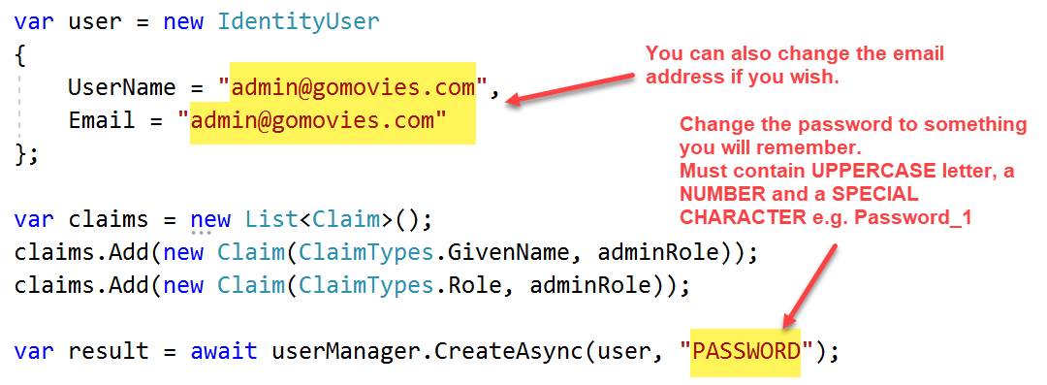
- If you wish to add other users, locate the SeeOtherUsers method and make sure you specify the following for each user:
  - Username
  - Email
  - Phone Number
  - Password
  - DOB
- Save your changes.

Updating StartUp
- Go the GoMovies2020.Web project.
- Open up the Startup.cs file.
- Locate the Configure method.
- Add the following as shown in the screenshot below.
, UserManager<IdentityUser> userManager, GoMovies2020DbContext context
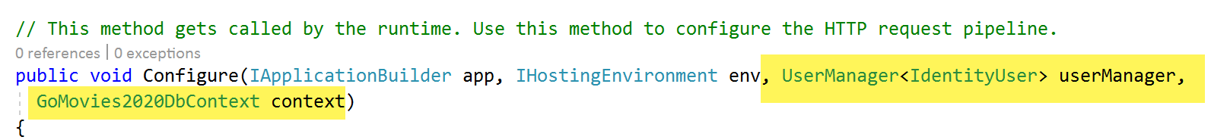
- Now, add the following line of code (see screenshot) – this will call the method in the SeedUsers class to create the users.
GoMovies2020.Shared.DataSeeder.SeedUsers.SeedData(userManager, Configuration, context);
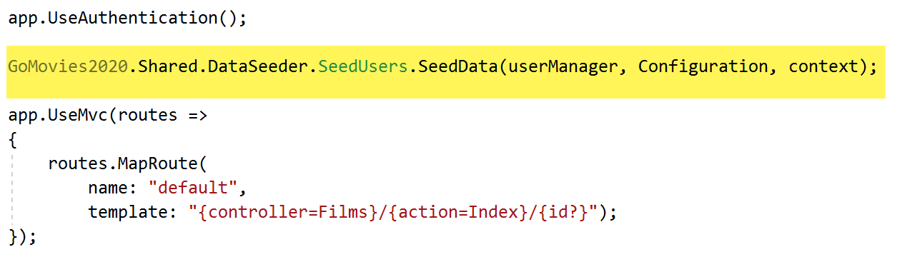
- Save your changes.
- Important:
  - Run your application.
  - Once the web page displays, close your application. If it blows up, you have made a mistake somewhere – call for help.
  - Delete the last line of code added in step 60.

Testing
- You can check the values in the database by running the following SQL commands:
SELECT * FROM AspNetUsers

SELECT * FROM AspNetUserClaims
- Run your application again and try logging in as the admin user.
- Important: Ideally, you should remove the SeedUsers class from your application once done as it contains sensitive information.
  - At the least, go to the file and delete the password.
  - Alternatively, you can either delete the file or cut and paste it somewhere else.

