Introduction:
The purpose of this essay is to critically analyse the circumstances, elements and aspects that led to the Saxetenbach Canyon disaster of 1999, as well as with reference to the “Swiss Cheese model”, reviewing the event and putting forward appropriate measures to minimise the issues that led to this tragedy.

Section 1: Reason’s Swiss Cheese Model:

The Swiss Cheese Model will be referred to as the SCM hereafter; it was designed by James Reason (1990) based on the understanding that within every process and system there are weaknesses that can lead to failure. Within this Organizational Accident Model structure (Larouzee, 2020), Reason likened processes or systems to slices of Swiss cheese laid side by side, with the holes representing potential weaknesses at each layer. Some of these holes are considered "active" - an individual making an error - and others are considered "latent" (these weaknesses are inherent to the system and may include poor organisational design or weak management systems) (RCN, 2017). “Although the SCM has become one of the most popular models for both practitioners and safety scientists” (Underwood, 2013), it has also been widely criticised” (Larouzee, 2020).
"Reason's model has become the common language through which complex accidents can be understood. The popularity of this model obviously comes from its wide application, a common ground for discussing system safety" (Westrum, 2000); but as to its wide application it allows room to be misinterpreted. This can be considered as such: “the interpretations of specific features of the SCM vary considerably among quality and safety professionals. There is no clear evidence, that the Swiss cheese metaphor is understood in the same way by all concerned” (Perneger, 2005). Due to the possibility of misinterpreting the model, further research suggests that “Reason hypothesized that most adverse events can be traced to one or more of four failure domains: organizational influences, supervision, preconditions, and specific acts” (Thin, 2018). These four domains of failure will shape the Swiss cheese model within this document, for use with the Saxetenbach tragedy, without misinterpretation of the model.
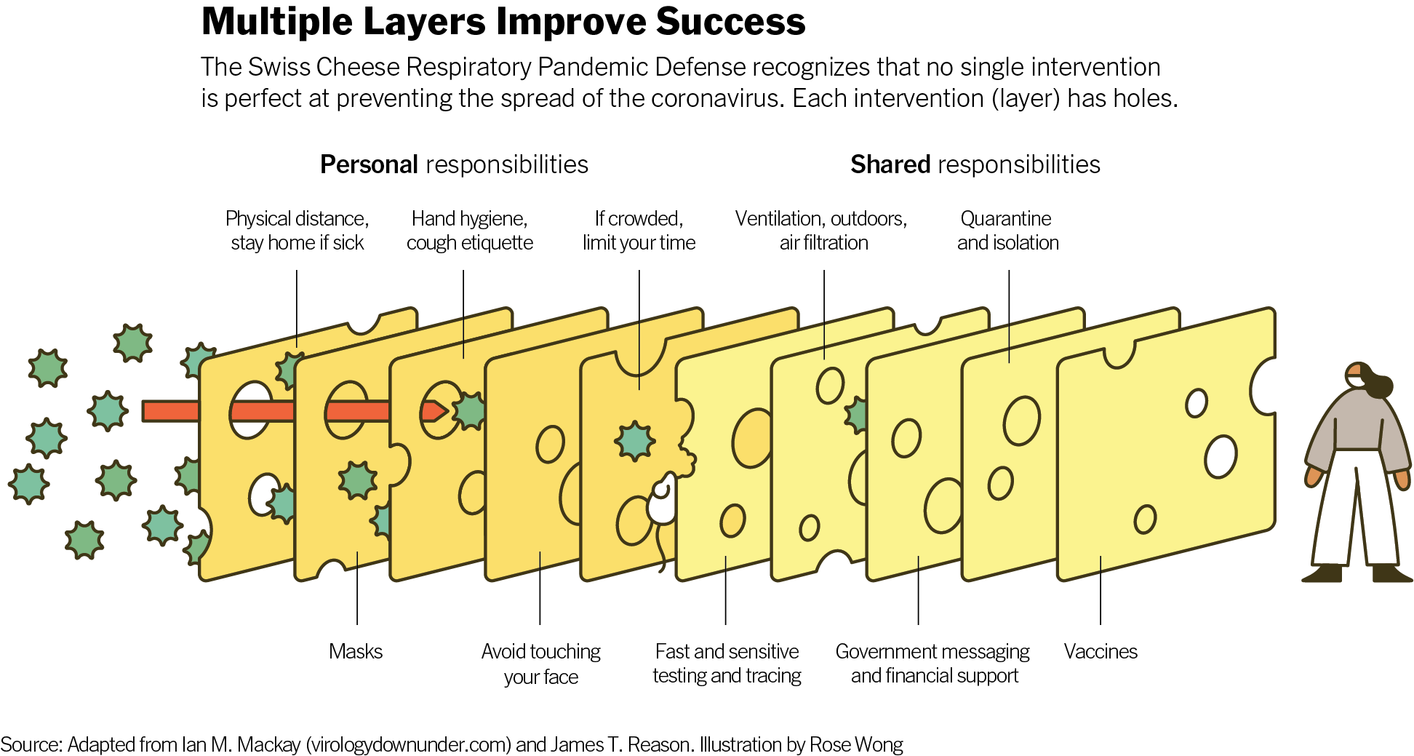
Section 2: Saxetenbach Gorge

In the Saxetenbach Gorge near the resort of Interlaken in Switzerland, is where the company Adventure World was selling adventurous days out canyoning, as to the level of risk the customer was aware of is uncertain, but as Adventure World worked with an international travel group Contiki Holidays, it seems likely they would be selling a high thrill - low risk package. This would likely appeal to a reasonably large demographic. Due to the nature of it being seasonal work, there would have been a high turnover rate of staff which could lead to a lack of correct training or low competency within leaders. Former employee of Adventure World David Eriksen “left Adventure World in 1996 because he became concerned that the company was hiring inexperienced guides and pushing them to take risks in bad weather. He said he understood that seven of the eight guides who took to the canyon on July 27 had less than one year's experience” (Head, 1999). The people involved can be split into four groups: The first group being the organisers of the adventure trip, which is Adventure World, and international travel group, Contiki Holidays (Head, 1999). The second group being the guides taking the customers out canyoning for Adventure World, the third group being the customers of which there was “a party of 45 tourists canyoning with eight guides” (BBC News, 1999). This group included the victims, from Australia, Britain, New Zealand, South Africa and Switzerland and aged between 18 and 31 (BBC News, 2001) - a young group likely due to the thrill-seeking holiday sold by Adventure World. The last group then would be those that came to aid in the aftermath, searching the river for bodies and searching the gorge.
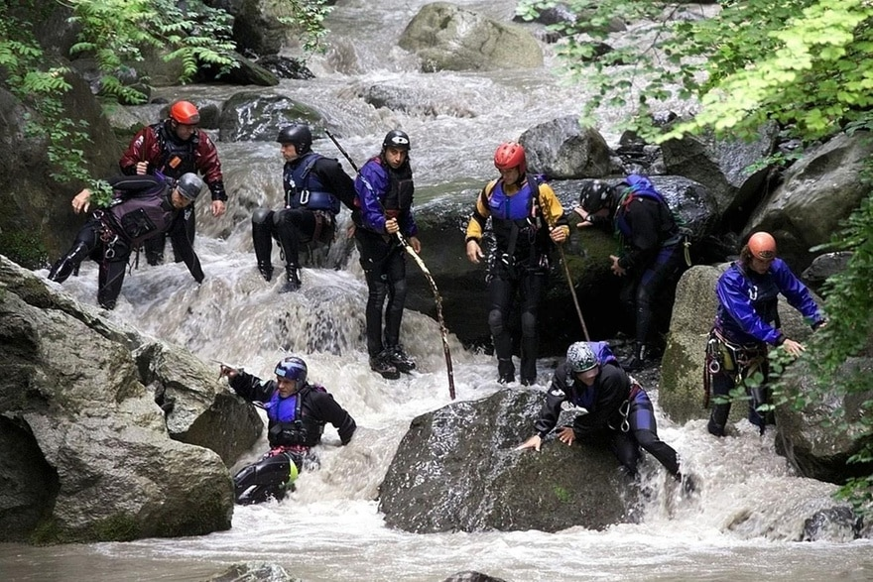
Image reference: Valle. A,D (1999).

Section 3: Key Factors and applying the SCM

Splitting the day into “slices of cheese” is useful as there were certain key factors that led to the incident, the first slice being the organisational influence in which failing to acknowledge the severity or consequence of the weather was a hole that went through every slice of cheese which then led to disaster. “The co-owner of the now-defunct tour firm, Adventure World, told the court he deeply regretted the incident, but claimed there was no way the tragedy could have been foreseen. “I am not conscious of having made a mistake," Stephan Friedli said” (BBC News, 2001). Furthermore, Adventure World and Contiki Holidays, had declared that the fatalities were simply the product of a freak accident that they could not possibly have predicted (Head, 1999). Those comments are very telling of the priorities of the organisational influence, in that they were unwilling to take any accountability to avoid lawsuits, as well as well as a complete lack of willingness to learn and put in place measures to not allow anything similar to happen again. This is reinforcing that “fallible decisions of upper-level management directly affect supervisory practices, as well as the conditions and actions of operators” (Shappell, 2000).
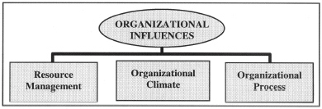
Shappell (2000).

Due to the organisational influence being one of disorder and confusion, and from a lack of leadership, this trickled down the chain of command until directly effecting the customers as according to Brooks (1999) in an article from The Guardian. Gordon Dirker, Contiki Holidays’ director of European sales, said that the “risk attached to canyoning meant customers signed a waiver from Adventure World before taking part.” But in contrast to that from an article from BBC News (2001), “Survivors say the trip was hurried and had not been properly explained to them, many thought they were going canoeing.” There could have been several negative influences from the companies' owners and management, a lot of them pertaining to money-orientated goals of the organisation, as according to former employee David Eriksen who quit in 1996; but in an article written by Head (1999) they state that money had become "quite important" to the owners of Adventure World and "I felt there was a disaster waiting in the wings". Due to the high turnover rate of customers and staff, allowed for several holes in the organisational influence layer of cheese allowing many failures/errors/risks to go through unchallenged, thus becoming the next layer’s issue.

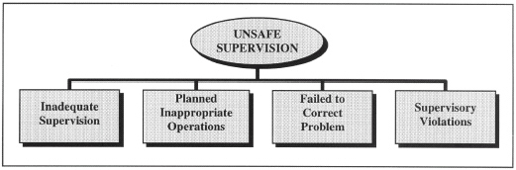
Shappell (2000).

The next layer being unsafe supervision, due to the corner cutting nature of the organisational influence, that would directly affect the staff’s judgements and priorities. BBC News (2001) reported “Judge Thomas Zbinden told the Interlaken court that safety measures taken by now defunct Adventure World were totally inadequate - with no proper safety training for the employees.” Without proper training the ability to assess risk and assess one’s competency becomes distorted, as it can only be related to experiential learning on the job/in the activity, as there is no set standard to compare to. That may have been one of the influences for the company remaining open during the recent storm and therefore “failed to heed storm warnings and had took no steps to prepare for any sudden rises in the water level of the alpine gorge” (Brooks, 1999), despite being specifically told to not go up from the local fire brigade which was an emergency plan, formulated three years ago after a similar incident - as well as another warning system from the police due to flooding and devastation downstream in 1987 in Saxetenbach, but not specifically for canyoning (Head, 1999). To elaborate on the interaction of the fire service and some of the staff of Adventure World this moves into the third slice of the SCM, which would be preconditions for unsafe acts.

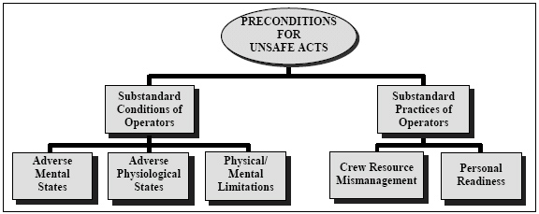
Shappell (2000).

Head (1999) mentions Martin Seematter (local fireman who was sent to warn the group of the severe weather and changing water level). He found the group getting ready to go into the water and said to not go in, but the guides replied that: “they had enough experience to know when to call it off...”. Now, each layer of cheese is not working due to the first layer's influence/attitude of staff/customers, by getting as many customers in and out of the gorge as quickly as possible (high turnover), it effects the second slices standards of safety, which effects the mental preparedness of the staff, as well as allows for growth of negative personality traits and pernicious attitudes - for example; overconfidence, complacency, and misplaced motivation. As well as other mental conditions that affect performance, principal among these are the loss of situational awareness, task fixation, distraction, and mental fatigue due to sleep loss or other stressors (Shappell, (2000). Most of these are applicable to the guides’ behaviour, but mostly overconfidence, poor situational awareness and task fixation - this becomes obvious due to the guides’ complete disregard of the weather warning due to believing they had enough experience to deal with it. This is a failure of leadership, as it puts abilities above the safety of the group, whilst not listening to others’ informed guidance. Head (1999) quotes one of the survivors, Kelly Swanson-Roe, who saw her husband Jon swept away, stating: “It was thundering and lightning before we left, and it was raining, and I believe we shouldn't have been in that canyon.” It seems important to ask why the guides were so confident in continuing to the gorge in those conditions, could there have been unseen pressures for them? Notably, the organisation (Adventure World) pressuring productivity form the guides, as "They were pushing younger, inexperienced people into the canyons to work there” (Eriksen cited in Head, 1999). “An experienced guide knows when to get out. An experienced guide is able to withstand the pressure from the organisation as well as say no. We experienced a little bit of pressure and that's why I left, so I didn't have to get involved in that. I saw it coming" David Eriksen told Head (1999). Several more holes in this layer of cheese are apparent due to failure of communication, leadership, misinterpretation of risks, overconfidence, failure to use the available resources of emergency warnings; as well as the other canyoning companies choosing to not go up in the weather that presented.

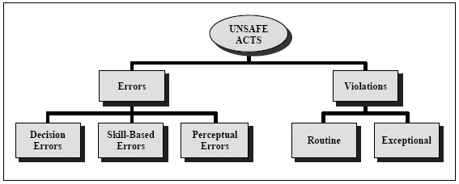
Shappel (2000)

Unsafe acts are the final section which can be broken down into two slices of cheese, with the categories of errors and violations; these relate mostly to poor judgment as well as oversights of the guides whilst in the gorge. The main issues to discuss in this segment which would have been one of the holes in the SCM is of attention failures, “these can commonly occur during highly automatized behavior. In fact, attention failures have been linked to many skill-based errors such as the breakdown in task fixation, it is not difficult to imagine that when under stress during emergencies, critical steps in emergency procedures can be missed” (Shappel, 2000). For example, the guides should have noticed the water levels rising and got the customers out of the water immediately, even as the water became muddy and full of debris that is an early sign of a flood, it seems possible that through a stress induced task fixation they (the guides) may have missed these early warning signs and moments to get people out of the water safely.

Section 4: The aftermath and an updated SCM

Adventure World proceeded to go out of business after a second fatal accident that happened within the time frame of 10 months from the Saxetenbach incident, a man died undertaking a bungy jump in which the rope was too long (SwissInfo, 2000). Which is for the best, as a company that sells adventurous holidays must ensure a high level of safety in relation to the activity, quite often the tourists that join will have to put absolute faith in the abilities and competency of the staff. In relation to the canyoning at that time there was no one level of quality for canyoning “The key criteria that changed after Saxeten: it was said that we needed a certification or training, but there was no common standard,” states Katrin Blumberg, president of the Swiss Outdoor Association (Giroud, 2019).

This is an updated SCM for if Adventure World had continued, and these are some ideas that could alleviate the chances of such a tragedy from happening again:
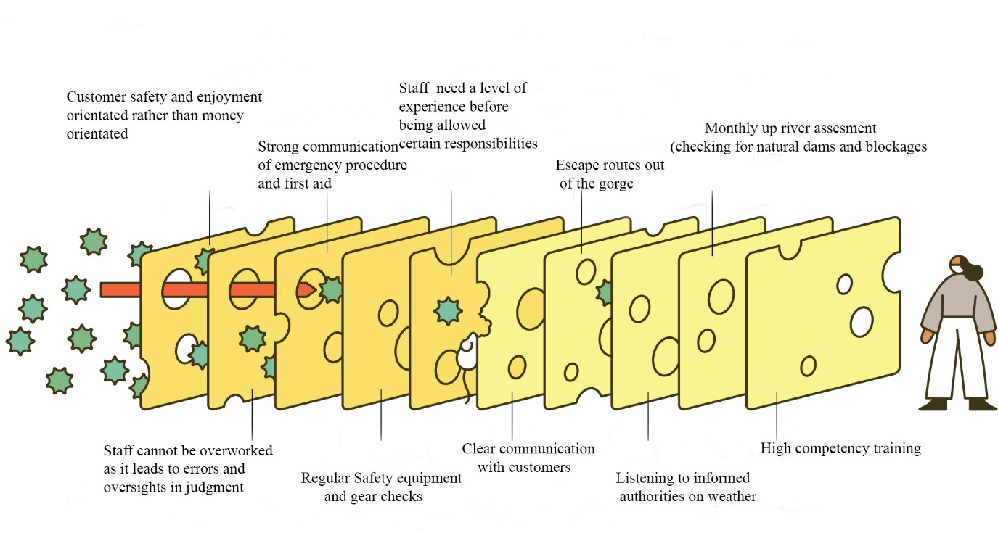

Section 5: Reflection and conclusion

Upon reflection, one of the most influential aspects learnt from this incident is to never assume absolute safety from someone leading you in an adventurous activity. Personal and dynamic assessments of risk must be on-going and constant, as there are many ways in which the leader can make errors or violations that directly affect a person’s level of safety if unaware; people will always make mistakes and even the most competent individual can still be negatively affected by poor organisational influences that directly affect the customer’s safety. Palmer (2010) talks about the issue of losing the ability to independently assess risk due to the dichotomy of the adventure holiday in these tourist-orientated versions of extreme sports, the very real prospect of injury and death has been stripped from the activity itself. The particular selling of risk that the commercial proponents of adventure travel engage in has fundamentally altered people's perceptions of risk, trust and danger.

References:

BBC News. (2001) Emotional start to Swiss canyoning trial

BBC News. (2001) Six guilty in Swiss canyoning trial

BBC News. (1999) World: Europe River disaster kills at least 18

Brooks, L. (1999) Criticism grows after disaster gorge trip. TheGuardian.com

Giroud, T. (2019) Safety still a question 20 years after Interlaken canyoning accident

Head, M. (1999) Profit drive blamed for Swiss canyon tragedy

Knowledge Hub. Flood-Flash Flood. Australian institute for disaster resilience. For reference: https://knowledge.aidr.org.au/resources/flood-flash-flood-switzerland/

Larouzee, J. and Coze, J.C. (2020) Safety Science. Good and bad reasons: The Swiss cheese model and its critics.

Palmer (2010) “Shit Happens”. The selling of risk in extreme sports

Perneger, T. (2005) The Swiss cheese model of safety incidents: are there holes in the metaphor?

RCN (2017) Royal College of Nursing: Core Concepts in Patient Safety

Thin, L, W,Y. (2018) Swiss cheese tragedy case study

Valle. A,D 1999. Keystone / Alessandro Dellla Valle. For reference it can be found here: https://www.swissinfo.ch/resource/image/45105310/landscape_ratio3x2/880/587/d0ab26d93062d015b43017d8c3f57ba4/A777643EAAD575D9881912199E28EE59/1623979_highres.jpg

Westrum, R. (April 25, 2000) United States Department of Health and Human Services. Blood Safety Transcripts. Advisory Committee on Blood Safety and Availability, 11th meeting http://www.hhs.gov/bloodsafety/transcripts/20000425.html Accessed on October 22, 2005.

Shappell, S.A and Wiegmann, D.A. (2000) The Human Factors Analysis and Classification System–HFACS

Swissinfo (2000) Adventure world announces closure. For reference it can be found here: https://www.swissinfo.ch/eng/adventure-world-announces-closure/1491934

Underwood, P., 2013. Examining the systemic accident analysis research-practice gap

