

Student name: Alya Toseef Javed
Student ID: 2328853
Module name: Empowering the older person
Module code: BMHP6027_LON
Lecturer’s name: Laila Surani

CARE, SUPPORT AND EMPOWERMENT NEEDS OF OLDER PEOPLE IN THE UK
 |  | EFFECTIVENESS AND BENEFITS OF APPROACHES AND INTERVENTIONS  Reablement services  - Help regain independence after illness.  - Improve confidence and daily living skills.  - Reduce hospital readmissions.  (NICE, 2023)  Person-Centred Care  - Respects individual preferences  - Encourages choice and control  - Promotes dignity and independence  (DHSC, 2014)  Policy 1: Care Act 2014  Key features:  - Promotes wellbeing  - Supports independence  - Provides care needs assessments  - Protects adults at risk through safeguarding  (DHSC, 2014)  - Strong legal frame  - Funding pressures affect service delivery  (The King’s Fund, 2023)  Policy 2: NHS Long Term Plan (2019)  Key features:  - Integrated health and social care  - Community-based care  - Preventative healthcare  - Improved support for older adults (NHS England, 2019)  - Improves coordinated care  - Workforce shortages remain a  Challenge (NHS England, 2019)  Safeguarding Older Adults  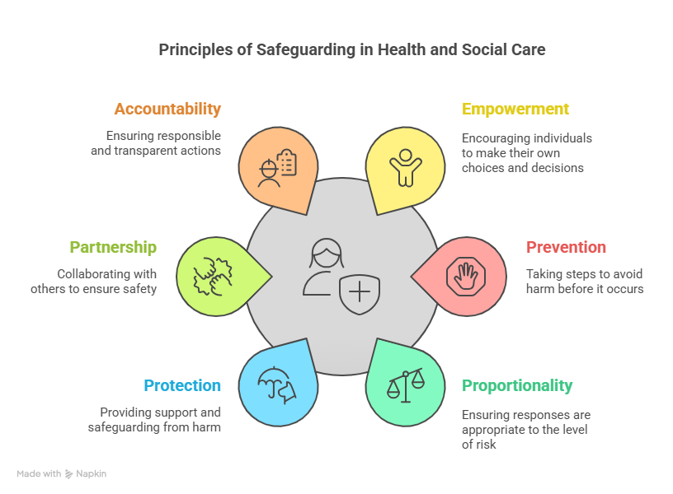  (Apex Learning, 2026)  - Multi-agency work improves protection  - Abuse can remain hidden due to underreporting |  | 
  Types of abuse | Role of Social services | Role of NHS
  Physical  Emotional  Financial  Sexual  Neglect | Investigate safeguarding concerns  Assess risk  Coordinate Protection Plans  (DHSC, 2014) | Identify signs of abuse  Provide treatment  Refer concerns to safeguarding teams  (NHS England, 2019)
INTRODUCTION  - UK population is ageing rapidly.  - 11+ million people aged 65+ in the UK (ONS, 2023).  - Increasing demand for health and social care services.  - Older adults often have multiple long-term conditions and require person-centred care (WHO, 2020).  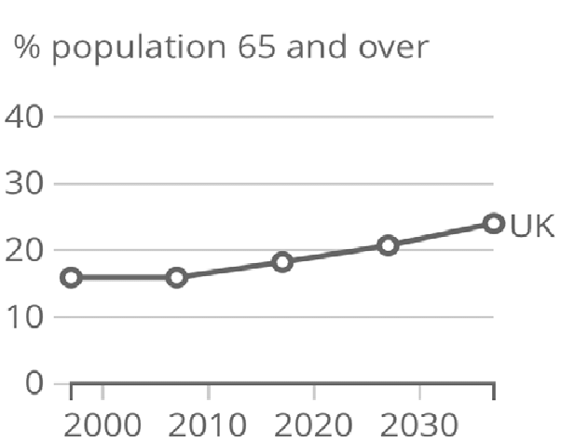  (ONS, 2019)  Focus of care = independence, dignity, functional ability (WHO, 2020)  Theories of Ageing  Activity Theory  Developed by Havighurst (1961).  Suggests older adults benefit from:  - Social engagement  - Physical activity  - Community involvement  Linked to:  - Better mental health  - Increased wellbeing  - Greater independence  - Encourages active ageing.  - Does not consider individuals with illness or disability  (Havighurst, 1961)  Disengagement Theory  Developed by Cumming and Henry (1961)  - Suggests withdrawal from society is a natural part of ageing.  - Older adults gradually reduce social roles and responsibilities.  - Recognises changing life stages.  - Contradicts modern policies promoting active ageing.  (Cumming and Henry, |  |  |  | CHALLENGES FACING OLDER ADULTS  Physical challenges:  - Fragility  - Falls  - Arthritis  - Dementia  - Multiple long-term conditions  (NHS England, 2019)  Psychological Challenges:  - Depression  - Anxiety  - Bereavement  - Reduced self-esteem  (Age UK, 2024)  Social Challenges:  - Loneliness  - Social isolation  - Digital exclusion  - Financial difficulties (Age UK, 2024)  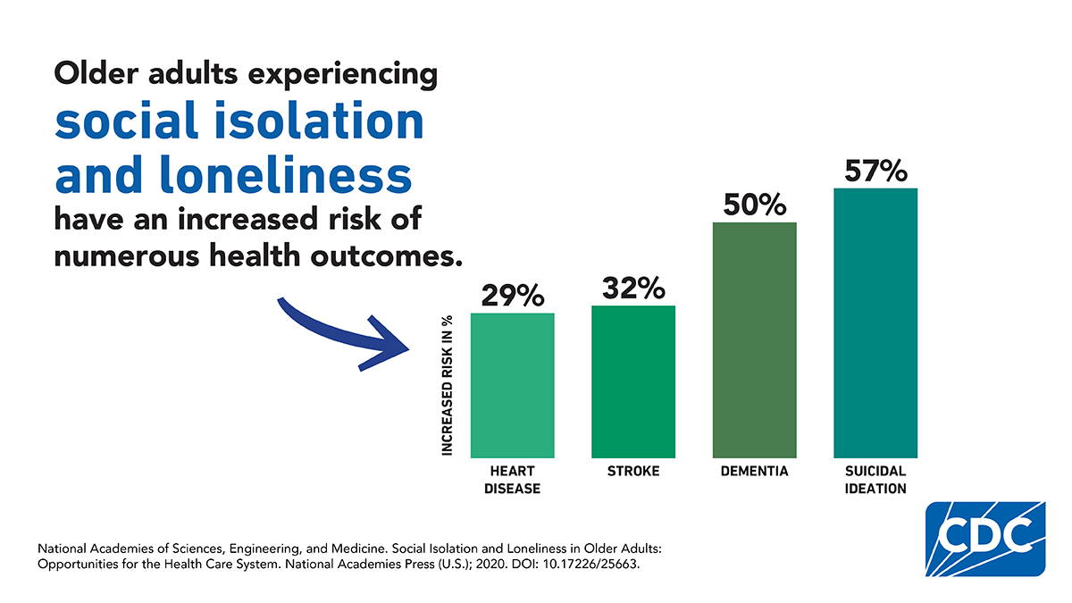  (CDC, 2024)  RECOMMENDATIONS  - Increase funding for community services  - Expand reablement programmes  - Improve NHS-social care integration  - Reduce digital exclusion  - Increase safeguarding awareness  - Provide anti-ageism training  CONCLUSION  - Older people have complex physical, psychological and social needs  - Person-centred care promotes independence & wellbeing  - The Care Act 2014 and NHS Long Term Plan support positive ageing  - Further assessment needed to address:  - Workforce shortages  - Loneliness  - Health inequalities  - Safeguarding concerns

References
Age UK (2024) Later life in the United Kingdon 2024. London: Age UK. Available at: https://www.ageuk.org.uk/globalassests/ageuk/documents/reports-and publications/later_life_uk_factsheet.pdf (Accessed: 23 June 2026).
Apex Learning (2026) What are the 6 principles of safeguarding in Health and Social Care? Available at: https://apexlearning.org.uk/6-principles-of-safeguarding-in-health-and-social-care (Accessed 9 July 2026).
Beattie, J. (2018). Britain’s population getting bigger and older – with 1 in 4 of us aged over 65 within 20 years. [online] Daily Mirror. Available at: https://www.mirror.co.uk/news/politics/britains-population-getting-bigger-older-13520641 (Accessed 8 July 2026).
Bing. (2026). Bing. [online] Available at: https://www.bing.com/images/search?view=detailv2&ccid=hd3e2zyf&id=657f1b688c02061b86dea3a9b7095cebd4fb040a&thid=oip.hd3e (Accessed 8 July 2026).
CDC (2024). Common Injuries as We Age. [online] Still Going Strong. Available at: https://www.cdc.gov/still-going-strong/about/common-injuries-as-we-age.html (Accessed 8 July 2026).

Cumming, E. and Henry, W.E. (1961) Growing Old: The Process of Disengagement. New York: Basic Books. Available at: https://archive.org/details/growingoldproces0000cumm (Accessed 8 July 2026).
Department of Health and Social care (2014). Care Act 2014. Available at: https://www.legislation.gov.uk/ukpga/2014/23/contents/enacted (Accessed 9 July).

Fleck, A. (2022). The Aging Population of England and Wales. [online] Statista Daily Data. Available at: https://www.statista.com/chart/27697/ccensus-shows-population-of-england-and (Accessed 8 July 2026).

Havighurst, R.J. (1961) ‘Successful ageing’, The Gerontologist, 1(1), pp. 8-13. Available at: https://academic.oup.com/gerontologist/article-abstract/1/1/8/639474 (Accessed 9 July 2026).

National Institute for Health and Care Excellence (2023). Intermediate Care Including Reablement (NG74). Available at: https://www.nice.org.uk/guidance/ng74 (Accessed 20 June 2026).

NHS England (2019). The NHS Long Term Plan. Available at: https://www.longtermplan.nhs.uk/publication/nhs-long-term-plan/ (Accessed 23 June 2026).
Office for National Statistics (2023) Overview of the UK population: August 2023. Newport: ONS. Available at: https://www.ons.gov.uk/peoplepopulationandcommunity/populationandmigration/populationestimates/articles/overviewofthepopulation/2023 (Accessed: 23 June 2026).
Office for National Statistics (2019). Research Gate Image, Ageing Population. Available at: https://www.ons.gov.uk/peoplepopulationandcommunity/populationandmigration/populationestimates/articles/overviewoftheukpopulation/
Office for National Statistics (2019) Research Gate Image, Ageing Population http://www.researchgate.net/figure/Graph-showing-the-proportion-of-the-UK-population-aged-65-years-and-over-which-is_fig1_336457956. (n.d.).
The King’s Fund (2023). Social Care 360. Available at: https://www.kingsfund.org.uk/insight-and-analysis/day-and-charts/social-care-360 (Accessed July 3 2026).

World Health Organization (2021). Decade of healthy ageing: baseline report. [online] www.who.int. Available at: https://www.who.int/publications/i/item/9789240017900 (Accessed 23 June 2026).

