Coexistent Perspectives
ACDC7001

Q. Research and critically evaluate the role of the artist/ designer/ maker in the context of space and place. Employing throughout critical analysis and relevant theoretical perspectives.

Emma Jenkins (1602880)
Word count: 3950
Pages: 13

How does the decoration and curation of objects create a telling place, can this then lead the abstract space in which the things are held, into acquiring philosophies of a heterotopia?

Introduction
This writing will explore and exhibit from a critical standpoint, the works of artist Damien Hirst and his installation ‘A Thousand Years’, alongside fashion designer, Alexander McQueen, and his fashion show ‘Voss’. By using key concepts of space and place, one will be discussing how their designed, made, and curated objects generate a meaningful place within an abstract space. How their works display similarities with materials and composition yet derive different notions of the philosophy heterotopia- a concept of space. Exploring how their made and curated objects act as vessels which can transport us into an unfamiliar space. Creative installation spaces are open to interpretation, but the space can exhibit as one of uncertainty, the objects can seem out of place- which acts as another place altogether. Lefebvre (1991, P.77) suggests that ‘space contains a great diversity of objects, both natural and social.’ Suitably, one will aim to discuss how the use of objects and things, manufactured or natural, can act as vessels. Descriptive things which can generate worlds within worlds; ethereal, material, and fictional spaces- a heterotopia. With the aim to dissect the premeditated aims of artist Damien Hirst and designer Alexander McQueen, one will discover how we interact with the place they curate within a space. How it embodies demonstrative importance, personal marks and how this enables spaces to mimic philosophies of heterotopia within their work. Establishing throughout, how a space is built up with their curated objects- things of meaning, which in result can generate otherworldly illusions. Overall, revealing the deconstruction of their praxis to form a critical evaluation.
Space and place; one rarely makes an appearance without the other, a formation which is naturally embedded within our lives as a cohesive partnership, and which Tuan (1977, P.3) suggests ‘are basic components of the lived world.’ So, we can acknowledge space and place as natural factors in the world, but there are many behaviours around how artists and designers curate a sense of place within a space. Bachelard (1969, P.203) states, ‘space of intimacy and world space- blend’. Consequently, creatives relate to and curate a certain place within a space because of how they build them up with their opinions and behaviour, they blend their personality into an open space to share, enabling curated spaces to become memorable places and sources of communication. Lefebvre (1991) acknowledges that objects are the pathways which facilitate the exchange of information. So, place has a strong relation to objects and things, place is where something is located. It is a structure for objects and things to evoke meaning and material. Tuan (1977) mentions, places are objects that catch our attention, we look at a scene and our eyes pause at points of interest. Each time we pause, we create an image of place that we remember. Subsequently, one can argue that it is through adorning with objects and/or material things, that enables artists and designers to generate memorable places within spaces, acknowledging that ‘such objects are thus not only things but relations.’ (Lefebvre, 1991, P.77).

Heterotopia philosophies and definition
Heterotopia is a type of space. According to the philosopher Michel Foucault, (1926-1984) who theorised heterotopia, he describes it as something which explains worlds within worlds. Things which can resemble that of our idyllic world yet upset our ideals, as Foucault (1986) describes, heterotopias are capable of juxtaposing different layers of disruptive and the unknown in the same real place and getting along and living together in a world of their own. Furthermore, Foucault uses examples such as prisons and asylums to demonstrate his meaning of worlds within worlds- real material places. Spaces that can mirror yet clash with our ideologies. However, heterotopia as another place within a space can also depict these mythical, fictional, abnormal, or ethereal environments, recognising ‘space is an abstract term for a complex set of ideas.’ (Tuan, 1977, P.34). Befittingly, heterotopia as an abstract concept has been deconstructed and interpreted in a far more imaginary manner in recent years. Kelvin knight (2016) wrote about resolving a paradox around Foucault's theory of heterotopia and states ‘heterotopies were never intended as an example for the study of real material sites, but rather concerns itself to fictional representations of these mythical and imaginary places.’ (Knight, 2016, P.141). So, one can suggest that heterotopia is an abstract space where people harvest these otherworldly or out of place philosophies and use it to portray their surreal or illusionary values.
Furthermore, Kant (1978) describes, the imagination (as a productive cognitive faculty) is very powerful in creating another nature out of the material which the real one gives it. Kant mentions the ability of imagination and how it can, for example, depict a certain place with the materials in which we see. With this in mind, one can insist that objects can be used as a vessel for the imagination to define a place, which in result can enable us to be submerged into heterotopies. When we are subjected to certain objects, the space becomes open to interpretation. Accordingly, Foucault (1986, P.23) states that it is ‘the space of our dreams and that of our passions which hold within themselves qualities that seem intrinsic.’ Rightfully, it is imaginative visions and passions that can enable people and artists alike to harvest the ideas of a heterotopia. Transmitting their customs and desires within a space for people to visit. A space which takes you to a surreal place of curiosity and intensity - a referential heterotopic world. One will aim to explore both notions of Heterotopia in contemporary art practice. To consider and present where Damien Hirst embodies Foucault’s (1986) heterotopia, where two worlds collide- the real and the unidyllic. Also, how Alexander McQueen embodies another representation of Heterotopia, one Knight (2016) describes as fictional or ethereal; blending objects, and personalities into an otherworldly space. Furthermore, considering how their ornamented spaces result in a story which evokes unidyllic and/or fictional places within spaces that are not often open to public view, leaving the imagination to wonder.

Damien Hirst ‘A thousand Years’
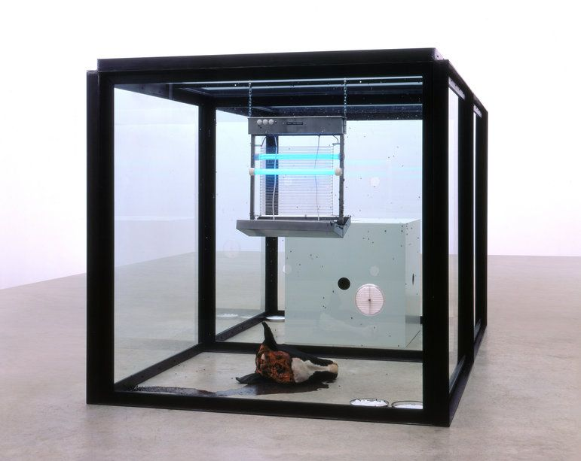Image one- Damien Hirst’s Installation,’ A thousand Years’, 1990. Available at: Our favorites of... Damien Hirst - Magazine Artsper
Artists have explored ways of bringing the personal and the daring into the public. Here, they create areas in which the unimaginable is forced to be imagined, form clashing with function. Tel Aviv University (2012) makes an inciteful observation regarding this topic, noting that space maintains a close relation with illusionism, narrativity, and the performative qualities of art. An extraordinary example of this (as seen above in image one) is Damien Hirst’s ‘A Thousand Years’. In this bold installation, Hirst is using the space as a performative display of life and death, with the use of living or live objects- maggots, flies, a severed cow’s head and a fly zapper. The initial fixed visual sight seems solely designed to test, frustrate or even, confuse and disgust. Hubbard et al (2004, P.137), supports this by insisting ‘space is not experienced and understood in a similar manner by all individuals.’ Therefore, establishing that Hirst is taking a concept which could produce polarising thoughts.
Initially, the focus is so heavy on death in the form of a severed cows head, that one does not always concentrate on the flies, which are a visual reminder of the reproductive cycle of life, demonstrating this ever-expanding, evolving space. This is because it is hard to digest such a gory notion (a severed cow’s head) and be in the initial intense place that Hirst has created. Wall (2000, P.36) recognises that, ‘the object is stripped of its everyday context and acts as the focus of pure contemplation.’ Therefore, it is the rotting severed cow’s head simply being present in the space, which produces a harsh picture for us to face. It becomes another place; one we would normally choose to avoid. Furthermore, the flies, which do not at first catch our attention, are there to eat and reproduce. This is only possible thanks to the severed cow’s head, which then creates another angle for us to look at this work. This offers the viewer the opportunity to take the opposite perspective and consider not only the death of the cow but the life of the flies. However, this perspective is one we will not initially see because we cannot help but focus on the shocking, almost overpowering object that is the cow’s head.
The result of this emotive space creates within us a place of pure uncertainty, as Kaye (2000, P.5) states, ‘space might be subject not only to transformation, but ambiguity.’ So, the space is open to interpretation- our perspective keeps changing to make sense of this piece because of the vivid impact it initially has. We see a huge clash between the objects within this space. It proposes that as a viewer, there are two places we can choose to be in: the vivid, harsh, and extremely bold depiction of death or the subliminal initially invisible representation of the natural life cycle. Whatever context in which we interpret this space, Hirst has created two provocative places which are confined within this one space. Minière, (2003, P.47) recognises that the objects are ‘enacting a fatal life cycle.’ Thus, it is the curated objects framed in a space, within another space- which clash and demonstrate as out of place. They generate another place for us to see, creating a world within a world- a descriptive example of Foucault’s (1986) philosophy of a heterotopia being a real material site. One which can mirror us- yet upset us.
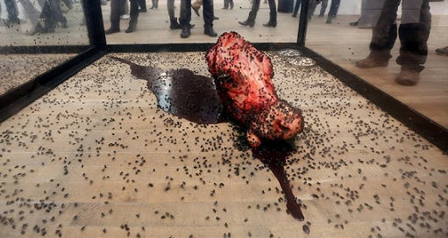
Image two- Damien Hirst’s Installation,’ A thousand Years’, 1990. Available at: (1) Damien hirst 1000 years - Bing images

As seen above in image two, overtime the objects (in this example the flies) used in the piece will develop. They are harvesting the space, adapting to survive, yet could be killed at any moment. A fragile but intruding life and death reality. The flies are demonstrating various places as they change and evolve, the installation is like a moving image, as Lefebrve (1991, P.183) notes, ‘the movement from obscurity to enlightenment- the process of decipherment is perpetual.’ So, we can acknowledge this is an ever-evolving space taking you from one place to another, this constant movement or change is essential in creating different meaning as we continue to observe this piece. Furthermore, by analysing the flies, we can suggest that they are only doing what they know best, but for us as humans, as spectators, we are literally looking life and death in the face. Chaudhuri (2007 P.14) acknowledges this by stating, ‘the viewer who can endure the sight is being asked to face an allegory of life and death, a drama of chance and determinism.’ Additionally, as hard as it is to process, after giving the installation some time, we can move with this installation and begin to make sense of these curated vivid objects on display. By taking time to see the deeper meaning of the objects in this work, we start to feel a strong sense of place. Notably, Lefebrve (1991, P.183) mentions that ‘a mere change of position or a change in places surroundings, is enough to precipitate an objects passage into the light: what was covert becomes overt what was cryptic becomes limpidly clear.’
This installation offers us the chance to evolve and move with it, to make sense of it. Hirst utilises the objects to depict the natural fragility of the life cycle. The presence of the fly zapper represents how fragile life is and how it can be taken away in the blink of an eye. While ‘the putrefying head is a way to face both our mortality and all devices through which we deny it.’ (Chaudhuri, 2007, P.14). So, we are transported into dealing with these fears and unideal pictures of life and death, Hirst’s piece ‘A Thousand years’ harvests the personal and the real. He enlightens us into confronting fears and these things we choose to supress or remain blissfully ignorant to. He poignantly broadcasts this perception in the most bold and unpleasant manner. We are initially heavily drawn to the notion of death, that it takes you a while to notice the other notion of life and it creates an ‘active back and forth between the material making and the formulaic meditation on the idea.’ (Minière, 2003, P.47). Thus, creating two places we can be in: the vivid notion of death or the subtle notion of life. Hirst boldly displays his curated objects and uses them to blur the boundaries of the humans pretty and peaceful place it normally likes to be. He transcends you into a sharp heterotopic picture which reflects that of life and death. Hirst is embodying fears and avoidance and forces us to confront them head on, literally!
Hirst is blending examples of life using objects which are the flies and death through the object being a severed cows head, equally depicting how fragile life is with the display of another object- the fly zapper. Chaudhuri (2007, P.14) describes it as ‘a crude parody of the life cycle of man.’ Hence, it is the objects we see in this installation; a cow’s head, flies and a fly zapper, that frames this crude representation of life and death. The objects we see in this installation would normally be seen in a farming type of environment, which are now displayed vulnerably in a museum setting, completely out of place. This then causes an unsettling almost unforgiving, yet forceful imitation of life and death. As Minière (2003, P.47) acknowledges, ‘the work summed up a biological process, it gives us life and death in a glass bubble.’ In result, the objects create a vexing place, framing a world within a world- mimicking Foucault’s earlier philosophy of a heterotopia. What presents this is the use of the living and vivid objects (the flies and the cow’s head) placed within a fragile glass box, which frame a contrasting space where two worlds collide. It is displaying a world that mirrors the happenings of our world, but in a vivid, grotesque way. Creating an intense heterotopia to contemplate, a place we would normally avoid, but are conflicted into confronting.

Alexander McQueen ‘Voss’
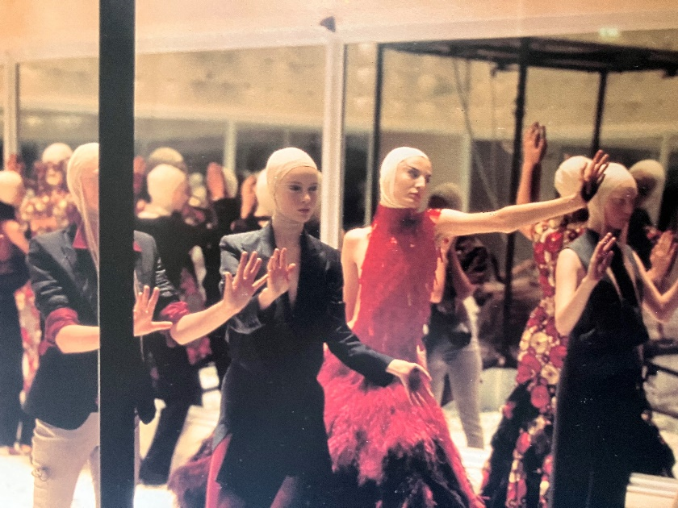
Image three- Alexander McQueen’s ’Voss’ collection showcase, 2001. Source: Evans, C. (2007) Fashion at the Edge: Spectacle, Modernity and Deathliness. New York: Yale UP. Page 95-98.

Fashion designers also embellish spaces by adorning the environment, blurring the boundaries of societies depictions on the perfect and the ugly, channelling their personal battles and boundaries. It can become a place of entanglement between opinions and point of views together all in one space. Tuan (1977, P.34) suggests that ‘man, out of his intimate experience with his body and with other people, organizes space so that it conforms with and caters to his biological needs and social relations.’ An example of this is fashion designer Alexander McQueen, he can harvest the notion of a personal place and protest this within a space, impacting the viewers outlook. He harmonises the topics of the sane and the insane, leaving the mind to wonder into unknown territories, namely uncomfortable ones. Fashion collections can have a powerful social impact in the way they are curated within a space, empowering the unspoken, empowering curiosity and boldness provoking the viewers, creating evocative experiences. A beautiful example of this is Alexander McQueen's 2001 show ‘Voss’.
The show is initially jaunting. It is a claustrophobic environment. The spectators are surrounded by mirrored glass, as Evans (2007, P.94) implies ‘the audience become progressively more uncomfortable as it was faced with its own reflection.’ Consequently, the space, becomes a place of uncertainty and frustration as the audience are initially the objective, because it is only themselves, they see. Making them the objects of the show for a short time. It is this concept of self-reflection that creates a place in which the viewers do not chose or desire to be within. They may feel out of place and the space becomes unpredictable, as Kaye (2000, P.5) notes, ‘space, as a practiced place, admits of unpredictability.’ Much like Hirst's depiction of the fragile concept and the use of glass to frame this, McQueen also depicts a meaning of sensitivity within his show with the use of the material mirrored glass, which is mirroring yet disturbing the viewer. This place of oppression is also echoed through the objects applied and curated within the glass mirrored box. The objects (being the models, displayed in image three) are fashioned with these otherworldly designs, intensifying these uneasy feelings. As Briseno (2021) notes, the line between fiction and reality is erased into a heterotopic space. Suitably, McQueen curates a place which is otherworldly, it mimics that of a fictional space- referencing Knight’s (2016) interpretation a Heterotopia.
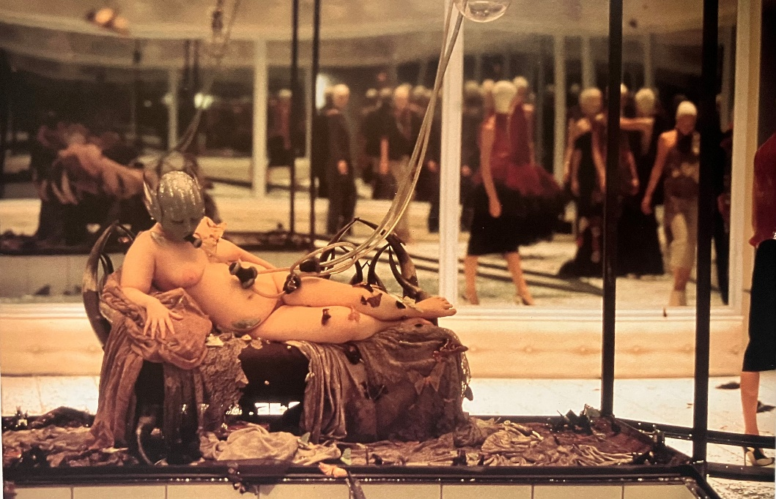
Image four- Alexander McQueen’s ’Voss’ collection showcase, 2001. Source: Evans, C. (2007) Fashion at the Edge: Spectacle, Modernity and Deathliness. New York: Yale UP. Page 95-98.

McQueen’s display is cleverly protesting the sensitive and uncomfortable topic of the misconstrued quintessential body image that society has, as Kwon (2004) notes, the space is one that is extending beyond familiar art settings to more public realms. This is achieved through the clever and organised use of objects - the models, accessories and clothing McQueen has created. He is protesting a topic which he, himself relates too, one he has derived from a personal place. Tuan (1977, P.16) notes that ‘spaces reflect the quality of the human senses and mentality.’ That being so, the space in the Voss show tells a personal story, McQueen is subliminally standing up against the law of beauty and the social conception of what we deem correct or perfect by placing an object, being a bigger, voluptuous, unidealistic model within the space (see example in image four). McQueen remodels the space which is usually heavily related to perfection and beauty and breaks it down into a concerning one, an intense one and an imperfect one. Knight (2016) implies, heterotopies open up a space, without law or rules, it breaks down the difference between the raw material of a story and the way a story is organised. So, McQueen’s cleverly organised display of a voluptuous model with grotesque and disturbing depictions, doesn’t impact the true meaning these objects are trying to portray. They are vessels which evoke uneasy emotions, creating a dark place to be in, it is symbolising a fictional heterotopic space, one where he wants us to reside and be absorbed in this shared societal shame of body imperfection.
McQueen’s show ‘Voss’ is a prime example of how we can be seen and be heard in an intense and powerful, dominating space which captivates us. Briseno (2021) suggest that fashion is exactly that, objects which denote a heterotopic space in which we can adorn. Accordingly, McQueen clearly transforms a space and fabricates a place of importance. A place that provokes disturbance. It is bold, and it is daring. It is the clever use of his designed objects which evoke such subjective notions. Identifying a place that can challenge the polished preconceptions of societies ideal. As Kwon (2000) also suggests, fundamentally tying a sense of identity to a place and reminding us of the values they embody. This intense heterotopic space we see in the Voss show, challenges topics that are not comfortable and that are not pretty. It curates a space that is meant to challenge, that is meant to be intense and disturbing, and he does it in a fictional presentation. McQueen is broadcasting his conviction so the only thing you can see and hear are the subjects and objects right in front of you. They are so dominating, you are in a place which smothers you, swallows you and takes you to a heterotopic realm where we must reside for a while. Bachelard (1969) notes, our vast dwellings are places where we can escape, there are moments when it is a brave thing to go and be in them. McQueen curates an uneasy heterotopia, advertising the dark side of how society can be, glorifying the shared societal shame. It is the curation of the objects; models, props, clothing, even the audience themselves, which generates this meaning. Evans (2017, P.94) acknowledges this by stating, ‘people live out their relations to each other via objects, displacing human emotions onto things, flooding them with meaning.’ Thus, enabling a captivating space with the use of his curated and made objects, which denote so much meaning. It subtly pushes us to reside and dwell in this controversial heterotopy.

Conclusion
This essay has described space and place, observing how it is the decoration and curation of objects that create a place of meaning, and in result can immerse us into a heterotopic space. We can see, as demonstrated throughout, that fashion designer Alexander McQueen inherits a philosophy of heterotopia in a far more fictional and ethereal manner. One which marries Knights (2016) claims of a heterotopia being a representation of a fictional, imaginary, or mythical space. Whereas fine artist Damien Hirst embodies Foucault’s (1986) earlier philosophy of a heterotopia- a world within a world, real material spaces. Although Alexander McQueen and Damien Hirst both address personal matters and relatable matters. The heterotopia we see in McQueen's show contrasts to that one we see in Hirst’s installation, because Hirst wants us to transcend into a place where we are faced with the fragility of life. He displays ‘messages, by virtue of space and of interplay of reflections and mirages within it, that are intrinsic to lived experience itself.’ (Lefebrve,1991, P.184). Therefore, we can acknowledge that Hirst curates his installation with vivid and upsetting objects which seem out of place, but ironically mirror that of cultural happenings. He frames a real material world within a world. Whereas McQueen frames a completely fictional or ethereal world with the use of his curated objects, Wall (2000, P.22) comments that ’we experience space and are able to explain it by virtue of the objects in it.’ Thus, McQueen creates a space where a story is generated from the objects curated within it. A place where we are held prisoner, where we dwell on his topic of shame and imperfection. A juxtaposition to Hirst’s notion of courageousness and realisation.
Throughout this essay one has highlighted how artists and designers use their made and curated objects to demonstrate feelings, as Bachelard (1969, P.203) mentions, ‘the coexistence of things in a space to which we add consciousness of our own existence, is a very concrete thing’. Thus, we can acknowledge that both McQueen and Hirst have embodied personal places in their work, which denotes meaning; factual and/or mythical. Concreting their personal consciousness within their designed objects. Creative installation spaces are open to interpretation, but the spaces demonstrated throughout do exhibit as ones of uncertainty, the objects can seem out of place- which acts as another place altogether. This is what mimics philosophies of heterotopia. Although both McQueen and Hirst inherit differed opinions of a heterotopia, both notions of heterotopia still blend as one- a world within a world. Regardless of it being a real material setting or a representation of a fictional environment. They both frame an otherworldly, unidyllic scene. It is the curation and adornment of the space built up of things, objects, subjects, choices, and personality which creates these otherworldly illusions and uncomfortable environments- heterotopies.
According to Lawson (2001, P.6), ‘the human language of space, whilst it has its cultural variations, can be seen all over the world wherever and whenever people come together.’ That being so, we come together socially and culturally to embed and engross ourselves within a space, we insert our identities and values to evoke meaning, as do artists and designers when they decorate their spaces. Advertising the significance of their made objects on display, curating a space which invites us to come together and be within. A shared space of realisation and reflection. In conclusion, this essay demonstrates that it is the place, which is built up of objects and things, that manifests otherworldly or out of place philosophies of heterotopia. As Tuan (1977, P.136) states, ‘space is transformed into place as it acquires definition and meaning.’ Thus, we can acknowledge that a curated place can outline philosophies of a heterotopic space when it gains meaning through objects. Resulting in us as humans, whether it be creative or not, using space as a place to broadcast personal meaning. Spaces where we gather to generate opinions and feelings, leading us to develop a sense of place within a space. Settling that space and place are natural parts of our lived world, unaffectedly shared environments which denote mixed opinions and feelings, and in result, form otherworldly heterotopies.

References
Books:
Kaye, N. (2000) Site- specific art, performance, place and documentation. London: Routledge.
Dean, T & Miller, J. (2005) Art works, Place. London: Thames and Hudson
Tuan, Y. (1977) Space and place, the perspective of experience. London: University of Minnesota press.
Kwon, M. (2004) One place after another, site specific art and locational identity. London: The Mit Press.
Lawson, B. (2001) The Language of SPACE. Oxford: Reed Educational and Professional Publishing.
Hubbard, P. Kitchin, R and Valentine, G. (2004) Key thinkers on space and place. London: Sage
Wall, J. (2000) Figures & Places. London: Prestel
Lefebvre, H. (1991) The production of SPACE. Oxford: Blackwell
Evans, C. (2007) Fashion at the Edge: Spectacle, Modernity and Deathliness. New York: Yale UP
Kant, I. (1978) A critique of judgement. USA: Hackett Publishing Company Inc
Foucault, M. (1986) Of other spaces. Baltimore: The Johns Hopkins University Press
Knight, K. (2016) Placeless places: resolving the paradox of Foucault's heterotopia, Textual Practice. Abingdon: Routledge
Bachelard, G. (1969) The poetics of space. Boston: Beacon Press
Minière, C. (2003). Bang! ou la mort-la vie chez Damien Hirst/Damien Hirst: bang-bang you’re alive. Paris: Art Press 289
Websites:
Chaudhuri, U. (2007) (De)facing the animals Zooesis and performance. Available at: https://www.jstor.org/stable/4492732 (Accessed 21st November 2022, 10.09am)
Briseno, A. H. (2021) La Poupee and voss: Alexander McQueen's heterotopias. Available at: La Poupee and Voss: Alexander McQueen's Heterotopias — The Fashion Studies Journal (Accessed 13th October 2022).
Tel Aviv University CFP. (2012): The Concept of Space & Place in Art. Available at: The Concept of Space & Place in Art (Tel Aviv, 16-17 May 12) - ArtHist.net: Network for Art History / Archive (Accessed 13th October 2022).
Images:
Image one- Damien Hirst ‘A Thousand Years’. Available at: Our favorites of... Damien Hirst - Magazine Artsper (Accessed November 3rd 2022, 15.47pm)
Image two- Damien Hirst ‘A Thousand Years’. Available at: (1) damien hurst 1000 years - Bing images (Accessed November 3rd 2022, 15.56pm)
Image three & four- Alexander McQueen ‘Voss’ Show. Evans, C. (2007) Fashion at the Edge: Spectacle, Modernity and Deathliness. New York: Yale UP. Page 95-98.

