Career Development

Student: Babar Hussain
Student ID. 2014975
Module code: BMSW 4005
Title: Reflective Portfolio
Lecturers Name: Besty Jose

Table of Contents

Introduction………………………………………………………………………3
Main skills………………………………………………………………………..4
SWOT Analysis……………………………………………………………….…6
PDP Personal development Plan …………………………………………..…7
Carer Development plan …………………………………………………….....8
Skills required for managerial role ……………………………………………10
Concepts Learnt from Module ………………………………………………...12
Learning style theories……………………………………………………….…13
Self Awareness………………………………………………………………….15
Conclusion……………………………………………………………..………..16
References ……………………………………………………….…………….17
Bibliography………………………………………………….………………….18
Appendix…………………………………………………………………..…….19

Introduction

The purpose of this report is to discuss what I have learned within the module of professional career development. Some of the topics that will be discussed in this report are:
- Different skills learnt.
- SWOT analysis of the skills.
- Personal development plant.
- Career development.
- Skills required for a managerial role in catering
- Concepts learnt within this module
- Learning style Theories
- Self-Awareness
- Reflection

Main skills

There were many skills I learnt from this module. Some of them included interview skills, communication skills, planning skills and how to write a cv. All these skills are very important for all professionals.
Interview skills
“Interview skills are skills or actions that allow a person to be more effective throughout the interview process for a new position” (Team, 2021) (1) good interview skills are required to allow you to have a better chance of getting a job. When going for an interview is essential for the interviewee to firstly do some research as to what job they are applying for and what is required from them for the job. Being polite is another skill that is essential when going for an interview. You must be polite from the start when you walk into the organisation you are going for an interview. Try not to be nervous, be confident in what you are saying. Body language says a lot about a person. Make sure you sit up straight, maintain eye contact without staring into the interviewer’s eyes. Maintaining eye contact will look like you are being honest but if you stare it may make the interviewer feel like you are being aggressive. Another thing to do before going to the interview is to make sure you know your curriculum vitae. As the interviewer may ask specific questions about you from the CV.
Make sure you wear appropriate clothing. As that is the first thing that the interviewer will see. Making a good first impression makes the interviewer feel you care about the job you are being interviewed for. Then get to the interview on time as being late to the interview will leave a bad impression, it will make the interviewer feel as though if you can’t be on time for the interview what the guarantee you will be on time to work. The last thing is to make sure you have some questions prepared to ask, but make sure it’s not something that the answer is available on their website or was in the job description. Also, don’t forget to say thank you.
Looking back at before I started doing this module, I had not really attended any interviews. So, when was told that in this module you will have to attend an interview I was very nervous. I didn’t know what to expect but after being taught the skills in this module it wasn’t so daunting.
I started preparing by firstly looking at the job description and then going through my cv. I then went on to make sure I was on time and had my clothes ironed and ready before the interview timing. I gained a lot of confidence from knowing what to expect. I was able to ask a question as well even though the job description covered everything I needed to know. I have attached a copy of the feedback that I received from the mock interview I did in (appendix 1)

Communication skills

“Communication is all about making contact with others and being understood” (care, 2018)(2). To communicate effectively is a very important life skill as well as a professional skill. Good communication enables you to pass information to other people and to understand the information given to you. There are many types of communication. Verbal communication, written communication, and visual communication.
Verbal communication
Verbal communication can be done face to face or through video calling. It is important to make sure you actively listen to what is being said so you can respond back in a friendly and respectful manner. You must make sure you speak clearly and loud enough so you are heard and understood, making sure not to shout.
Written communication
Written communication can be done through letters and email etc. it is essential what is communicated through writing is written clearly without spelling mistakes and in full sentences.
Visual communication
Visual communication is the body language that you use. This can be from facial expressions to the way you sit or stand when you are talking to someone. It is important to maintain good eye contact as this shows you are paying attention and are not getting bored of what is being said.
before learning about what good communication skills are I used to use a lot of slang words when speaking to professionals. I learned to speak slower as that was one thing, I did wrong was talking fast and then getting taken off track. I also learned to make sure I am not slouching when sitting and maintain good eye contact. I applied these skills during a presentation and interview that I did during the course.

SWOT Analysis

The SWOT analysis is an acronym for strength, weakness, opportunity, and threat. “A SWOT analysis is designed to facilitate a realistic, fact-based, data-driven look at the strengths and weaknesses of an organization, initiatives or within its industry” (KENTON, 2021) (3) The SWOT analysis can be done for personal use as well. Below I have done a SWOT analysis on my own strengths and weaknesses.

Strengths | Weaknesses | Opportunity | Threat
- Multilingual  - Polite & Friendly  - Dedicated  - Hardworking  - Quick learner | - Poor time management  - Anxious  - Lack of experience | - University Graduation  - Managerial position | - Personal health  - Other people interested in the same job role

PDP Personal development plan

“A Personal Development Plan is a written account of self-reflection and improvement, which doubles up as a detailed action plan used to fulfil academic, personal, or career-based goals.” (Rolfe, 2021)(4)
A personal development plan (PDP) is a framework that can be used to be aware of any skills that you may have, it can be used to develop skills that you need. It can be used to work out what you want to accomplish and how to reach it. It is used to focus on possible career, study, and personal development options and goals. The framework is used to develop information for CVs, interviews, job applications, and appraisals at work. I have done a Personal development plan for myself as to what I would like to achieve in the next year.

Career development

“A career development plan is a written list of the short- and long-term goals that employees have pertaining to their current and future jobs, and a planned sequence of formal and informal experiences to assist the employees in achieving their goals” (Trueba, 2008)(5)
Career development plans are action plans that can be used to build a roadmap to you preferred career. A career plan example can outline:
- The starting point- where you are in your career now
- The destination- this is where you want to be in your career
- The gap- this is the obstacle that will come in your way.
- The route- this is how you will go about closing the gap to reach your destination.
I have done career development for myself. This includes what I am currently doing and what I want to do in the near future. My current job is I am a driver for a food catering company. I am also studying and in the near future will continue to study and graduate in a business management course and open my own catering company that will serve food to the local care homes and to the elderly living on their own.
I am currently working in a business similar to what I want to own. I know I will have to employ a supervisor, health and safety advisor chefs, and drivers to ensure I have a smooth-running business.

CAREER DEVELOPMENT PLAN
CURRENT JOB- Delivery Driver
TITLE- Driver
DESCRIPTION- Delivering food
GOAL JOB- Manager
DESCRIPTION-Owning and Managing a company of my own.
COMPANY- Catering Company delivering to elderly and care homes.

Skills required for a managerial role in catering company

There are many skills required when you want to be a manager of a catering company some of them include:
- good communication skills
- to be able to take initiative
- teamworking skills
- able to lead a team, good teamworking
- be able to motivate and lead staff
- The ability to carry out admin work and IT literacy
- Financial and numeracy skills
- Customer service skills
- Skill to work under pressure
- Driving licence
- A certification in food hygiene, and health and safety
I have many skills but there may be some that I need to improve on. Looking at these skills I can see that my strong point for this job will be good communication skills,good team working.

Financial and numeracy skills
To become a good manager, it is essential to understand the profit and loss within a business. Financial skills are needed for this. I do not have enough knowledge on how to work the profit or loss of my business. I will have to gain this skill by studying the business management course and familiarising myself with the finance side of a business.

Admin work and literacy
This skill will include keeping a record of all employees, customers, and day to running of the business. I have never owned my own business so therefore do not know what is required from me this again is something I am going to have to learn. I will close this gap again by doing the business and management degree.

Certificate in food hygiene and health and safety
Food hygiene and health and safety ensures customers are safe with the food they eat and employees who are working within the company have a safe environment. The job role I want to go into will require me to have a certification in food hygiene and health and safety. This is something I may be a able to learn as an extra course alongside my degree.

Concepts learnt from this module

Setting goals and objectives (SMART)
“A SMART goal is used to help guide goal setting.” (What are SMART Goals?, 2021) (6)

SMART is an acronym for Specific, Measurable, Achievable, Realistic and Timely. It is important to set goal and objectives in life because you need to have a clear purpose in life. They may motivate you to achieve things withing your career and personal life.
While doing this report I have used the SMART tool to set goals within my personal development plan and career development plan. for example, to study business management is a long-term goal for myself looking at the SMART tool my goal is very specific it is measurable its accurate its realistic and in is timely. I have set short term long term and medium-term goals.

UK employment Law

“UK employment laws are in place to make sure that both employers and employees are protected. (UK Employment Laws Explained, 2021)(7). There are many laws in place for both the employer and employee. The employment law protects both employers and employees from any form of misconduct. Some of the common areas that I may come across as a business manager may include
- Employment contract-“An employment contract – or contract of employment, if you prefer – is an agreement between an employer and employee that one will work for the other in return for financial remuneration. (Slater+Gorden Lawyers, 2020)(8)
- Equal pay
- Holiday entitlement and pay
- Working hours
- Disciplinary procedures
- Different types of discrimination
- Equality and diversity in the workplace
- Adjustment for employees with disability
- Redundancy process

The employment law for employers will help me make during my role as manager for my catering company.

Learning style theory

There are different ways of learning some. “The term “learning styles” refers to the concept that individuals differ in regard to what mode of instruction or study is most effective for them. (Pashler, 2009)(9) there are a few different learning styles

Kolbe’s learning style

Kolbe’s learning theory has four stages to go through which can be into a diagram as shown below.

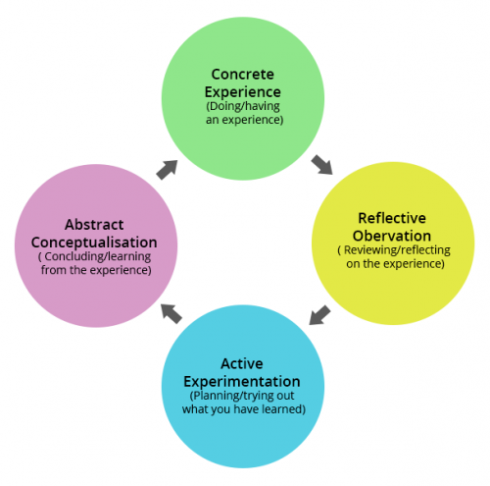

Honey and Mumford learning style
The Honey and Mumford learning style also consists of four styles of learning. They are the Activists, The Reflectors, The Theorists, and the Pragmatist. This theory states we will prefer one or two styles of learning.
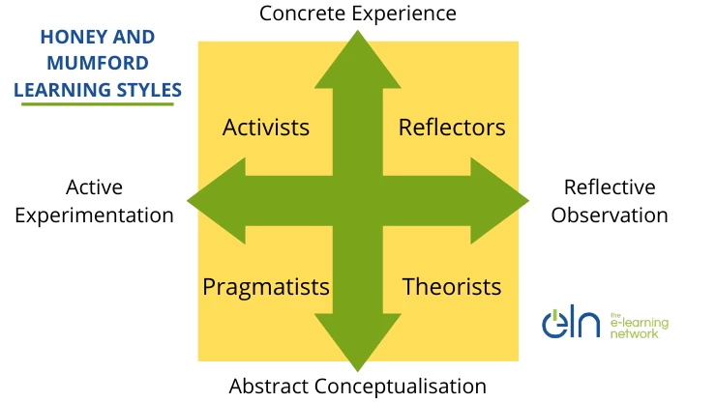

(Ruby, 2017)(10)

Looking at this theory I would say that I am a Theorist learner. I like to understand the theory behind why something is the way it is.

Self-Awareness
It is important to have self-awareness to improve yourself. Ther are tools to use to have personal development and be self-aware. “The ‘Johari’ window model is a convenient method used to achieve this task of understanding and enhancing communication between the members in a group” (Communication Theory, 2021)(11). The Johari window is a four box window that looks at what you know yourself and what others know.

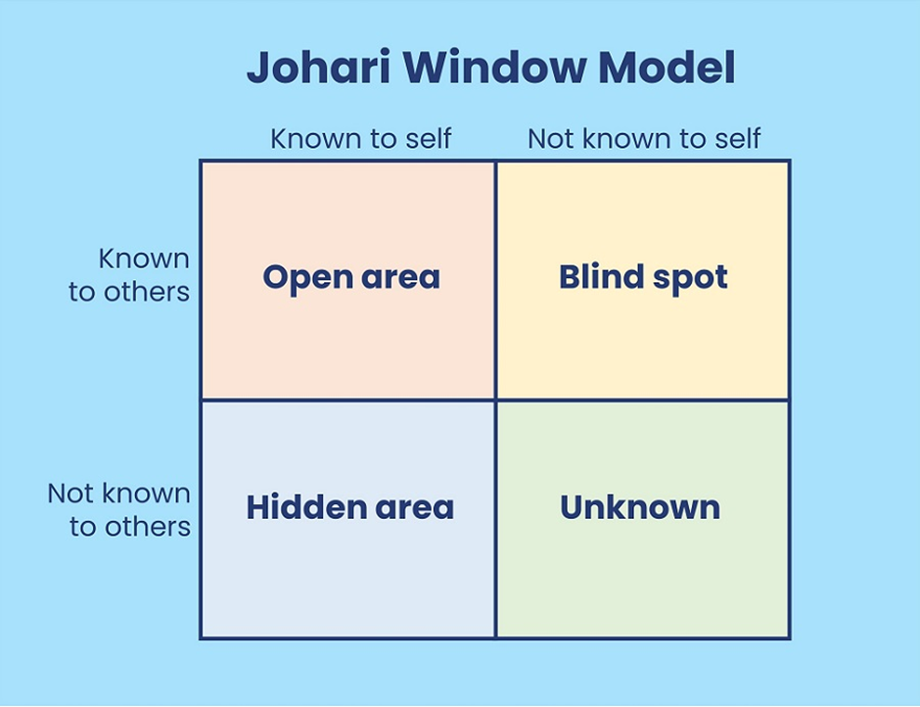
(The Johari Window model, 2021)(12)
I have used this tool to close the gaps I have in my career development plan.

Conclusion

Looking back at what I have learnt in this module I feel I am in a better position to be in a managerial role. After reflecting on my personal and career development plan I feel I still have a lot to turn and therefore will continue to study further to achieve my goal of opening my own business.

References

- 10 Skills You Need to Ace Your Next Interview | Indeed.com
- Communication skills in social care (skillsforcare.org.uk)
- Strength, Weakness, Opportunity, and Threat (SWOT) Analysis Definition (investopedia.com)
- Personal development planning: What you need to know | reed.co.uk
- The Career Development Plan - A Quick Guide for Managers and Supervisors (associationdatabase.com)
- SMART Goal - Definition, Guide, and Importance of Goal Setting (corporatefinanceinstitute.com)
- UK Employment Laws Explained | Citation
- UK Employment Law Explained | Slater + Gordon
- Learning Styles: Concepts and Evidence - Harold Pashler, Mark McDaniel, Doug Rohrer, Robert Bjork, 2008 (sagepub.com)
- Honey and Mumford Learning Styles (eln.co.uk)
- The Johari Window Model (communicationtheory.org)
- The Johari Window model: with personal examples and exercises (skillpacks.com)

Bibliography

care, s. f. (2018, January). https://www.skillsforcare.org.uk/Documents/Learning-and-development/Core-skills/Communication-skills-in-social-care.pdf. Retrieved from skills for care: https://www.skillsforcare.org.uk/Documents/Learning-and-development/Core-skills/Communication-skills-in-social-care.pdf
Communication Theory. (2021). Retrieved from The Johari window model: https://www.communicationtheory.org/the-johari-window-model/
KENTON, W. (2021, March 29). Investopedia. Retrieved from https://www.investopedia.com/terms/s/swot.asp: https://www.investopedia.com/terms/s/swot.asp
Pashler, H. (2009, Dec 1). Sage Journals. Retrieved from Learning styles and concepts: https://journals.sagepub.com/doi/10.1111/j.1539-6053.2009.01038.x
Rolfe, A. (2021). Personal development planning: What you need to know. Retrieved from Reed.co.uk: https://www.reed.co.uk/career-advice/personal-development-planning-what-you-need-to-know/
Ruby. (2017, 01 08). Honey and Mumford learning style. Retrieved from The e-learning network : https://www.eln.co.uk/blog/honey-and-mumford-learning-styles
Slater+Gorden Lawyers. (2020). Retrieved from UK employment law: https://www.slatergordon.co.uk/employment-law-solicitors/uk-employment-laws/
Team, B. I. (2021, november 17). Indeed. Retrieved from https://www.indeed.com/career-advice/interviewing/interview-skill.
The Johari Window model. (2021). Retrieved from Skill Packs: https://www.skillpacks.com/johari-window-model/
Trueba, J. A. (2008, 12 1). NCDA National Career Development Association. Retrieved from The Career Development Plan: https://associationdatabase.com/aws/NCDA/pt/sd/news_article/6420/_PARENT/layout_details/false
UK Employment Laws Explained. (2021). Retrieved from Citation: https://www.citation.co.uk/news/hr-and-employment-law/uk-employment-laws-explained/
What are SMART Goals? (2021). Retrieved from CFI Corprate Finance Institute : https://corporatefinanceinstitute.com/resources/knowledge/other/smart-goal/

Appendix 1

Interview feedback link:
https://uowtsd-my.sharepoint.com/:b:/r/personal/2014975_student_uwtsd_ac_uk/Documents/Attachments/Babar.pdf?csf=1&web=1&e=Edu3pk

