

Task 2 Report – Port Talbot Hourly AQ[data Analysis]
Student Name: Podili Deepthi
Student Id: 2432738
Lecturer Name: Dr. Aliyu Sambo
Module: Advanced Statistical Programming [ACCA7022]

1.Reflective Summary
This project on the analysis of air-quality data enabled me to practice statistical programming on a real dataset and enhanced my expertise in R. I did not initially intend to complete the assignment by merely providing the answers to the technical questions, but by treating the project as a data analyst would treat actual environmental monitoring data: sorting out the working process, generating reproducible code, documenting the choices, and making some meaningful conclusions based on the visual and statistical results.
I started by loading all the libraries needed with the pacman::p_load () function. This removed the cumbersome activity of separately installing and loading packages hence the inception of the script cleaner. I then imported the dataset with read csv and confirmed that the file had loaded by printing its dimensions, column names, data types, and summary statistics. The visualization of the structure made me have a better idea of the dataset since the column names in the raw form were long and at times included spaces. This complicated the process of coding and thus, to reduce coding errors, I gave key columns short and easy to read names like NO2, PM10, PM25, O3, and wind-speed.
There were separate Date and Time fields in the original data set. Making them one timestamp column enabled me to extract other variables like year, month and hour that could create meaningful trend analysis. At this point, I found the strength of lubridate to be impressive as date manipulation became a simple process.
mutate(datetime = as.POSIXct(paste(date, time), format = "%Y-%m-%d %H:%M"))

Visualisations: Why I choose specific plots
I developed a number of graphs to illustrate trends and comparisons of pollutants. I intended to ensure that each visualisation captured a concise story without any unnecessary details.

Line Graph: Trend of NO2 across months
geom_line(linewidth = 1.3, color = "steelblue")
geom_point(size = 2.3, color = "darkred")
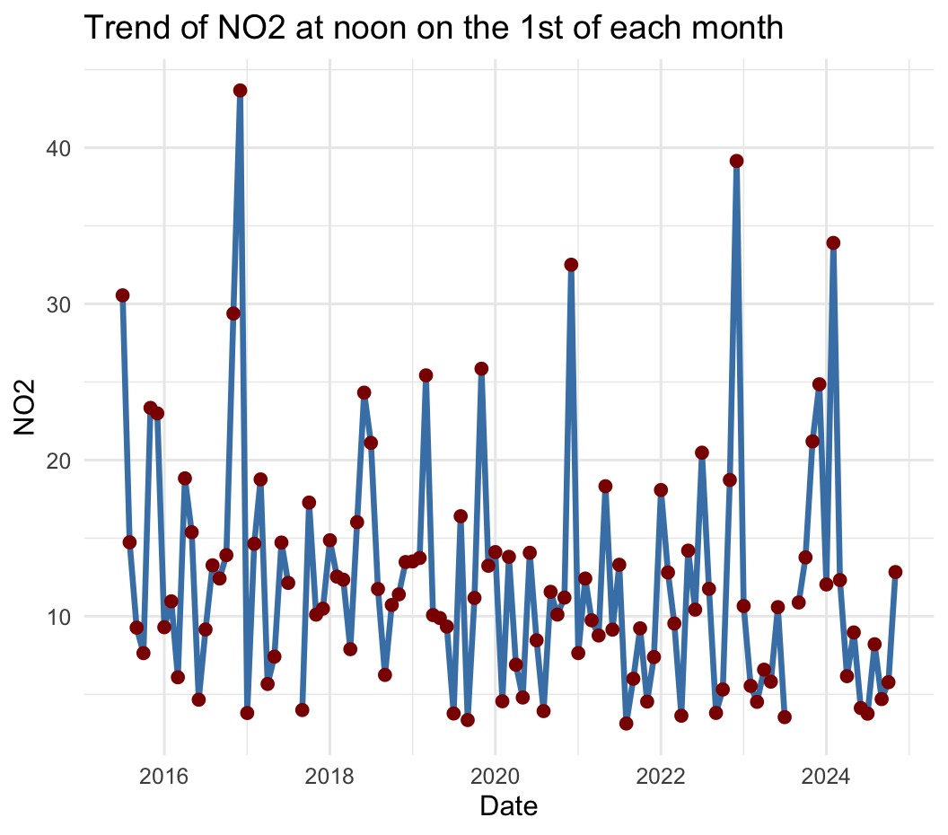
The line plot was suitable due to the nature of this assignment where it was necessary to monitor the level of NO2 over time. The points have brought out clear individual monthly readings.

Multiple Pollutant Comparison
In order to compare pollutants (O3, NO2, PM10, PM25) I resorted to colored line graphs. I assigned different colors with the scale color manual to ensure that there is not confusion between colors and the legend matters. This image instantly indicated the increase and decrease of some pollutants as others declined to provide a brief impression of the seasonal trends.

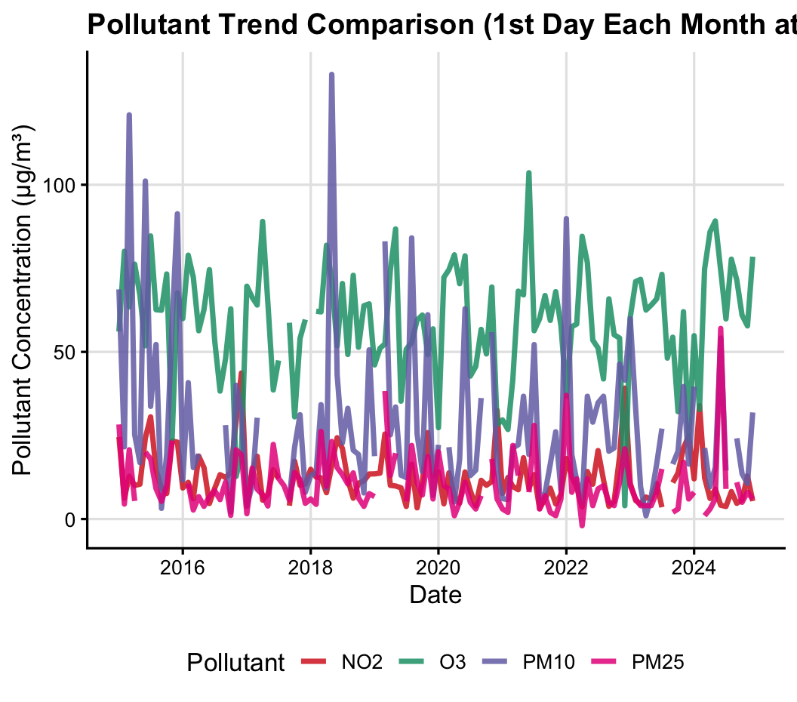

Scatter Plot with Regression Line (O3 vs NO2)
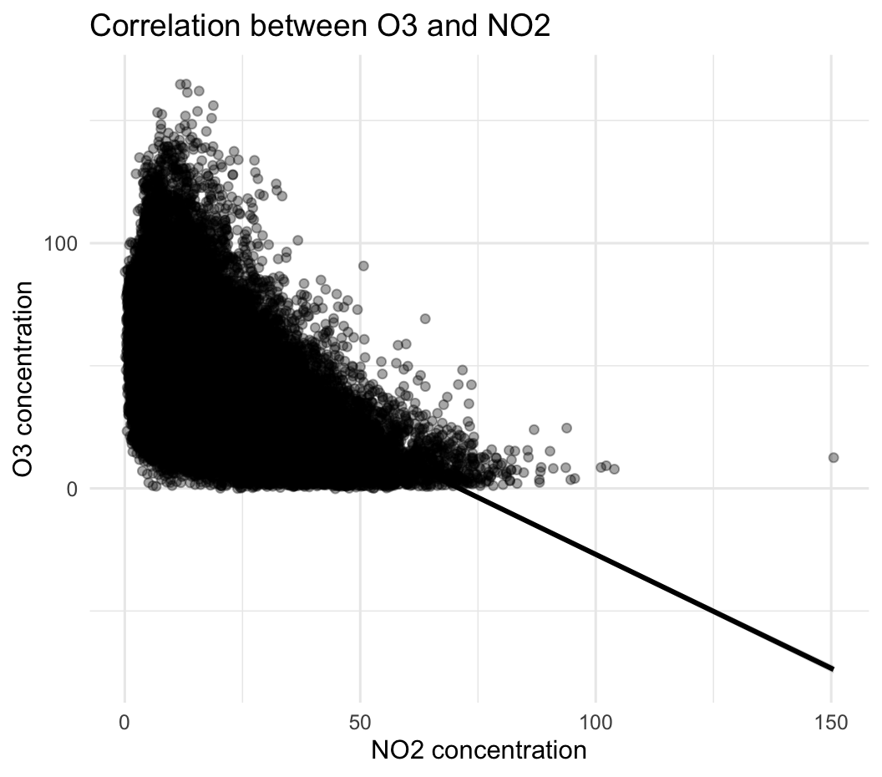
This figure aided the correlation and hypothesis testing section. I used:
geom_smooth(method = "lm")
This aided in visual presentation of the negative relationship between O3 and NO2.

Boxplot + Violin for T-test and ANOVA
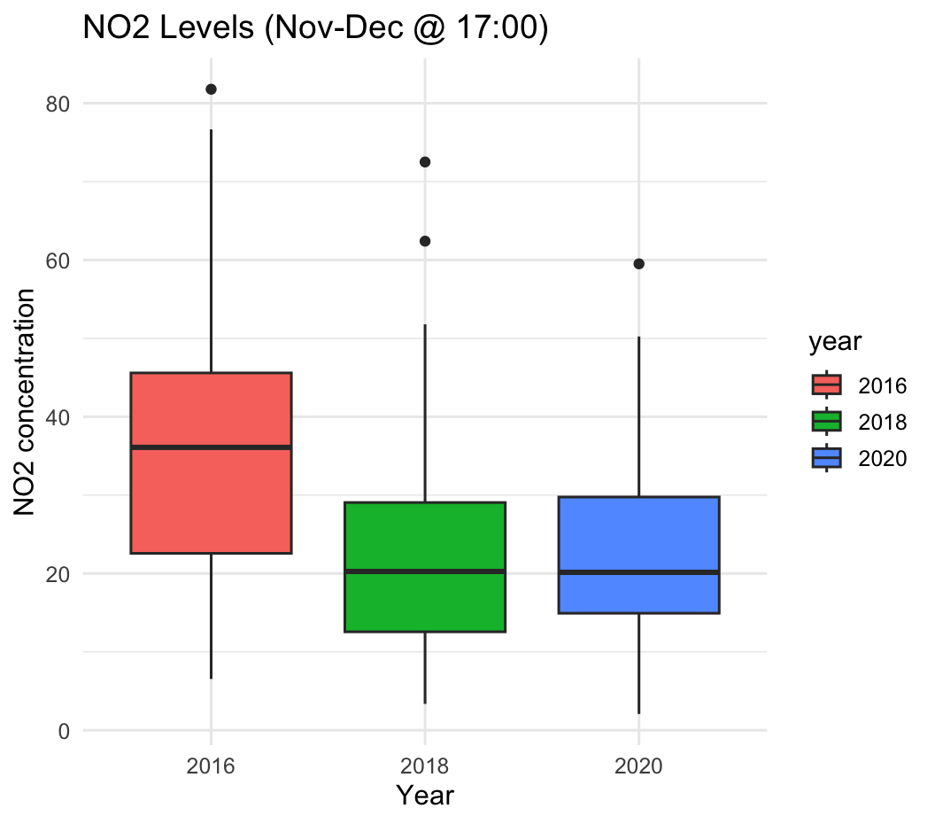
Violin and boxplot were used to demonstrate distribution and quartiles, but were not confusing. These were useful in comparison of groups statistically. On the whole, visualisations made it possible to find patterns in a shorter time than they were possible with tables, and these visualisations reinforced my conclusion.
The tasks in the statistics analysis enhanced my knowledge of inferential testing. In the comparison of the ozone conditions under high and low wind conditions a two-sample t-test was done after defining a binary category of wind. Before executing the test, I ensured that I checked some assumptions which include normality and equality of variances. This solidified the fact that statistical analyzing is not only about performing functions but is a serious matter of discursive judgement and consciousness of the assumptions.
The ANOVA test was needed to compare the level of NO2 in various years. I verified assumptions by verifying homogeneity of variance, and examining diagnostic plots before running ANOVA.
Missing values had been the greatest challenge to determine and manage. There were up to 7% missing values of some of the pollutants. To determine missing percentage, I used the following calculation:
summarise(across(all of (pollutants), ~ round (mean (is.na(.)) * 100, 2))
Tthere are warnings of deleted rows in plotting.I also learned to put na.rm = TRUE within geom_point() and geom_line, which avoided unnecessary warnings.
Another learning pivot was the development of reusable functions. This coursework has increased my confidence in R as a data analysis and visualisation tool. I also created a more methodical workflow, which included load, inspect, clean, visualise, test, interpret, and learned to process raw data into action. The assignment has shown that statistical programming is applicable to real environmental decision, and now I feel more ready to address such tasks of analysis in the future projects.

