Marketing Fundamentals Analysis and Evaluation

- Assessment 2

Student: Paul Sebastian Parfene
ID Number: 1813737
Lecturer: TANJA NATHAN
Module: MARKETING FUNDAMENTALS

Introduction
Marketing is referred to as the process of plan and execution of activities which includes conception, pricing, promotion and distribution of goods and services or ideas with a view to satisfying customers and organizations as well by adding value in their lives (Armstrong, 2016). In order to do so, there is some step which needs to be followed and their steps together make the marketing process.

Marketing Process
The first phase included in the marketing process is referred to as the situational analysis. A situational analysis is referred to as the thorough analysis and examination of all the related factors of the macro and microenvironment that can affect the functions of the business (Armstrong et al., 2015). It is normally referred to as the foundation or base of the marketing plan as, without a proper situational analysis, the next steps of the marketing process cannot be carried out effectively. In order to conduct a situational analysis, there are some tools such as Porter’s 5 forces model ad SWOT analysis available which can be used for situational analysis. Moreover, there are factors of the macro and microenvironment which need to assessed and evaluated properly under their effect.
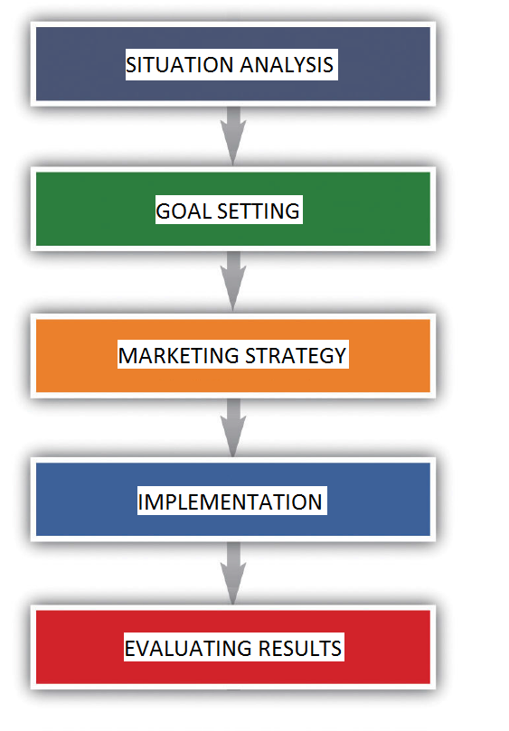
Figure: Marketing Process (Grewal and Levy, 2012)
The second phase of the marketing process is referred to as the goal-setting phase. In this phase, the organization or the business sets the goals or aims to the objectives that it wants to achieve. The goals for the organization are normally set by analyzing the market, keeping the available resources, and time period for production. The third phase of the marketing process is generating the marketing plan. Generating the marketing plan can be a single step with one single plan or a set of plans for each step when all of them are aimed to achieve the business goals of the organization over a period of time. Setting the marketing plan right takes a number of elements to be ticked in the checklist such as the market segmentation, setting target groups, and market positioning (Heidingfield and Blakenship, 2015). Segmenting the market into different groups of the customer allows the organization to focus on similar groups of customers who have the same interest in the product and approach them with the best sales pitches to earn a higher profit out of the groups. Setting the target group rights makes it easier for the company to target and approach to customers with their products. However, market positioning is all about setting the product into the right category of the market considering the attributes and value addition to the customer’s life. This allows the company to establish a good stand in the customer’s mind by educating the customer about the product. The fourth phase of the marketing process is implementing the whole plan that was set in the previous phase. This phase ensures that all the previously made up plan is executing itself right by adding value to the customer and generating revenue for the company. Implementing the plan right can require a number of things such as CRM activities, establishing good relationships with customers, good partnerships and mergers with other organizations, etc (Keegan et al., 2015). The fifth phase of the marketing process is establishing control. Establishing control in the marketing process is referred to as a number of procedures that include a set of practices of monitoring and regulating all the marketing activities which will contribute to achieving the previously get goals and objectives. By ensuring the effective operations of all the activities, the business will be able to gain the trust of its customers by adding value in their lives. In this way, they will be able to establish a loyal customer base for their company which will contribute to increasing the Customer Lifetime Value (CLV) and boost the revenue generation. Not only this, but it will also help the company to send good words out in the market and it will attract a new customer as well.

Stages of Marketing
Marketing can be defined as the combination of a process that starts from the planning of the product and ends with delivering the product by convincing the customer to buy it. The stages of marketing are categorized into five stages. They are development stage, introduction stage, growth stage, maturity stage and decline stage.
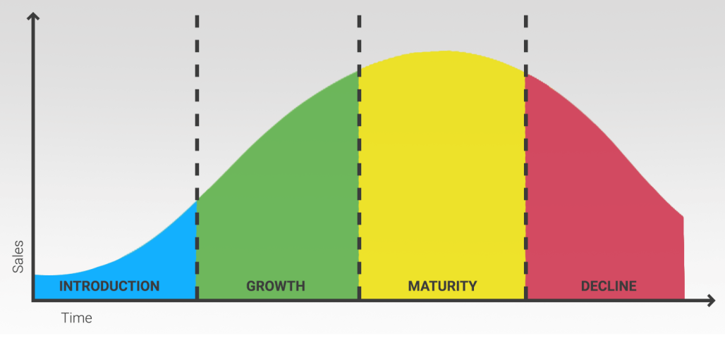
Figure: Stages of Marketing (Kotler and Keller, 2020)
In the development stage in this stage, the product is developed. In this stage, the product development department analyzes the attributes of the product and the marketing department works with them in order to make sure that these attributes will add value to their customers' life. The first stage is referred to as the introduction stage and in this stage, the product is introduced in the market and the marketing department works in the marketing of this product to educate the customer about his product. The expenses of the company might be high due to the branding cost and marketing of the product in this sage (Kotler and Keller, 2020). The second stage is referred to as the growth stage and in this stage, due to the marketing activities and branding of the product, the sales grow. The other competitors try hard to increase their share in the market and due to that, the company needs to adapt well-revised business strategies and increase their advertising activities. The third stage is the maturity stage and, in this stage, due to the marketing activities done in the previous stages, the revenue generation reaches new heights and the company can now afford the luxury to reduce its marking budget. Because now the company no longer needs to attract new customers to push its profit margin, but what it needs to do right now is to retain its existing customers by using differentiation strategies (Pride and Ferrell, 2017). The fourth stage is referred to as the decline stage and in this stage, due to the more and more competitors coming to the market which are identical and costs less, the revenue generation of the company takes a hit and stats falling down. In this stage, the company can think of new marketing strategies in order to strengthen the revenue generation process. After that, with newfound strong formulas and strategies, the company comes back into the market with better products in order to capture the market.

Marketing Mix
The marketing mix is a marketing tool which allows the organization which allows the organization to set the attributes of product, place, price, and promotion right which not only helps to establish a fine image of the organization before the customer but it influences them into buying the product or service.
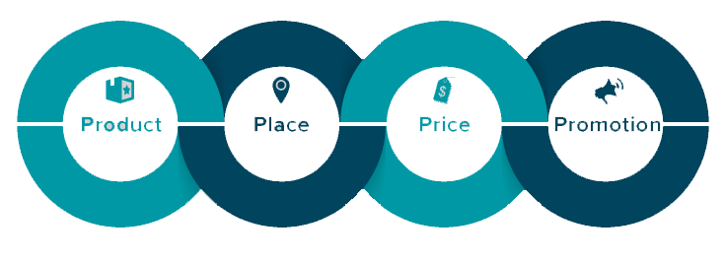
Figure: Marketing Mix (Zikamund and D’Amico, 2019)
The product can be referred to like all the attributes that are offered by the product or service which can add value to the customer’s life. Unique features, good quality, sleek design, low cost, etc. allows the product to stand out from its competitors (Kotler et al., 2010). The place is referred to as how the company brings the product into its customers’ lives. The main operation of this phase is to make sure that the product reaches the customer. Price is referred to as the amount of money that the customer needs to pay for availing the product and it needs to be set right considering the attributes of the product and existing competitors in the market (Miles and Darroch, 2016). Promotion is referred to all the activities that uphold the qualities and attributes of the product and finally influence the customer into buying the product. Promotion can be done through a number of activities such as Personal sales, branding, advertising etc.

The Role of markeTing in Creating Value
Value is referred to as the measurement of the benefits gained from a particular product or service by the customer while making a perfect sense of the price of the product. Of course, marketing is comprised of all the strategies and tools that help the companies to attain their objectives and goals but the goals of marketing itself are not just confined in the boundaries of branding and promoting the product and generating revenue (Cravens and Piercy, 2016). One of the fundamental objectives of marketing itself is to create value in the customers’ lives because it only helps to provide the customer that he actually paid for but it forms rustable relationship which creates a loyal customer base for the product of the company and keeps the wheel of the revenue generation spinning (Dube et al., 2011). In order to create value, the steps resolve all around the customers and they are identified, satisfy, and retain customers. Before creating a product or service of value, first, the needs of the products or service must be identified in the market and thus the lives of the customers. so, in the first phase, the prospective customers must be identified who have a prospective need for the product or service and willing to pay for it (Vernon, 2019). Then the next phase would be satisfying the needs of the customers by creating a product of value that will add value to their lives and make sure that they are getting what they paid for. This is making the two involved parties happy as the customers are happy because they paid for a product or service which created value for their money and the organization is happy with their revenue generation (McDaniel and Gates, 2013). Now to keep the flow going, organizations need to retain this relationship with their customers. in order to make sure of that, organizations need to set the prices right and keep the product at places that can easily be availed by the customers (Laws, 2013). Moreover, the organization is expected to serve better than the identical products available in the market, otherwise, the customers are bound to shift to their competitors.

Stakeholders Engagement
Stakeholders are normally referred to as those entities who are related to the business and while taking any decision, the organization must consider the interests of these entities. These entities include the shareholders, owners, employees, customers, suppliers, distributors, partners etc (Prahalad and Ramaswamy, 2014). Previously only the people who have a direct relationship with the organization like owners and shareholders were referred to as the stakeholders but with the development of time and business, more and more entities started to come under the umbrella of stakeholders. In order to formulate effective marketing strategies and making sure that it is successful in engaging with the audience of the product, all the entities of the stakeholders are required to be involved. For instance, the owners of the company need to make the main decisions of marketing and allocate the budget of marketing. In this way, they are involved in crucial decisions and handle the financial aspects of marketing by allocating resources and finance. Employers of the company reflect on the strategies formulated by the top level of the organization i.e. the owners and they try to implement the decisions in the organizations through their employees (Prahalad and Ramaswamy, 2014). With a view to implementing the decisions and strategies, the employees engage with the customer with the precuts and services and they gain feedback from the customer which they pass on to the authority of the organization for further consideration. Moreover, they work as a speaking person for their organization and they successfully recommend the products to the customers (Savage et al, 2011). The customers of the company help the organization by buying the products and service and loyal customers of the organization recommend the product to their peer groups which work as a buzz marketing for the company (Roper and Davies, 2017). In this way, all the entities of the stakeholders contribute to the successful and effective implementation of marketing strategies and marketing campaigns. It allows the process to be easier for the organization as different people groups are involved in the process to increase making the implementation of marketing strategies easier. It helps the growth of the company and establishing a loyal customer base of the product of the organization which contributes to making the business more sustainable.

Reflective Conclusion
Generally, tactical communication is referred to as the secured communication systems that are mostly used by the government and the military to transmit important data through a secure network. However, with the emergence of digital marketing, the term tactical communication is used in marketing as well. This tactical communication is a part of digital marketing tactics that covers the strategies used, marketing channels, segmenting the customer section, and performance measurement. There are a number of digital marketing communication tools such as email marketing, blogging, search engine optimization (SEO), content marketing, social media marketing, setting up a website, online selling, pay per click advertising, paid search adverting, etc (Stokes, 2011). Each of these communication tools has their own advantages and uses. For instance, email marketing is referred to as one of the low costs and an effective option to reach the audience. On the other hand, blogging is referred to as the option of reaching and educating all the audience of a particular group about the product and generate hype for the particular product, brand, or issue. each of these digital marketing tactical communication tools includes a digital marketing mix of the particular channel, justification of choosing each channel and explanation of implementation, customer segmentation that will be used by each channel to target and a performance measurement system which will include the summary of performance measurement of each used channel (Holm, 2016).
In order to generate awareness and interest in my project, I have used a number of tactical communication tools and they are blogging, email marketing, and social media marketing. The success of the used tactical communication tools has been measured by the AIDA model. The acronyms of the AIDA model is used for attention, interest, desire, and action.
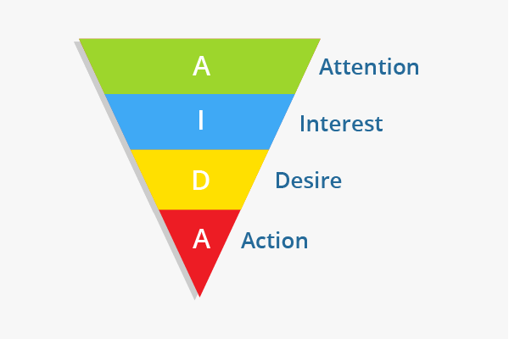
Figure: AIDA Model (Kaufman and Horton, 2014)
The AIDA model is divided into the four mentioned categories and each of these stages represents the whole process that the customer goes through while purchasing a product. The first phase of this process is attracting the attention of the customer. To attain the audience’s attention in my project, I have used email marketing to grab their attention, and every email was equipped with the link of the blog post. Moreover, to generate more views and visits, I have also used social media marketing. The number of visits on the blog posts was used as the measure of success. After attaining the attention of the audience, I entered the maintaining interest phrase with my tactical communication tools where all the tools were used to take their interest in my project to the peak, and to do so, detailed description with photos were mailed and uploaded on the blog. After maintaining the interest of the audience, I educated the audience about the advantages of my project so that a desire is created in their mind for having the product. Lastly, in the taking action phrase, a call to action opportunity was given in the mail so that the interest and desire of the audience can be transformed into action.

Reference
Armstrong, G., 2016. Marketing.
Armstrong, G., Kotler, P. and Opresnik, M., 2015. Marketing.
Cravens, D.W. and Piercy, N., 2016. Strategic marketing (Vol. 7). New York: McGraw-Hill.
Dubé, L. and Renaghan, L.M., 2011. Creating visible customer value: How customers view best-practice champions. Cornell hotel and restaurant administration quarterly, 41(1), pp.62-72.
Grewal, D. and Levy, M., 2012. Marketing.
Heidingsfield, M. and Blankenship, A., 2015. Marketing. New York: Barnes & Noble Books.
Holm, O., 2016. Integrated marketing communication: from tactics to strategy. Corporate Communications: An International Journal.
Kaufman, I. and Horton, C., 2014. Digital marketing: Integrating strategy and tactics with values, a guidebook for executives, managers, and students. Routledge.
Keegan, W., Moriarty, S. and Duncan, T., 20155. Marketing. Englewood Cliffs, New Yersey: Prentice-Hall.
Kotler, P. and Keller, K., 2020. Marketing Management. Melbourne: P. Ed Custom Books.
Kotler, P., Armstrong, G., Harker, M. and Brennan, R., 2010. Marketing: an introduction (Vol. 1). Englewood Cliffs, NJ: Prentice-Hall.
Laws, E., 2013. Creating value for customers: Designing and implementing a total corporate strategy. The Service Industries Journal, 13(2), p.171.
McDaniel, C. and Gates, R., 2013. Marketing research. Singapore.
Miles, M.P. and Darroch, J., 2016. Large firms, entrepreneurial marketing processes, and the cycle of competitive advantage. European journal of marketing, 40(5-6), pp.485-501.
Prahalad, C.K. and Ramaswamy, V., 2014. Co‐creating unique value with customers. Strategy & leadership.
Prahalad, C.K. and Ramaswamy, V., 2014. The future of competition: Co-creating unique value with customers. Harvard Business Press.
Pride, W. and Ferrell, O., 2017. Marketing.
Roper, S. and Davies, G., 2017. The corporate brand: Dealing with multiple stakeholders. Journal of Marketing Management, 23(1-2), pp.75-90.
Savage, G.T., Nix, T.W., Whitehead, C.J. and Blair, J.D., 2011. Strategies for assessing and managing organizational stakeholders. Academy of management perspectives, 5(2), pp.61-75.
Stokes, R., 2011. eMarketing: The essential guide to digital marketing. Quirk eMarketing.
Vernon, R., 2019. The product cycle hypothesis in a new international environment. Oxford bulletin of economics and statistics, 41(4), pp.255-267.
Zikmund, W. and D'Amico, M., 2019. Marketing. Cincinnati: South-Western.

