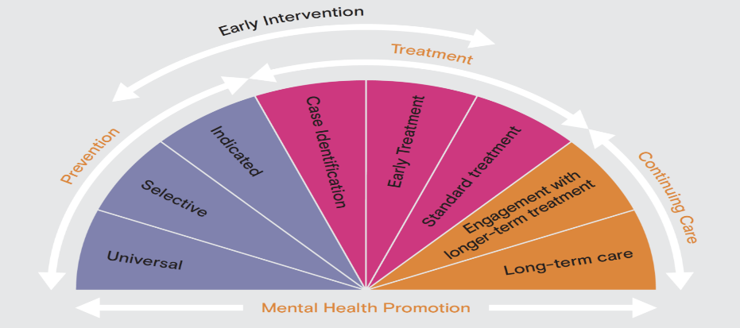
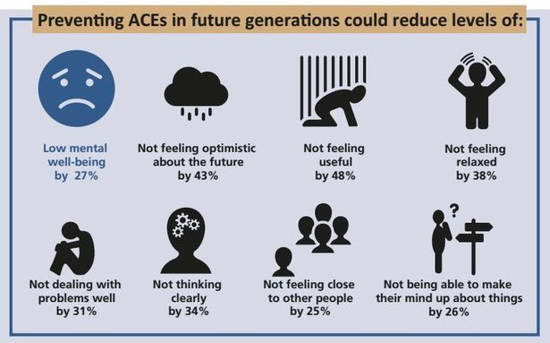
Limitations of Early Intervention:
- Can be difficult to gauge success and effectiveness short term.
- The procedures, resources and manpower required can be expensive,
- Can be difficult to get the required balance between over using and under using the service.
(Image above: Emerging Minds Organisation, 2019).
The following image provides an outlook of all that is included in relation to the process of Early Intervention and also, gives an insight into which stages exactly there should be notable intervention.
What does the future hold?
A £6.78million Police Transformation Fund has been secured to facilitate the transformation of policing in Wales to a multi-agency, ACE informed approach that ensures early intervention and root cause prevention (Fitzgerald, 2019).
Why Focus on Early Intervention?
- Rapid pace of Physical and social development in childhood makes it the most effective time to intervene.
- The more embedded experiences or behaviours become the more difficult they are to alter and correct.
- The Early Years offer the most opportunities for natural correction and development such as education or child healthcare. (Home Office, 2019).
The importance of balance with early intervention:
As Goldson (2007) makes clear, the key to effective and efficient early intervention is to get the balance of it correct in regards to youth justice and crime prevention. This is because, throughout the past two decades since early intervention has gained publicity, there are numerous examples of too much emphasis being put on early intervention thus declining the effectiveness of youth justice which is still a fundamental need in the Criminal Justice System Alongside Early Intervention.
Most Suffered ACEs in Wales
Verbal Abuse (23%), Parental Separation (20%), Physical Abuse (17%) (Public Health Wales, 2018).

Early Intervention is all about trying to use effective methods to intervene soon enough that it improves the lives of children and young people that are recognised to be at risk of poor life situations and outcomes (Early Intervention Foundation, 2019).

In regard to this, there are five generally agreed threads across the UK public sector that are seen to be key elements when implementing early intervention and also countering Adverse Childhood Experiences (ACEs), the listed five are seen to be:
- The Best Possible Start in Life.
- Language for Life Provided.
- Engaging Parents.
4. Smarter Working, Better Services on hand.
5. Making clear that Knowledge is Power. (FA. Org, 2014). (Image below: Smith, 2016).

Regarding early intervention, the famous saying it is never too late could not be more wrong. The earlier, the better the chance for a positive adulthood (Carpenter, 2007).
Adverse Childhood Experiences (ACEs):
ACEs are traumatic events that occur during childhood. They can have a major impact on a person’s physical, emotional, and mental health throughout their life.
Although ACEs increase a person’s risk of certain health conditions and behaviours in later life, they do not necessarily guarantee them. This is why, children who face difficult events are in crucial need of some forms of early intervention to allow them to learn to either move on from or manage their adverse experiences and still lead meaningful lives (Klein, 2020).
(Image Below - Young Minds (2017). 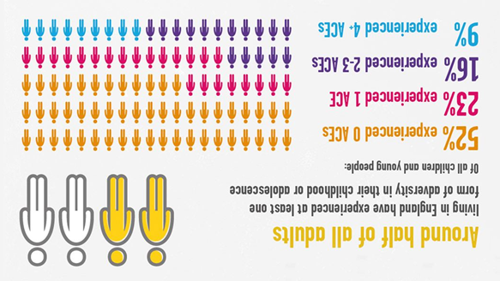The image above also provides insight into just how widespread and perhaps under emphasised the matter of ACEs is. Additionally, although some of the percentages may back the belief that early intervention is not a fundamental requirement, it is the 25% made up of the 2-3 & 4+ ACEs that is the key factor. This is because, when taking this 25% into account alongside other things such as rising mental health, poverty, unemployment and substance misuse rates, the significance of ACEs is much clearer.
ONLY 14% OF ADULTS IN WALES EXPERIENCED NO ACEs DURING CHILDHOOD (Public Health Wales, 2018).
(Image above from Mental Health Foundation, 2018).
This chart clearly showcases that there is both a disconnect with emotional support and accessibility from the teenage years on as well as, perhaps showing that the emphasis on early intervention and tackling problems like ACEs is still not at the required level.
Wales & The Commitment to ACEs Awareness

- Breaking the cycle of ACEs is seen to be the key to combating the impact of it. The most effective solution is to try and prevent ACEs in a single generation because this will not only benefit them, but it could also help educate and install benefits for future generations in Wales.
- Being ACE aware could contribute to an array of benefits for Wales such as – Reducing reoffending rates, reducing the prison population, improving education rates like attendance and performance, reduced unemployment and, increased expenditure meaning an improved Welsh economy. (ACE Aware Wales, 2019).

References
ACE Aware Wales (2019) ‘Together, Wales Can tackle ACEs’ [Online] (Published – Autumn 2019) Available at - https://www.aceawarewales.com/welcome (Accessed on - 15/10/2020).
Carpenter, B. (2007) The Impetus for Family-Centered Early Childhood Intervention. Published – January 2007. Published by Wiley Publications Inc, Hoboken New Jersey, USA. (Accessed on – 15/10/2020).
Early Intervention Foundation (2019) ‘About EIF’ [Online] (Posted – December, 2019) Available at - https://www.eif.org.uk/about (Accessed on - 14/10/2020).
Family Action Organization (2014) Grasping the Nettle: Early Intervention for Children, Families and Communities. Published – July 2014. Published by Social Care Institute for Excellence Press, Watson House, London UK. (Accessed on – 14/10/2020).
Fitzgerald, A. (2019) Adverse Childhood Experiences. Published – November 2019. Published by Future Generations Commissioner for Wales Publications, Cardiff UK. (Accessed on – 15/10/2020).
Goldson, B. (2007) Child Criminalization and the mistake of Early Intervention. Published – December 2007. Published by Centre for Crime and Justice Studies Publications, Vauxhall, London UK. (Accessed on – 23/10/2020).
Home Office (2019) Early Intervention: Briefing Paper. Published – July 2019. Published by House of Commons Library, Westminster, London UK. (Accessed on – 24/10/2020).
Klein, A. (2020) Adverse Childhood Experiences. Published by Centers for Disease Control and Prevention, California USA. (Accessed on – 15/10/2020).
Public Health Wales (2018) ACE Reports. Published - Summer, 2018. Published by NHS Wales Publications, Tyndall Street, Cardiff UK. (Accessed on – 15/10/2020).

Appendices
Emerging Minds Organization (2019) ‘Prevention and Early Intervention: Our Table of Work’ [Online] (Posted – November 2019) Available at - https://emergingminds.com.au/our-work/prevention-and-early-intervention/ (Accessed on – 24/10/2020).
Mental Health Foundation (2018) ‘What New Statistics show about UK children’s health’ [Online] (Posted – 23/11/2018) Available at - https://www.mentalhealth.org.uk/blog/what-new-statistics-show-about-childrens-mental-health (Accessed on - 16/10/2020).
Smith, M. (2016) ‘Why Traumatic Experiences during childhood could cause lasting mental health damage; [Online] (Posted – 4/07/2016) Available at - https://www.walesonline.co.uk/news/health/traumatic-experiences-during-childhood-could-11553427 (Accessed on - 15/10/2020).
Young Minds (2017) ‘Adversity Book Percentage Image’ Available at - https://youngminds.org.uk/resources/policy-reports/addressing-adversity-book/ (Accessed on – 15/10/2020).

