

Business Report
Comparison of Two Hospitality Organizations

Student Name: Mihai Diaconu
Student ID: 2131599
Lecturer: Tristan Hawkins
Module: Financial Management for the Hotel Industry (BMIH5007)

Table of Contents
Introduction 3
Overview of Mandarin Oriental Hotel Group and Premier Inn 4
Comparison of Mandarin Oriental Hotel Group and Premier Inn 5
Total revenue 5
Sources of revenue 6
Revenue trends 6
Factors driving revenue growth or decline 7
Market position 7
Growth potential 8
Expansion strategies 8
Market opportunities 8
Potential barriers to growth 9
Financial commitment to CSR 9
Recommendations 10
Conclusion 12
References 13

Introduction
The purpose of this report is to compare two hotel chains: the Premier Inn and the Mandarin Oriental Hotel Group. In the report company's background, finances, sources of income, revenue generation patterns, market position, consumer demographics, brand reputation, expansion opportunities, market challenges, and CSR initiatives, among other things.

Overview of Mandarin Oriental Hotel Group and Premier Inn
The Mandarin Oriental Hotel Group was founded in Hong Kong in 1963 and now manages a collection of luxury hotels worldwide. A worldwide firm oversees a total of 36 hotels and 7 residential complexes throughout 24 countries and territories (Gozgor and Lau, 2023). The Mandarin Oriental is renowned for its opulent suites, gastronomic dining options, and exceptional wellness facilities. The Mandarin Oriental in Hong Kong is widely acknowledged as one of the most renowned hotels globally, frequently regarded as the flagship property of the corporation.
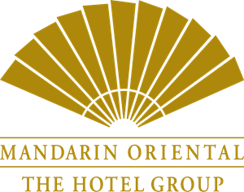
Figure 1 - Mandarin Oriental's Logo
(Sampson, 2018)
The British hotel brand Premier Inn is owned by Whitbread. The United Kingdom is home to a vast network of hotels, with over 800 establishments belonging to this hotel chain, so establishing it as the largest hotel network in the nation (Buttle et al., 2016). The Premier Inn brand is well recognized for offering high-quality accommodation at an affordable rate. Premier Inn hotels are often located near major transportation routes, making them an appealing choice for both corporate and recreational travellers.

Figure 2 - Premier Inn’s Logo
(Ternès, 2018)

Comparison of Mandarin Oriental Hotel Group and Premier Inn

Total revenue
Mandarin Oriental Hotel Group
According to the financial records of Mandarin Oriental, the company generated a total sales revenue of $0.45 billion over the preceding 12-month period. The corporation had a positive trend in its financial performance, as seen by its sales of $0.45 billion in 2022, which marked an increase compared to the previous year's profits of $0.31 billion (Financial Times, 2023).
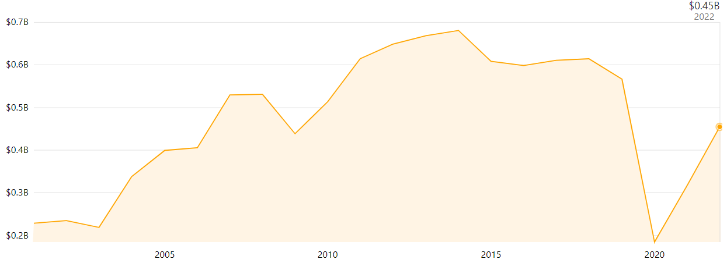
Figure 3 - Revenue of Mandarin Oriental Hotel Group 2005-2022
(Growjo, 2023)
Several variables have contributed to the company's recent financial success. These include the recovery of the global travel sector after the COVID-19 epidemic, the company's strong brand recognition, and its concentration on growing into new areas. In the next years, expansion will likely be aided by the 26 hotels and homes already in the works by Mandarin Oriental.
Premier Inn
According to Whitbread's annual report for the fiscal year 2022/23, the firm had revenues of more than £2.62 billion British pounds (Statista Research Department, 2023). Whitbread, headquartered in the United Kingdom, is a global leisure and hospitality firm best known as the owner of the Premier Inn chain of budget hotels. The company transferred ownership of the Costa Coffee shop chain to Coca-Cola in 2018 (Statista Research Department, 2023). Premier Inn UK outperforms its competitors in the mid-range and budget hotel categories.
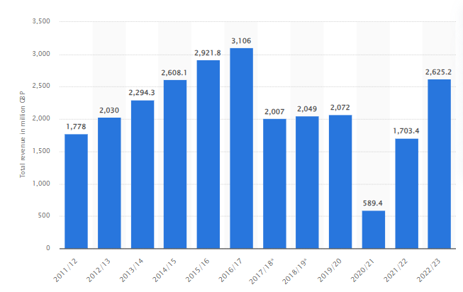
Figure 4 - Annual revenue of Premier Inn 2011-2023
(Statista Research Department, 2023)
It is also true that Premier Inn UK is the unrivalled market leader in the economy and midrange hotel categories. Premier Inn's popularity among vacationers stems from its central location and low room rates. The quality of the company's customer service is also well-praised. Financial success in fiscal year 23 was largely due to Whitbread's expansion and the continued success of its Premier Inn brand of hotels (Gehrels, 2019). The rise in UK tourism and the company's investigation of new international markets are two encouraging trends that bode well for the company's growth prospects in the future.

Sources of revenue
The Mandarin Oriental Hotel Group produces money from many sources, including the selling of lodgings and dining services, as well as the supply of spa treatments and the sale of merchandise (Buttle et al., 2016). The primary source of income for Premier Inn is generated through the supply of accommodations, with additional money generated from the selling of food and drinks.

Revenue trends
The Mandarin Oriental Hotel Group saw a decline in revenue in 2020 because of the COVID-19 pandemic, in comparison to the preceding year of 2019. The pandemic has also impacted the financial performance of Premier Inn, resulting in a decrease in profits for the year 2020 as compared to the previous year, 2019. Premier Inn UK has achieved success in surpassing the midscale and budget hotel market due to a combination of heightened occupancy rates and elevated average room costs (Roll, 2018).
According to the report of 2023, Mandarin Oriental Hotel Group is gaining more growth than in previous years in their revenue. Also, Premier Inn is resulting in an increase in their revenue from the previous year (Acharya, 2018).

Factors driving revenue growth or decline
Revenue drops at the Mandarin Oriental Hotel Group and Premier Inn causeddue to the global spread of the COVID-19 virus. Several variables, including shifting customer tastes, the state of the economy, and the intensity of competition from other hotels, may affect a chain's long-term revenue growth.

Market position
 | Mandarin Oriental Hotel Group | Premier Inn
Market share | The Mandarin Oriental is only one of several hotels owned and operated by the famous Mandarin Oriental chain. According to the Financial Times, the current market share price is 1.60 USD and shares traded today are 12.06k(Financial Times, 2023). | Premier Inn is a renowned hotel brand that has a significant market share within the affordable lodging sector in the United Kingdom.The market shares according to Sweney, EPS is 1.35(Sweney, 2023).
Customer demographics | Mandarin Oriental serves mostly well-heeled tourists in search of luxurious spa treatments. | Premier Inn invites those on a tighter budget who nevertheless want a comfortable place to stay. Almost all the chain's hotels are in prime locations, witheasy access to major thoroughfares and transit hubs like airports(Mutuku, 2018).
Brand perception | The Mandarin Oriental is well-known for its high-quality service, luxurious rooms, and cutting-edge amenities. Over time, the phrase has come to signify membership in a select group or extreme caution(Lojacono and Ru, 2021). | The Premier Inn is a great choice for travellers because of its convenient location, affordable pricing, and comfortable amenities.

Growth potential

Expansion strategies
Mandarin Oriental Hotel Group
The number of hotels offered by the Mandarin Oriental Hotel Group has grown significantly in recent years. Two hotels and two apartment complexes' construction in 2022 boosted the portfolio's worth by 7% that year. Since the beginning of 2022, the company has announced eight new ventures (Growjo, 2023). The Group's technical, feasibility, and development teams are currently focusing on luxury real estate prospects in the world's most popular tourist destinations.
Premier Inn
By opening a hotel in the Kingdom of Saudi Arabia, Premier Inn is increasing its foothold in the booming tourism business of the Middle East and North Africa (MENA) area (Gehrels, 2019). The firm now manages 45 hotels in Germany, with another 36 hotels in various stages of development.

Market opportunities
Mandarin Oriental Hotel Group
The Asia-Pacific, European, and Middle Eastern areas all have high potential for growth for the Mandarin Oriental Hotel Group. The company's established standing in the market might be an enticing selling point for well-heeled vacationers.
Premier Inn
Premier Inn can expand within the cheap hotel industry in strategically important areas including the United Kingdom, Germany, and the Middle East. The chain is well-known among budget hotel establishments, which might make it attractive to customers who put a premium on saving money while booking a vacation (Guliani and Rizwan, 2016).

Potential barriers to growth
Mandarin Oriental Hotel Group
The Mandarin Oriental Hotel Group's plans for development have been significantly impeded by the worldwide spread of the COVID-19 disease. Because of this tragic occurrence, the tourist and hospitality sectors have been significantly impacted. The Mandarin Oriental Hotel Group's projected growth might be stymied by competition from other high-end hotel companies.
Premier Inn
The worldwide spread of the COVID-19 pandemic has hampered Premier Inn's development ambitions due to the destructive consequences the pandemic has had on the tourism and hospitality sectors (Gozgor and Lau, 2023). Expanding Premier Inn's business is difficult because of other budget hotel businesses.

Financial commitment to CSR
Mandarin Oriental Hotel Group
The Mandarin Oriental Hotel Group has set up a thorough governance system to help it effectively reach its environmental targets. The "Naturally Better" strategy was undertaken by the company to further the cause of promoting health and wellness in the areas of the environment, society, and the individual (Mandarin Oriental Hotel Group, 2022). The company has set ambitious goals, including the eradication of single-use plastics across all its hotels and a deeper commitment to ethical sourcing. Seafood, coffee, tea, vanilla, chocolate, and eggs sourced from cage-free environments are all part of this broader commitment.
The Mandarin Oriental Hotel Group is committed to fostering an atmosphere that is beneficial to all parties involved. A wide variety of free and low-cost CSR activities are offered by all the hotels in the collection as part of their community outreach efforts.
Mandarin Oriental is committed to preserving ethical practices and the values of corporate responsibility, which are deeply ingrained in the company's culture (Mandarin Oriental Hotel Group, 2022). To achieve it’s mission, the group has implemented stringent governance procedures to ensure its long-term viability.
Premier Inn
Premier Inn places a premium on CSR. Many different sustainability efforts, social responsibility programs and ethical business principles have the full support of the corporation. Premier Inn has a variety of environmental aims, including reducing its energy use, water consumption, and waste output (Lojacono and Ru, 2021). The business has also promised to enhance its usage of renewable energy sources and its purchases of food and beverages from suppliers that adhere to ethical practices.
Premier Inn strongly supports a wide range of community service projects, including those that broaden access to education, expand economic opportunity, and promote social mobility. In addition, staff members are urged to contribute their skills and time to charitable causes in their communities via volunteer work (Lojacono and Ru, 2021). Premier Inn has been attacked for being secretive about how they spend their corporate social responsibility money. The corporation insists, however, that it will invest in CSR initiatives that benefit the communities in which it operates.
The Mandarin Oriental and Premier Inn are both committed to investing in CSRprojects. Both groups are committed to a broad variety of environmental and social justice initiatives. Since neither company reveals the specific amounts of money they allocate to CSRprojects, it is impossible to compare their commitment to CSR (Guliani and Rizwan, 2016). Both organizations exhibit a deep dedication to CSR that is in line with their publicly declared values and objectives.

Recommendations
Mandarin Oriental Hotel Group
- With great success, the Mandarin Oriental Hotel Group has expanded its services. Only by expanding into emerging economies like those in Europe, Asia, and the Middle East can the corporation expect to maintain double-digit annual sales growth (Gozgor and Lau, 2023). The company's existing reputation may help it attract high-spending customers from locations.
- By diversifying its income sources, the corporation may reduce its vulnerability to a global economic collapse. Even if food and shelter are essential, the business may fare better if it targets the wealthy.
Premier Inn
- The United Kingdom's budget and middle-range hotel market is dominated by Premier Inn (Gehrels, 2019). The most effective leaders make their products or services convenient, affordable, and simple to use. Consistency in these regards is essential for keeping customers happy.
- Premier Inn's charitable efforts are admirable. Supposedly, the company's CSR efforts are kept under wraps (Buttle et al., 2016). Premier Inn should be more forthcoming with customers and other stakeholders regarding the outcomes of its CSR initiatives.

Conclusion
Premier Inn and the Mandarin Oriental Hotel Group are two separate types of hotel chains. The global growth of the COVID-19 outbreak has influenced both companies, but they have dealt with the issue in quite different ways. Both hotel brands provide a variety of services to their guests. Both companies are committed to CSR, which will help them maintain their sterling reputations even as they take advantage of growth opportunities in the market (Acharya, 2018).

References
Acharya, A. (2018). Management of Training and Development in Hospitality Industry. Archers & Elevators Publishing House.
Bowie, D. and Buttle, F. (2013). Hospitality Marketing. Routledge.
Burkard, N. (2013). Market segmentation and branding in the hotel industry with special. Grin Verlag.
Buttle, F., Bowie, D., Brookes, M. and Mariussen, A. (2016). Hospitality Marketing. Taylor & Francis.
Financial Times (2023). Mandarin Oriental International Ltd, M04:SES profile - FT.com. [online] markets.ft.com. Available at: https://markets.ft.com/data/equities/tearsheet/profile?s=M04:SES [Accessed 17 Oct. 2023].
Gehrels, S. (2019). Employer Branding for the Hospitality and Tourism Industry. Emerald Group Publishing.
Gozgor, G. and Lau, C. (2023). Economic and financial issues in the post-covid-19 world: Implications and role of public health. Frontiers Media SA.
Growjo (2023). Mandarin Oriental Management Ltd.: Revenue, Competitors, Alternatives. [online] growjo.com. Available at: https://growjo.com/company/Mandarin_Oriental_Management_Ltd. [Accessed 17 Oct. 2023].
Guliani, L.K. and Rizwan, S.A. (2016). Corporate social responsibility in the hospitality and tourism industry. Hershey, Pennsylvania (701 E. Chocolate Avenue, Hershey, PA 17033, USA): IGI Global.
Lojacono, G. and Ru, L. (2021). Resilience of Luxury Companies in Times of Change. Walter de Gruyter GmbH & Co KG.
Mandarin Oriental Hotel Group (2022). Business Profile. [online] Available at: https://photos.mandarinoriental.com/is/content/MandarinOriental/corporate-business-profile.
MarketScreener (2023). Whitbread pushes ahead with Premier Inn growth in Germany -January 12, 2023 at 05:14 am EST | MarketScreener. [online] www.marketscreener.com. Available at: https://www.marketscreener.com/quote/stock/WHITBREAD-PLC-4006657/news/Whitbread-pushes-ahead-with-Premier-Inn-growth-in-Germany-42717178/ [Accessed 17 Oct. 2023].
Maynard, J. (2017). Financial Accounting, Reporting, and Analysis. Oxford Oxford University Press.
Mutuku, C. (2018). The Application of Balanced Scorecard in Hospitality Industry. GRIN Verlag.
Prideaux, B., Moscardo, G., Laws, E. and Netlibrary, I. (2013). Managing tourism and hospitality services : theory and international applications. Wallingford, Uk ; Cambridge, Ma: Cabi Pub.
Roll, M. (2018). Mandarin Oriental - An Iconic Asian Luxury Hotel Brand - Martin Roll. [online] Martin Roll. Available at: https://martinroll.com/resources/articles/asia/mandarin-oriental-a-leading-asian-hospitality-brand/.
Sampson, E. (2018). Hospitality Management. Scientific e-Resources.
Schwab, K. (2016). The Fourth Industrial Revolution. New York: Crown Business.
Statista Research Department (2023). Whitbread revenue by business segment 2021. [online] Statista. Available at: https://www.statista.com/statistics/739891/revenue-whitbread-united-kingdom-uk-by-segment/.
Sweney, M. (2023). Premier Inn owner surpasses pre-Covid profits as travellers seek deals. The Guardian. [online] 25 Apr. Available at: https://www.theguardian.com/business/2023/apr/25/premier-inn-whitbread-pre-covid-profits-deals.
Ternès, A. (2018). International Digitalization Trends. AkademischeVerlagsgemeinschaftMünchen.
Tesone, D.V. (2012). Principles of Management for the Hospitality Industry. Routledge.

