Professional Career Development in Health and Social Care (LCHS 4009)

ASSIGNMENT 2

Name of Student:
Anzhelika Volosianko

I.D. Number:
2440645

Name of Tutor:
Odette Jack

Acknowledgement of AI use: I confirm that I have used AI to complete my work.

Table of Contents Page Number

Job tittle …………………………………………………………….3-4
Practical portfolio ……....………………………………………….5
Personal statement ……………………………………………….8-9
SWOT analysis ……………………………………………………10
PDP plan……………………………………………………………10
Gibbs Reflective cycle…………………………………………….10-12
References…………………………………………………………12

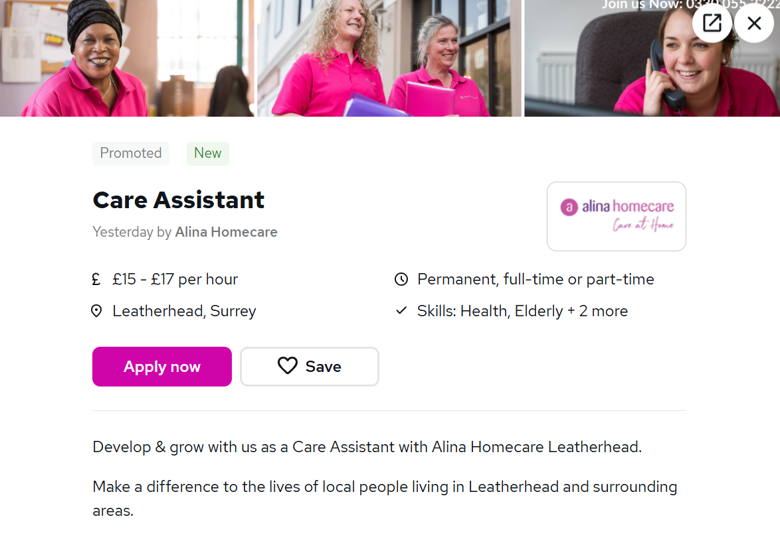

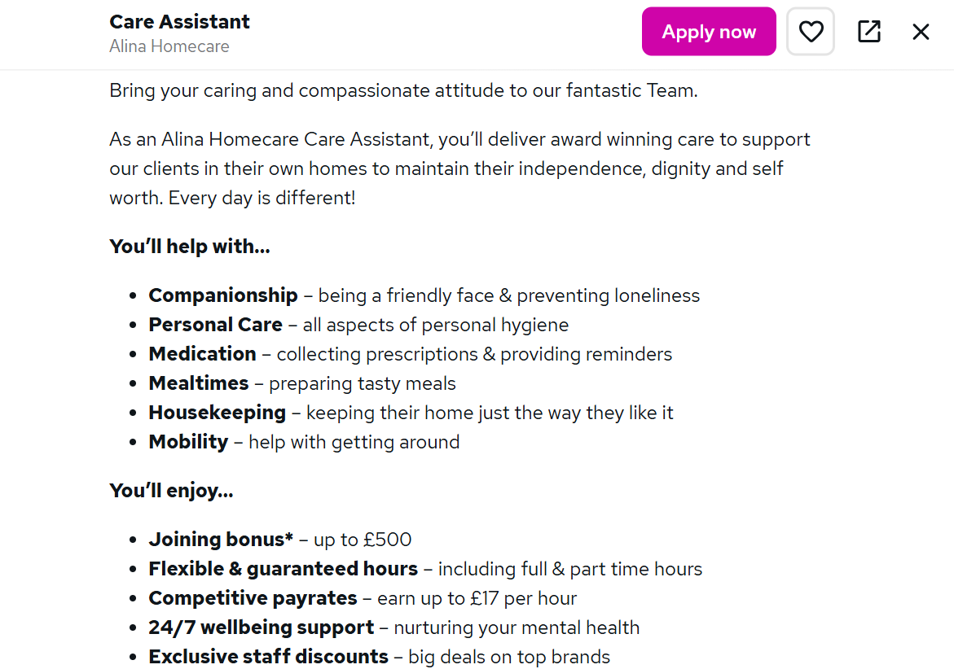

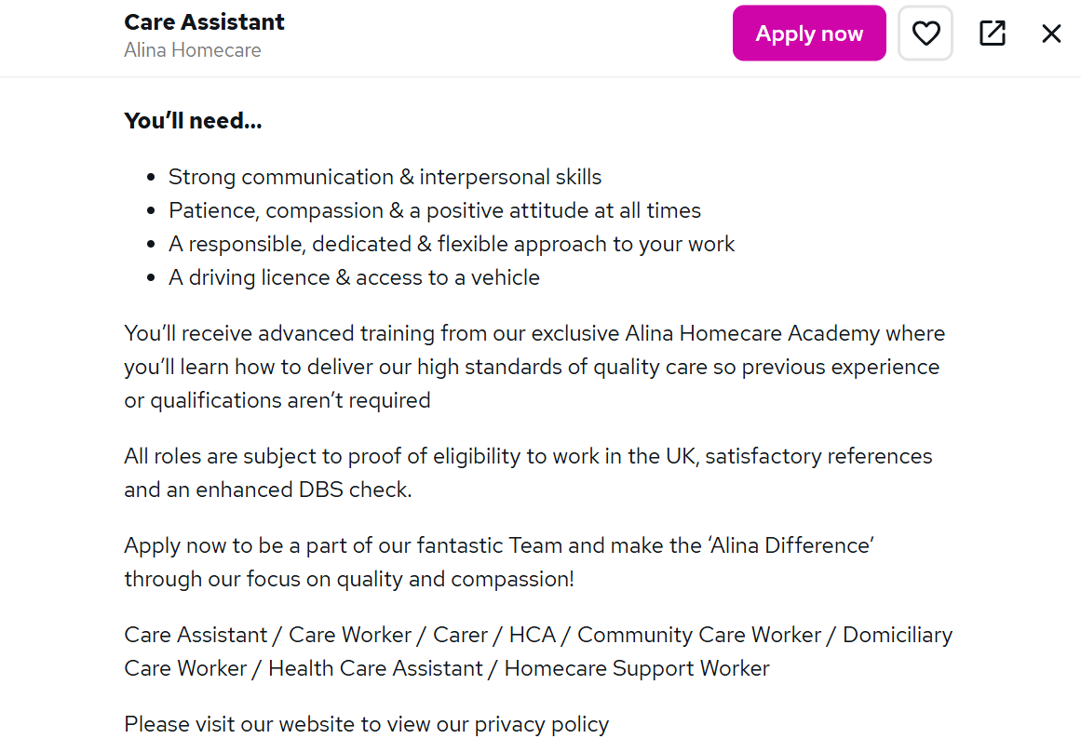

Practical Portfolio

Introduction:

This portfolio delves into my personal profile, SWOT analysis in relation to my desired health and social care job role, and a personal development plan outlining how I can enhance my skills to advance and engage in self-critical reflection using the Gibbs model.

Task 1 of 4

PERSONAL PROFILE

I am a compassionate, reliable, and motivated individual currently pursuing a Level 4 Health and Social Care qualification. My passion lies in building a career within the healthcare sector.

I have valuable experience from both a clinical pharmacy placement and a high-quality hospitality environment. During my pharmacy placement, I gained hands-on experience in handling prescriptions, maintaining patient confidentiality, and understanding the importance of accuracy and responsibility in healthcare.

In the hospitality industry, I developed excellent communication skills, patience, and the ability to support individuals in a calm, respectful, and person-centred manner. I am committed to helping individuals maintain their independence, dignity, and well-being in their own homes.

I am excited about starting a career as a Care Assistant and making a meaningful difference in people’s daily lives through compassionate and high-quality care.

KEY SKILLS
- Strong communication and interpersonal skills.
- Compassionate and patient approach to supporting others.
- Understanding of person-centred care and dignity.
- Knowledge of medication handling and confidentiality.
- Health, safety, and hygiene awareness.
- Ability to build trust and positive relationships.
- Calm and reliable under pressure.
- Teamwork and adaptability in fast-paced environments.
- Organised with good attention to detail.

RELEVANT EXPERIENCE
Pharmacy Student Placement
Completed 200 Hours
- Assisted in locating and preparing prescriptions using pharmacy systems.
- Always maintained strict patient confidentiality.
- Supported pharmacists with accurate handling and organisation of medication.
- Interacted professionally with patients, offering polite and supportive communication.
- Gained a better understanding of healthcare procedures, patient safety, and responsibility.

WORK EXPERIENCE:

Barista
- Worked at a 4-star hotel in Central London since 2023.
- Provided exceptional service to a diverse clientele in a fast-paced environment.
- Cultivated positive relationships with customers through friendly and attentive interactions.
- Ensured the highest standards of cleanliness and hygiene.
- Excelled under pressure, maintaining composure and professionalism.
- Accurately and responsibly handled payments.

Host
- Worked as a host at a 4-star hotel in Marble Arch, London, since 2023.
- Welcomed guests and created a welcoming atmosphere.
- Managed bookings and supported smooth daily operations.
- Responded promptly to inquiries and resolved issues with calmness and professionalism.
- Demonstrated strong organisational and communication skills.

Makeup Artist:
- Currently freelancing as a makeup artist, starting in 2025.
- Conducts client consultations to understand individual needs and preferences.
- Prioritises attention to detail and adheres to strict hygiene standards.
- Builds trust with clients through effective communication and professionalism.
- Efficiently manages appointments and delivers services on time.

EDUCATION:
- Health and Social Care Level 4 (Ongoing): Studying at the University of Wales Trinity Saint David. (2025-2026)
- Applied Science Level 3 (BTEC): Completed at West Thames College. (2023-2025)

LANGUAGES:
- English
- Ukrainian
- Russian
Task 2 of 4 Personal Statement

I am applying for the Care Assistant position because I am passionate about building a meaningful career in healthcare and making a positive impact on people’s lives. My long-term goal is to progress within health and social care and eventually pursue a career in the medical field. This opportunity is essential for me to gain practical experience in delivering compassionate, person-centred care while supporting individuals in maintaining their independence, dignity, and well-being.

Currently, I am studying Health and Social Care Level 4 at the University of Wales Trinity Saint David. My studies provide me with a solid foundation in care principles, safeguarding, communication, and the importance of promoting dignity and respect in all aspects of care. I’m eager to apply this theoretical knowledge in a real-life care setting.

In addition to my education, I have completed 200 hours of placement at a pharmacy. This experience gave me valuable insights into working in a clinical environment. I assisted in locating and preparing prescriptions, handled sensitive patient information, and observed the significance of accuracy, responsibility, and confidentiality. I also interacted with patients professionally and respectfully, enhancing my communication skills and ability to provide reassurance and support. This experience has helped me understand the importance of patient safety and the role of effective communication in delivering high-quality care.

My work experience as a Barista and Host at a four-star hotel has honed my interpersonal and organisational skills. Operating in a fast-paced, high-quality environment taught me how to remain composed under pressure, communicate effectively with people from diverse backgrounds, and provide exceptional service. I have learned how to build positive relationships, listen attentively to individual needs, and respond with patience and professionalism—all crucial qualities in a care role.

I believe my key strengths lie in my compassion, reliability, and strong work ethic. I naturally empathise and enjoy helping others, which drives me to provide the best possible support to those in need. I am also highly responsible and understand the significance of trust when working with vulnerable individuals. My meticulous attention to detail, coupled with my commitment to maintaining high standards of hygiene and safety, ensures that I contribute to a safe and supportive care environment.

I think my combination of education, healthcare exposure, and strong interpersonal skills would be valuable to an employer. I am eager to learn, open to training, and committed to delivering high-quality care that makes a real difference. I would be delighted to contribute positively to your team while continuously developing my skills and experience within the care sector.
Task 3 of 4 SWOT Analysis
Strengths | Weaknesses | Opportunities | Threats
Bilingual in three languages | Not enough experience in the pharmacy | Growing in health and social care field | Emotional and physical demand
Excellent time management | Makeup role is unrelated to this role | Level 4 qualification will increase the chance of employability | Balancing ongoing studies with a new care role
Proven composure under pressure | Short individual experience in each role | Pharmacy background could increase progression | Competitive job market

Personal Development Plan (PDP) — Care Assistant Role
Goal 1: Obtain Mandatory Care Certifications (Months 1–6)
During this period, I will complete First Aid at Work, Manual Handling, and Safeguarding Adults training. I will also apply for an Enhanced DBS check, which are statutory requirements for my role. By the end of month six, I aim to hold all these certificates and document them in a quarterly CPD log.
Goal 2: Gain Direct Care Experience (Months 1–12)
Within the first three months, I will secure a volunteer placement with a local care organisation and complete a minimum of 20 hours of shadowing. From month six onwards, I will apply for paid Care Assistant positions. To monitor my progress, I will keep a weekly reflective journal and conduct a formal self-review at the six-month mark. My goal is to secure paid employment by the end of month twelve.
Goal 3: Complete Level 4 Health and Social Care Qualification (Year 1–2)
To achieve this goal, I will maintain a structured study timetable and meet with my personal tutor regularly to review my academic progress. By the end of year two, I will complete my qualification and identify a clear progression route, such as senior care, nursing, or social work.
Review and Sign-Off:
Progress against all three objectives will be discussed during a mid-year review and a comprehensive annual appraisal. The outcomes will be recorded and agreed upon in accordance with the NHS Scotland PDP framework.

Task 4 of 4

Description
I was tasked with creating a word document, which included my CV, SWOT analysis, and Personal Development Plan (PDP) for a Care Assistant position. The SWOT analysis highlighted my strengths, such as my bilingualism in three languages, excellent time management skills, and proven composure under pressure. However, it also identified areas for improvement, including limited experience in the pharmacy setting, an unrelated makeup artist role, and insufficient experience in each previous role. Additionally, I outlined three PDP goals aimed at obtaining mandatory care certifications, gaining direct care experience, and completing my Level 4 qualification. Following the presentation, my lecturer provided verbal feedback, which I will critically examine in this reflection.
Feelings
Before making this, I felt reasonably prepared because the content was based on my own experiences and personal goals. However, I was nervous about openly discussing my weaknesses, particularly acknowledging that my pharmacy experience was limited and that some of my roles, such as makeup artistry, were not directly related to Health and Social Care. I worried that this might create a negative impression. As I presented, I became more confident in discussing my strengths, especially my trilingual ability and composure under pressure, which I felt genuinely relevant to care work. However, when I reached the weaknesses section of my SWOT, I felt exposed and rushed through it instead of addressing it with the confidence and critical awareness it deserved.
Evaluation
My document had several notable strengths. The document’s structure was logical and professional, transitioning smoothly from the SWOT analysis to a clearly defined PDP with three SMART goals. The content showcased my knowledge of the Health and Social Care sector, highlighting the significance of certifications like First Aid, Manual Handling, and Safeguarding, as well as the value of volunteering to gain practical care experience. However, my lecturer suggested that I should delve deeper into analysing my weaknesses rather than merely listing them. Additionally, they emphasised the need to draw stronger connections between my existing experiences and the competencies required for a Care Assistant role.
Analysis
Reflecting on this feedback, I realise that I was more at ease presenting the positive aspects of my profile than critically analysing the areas that require improvement. For instance, while I acknowledged that my makeup artistry role was unrelated to care, I neglected to emphasise the transferable skills it encompasses, such as client consultations, building trust, respecting individual preferences, and maintaining hygiene standards—all of which directly align with person-centred care values. Additionally, I downplayed the significance of my trilingual in English, Ukrainian, and Russian, which is a genuine professional asset when supporting service users from diverse backgrounds. As Gibbs’ model illustrates, honest evaluation and in-depth analysis are what transform an experience into meaningful professional learning.
Conclusion
This assessment revealed that presenting professional documents in Health and Social Care demands more than just organisational and content knowledge. It requires critical self-awareness, which involves acknowledging one’s weaknesses honestly while simultaneously demonstrating active efforts to address them. While my PDP goals were well-structured, I lacked the analytical confidence to present them effectively. I now realise that establishing a clear connection between past experiences and future professional practice is crucial, rather than assuming it.
Action Plan
Going forward, I will meticulously prepare critical commentary for every section of any professional document before presenting it. I will practice verbalising weaknesses as development opportunities, enabling me to discuss them confidently rather than anxiously. Additionally, I will revisit my lecturer’s feedback and incorporate it to enhance both my academic writing and professional presentation skills. By doing so, I aim to ensure that future assessments not only reflect my accomplishments but also demonstrate my learning and growth within the Health and Social Care sector.

References
Alina Homecare (2026) Carer jobs in Leatherhead. Available at: https://jobs.alinahomecare.com/care-assistant-jobs/carer-jobs-in-leatherhead/ (Accessed: 23 April 2026).
Care Learning (2024) How to use a SWOT analysis in health and social care. Updated 19 August 2025. Available at: https://carelearning.org.uk/blog/feedback-and-improvement/how-to-use-a-swot-analysis-in-health-and-social-care/ (Accessed: 23 April 2026).
Workforce.nhs.scot (2025) Personal Development Planning and Performance Review Policy: guide for employees. Available at: https://workforce.nhs.scot/supporting-documents/guide/personal-development-planning-and-performance-review-policy-guide-for-employees/ (Accessed: 23 April 2026).

