
Datacentre Technologies and Proposal for Enhance System Architecture for the University of Manchester.

Modou Pene
University of Trinity Saint David
1810381@student.uwtsd.ac.uk

Abstract
Those in favour of datacentres have recently promoted them as an effective long-term solution to the problem of the internet gradually becoming ossified. Datacentres enable flexibility, variety, security, and management by allowing several heterogeneous network designs to coexist on a common physical network. As well as the past and current state of the art in datacentres, this paper will also look at the long-term difficulties that must be solved in order to arrive at a feasible solution.
Keywords Datacentre architecture.

Introduction

Datacentre it is the engine room that house servers, storage, uninterruptible power supplies and all the equipment that allows to govern the processes, communication as well as the services that support any business activity. In a nutshell, it is datacentres that guarantee the operation 24 hours a day, every day of the year, of any information system. The datacentre today represents the beating heart of the business. Additionally, it provides all technical-scientific assistance to the various structures in the sphere of process digitisation, electronic data processing, definition of computing networks, as well as the design and implementation of information systems All support applications, as well as integration and interaction with systems outside the organisation, are included in this category as well.

In this paper we will detailed and comprehensive guide to datacentre, we will see in depth what a datacentre is and after the merging of the two Universities how the University of Manchester can enhance his IT operation and other insights into the datacentre such as network topology, management faulty tolerance, performance, scalability, energy usage and sustainability and security.

Before going through the details of these basic aspects, let’s remember that today, when we talk about datacentres, we often no longer think of a physical place because datacentre is now by definition hybrid. More and more often it is composed of:

- In house environment.
- Private cloud and public provided by different providers.

DATACENTRE OVERVIEW

Highly specialised structures, organised to allow maximum functional efficiency to devices, systems and services, it is the datacentres that ensure global business continuity. Thanks to stable and redundant connectivity systems, or through a duplicated configuration that guarantees operational continuity in the event of one or more system failing. This is to always guarantee maximum functionality. The entire infrastructure of a datacentre is centred on network that the IP protocol and connect machines and application to each server farm host different set of routers for example: network devices that are responsible for routing data, divided into packets, between different subnets. It also houses switches designed and configured to carry data traffic bi-directionally between servers and the rest of the world
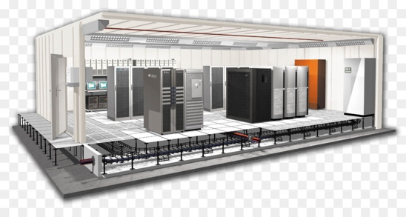

Fig 1 Datacentre []
Inside a datacentre, in addition to servers, there are various data storage systems, various IT systems for monitoring, controlling and managing machine, application and telecommunication infrastructures as well as all accessories connected to them. To ensure the operation and full efficiency of the machines, in addition to uninterruptible power supplies (UPS centres), the datacentre provide very special air conditioning and environmental control systems, fire prevention system and advanced safety system.

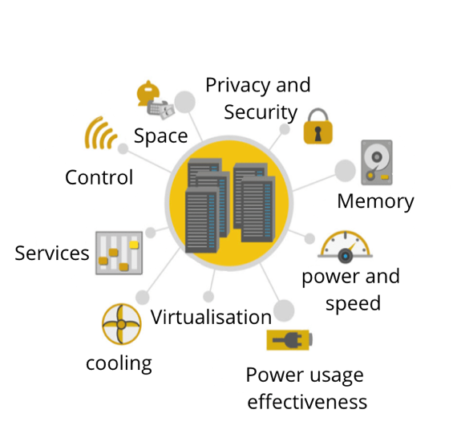

Fig 1 Datacentre concept

EQUIPMENT | STRUCTURE | INTELLIGENCE
SERVER  STORAGE  SWITCH  ROUTER  FIREWALL  APPLIANCE | Primary machine room  Secondary machine room  Wired building  In accordance  Protected  With dedicated personal | Application Systems  Monitoring Systems  Virtualisation  Auto-repairing systems  Measuring systems  Security System
INFRASTRUCTURE
CABLE UPS
TRUNK CRAC System (Computer Room Air Conditioner)
RACK HVAC System (Heating, Ventilating Air Conditioner)
CABINETS Exhaust systems
SHELVES Monitoring System and Control
CASE Surveillance systems

Datacentre classification

Designing a datacentre is extremely complex. Building a centralised, suitable and performance environment for the University of Manchester, equipment in good proportions high-level structures of safety, trustworthiness and efficiency when it comes to providing services is not easy. For this reason, a reference standard was created. The best practices for building a datacentre, follow the TIA-942 standard. In the TIA-942, are indications on the following definition of spaces and the design of the datacentres, on the realisation of the wiring, on the environmental conditions.
The guidelines also include a classification of datacentre according to 4 levels, called TIER mean the system for identifying the structure of a datacentre. The first is the basic one, in which operational continuity has deltas of interruption times of almost 30 hours a year. It seems like a small number, but it isn’t. Think about what is means for the University of Manchester to be unavailable even for only two or three hours of service, it may impact the university activities. It is therefore clear why, depending on the core business, it is necessary to aim for the higher levels.

TIER I and II datacentre
To be classified as a Tier I datacentre, an IT infrastructure requires the use of a dedicated room separated from the office areas, plus a UPS to filter power peaks and drops, an air conditioning system operating 24 hours a day and a power generator. Therefore, these are the minimum requirements to define, nowadays, a datacentre capable of supporting a company that does not need high performance and security levels

By introducing the Tier II category, we start talking about redundant component and therefore real resistance to adverse circumstances: to be defined tier II, a datacentre requires partial redundancy in the field of electrical and cooling components, but is not yet a level suitable for those companies that require rigorous uptime as each maintenance operation involves a reduction in capacity

TIER III datacentre
Huge step forward in business continuity is offered by the TIER III datacentre, which add a redundance branch for both power and cooling including subsystems to the specifications of the underlying level, thus offering an average availability of 99.982% on an annual basis. TIER III introduces the concept of concurrent maintenance of components, which means being able to intervene on any component that is decisive for the purpose of the service without causing discontinuity.

TIER IV datacentre
Finally, let’s talk about the TIER IV, the highest and most prestigious level, so much so that is has been assigned to only few datacentres throughout UK and true reference point for anyone who must host their mission critical application. Here too we start from the previous TIER specifications but add the concept of fault tolerance: in practice, a TIER IV datacentre must be able to tolerate the cumulative impact of failure on multiple systems and components, managing operational continuity without any human intervention, for an annual uptime level of 99.995%.

BACKGROUND
Throughout this section, we will first provide a brief overview of datacentre technologies, highlighting the most important concepts.

The origins of the first datacentre can be traced back to the 1940s and the existence of the first computer systems such as the Electronic Numerical Integrator and Computer (ENIAC). These early machines were complex to maintain and operate and had a slew of cable connecting all the necessary components. They were also in use by the military, which meant that specialised computer rooms with racks, cable trays, cooling mechanisms, and access restrictions were needed to both house all equipment and implement appropriate security measure. However, it wasn’t until the 1990s, when IT operation began to get more complex and inexpensive networking equipment became available, that the term datacentre first came into the use. It has become possible to store all the necessary servers of a company in one room within the company. These specialised computer rooms have been dubbed datacentres within companies and term has caught on.

Around the time dot-com bubble in the late 1990s, the need for the internet speed and constant Internet presence for businesses required larger facilities to house the amount of network equipment needed. It was at this point that datacentre became popular and began to resemble the ones describe above. Throughout the history of computing, as computer became smaller and networks larger, datacentre has evolved and moved to accommodation the necessary contemporary technology.

Datacentre topologies and architectures
A datacentre networking is a cabling infrastructure layout and how servers are connected to switches should find the right balance between stability, efficiency, flexibility expandability and charge. It should also be capable of supporting both current and future application and speeds. The following are important consideration when choosing a datacentre architecture:

- Actual datacentre’s size
- Datacentre expansion is expected
- If it's a brand-new construction or an upgrade to an existing system.

TOPOLOGIES
Currently, there are three primary types of datacentre topologies in use, each with its own set of pros and disadvantages. Indeed, larger datacentre may implement two or perhaps all three of them in the same datacentre.

Centralised
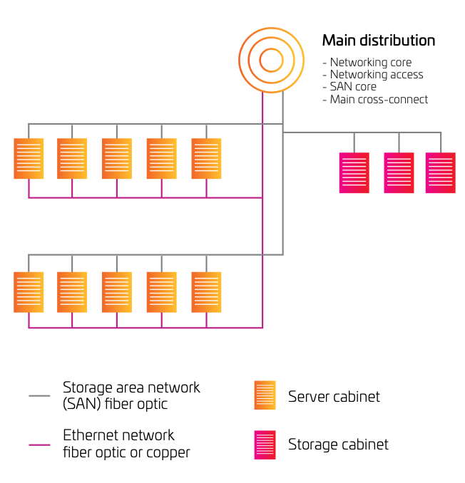
This is a good topology for smaller data centres because it is centralised (under 5,000 square feet). In the diagram, there are separate LAN and SAN environments, with home run cabling going to each of the server cabinets and zones in each environment. Essentially, each server is tethered to the core switches, which are located in the primary distribution area of the network.

As a result, port switches may be used more efficiently, and components can be managed and added more easily. While the centralised topology works well for smaller data centres, its limitations make it difficult to expand. Because of the enormous number of long-distance cable lines necessary in larger data centres, cable paths and cabinets become congested, increasing costs. However, while some bigger data centres employ a zoned or rack-to-rack design for LAN traffic, they may also use one for the storage area network (SAN). When the cost of SAN switch ports is high and port utilisation is critical, this is true even more so than usual.

ZONED

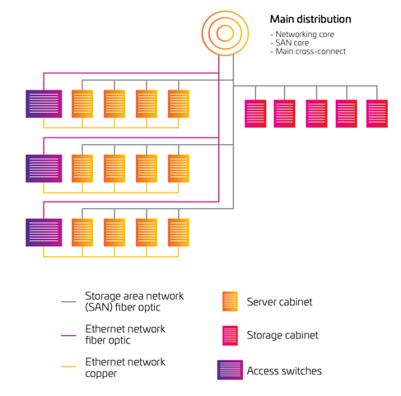
In a zoned network, switching resources are dispersed throughout the system. For example, end-of-row (EoR) switches could be used to support a single server cabinet, while middle-of-row switches are used to support numerous server cabinets. Datacentre Standards ANS/TIA-942 have advised the use of this approach because it is scalable and predictable. When it comes to cost-effectiveness, zoned architecture is usually the best choice, since it maximises switch and port utilisation while minimising cabling expenses.

End-of-row switching offers performance advantages in some situations. For low-latency port-to-port switching, the local area network (LAN) ports of two servers (that exchange significant amounts of information) can be placed on the same end-of-row switch. There is a potential drawback to using end-of-row switching, which is the necessity to run wire back to the switch at the end of the row. In a top-of-rack architecture, if every server is connected to redundant switches, the amount of cabling required can be more.

TOP OF RACK
According to this diagram, ToR switching comprises of two or more switches mounted on top of each server cabinet. For dense 1RU server settings, this design can be a viable solution. Redundancy is ensured by connecting all servers in the rack to both switches. They also have uplinks to the following switch layer. As a result, top of rack cable management is much simplified, as is the need for cable containment.
Fast port-to-port switching for the servers in the rack is also possible with this strategy, and the uplink's capacity is not oversubscribed in the future.
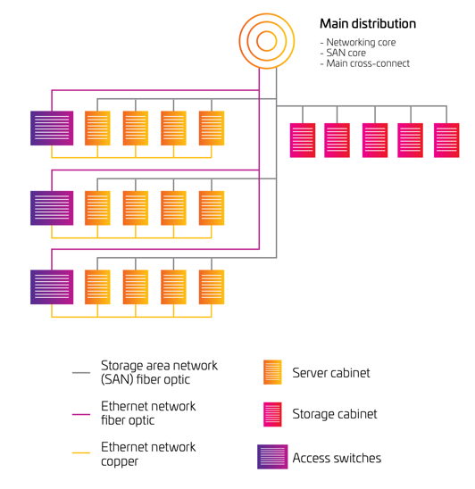

A top-of-rack design makes better use of cabling. The downsides are frequently an increase in switch costs and a significant cost for port underutilization. In large deployments, top-of-rack switching can be difficult to monitor, and there's also the risk of local area network (LAN) switch gear overheating in server racks. As a result, some data centres use top-of-rack switches in a middle-of-row or end-of-row architecture to maximise switch port utilisation and reduce overall switch count.

ARCHITECTURE

