

LOCATION: Swansea | LLEOLIAD: abertawe
LEVEL 4 | LEFEL 4
EXAMINATION PERIOD | CYFNOD ARHOLIADAU
MAY 2023 | 2023

MODULE CODE: ACDA4016
INTRODUCTION TO DIGITAL ELECTRONICS

Programme:
CERTIFICATE OF HIGHER EDUCATION: SKILLS FOR ELECTRONICS

- Generate the Logic symbols and truth tables for the following : [20 marks]
  - An AND gate.
  - A OR gate.
  - A XOR gate.
  - A NAND gate.
  - A NOR gate.
Answer:
- AND Gate [4 marks]
Logic Symbol:
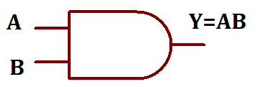
Truth table
Input |  | Output
A | B | Y=A.B
0 | 0 | 0
0 | 1 | 0
1 | 0 | 0
1 | 1 | 1

OR Gate: [4 marks]
Logic symbol
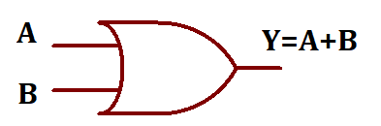
Truth table
Input |  | Output
A | B | Y=A+B
0 | 0 | 0
0 | 1 | 1
1 | 0 | 1
1 | 1 | 1

c) X-OR Gate: [4 marks]
Logic symbol
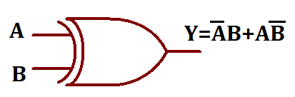
Truth table
Input |  | Output
A | B | Y=$\overline{A}B+A\overline{B}$=$A⨁B$
0 | 0 | 0
0 | 1 | 1
1 | 0 | 1
1 | 1 | 0

NAND Gate: [4 marks]
Logic symbol
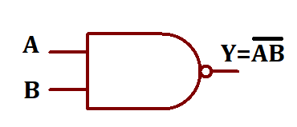
Truth table
Input |  | Output
A | B | Y=$\overline{A.B}$
0 | 0 | 1
0 | 1 | 1
1 | 0 | 1
1 | 1 | 0

NOR Gate: [4 marks]
Logic symbol
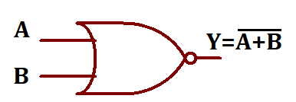
Truth Table
Input |  | Output
A | B | Y=$\overline{A+B}$
0 | 0 | 1
0 | 1 | 0
1 | 0 | 0
1 | 1 | 0

- Design a logic circuit using a software for the following equations [30 marks]
- $Y=\left(\overline{AB}\right)C+\overline{A}B\overline{C}+\overline{A+C}$
- $Y(A,B,C, D) =$ $\sum_{m}{(0,1,5,6,9)}$
Answers:
- [15 marks]
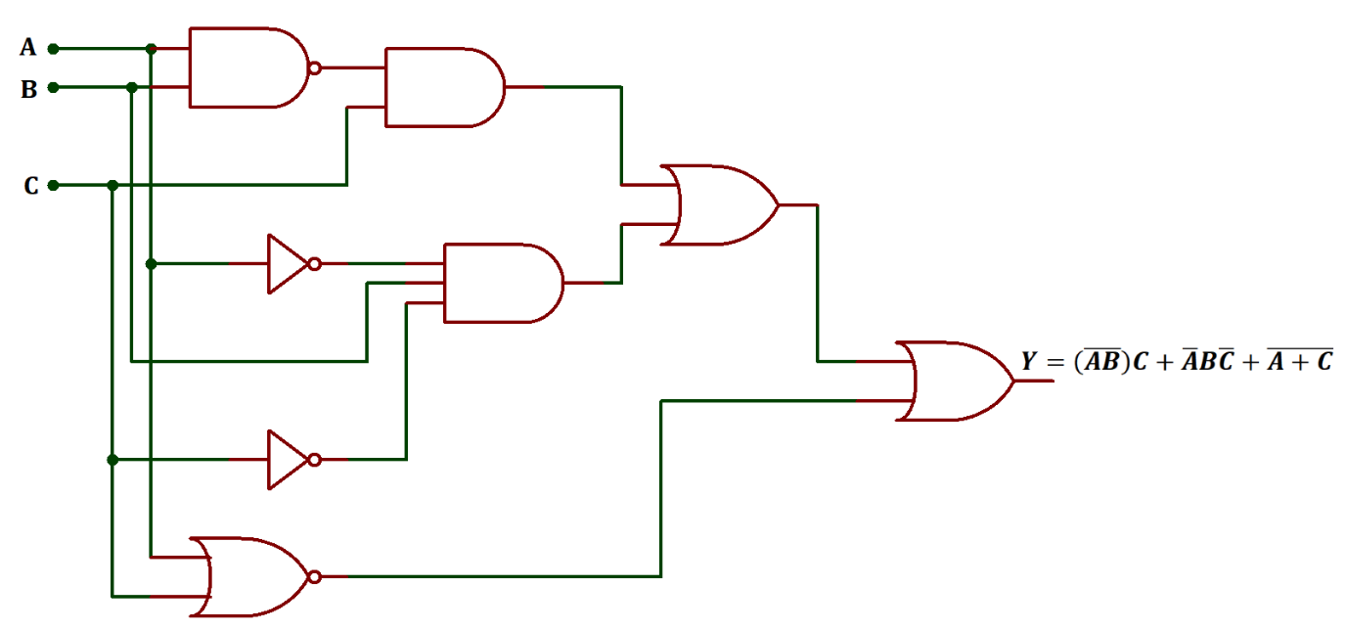
- $Y=\overline{A}\overline{B}\overline{C}\overline{D}+\overline{A}\overline{B}\overline{C}D+\overline{A}B\overline{C}D+\overline{A}BC\overline{D}+A\overline{B}\overline{C}D$ [15 marks]
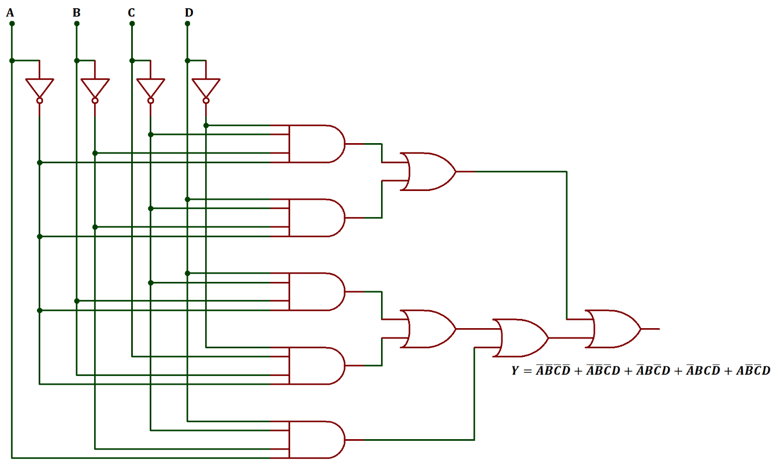

- Determine the Boolean expression for the circuit shown below. Simply the Boolean expression and design circuit for the simplified equation using the software. Draw the truth table for the same. [20 marks]

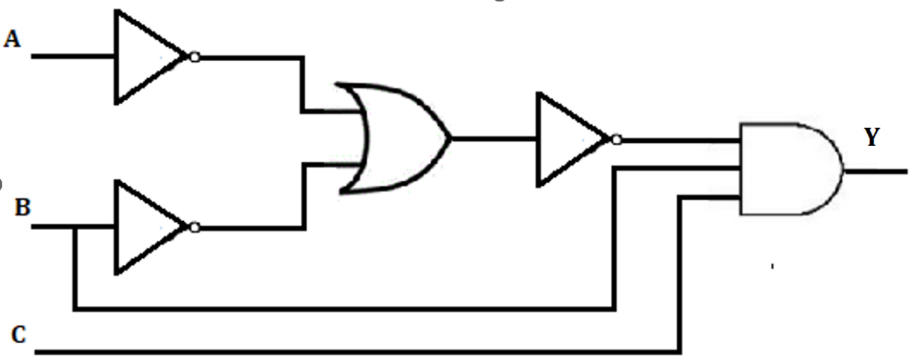
Answer:
Y= $(\overline{\overline{A}+\overline{B}})BC$
Y= $(\overline{\overline{AB}})BC$ [Demorgan’s Theorem 2]
Y= $ABBC$ [$\overset{̿}{A}=A$ ]
Y= $ABC$ [B.B=B] [6 marks]

Truth table
Inputs |  |  | Outputs
A | B | C | Y=ABC
0 | 0 | 0 | 0
0 | 0 | 1 | 0
0 | 1 | 0 | 0
0 | 1 | 1 | 0
1 | 0 | 0 | 0
1 | 0 | 1 | 0
1 | 1 | 0 | 0
1 | 1 | 1 | 1
[6 marks]
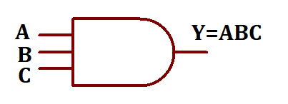
[8 marks]

- Design a 4 bit Synchronous counter circuit using Proteus software. Draw a truth table for the input and outputs. [20 marks]
Answer: [15 marks]
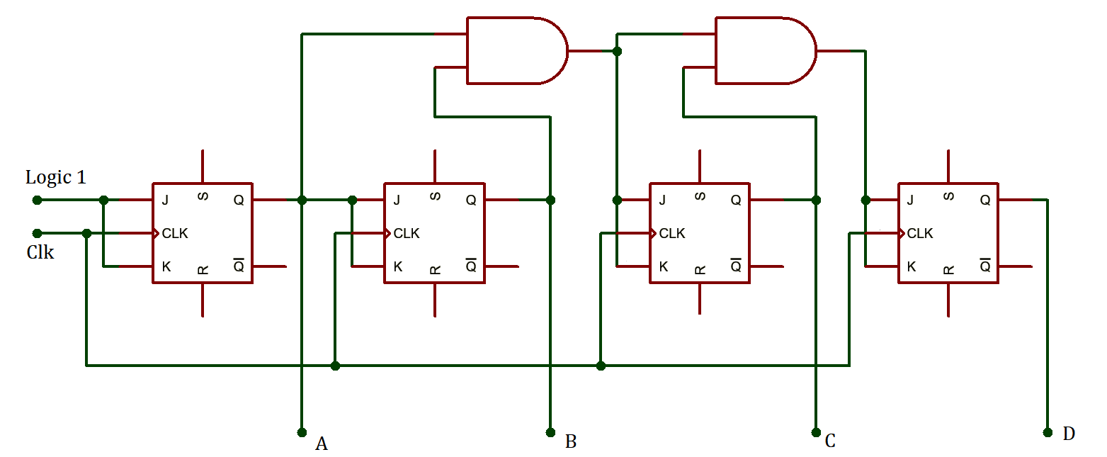
Truth Table
Input |  |  | Output
Clock | JK | State | D | C | B | A
1 | 1 | 0 | 0 | 0 | 0 | 0
2 | 1 | 1 | 0 | 0 | 0 | 1
3 | 1 | 2 | 0 | 0 | 1 | 0
4 | 1 | 3 | 0 | 0 | 1 | 1
5 | 1 | 4 | 0 | 1 | 0 | 0
6 | 1 | 5 | 0 | 1 | 0 | 1
7 | 1 | 6 | 0 | 1 | 1 | 0
8 | 1 | 7 | 0 | 1 | 1 | 1
9 | 1 | 8 | 1 | 0 | 0 | 0
10 | 1 | 9 | 1 | 0 | 0 | 1
11 | 1 | 10 | 1 | 0 | 1 | 0
12 | 1 | 11 | 1 | 0 | 1 | 1
13 | 1 | 12 | 1 | 1 | 0 | 0
14 | 1 | 13 | 1 | 1 | 0 | 1
15 | 1 | 14 | 1 | 1 | 1 | 0
16 | 1 | 15 | 1 | 1 | 1 | 1
17 | 1 | 0 | 0 | 0 | 0 | 0

- Describe the types and applications of Sequential Circuits. [10 marks]
A sequential circuit is a logical circuit, where the output depends on the present value of the input signal as well as the sequence of past inputs. While a combinational circuit is a function of present input only.
A sequential circuit is a combination of combinational circuit and a storage element. The sequential circuits use current input variables and previous input variables which are stored and provide the data to the circuit on the next clock cycle.
The sequential circuits are classified into two types
- Synchronous Circuit
- Asynchronous Circuit
In synchronous sequential circuits, the state of device changes at discrete times in response to a clock signal. i.e. the output depends on the clock signal.
In asynchronous circuits, the state of the device changes in response to changing inputs. i.e. the output depends on the input signal. [6 marks]
Sequential Circuits are used as
- Shift registers.
- Flip flops.
- Analog to digital and digital to analog converters.
- Counters.
- Clocks.
- Storage device
- programmable devices such as CPLD, PLD, and FPGA. [4 marks]

Diwedd/End

