

Analysing the United Kingdom’s Police Response Times and what can change to improve this service.

Jordan Morris
Student ID: 2125113
BSc (Hons) Professional Policing Practice
October 2024

Word Count: 8602 (Not including anything other than chapters)

Recognition:

I would firstly like to give my sincere thanks and gratitude to my colleagues for their feedback and importantly the respondents within this survey who gave their valuable time, and feedback when completing the survey as part of this dissertation.

If possible, I would like to thank my partner who has been by my every side in this personally challenging year, her guidance and support has been hugely appreciated.

I would also like to thank the university of Wales Trinity St David staff throughout the past three years for their feedback and support both on a professional level but also for their personable approach.

Lastly, I would like to give thanks to Samantha Mcalister Wilson whose advice and support throughout this research proposal has been hugely appreciated and I give thanks for the time and effort she has put in me with support on all fronts. Thank you.

Declaration
This work has not previously been accepted in substance for any degree and is not being concurrently submitted in candidature for any degree.
Signed:
Date:

STATEMENT 1
This dissertation is being submitted in partial fulfilment of the requirements for the degree of BA.
Signed:
Date:

STATEMENT 2
This dissertation is the result of my own independent work/investigation, except where otherwise stated.
Other sources are acknowledged by footnotes giving explicit references. A bibliography is appended.
Signed:
Date:

STATEMENT 3
I hereby give consent for my dissertation, if accepted, to be available for photocopying and for interlibrary loan, and for the title and summary to be made available to outside organisations.
Signed
Date:

STATEMENT 4
I hereby give consent for my dissertation, if accepted, to be available on the university’s IT system to those who have consent to use the system.
Signed:
Date:

Abstract:
The objective set out of this research project was to analyse the United Kingdom’s policing response times and how people felt on the matter and what could improve this vital service. The project aimed to provide honest recommendations on what could be improved for this service to become world class and ultimately provide the important life-saving calls are answered as quick and efficiently as they can.

This research was conducted using a quantitative and qualitive research survey with members of the public and also a comprehensive literature review which used previous data collected and feedback from leading persons in the field. The responses received were wide reaching and enabled the reader to really put a personal spin on what they felt was affecting response times for the police, and how they had been affected.

The following research proposal successfully achieves the objectives set out in the first chapter of this dissertation. The respondents of this survey give their recommendations on what could improve this service and it is further supported by the extensive literature carried out in this dissertation.

Table of Contents
- Abstract (Page 5)
- Chapter 1: Introduction (page 7)
- 1.1 Background (page 7- page 9)
- 1.2 Objectives (Page 10)
- Chapter 2: Literature Review (page 11)
- 2.1 Introduction (page 11)
- 2.2 defining police response time (page 12-page 13)
- 2.3 impact on crime resolution (page 13-14)
- 2.4 Technological Advancements (page 14)
- 2.5 Operational Strategies (page 14-page 15)
- 2.6 Public perception and trust within the police (page 15)
- 2.7 Challenges and limitations (page 15-page 16)
- 2.8 Previous recommendations and improvements (page 16-page 17)
- Chapter 3: Methodology (page 18)
- 3.1 Introduction (page 18)
- 3.2 Research strategies and the impact of regional differences (page 18)
- 3.3 means of data collection (page 19-page 20)
- 3.4 ethical principles and considerations (page 20 – page 22)
- Chapter 4: Research Analysis (Page 23)
- 4.1 Introduction (page 23)
- 4.2 Analysis of survey answers (Page 23-page 30)
- Chapter 5: Research findings, conclusions, and recommendations (page 31)
- 5.1 recommendations (page 31)
- 5.2 Findings and objectives (page 31- page 32)
- 5.3 Theme 1 (page 32)
- 5.4 Theme 2 (Page 33)
- Chapter 6: Limitations and recommendations (page 34)
- 6.1 Limitations (page 34)
- 6.2 Recommendations (page 35)
- Bibliography (page 36-page 37)
- Appendix (Page 38-Page 42)

Chapter 1: Introduction

1.1 Background
The analysis of UK police response times is a critical aspect of evaluating law enforcement effectiveness and public safety. Response times refer to the period between when an emergency call is made and when police officers arrive on the scene. As one of the most visible indicators of police performance, response times can shape public perceptions of police efficiency and trustworthiness. In the context of the UK, understanding and analysing police response times is essential not only for improving service delivery but also for ensuring the safety and well-being of communities. This essay explores why analysing police response times is important and the benefits of understanding this topic in detail, backed by academic and policy research.
The primary role of the police is to protect citizens and prevent crime. Timely responses to emergency calls are vital in situations where lives are at risk, such as violent crimes, accidents, or instances of domestic abuse. Faster response times can prevent incidents from escalating and reduce harm to victims (College of Policing, 2020). In contrast, delayed responses can result in further violence, injury, or loss of life, which has significant implications for public safety. Therefore, analysing response times allows policymakers and police departments to identify where delays occur and address them, improving the overall safety of communities. Police response times are a key factor influencing public confidence in law enforcement. Studies have shown that citizens place significant importance on how quickly police respond to their calls, especially in emergency situations (Myhill & Bradford, 2012). Fast responses demonstrate that the police are reliable, efficient, and committed to public service, which enhances trust in law enforcement agencies. However, slow or inconsistent response times can lead to dissatisfaction and a perception that the police are unresponsive or ineffective. Analysing response times helps police forces understand how public confidence may be affected and where improvements can be made to rebuild trust.
Another important reason to analyse police response times is to better understand resource allocation within police forces. Response times can vary significantly depending on location, time of day, and the nature of the incident. For example, rural areas often experience slower police response times due to fewer available officers and greater distances to travel (HMICFRS, 2020). By analysing this data, police forces can optimize resource distribution, ensuring that more officers are available during peak times or in areas where delays are more common. This strategic allocation of resources can enhance overall police efficiency and ensure that emergency calls are prioritized appropriately. Police response times also depend on the efficiency of the triage system used to prioritize calls. High-priority calls involving threats to life are typically given precedence, while less urgent matters may be handled at a slower pace. By analysing response time data, police forces can assess whether their call triage systems are effective and make adjustments to ensure that emergencies receive the fastest possible response (HMICFRS, 2020). This can lead to better outcomes for the public by ensuring that officers are dispatched to the most critical incidents first, potentially saving lives and reducing the severity of crimes.
Police forces are publicly funded institutions and, as such, are accountable to the communities they serve. Analysing response times provides an objective measure of police performance, which can be used to assess whether police forces are meeting public expectations and delivering services efficiently. Transparency in reporting response times can also foster greater accountability, as the public can see whether police departments are improving over time or if they are failing to address critical issues (HMICFRS, 2020). This data can be used by government bodies, such as the Home Office or HM Inspectorate of Constabulary, Fire and Rescue Services (HMICFRS), to hold police forces accountable for their performance.
Benefits of Understanding UK Police Response Times
Understanding response times can lead to improvements in crime prevention and detection. Research has shown that police intervention within minutes of a crime being reported increases the likelihood of apprehending suspects and preserving evidence (College of Policing, 2020). Faster response times can deter potential offenders, who may be less likely to commit crimes if they know the police can arrive quickly. Additionally, shorter response times can lead to more effective investigations, as officers are more likely to gather critical evidence or eyewitness accounts immediately after an incident.
Faster and more reliable police response times can strengthen relationships between the police and the communities they serve. Communities are more likely to engage with the police and report crimes if they trust that their concerns will be addressed in a timely manner (Myhill & Bradford, 2012). This increased cooperation can lead to more effective policing, as officers are able to gather intelligence and build partnerships with local residents. Analysing and improving response times is therefore crucial for fostering positive community-police relations, which are essential for maintaining public order and safety.
Analysing response times also highlights disparities in service delivery between different regions or demographics. For example, rural areas or poor neighbourhoods may experience slower response times due to fewer resources or longer distances (HMICFRS, 2020). Understanding these disparities allows policymakers to address them through targeted resource allocation or policy changes. Ensuring that all communities receive prompt and effective policing services is critical for maintaining fairness and equality in law enforcement. Policymakers and leaders within policing rely on data to make informed decisions about public services, including policing. Analysing response times provides valuable insights into how police resources are being used and where improvements are needed. This data can inform decisions about police funding, staffing levels, and the development of new technologies or strategies to improve emergency response. For example, if analysis shows that response times are significantly slower in certain areas, policymakers may choose to allocate additional funding to those regions or invest in new technologies, such as real-time crime mapping, to improve efficiency (College of Policing, 2020).
Analysing UK police response times is essential for improving public safety, building trust in policing, and optimizing resource allocation. The benefits of understanding this topic extend beyond immediate police performance, affecting crime prevention, community relations, and policy development. By closely examining response times and addressing the factors that contribute to delays, police forces can enhance their effectiveness and better serve the public. As police organisations continue to evolve and adapt to the policing vision 2025 (College of Policing, 2024), especially in the face of budget constraints and rising demand, maintaining a focus on response times will remain a key priority for improving overall public safety and satisfaction.
1.2: Objectives
This research proposal will focus on the aims and objectives set out by conducting a detailed and comprehensive literature review and an anonymous multiple choice survey with members of the public to gather their own thoughts and feelings but importantly it allows the respondent to input their own ideas on how to improve the service.
The purpose of this research proposal will be to analyse the United Kingdom’s policing response times and utilise previously set out data from the literature provided whilst enabling members of the public their own autonomy to provide feedback and suggestions.

Objective 1:
- To analyse the United Kingdom’s police response times based on the times it took police to arrive at an incident.

Objective 2:
- To gather feedback on why people, feel the police are not currently meeting the demands of the public.

Objective 3:
- The ethical considerations and does where someone live affect the police response time and the impact the police response time had on the incident.

Chapter 2: Literature Review

2.1 Introduction
Police response times are critical in ensuring public safety and maintaining trust between law enforcement agencies and the communities they serve. This literature review critically analyses the effectiveness of UK police response times by examining empirical research, technological advancements, operational strategies, and public perceptions. It aims to provide a comprehensive understanding of how response times influence police performance and the various factors affecting their optimization. Police response time is the duration between the initial report of an incident and the arrival of police officers at the scene. This metric is vital for several reasons. Firstly, quick response times can prevent crimes from escalating, reduce the chances of injuries, and increase the likelihood of apprehending suspects at the scene. For instance, rapid response to violent crimes can be crucial in preventing further harm and ensuring swift justice (Stevens et al., 1980). Secondly, the speed of police response significantly impacts public perception of police effectiveness. Studies have shown that communities with faster police response times report higher levels of trust and satisfaction with their local police forces. Public confidence is essential for effective policing as it encourages cooperation between the community and law enforcement agencies, thereby facilitating better crime reporting and collaborative problem-solving (Brown & Coulter, 1983). Analysing the effectiveness of police response times extends beyond immediate crime resolution. It encompasses broader implications for policing strategies and resource management. For instance, while faster response times are desirable, they must be balanced with other critical policing functions such as crime prevention, community engagement, and investigative work. Policymakers and law enforcement leaders must adopt a holistic approach that integrates multiple performance metrics to evaluate overall police effectiveness (Oxford Academic).m Moreover, improving response times can have a ripple effect on other aspects of policing. Enhanced response capabilities can lead to higher crime detection rates, better evidence collection, and more successful prosecutions. Furthermore, visible and prompt police responses reinforce the presence of law enforcement in communities, deterring potential offenders and contributing to overall public safety (LSE).
2.2 Defining police response time.
Police response time is generally divided into three key components:

1. Call Handling Time: The duration from when an emergency call is received to when it is logged and assigned. The call handling process for UK police begins with the reception of an emergency call, typically via the 999 system or the non-emergency 101 number. Calls are answered by trained operators who quickly assess the nature of the incident, collect essential information, and prioritize the call based on its severity and urgency. This initial assessment includes verifying the location, understanding the type of incident, and determining any immediate risks to individuals involved (Home Office, 2020).

Once the details are logged, the call is categorized and either handled directly or transferred to the appropriate department. High-priority incidents, such as violent crimes or accidents with injuries, are dispatched immediately to available units through a Computer-Aided Dispatch (CAD) system, which helps to streamline the allocation of resources and reduce response times (College of Policing, 2019). The CAD system ensures that the nearest available officers are alerted and dispatched to the scene, enhancing the efficiency and effectiveness of the police response. Throughout this process, communication between the call handler, dispatchers, and responding officers is maintained to ensure accurate and timely updates (Her Majesty’s Inspectorate of Constabulary and Fire & Rescue Services, 2018).

2. Dispatch Time: The time taken for the dispatch centre to allocate the call to an available unit. UK police dispatch time refers to the period between when a call handler categorizes an incident and when a police unit is dispatched to the scene. Efficient dispatch is crucial for ensuring rapid response, particularly for high-priority incidents. Utilizing Computer-Aided Dispatch (CAD) systems, dispatchers quickly locate and assign the nearest available officers to incidents, thus minimizing delays (College of Policing, 2019). Effective dispatch processes involve continuous communication between call handlers, dispatchers, and responding units to ensure accurate and timely updates, enhancing overall response effectiveness (HMICFRS, 2018).
3. Travel Time: The time it takes for the dispatched unit to travel to the incident location. More specifically, it refers to the duration it takes for officers to reach an incident scene after being dispatched. This period is critical in ensuring prompt intervention, particularly for urgent calls such as violent crimes or serious accidents. Travel time is influenced by several factors including traffic conditions, geographic location, and the availability of nearby units (Home Office, 2020). Urban areas often benefit from shorter travel times due to higher police density, whereas rural areas may experience longer delays due to greater distances and fewer resources (HMICFRS, 2018). Effective deployment strategies and the use of GPS technology in patrol vehicles help mitigate these challenges, optimizing response times and improving overall police efficiency (College of Policing, 2019).

Together, these elements form the overall response time, which can significantly influence the outcome of incidents and the public's perception of police effectiveness (Crime Science Journal).

2.3 Impact on crime resolution
Several studies have explored the direct correlation between police response times and crime resolution rates. The general consensus is that quicker response times can increase the likelihood of arrest and the resolution of crimes, especially for incidents in progress. A notable study by Stevens, Webster, and Stipak (1980) found that faster response times were significantly associated with higher clearance rates for crimes such as burglary and assault. However, the relationship was less clear for other crime categories, suggesting that factors beyond response time also play a crucial role in crime resolution (Stevens et al., 1980).

Another study highlighted by the London School of Economics (LSE) indicated that rapid police response could deter crimes by increasing the perceived risk for offenders. This deterrent effect is particularly potent in high-crime areas where quick police action can prevent potential incidents (LSE).

Despite these findings, some research suggests that the overall impact of response times on crime resolution is mixed. For instance, Decker (1980) argued that while response times are essential, they are just one of many variables influencing police effectiveness, including the quality of investigation, community cooperation, and availability of resources (Decker, 1980).

2.4 Technological Advancements
Technological innovations have significantly enhanced police response capabilities. Computer-Aided Dispatch (CAD) systems, Geographic Information Systems (GIS), and real-time data analytics have streamlined the dispatch process, reduced delays and improving resource allocation. These technologies enable dispatch centres to quickly locate and assign the nearest available units to incidents, thereby shortening response times (Crime Science Journal). Moreover, the integration of predictive policing tools allows law enforcement agencies to anticipate crime hotspots and allocate resources more effectively. Predictive analytics can identify patterns and trends in criminal activity, enabling proactive deployment of police units to areas with a high likelihood of incidents (LSE).

The use of body-worn cameras and mobile data terminals has also improved communication and situational awareness among officers, further enhancing response efficiency. These technologies facilitate real-time information sharing, allowing officers to respond more effectively to dynamic situations (Oxford Academic).

2.5 Operational Strategies
Operational strategies play a crucial role in optimizing police response times. One common approach is the prioritization of calls based on their severity. High-priority incidents, such as violent crimes in progress, receive immediate attention, while lower-priority calls, such as non-urgent inquiries, are addressed based on resource availability. This triage system ensures that critical incidents receive the prompt response they require (Carlson & Sutton, 1981).

Strategic positioning of patrol units is another effective strategy. By analysing crime data and identifying high-risk areas, police departments can deploy units to locations where they are most likely to be needed. This proactive approach reduces travel times and enhances the ability to respond swiftly to incidents (Parks, 1984).

Furthermore, community policing initiatives can indirectly improve response times. By fostering strong relationships with the community, police can encourage quicker reporting of incidents and better cooperation during emergencies. Community engagement also helps in building trust, which is essential for effective law enforcement (Brown & Coulter, 1983).

2.6 Public perception and trust within the police
Public perception of police effectiveness is heavily influenced by response times. Prompt responses to emergency calls not only aid in crime resolution but also reinforce public confidence in law enforcement. Studies indicate that visible police presence and quick response are key factors in public satisfaction with police services (Oxford Academic). Conversely, slow response times can erode public trust and lead to negative perceptions of police efficiency. This is particularly true in cases where delayed responses result in adverse outcomes, such as unaddressed crimes or prolonged victim distress (Carlson & Sutton, 1981). A study by Brown and Coulter (1983) emphasized the importance of balancing objective measures of police performance, such as response times, with subjective measures, such as public satisfaction. They found that while administrative metrics are crucial for evaluating efficiency, public perception and community relations are equally important in assessing overall police effectiveness (Brown & Coulter, 1983).

2.7 Challenges and limitations
Despite the critical role of response times, several challenges affect their optimization. Resource constraints are a significant barrier, as limited personnel and equipment can hinder the ability to respond swiftly to all incidents. Budget cuts and financial pressures further exacerbate this issue, forcing police departments to make difficult decisions about resource allocation (Stevens & McDavid, 1981).

Geographical factors also play a role in response times. Urban areas, with their higher population density and greater availability of resources, generally experience faster response times compared to rural areas. In rural settings, longer distances and sparser police presence can delay responses, impacting overall effectiveness (Stevens et al., 1980). Moreover, the focus on response times alone may not fully capture the effectiveness of police services. Other performance indicators, such as crime prevention, community engagement, and overall crime rates, should also be considered when evaluating police effectiveness. A holistic approach that incorporates multiple metrics provides a more comprehensive assessment of police performance (Crime Science Journal).

2.8 Previous recommendations and improvements
To improve police response times and overall effectiveness, several recommendations have been proposed:

1. Enhanced Resource Allocation: Ensuring adequate resources and strategic deployment of patrol units can enhance response efficiency. Investment in technology and infrastructure is also crucial for maintaining and improving response capabilities (Parks, 1984).
2. Training and Development: Continuous training for dispatchers and officers on new technologies and response protocols can improve efficiency and effectiveness. Regular drills and scenario-based training can prepare officers for a variety of emergency situations, enhancing their ability to respond promptly and effectively (Crime Science Journal).
3. Community Engagement: Building strong community relations can aid in quicker reporting of incidents and better cooperation during emergencies, indirectly improving response times. Community policing initiatives that foster trust and collaboration between police and residents are essential for effective law enforcement (Brown & Coulter, 1983).
4. Data-Driven Strategies: Utilizing data analytics to predict high-risk areas and times can help in pre-emptive positioning of police units, reducing response times for incidents in those areas. Predictive policing tools and real-time data analysis can enhance the strategic deployment of resources (LSE).
5. Policy Reforms: Revising policies to ensure a balanced approach between rapid response and other critical policing functions can optimize overall effectiveness. Policymakers should consider the broader context of police performance, including crime prevention, community engagement, and resource management, when evaluating response times (Oxford Academic)
The effectiveness of police response times in the UK is a multifaceted issue influenced by technological, operational, and resource factors. While faster response times can enhance crime resolution and public trust, they must be balanced with other policing priorities and resource limitations. Technological advancements, strategic operational approaches, and strong community relations are critical in optimizing response times and improving overall police effectiveness. Continuous evaluation and adaptation of strategies, coupled with investment in technology and training, can help law enforcement agencies meet the challenges of modern policing. A holistic approach that incorporates multiple performance metrics provides a comprehensive assessment of police effectiveness, ensuring that response times contribute positively to public safety and trust.

Chapter 3: Methodology

3.1 Introduction
A quantitative analysis of response time data for police in the United Kingdom provides insight into operational efficiency and the effectiveness of emergency services. Response time refers to the time it takes for police officers to reach the scene of an incident after it has been reported. This is a critical metric for evaluating police performance, particularly in urgent situations such as violent crimes, road accidents, or incidents where public safety is at immediate risk. A key variable in this analysis is the categorization of incidents. In the UK, police responses are typically classified by priority: "Immediate" (Grade 1), "Prompt" (Grade 2), and "Scheduled" (Grade 3). For Grade 1 calls, police aim to respond within 15 minutes in urban areas and within 20 minutes in rural areas. However, data from recent years indicate that the average response time for Grade 1 calls in some areas has exceeded these targets, reaching 16-18 minutes in cities and over 20 minutes in rural areas.

3.2 Research strategies and the impact of regional differences
Analysis of response time data across different regions shows significant variation. Urban areas, due to higher police density, tend to have shorter response times compared to rural or remote areas. Moreover, response times have been impacted by factors such as budget cuts, a decrease in police officers, and increasing demand for police services. Between 2010 and 2020, a reduction in police staff by approximately 20,000 officers correlated with an increase in response times across the UK.

Statistical analysis also reveals seasonal and temporal patterns. For example, response times are generally slower during weekends and night shifts when fewer officers may be available. Furthermore, during periods of heightened incidents, such as public events or holidays, response times tend to rise.

3.3 Means of Data Collection
Data collection through online questionnaires is a valuable method for assessing the impact of UK police response times from both public and police staff perspectives. By designing a survey that targets these two distinct groups, researchers can gather quantitative and qualitative data to understand how response times affect public confidence, safety perceptions, and operational challenges within the police force. For members of the public, the questionnaire would aim to measure their experiences and satisfaction with police response times. Key questions would ask respondents to rate their confidence in the police's ability to respond quickly in emergencies, their personal experiences with police response (if applicable), and how response times have influenced their sense of safety. Closed-ended questions might use a Likert scale to quantify levels of satisfaction or concern, while open-ended questions can provide nuanced insights into how delays or prompt responses impacted specific incidents.

For police staff, the focus would be on operational factors influencing response times and the challenges faced. Questions could cover workload, staffing levels, geographical challenges (urban vs. rural policing), and the availability of resources such as vehicles or technology. Police staff would also be asked for their views on how response times affect their ability to effectively manage incidents, prioritize calls, and maintain public trust. A mixed-method approach, including both multiple-choice and open-ended questions, would allow police personnel to provide both statistical data and contextual explanations of the challenges they face.

Using an online platform offers the advantage of reaching a broad and diverse sample, improving the representativeness of the data. However, considerations need to be made for ensuring anonymity and encouraging honest feedback from both the public and police staff. Data analysis would focus on identifying trends, correlations, and differences in perception between the two groups, providing a holistic view of how police response times impact both public perception and internal police operations. Studying UK police response times involves several ethical considerations to ensure the research is conducted responsibly and does not harm participants or compromise their privacy. These considerations apply both when gathering data from police staff and members of the public.

3.4 Ethical principles and considerations
Informed Consent: The first ethical principle is obtaining informed consent from participants. Whether the data is collected through surveys, interviews, or other means, participants must be clearly informed about the study’s purpose, how their data will be used, and any potential risks involved. Consent must be voluntary, and participants should have the option to withdraw at any point without repercussions.

Confidentiality and Anonymity: Maintaining the confidentiality of participants is crucial, particularly when dealing with sensitive topics like police performance or public safety. For police staff, discussing internal processes and operational shortcomings could lead to personal or professional risks. As such, steps should be taken to anonymize responses, ensuring that individual respondents or departments cannot be identified. Similarly, for members of the public, it is essential to protect their personal data and anonymize any incident reports they might provide.

Data Security: Ensuring that all data collected is stored securely is a key ethical obligation, especially when handling potentially sensitive information about crime incidents or policing operations. Data should be encrypted, and access should be restricted to authorized researchers to prevent breaches or misuse.

Avoiding Harm: Researchers must consider the potential harm the study might cause. For instance, surveying the public about their experiences with delayed police responses may cause distress, particularly for individuals who have faced traumatic incidents. Similarly, police officers may feel pressure or stress when asked to critique their work environment. Researchers should provide appropriate support resources and conduct the study in a way that minimizes emotional or psychological distress.

Transparency and Accountability: The research process should be transparent, and findings should be reported honestly, without manipulation to fit preconceived narratives. Moreover, ethical review boards should oversee the study to ensure that it complies with ethical standards. When members of the public complete questionnaires on UK police response times, several limitations and potential biases can affect the accuracy and representativeness of the data collected.

Sampling Bias: One of the main limitations is the potential for sampling bias. If the questionnaire is distributed online, it may disproportionately reach certain demographics—those with internet access, higher digital literacy, or a specific interest in police performance. This could result in underrepresentation of individuals from rural areas, older populations, or those less familiar with technology. Additionally, people who have had negative experiences with police response times may be more inclined to participate, skewing the results towards more critical feedback.

Recall Bias: Public respondents may experience recall bias, where their recollection of police response times is not entirely accurate. Participants might either overestimate or underestimate how long it took for the police to respond to their incident, particularly if the event occurred under stressful conditions or was some time ago. This can lead to data that does not accurately reflect actual response times.

Response Bias: Participants may also exhibit response bias, where they provide answers they believe are socially acceptable or align with perceived expectations rather than their true opinions. For example, some respondents might overstate their dissatisfaction with police services due to media coverage or political views, while others might be hesitant to criticize law enforcement for fear of judgment.

Emotional Influence: The emotional impact of an incident involving the police can greatly affect responses. Individuals who have had particularly traumatic experiences may provide more extreme evaluations, which may not reflect their general attitude towards police response times in other contexts. Conversely, people who received quick help in a less severe situation might provide overly positive feedback.
Nonresponse Bias: Nonresponse bias can also occur, where individuals who do not participate in the survey may have different views than those who do. If certain segments of the population, such as crime victims who had negative experiences, choose not to respond, this could skew the data. These limitations and biases must be accounted for in the research design to ensure that findings are as objective and reliable as possible.

Chapter 4: Research Analysis

4.1 Introduction
The aim of this chapter is to examine the results of the primary research questionnaire carried out to determine the public perception of the United Kingdom’s police response times for immediate, priority and routine response and how or what could improve them. The second research objective is to gather the information on the subject matter being discussed by members of the public. This objective has been achieved by examining the results gathered from the questionnaire, what has been interesting is comparing the different answers and it is clear to see who has required police and who has not. The survey has gathered multiple responses, namely 30. A copy of the results in bar chart percentages is provided within the appendix section of this research project. I am pleased that the volume of responses I have gathered from the survey ensures an equal opportunity for people to share their opinions on the subject matter and what can help. The final objective of this research was to analyse the findings of the primary research obtained through the survey of analysing the United Kingdom response times.

4.2 Analysis of survey answers
Question 1: How satisfied are you with the overall response times of the police in your area?
Interestingly, the first question of the survey was measuring the satisfaction levels of the overall response times of police in a person’s local area. 15% of individuals stated they were dissatisfied with the overall response times within their local area. Whereas 29% of the people completing the survey explained they were very satisfied within the response times in their local area. This disparity in satisfaction levels regarding the United Kingdoms police response times is influenced by factors involving, the geographic location, available resources and the overarching nature of the incidents being reported. Urban areas which often carry a higher police presence will often report greater satisfaction levels, whereas more rural locations will often experience longer wait times for a police response, which in turn will lead to greater dissatisfaction levels. A report in 2010 by his majesties inspectorate of constabulary found that response times were especially lower in rural locations. This led to less public confidence. In this report it also highlighted emergency incidents receive more favourable responses, while non-emergency graded response calls which often lead to delays and slower response times will lead to dissatisfaction from members of the public.

Question 2: Have you ever reported an incident to the police that required an immediate response?
Whilst critically analysing the impact of the survey, 72% of people stated they had never reported an incident to the police which required an immediate response from police. People who feel the need for an immediate response from UK police often do so due to the urgency or severity of the situation they are facing. Incidents involving violent crimes, burglaries in progress, or threats to personal safety are situations where people perceive an immediate police presence as essential to preventing harm or mitigating risks. Studies show that the public’s expectation of police response is particularly high during emergencies, as timely intervention is seen as critical to controlling dangerous situations and providing reassurance (Millie, 2013). Additionally, victims of crimes like domestic violence or theft often require immediate action to feel protected and regain a sense of security. Conversely, individuals reporting non-emergency issues, such as minor thefts or neighbourhood disturbances, may not expect or need rapid police intervention. These situations typically involve less imminent danger, allowing for a more delayed response without significant consequences. Research by Myhill and Bradford (2012) highlights that people reporting non-urgent incidents often prioritize resolution over response time, valuing police effectiveness in handling the matter once they arrive rather than the speed of their response. This disparity in expectations between urgent and non-urgent incidents creates differing levels of demand and satisfaction regarding police response times.

Question 3: For the most recent incident reported, how long did it take for the police to arrive?
UK police response times vary due to several factors, leading to longer waits for certain calls and increasing public dissatisfaction. One major reason is the prioritization system used by police forces. Incidents are classified into categories based on urgency: Grade 1 (immediate response), Grade 2 (prompt response), and Grade 3 (routine or scheduled response). Emergency calls involving threats to life or serious crimes receive immediate attention, while less severe incidents, such as minor property damage or antisocial behavior, are deprioritized, often resulting in slower response times (HMICFRS, 2020). This can frustrate those reporting non-emergency crimes, as they may perceive the police as slow or unresponsive to their concerns.

Resource constraints also play a critical role. The UK has seen a reduction in police numbers over the past decade, with about 20,000 fewer officers between 2010 and 2019 (Home Office, 2020), limiting the police's ability to respond swiftly to all calls. Rural areas experience particular challenges, with greater distances to cover and fewer officers available, which significantly extends response times (Her Majesty's Inspectorate of Constabulary, 2020). The impact of these delays on public satisfaction is substantial. Studies show that longer response times directly correlate with lower levels of public confidence in the police (Myhill & Bradford, 2012). Citizens often view delayed responses as a sign of inefficiency, leading to dissatisfaction and decreased trust in the police's ability to manage non-emergency incidents effectively.

Question 4: How satisfied were you with the police response time during that incident?
Some members of the public are neither satisfied nor dissatisfied with UK police response times due to a range of moderating factors. For many, the police are often seen as doing the best they can within the constraints of limited resources and high demand. People may recognize that emergency situations receive priority, and as a result, they may accept longer wait times for non-urgent matters, viewing these delays as a pragmatic reality of modern policing (Millie, 2013). This understanding can lead to more neutral attitudes toward response times, especially when individuals have no direct experience of emergencies requiring police intervention.

Additionally, variations in personal experiences can contribute to this ambivalence. Those who have not encountered extreme delays or emergencies may have limited grounds to be either satisfied or dissatisfied, fostering a more indifferent stance. For some, the focus may be on the quality of police service once officers arrive rather than the speed of their response. Research by Myhill and Bradford (2012) found that many members of the public prioritize police effectiveness in resolving issues over response times alone. This neutral position reflects a nuanced perspective where the public balances expectations against the realities of police work, acknowledging both challenges and improvements in service delivery.

Question 5: How did the police response time impact the outcome of the incident?
UK police response times can significantly impact the outcome of incidents, particularly in emergencies where delays may exacerbate harm. Swift police response is crucial in violent crimes, domestic abuse cases, and serious accidents, as timely intervention can prevent further injury, apprehend offenders, or control escalating situations (College of Policing, 2020). Conversely, slower response times in critical cases may result in victims feeling unprotected and can lead to negative public perceptions. Research shows that rapid responses are linked to greater public satisfaction and more successful outcomes in urgent situations (Myhill & Bradford, 2012).

In some cases, delayed UK police response times have been reported to worsen situations, particularly in emergencies involving violence, domestic abuse, or severe accidents. A slow response can allow incidents to escalate, leading to increased harm or prolonged danger for victims. For example, in cases of domestic violence, delays may leave victims vulnerable to further assault or coercion, diminishing their trust in police protection (HMICFRS, 2020). Furthermore, when police arrive late, opportunities to apprehend offenders or gather timely evidence can be lost, complicating investigations, and reducing the chances of successful prosecution. Such delays contribute to public dissatisfaction and erode confidence in the police, especially when victims feel unprotected or neglected in critical moments (Myhill & Bradford, 2012). These situations highlight the importance of rapid police intervention, not only for immediate safety but also for long-term justice outcomes.

Question 6: In your opinion, what factors most affect police response times in your area?
A lack of resources significantly affects UK police response times, limiting their ability to promptly attend to incidents, especially in high-demand areas. Over the past decade, police forces in England and Wales have faced substantial budget cuts, resulting in a reduction of approximately 20,000 officers between 2010 and 2019 (Home Office, 2020). This decrease in personnel, combined with increasing workloads, means fewer officers are available to respond to calls, causing delays, particularly for lower-priority incidents. Also, police vehicles, equipment, and technology are also impacted by resource shortages. Limited access to patrol cars, for example, can delay responses, especially in rural or remote areas where officers must cover larger geographical distances. Furthermore, resource constraints can hamper communication and coordination between emergency services, contributing to inefficiencies (HMICFRS, 2020). These factors have led to longer wait times and lower public satisfaction, as citizens often experience delays in police response, particularly in non-urgent cases. As a result, public confidence in police efficiency is eroded, with people perceiving the force as under-resourced and unable to meet the demands of timely service (Myhill & Bradford, 2012).

Additionally, Traffic and distance are significant factors that affect UK police response times, particularly in urban and rural areas. In densely populated cities, traffic congestion can cause delays in police vehicles reaching the scene of an incident, even when officers are nearby. Heavy traffic, road closures, and diversions, especially during peak hours or large public events, make it difficult for emergency services to navigate quickly through urban streets (HMICFRS, 2020). Despite police vehicles often having priority through blue lights and sirens, congested roads can still slow their response.

However, in rural areas, the issue is often not traffic but distance. Police officers must cover larger geographical areas with fewer resources and stations compared to urban environments, meaning longer travel times to reach incidents. A study by the Rural Crime Network (2018) found that response times in rural areas were frequently delayed due to the distances involved, exacerbated by fewer patrols in these regions. This disparity in response times between urban and rural settings leads to varying levels of public satisfaction, as residents in rural areas often experience longer waits for police assistance. These factors highlight the geographical challenges police face, emphasising the need for improved infrastructure and resource allocation.

Question 7: Do you feel that police response times differ depending on the type of area (urban, suburban, rural)?
The public often perceives UK police response times to be faster in urban areas due to the higher concentration of police resources, stations, and patrols. Urban environments typically have more officers on duty, greater availability of vehicles, and shorter distances between incidents and police stations, enabling quicker responses (Home Office, 2020). Additionally, cities benefit from more advanced technological infrastructure, such as CCTV networks and communication systems, which help police identify incidents faster and deploy resources more efficiently (HMICFRS, 2020). In contrast, rural areas tend to have fewer officers per capita, with limited police stations and resources spread over large geographical regions. This often leads to longer travel distances and slower response times for incidents outside major urban centres. Public perception is shaped by these realities, as people in rural areas commonly report slower responses, while urban residents witness more visible and frequent police activity (Rural Crime Network, 2018). Furthermore, urban areas often face higher crime rates, leading to more frequent and urgent police responses, which reinforces the perception that police react more swiftly to incidents in cities. This disparity in experiences contributes to the belief that response times are faster in urban areas.

Question 8: What do you think the police could do to improve response times in your area?
Having more localized UK police officers could significantly improve response times by reducing the distances officers need to travel to incidents and increasing their familiarity with local areas. Localized officers can respond more quickly due to their proximity and knowledge of specific neighbourhoods, road networks, and potential risks, which allows for faster decision-making and navigation (Millie, 2013). Additionally, more localized officers create a stronger community presence, improving public trust and ensuring more efficient responses to both urgent and non-urgent calls (HMICFRS, 2020). This strategy would particularly benefit rural areas where response times are often delayed.

Increasing the number of police officers in the UK can lead to improved response times by enhancing the availability of personnel to handle calls and decreasing the distance officers must travel to incidents. With more officers on duty, particularly in high-demand areas, police can prioritize urgent calls effectively and maintain quicker response capabilities (HMICFRS, 2020). Additionally, a higher officer presence allows for better coverage of both urban and rural areas, enabling faster responses to emergencies and reducing wait times for non-urgent incidents. This increase in workforce can ultimately boost public confidence in policing services (Myhill & Bradford, 2012). Improving recruitment and funding for UK police forces can significantly enhance response times by increasing the number of available officers and resources. Adequate funding allows for hiring more personnel, ensuring that there are enough officers to respond swiftly to incidents, particularly in high-demand areas (HMICFRS, 2020). Moreover, better funding can improve training and equip officers with advanced technology, enabling quicker and more effective responses to emergencies. A well-resourced police force can maintain higher staffing levels, ultimately leading to reduced wait times for public calls and increased community confidence in police effectiveness (Myhill & Bradford, 2012).

Also, a better allocation of calls made to UK police can significantly improve response times by ensuring that resources are directed to incidents that require urgent attention. Implementing a triage system for incoming calls can help prioritize responses based on the severity of incidents, allowing officers to focus on high-priority emergencies while managing lower-priority calls separately (College of Policing, 2020). This approach can lead to faster response times for critical situations, such as violent crimes or serious accidents, while non-urgent incidents can be addressed through alternative methods, such as online reporting or scheduled visits. Additionally, effective communication and collaboration between police and other agencies, such as local councils or community organizations, can help address underlying issues without diverting police resources (HMICFRS, 2020). By optimising the allocation of calls and enhancing the overall response strategy, police forces can better meet public expectations and improve community safety and satisfaction.

Question 9: How confident are you that the police will respond promptly If you report an emergency in the future?
Many members of the public in the UK express uncertainty regarding the police’s ability to respond effectively to emergency calls in the future due to a variety of factors, including resource constraints, previous experiences, and broader perceptions of police effectiveness. A significant reduction in police funding and personnel over the past decade has led to concerns about the adequacy of resources available to respond to emergencies. According to the Home Office (2020), police forces have faced budget cuts that resulted in a loss of around 20,000 officers, which raises questions about their capacity to respond promptly to emergencies.

Additionally, high-profile cases of delayed responses have contributed to a growing scepticism among the public. For instance, reports of delayed police intervention in domestic violence cases or serious crimes have garnered significant media attention, leading to a perception that the police may not prioritize or be adequately prepared for all emergency situations (HMICFRS, 2020). Furthermore, the complexity of managing multiple incidents simultaneously during high-demand periods can exacerbate response delays, reinforcing public doubts about the police's reliability. Research indicates that individuals who have experienced slower response times or have been dissatisfied with previous interactions are more likely to carry these negative perceptions into future expectations (Myhill & Bradford, 2012). This cycle of scepticism can diminish public confidence in police effectiveness and responsiveness. Ultimately, improving public confidence requires transparent communication regarding resource allocation, proactive community engagement, and ensuring that police forces are adequately staffed and funded to meet the demands placed upon them. A commitment to enhancing the quality and speed of responses to emergency calls is essential for rebuilding trust in police services.

Chapter 5 Research findings, conclusions, and recommendations

5.1 Introduction
This dissertation examined the question: Analysing the United Kingdom’s police response times? The primary and secondary research carried out were used to examine the validity of this question and to gauge a better understanding. The secondary research carried out throughout the literature review, chapter 2 was sourced from books, online journals, government websites, online newspaper websites. Whereas, the primary data used in chapter 4 was established from a survey carried out with members of public using both qualitative and quantitative data.

5.2 Findings and objectives
When conducting this research proposal, three objectives were identified to examine the proposal in greater detail. The first objective was to to analyse the United Kingdom’s police response times based on the times it took police to arrive at an incident. This proposal has assisted in establish the baseline of United Kingdom’s policing response time and to outline what are the strengths of the CAD system, against the disadvantages of using this system in modern day policing with the recruitment and financial constraints impacting the police organisation.
This objective was achieved during the literature review. The findings established The UK police Computer-Aided Dispatch (CAD) system has strengths and weaknesses that impact response to emergency calls. One of the primary strengths of the CAD system is its ability to efficiently manage and prioritize incoming calls, allowing dispatchers to allocate resources based on the urgency and nature of incidents (College of Policing, 2020). This prioritization can lead to faster response times for critical incidents, as dispatchers can quickly assess the situation and direct the closest available officers. However, weaknesses exist within the CAD system that can hinder effectiveness. For example, reliance on accurate input data from callers can lead to miscommunication or delays if the information provided is unclear or incomplete (HMICFRS, 2020). Additionally, technical issues, such as system outages or slow processing speeds, can disrupt operations and slow response times. The CAD system's integration with other databases and agencies is also crucial; any lack of interoperability may limit the ability to gather necessary information efficiently (Becker et al., 2022). Overall, while the CAD system enhances the police response process, ongoing improvements in technology, training, and inter-agency collaboration are necessary to address its limitations and ensure optimal performance.
The second objective was to gather feedback on why people, feel the police are not currently meeting the demands of the public and ask the respondents their opinions on the effectiveness of the United Kingdom’s police response times and specifically what they could do to improve on them. This objective was achieved through an anonymous survey carried out through the online service, survey monkey. Members of the public were invited to carry out the short survey through a secure link, at no point they were required to input any personal information. The number of respondents ensured the validity of the research proposal to present the findings in the form of this research project.

Lastly, the final objective was to understand the ethical considerations that would someone’s perception change depending on where someone live and could it affect the police response time and the impact the police response time had on the incident. This was achieved by analysing the answers and inputting them into the general United Kingdom wide surveys. This lower scale, specific to one area of South Wales ensured how the ethical considerations have to be considered when decisions are made on improving and changing the ageing CAD system against the overall perception of the members of the public regarding the police perception.

5.3 Theme 1
The first theme highlighted from the research proposal identified overwhelmingly a lack of police resources as a major contributor as to why the response times are faltering. Interestingly over 57% of the people who completed the survey selected this option. Personnel and funding has majorly affected the UK police response time for attending calls. Cuts to budgets have led to fewer police officers on duty, which result in a longer wait time for all types of calls made to the police control room. Also, limited resources also affect the wider coverage of the ability to answer calls, especially in rural areas. If police officers do not have the correct equipment, they cannot attend the call in a timely manner.

5.4 Theme 2
The second theme highlighted from the survey evidenced 43% of the people completing the surveys believed if a person lived in a more urban area, then they believed the police would attend the call more promptly then if they lived in a more rural area. It is a matter of fact in cities including London, Manchester, Birmingham there would be a greater amount of police officers than in more rural towns such as: Merthyr Tydfil, Tredegar, and Caerphilly. This is purely based upon call demand and whilst it will be frustrating for members of the public living in these areas it cannot be understated the importance of having more police officers in the bigger city environments from a security point of view for major events, and potentially disorder across the country.

Chapter 6: Limitations and recommendations

6.1 Limitations
When creating and developing this research proposal in the form of an anonymous survey. I identified numerous limitations which I felt would no doubt hinder the legitimacy of the survey. The first limitation identified was the general lack of accountability. As the survey was anonymous in nature, respondents of the survey could feel less obliged to provide a truthful and accurate answer to a question. This limitation could lead to incomplete responses, or even a fabrication of the input data. Another limitation highlighted after the commencement of the survey was the lack of demographic data – the survey did not ask people for their age, gender, where they live. This assisted in the overall mass completion of the survey, it would of course hinder the surveys’ ability to accurately analyse specific data and put into a localised area. Furthermore, due to the surveys look and feel it did not allow for any follow up questions, during question 7 the respondents were asked to provide an answer for what is specifically hindering the United Kingdom’s policing response times and the answers back were certainly thoughtful, they were however vague. If not understood by the author accurately it could lead to a misinterpretation of the responses.

Lastly, as the survey was anonymous in nature it makes it difficult to prevent duplicate responses or prevent any negative bias from entering the research project. In essence, respondents could have taken the survey multiple times and inputted completely different answers every time which would dramatically alter the information coming back to analyse. However, Survey Monkey have attempted to prevent this with the sharing of a single use link using smart technology it can detect if a person has already accessed the link from their smart phone or device. To summarise, anonymity can encourage open and honest feedback when completing surveys of this scale, it can also limit the true accountability of the person and severely impacts the ability to further probe in more detail an answer.

6.2 Recommendations
The limitations identified above highlights what changes could be made or adapted to future research in this specific area. United Kingdom’s response times in policing is a wide and often thought-provoking topic, and a way to gather the publics true opinions and thoughts on the matter and a way to improve it is to localise the surveys to different areas. For example, this survey was done via social media, using a shared link to Survey Monkey. If these surveys were issued in local catchment areas, it would give a more balanced and accurate response data to analyse.

This survey was detailed in its approach and specific in the questions used, however if more personal questions were asked including someone’s age, birthplace, location, if they have had negative experiences with the police prior it could assist the author in understanding negative and positive bias when analysing the data provided and in turn it will give the opportunity to ask more follow up questions in the survey which will further probe the respondent in giving a potentially more truthful, and personal answer.

Bibliography:
College of Policing. (2020). Response Policing Guidelines.
HMICFRS. (2020). State of Policing: The Annual Assessment of Policing in England and Wales.
Myhill, A., & Bradford, B. (2012). Public confidence in the police: Findings from the Crime Survey for England and Wales.
Brown, K., & Coulter, P.B. (1983). Subjective and objective measures of police service delivery. Public Administration Review.
Carlson, H.M., & Sutton, M.S. (1981). A multimethod approach to community evaluation of police performance. Journal of Criminal Justice.
Crime Science Journal. (Various Articles).
Decker, S.H. (1980). The effect of police characteristics on alternative measures of police output. Criminal Justice Review.
LSE. (Various Articles).
Oxford Academic. (Various Articles).
Parks, R.B. (1984). Linking objective and subjective measures of performance. Public Administration Review.
Stevens, J.M., et al. (1980). Response time: Role in assessing police performance. Public Productivity Review.
Stevens, J.M., & McDavid, J.C. (1981). Urban police performance attitudes. Computers, Environment and Urban Systems.
College of Policing. (2020). Response Policing Guidelines.
Myhill, A., & Bradford, B. (2012). Public confidence in the police.
HMICFRS. (2020). State of Policing: The Annual Assessment of Policing in England and Wales.
Myhill, A., & Bradford, B. (2012). Public confidence in the police.
Home Office. (2020). Police workforce, England and Wales.
HMICFRS. (2020). State of Policing: The Annual Assessment of Policing in England and Wales.
Myhill, A., & Bradford, B. (2012). Public confidence in the police
HMICFRS. (2020). State of Policing: The Annual Assessment of Policing in England and Wales.
Rural Crime Network. (2018). The Rural Crime Survey
Home Office. (2020). Police workforce, England and Wales.
HMICFRS. (2020). State of Policing: The Annual Assessment of Policing in England and Wales.
Rural Crime Network. (2018). The Rural Crime Survey
Millie, A. (2013). Understanding the Public's Expectations of the Police.
HMICFRS. (2020). State of Policing: The Annual Assessment of Policing in England and Wales
HMICFRS. (2020). State of Policing: The Annual Assessment of Policing in England and Wales.
Myhill, A., & Bradford, B. (2012). Public confidence in the police.
HMICFRS. (2020). State of Policing: The Annual Assessment of Policing in England and Wales.
Myhill, A., & Bradford, B. (2012). Public confidence in the police.
College of Policing. (2020). Response Policing Guidelines.
HMICFRS. (2020). State of Policing: The Annual Assessment of Policing in England and Wales.
Home Office. (2020). Police workforce, England and Wales.
HMICFRS. (2020). State of Policing: The Annual Assessment of Policing in England and Wales.
Myhill, A., & Bradford, B. (2012). Public confidence in the police: Findings from the Crime Survey for England and Wales
College of Policing. (2020). Response Policing Guidelines.
HMICFRS. (2020). State of Policing: The Annual Assessment of Policing in England and Wales.
Becker, K., et al. (2022). Improving Police Information Sharing: Lessons from CAD Systems.

Appendix:

Question 1 survey:
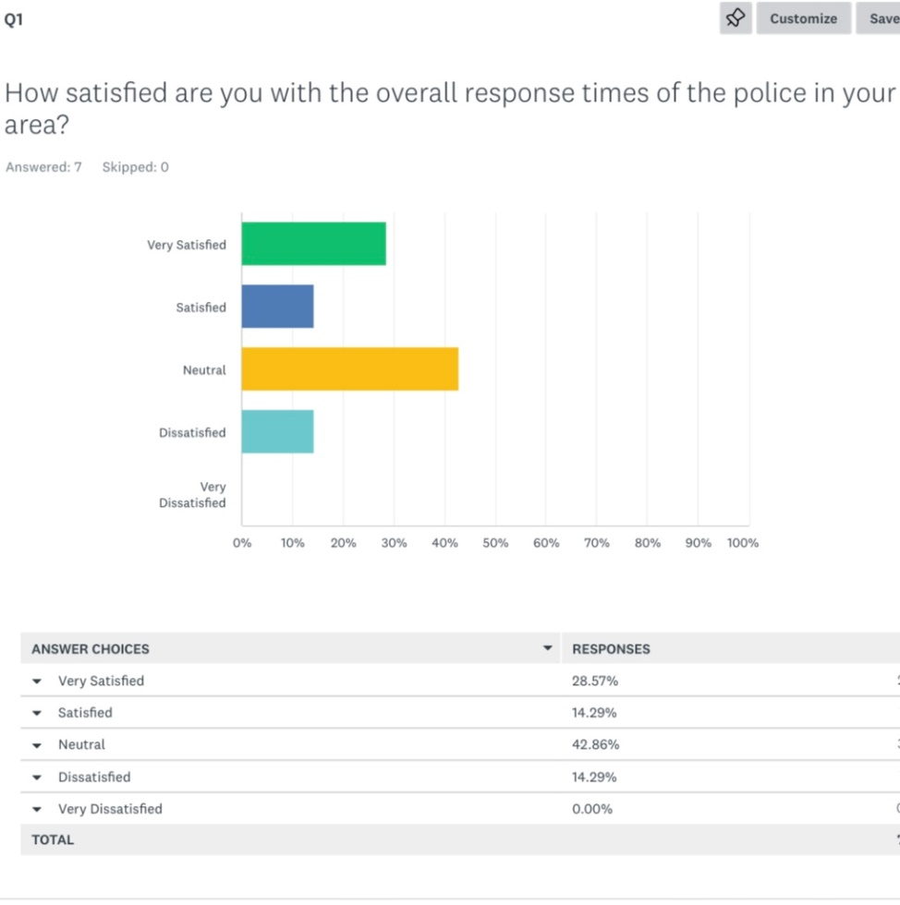

Question 2 survey:
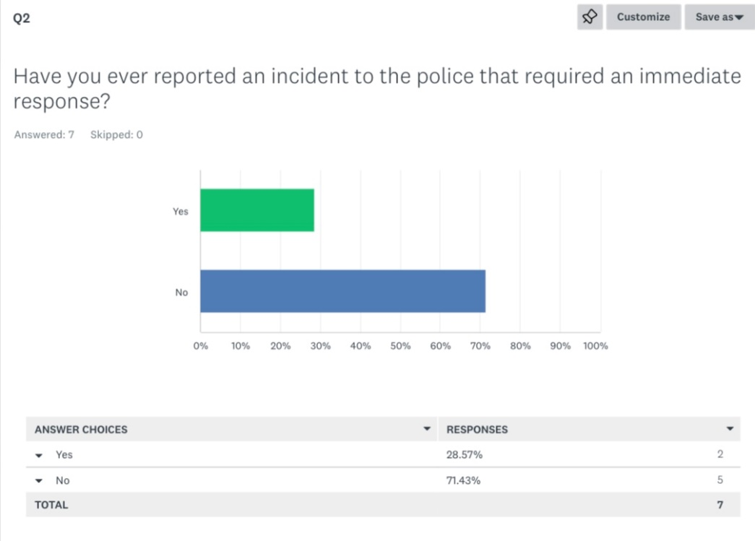
Question 3 survey:
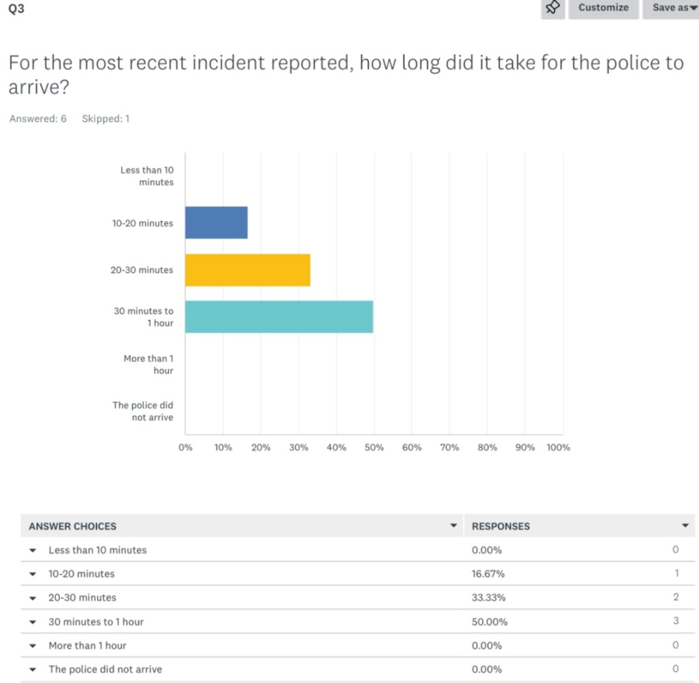

Question 4 survey:
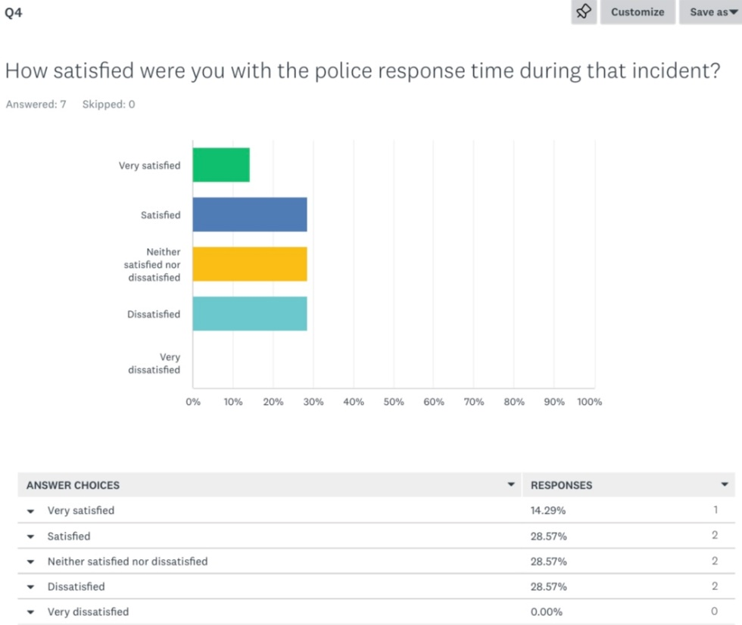

Question 5 survey:
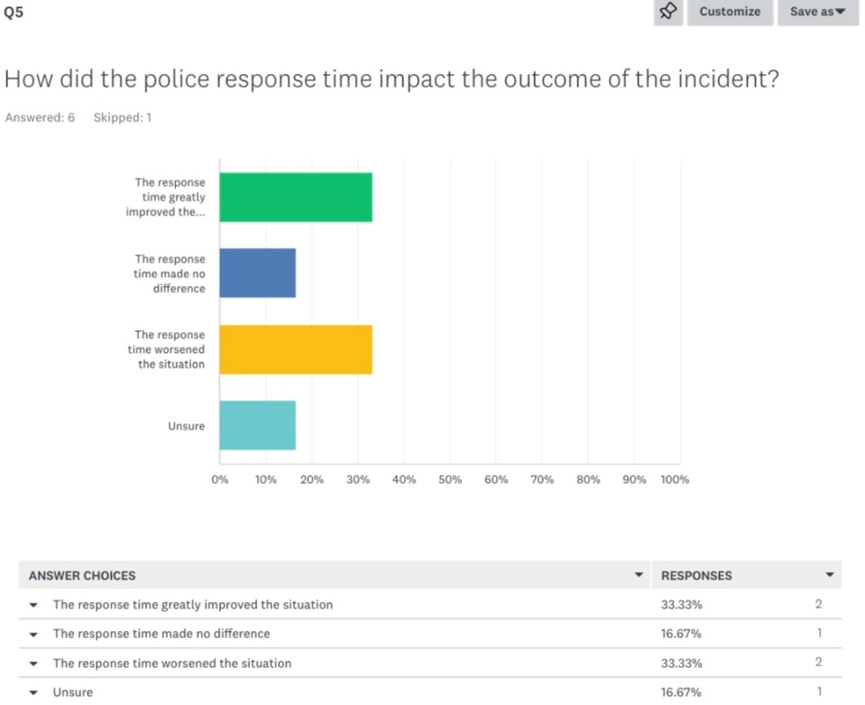

Question 6 survey:
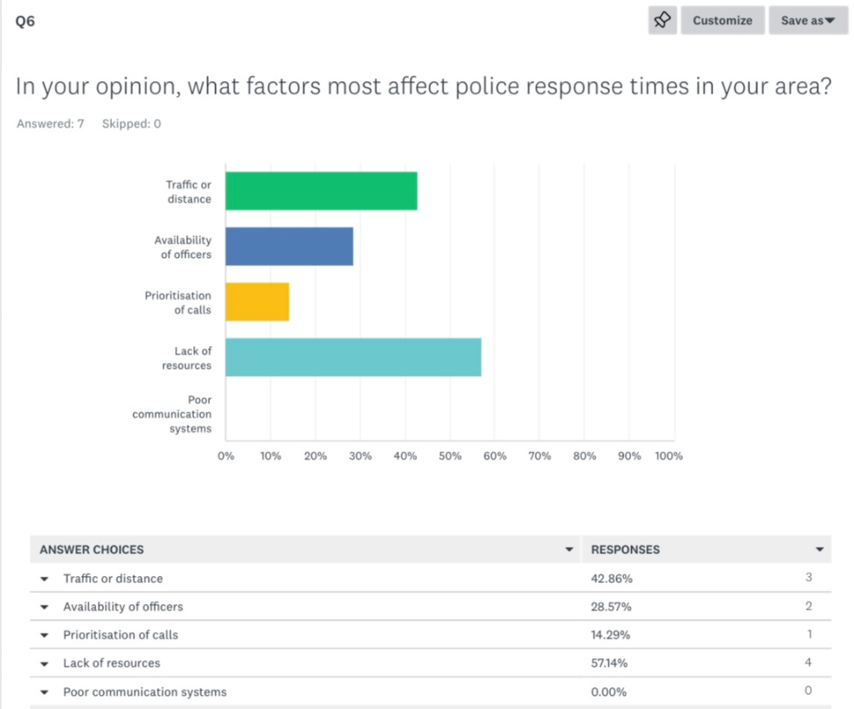

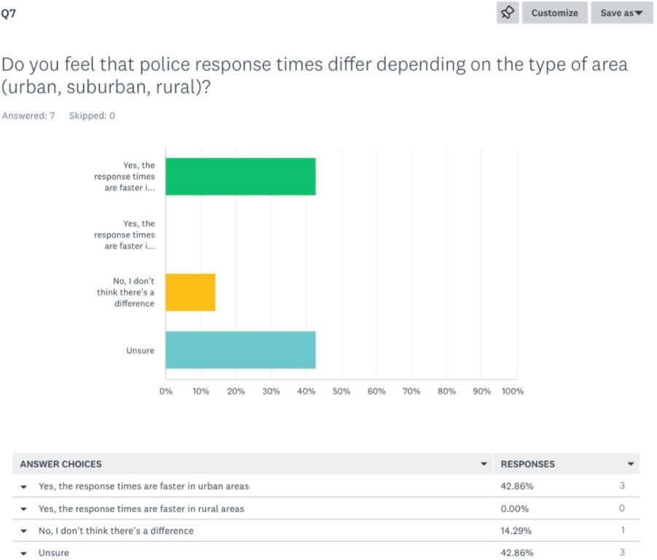
Question 7 survey:

Question 8 survey:
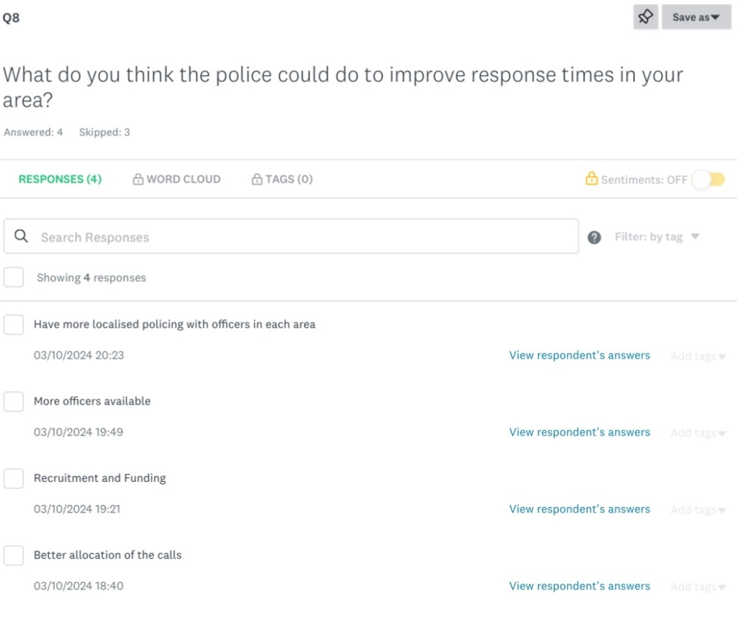
Question 9 survey:


