Sophie Phillips (2003475)
Assignment Two – ECGE5002P/C
REflective Account on Personal Development Module

Introduction
For my reflective account I will be critically reflecting my experience within this module and discussing the skills that I have gained and developed upon during this module on personal development. My expectation and initial thoughts about this module before starting were that this module was going to contain useful resources and skills that we can used and develop upon to strengthen our employability skills. I felt slightly prepared for this module due to already having some pass learning experience with similar aspects of this course and already having various resources already completed previously, such as a CV, due to already being employed. However, I was aware that I have many areas in my employability skills that need development on. Another initial thought about this module was, having hands-on experience out in the working world and seeing what skills employers are looking for the most.

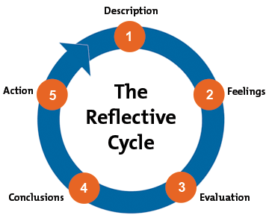
Throughout this reflective account I will use Gibb’s reflective method. This method was first published in 1988 by Graham Gibbs. (Mindtools, 2022). Gibbs Reflective Cycle is shown in Figure 1. This cycle works in steps, which are: 1. Description, 2. Feelings, 3. Evaluation, 4. Conclusions, 5. Action. (Mindtools, 2022) To reflect on my experience during the module I will be using these five steps to support my writing during this reflective account.

By using this model, I can explore the situations I was in and fully reflect on thoughts, feelings, and actions. Through this I can make sense of what did and didn’t work well and will be able to learn from that experience. This module has helpful guidance questions to help with the reflection process, however, not all these questions will be useful in certain experiences, this means that these questions don’t need to be answered. (Oxford Brookes University, 2013)
Figure 1 From (Oxford Brookes University, 2013)

Reflective Account
One of the first challenge that I faced in this module was having to talk about myself and pick out my strengths and weaknesses, to be able to complete assignment one. Also having to talk about myself and what skills I have to other individuals in my class. This was a big barrier for me to overcome as these actions cause me to feel self-doubt and anxiety. However, through this challenge I was able to create a list of skills that I class as my strengths and skills that I need to develop upon for me to refer to while I was working on my first assessment for this module. Through this challenge I developed skills to use for when I struggle to assess myself. Also developed on my communication skills with my peers, being able to talk to about myself.
Another challenge that I faced throughout this module was doing an activity that was set during class which was “speed-dating”, with a twist we had a minute to tell the other person in the class what our strengths are and what skill we had. I found this difficult as I’m a nervous person around people I have never meet, however, having the class session online it allowed me to be slightly more confident in talking to my peers I got to talk to. During this activity I feel that it went well as I was able to tell others what my strengths are, along with learning about other strengths. However, one part that didn’t go well was noting skills that I wanted to develop upon, another area was that one person that I was paired with did not finish their strengths and weaknesses. I learnt that there are more skills that can be effectful and useful for my choice of profession, such as behaviour management strategies and methods or British Sign Language (BSL) that I can develop upon. These will effectually strengthen my employability skills.
An area I feel that went well and succeeded in completed, was completing my professional cv and personal development plan (PDP) for my assignment. For the first assessment I need to create a Professional CV and PDP for part one of this assessment. I feel that this went well as I looked at other professional CV’s and PDP for guidance on how to present these types of information. While creating these pieces of work I felt confident, as from the class sessions I had already created a list of skills that I could confidently use in my CV and a list on skills that I need to improve on that I could put in my PDP, I was prepared and organised for this part of the assignment. Through creating these pieces of writing I learnt how to create and present a professional CV that will help me through my professional career. With this I can now add any new skills or educational achievement, regularly updating my CV means that anytime a career role that a feel I am suitable for I can use this resource to support the application. Through this task I learnt …
An area that I struggled the most with was the E-learning. I struggled to find the time to go through all areas of the e-learning, which led to me skipping to areas that was useful in supporting me through my assessment writing. The online learning resources did feel like to much information at one time. However, if I organised my time effectively, the information might have not felt overwhelming. I now feel that I should have gone through all aspects of the online learning resources, as they are there to support us and give us the skills to complete our writing for this module. Through this reflection I have learnt that I need to develop more on my time management and my organisation skills when it comes to go through the e-learning units.
One part of the e-learning I struggled the most with was within unit four which was the Zander Letter, I struggled to understand the concepted of creating a zander letter. To overcome this, I read through the e-learning a few times and done some research to help me understand the zander letter before creating one for my assessment. During writing the zander letter for the assessment I felt a bit more confident as I understood what I needed to write about after using my research skills. I feel that my first draft of my zander letter that I completed on the online learning was a little unorganised. However, that first draft supported my writing the second time, this time I organised the letter into sections that I wanted to talk about, which means that it had structure within the letter. This made me feel a lot more confident with the rest of my writing, as I later learned that if the first draft fails or is a mess, I can learn from that mistake and start again. This can be supported by Gibb’s reflective method, his method of reflection works around learning from past experiences (Oxford Brookes University, 2013)
If I was to redo this module I would interact with the e-learning and class session a lot more, I feel that if I interacted with my lecture and peers during taught sessions, I would have felt a lot more confident about my personal development, where I need to improve upon and where I could us my already developed skills to support others in there learning and personal development. Also feel that if I had completed more sections of the e-learning that I would have develop upon skills like professional writing and how to present myself through my writing.
Also, if I was to change anything if I was to redo this module, I would use the skills I learnt about within this module and modules I’ve completed before, to support me during this module and thought the assignments. A skill I could have used is transferable skills, these are a range of skills that give the individual self-awareness and communication skill to be able to work independently or with a group to work through any problem solving. Transferable skills are very important for practitioners to be able to use as it “Contributes to your success and success of a team” (May, 2021). Being able to work within a team is also a vital skill that a practitioner would need to have, this module has helped me develop upon this and I know that I need to develop more upon it. As during group tasks, I didn’t fully interact with, I completed the task but struggled to communicate my findings.

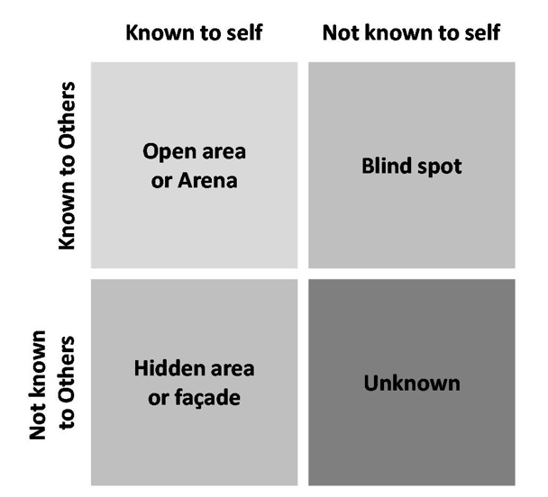
Throughout this module I have develop upon various skills and employability skills and knowledge that will become useful when I eventually finish my university course and start looking for careers, I will have the skills and knowledge on how to create different resources to support my application such as cover letters and cv’s that look professional and have the correct information. Without this module, skills like creating employability resources, awareness of own strengths and weakness that I would have had to learn by myself through trial and error and learning from mistakes.
This module has helped me discover skills I didn’t know I had by using the Johari Window model. This model is used to “Improve self-awareness and personal development” (Communication Theory, 2013), this can be used by yourself and in a group. It is made up of four parts looking like a window (Shown in Figure 2). The left panels are self-recognition, and the left side represents unknown areas of yourself. This model has helped me to recognise that I have many skills that I was unaware of that I can now develop more upon. This model can be used in many different ways to help support individuals on their personal development. However, to be able to use this model effectively the individual needs to know about any skills that they have, which other can be but they can not. That means that this model is only fully effective when used in groups.
Figure 2 From (Communication Theory, 2013)

Conclusion
Overall, this module has given me the opportunities to develop on various skills to improve my overall employability skill. This module has given me skills to improve upon along with resources that I can take with me after university to use in my professional and personal development. Gibb’s reflective cycle has supported me throughout writing my reflective account about this module, it has help give structure to the reflective process. The cycle has also help me understand experience in a different perspective which is another skill I need to develop on, which is seeing things in other perspectives and seeing the whole picture. This module has given me the knowledge of different models of reflection that I will now be able to use throughout the rest of my academic study to help me develop on my skills and develop personally.

References
Carson, L., 2018. How to become a more confident writer. [Online]
Available at: https://writingcooperative.com/how-to-become-a-more-confident-writer-f8b71c903c31
[Accessed 03 04 2022].
Communication Theory, 2013. The Johari Window Model. [Online]
Available at: https://www.niagarainstitute.com/blog/what-are-transferable-skills
[Accessed 04 04 2022].
May, E., 2021. TRANSFERABLE SKILLS AND WHY ARE THEY IMPORTANT?. [Online]
Available at: https://www.niagarainstitute.com/blog/what-are-transferable-skills
[Accessed 04 04 2022].
Mindtools, 2022. Gibbs' Reflective Cycle Helping People Learn From Experience. [Online]
Available at: https://www.mindtools.com/pages/article/reflective-cycle.htm
[Accessed 03 04 2022].
Oxford Brookes University, 2013. Learning By Doing by Graham Gibbs. 1st ed. Oxford: Oxford University.

