Katie L Pullen-O’Brien
HPHI 5902. – Britain & The First World War

Portfolio Part 1 –
Book Review or Journal Article, step-by-step analysis.

For my analysis, I have chosen to examine "White Feathers and Wounded Men: Female Patriotism and the Memory of the Great War" by Nicoletta F. Gullace. Although I was unfamiliar with the author or her work before reading this journal, I am keen to explore more of her writing.
Meet Nicoletta F. Gullace an esteemed author and a renowned professor of modern British and European cultural history. She is a public historian, currently affiliated with the history department of the University of New Hampshire in the United States. With an exceptional career spanning nearly 30 years, Gullace has authored numerous journal publications, primarily focusing on the First World War. Her book, The Blood of Our Sons: Men, Women and the Renegotiation of British Citizenship During the Great War, is also highly acclaimed.
Gullace was awarded the 2022 Excellent in Teaching award by the University of New Hampshire for her exceptional teaching standards and engaging approach.
In her journal "White Feathers and Wounded Men: Female Patriotism and the Memory of the Great War," Gullace explores the complex relationship between gender, nationality and how the Great War is remembered. As a feminist historian, Gullace skilfully navigates through various sources, including archives, literature, and cultural artefacts, to reveal women's complex and nuanced role in shaping the shared memory of wartime experiences.
Throughout Gullace’s journal she highlights in the first paragraph the fact that shortly after the United Kingdom declared war on Germany in August 1914, a prominent military figure encouraged women from Folkestone, a port town close to France, to distribute white feathers to men, not in uniform to remind them to enlist. Starting the journal this way is interesting as it shows how women's power started and continued to be influential throughout the war. I found the sources she included to support her argument quite intriguing. They made the journal more relatable and helped readers understand the subject better.
Gullace included the focus on the practice of women giving out white feathers to soldiers in civilian clothes or even veterans. I found this interesting with the evidence she included and referenced, as women were expected to target any man out of uniform regardless of how they presented themselves. On one occasion, as evidenced in Gullace's journal, one of these women presented a white feather, the 'emblem of cowardice' to a young soldier on leave who had just been awarded the Victoria Cross. During another instance, Gullace mentions a man who has been medically discharged. One day, while waiting for a train, the man is targeted by a woman who does not see his artificial leg and presents him with a white feather due to him not being in a uniform. However, as soon as the man discloses his disability to her, she walks away and does not apologise. Gullace makes a valid point by stating that during the First World War, women believed wearing a uniform symbolised manhood. I strongly agree with this; however, times have changed, and women now wear uniforms and serve in the armed forces. It is worth noting that the members of the Women’s Army Auxiliary Corps (WAAC), who were later known as the Queen Mary's Army Auxiliary Corps, played a significant role during the First World War in providing support services such as cooking, clerical work, and other non-combat duties. Their contributions were critical to the overall war effort, and their service paved the way for future generations of women to serve in the military. Understandably, men were the only ones able to physically fight the Germans during that time. It is highly likely that a significant number of women have harboured feelings of resentment towards men who were not in uniform and may have even singled them out, particularly if they have friends or family members serving in the military.
You would think women of this time would ask the gentleman if they were serving and then follow up with the serving of a white feather; however, this does not seem to be the case. This shows that women can be easily influenced by authority but primarily by men, which still occurs today in modern-day society. The evidence implies that the government may have utilised a tactic involving the presentation of white feathers to encourage men to enlist for conscription. According to Gullace, famous Sherlock Holmes writer Arthur Conan Doyle even urged women to 'shun' men who are out of uniform, to show their contentment for the unlisted, and to hand out white feathers to men wearing civilian clothes. This approach appeared to have the effect of humbling the men's egos and making them sign up for military service.
An additional example from Gullace's research supports the notion that men in positions of power significantly impact women, as evidenced by the government and other authorities utilising women at the forefront of their efforts to enlist men in the fight. This particular quote was featured on a recruitment poster commissioned by the Duke of Bedford. "MOTHERS!" and "SWEETHEARTS" reminded mothers of Belgian atrocities and warned sweethearts, "If you cannot persuade him to answer his Country's Call and protect you now, Discharge him as unfit!"
The government and authorities' requests imply a woman's patriotic duty to encourage men in their lives or anyone else to sign up for the fight. Gullace's research further highlights this as women actively fulfilled their duty by recruiting more men. It is noteworthy that Gullace's research includes a meticulously crafted annotated bibliography that significantly enhances the reader's understanding of her references to specific sources. This feature of her work powerfully encourages readers to delve deeper into the topic. One notable example that caught my attention can be found on page 205, under reference number 91. In this passage, Gallace delves into the significance of white feather stories during wartime, particularly the employment of white feathers by pacifist Sylvia Pankhurst. Pankhurst attributed the distribution of these feathers to members of the Women's Social and Political Union (WSPU) throughout the war. Furthermore, Gallace provides additional insight in this footnote by revealing that Pankhurst's pro-war opponents and relatives, Emmeline and Christabel Pankhurst, were the ones in charge of running the WSPU.
Throughout Gullace's journal, she examines one of the most complex gestures of how the war and patriotism implicated women in raising armies while providing veterans with a concise, pompous trope to remember gendered patriotism during the Great War.
I found Gullace's journal to be a fascinating read and am eager to explore her other works. The journal provides valuable insight into the government's efforts to conscript men into military service and women's significant role in shaping men's opinions during this era. Additionally, her annotated bibliography was informative, enhancing my understanding of the sources she included in her journal and providing additional avenues for further research.

Bibliography

Dugdale Weir, Elizabeth Ruth, Dame Christabel Pankhurst 1880-1958, (2011)
<https://www.npg.org.uk/whatson/display/2014/suffragettes-deeds-not-words/dame-christabel-pankhurst-1880-1958> [accessed 3 May 2024]

Gullace, Nicoletta F., The Blood of Our Sons: Men, Women and the Renegotiation of British Citizenship
During the Great War, (New York: St Martin's/Palgrave Macmillan, 2002)

Gullace, Nicoletta F., "White Feathers and Wounded Men: Female Patriotism and the Memory of the Great War",
Journal of British Studies, 36.2, Twentieth-Century British Studies, 1997), p.178-206 <https://www.jstor.org/stable/176011> [accessed 5 April 2024]

National Army Museum, Queen Mary's Army Auxiliary Corps, (2024)
<https://www.nam.ac.uk/explore/queen-marys-army-auxiliary-corps> [accessed 03 May 2024]

Pankhurst, Sylvia, About, (2024)
<https://www.sylviapankhurst.com/about> [accessed 3 May 2024]

UK Parliament 2024, Women's suffrage campaigners: Emmeline Pankhurst,
(2024) <https://www.parliament.uk/about/living-heritage/transformingsociety/electionsvoting/womenvote/parliamentary-collections/speakers-conference/emmeline-pankhurst/> [accessed 3 May 2024]

University of New Hampshire, Nicoletta Gullace,
(2024) <https://cola.unh.edu/person/nicoletta-gullace> [accessed 5 April 2024]

University of New Hampshire, Nicoletta Gullace,
(2022) <https://www.unh.edu/awards/resource/nicoletta-gullace#:~:text=Gullace%20is%20a%20scholar%20of,also%20brings%20to%20her%20classrooms> [accessed 5 April 2024]

Wallace, Eleanor, Suffragette Outrages – The Women's Social and Political Union WSPU,
(2022) <https://www.historic- uk.com/HistoryUK/HistoryofBritain/Suffragette-Outrages-WSPU/> [accessed 3 May 2024]

Katie L Pullen-O’Brien
HPHI 5902. – Britain & The First World War

Portfolio Part 2 –
Document Report, step-by-step analysis.

Trench newspapers, otherwise known as "soldiers' newspapers," "unit magazines," "trench journals," or "field publications," were created and shared among soldiers due to the absence of the internet, radio, or television. The Listening Post is a comical trench newspaper first published on 10 August 1915. It was written and edited by soldiers for soldiers and ran throughout the First World War.
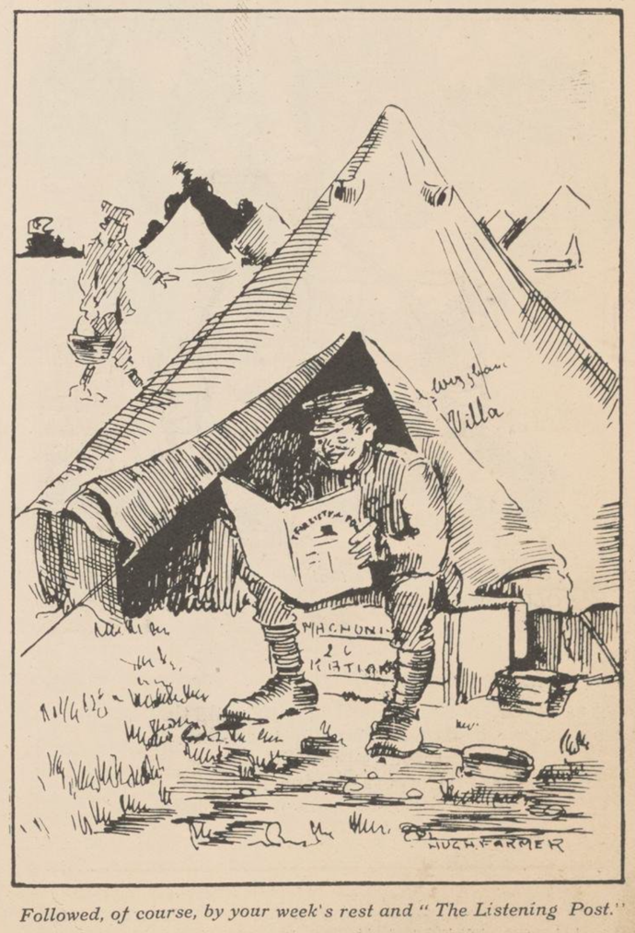
During the First World War, soldiers from both the Allied and Axis forces resorted to seeking news from one another, which led to the publication of newspapers by some military units. This practice was an attempt to bridge the gap between opposing forces and to provide soldiers with valuable information about the war. It also highlights the importance of communication and the human desire for connection, even in conflict.
For example, Canadian soldiers published over 30 different trench newspapers, according to the records of the Canadian War Museum. However, only a handful of copies of these newspapers have survived to date. The existence of these newspapers highlights the importance of journalism in wartime and provides valuable insight into the experiences and perspectives of Allied soldiers during the conflict.
This newspaper was created by Canadian troops serving in the British Expeditionary Force stationed in France. The format contains informative content and hand-drawn war-related cartoons. The soldiers who crafted these publications put a great deal of care and attention into the design, intending to combat the repeating dull nature of trench warfare and boost the morale of their fellow soldiers. These newspapers were likely written and created near the front line.
The concept behind the newspaper's name, 'The Listening Post,' is fascinating and creative. In times of war, listening posts were covert bunkers used by soldiers to monitor enemy activity and gather intelligence. Soldiers on listening post duty were expected to pass on information, and similarly, the newspaper(s) would be shared and discussed amongst themselves. The newspaper may set the idea that individuals have been unconsciously training for listening post-duty throughout their careers.
Figure 1- Soldier taking a break & reading The Listening post
After analysing the text, it is evident that the newspaper can offer readers a striking portrayal of the experiences had by individuals on the front line, particularly in the days leading up to Christmas. Receiving a copy of such a newspaper would have sparked a sense of excitement among individuals, given the crucial role that printed media played in providing comfort and a link to normality.
The newspapers available to soldiers are essential tools that provide amusement and a detailed guide to operational processes. They encompass everything from ranks to the crucial specifics of going over the top. They significantly contribute to soldiers' psychological well-being and are a valuable source of information and support.
When reading this issue of the Listening Post, I noticed that the editors skilfully incorporated black humour into their imagery and content. This type of humour, also called dark humour, centres around sensitive and controversial topics and often involves finding humour in difficult and challenging situations such as death, tragedy, and illness, which many soldiers would’ve experienced. While some may find it offensive or inappropriate, black humour has become increasingly popular in modern media, including literature, films, and television shows. The role of black humour in boosting morale among soldiers on the front line has been a topic of interest among scholars and historians. It is believed that the jokes and negative commentary about situations helped soldiers bond and cope with their challenges. It provided a break from their daily routine's monotonous and repetitive nature. The anticipation of receiving news from outside the trenches and the opportunity to break from the harsh realities of war made the newspaper a valuable commodity for soldiers. Black humour remains a subject of controversy regarding its cultural significance and appropriateness. As these newspapers were written by soldiers for soldiers, they would have played a crucial role in providing soldiers with a platform to discuss sensitive topics openly.
Throughout my research, I have discovered that this type of humour, particularly imagery, has been prevalent in newspapers, magazines, postcards, and even propaganda. It is interesting to see how societal norms and values have evolved over time.
Looking at Figure 2, which I have included below, it's clear that it was once acceptable to publish such content in newspapers or written publications. However, in today's world, such content would not meet the standards of most publications and would be incredibly controversial.

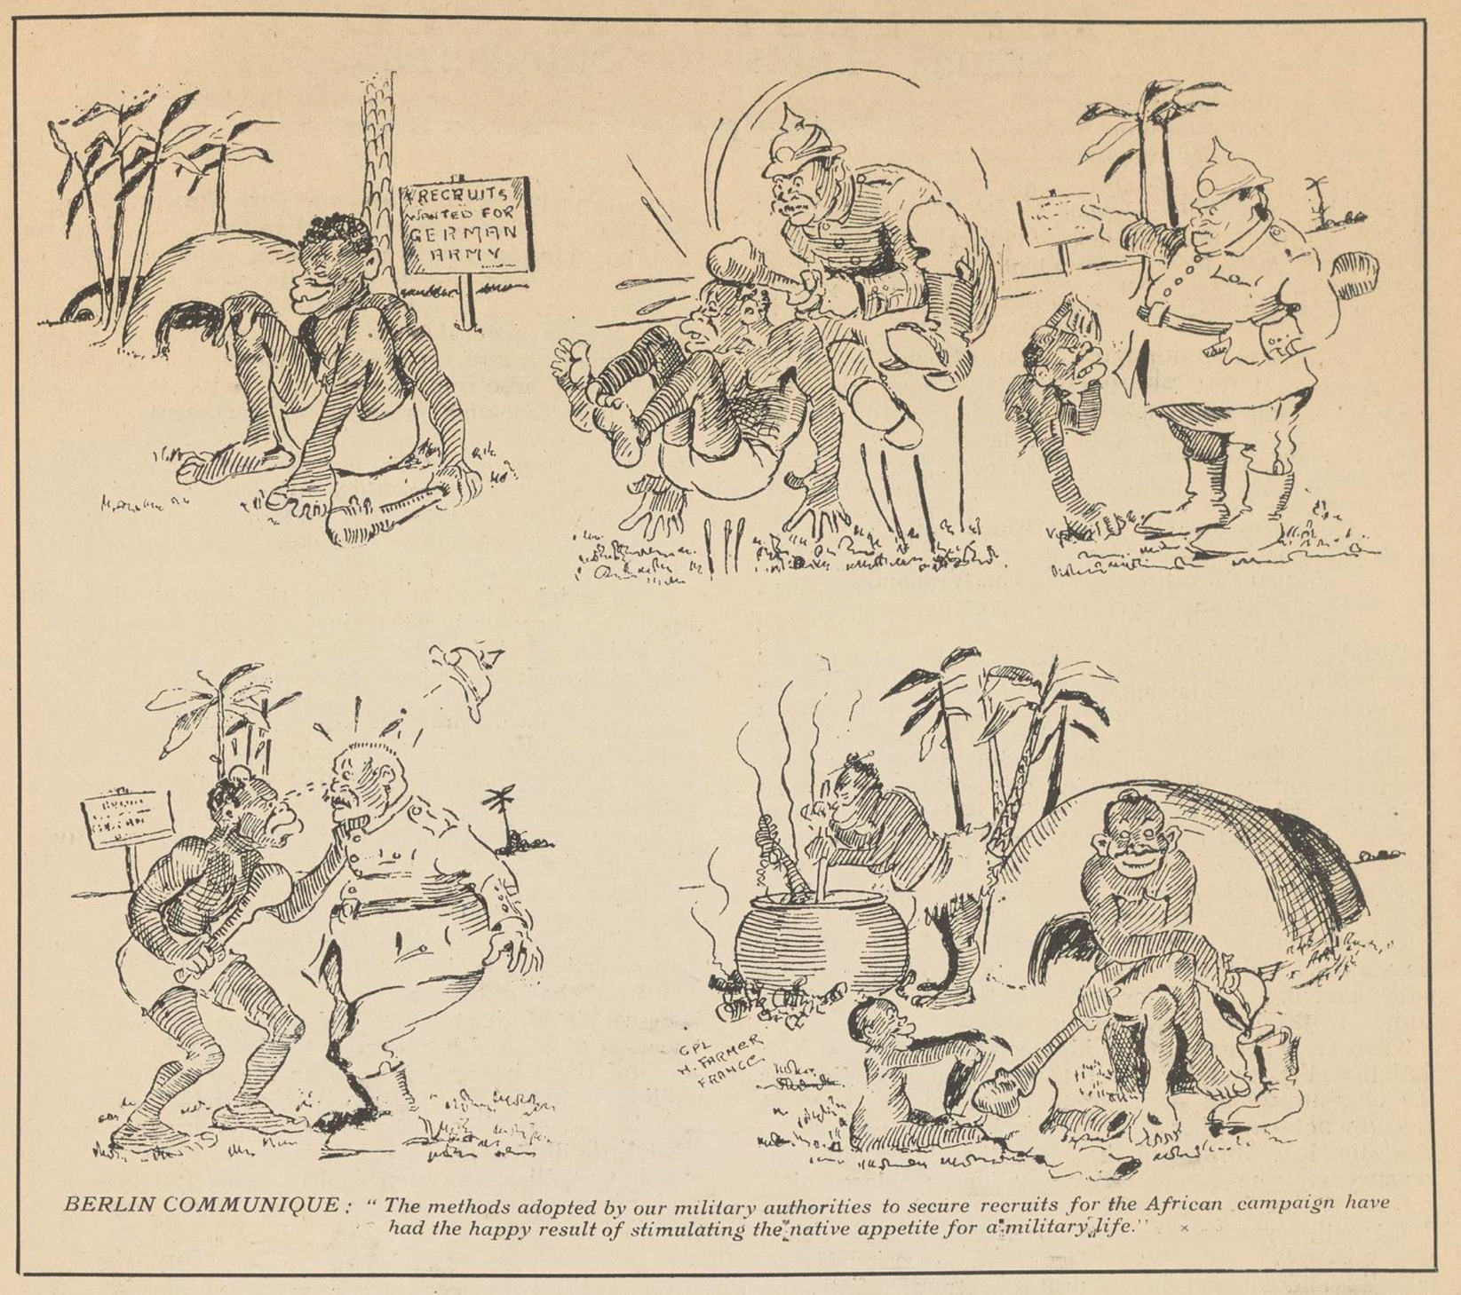
Figure 2 - Taken From The Listening Post p.g.35 referencing dark humour regarding how the Germans gained African recruits.

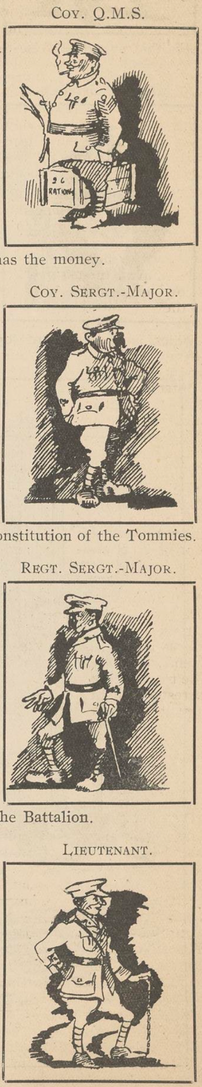
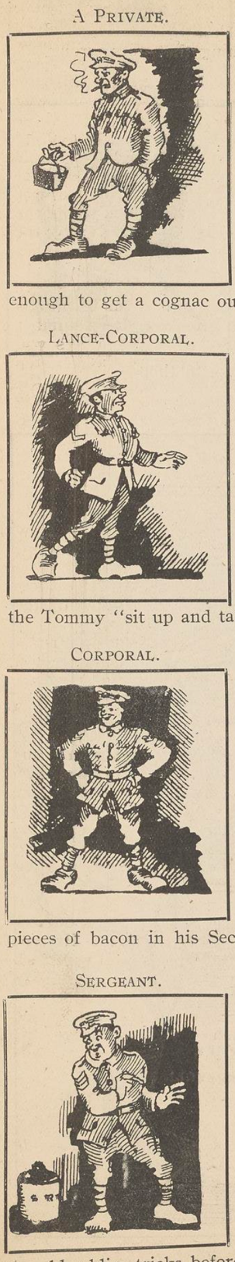
The article has hand-drawn illustrations that enhance its authenticity. These images are excellent illustrations of how visual aids can effectively convey the rank structure to readers clearly and distinctively. For these examples, please refer to pages 19 and 20 and see Figures 3 and 4 to your right.
The publications in question offer highly detailed images and content, rendering them indispensable resources for those wishing to broaden their understanding of soldier life and moral and operational protocols. These materials are of great value to scholars and researchers in military studies.
Integrating operational procedures into a newspaper is a fascinating decision I was not expecting. This innovative implementation is an unusual but effective means of sharing information among soldiers and officers. It highlights the importance of effective communication channels in military operations and underscores the need for creative approaches to disseminating critical information. Further research into the impact of such integration on operational outcomes could yield valuable insights and inform future military practices.
The Defence of the Realm Act (DORA) was enacted on 8 August 1914 in the United Kingdom during the First World War. This law granted the government extensive authority to regulate ports, limit mobility, requisition buildings and, most importantly, censor information. Its purpose was to provide the government with the necessary tools to secure victory in the war and safeguard the nation from external dangers. The Act was repealed in 1920, following the conclusion of the war.
DORA significantly impacted trench newspapers. The government had the power to censor any publication they deemed a threat to national security, which meant that many trench newspapers had to submit their content to be censored before publication. The censors removed any content they deemed critical of the war effort or could demoralise soldiers. Superior officers would likely do this as they were already going through the personal letters soldiers wrote to their families and friends back home in Britain. They would then cross out any information that could reveal their location or other secrets if it fell into German hands. The aim was to ensure that the letters did not inadvertently give away any critical information that could jeopardise the safety of the soldiers and their allies.
Figure 3 & 4 - Rank Structure in the Listening Post referencing webster's dictionary. p.g.19
This led to many trench magazines self-censoring and avoiding controversial topics, resulting in a need for more diversity in content. The top of the front cover of The Listening Post reveals that the publication went through a process of censorship. Despite potential restrictions, the magazine continued to play a crucial role in boosting morale among soldiers. Notably, the cover indicates the name of the censor responsible for this Act. After reviewing it, I am surprised that it passed censorship. If The Listening Post got into the hands of the Germans, it could reveal specific information, secrets or plans.
Researching the number of trench newspapers and magazines that existed during the war would provide valuable insights into how soldiers communicated with one another and how they received information. Understanding the scope and reach of these publications would shed light on the experiences of soldiers on the front lines and their efforts to stay informed and connected. This topic could be explored through various methods, including archival research, pre-recorded interviews with veterans, and analysis of surviving publications. Further research could contribute to a deeper understanding of the social and cultural dynamics of the war and its impact on those who fought in it.
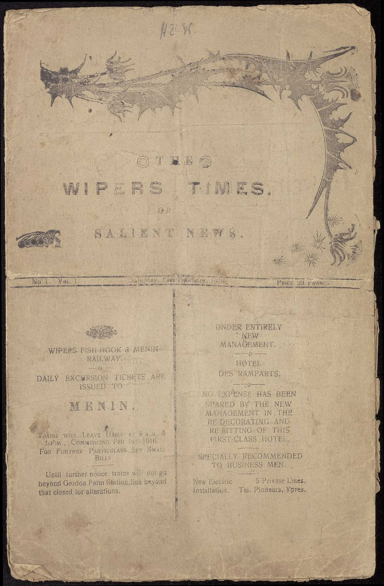
Another famous newspaper of the time was the Wipers Times. The Wipers Times was named after Tommy, slang for Ypres, Belgium. The Wipers Times embodies the essence of The Listening Post, with its well-informed articles, dark humour, and focus on the soldiers' perspective. However, in this instance, the publication is written by British soldiers from the 12th Battalion Sherwood Foresters (Nottinghamshire and Derby Regiment) of the 24th Division.
The Wipers Times was created when the 12th Battalion, stationed on the front line at Ypres, stumbled upon an abandoned printing press. Thanks to an officer's civilian knowledge and resourcefulness, they were able to take control of the situation and start the printing process.
The publication ran successfully for 23 issues from 12 February 1916 until shortly after the war ended. Twelve years after the war's end, a special edition featuring a foreword by the former editor, Fred Roberts, was later released. However, no further publications were released after that.
The Wipers Times gained immense popularity among the soldiers during the war and was later adapted into a comical and engaging war film by the British Broadcasting Corporation in 2013.
Figure 4 - 1st edition of the wipers times

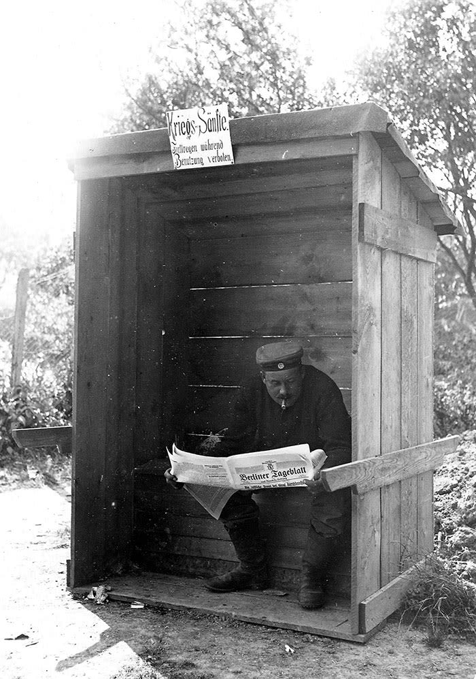
During my research, I recently found an intriguing image depicting German soldiers sitting in what looks like a toilet or seated area, engrossed in reading their trench newspaper. This photo provides a fascinating glimpse into the daily life of German soldiers during this time and invites us to contemplate how soldiers across different armies and nationalities may have experienced similar routines and habits. It is easy to imagine soldiers from other countries engaging in similar activities as they sought to pass the time and stay informed about the latest news and developments from the front lines. Figure 1 supports this, as the illustration shows a soldier taking a break from fighting and reading The Listening Post.

In conclusion, the trench newspapers of the First World War were not just a means of entertainment but also served as an essential tool for educating soldiers and boosting their morale. Their carefully curated content played a crucial role in keeping the spirits of the soldiers high during a time of great adversity. The impact of these newspapers on the well-being of soldiers and officers who had access to them cannot be overstated. It is a testament to the power of the written word in providing comfort and hope to those facing difficult circumstances.
Figure 6 - German soldier reading a trench newspaper on the toilet

Bibliography
Andy De Emmony (dir.) The Wipers Times,
[Film], (London: British Broadcasting Company)

Canadian War Museum, Trench Newspapers,
(2024) <https://www.warmuseum.ca/firstworldwar/history/life-at-the-front/trench-culture/trench-newspapers/> [accessed 12 March 2024]

Norco College, Online Historical Newspapers: Trench Newspapers/ Journals - 1st World War,
(2023) <https://norcocollege.libguides.com/c.php?g=33030&p=209267> [accessed 4 March 2024]

The Listening Post, 10 August 1915
<https://www.canadiana.ca/view/oocihm.8_06774_1/1> [accessed 4 March 2024]

The Listening Post, 1 December 1917
<https://search.library.wisc.edu/digital/AFEVUDUZI7W5ON8U> [accessed 4 March 2024]

Tim Masters, World War One exhibition explores the role of black humour,
(2014) <https://www.bbc.co.uk/news/entertainment-arts-27905600> [accessed 12 April 2024]

UK Parliament, Defence of the Realm Act 1914,
(2024) <https://www.parliament.uk/about/living-heritage/transformingsociety/parliament-and-the-first-world-war/legislation-and-acts-of-war/defence-of-the-realm-act-1914/> [accessed 20 March 2024]

Figures

- The Listening Post, 1 December 2017, middle page (no number)
- The Listening Post, 1 December 2017, p.g.35
- The Listening Post, 1 December 2017, p.g.19
- The Listening Post, 1 December 2017, p.g.19
- The Wisper Times, 12 February 1916,
- Europeana (Collector), 'Max Kranz – Soldier’s everyday life' (1900s)
<www.europeana.eu/en/blog/reporting-from-the-trenches-newspapers-in-world-war-i> [accessed 2 May 2024]

Nicoletta F. Gullace, "White Feathers and Wounded Men: Female Patriotism and the Memory of the Great War", Journal of British Studies, 36.2, Twentieth-Century British Studies, 1997), p.178-206 <https://www.jstor.org/stable/176011> [accessed 5 April 2024].
University of New Hampshire, Nicoletta Gullace, (2024) <https://cola.unh.edu/person/nicoletta-gullace> [accessed 5 April 2024].
Nicoletta F. Gullace, The Blood of Our Sons: Men, Women and the Renegotiation of British Citizenship During the Great War, (New York: St Martin's/Palgrave Macmillan, 2002).
Gullace, "White Feathers and Wounded Men: Female Patriotism and the Memory of the Great War", p.200.
Gullace, "White Feathers and Wounded Men: Female Patriotism and the Memory of the Great War", p.201.
National Army Museum, Queen Mary's Army Auxiliary Corps, (2024) <https://www.nam.ac.uk/explore/queen-marys-army-auxiliary-corps> [accessed 03 May 2024].
Gullace, "White Feathers and Wounded Men: Female Patriotism and the Memory of the Great War", p.186
Gullace, "White Feathers and Wounded Men: Female Patriotism and the Memory of the Great War", p.184
Sylvia Pankhurst, About, (2024) <https://www.sylviapankhurst.com/about> [accessed 3 May 2024].
Eleanor Wallace, Suffragette Outrages – The Women's Social and Political Union WSPU, (2022) <https://www.historic- uk.com/HistoryUK/HistoryofBritain/Suffragette-Outrages-WSPU/> [accessed 3 May 2024].
UK Parliament 2024, Women's suffrage campaigners: Emmeline Pankhurst, (2024) <https://www.parliament.uk/about/living-heritage/transformingsociety/electionsvoting/womenvote/parliamentary-collections/speakers-conference/emmeline-pankhurst/> [accessed 3 May 2024].
Elizabeth Ruth Dugdale Weir, Dame Christabel Pankhurst 1880-1958, (2011) <https://www.npg.org.uk/whatson/display/2014/suffragettes-deeds-not-words/dame-christabel-pankhurst-1880-1958> [accessed 3 May 2024].
Nicoletta F. Gullace, "White Feathers and Wounded Men: Female Patriotism and the Memory of the Great War", p.182.
The Listening Post, 1 December 1917 <https://search.library.wisc.edu/digital/AFEVUDUZI7W5ON8U> [accessed 4 March 2024].
The Listening Post, 10 August 1915 (2024) (https://www.canadiana.ca/view/oocihm.8_06774_1/1> [accessed 4 March 2024].
Norco College, Online Historical Newspapers: Trench Newspapers/ Journals - 1st World War, (2023) <https://norcocollege.libguides.com/c.php?g=33030&p=209267> [accessed 4 March 2024].
Canadian War Museum, Trench Newspapers, (2024) <https://www.warmuseum.ca/firstworldwar/history/life-at-the-front/trench-culture/trench-newspapers/> [accessed 12 March 2024].
Tim Masters, World War One exhibition explores the role of black humour, (2014) <https://www.bbc.co.uk/news/entertainment-arts-27905600> [accessed 12 April 2024].
UK Parliament, Defence of the Realm Act 1914, (2024) <https://www.parliament.uk/about/living-heritage/transformingsociety/parliament-and-the-first-world-war/legislation-and-acts-of-war/defence-of-the-realm-act-1914/> [accessed 20 March 2024].
Andy De Emmony (dir.), The Wipers Times, [Film], (London: British Broadcasting Corporation).

