Down loading maps from DIGMAP

In the same way as we log onto UK Data service we can get maps from the additional site that we registered on at the beginning of the year i.e. DGIMAP

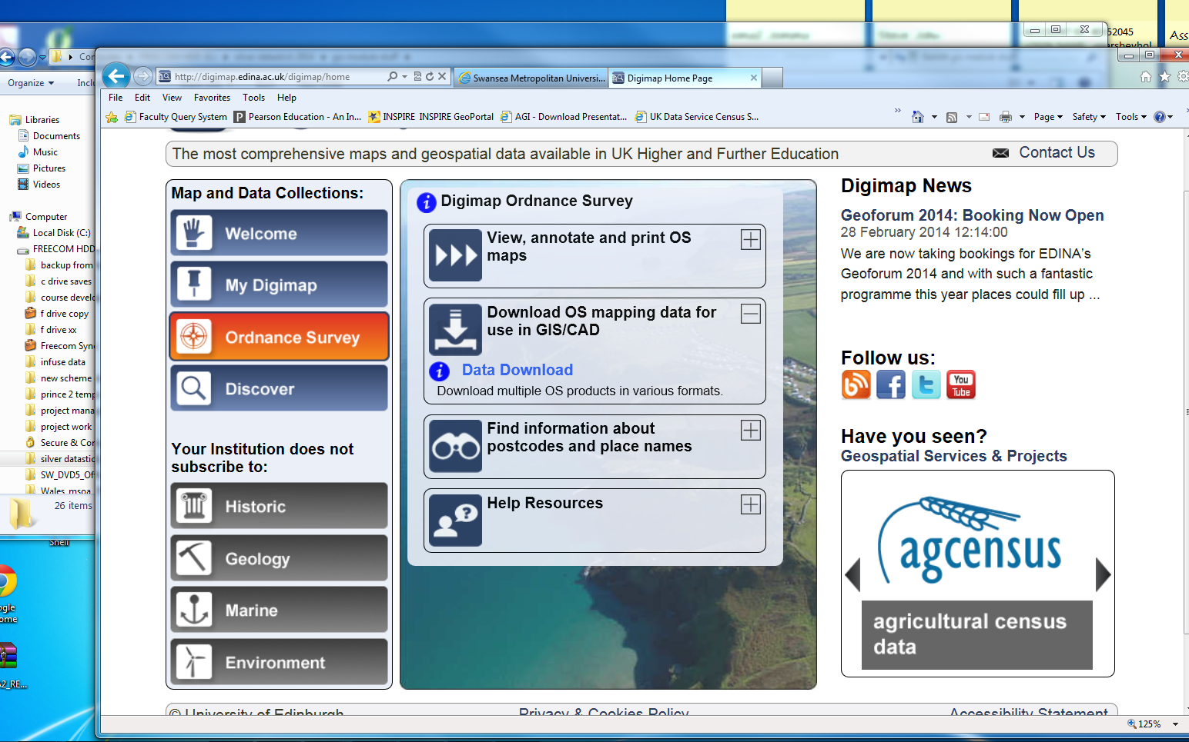

Several different formats are available. We will use OS mastermap as this provides us with detailed information of very small geographic area. Vector data and backdrop maps also provide far more detail than the boundary data layers that we have been using and this kind of data help toward building location based services.
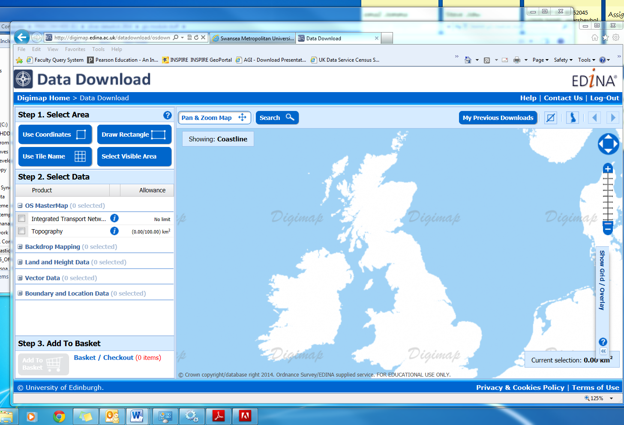

Try to download a digimap map set of your house/ old school and surrounding buildings to test out the procedures.
Try to zoom in on the UK map roughly in the area of your search or type in a postcode or grid reference into the search window.

For example SA1 6ED will provide use with the location of the university. Zoom in and out to capture more or less detail then draw a rectangle to capture the map data.
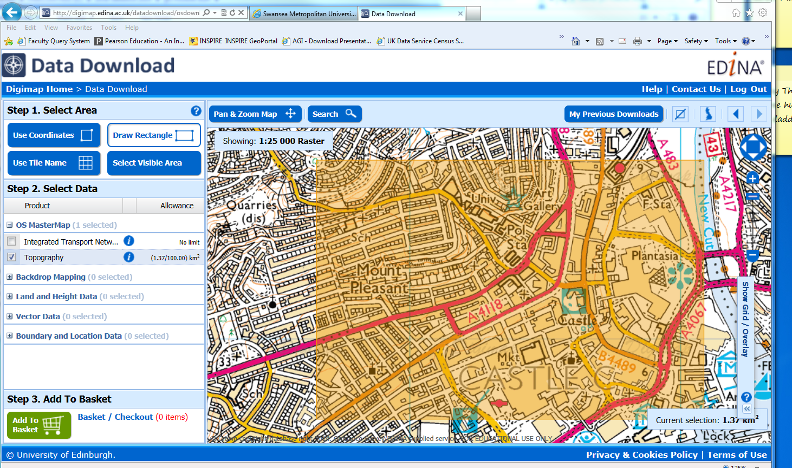
Add your selection the basket and give the download a name your collection will then be sent to your uni e-mail address. You will then need to click on the link to obtain the data. This can take 24 hours and it will only work on campus. The format of the file you receive will be in GML2 format. You will need to download a suitable package to unzip the file (7zip works well).

Once you have received your order you need to unzip to a GML file. You cannot directly load this into MapInfo you have to use Table > Import …. Remember to change the file type to GML
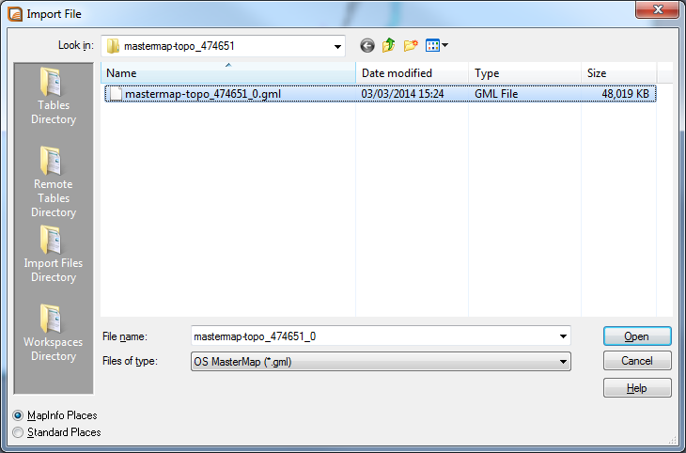

In true MapInfo style once this is complete it looks as if nothing has happened, You now need to open the tables from the file drop down you should see 7 files providing detailed topological layers of your chosen area.

Your data should look something like this :-

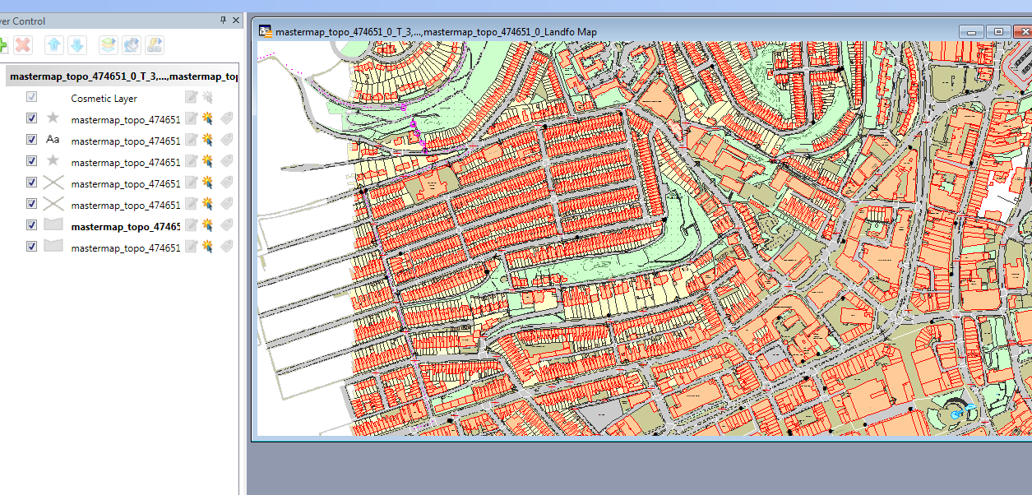

Vector Data

Because we have downloaded the data in vector format we are able to select any object on the map. All objects have attribute data that has been added at the time of the map creation by the ordnance survey. Have a look at the browser data. Again because we can select any object we can in effect manually build a query. Once we have our selected object we can add our own data. We have now created a new map layer ( .tab file).

