LEADERS AND MANAGERS
COURSEWORK: ESSAY

Programme: BA Business Management
Module: Leadership and management, theory, and practice
Module code: LCBB6003
Lecturer/Module Leader: Mushfiqur Rahman/Tanja Nathan

Student Name: Valeria Peeva
Student Number: 2029005


This Photo by Unknown Author is licensed under CC BY

Table of Contents
INTRODUCTION 3
“A MANAGER CAN BE A LEADER BUT A LEADER CANNOT BE A MANAGER” 3
PERSONAL AND EMPLOYABILITY SKILLS 5
1. Managing: 5
2. Leading: 6
3. Growth and Enhancement of Performance: 6
CONCLUSION 7
REFERENCES 7

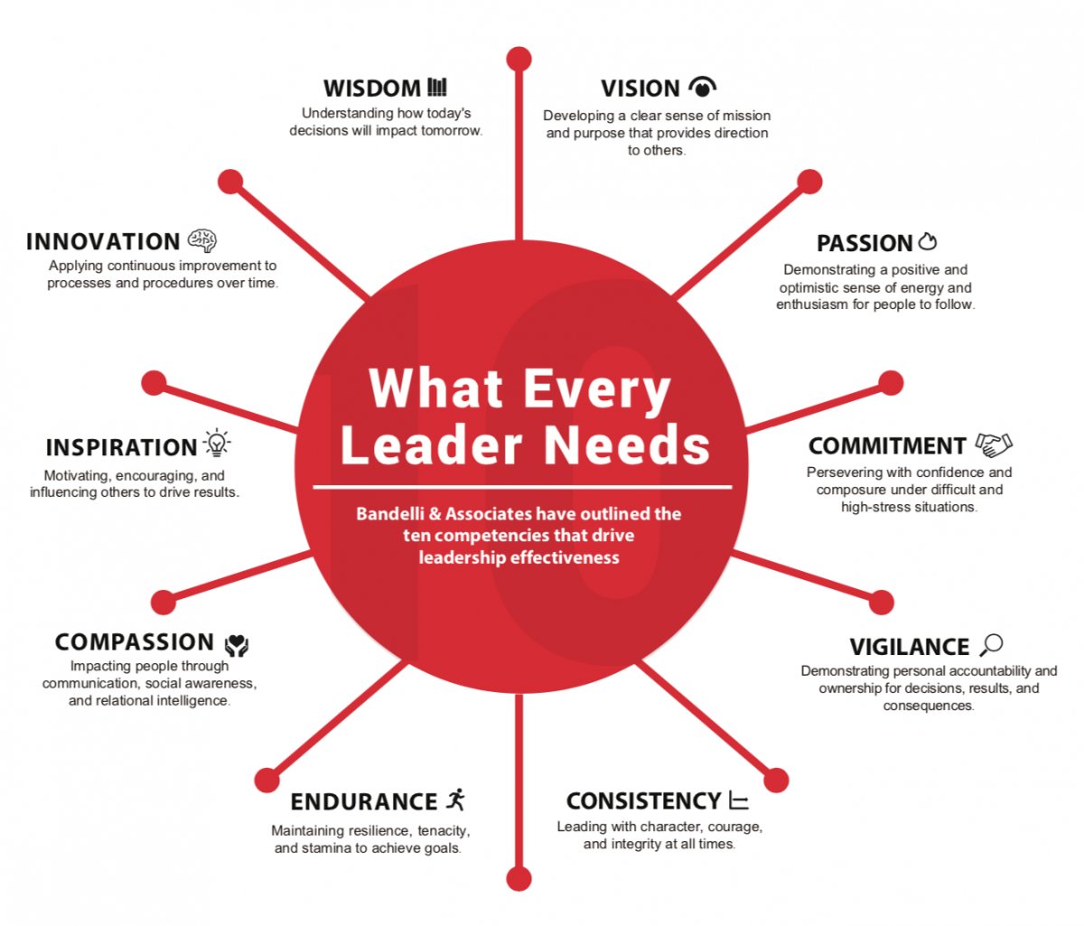
This Photo by Unknown Author is licensed under CC BY-SA

INTRODUCTION
It occurs critical to examine the differences between management and leadership while examining the claim that "A manager can be a leader, but a leader cannot be a manager." Although both jobs are essential to the success of a business, their approaches and areas of focus are different. Although the terms management and leadership are frequently used synonymously, they have distinct roles and requirements. This paper investigates the degree to which a manager might exhibit leadership traits while acknowledging the inherent distinctions. Charismatic communication, emotional intelligence, imaginative thinking, inspirational motivation, coaching, trust-building, resilience, optimism, and recognition are all necessary for effective leadership. Leaders may foster an environment where people are motivated and excited to put in their best efforts, in addition to understanding what needs to be done, by using these employability and personal skills (Collins, 2018).

“A MANAGER CAN BE A LEADER BUT A LEADER CANNOT BE A MANAGER”
Leadership is about inspiring change and providing vision, whereas management is about operational control and efficiency. Although a manager can have leadership skills, the examples show that leadership is not limited to typical managerial jobs (Brown, 2018).
Bass's theory of Transformational Leadership is a well-known framework. Beyond their own self-interest, followers are inspired and motivated by transformational leaders. Considering this, the first example is the CEO of SpaceX and Tesla, Elon Musk. In addition to being a visionary leader who fosters creativity, Musk also oversees complex operational details. His ability to successfully combine direct management and transformational leadership is evidence of the flexibility between both roles. Given his significant involvement in managing and guiding the operations of his enterprises, Elon Musk can be viewed as both a manager and a leader (Vance, 2015). Let us examine each of the two:
- Manager:
Operational Oversight: Musk takes an initiative-taking approach to overseeing the daily activities of his businesses, deciding on production, coordination, and other business-related matters.
Resource Allocation: He is responsible for effectively distributing resources as a manager and making sure that projects are completed on time and within budget.
Task-oriented: Musk has demonstrated his managerial attention on tasks and processes by his involvement in resolving technical and operational issues.
- Leader
Visionary Leadership: Musk is a visionary businessperson who establishes lofty objectives and long-term plans for his enterprises. His approach to leadership is motivating people by sharing a common future vision.
Creativity and Risk-Taking: He pushes limits and fosters a culture of creativity in his teams by taking calculated chances and encouraging innovation.
Charismatic Leadership: Musk possesses charismatic leadership traits that stem from his ability to inspire and motivate his teams (Vance, 2015).
Hersey and Blanchard's Situational Leadership Model suggests that leaders should modify their approaches according to followers' willingness and readiness. Using this concept, the second example is Apple’s CEO Tim Cook. Cook demonstrates situational leadership by changing his strategy depending on the circumstances. He shows leadership by steering Apple through technology changes while overseeing the company's complex supply chain. As the CEO of Apple Inc., Tim Cook strikes a balance between operational effectiveness and strategic vision, exhibiting traits of both a manager and a leader (Segall, 2018).
- Manager:
Operational Expertise: Cook is well-positioned as a manager due to his experience in supply chain management and operations. He is credited with increasing production process efficiency and streamlining Apple's supply chain.
Financial Management: Cook has played a key role in Apple's financial performance as a manager by emphasizing financial discipline. He oversees financial planning, cost management, and budgeting.
Daily Operations: Cook actively participates in Apple's daily operations, making sure that the business accomplishes its operational targets and that products are delivered on schedule.
- Leader
Strategic Vision: Cook has led Apple via product innovation and market expansion, exhibiting leadership. He was instrumental in the introduction of well-known devices including the iPad and iPhone.
Inclusive Leadership: Cook is renowned for encouraging diversity and inclusion at Apple through his inclusive leadership style. He believes in open communication and teamwork.
Cook leads with an emphasis on Apple's core principles, which include social responsibility and environmental sustainability. This is known as values-driven leadership. He is a supporter of ethical business practices and corporate responsibility (Segall, 2018).
The managing roles hypothesis developed by Henry Mintzberg divides managerial tasks into three categories: informational, decisional, and interpersonal. As a management expert, Henry Mintzberg is well-known for his studies on managerial responsibilities. His achievements are more in line with managerial than with leadership positions, and he is recognized as a management researcher and academic (Covey, 2013).
- Manager:
Management Roles Theory: As described in his book "The Nature of Managerial Work," Mintzberg's most significant contribution is the management roles theory. He highlighted the daily tasks and responsibilities of managers by identifying ten managerial positions, such as informational, decisional, and interpersonal roles.
Mintzberg conducted a great deal of observational study to get insight into the day-to-day activities of managers. His research shed important light on the duties and responsibilities of managers in businesses (Covey, 2013).
- Leader
Less Emphasis on Leadership: Although Mintzberg recognizes the value of leadership, his main area of interest has been working management. In comparison to certain other management theorists, he places less emphasis on leadership.
Interpersonal Leadership Roles: While they touch on some aspects of leadership, several of Mintzberg's defined roles—such as the figurehead and leader interpersonal roles—are imbedded in the larger management framework (Covey, 2013).
Effective leaders who value delegation tend to have a laissez-faire leadership style, which is defined by less intrusion. Richard Branson, the man who founded the Virgin Group, is one example. Branson gives his employees freedom and exemplifies a laissez-faire leadership style. Nonetheless, his ability as a manager is seen in the way he systematically directs the Virgin brand throughout many businesses. Often, Richard Branson is regarded as a leader rather than a conventional manager. His focus on invention, entrepreneurial approach, and capacity for inspiring and motivating others are more in line with traits of a leader (Branson, 2018). This is a synopsis:
- Leader:
Enterprising Spirit: Branson founded the Virgin Group, an enterprise spanning multiple industries. His aptitude for seeing possibilities, taking calculated chances, and transforming creative concepts into profitable ventures is indicative of a powerful sense of leadership and entrepreneurship.
Visionary Leadership: Branson is renowned for his ability to inspire a creative and forward-thinking culture within his organizations and for setting lofty goals. His emphasis on disruptive innovation and long-term vision is a defining characteristic of his leadership style (Branson, 2018).
- Manager
Delegation and Empowerment: According to Branson, he prefers to hire bright people and give them the freedom to decide for themselves. This method is more in line with empowerment and leadership than with conventional management techniques.
Informal Management Style: Branson's personable and informal management style is well-known. In contrast to conventional, hierarchical management models, he supports open communication and a flat organizational structure (Branson, 2018).
The statement "A manager can be a leader, but a leader cannot be a manager" is complex, to sum up. Examples from the real world, such as Mary Barra and Elon Musk, show that people can move between the two roles with ease. Dynamic interactions between management and leadership highlight the necessity for a flexible skill set in the complicated corporate environment of today (Brown, 2018).

PERSONAL AND EMPLOYABILITY SKILLS
Having a healthy balance between leadership and management abilities is essential for success in the workplace. Ongoing skill development promotes improved organizational performance in addition to personal development. A complex collection of employability and personal skills is necessary for efficient management and leadership of individuals in an organizational setting. This talk examines the abilities necessary for managing and leading by using both personal and real-world examples (Covey, 2013).

1. Managing:
Task-oriented abilities:
- Communication Skills: Skilled managers have little trouble outlining expectations. Having clear communication guarantees that team members are aware of responsibilities and goals. For example, effective communication of project goals and schedules is essential to project management success. For a manager, communication must be precise and unambiguous. This entails actively listening to team members in addition to communicating expectations. It increases mutual understanding, reduces miscommunication, and unites people behind shared objectives.
- Organizational Skills: Effective resource organization is a need for managers. This include prioritizing tasks, allocating resources, and managing time. A case in point is retail management, where seamless store operations are guaranteed by effective organization. Effective management and leadership go hand in hand. Inspiring and motivating team members fosters a positive work atmosphere and a sense of purpose. To create passion and dedication in their workers, managers must set a good example (Covey, 2013).

2. Leading:
Capabilities to Motivate Action:
- Motivational Speaking: Through engaging speech, leaders motivate followers to act. One such example is Steve Jobs, whose inspirational lectures attracted and motivated both Apple's employees and customers, contributing to the company's success. Effective leaders can communicate a compelling vision through their charm. They communicate goals in a way that people can relate to, which inspires passion and enthusiasm for the common aims.
- Emotional Intelligence: Leaders can relate to and comprehend the feelings of others around them. This promotes a happy atmosphere at work. Leaders such as Oprah Winfrey, who is renowned for her compassionate leadership style, serve as examples. When a leader possesses emotional intelligence, they can comprehend and relate to the feelings of their team members. This ability develops empathy, solidifies interpersonal bonds, and improves workplace culture (Goffee and Jones, 2015).

3. Growth and Enhancement of Performance:
- Personal Achievement:
Constant Learning: A dedication to ongoing education is advantageous for managers and leaders alike. This improves flexibility and the capacity to manoeuvre through changing business environments. One good example is Google's emphasis on fostering a culture of learning.
Constructive criticism and acknowledgment: accomplishments obtain a favourable influence on every individual's performance. For instance, staff performance reviews and recognition initiatives encourage excellence.
Optimal Workplace Culture: Developing a positive work culture involves a blend of emotional intelligence, trust-building, and visionary thinking. This in turn draws in top talent, enhances collaboration, and fosters an atmosphere where people may flourish (Grant, 2013).
- Performance of the Organization:
Team Building: Capable managers and leaders create cohesive teams. The significance of psychological safety in teams for overall organizational effectiveness was brought to light by Google's Aristotle project. Team engagement increases because of improved communication, emotional intelligence, and inspirational motivation. People are more inclined to give their discretionary effort when they identify with the organization's mission.
Making Strategic Decisions: Making strategic decisions is a crucial leadership ability. Successful CEOs like Jeff Bezos provide examples of how strategic choices affect the expansion of their organizations.
Corporate Image: A good organisational reputation is a result of a leadership style that values people, conveys a compelling vision, and encourages growth. In turn, this reputation draws clients, collaborators, and elite personnel (Northouse, 2018).
The performance of individuals and organizations is enhanced by the development of management and leadership abilities. While successful leadership fosters a common vision and dedication, efficient management ensures that duties are completed. When combined, these abilities produce a powerful constructive collaboration that leads businesses to success (Sinek, 2014).

CONCLUSION
In summary, effective communication, leadership, flexibility, problem-solving, team building, time management, and conflict resolution abilities are all necessary for successful management. By building these talents, managers can traverse the intricacies of the corporate world, ensuring that teams not only understand what needs to be done but are also motivated and empowered to achieve it. In conclusion, given the specialized nature of managerial jobs, the claim that "A Manager can be a Leader, but a Leader cannot be a Manager" is valid. Although leaders provide direction and inspire others, it is the skill of management that turns these visions into actual results. Acknowledging and respecting each role's distinct contributions helps to create a cohesive organizational structure that effectively manages the challenges of the modern corporate environment (Sinek, 2014).

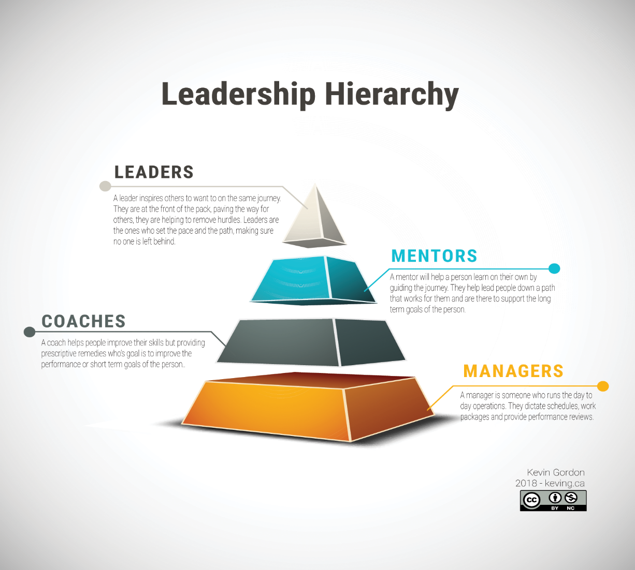
This Photo by Unknown Author is licensed under CC BY-NC

REFERENCES
Branson, R. (2018). Finding My Virginity: The New Autobiography. Portfolio.
Brown, B. (2018). Dare to Lead: Brave Work. Tough Conversations. Whole Hearts. Random House.
Collins, J. (2018). Great by Choice: Uncertainty, Chaos, and Luck--Why Some Thrive Despite Them All. Harper Business.
Covey, S. R. (2013). The 7 Habits of Highly Effective People: Powerful Lessons in Personal Change. Simon & Schuster.
Goffee, R., & Jones, G. (2015). Why Should Anyone Be Led by You? What It Takes to Be an Authentic Leader. Harvard Business Review Press.
Grant, A. (2013). Give and Take: Why Helping Others Drives Our Success. Penguin Books
Northouse, P. G. (2018). Leadership: Theory and practice. Sage Publications.
Segall, K. (2018). Tim Cook: The Genius Who Took Apple to the Next Level. Penguin.
Sinek, S. (2014). Leaders Eat Last: Why Some Teams Pull Together and Others Don't. Portfolio.
Vance, A. (2015). Elon Musk: Tesla, SpaceX, and the Quest for a Fantastic Future. HarperCollins.


This Photo by Unknown Author is licensed under CC BY

