Transcription Assignment January 2021
Magna Carta 1215 –Latin
Salisbury manuscript
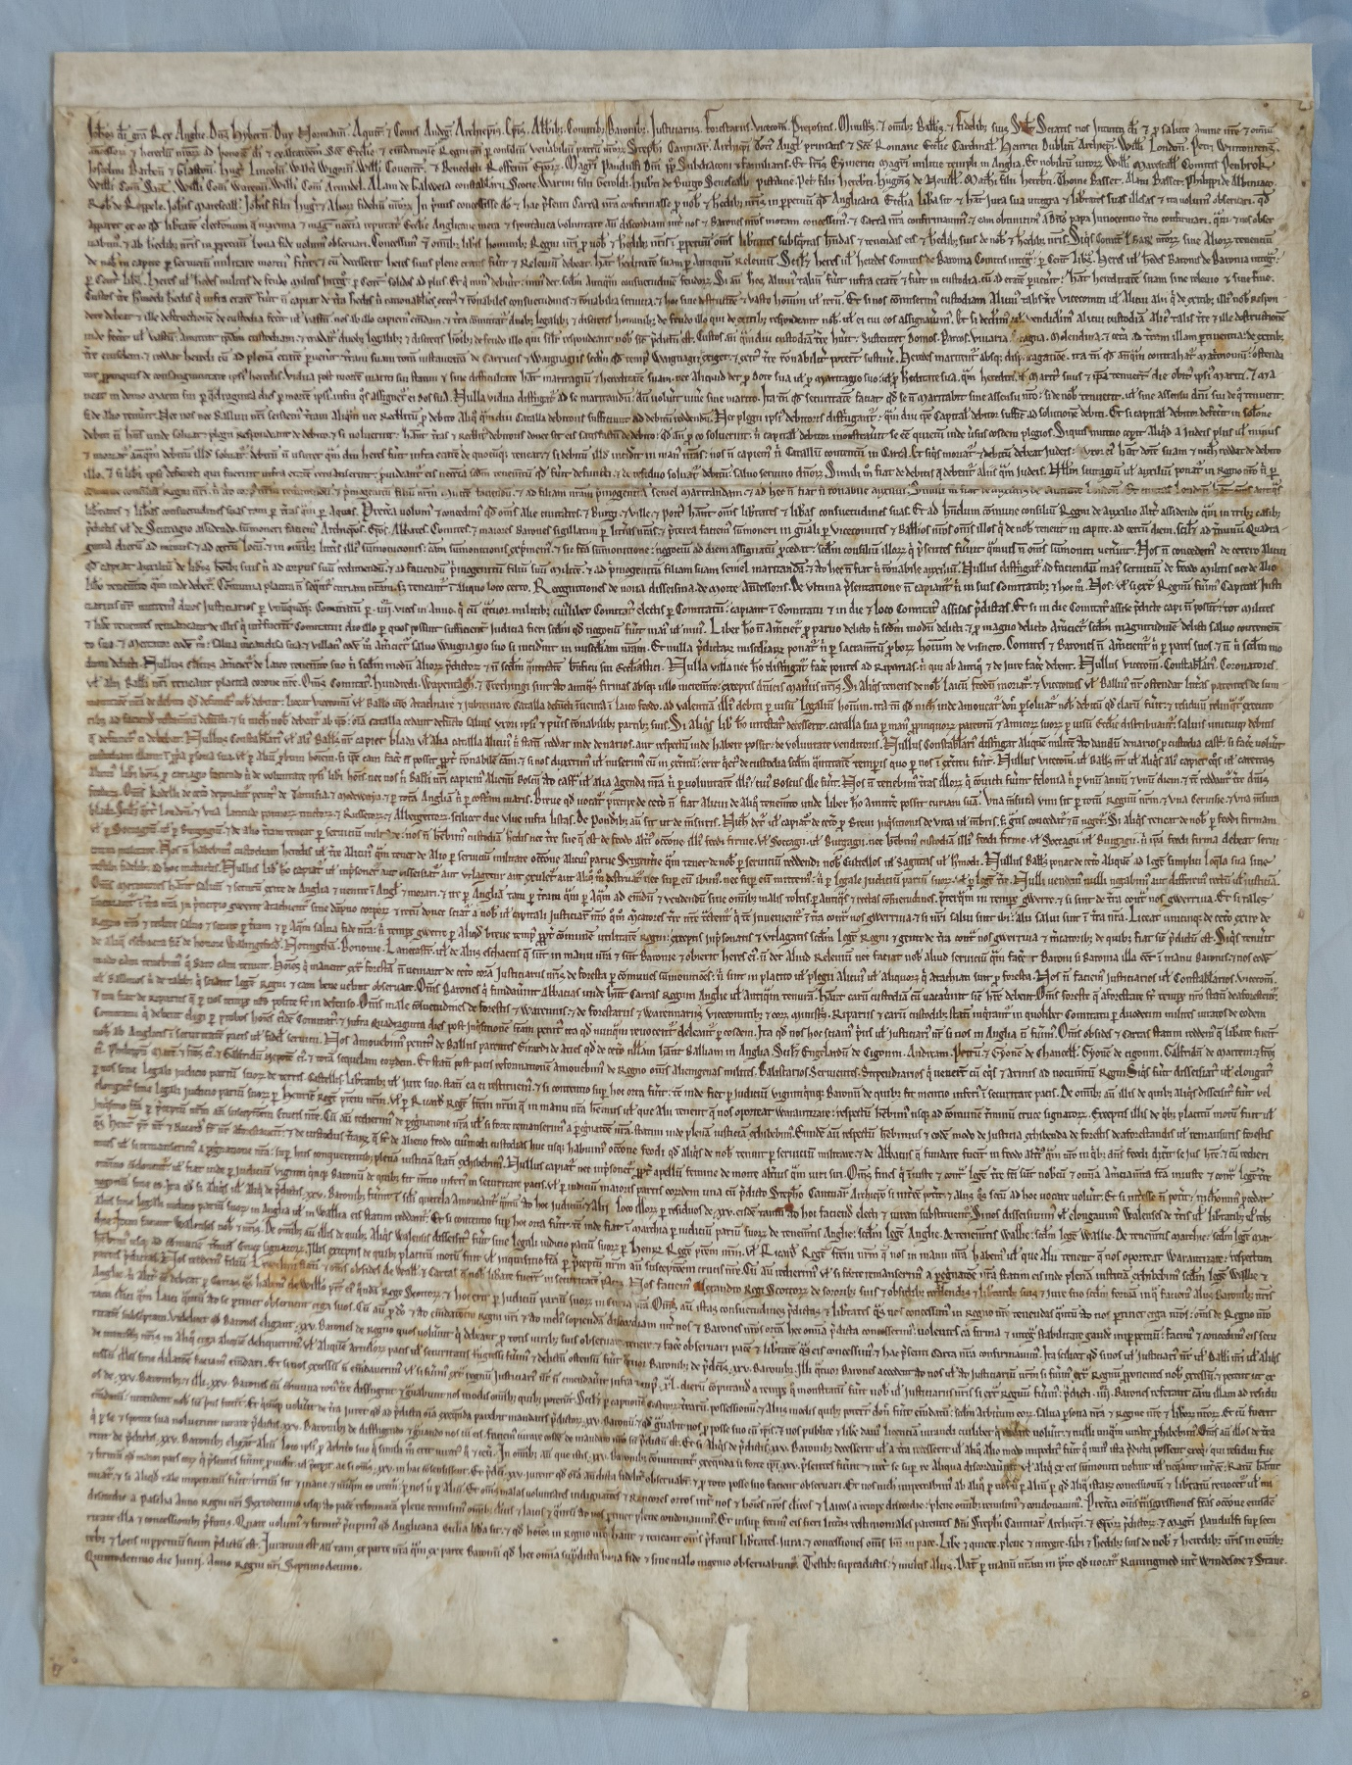

Context of Magna Carta
The document universally known as Magna Carta, does not carry that title anywhere within its own text. The ‘great charter’, cited both as the progenitor of modern global democracies and as the supposed gold-standard of liberties that must not be transgressed, simply refers to itself as a ‘carta’, a charter of King John (r.1199 – 1216), and in the years immediately following its creation, it was known as the ‘Charter of Runnymede’(1), the Thames-side meadow in Surrey where it was negotiated and agreed, on 15th June 1215.
The charter’s titular ‘magnitude’ may actually have been rooted in something as banal as one scribe’s method of distinguishing a 1217 version of it from a separate, smaller charter (Charter of the Forest), that happened to have been produced for proclamation at the same time (2). In other words, the greatness refers to its physical comparative size, as opposed to any foreseen or anticipated actual impact it would have within, and indeed well beyond, the confines of John’s reign (in terms of both space and time).
However, through serendipitous accident or not, the charter’s name accurately reflects the significance of the circumstances in both the course of its creation and the ultimate aftermath of its proclamation (or at least that of its rebooted versions in 1216, 1217 and 1225).
The charter’s purpose as a document was to restore peace between the king and a collective of rebellious barons, aggrieved, amongst other issues, by the imposition of taxes to fund the recovery of Henry’s ancestral lands in France, lost to King Philip II in the early years of the thirteenth century. This grievance, no doubt exacerbated by John’s own personal unpopularity, as recorded in various accounts, and likely due to various reasons, not least power struggles with his brother Richard and his nephew Arthur, took the country to the brink of civil war.
Despite the almost mythic status that its name conjures today, it was not intended to benefit every subject of the realm, and beyond the Church and the barons themselves, there were no concessions of any advantage to the country’s peasantry, who were decidedly not ‘liberis hominibus’.
In fact, its early existence did not really benefit anyone and it did not produce the immediate restorative result that may have been hoped for. A mere two months after its creation, the charter was annulled by Pope Innocent III, and civil war ensued for the next two years.
The charter’s comeback was as a result of John’s death in October 1216 and the accession of his nine year old son Henry III to the throne, when a new version was issued in an attempt to end the war and a further re-issue of it in 2017 to help restore the peace (triggering the first usage of the title ‘magna carta’). The ‘definitive’ version was issued again in Henry III’s reign, in 1225, and by the end of the thirteenth century, following further confirmation by Henry III’s son, Edward I, its reputation was assured (3).

1 D. Carpenter, Magna Carta, (Penguin, London, 2015), p. 6
2 ibid., p. 5
3 ibid., p. ix

Notwithstanding its comparative false-start, the proceedings around its negotiation (brokered by Stephen Langton, Archbishop of Canterbury), agreement, composition and proclamation seem to have been taken seriously at the time. Rather than being one authorised signed or sealed document, an unknown number of original documents, all of equal weight and standing (‘engrossments’) (4), and all bearing John’s seal, were distributed around the country. Views differ as to whether engrossments were produced for each county (approximately forty) or each bishopric (around thirteen) (5). Whatever number were originally dispatched, four of the original versions have survived; two held by the British Library (Ci and Cii originally part of the Cotton Collection), and two belonging to the cathedral archives of, respectively, Lincoln and Salisbury.

Surviving copies of Magna Carta
As with all documents of record of the period, Magna Carta was written in Medieval Latin. The four surviving copies, whilst all being identical in textual content (save for minor differences such as order of words or missing prepositions or capitalisation) and all bearing evidence of John’s royal seal in one way or another, differ in size and proportion and the hand of each scribe, confirming that various scribes were employed (on the basis that the authorised charter would have had to have been swiftly copied out multiple times for its rapid national distribution, this is not surprising). With regard to the varying shapes and sizes, David Carpenter surmises that ‘the (various) clerks either took whatever size of parchment was at hand, or cut it themselves into the size with which they felt most comfortable’(6).
However, the effect of this possible personalisation of parchment selection, meant that another difference between each copy was the ‘flow’ of the text in terms of the nature, location and extent of the abbreviations used and words being split between lines.
What is common to all the surviving copies however, is the text arranged as one continuous ‘block’, with the start of each new clause (of which four remain part of English law today), emphasised by the presence of a prominent capital letter

Salisbury manuscript
Carpenter suggests that the evidence of John’s original seal on this manuscript, thereby confirming its 1215 vintage, is from the two gashes at the bottom of the page, indicative of a seal connected by cords having been ripped off (7). The 1215 provenance of the Salisbury manuscript has been questioned on the basis that the script differs to that of the other three, with Carpenter stating that it is ‘more formal, more akin to what might appear in bibles and psalters’(8).

4 D. Carpenter, Magna Carta, (Penguin, London, 2015), p. 9
5 N. Vincent, ‘Consequences of Magna Carta’, British Library www.bl.uk/magna-carta/ articles/consequences-of-magna-carta [accessed 5 January 2021]
6 D. Carpenter, Magna Carta, (Penguin, London, 2015), p. 11
7 ibid., p. 13
8 ibid., p.12
In article published to coincide with the 800th anniversary in June 2015, Elaine Treharne discusses the style of handwriting (Textualis) which shows a number of identifiable features and a commonality with other contemporary documents in situ at Salisbury drafted around the same time, thereby arguing that the Salisbury version is a 1215 original, albeit produced by the ‘beneficiary’ cathedral by a cathedral-appointed scribe and subsequently officially sealed (9).

Transcribing exercise
For the purposes of transcribing a section of the Salisbury manuscript, I obtained a hardcopy facsimile from the cathedral shop, measuring approximately 420mm x 590mm and I examined this with a magnifying eyepiece.
Certain sections of the text were difficult to discern due to merged blots of ink etc, and in such instances, I photographed, enlarged and printed sections to provide better views.
The text included many suspension and contraction abbreviations, some of which were difficult to ascertain merely from the context. However, online versions of both the 1215 and 1225 charters (British Library and The National Archives respectively) assisted to the extent that many words in these other documents were not so heavily abbreviated.
A further reference source was an online copy of Adriano Capelli’s Lexicon Abbreviaturarum. In addition, as a legal document, much of the manuscript’s text is repeated and so many of the same abbreviations were likewise repeated and became familiar and various patterns emerged.
If unable to establish the correct abbreviation through any of the above resources, I referred to the Latin text provided in David Carpenter’s Magna Carta (Penguin Classics).
The below transcription covers the initial preamble which sets out John’s greeting, the list of his titles and a list of those who provided counsel, followed ‘In primis’ by the granting of freedom to the Church, then a clarification of who the concessions of the charter are to apply to (‘free men’) and lastly two clauses relating to the restrictions, monetary obligations, inheritance tax etc., on the deaths of noblemen.
The below transcription is arranged with each paragraph representing a separate line of the manuscript.

9 Elaine Treharne, ‘The Scribes of the Salisbury Magna Carta’, History Today, www.historytoday.com/scribes-salisbury-magna-carta

Salisbury Transcription
Joh[ann]es d[e]i gr[ati]a Rex Anglie, D[omi]n[u]s Hibern[ia], Dux Normann[ie], Aquit[anie] et Comes Andeg[avie], Archiep[iscop]is, Ep[iscop]is, Abb[at]ib[us], Comitib[us], Baronib[us], Justiciariis, Forestariis, Vicecom[itibus], Prepositis, Minist[ri]s, et om[n]ib[us] Ball[iv]is, et Fidelib[us] suis Sal[ut]e[m]. Sciatis nos Intuiti d[e]i et p[ro] salute anime n[ost]re et om[n]iu[m]

an[te]cesso[rum] et heredu[m] n[ost]o[rum] ad honore[m] d[e]i et exaltac[i]o[n]em S[anc]te Eccl[es]ie et em[en]datione[m] Regni n[ost]ri p[er] consiliu[m] ven[er]abiliu[m] partum n[ost]ro[rum] Steph[an]i Cantuar[iensis], Archiep[iscop]i Toti[us] Angl[ie] primatis et S[anc]te Romane Eccle[es]ie Cardinal[is] , Henrici Dublin[iensis] Archiep[iscop]i, Will[elm]i London[iensis], Petri Wintoniens[is],

Joscelini Bathon[iensis] et Glaston[iensis], Hug[onis] Lincoln[iensis], Walte[r]i Wigorn[iensis], Will[elm]i Coventr[ienis] et Benedicti Roffen[sis] Ep[iscop]o[rum]. Mag[ist]ri Pandulfi D[omi]ni p[a]p[a] Subdiaconi et familiaris. Et fr[at]is Eimerici Mag[ist]ri militie temple in Anglia. Et nobiliu[m] vivo[rum] Will[elm]i Marescall[i] Comitis Penbrok,

Will[elm]i Com[itis] Sar[isberia] (10), Will[elm]i Com[itis] Warenn[ie], Will[elm]i Com[itis] Arundel, Alani de Galweia, constab[u]larii Scotie, Warini filii Geroldi, Hub[er]ti de Burgo Senescalli Pictavie, Pet[ri] filii Hereb[er]ti, Hugo[n]is de Nevill, Math[e]i filii Hereb[er]ti, Thome Basset, Alani Basset, Philippi de Albiniaco,

Rob[erti] de Roppele, Joh[ann]is Marescall[i], Joh[ann]is filii Hug[onis] et alio[rum] fideliu[m] n[ost]ro[rum]. In p[ri]mis concessisse d[e]o et hac p[re]senti Carta n[ost]ra confirmasse p[ro] nob[is] et h[er]edib[us] n[ost]ris in p[er]petuu[m] q[uo]d Anglicana Eccl[es]ia lib[er]a sit et h[abe]at jura sua integra et lib[er]tates suas illesas et ita volum[us] observari, q[uo]d

10 This is taken to be Salisbury but there appears to be no consistent definitive Latin version of the spelling. David Carpenter’s Magna Carta provides Sarresbyrie, but I cannot find any other source for this spelling

apparet ex eo q[uo]d lib[er]tate[m] elect[i]onum q[ue] maxima et mag[is] nec[essa]ria (11) reputat[ur] Eccl[es]ie Anglicane mera et spontanea voluntate an[te](12) discordiam int[er] nos et Barones n[ost]ros motam conemssim[us], et Carta n[ost]ra confirmaui[mus], et eam obtinuim[us] a D[omi]no papa Innocentio T[er]tio confirmari, q[ua]m et nos obser

vabim[us] (13), et ab h[er]edib[us] n[ost]ris in p[er]petuu[m] bona fide volum[us] observari. Concessim[us] et[iam] om[n]ib[us] lib[er]is hominib[us] Regni n[ost]ri p[ro] nob[is] et h[er]edib[us] n[ost]ris i[n] p[er]petuu[m] om[ne]s lib[er]tates subsc[ri]ptas h[abe]ndas et tenendas eis et he[er]edib[us] suis de nob[is] et h[er]edib[us] n[ost]ris. Siqu[ui]s Comit[um] [ve]l Bar[onum] n[ost]ro[rum] sive alio[rum] tenenti[um]

de nob[is] in capite p[er] serviciu[m] militare mortu[us] fu[er]it et cu[m] decesserit heres suus plene etatis fu[er]it et Releviu[m] debeat, h[abe]at h[er]editate[m] suam p[er] antiquu[m] Releviu[m]; Scil[ic]et heres v[e]l heredes comitis Baronia Comitis integ[ra] p[er] cent[um] Lib[ra]s. Heres v[e]l h[er]edes Baronis de Baronia integ[ra] p[er] cent[rum] Lib[ra]s. Heres v[e]l h[er]edes militis de feudo militis integr[o];

p[er] cent[rum] solidos ad plus. Et q[ui] min[us] debu[er]it; min[us] det, se[cun]d[u]m antiq[uu]m consuetudine[m] feudo[rum]. Si au[tem] h[er]es alicui[us] taliu[m] fu[er]it infra etate[m] et fu[er]it in custodia, cu[m] ad etate[m] p[er]ven[er]it; h[abe]at hereditate[m] suam sine relevio et sine fine.

Custos t[er]re h[uius]modi h[er]edis q[ui] infra etate[m] fu[er]it n[on] capiat de t[er]ra h[er]edis n[isi] rationab[i]lies exit[us] et r[ati]onabiles consuetudines, et r[ati]onabilia servitia, et hoc sine destruct[io]ne et vasto ho[m]i[n]um v[e]l reru[m]

11 & 12 The four surviving manuscripts are all of differenrt size and shape as some have more words on each line, and words abbreviated in the Salisbury MS are not necessarily abbreviated in others, E.g. Salisbury MS has the abbreviated words nec¯ria and an¯, but the BL Cii copy has the fully written necessaria and ante.
13 The word observabimus is carried over two lines on the Salisbury copy

Secondary Sources
Cappelli, A., Lexicon Abbreviaturarum, (Verlagsbuchhandlung von J.J. Weber, Leipzig, 1928)
Carpenter, D., Magna Carta, (Penguin, London, 2015)

Electronic Sources
‘Consequences of Magna Carta’, Vincent, N., British Library, www.bl.uk/magna-carta/articles/ consequences-of-magna-carta [accessed 5 January 2021]
‘The David P. J. Ross Magna Carta Vault’, Historic Lincoln Trust www.historiclincolntrust.org.uk/about/castle/plans-for-magna-carta-vault/ [accessed 7 January 2021]
‘Magna Carta 1215’, Cotton MS Augustus ii.106, British Library www.bl.uk/collection-items/magna-carta-1215 [accessed 5 January 2021]
‘Magna Carta 1225’, The National archives, www.nationalarchives.gov.uk/education/resources/magna-carta/magna-carta-1225-westminster/ [accessed 6 January 2020]
‘Magna Carta and Archives’, Salisbury Cathedral, www.salisburycathedral.org.uk/magna-carta-and-archives [accessed 4 January 2021]
‘The Scribes of the Salisbury Magna Carta’, Treharne, E., History Today, www.historytoday.com/ scribes-salisbury-magna-carta [accessed 4 January 2021]

