effective team working & communication
Kulsuma Miah 1706726

Table of Contents
Introduction 2
Communication 2
Different types of communication 2

Introduction
In this report I will be talking about the communication within the workplace, also demonstrate effective communication in management. I will also show a effective management cycle that is used for management purposes, also the importance of tone, language and level of formality, along with written and verbal communication.

Communication

A simple definition of communication is sharing information between two or more individuals. There are many ways to communicate whichever one is chosen has to be thought through correctly as it has a lot of impact.
Communication within the workplace is very important as it allows the companies to be more productive. By communication you can get urgent messages across amongst employees to aid the betterment of the workplace. Keeping a friendly atmosphere is also a crucial part of a healthy workplace and without communication there would be an absolute catastrophe, because it is difficult to maintain these important aspects without communication.

Different types of communication

1. Open meetings:
It is an effective and easy way to communicate within a workplace as you can share your feelings and your emotions openly. The individuals you are talking to can see directly your expressions and understand the message you trying to get across without difficulty.
‘Staff meetings allow people to share information with everyone, face-to-face. They give everyone the chance to hear the same messages at the same time and give everyone a chance to participate. If you’re a leader or manager, make it a habit to solicit something from every single staff member. Another idea is to have the staff members rotate responsibility of running the meeting and setting the agenda.’ (Castro) I agree with Castro that this method gives the a large audience to hear what you have to say as a group so if one message is needed to get across then this is the best way.

2. Emails:
The use of modern technology is not something new within the workplace at this day and age. Emails are another way of communicating it can be sent to your receiver even if you are not with them. You will not have to disturb the person you are sending the message to immediately. There are also many ways to message so the opponent can understand what type of message you have sent. Messages can be marked as urgent or can be given privately or along several other recipients. Not everyone agrees with emails because it does come with some hassle, whether the recipient has read the message or if they will reply back. The message might not even reach them due to connection problems. Another person who does not agree with emails in a work place is Emily Kramer of Asana who recently wrote a really interesting post about why she decided to give up email for a month, and through doing so, was able to really see how much "email is a time suck." After all, the minutes or hours that we spend drafting up emails each day and reading through email threads is time away from when we should be working. Plus, when employees are using email to replace verbal workplace interactions such as brainstorming sessions, team presentations. (sococo, 2017)

3. One on one:
Experts have proved that some people understand better if they are spoken to one on one. The importance of the message is large because you have taken the time and effort out to find them singularly and convey the message to them. Also they will be able to again see the facial expression and tone face to face. ‘one-on-one meetings help ensure managers and employees remain on the same page. Speaking for myself, it’s great to know that my manager always has my back — whenever I have a question, a comment, or a concern, I know I’ll get helped right away or we'll work on a solution together.
From an organization’s point of view, one-on-one meetings help employees stay engaged. Since engaged employees are more productive and more likely to stick around, it’s definitely in your company’s best interest to keep one-on-one meetings in place — or hold more of them if your company has been slacking in this area.
Beyond engagement, one-on-ones provide great opportunities for managers to coach and train their employees. You can discuss an employee’s weekly performance and offer a few tidbits of advice as to how they could do better next week.’ (Reynolds, 2016)

4. Presentations:
In this kind of communication pictures and sound can be used to guide the message. Some people find these kind of messages easy to read and take in, if words can not be understood then pictures help guide the message. It is said by Ganwer people who visually learn they are more likely to remember what they have learnt.
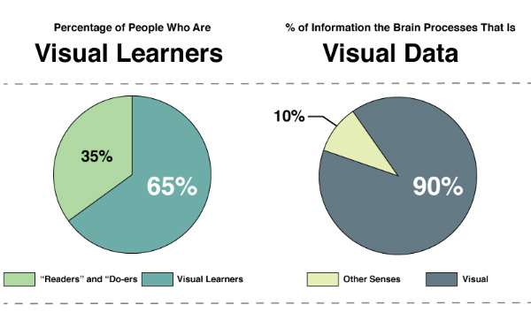 (Gangwer, 2009)

Presentations are more productive and maybe easier to understand but its not always the easiest to do because you have to prepare beforehand. Presenting takes a lot of effort and preparation, for example
- Set clear aims and objectives
- Properly plan and design presentations to stand the greatest chance of success
- Assess all the available information to ensure thorough preparation
- Use communication skills to create impact
- Consider all aspects of their delivery including vocal projection and environment
- Consider how to use questions and feedback constructively to improve results

Communication in whatever way you choose to do has certain elements it has to follow
a protocol as described by the model below:
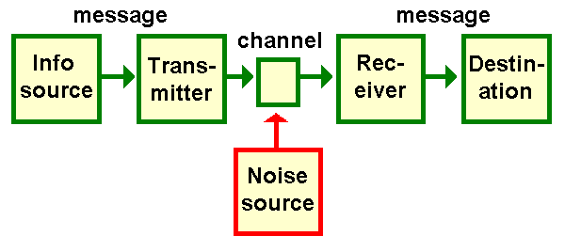
(weaver, 1949)

Claude Shannon and Warren Weaver were not social scientists but engineers working for Bell Telephone Labs in the United States. Their goal was to ensure the maximum efficiency of telephone cables and radio waves. They developed a model of communication which was intended to assist in developing a mathematical theory of communication. Shannon and Weaver's work proved valuable for communication engineers in dealing with such issues as the capacity of various communication channels in 'bits per second'. It contributed to computer science. It led to very useful work on redundancy in language. And in making 'information' 'measurable' it gave birth to the mathematical study of 'information theory'. However, these directions are not our concern here. The problem is that some commentators have claimed that Shannon and Weaver's model has a much wider application to human communication than a purely technical one. C & W's original model consisted of five elements:

- An information source, which produces a message.
- A transmitter, which encodes the message into signals
- A channel, to which signals are adapted for transmission
- A receiver, which 'decodes' (reconstructs) the message from the signal.
- A destination, where the message arrives.
A sixth element, noise is a dysfunctional factor: any interference with the message travelling along the channel (such as 'static' on the telephone or radio) which may lead to the signal received being different from that sent.
For the telephone the channel is a wire, the signal is an electrical current in it, and the transmitter and receiver are the telephone handsets. Noise would include crackling from the wire. In conversation, my mouth is the transmitter, the signal is the sound waves, and your ear is the receiver. Noise would include any distraction you might experience as I speak.
Although in Shannon and Weaver's model a speaker and a listener would strictly be the source and the destination rather than the transmitter and the receiver, in discussions of the model the participants are commonly humanised as the sender and the receiver. My critical comments will refer less specifically to Shannon and Weaver's model than to the general transmission model which it reflects, where communication consists of a Sender passing a Message to a Receiver. So when I am discussing transmission models in general I too will refer to the participants as the Sender and the Receiver.
Shannon and Weaver's transmission model is the best-known example of the 'informational' approach to communication. Although no serious communication theorist would still accept it, it has also been the most influential model of communication which has yet been developed, and it reflects a commonsense (if misleading) understanding of what communication is. Lasswell's verbal version of this model: 'Who says what in which channel to whom with what effect ?' was reflected in subsequent research in human communication which was closely allied to behaviouristic approaches. (chandler)

This is a very popular model of communication by Shannon and weaver.

Bibliography
https://smallbiztrends.com/2013/11/ways-to-communicate-effectively-in-the-workplace.html

http://www.amy-castro.com/8-reasons-regular-staff-meetings-must/

https://www.sococo.com/blog/email-best-form-communication-your-workplace

https://www.tinypulse.com/blog/-importance-of-11-meetings-and-what-you-should-discuss-in-them

Visual Impact, Visual Teaching: Using Images to Strengthen Learning Paperback use pre formatted date that complies with legal requirement from media matrix – 23 Mar 2009
by Timothy Patrick Gangwer (Editor)

http://visual-memory.co.uk/daniel/Documents/short/trans.html

