Student Name: Abdulla Al Mamun
ID: 1606019
Module Name: Developing Relationship and workplace achievement

Contents
Introduction 3
Explain about the Examining the expectations and requirements of people 3
Explain the Administering people in accordance with guidelines and career pathways 4
Explain about the Managing career development of people 6
Discuss about the Managing performance and succession planning 7
Discuss and explain about the Succession planning using its parts individually 9
Explain briefly about the Techniques for supervision and formal appraisal 10
Justify Methods of ensuring fair and objective assessment/appraisal 12
Critically analyze Reporting performance appraisal including the importance of confidentiality 13
Analyze the Learning styles and the range of training/development opportunities available 14
Discuss about the Mechanisms to provide appropriate feedback to individuals 16
Define the methods of Career development strategies including the wider context of sustainability 16
Conclusion 17
References 17

Introduction
The industry revelation opens the gate to make more and more organization globally of different types of products and services. According to the demand and expectation the organization provide services and goods to the consumers, in the way of this industrialization the various organization sets up their total function and execute innovative idea and conception and creative strategy to gather most success in the field of similar kinds of organization (Engelbert & Kubbe, 2017). Aldi is such kinds of organization in the retailing section of business. The organization started its journey from 1946 and it ran after two names like Aldi Nord, 1960 and Aldi Sud 1962. It a German multinational company which runs its business in almost 20 countries with 10000 stores all over the world. Grocery and household goods are the main products of the company. The company is listed stock exchange in u K and Germany. The revenue of the company is $ 53 billion. The report will show about the organizations and the employees interrelationship of the in the organization

Explain about the Examining the expectations and requirements of people

When an organization starts its journey then the three are lot of people around the organization who expect to the organization as like as they need. The shareholders, the managers, the employees, the consumers, the providers all are different parties who are related to the organization. Aldi has also issue that the persons who are involved with organization are expected and required different things. The factors are disclosed in the next steps which are given below,
Respectful behavior of all employees at all level: Aldi is a multinational company which operates its action in almost 20 countries of different content of the world and it has 10000 stores and the number is increasing day by. As a result there huge number of employees from different level but the employees want to get respect as an employee of Aldi. This is their right to get proper treatment at all the level of the organization (Guo, 2015). The management should ensure to establish the right of the employees at any cost. The employees should respect one another in the workplace.

Belief between employees and s management: Literally there are two types of functions in the organization, the management and the employees of different level of the organization. The management is the decision makers and the employees are the decision appliers. Though their function is different but they are dependent on another in most cases (Hansson, 2001). If there is no interconnection between the two parties, the success of them are impossible. So the management should trust the employees to hand over the responsibilities in most of the activities and then the employees are inspired to work with the best effort and thinking the work of their own
Overall benefits: an organization runs to set different target and gains benefits by exchanging services and products to the mass people of the market of many communities where the particular organizations operate the business activities. Though all the benefits enjoy the organization but the employees are the key persons to gain those. So the employees are the main proprietor of the benefits (Thyssen, 2009). The organization also should try to go through the successful ways where the organization activities should be done according to the foundation of the company. The management should be concern about getting benefits and share with the root level employees to boost up them
Overall compensation/pay: As the company has lot of benefits, the companies have also some compensation and pay to several parties where the organization operates its services worldwide. The companies like Aldi, who collects different goods and products from vendor or other providers so the organizations would pay to them and the amount are considered as the pay of the organization. The employees are also the part of the compensation in different point of view
Job safety: In the Multinational organizations who are in available in different countries with lot of employees from various culture and nation work to make their career in a certain level. The employees want the job security as it is well known that the private employees are not permanent they can be removed from the organization in any time without any notice (Thomas &Jaya, 2012). The employees of the private organization want to get the job security as this is the only way for them to earn bread and butter. Beside the employees want to make an strong position showing the professionalism in the organization but they should have get the chances and they long time to exist in the organization

Explain the Administering people in accordance with guidelines and career pathways

Though the organization has different employees from different culture, there are lot of variation among them in their attitude and behavior about they cannot shows their own attitude and personality in the organization as the organizations run according to the principles and rules and regulation of the companies. They employees are also bound to the rules in every spare of career life in the particular organization (David & Mila, 2013) The employees have to follow the guidelines of the organization beside they have to follow the careered path which is very important for them to make the career smoothly. The employees follow the career mapping to make their career bright and the HR and the management should analysis the factors with the employees in the organization,
Self-assessment: Self-assessment works as the tonic to make the employees devoted to the work and responsibilities in the organization. In an organization the employees complete lot of deeds and they are various in standard and quality. But the employees do the work with lot of creativity and innovation so the persons want to get assessment from the management and they also should self-assess them when they perform a duty in the organization for the betterment to them personally and for their personal skills and interest. The employees can find the interest and expected respect in the process of self-assessment
Personal career map: every individual employee in the business organization want to get the better position and designation where they work. So the employees are interested to show their personal skills and get the proper respect and position among all the employees in the organization (David, 2014). In this way the employees can follow the personal career map which can show them the right path how they can achieve the personal promotion the organization. The management also should make them sure that if they can perform on top level they can get promotion in the organization. Personal career map is also effective for the employees to build up the career in the organization
Exploring other opportunities: in this way the employees of a particular company can get the chances to work in the same place and if they get the chances they can also take the opportunities to work another with lot of efficiency and capabilities to develop the organizations where they work. The manager of the organization should prepare the employees ready and skilled as they can be the best asset of the organization and also play the important role to make impact on the developing operation in the organization.
In Aldi the management and the employees of different function cooperate each other to develop the career and also helpful to bring success for both the organization and the individualism. The employees perform according to the direction of the management and work sincerely to develop the total activities in the working environment beside they are busy with the activities of making their career strong to the organization

Explain about the Managing career development of people
When an employee enter into a new organization the main purpose of the employee is to develop career and certainty of their job security in the organization. They are so much concern about the career development in the workplace and doing that the employees should follow different strategy which are effective on the way of developing career (Steve & Eduardo, 2009). To manage the fact, the employees should have the quality to survive in the organization for a long run which can bring success for the employees.
Mainly career development has five stages like,
Exploration: exploration is the first steps of the term and the employees join the organization as raw materials and the manager and the authority train them and make them usable for the organization. So there are many things to explore in the skill and capacity of the employees. The management should find out the strength and weakness of the employees and use them according to their merit and quality in the proper places of them. If the management can explore the talent and creativity of the employee’s, then the organization can be able to use them for the development purposes in the organization and the employees also can be the main figures of the company
Establishment: after passing the probation period the employees enter into the full professional life which is the first step of the work as the permanent employee of the organization. The employees start to understand the responsibilities which are given by the management to do as the won work for the company. Thus the employees establish their personal life in the organization. This is the very important period as the employees can address themselves to the management and then their acceptability can be increased if they can present themselves as the best workers among the thousands of workers in the company.
Mid-career: this is the age in the organization for an employee when the persons pass the mid-level of their career. Here is the organization depends most on them and they are very much dependable and the decision makers of the organization. They also share the experience with the new comers who needs much experience from the senior to settle in the organization. Here the employees are respected by all the members as they are the senior’s persons and are key persons to work with more effective knowledge. They are in physical labor and mental sacrifice in this age.
Late Career: This is the last stage of an employee to pass the late career duration in the different workplace where they work. In this stage the employees are mostly can play the role to make the strategy and use the experience of the whole life they worked in the organization. They are also in sharp knowledge and they are considered the most valuable persons of the business organization. Most of the time they are away from the physical labor and they work as the management in the organization. They also share the working experience with the employees who work hardly for the development of the organization
Decline: as the every live has an ending touch so the employees in the organizations are also not out of the rules. The employees also say bye one day from the workplace. They go to the retirement after some certain period and when the body of the employees cannot support them to continue the work in the organization. The management of the particular organization give tribute for the farewell from the organizations. The employees take the ending from the workplace after passing a long period in their life actually

Discuss about the Managing performance and succession planning
An organization can make the plan and show the performance to achieve the success in the organization. This process can be effective for themselves and for the institution (Steve & Eduardo, 2009). The employees perform from different point of view and their work and responsibilities are evaluated by the managerial figures to acknowledge the working success. Performance management is very important as the evolution process inspire the employees to give full effort to make the success of the organizational aim and goal. There are different steps of performance management which are followed by the performers to show their competence in the organization,
Stage 1: Pre- requisite: pre requisite is the first step to manage the performance in the particular organization. The management of the organization here set the target and goal for the next assignment of the organization and how the organization will run the management can make the set up in the initial stages of the management. The employees should get the clear concept about the pattern and structure of the goal and target.
Stage 2: Performance planning: as the management make the diagram of further assignment and working plan. The employees also should make proper plan how the employee will obey th responsibilities and execute organization plan in the organization. Then the employees can perform smoothly to success the plan and show the lot of skill and appropriateness to make the plan successful
Stage 3: Performance Execution: in this stage the employees execute the plan which the management taken to for the employees. The employees try to perform according to the plan and with lot of standard and quality to make the consumers happy and satisfied on behalf of the organization. The employees want to express themselves better than other employees. As result the organization can be benefited by the employees and make develop in the competitive market.
Stage 4: Performance Assessment: as the employees sacrifice a lot of labor and difficulties to performing staying different critical environment, the management should assess them for their labor and sacrifices. Then the employees can be inspired and get the interest to work in new speed and look. So the management should inspire them in best way to get the fluent services from the sincere employees who think about the progress of the company in possible ways
Stage 5: Performance review: performance review of all the completed work is very necessary to keep the proper standard of the performance. If the management review or evaluate the performance, then there are little chances to make any mistakes in the organization. The employees also should recover the mistakes which they do during the performance time in the workplace. So the review of the performance is very necessary and effective in the organization
Stage 6: Performance renewal and reconstruction: sometimes it can be seen that the organization change the performance strategy and newly make the plan to perform in the organization. Or they renew the plan and strategy to go with the moving world. The demand and expectation of the customer’s changes very often so the organizations also change the plan to serve the consumers in several ways and the employees performing various ways in the organization

Discuss and explain about the Succession planning using its parts individually
Succession planning is such an idea which gives the chances to the organization to reform the leadership of the organization in new shape on the place of old leaders in the organization. As the employees who are old aged in office and cannot serve like before, they employees say bye from the organization (Steve & Eduardo, 2009). Then the management takes the responsibilities to make new leaders for the organization to lead next generation of the organization. In this way the management does the job step by step and those are given in the following part of the report,
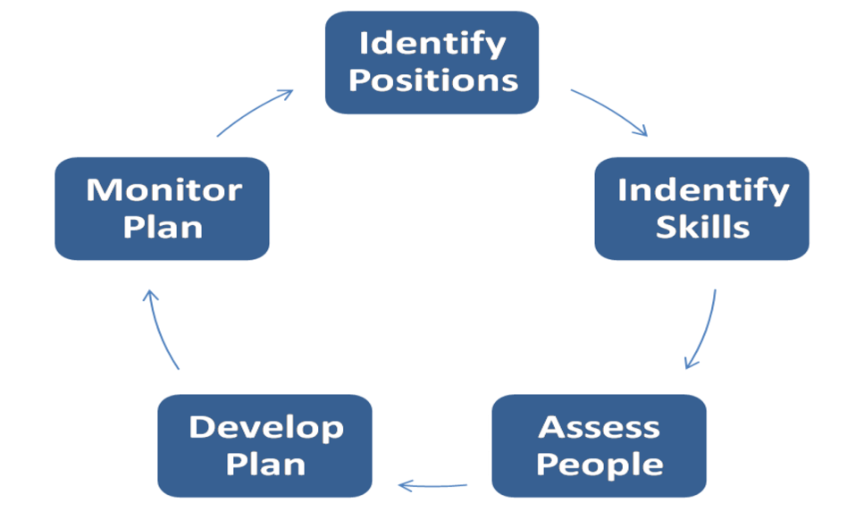
Figure: Succession planning
Identify positions: in the organization the position of all the employees are not equal. The employees are from different function and different position. But all the employees are not capable to get the leadership from all the position. SO the management should find out the position of the employees and should think about the fact who capable to take leadership among the total employees. And who have the capability to lead a group of employees by the leadership and quality which can help to be success in succession process
Identify skills: leadership is such a quality which can lead an organization to the positive and negative. IF the organization can get the skilled and talented leader among the employee’s then the organization can be best among the all organization in the world by dint of leadership (Morgan, 2014). On the other hand, if the leader is not qualified and creative then the organization stays is in the same place for a long duration. So the managers of the organizations should find out the most skilled and competent employees who have the quality to lead the employees in the workplace
Assess people: this is one of the steps of the process of succession where the managers of the organizations should assess the employees for their heroic deeds in the organization (Morgan, 2014). When the common people get the treatment for their attempt they can be very pleased and satisfied and further they will work with more strength and the management of the organization should take the chances to use the fluency in the work of the employees. Then they can be able to take the leadership to lead the organization and use the man power for the development and innovative work in the inside and outside of the organization
Develop plan: a proper plan can solve all the problem and make sure the answer to make new leadership in the organization. So the management and the authority should make proper and wise planning which can help to select the best persons as the leader of the organization. Beside the employees also should make the plan execute to increase their capability and skill to develop their career.
Monitor the plan: only develop the plan is not the solution to complete the succession process, so the organization should monitor the execution process in the workplace. Then the management can easily evaluate the working competency of each individual and can select the best performers and make them use for the further action in the organization (Steve & Eduardo, 2009). And monitoring the total action can also help to increase the positive impact on the organization as there are any mistakes easily can be caught by the evaluators and then they can get the chances to make them correct

Explain briefly about the Techniques for supervision and formal appraisal

Appraisal is such term which is considered the best way to find out the skill of the employees and make them also inspire take the charges of the responsibilities which are their duty. Beside the word appraisal also helps the senior employees to take respect from the management and junior employees in the organization (Morgan, 2014). Appraisal factor is very influential factor which have lot of positivity to find out the best feedback for the service quality of the employee foretop to bottom level in any particular company.
Methods of appraisal: To make the term active in the organization there are some methods which are very essential for both the parties alike the management and the employees. Among them the main methods are given in the following parts of the report which are most common and used in all the organization of the world business,
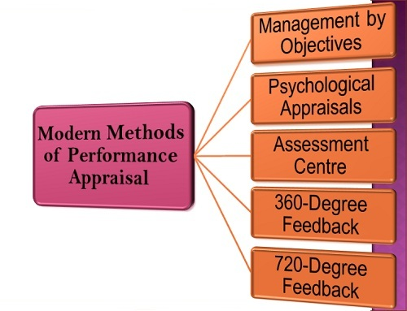
Figure: Methods of performance Appraisal
Management by Objects: MBO is the first step of appraisal methods where the management and employees work together in all the action in the organization. To set the target, to make new strategy, to fix the goal, to earn money and reputation, in all the sections the both parties take places as a result there is friendly environment and mutual understanding among the employees in the organization.
Psychological appraisal: Psychological appraisal is also a part where the professional psychologist measures the employee’s mental capability and make them skill in thinking about the positive aspect for them to recover any difficulties by thinking a better way in the organization. The method helps the organization to make the employees stable in mental cases as they have to face many complexities to play t5he role for the development of the functions of the organization
Assessment center: assessment center is very effective and influential for the evaluation process of the organization. As the management can take care all the working action and make them find out about the performance graph which are clear to them about the quality of th employees. And then the management can assess the best employees and inspire them to give the best capability to make the organization success gradually. Beside the Employees also get the expected assessment from the high command of the working company
360 Degree feedback: the employees of any kind of organization are appointed to performing both the inside and outside of the organization. Sometimes they serve directly t the consumers and sometimes they cooperate to serve them in different ways. But they must can get the feedback of their own work (Morgan, 2014). It can be from direct the consumers and sometimes from the management of the organization. Then the employees can know about the performance and service quality of the employees and they can use the report for their own interest
Behaviorally Anchored Rating Scale (BARS): Bars is effective for evolution the quality and quantity of the behavioral effect in the organization by the employees. Here the management can understand about the behavior quality and how many times they show It. This fact is also effective method of appraisal and it is also important to make the career on the foundation of strength and faith

Justify Methods of ensuring fair and objective assessment/appraisal

There are different methods of ensuring fair and objectives assessment. The most flexible and important methods are discussed in the following parts to understand the effect and action of the fact,
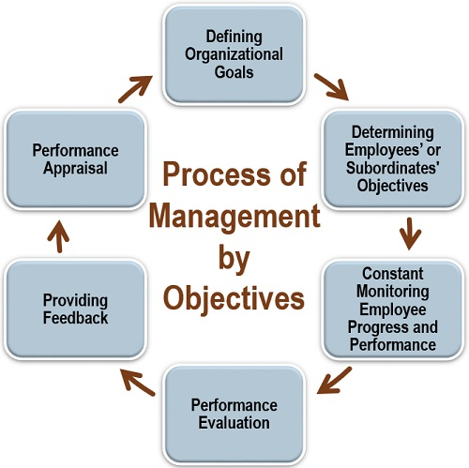
Figure: Process of MBO, Source: (Steve & Eduardo, 2009)
- Define the organizational goal: all the organization have some specific goal and the management of the organization should set up the plan and expected goal to earn. Besides making profit, different kinds of organization set individual goal. The employees should know about the goal so that they can work for attaining the goal timely
- Define employees object: There are lot of function in the organization and the employees work in several function so their object are also different from each other. The management should make learn the employees about the specific goal and target of the employees. And the employees should work to earn the objects which are given by the management to them
- Continues monitoring performance and progress: if any organization can monitor the regular performance of the employees and continue it for a long time then the organization can enjoy lot of organizational benefit in the organization (Steve & Eduardo, 2009). The employees also can understand about the value and ways of their performance
- Performance evaluation: evaluation of any work can provide the perfection to the related parties. So the management should evaluate the performance of the employees so that they can know about the standard of their performance when the provide services for the organizations to the consumers and other parties
- Providing feedback: When the employees make any duty they can get feedback for every occasion it may be from the QA or the consumer’s directly. If the feedback is positive then the employees can take inspire or if the attempt is not in favor of them they should work about the mistakes and try to do better in the further steps
- Performance appraisal: performance appraisal is also a fact which has impact to lead the working space in the organization. The management should appraise the performance of the employees from root level to top. Then then can find the inspiration to work in new spirit.

Critically analyze Reporting performance appraisal including the importance of confidentiality
Performance appraisal process:
Performance appraisal is part and parcel to get different benefits for the organization. To evaluate the fact there are different ways and process. Different organization follow different process,
As the repot is written about the Aldi, A German multinational company and the company follow the performance process to appraise the employees and their performance. The company set the target for the employees and get creation period to achieve the goal and the employees have to attain the goal with in the certain period and the organization appraise the working success on the basis of performance which they do for the organization. Thus the employees get the proper appraisal from the management of Aldi
Confidentiality and its benefit: confidentiality is term which is very common in the industrial areas as the different organization have different strategy to apply in the market. The organizations want to dominate the market by their own strategy which is different from another so the management of the organization wants to keep the strategy confidential so that the other company cannot apply the same strategy (Jawad & Robin, 2017). This policy can be effective in the organization and it can help the organization to be separated in decision making from the other organization in the market. the management of the organizations take proper steps to keep the decision and strategy confidential and maintain privacy in all the sections of the company and the employees also maintain the fact.

Analyze the Learning styles and the range of training/development opportunities available

Trainings a part and parcel all the organizational and the employees are taken training after joining a new organization and the training can let them know about the organization, their goal and strategy and working areas of the employees. So training is an important process so for the organization to make the employees skilled and competent in different point of view
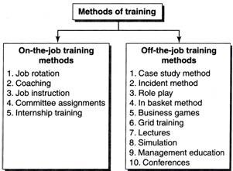

Figure: Training methods
Training are mainly two kinds like on the job training and of the job training. There are different training methods which are followed by the different organization. In the following the methods which are followed by Aldi are discussed
Coaching: Coaching is the vital period for the Aldi to make arrange the coaching period by an expert coach in the organization. The person helps the new employees to make learn about the techniques, strategy, behavior etc. will the key points for the employee to be success in the organization. The employees should learn as much as possible which are very effective in th life of operation for them
Committee assignment: This is the method for the training period of the organization. Aldi Company also introduces the fact with the new employees in the organization. In this way the management train the employees about the committee assignment which can help the organization to share the personal views and ideas with the other and they can get the proper idea about the function of the organization in large
Lectures: The Aldi Company sometimes arranges the opportunities to deliver lectures from the employees which can help the employees to increase their idea and speaking skills and shows the knowledge about the organizational environment. This type of training can help the employees to be fluent withy customers and they can serve them in best ways.

Discuss about the Mechanisms to provide appropriate feedback to individuals

When the employees deliver services to the organization from their own responsibility they can receive the feedback from different persons as the acknowledgment of their own work. Sometimes the feedback come as blessing and sometimes as the negative impact in the organization. The ways how the feedback come to the in the light of Aldi is given below,
- Don't wait for a Quarterly Review: the employees of Aldi don’t wait for a queerly review as the feedback which the employee get. They work according to the rules and regulation of the organization. And they believe themselves about to the serve in the best ways
- Make it one on one: the employees of Aldi take the feedback one in one. They are instructed to analyses the feedback one after another should give the privacy over every and single facts which can be effective on the way of their operation in the organization
- End on a positive note: person can learn through making mistakes and it’s applicable for all the persons. The employees of Aldi are not out of the fact. The persons also can learn if they get the negative feedback from the management or the customers themselves. The employees should take it positive and work about the facts. Thus they can end the assignment on appositive note

Define the methods of Career development strategies including the wider context of sustainability
Career development is an important issue for all the employees in the organization. When they enter into a new organization they think about the career development. The employees of Aldi follow the Goal management method to develop their career in the organization,

Figure: Goals management
Focus attention: The employees of Aldi give priority to focus the attention of the management and the stakeholders in the organization and thus the persons can draw the attention to make their career secured among the other employees in the workplace. The persons who are in this process they are more fluent in the organization
Energize a person: The employees of Aldi should try to energize themselves in the organization to draw the attention of the think-tank then the can count them as the most prolific and promising employees in the organization
Encourage thought: the employees should encourage their thoughts and they should take brave decision in the questions making any decision in the organization. If the employees can show their encouragement and creativity in their thoughts, then the management can be impressed and it will be easily for them to develop career
Activate planning: The employees of Aldi should take active and timely plan to highlight their own capability and integrity in the organization so that they can be the most valuable employees in the organization

Conclusion
Aldi is a multinational company with 1000 + stores in almost 20 countries in the world. So the organization have large numbers of employees who work in different environment but their relationship among the internal external employees of the company are the main key to achieve success in the organization. If the employees can want to develop their career and job security the persons should come forward together to attain success for the organization and make impact on the domination process in the market (Alvesson, 2012). The employees are also should be observed to secure the better performance by the management in the organization

References
Alvesson, (2012) Understanding Organizational Culture, London: SAGE.
Engelbert, A. and Kubbe, (2017) Corruption and Norms: Why Informal Rules Matter, New York City: Springer.
Guo, (2015) Cross-Border Management: Theory, Method and Application, London: Springer.
Hansson, O. (2001) The Structure of Values and Norms, Cambridge: Cambridge University Press.
Thyssen, O., 2009. Business Ethics and Organizational Values: A Systems Theoretical Analysis. New York City: Springer.

Thomas J Delong, Jaya Tandon, Ganesh Rengaswamy. (2005). Infosys (A): Strategic Human Resource Management. Harvard Business Case Study.

Jawad Syed, Robin Kramar. (2017). Human Resource Management: A Global and Critical Perspective 2nd edition. Macmillan Education UK

David C. Thomas, Mila B. Lazarova. (2013). Essentials of International Human Resource Management: Managing People Globally. SAGE Publications

David McGuire. (2014). Human Resource Development 2nd edition. SAGE Publications

Steve W.J. Kozlowski, Eduardo Salas. (2009
Morgan J. (2014) The Future of Work: Attract New Talent, Build Better Leaders, and Create a Competitive Organization. John Wiley & Sons

