

MICHEL CHION’S AUDIO-VISUAL CONTRACT

LEE HENDRY (P151809)
B.A. MUSIC TECHNOLOGY
CREATIVE RESEARCH (M4X01559)
LECTURERS: ROB JONES, SIMON KILSHAW, JENNY KIRBY
Word Count: 2150

Introduction
Ever since the very early days of cinema, the moving image has been accompanied by sound. The visual and aural elements of the cinematic experience have gone hand in hand with each other from the beginning, and they have since become inextricably linked within the realm of the ‘motion picture’.
When the first movies were exhibited to the public from the late 1890’s onwards, they were invariably accompanied with a wide range of audio embellishments, including live musicians (usually a pianist), music recordings, narrators and sometimes even off-screen actors reciting dialogue. There were a few reasons why sound was included as part of the show. It served to cover the noise of the audience and the film projector. It also helped to heighten excitement amongst the crowd, especially when the ‘slapstick’ comedies were being shown. On occasion, real sound effects were generated either by special equipment located behind the screens, or by performers using sound-producing objects of various kinds. Also at this early stage, audience participation was much more prevalent than it is today and people would laugh out loud, shriek and gasp at the images projected in front of them. Paradoxically, while this became known as the era of the ‘silent movie’, a visit to the cinema during this period was usually anything but silent.
During the intervening years as movie making developed, sound (and especially music) began to play an ever-more crucial role in affecting the way audiences responded to the moving image. With the advent of the first ‘talkies’ in the late 1920’s, the door was well and truly opened for the advancement of audio in the cinema.

Michel Chion’s ‘Audio-Visual Contract’
To help us to interpret the often-complex relationship between image and sound, we can refer to Michel Chion’s ‘Audio-Visual Contract’ from his book ‘Audio-Vision: Sound on Screen’. Here, the French composer, film-maker and critic examines how image and sound can be used together to manipulate and alter the viewer’s audio-visual perception. Chion explains that this is achieved by means of an ‘Audio-Visual Contract’, which is “a kind of symbolic contract that the audio-viewer enters into, agreeing to think of sound and image as forming a single entity” (Chion 1994, p.216). Chion uses specific terms to describe the many functions and devices used within the ‘Audio-Visual Contract’, and he also outlines how these various audio-visual effects and phenomena can be employed to influence the perception of a film’s rhythm and tone.
In the ‘Audio-Visual Contract’, Chion states that ‘Added Value’ is “the most important of the relations between sound and image” (Chion 1994, p.5). When a series of images are shown on screen without any audio, they can appear unconnected, fragmented, more abstract and lacking in unity. Similarly, sound played through the cinema speakers without any imagery to anchor it will be meaningless and unfocused. However, when combined, image and sound can manipulate the viewer into seeing and hearing things completely differently. Sound gives the viewer the impression that the image is ‘more real’. ‘Added Value’ through sound can help link separate images together, and this is its most common function in film. Reciprocally, ‘Added Value’ also influences us to hear the sound differently when accompanied by images. A further example of ‘Added Value’ is through music, which can either reflect the exact feeling of the images we see (empathetic music), or which can express a marked contrast to the visuals shown on screen (anempathetic music). Sound and music in film can be used in many ways. It can heighten the anticipation and tension in a scene with effective use of musical cadences and silence. It can help define the space within an image and also off-screen (e.g. null extension, vast extension). A character can be distinguished by use of a musical leitmotif and its movement can be accentuated by a descending/ascending musical phrase. Sound and music also influence the viewer’s perception of time and speed. Our ears analyse and process information faster than our eyes however, rather than sound, it is the image that provides the reference point for the viewer’s perception. Audio can provide context to the image, guiding and filling in the gaps for the viewer. Sounds are more linear in time and can ‘vectorize’ scenes, whereas the order of images can be frequently reversed.
While the images seen on screen are confined to the boundaries of the visual frame, the sounds that we hear in film are unrestricted, as “there is no auditory container for film sounds” (Chion 1994, p.68). There isn’t a limit to how many sounds can be placed onto the sound-track. Film neither inhibits the types of sounds that can be used or indeed how many different combinations of sounds that can be heard. There can be a mix of diegetic and non-diegetic sounds, on-screen and acousmatic sounds, music and narrative voices. The sounds can also be placed at differing audio levels within a scene (e.g. non-diegetic background music or diegetic synchronized dialogue).
Another important element of the ‘Audio-Visual Contract’ is what Chion terms as ‘synchresis’, which is “the forging of an immediate and necessary relationship between something one sees and something one hears at the same time” (Chion 1994, p.224). ‘Synchresis’ is based on the notion of synchronization and synthesis – where a visual event and a sound event converge together at a specific ‘synch point’. These ‘synch points’ provide an audio-visual sequence with its phrasing and naturally signifies its content and overall dynamics. ‘Synchresis’ allows us to believe that the sounds we hear are real. According to Chion, “we classify the sounds we hear in a film to what we see in the image” (Chion 1994, p.68). How the sound is produced is not important, but how we perceive the sound is. Therefore, it is possible to use a variety of sounds with a variety of different images, and it permits for the most subtle and astonishing use of audio-visual combinations. It can be said that the subsequent effective development of ‘synchresis’ has resulted in it being often overlooked and taken for granted.

Scene Analysis
To highlight further certain relationships between image and sound, it would be beneficial to analyse a couple of film scenes that employ some of the functions and devices that Chion refers to in his ‘Audio-Visual Contract’.

‘Driving Out of Town’ – Psycho (1960)
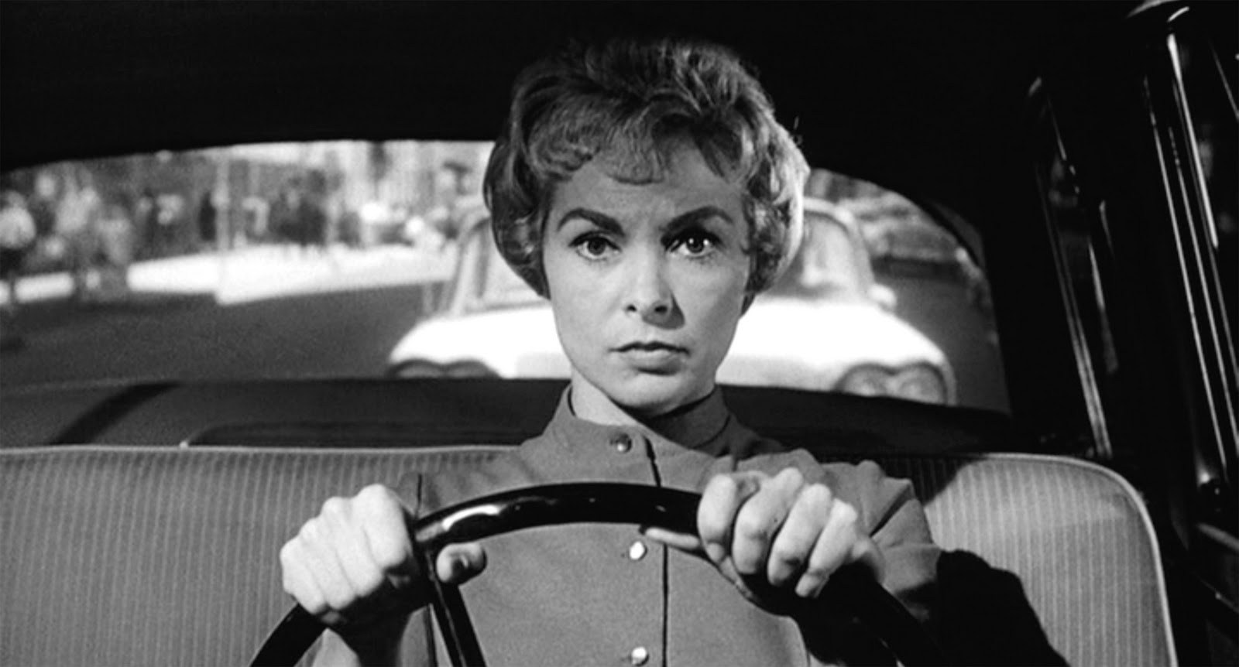

This scene follows the movie’s main female character as she absconds with thousands of dollars entrusted to her by her employer. We see her alone at the wheel of a car as she is driving out of town. During her journey, she is thinking about the fall-out that her actions will cause back home, and she is imagining her employer’s reaction when he realises that she has run off with his money.
The images that we see during this scene are unremarkable. There are just two camera angles throughout, one facing inwards, directly toward the female, and the other looking out at the road ahead. At the beginning of the scene, she is driving on an urban road in daylight, but a few frames later she finds herself on a deserted road, in darkness and torrential rain. It ends with her car pulling up to the entrance of a roadside motel.
Without sound there appears to be not much happening, and the images switch from day to night very quickly. However, when the audio is present, the whole tone of the scene changes dramatically. We are transported into the character’s imagination as we hear the voices of her employer and colleagues, and their conversations as the truth dawns on them about the missing money. These voices are what Chion terms as ‘acousmetres’ (acousmatic characters whose place is neither inside or outside of the image). This is also an example of ‘null extension’, where the sound world has been reduced (in this case to the inside of the character’s mind). Visually, the female’s subtle facial expressions react to the imaginary voices that we hear, providing ‘synch points’ where the image and sounds meet. Underpinning the whole sequence is a passage of non-diegetic music. Bernard Herrmann’s haunting string score augments the images with tension and evokes a nightmarish atmosphere. It also gives to the scene the impression of ‘temporal elasticity’, linking the shots at various stages of the long car journey and helping to condense them into only a few short minutes on screen.
The spectator’s focus during these moments is almost entirely on the sound rather than what is seen. This, in fact, mirrors the focus of the female character herself, and it feels as if we are in her shoes. She is concentrating on her inner thoughts, rather than the road ahead. It is only when the rain starts falling that she switches her attention to the present. At that same point, the spectator is taken out from the female’s inner sound world. The imaginary voices and then the music fade away, leaving only the synchronous sound of the rain falling and the hum of the windscreen wipers as the car approaches the entrance to the motel.

‘The Shower Attack’ - Psycho (1960)
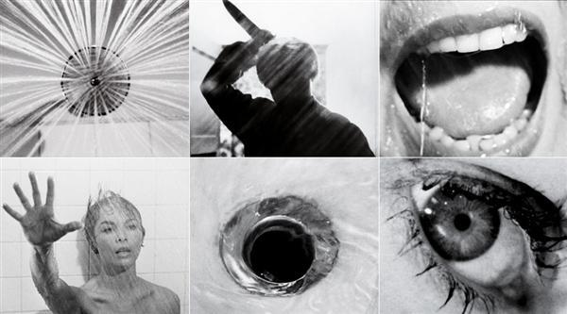

From the same movie, this scene depicts the gruesome and unexpected death of the above female character, and it has subsequently become one of the most infamous moments in cinematic history. She is taking a shower in her cabin at the motel, when a mysterious figure enters the bathroom and stabs her multiple times before marching off, leaving her bleeding and dying in the shower.
In contrast to the ‘driving scene’, this sequence is shot from numerous camera angles and the viewpoint fluctuates from in front of and behind the shower curtain, as well as from the sides and above. There are also close-up shots of the female, her attacker, the blade of the knife, the shower-head and the plug-hole.
At the beginning of this scene, the sounds that are heard are both on-screen (such as the closing door and the running shower) and off-screen (e.g. the toilet flush, the opening of the soap packet and the pull of the shower lever). Here is another example of ‘null extension’, where the sound world is confined to the inside of the bathroom and is heard only by the female character. This enhances the sense of claustrophobia.
The attacker enters the bathroom silently and suddenly flings back the shower curtain. At that exact moment, the piercing and distinctive staccato violin music of Bernard Herrmann begins. Chion states that “music can play a major punctuative role, thanks to editing and can help create a scenes overall rhythm” (Chion 1994, p.55). This is exactly what Herrmann’s music achieves here. The harsh and brutal attack of the violin strings reflect what is seen on-screen. Here the editing is quicker and the image cuts are synchronized with each blow of the attacker’s knife. This re-enforces the frenzied nature of the attack and adds to the overall chaos and confusion.
Chion’s concept of ‘synchresis’ is also very much at play here in this sequence. During the attack, we never actually see the knife entering the female’s body, but we believe that we are ‘hearing’ each cut (and in clear detail). Each forceful, downward motion of the blade is accompanied by a sharp, ‘stabbing’ sound, thus creating several ‘synch points’. In the ‘Audio-Visual Contract’, Chion refers to a punch as being an ‘emblematic synch point’, toward which “everything converges and out from which all radiates” (Chion 1994, p.61). The cut of a knife can also be considered as such.
When the attack is over, the doom-laden music fades away, as if symbolic of the female’s fading consciousness. As she lies lifeless and face down on the bathroom floor, we hear the shower continue to run and the water continue to flow down the plug-hole, as if nothing has occurred (which Chion classes as ‘anempathetic effect’). Within the context of the movie, this scene is also important since it marks a change in the ‘subjective cinematic point of view’. Up to here (approximately an hour into the film), almost everything has been seen from the female character’s viewpoint. Once she is dead, however, the point of view switches to other characters in the movie.

Conclusion
Whilst the above examples highlight some of the ways in which image and sound can be effectively used together, there are numerous other functions and techniques employed by film-makers that manipulate and influence an audience’s perception of what they see and hear on-screen. With the relentless advancement of film-making technology, along with innovative and forward-thinking production studios, directors and editors, it is inevitable that the boundaries of this relationship between vision and audio will be expanded upon and pushed even further in the future. Chion’s ‘Audio-Visual Contract’ succeeds in classifying the myriad examples of audio-visual phenomena, and goes some way towards shaping our understanding of the many complex ways in which image and sound are linked within the realm of cinema.
Bibliography:

Books:

Bloch, R. (2014). Psycho. New York: Overlook Press.

Buhler, J, & Neumeyer, D (2015). Hearing the Movies: Music and Sound in Film History. Oxford: Oxford University Press.

Chion, M. (1994). Audio-Vision: Sound on Sound. New York Chichester, West Sussex: Columbia University Press.

Cooke, M. (2012). A History of Film Music. Cambridge: Cambridge University Press.

Krohn, B. (2003). Hitchcock at Work. London: Phaidon

Slowik, M. (2014). After the Silents. New York: Columbia University Press

Journals:

Corne, J. (2016) “Michel Chion: Listening to Cinema.” Thinking in the Dark: Cinema, Theory, Practice, edited by Murray Pomerance and R. Barton Palmer, Rutgers University Press, pp. 229–240. JSTOR [online]. Available at: www.jstor.org/stable/j.ctt1bc53zs.24. [Accessed: 27 Oct 2017]

Horton, J. (2013) “The Unheard Voice in the Sound Film.” Cinema Journal, vol. 52, no. 4, pp. 3–24. JSTOR [online]. Available at: www.jstor.org/stable/43653146. [Accessed: 29 Oct 2017

Sobchack, V. (2005) “When the Ear Dreams: Dolby Digital and the Imagination of Sound.” Film Quarterly, vol. 58, no. 4, pp. 2–15. JSTOR [online]. Available at: www.jstor.org/stable/10.1525/fq.2005.58.4.2. [Accessed: 29 Oct 2017]

Sullivan, J. (2006) “Psycho: The Music of Terror.” Hitchcock’s Music, Yale University Press, pp. 243–258. JSTOR [online]. Available at: www.jstor.org/stable/j.ctt1nq2q6.24. [Accessed: 29 Oct 2017]

Websites:

Filmsound.org. (2017). Audiovisual Contract. [online] Available at: http://filmsound.org/chion/av-contr.htm [Accessed: 19 Oct 2017]

YouTube Videos:

InfoSpective (2016). The Making of Psycho (1997). [online] Available at: https://www.youtube.com/watch?v=8mpliAmZACQ [Accessed 24 Oct 2017]

Movieclips. (2011). Psycho (1/12) Movie Clip - The Bates Motel (1960) HD. [online] Available at: https://www.youtube.com/watch?v=f-PnGRaJaSA [Accessed 23 Oct 2017]

Movieclips (2011). The Shower – Psycho (5/12) Movie Clip (1960) HD. [online] Available at: https://www.youtube.com/watch?v=0WtDmbr9xyY [Accessed 23 Oct 2017]

