
THE STAFF MOTIVATION CONSULTANCY FOR THE CHINESE SCHOOL IN SWANSEA
Organisational Consultancy (M6X01422)

UWTSD
ZHELUN YIN
1801024

Summary
The aim of this project is to provide recommendations on how to improve staff motivation consultancy for the Chinese school of Confucius Institute in Swansea.
Project Objectives
- Researcher assess the teaching environment. produce and distribute a questionnaire on staff motivation to obtain the view of the employees on the organisation.
- Collect data to identify reasons for low employee motivation and satisfaction, analyse the teaching quality.
- Analyse the questionnaire results to find where the company can make improvements to its staff motivation.
- Use secondary research with primary research to critically analyse the situation into staff motivation.
- Provide recommendations on how to improve staff motivation for the Chinese school of Confucius institute in Swansea.
The results of staff motivation questionnaires can be seen in the appendix of this report. And the results find there is a mixture of opinions on areas of staff motivation within the organisation. Through secondary research have found that theory in to staff motivation supports this article primary research findings. For this research, according to analysis by motivation theory, discuss by the Maslow’ hierarchy need theory (Maslow, A.H. et al. 1998), and provide some suggestion by Total rewards and Herzberg two-factor theory of motivation for all relevant and stakeholder to resolution this situation.

Summary 1
1.0 Introduction 3
1.1 Aim and Objectives 3
1.1.1 Project Aim 3
1.1.2 Project Objectives 3
1.2 Rational 3
2.0 Research Methods 5
2.1 Data Collection 5
2.2 Approach 5
2.2.1 Primary Research 5
2.2.1.1 Questionnaire 5
2.2.1.2 Interview 5
2.2.1.3 Cost 6
2.2.2 Secondary Research 6
2.3 Ethical Considerations 6
3.0 Research Result Analysis 7
3.1 Primary Research Result 7
3.2 Secondary Research 9
3.2.1 Maslow's Hierarchy of Needs Theory 9
3.2.2 Motivation 10
3.2.3 Reward and Total Rewards 11
4.0 Conclusion 13
4.1 Recommendation 13
Appendices 14
Appendix 1 -- Questionnaire 14
Appendix 2 – Interview 18
Bibliography 19

1.0 Introduction

1.1 Aim and Objectives

1.1.1 Project Aim
The aim of this project is to provide recommendations on how to improve staff motivation consultancy for the Chinese school of Confucius Institute in Swansea.

1.1.2 Project Objectives
The objective is according to research and analysis, find out the solution ways for improve staff satisfaction and employee engagement. And another one objective is the staff comes from a wide range of sources, such as full time and part time employees, so they need different motivation ways to satisfied to different levels of demand.
- Researcher assess the teaching environment. produce and distribute a questionnaire on staff motivation to obtain the view of the employees on the organisation.
- Collect data to identify reasons for low employee motivation and satisfaction, analyse the teaching quality.
- Analyse the questionnaire results to find where the company can make improvements to its staff motivation.
- Use secondary research with primary research to critically analyse the situation into staff motivation.
- Provide recommendations on how to improve staff motivation for the Chinese school of Confucius institute in Swansea.

1.2 Rational
Confucius Institute is a non-profit public educational organisation affiliated with the Ministry of Education of China. And it stated aim is to promote Chinese culture and language, support local Chinese teaching internationally, and facilitate cultural exchanges (Sahlins, 2013; Penn, 2014). The Confucius Institute program began in 2004 and is overseen by Hanban, it is official office of Chinese language council international. They are operated in partnership with local affiliate colleges and universities around the world, and budget is shared from the host institutions with Hanban. The teachers and instructional materials are provided by related Confucius Classroom program partners with local affiliate schools or school districts (Economist, 2009) (Norrie, 2011).The mission of Confucian Institutes’ stated is “to fulfil the demand of people who are absorbed in Chinese culture all around the world, disseminate the understanding of Chinese words civilization, improving the instructive and cultural collaboration between China and the world, build on the friendship between China and other countries, to help acquire a multicultural environment and construct a friendly world” (Mattis, 2012).

2.0 Research Methods

2.1 Data Collection
The key advantage of sending questionnaires is many people can be touched comparatively easily and frugally. A normal questionnaire gives calculable responses for a research subject. These answers are comparatively comfortable to analyse (Bremer, 2011). For this study, researcher will collect primary data which will be collected by questionnaire and interview. Because the deceit can be an issue on questionnaires. Respondents may not be 100% honest with their response (Wickham and Wilcock, 2016). This can happen for a diversity of reasons, including attempting to protect privacy and social desirability bias. And then, any questionnaire data is at possibility of seeming anonymous unless time and care are taken to individualize it (Debois, 2016). And Interview can fix this issue, make it more depth.

2.2 Approach

2.2.1 Primary Research

2.2.1.1 Questionnaire
The most common in the survey is questionnaire survey, which collects data from a written question and gives feedback to a case company's direct marketing, and analyses, compares, sums up a large amount of data collected, to provide people with regular knowledge (Debois, 2016) (Chandler and Munday, 2011). This study will send the questionnaire from March to April, and make it from “SO JUMP”, according to send it in WeChat and QQ for collection data. This research activity is ethical. researcher get in touch with them in advance and have won the teacher's permission. Putting out questionnaire to teacher of Chinese school by WeChat, it is about 10 teachers. That is for project as the object is to understand the problem confronted by the organisation in the hence engaging with the organisation’s staff can provide important vision into the administration.

2.2.1.2 Interview
Interviews generally are set in two presentation modes either face to face or via the telephone. One can contrast a two-way interview with a one-way flow of information (Biggs, 2010). Here it is worth mention that, the questionnaire is relatively general and lacks in-depth information mining and understanding. Because something is hard to convey feelings and emotions, and lack of personalization, while the interview can be improved through communication and exchange. The combination of questionnaire and interview can deepen the understanding of the survey results (Wickham and Wilcock, 2016). For this study, the researcher could contact volunteer manager and a leader of Confucius institute and get the them permission, put down some in writing record.

2.2.1.3 Cost
Item | Cost
Printing | £6.00
Distribution Cost | £10.00
Total Cost | £16

2.2.2 Secondary Research
Secondary research involves the summary, collation and/or synthesis of existing research. Secondary research is contrasted with primary research in that primary research involves the generation of data, whereas secondary research uses primary research sources as a source of data for analysis (Biggs, 2010). For this research, compare with other non-profit company to find good way to help Confucius instrument increase staff motivation.

2.3 Ethical Considerations
Research ethics is the suitability of the researcher’s action in relation to the rights of those who become the topic of a research project, or who are influenced by it (Saunders and Lewis, 2012). For this study, researcher will not disclose interviewees privacy, and they have obtained the consent of interviewees to participate in the research voluntarily.

3.0 Research Result Analysis

3.1 Primary Research Result
The results from the questionnaires can be seen in the form of graphs and pie charts in the appendix on this report. The results from the questions have produced both positive and negative feedback to the areas covered by the questionnaire (Bremer, 2011) The results have also showed that many employees have responded with a neutral response to several questions. Researcher believe that the neutral responses show that their room for the organisation to improve (Chandler and Munday, 2011).
The first area of the questionnaire is basic information about some employees. For example, full-time or part-time employees. And the way in organization manages employee motivation. The results show that there is a higher percentage of staff that is satisfied with the way in which their incentive system is managed however; there are still 10 percent of employees who unsatisfied with their performance programme. There are also 40 percent of staff within the organisation who gave a neutral response. This suggests that there are improvements that could be made within the organisation’s motivation system.
The second area and interview that was looked at was the way in which Chinese School reward their staff and the benefits that they offer, this is hard to say in questionnaire. The results of interview show that most staff are not only motivated by the rewards that the organisation is offering to them. Being able to offer methods of motivation for employees is an important factor to employee engagement. This result is will supported by secondary research in to motivation. Personal growth and the opportunities for employees to develop themselves produced a large neutral result. This could be due to employees being unaware of what opportunities are available for them. This result may stem from the need to improve motivation management.
In correlation with how satisfied staff in Chinese school looked at how employees feel about the level of feedback they receive from their leaders. The staff often communicate with their superiors? More than 60 percent staff are not often community with their leader, and there is 60% staff think feel motivated by recognition and appreciation from the superiors. Being able to offer methods of motivation for employees is an important factor to employee engagement. This result is supported by secondary research in to reward and total reward.
These figures responded in line with the response from the question into reason motivates staff to do this job. It is multiple choice, 10 persons choose wage income, 6 staff choose the work environment, 5 people choose prospects for development, and 4 people choose the team atmosphere, and have 7 people choose family factors, this result is support by secondary research into Maslow’s needs theory.
For this case, the result of interview to shed light on, different staff should use different motivation method. This result is will supported by secondary research. Such as some of staff are work in UK for keep company with their child, because they can allow them child study in UK. And some staff are live in UK, and they also have Chinese teaching qualification, it is a good part-time job.
Here it is worth mentioning that questionnaire about staff think their strength has been fully developed, 7 persons choose ‘hard to say’. Therefore, the chinses school must change they motivation ways and increase employee’s engagement.

3.2 Secondary Research
Researcher have conducted secondary research to support primary research, which shows Confucius institute how to motivate employees. Secondary research involves the summary, collation and synthesis of existing research (Biggs, 2010). Researcher gathered this information through the use of online resources and textbooks.
The Confucius Institute is named after the noted Chinese philosopher Confucius (551–479 BC). Hanban is a non-profit government organization, The Confucius Institute headquarters in Beijing establishes the guidelines which the separate Confucius Institutes worldwide follows.
Swansea Confucius Institute is a non-profit public educational organization (Sahlins, 2013), staff are not motivated enough, this may be due to a high proportion of part-time workers and a low level of participation. And then, the staff of Chinese’s school, they need to spend a lot of time for join some promotion activity, such as traditional handicraft event. These cultural activities bring the taste of "year of hometown" to Chinese students in universities and satisfy their homesickness (Libin, 2018). This flexibility may be to better meet family and personal needs, have more control over they time schedule and working environment, but also bring some problem, such as some employees may not work efficiently without supervision, and feelings of unfairness when only certain employees have work that can be done remotely (Heathfield, 2019)

3.2.1 Maslow's Hierarchy of Needs Theory
There is a model of people motivation developed by Abraham Maslow represented as a pyramid of levels, with the most essential needs at the bottom and the most characteristically people demands at the top. This module can be use on research employee needs and find solution way of motivating them (Maslow, A.H. et al. 1998). In ascending order, these levels are: physiological, safety, love and belonging, esteem and self-actualization. For physiological, such as food and sleep. For the esteem, such as competence and recognition. And self-actualization, which is to fulfil one's personal potential, such as creativity. sometimes self-transcendence (spirituality) is add topmost level. Maslow’s (1943) hierarchical theory suggests that individuals seek to satisfy their basic needs first to move on to social needs or self-esteem. He believes that when lower needs are satisfied, individuals will seek higher needs. He developed this model as a response to behaviourism, which focuses on rewards (Chandler and Munday, 2011).
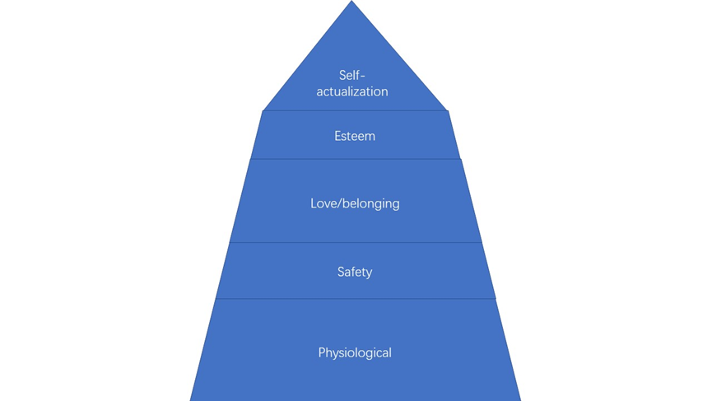
(Figure 1: Maslow's hierarchy of needs)

3.2.2 Motivation
There are many definitions of motivation. Baron (1991) states that motivation is ‘the internal processes that activate, guide, and maintain behaviour (especially goal-directed behaviour)’. Robertson and Smith (1985) agree, declaring that ‘motivation is a psychological concept related to the strength and direction of human behaviour’ (Hollyforde and Whiddett, 2002). So, people cannot be motivated to do something if there is nothing in it for them. Of course, the ‘reward’ may be instrumental in achieving something else (ie. a person may be motivated to do something they do not find rewarding because it will help them get something else, they do find rewarding). Also, the ‘reward’ may be the avoidance of a negative outcome as much as it may be the achievement of a positive outcome (Hollyforde and Whiddett, 2002). Motivation is the strength and direction of behaviour and the factors that influence people to behave in certain ways. There are two types of motivation, which is intrinsic motivation and extrinsic motivation (Armstrong and Taylor, 2017). Intrinsic motivation involves motivating employees through non-tangible assets such as the chance to grow and develop within an organisation. Extrinsic motivation is the opposite of intrinsic involving tangible assets such as pay (Armstrong, 2007). The intrinsic motivation can increase job satisfaction, which is relate to job content, especially the five dimensions of jobs identified by Hackman and Oldham (1974): Task identity, task significance, autonomy, skill variety and feedback (Armstrong, 2017). For this case, when the rise of staff satisfaction, the organisation can increase their productivity and performance, the internal stakeholder could influence external stakeholder, such as student’s satisfaction (Hollyforde and Whiddett, 2002).
It shows in questionnaire and interview results that motivational factors may be lacking within Chinese school. Both intrinsic and extrinsic could be seen as being in need to improvement. Looking at intrinsic factors a percentage of employees were unsatisfied with the training offered to them by the organisation however the level of positive feedback on intrinsic factors was higher than that towards extrinsic factors when asked about rewards and benefits in general the majority of employees were unsatisfied with what the organisation is offering.
As mentioned before Maslow’s Hierarchy of needs suggest that once people have reached one goal their motivation changes to another want. Maslow proposed that there are five levels of motivation starting with physiological needs such as wanting to satisfy basic human needs such as hunger and sleep this would then be followed by safety needs, love needs, esteem needs and lastly self-actualisation (Mullins, 2013). Basic needs of an employee would be met by organisations through pay and extrinsic motivators. As an employee’s motivation progresses up the hierarchy their motivators would become more intrinsic.

3.2.3 Reward and Total Rewards
On the broad side, reward is something given in exchange for behaviour or work, such as compensation and benefits (Armstrong, 2002). And reward also could be anything to which staff as individuals fasten positive value as a satisfier of evident self-defined demands. Corporate ask for design and develops awards, which is staff with three main objectives: motivating staff to explain their best abilities, retaining the best people and attract the right person at the right time (Shields, 2007).
According to primary research results show that many staff at Chinese school are unsatisfied with the rewards and benefits offered to them by their employer. Through the research, there is some methods of reward employers can offer their employees.Total reward is covering all types of work that worker value (Manus and Graham, 2003), the part of an overall reward strategy is from both intangible and tangible (CIPD, 2019b). All aspects of remuneration, namely basic salary, non-financial rewards, employee benefits and contingent salary, including the intrinsic remuneration of the work itself, are interrelated and cohesive whole and regarded as a complete (Armstrong and Taylor, 2017). On this definition, rewards not only include financial rewards, but also beneficial non-financial rewards. Rewards fall into 2 broad categories both “extrinsic” and “intrinsic” (Perkins and White 2011). Extrinsic rewards, transactional rewards are quantitative, tangible remuneration arising from an exchange between an employer and an employee on remuneration and benefits. Such as bonuses, pay, paid leave and holidays (Armstrong and Murlis, 2007). On the other hand, Intrinsic rewards arises from the content of the job itself, which is intangible and satisfy employee demand (Fazal, 2011).
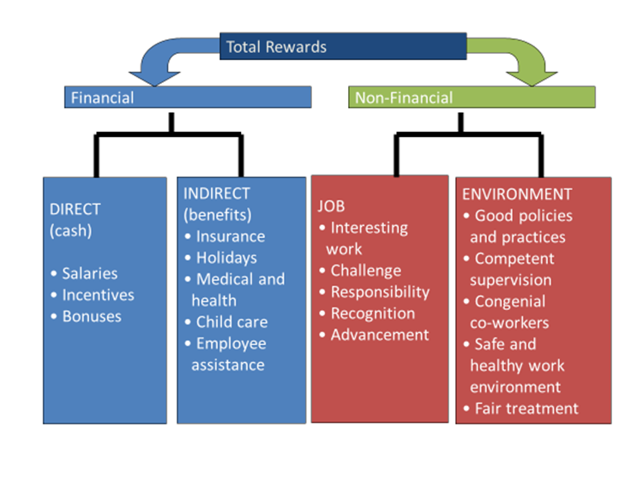
(Figure 1: The components of total rewards)
Therefor, Confucius institute manager should recognize the importance of both tangible and intangible rewards in the context of broader work experience, total rewards have broad implications for both employees and employers (Perrin, 2005).
There is some example for help Confucius institute reference. They are also non-profit organisation. It is one of the best in the Sunday Times Best Companies to work for 2019. Transforming Lives for Good (TLG) is a positive force for disadvantaged children and their families, and for its own 70-strong staff, who have voted this Christian charity the Best Not-For-Profit Organisation to Work For on its debut in this survey. Employees’ work is celebrated at an annual awards ceremony – Barnett won an accolade for her outstanding contribution last year – and praise and encouragement arrive regularly via email, text and monthly one-to-one meetings. TLG helps him understand that the contribution I make is big and it is seen. The training includes job shadowing, coaching and an in-house leadership programme that is open to all, while there are three wellbeing days a year when staff relax, have fun together and focus on recharging their batteries. They really emphasise team and supporting one another (The Times, 2019).
Another excellent example is John Lewis Partnership, it is an employee-owned UK company. They have three principles base on partnership system is the sharing of knowledge, power and wealth. John Lewis's partnership is both a labour relations process and a model of ownership and organisational structure (John Lewis Partnership, 2019). This structure means that the new organisation was made up of partners, instead of employees, managers and owners, all of whom own shares in the company. These principles underpin the potential for mutual gains (Cathcart, 2014).

4.0 Conclusion
In conclusion, through conducting this consultancy project into the staff motivation at Confucius institute, researcher have found that there are improvements that can be made to certain parts of the organisation’s employee engagement plan. The main area for focus and that employees to be most unsatisfied with it the reward system that the organisation has. Concluded from research that motivation is a vital part of encouraging employees to work and that providing them with goals and benefits will be a great improvement to the organisation. Employers offer their employees with Total Reward schemes have been found to have motivated employees that are engaged with their organisations.

4.1 Recommendation
Herzberg believe in a two-factor theory of motivation, and he had close links with Maslow. He claims there were evident issue factors that a business could introduce that would directly motivate worker to work harder, that is motivators. However, there were also issue that would de-motivate a worker if not current but would not in themselves inspire worker to work harder, this is hygiene factors. For example, the workers motivated to work harder by motivators, such as the more interesting work and more praise for good work. And workers can become de-motivated if hygiene factors are not met, such as paying and relationships with colleagues (Riley, 2018). So, the Chinese school leaders should change them mind focussing on intrinsic rewards. This is same as Confucius opinion: “teach students in accordance of their aptitude”. The manager should use different way to motivate different staff, to satisfied them needs (Confucius and Legge, 2013). One of the greatest challenges for organization is to improve its level of efficiency and productivity. Moreover, an increase in productivity and efficiency can be achieved not only by applying techniques and adapting advanced technologies, but also needs motivated and enthusiastic employees. To gain a productive and positive behaviour through its employees, management needs to create a sound motivational environment within the entire organization. A positive motivation through the workforce is likely to lead a company to grow more smoothly in terms of production, productivity and effectiveness (Nawaz, 2011). Therefore, Chinese school leader should more communicate with employees. And also create a Total Reward scheme that fits the organisation business plan and that motivates employees using the results from the conducted research. To be effective, Chinese school can use ‘workshop’ to help staff communication and improve engagement, to organise a group of people engage in intensive discussion some teaching project.

Appendices

Appendix 1 -- Questionnaire
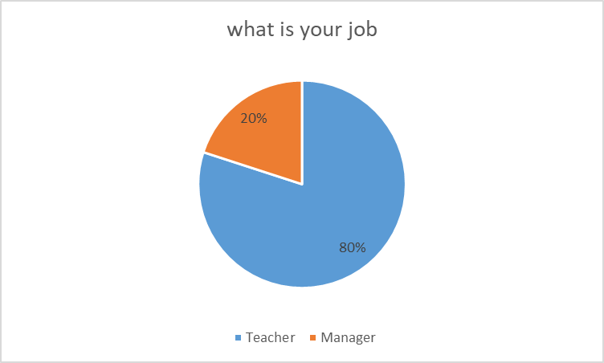
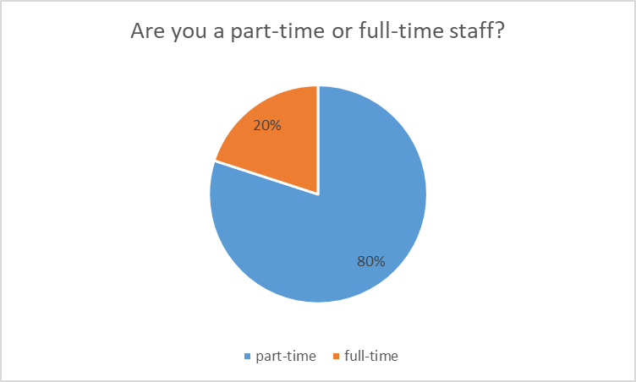
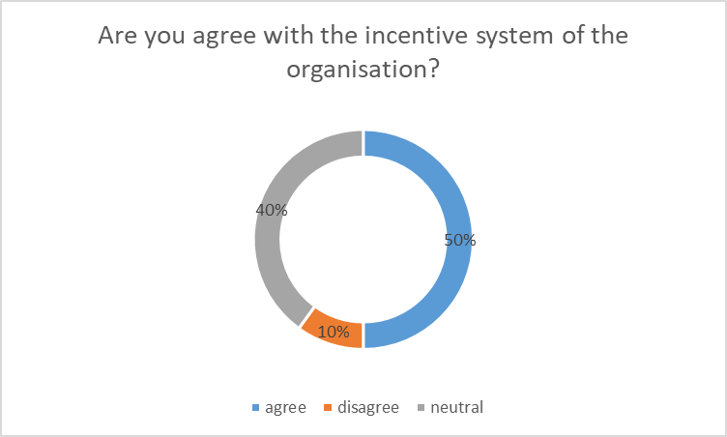
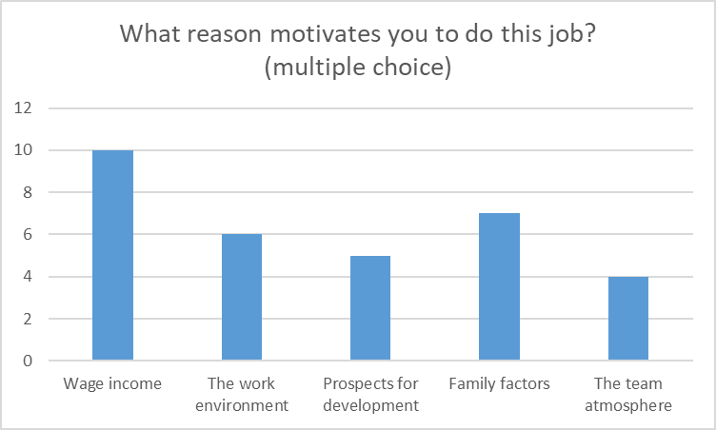
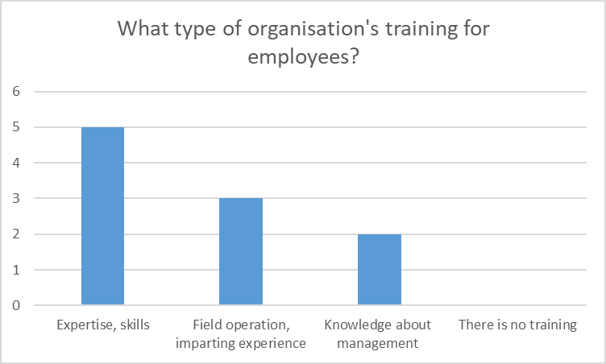
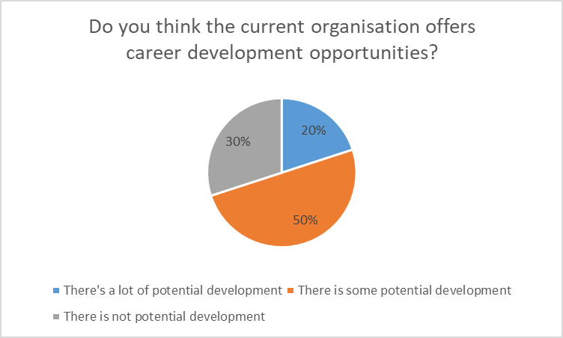
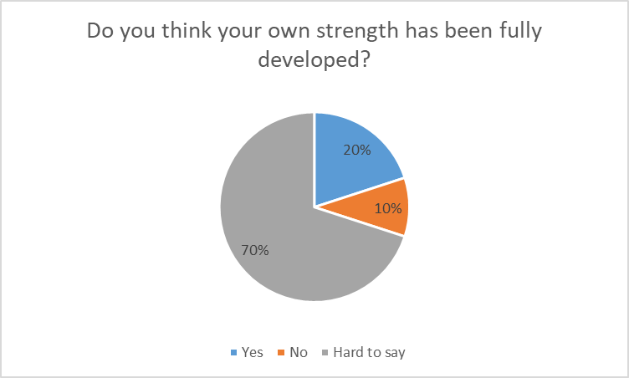
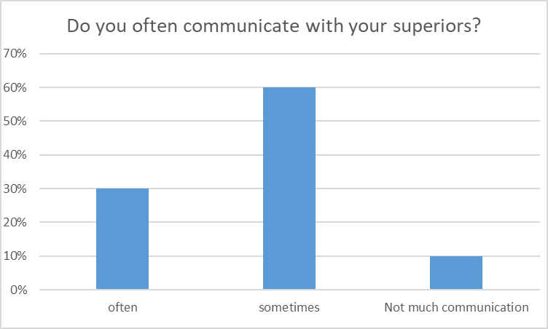
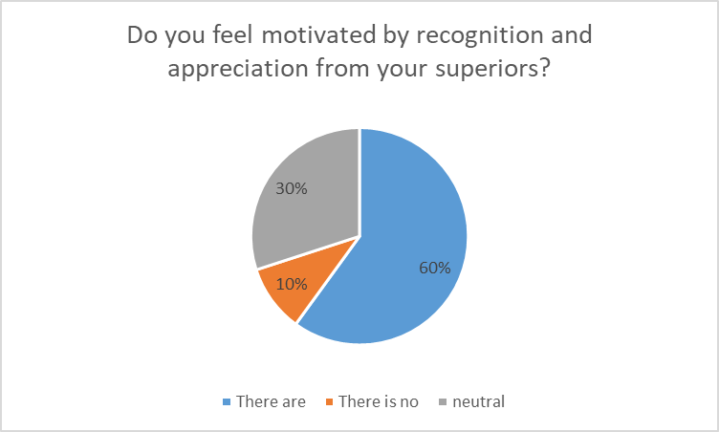

Appendix 2 – Interview
Could you briefly introduce the status of the organization and the working atmosphere of the staff?

What are the organization requirements on recruitment? Hanban dispatch or social recruitment?

What are the current incentive mechanisms? Are there different types of incentives for employees at different levels?

What do you think of the difficulties and obstacles in the implementation process?

What do you think are the main needs of employees?

Do you think we should stick to the incentive mechanism or change some schemes?

What do you think are the parts that need to be improved?

Bibliography
Armstrong, M. (2002) Employee reward. 3rd ed. London: Chartered Institute of Personnel and Development.
Armstrong, M. (2007). Employee Reward Management and Practice. 2nd Ed. London: Kogan Page Limited.
Armstrong, M. and Murlis, H. (2007) Reward Management. 5th Ed. London: Kogan Page.
Armstrong, M. and Taylor, S. (2017) Armstrong's Handbook of Human Resource Management Practice. 14th Ed. Ringgold Inc.
Biggs, D. (2010) Management consulting: a guide for students. Andover: Cengage Learning.
Bremer, V. (2011) Advantages and Disadvantages of Questionnaires. Available at: https://wiki.ecdc.europa.eu/fem/w/wiki/advantages-and-disadvantages-of-questionnaires (Accessed on: 6 April 2019)
Cameron, E. & Green, M. (2012) Making Sense of Change Management, 3rd edition, London: Kogan Page
Cathcart, A. (2014) ‘Paradoxes of participation: non-union workplace partnership in John Lewis’, The International Journal of Human Resource Management, 25(6), pp. 762.
Chandler, D. and Munday, R. (2011) Maslow's hierarchy of needs. A Dictionary of Media and Communication. Oxford University Press.
Chandler, D. and Munday, R. (2011) Questionnaire. A Dictionary of Media and Communication. Oxford University Press.
CIPD. (2019a) People Management Awards. Available at: http://www.cipdpmas.co.uk/categories-2019/ (Accessed on: 1 May 2019).
CIPD. (2019b) Strategic reward and total reward. CIPD. 24th April.
Confucius and Legge, J. (2013) Confucian Analects, The Great Learning & The Doctrine of the Mean. Newburyport: Dover Publications.
Debois, S. (2016) 9 Advantages and Disadvantages of Questionnaires. Available at: https://surveyanyplace.com/questionnaire-pros-and-cons/ (Accessed on: 6 April 2019).
Economist. (2009) A message from Confucius. Available at: https://www.economist.com/special-report/2009/10/22/a-message-from-confucius (Accessed on: 6 April 2019).
Fazal, H. (2011) What is the difference between Intrinsic and Extrinsic rewards. Available at: https://pakaccountants.com/difference-between-intrinsic-extrinsic-rewards/ (Accessed on: 1 May 2019).
Heathfield, S.M (2019) The Advantages and Disadvantages of Flexible Work Schedules. Available at: https://www.thebalancecareers.com/advantages-and-disadvantages-of-flexible-work-schedules-1917964 (Accessed on: 5 April 2019).
Hollyforde, S. and Whiddett, S. (2002) The Motivation Handbook. London: Chartered Institute of Personnel and Development.
Jenny. (2014) Clearly Define Your Research Strategy. Available at: https://www.mackenziecorp.com/phase-2-clearly-define-research-strategy/ (Accessed on: 3 April 2019).
John Lewis Partnership (2019) Our Business. Available at: https://www.johnlewispartnership.co.uk/about.html (Accessed on: 2 May 2019).
Libin, X (2018) Spread Chinese culture and carry forward the spirit of volunteers. Available at: http://paper.people.com.cn/rmrbhwb/html/2018-04/12/content_1847592.htm (Accessed on: 11 April 2019).
Lien, D. Yao, F. and Zhang, F. (2017) Confucius Institute's effects on international travel to China: do cultural difference or institutional quality matter? Applied Economics, 49(36), pp.3669-3683.
Manus, T. M. and Graham, M. D. (2003) Creating a Total Rewards Strategy. New York: American Management Association.
Maslow, A.H. et al. (1998) Maslow on management. New York: Wiley.
Mattis, P. (2012) Re-examining the Confucian Institutes. Available at: https://thediplomat.com/2012/08/reexamining-the-confucian-institutes/ (Accessed on: 5 April 2019).
Nawaz, S. A. (2011) ‘Employee motivation: A study on some selected McDonalds in the UK’, African Journal of Business Management, 5(14), pp. 5541-5550.
Norrie, J. (2011) Confucius says school's in, but don't mention democracy. Available at: https://www.smh.com.au/education/confucius-says-schools-in-but-dont-mention-democracy-20110219-1b09x.html (Accessed on: 4 April 2019).
Penn, B. (2014) China Business: A broader education. Available at: https://www.nzherald.co.nz/china-business-2013/news/article.cfm?c_id=1503331&objectid=11238085 (Accessed on: 3 April 2019).
Perkins, S. J. and White, G. (2011) Reward management: alternatives, consequences and contexts. 2nd Ed. London: Chartered Institute of Personnel and Development.
Perrin, T. (2005) Reconnecting with Employees: Quantifying the value of engaging your workforce, London.
Riley, J. (2018) Motivation - Herzberg (Two Factor Theory). Available at: https://www.tutor2u.net/business/reference/motivation-herzberg-two-factor-theory (Accessed on: 4 April 2019).
Sahlins, M. (2013) China U. Available at: https://www.thenation.com/article/china-u/ (Accessed on: 5 April 2019).
Saunders, M. and Lewis, P. (2012) Doing Research in Business & Management. Harlow: Financial Times Prentice Hall.
Shields, J. (2007) Managing employee performance and reward concepts, practices, strategies. New York: Cambridge University Press.
Sridhar, J. (2018) How Is Data Analysis Performed? Available at: https://www.makeuseof.com/tag/what-is-data-analysis/ (Accessed on: 5 April 2019).
The Times. (2019) The Sunday Times Best Companies to Work For 2019. Available at: https://appointments.thetimes.co.uk/article/best100companies/ (Accessed on: 4 May 2019).
UWTSD. (2016) About us. Available at: https://www.uwtsd.ac.uk/confucius-institute/about/ (Accessed on: 6 May 2019).
Wickham, L. and Wilcock, J. (2016) Management consulting: delivering an effective project. 5th Ed. New York: Pearson.
Ye, W and Edwards, V. (2018) ‘Confucius institute teachers in the UK: motivation, challenges, and transformative learning’, Race, Ethnicity & Education, 21 (6), pp.843-858.
Ying, W. (2016) ‘Review of the Confucius Institutes’ Strategy for the Dissemination of Chinese Culture,’ Chinese Education & Society, 49 (6), pp. 391-402.

