

UNILEVER

Module Code: LCBB6001
Assignment Title: Assignment 1
Module Lecturer’s Name: Rexon Nting
Student Name: Simona Mocanu

Student ID: 1905164

Table of Contents
Introduction 1
Introduction to the developing countries 1
Cultural differences 3
Cultural Sensitivity 4
Communication barriers and challenges 4
Communication strategies and recommendations 5
Conclusion 6
Reference list 6

Introduction
International business refers to a business that is working across the national border. The organization needs to operate its business and commerce in many countries. This business can be selling and producing goods and services in many countries. International business and communication show that the business has to run its operation in more than one country, and by doing business internationally, the organizations are facing many cultural and language problems. These problems can create communication challenges for the business. Because of this reason, international business practices about the international communication process to deal with this challenge. The absence of good communication practices in the organization can lead to a huge loss of the company as well as increases the tension of the business when it is working in a different country and culture. In this report, cultural differences and sensitivity will be presented that are faced by the company when it is working in different countries. Hofstede's cultural dimension model will be discussed to show the cultural differences between the home country and the host country. Unilever is planning to expand its business in China. Cultural differences and sensitivity are very common between UK and China. China's culture, population, language, economy, technology advancement, workforce, and unemployment will be described properly in this paper. Communication barriers, challenges, and required communication strategies will be presented in this report. Production challenges demonstrate the factors which have to face when the company produces the goods. Some production challenges in the UK are organization challenges, technological challenges, product-related problems, employee problems, society and political challenges, and procurement challenges. The company in China faces a lack of technical knowledge, lack of storing facilities, product processing challenges, logistics-related challenges, information or communication challenges, inventory management challenges, economic challenges, and employment-related issues. So, Tesco has to face these production-related issues in both countries.

Introduction to the developing countries
China has been selected country to shift business from the UK. China has the world’s largest developing economy which is a positive fact to expand the business in China. One of the biggest manufacturing companies in the UK is Unilever which is considering shifting its production. It selects China to shift its production process. China is one of the most significant countries for manufacturing business. The government of China can better monitor and control the environmental and labour standards. Developing countries' government provides more incentives in the manufacturing sector than developed countries. Unilever can shift its production process in China because of getting these incentives. Being a developing country, the government of China gives attention to the manufacturing sector instead of the agriculture sector which can be an advantage for Unilever. The main reason behind this decision is to create jobs and to reduce the dependency on the agriculture sector. China is a large populous country with a 1414.00 million population. According to Trading Economics global macro model and analysis expectations, the population of China will be 1425.00 million in the long run. The official language of China is Mandarin Chinese, and this language is the most widely used native language in the world (Spolsky, 2014). Though there are many dialects in China, Mandarin Chinese is considered the official language.
The culture of China is diversified among the people, and it is a multi-religious country. Some significant religions are Taoism, Islam, Buddhism, Protestantism, and Catholicism which have played a vital role to shape the culture. There are some differences in business culture between UK and China. In China, business negotiation depends on customer long-term relationships. For example, restaurants, bars, and coffee shops are used to complete final business negotiations and business dealings (Liao, 2017). Visual expression and formal appearance are very significant in Chinese business culture. Moreover, Unilever should be concerned about any kind of gift-giving process as gift-giving is one kind of tricky topics in Chinese business culture. So, Unilever must follow these Chinese business cultures if it wants to shift its production operation to China. China has the fastest-growing economy in the world with the average growth of the actual annual gross domestic product. In 2021, the gross domestic product was $17.7 trillion, and the growth of GDP was increased by 8.1% from the previous year (Saeed and Balan, 2021). Industrial production and manufacturing export have played the most important role to increase GDP growth. It can be predicted by many observers that China can lead the future technological sector.
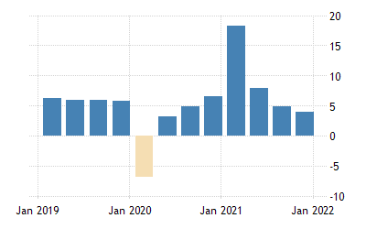
Figure 1: GDP Growth
Source: (Sheng, 2022)
In recent days, China has invented some great innovations which make it easy to operate a business in China. These innovations are high-speed rail, Alipay, bike-sharing, and online shopping. The workforce in China refers the people who are more than 16 years old and capable of working. In 2020, China’s workforce was approximately 784 million (Kuhlmann et al, 2020). This workforce can be divided into two parts, and these are employees and contingent workers. The unemployment rate in China has increased to 5.5% up from 5.3% in 2022. The reason behind this rising unemployment rate is the Covid-19 pandemic.

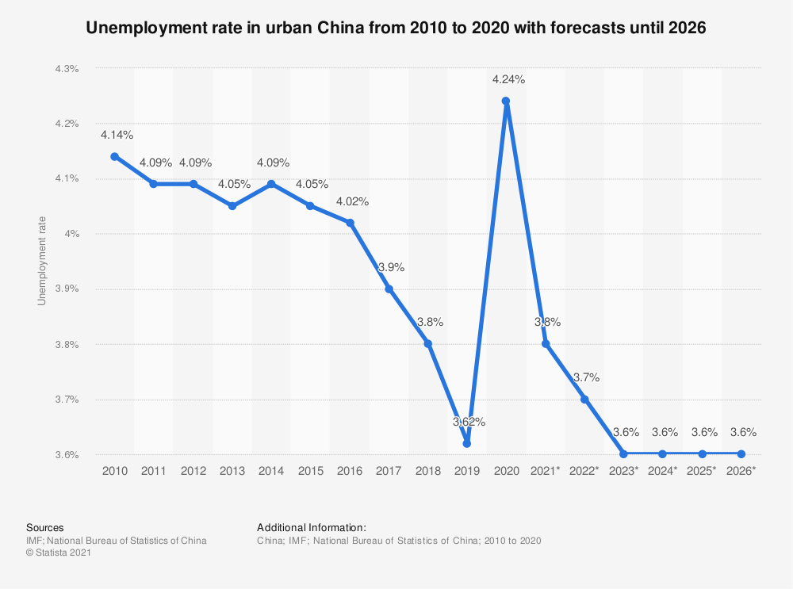
Figure 2: Unemployment Rate
Source: (Li, Fu, and Wu, 2020)

Cultural differences
Cultural differences refer to the expectation gap between two countries' cultures. Personal space and physical contact show the business cultural differences. How peoples behave in a certain environment is shaped by the culture. For example, European and South American culture prefers a kiss on the cheeks in greetings rather than shaking hands. In Chinese culture, shaking hands is a very common manner in which greetings, as well as nodding and smiling faces, are very important (Aggarwal and Zhan, 2017). To find out the cultural differences between UK and China, Hofstede's cultural dimension model is used in this report. Power distance is the first cultural dimension that is used to differentiate the cultural difference among the countries. China is a highly power-distanced country where the UK shows a low score in the power distance dimension. In China, it is accepted that all people in society are not equal, and they cannot get equal power and facilities (Mousavi, 2012). In the UK, low power distance demonstrates that the superior enjoyed less power over the subordinate. This culture approves that the people in the society should be treated in some ways as equals. Individualism factor shows the interdependence among the members of society. Whether the people are more likely to work in group or individual. There is a high score in the UK society which means the people in the UK are less collectivist. The people in the UK are self-centred and look after their direct family only. On the other hand, China is a collectivist society where peoples are more likely to work as a group, and they are more concerned about the group's interests. Masculinity indicates the competitive nature of society's members, with quality determining success and achievement. China seems to be a very masculine society, which means they are goal-oriented. People make a concerted effort to improve their wages, that's why people do not have enough free time. The UK is also a masculine country where peoples are also goal-oriented (Hofstede, 2011). Uncertainty avoidance reveals a culture's risk-taking practices. How do people in several societies are responding to unexpected and unpredictable events? In China and UK, the score for uncertainty avoidance is low, indicating that Chinese individuals are more receptive to different conditions. The long-term orientation component shows how people connect their current situation to their earlier experiences. China and UK both have a high score in Long term orientation. The final category is an indulgence, in which China scores poorly. China is a conservative society prone to scepticism and pessimism. On the other hand, the UK has a high score in indulgence which means people have more control over their desires and feelings.

Cultural Sensitivity
Cultural sensitivity refers to the willingness to acknowledge the cultural differences among the countries. Moreover, cultural sensitivity indicates how people are reacting to the different cultures, such as being confused, sad, angry, etc. In a business organization, cultural sensitivity demonstrates that the company should understand that every worker or employee has not the same culture and values. Unilever should have the ability to function effectively in different cultures. The opposite condition is called cultural intelligence which includes knowing the own employee's culture, knowing the Chinese employee's culture, and leading together (Holan et al, 2017). To evaluate China's cultural sensitivity, the intercultural sensitivity model can be used which has six steps. These steps are Denial, Defence or reversal, Minimisation, Acceptance, Adaptation, and Integration. In the first stage, the peoples in China are not interested in cultural differences and could care less about people from other cultures. The second step is a reversal which shows that the Chinese people heavily criticize their own culture. For example, if the people say that we are very lazy. The minimization stage demonstrates the opinion about other's cultures that they are doing wrong. Acceptance tells that the people appreciate and recognize the cultural differences though they do not agree. In this stage, the people should have respect for other's cultures and values as well as tolerance of ambiguity. Adaptation refers that the people being willing to adapt to other's cultures and behaviour to communicate more effectively (Ranna Parekh and Trinh, 2019). The last step is the most appropriate where the employees help each other to understand the different cultures and increase unity between different cultures. To get the best result from cultural sensitivity, Unilever should use the integration process of the cultural sensitivity model. The integration allows the organization to encourage the employees to support each other to understand the cultural difference between UK and China. For example, Unilever should train its employees in the Chinese language because it should not expect the English language in a business meeting in China.

Communication barriers and challenges
As there is a vast population of various kinds of ethnic groups, the language barrier is one of the most vital barriers for foreign organizations. Unilever has to face three common communication barriers when it shifts its manufacturing process in China. These three communication barriers are linguistic barriers, cultural, and psychological. These seem to be very difficult for foreign organizations (Shim, 2018). Moreover, physical barriers, perceptual barriers, emotional barriers, language barriers, and interpersonal barriers are also included in communication barriers. For example, when a senior manager shut the door of his office then a physical distance is created which can be a barrier to effective communication. Perceptual barriers show the way of talking and the behaviour of someone can affect the preconceived idea of another. Emotional barriers refer the anger, sadness, anxiety, and pride which can be under-emphasized or overemphasized the communication. The emotional barrier can negatively affect the great communication process. The cultural barrier can play a major role in the poor communication process (Mateo González, 2018). For example, the meaning of gift-giving can vary in UK and China. Gender barriers indicate the different communication styles between males and females which can create a communication barrier.
The main problems or challenges in China are human resource management, consumer loyalty, and cultural differences. Human resource management is considered a challenge for a foreign company in the UK because of this large population. It is very tough to find out the potential workforce of the 1.3 billion population. Selecting a qualified person will be the main challenge for Unilever (Clifton, 2019). Employee motivation is another problem that has to be faced by a foreign organization. Motivational incentives are not the same in the UK and China that's why Unilever may face this problem when it provides incentives to its employees. Employee firing and compensation policy can also be a challenge. Consumer preferences and loyalty is considered a challenge for foreign organization.

Communication strategies and recommendation
Communication strategy demonstrates the standard way in which the organization can create good contact among the employees. To continue the business adequately, Unilever can use some communication strategies in China which can help to operate its business. Unilever should train its employees about the right timing. The right moment is very important for effective communication (Kernbach et al, 2014). The employees should respect Chinese people's opinions or points of view. It should be considered by the organization in any communication process. Before developing a communication strategy, there must be a plan about the communication strategy. Five steps of the communication strategy that Unilever follows in communication strategies are determining the goals and objectives of the communication strategy. The organization should set the goals such as what exactly it wants to communicate. For example, the communication objective of Unilever is to create an integrated business environment. Communication objectives should be smart. The second step is identifying the target audience which is the Chinese employees (Andrews, 2016). Developing a creative message means what are the messages Unilever wants to deliver to its Chinese workers or employees. Channels of communication are another step in communication strategy. Unilever can use face-to-face communication or other mediums to complete communication. Feedback is the last stage, and Unilever should focus on the message's feedback. So that it can take necessary steps to achieve the communication objective.
To develop an appropriate communication strategy, Unilever can use some steps through which it can establish a proper communication process. These recommendations are:
- Determining the promotional mix which allows the organization to set its communication strategy. According to products and services, the communication strategies can be changed (Bradley and Campbell, 2016).
- Develop a standardization process that means the similarity between the UK and China. Standard communication in the organization helps to operate the business in China.

Conclusion
This report is based on international business communication and cultural differences. Unilever is a UK-based company that selects to shift its production process to China. To start the manufacturing process in China, Unilever has to face cultural differences and cultural sensitivity. In this report, Hofstede's cultural model has been used to find out the cultural differences between UK and China. The stage of cultural sensitivity has also been discussed in this paper. What are the communication barriers and challenges that can be faced by the organization have been emphasized here? How communication barriers affect Unilever to operate its business in China is also described. The steps of communication strategies are demonstrated properly such as developing goals, selecting target audiences, right message, right channel, and feedback. At last, some recommendations have been made for the communication strategies of Unilever.

Reference list
Aggarwal, R. and Zhan, F. (2017). Teaching Management of Cultural Differences. Journal of Teaching in International Business, 28(1), pp.1–3.
Andrews, D.C. (2016). A Space for Place in Business Communication Research. International Journal of Business Communication, 54(3), pp.325–336.
Bradley, G.L. and Campbell, A.C. (2016). Managing Difficult Workplace Conversations. International Journal of Business Communication, 53(4), pp.443–464.
Clifton, J. (2019). Book Review: Language in Business, Language at Work, by E. Darics and V. Koller. International Journal of Business Communication, 56(3), pp.449–451.
Hofstede, G. (2011). Dimensionalizing Cultures: The Hofstede Model in Context. Online Readings in Psychology and Culture, [online] 2(1), pp.1–26. Available at: https://scholarworks.gvsu.edu/cgi/viewcontent.cgi?article=1014&context=orpc.
Holan, J.R., King, C.K. and Davis, A.R. (2017). Comparative copper sensitivity between life stages of common subantarctic marine invertebrates. Environmental Toxicology and Chemistry, 37(3), pp.807–815.
Kernbach, S., Eppler, M.J. and Bresciani, S. (2014). The Use of Visualization in the Communication of Business Strategies. International Journal of Business Communication, 52(2), pp.164–187.
Li, X., Fu, H. and Wu, Y. (2020). Pollution mitigation, unemployment rate, and wage inequality in the presence of agricultural pollution. China Economic Review, 61, p.101425.
Liao, S. (2017). Fashioning China: Precarious Creativity of Women Designers in Shanzhai Culture. Communication, Culture & Critique, 10(3), pp.422–440.
Mateo González, R. (2018). Cultural barriers in German-Spanish business communication. Glottodidactica. An International Journal of Applied Linguistics, 45(1), pp.41–49.
Mousavi, M. (2012). Assessing the Consistency of the Design of Iranian Websites with Cultural Characteristics of their Target Users: An Investigation of the Hofstede Model. Information Management and Business Review, 4(6), pp.362–369.
Ranna Parekh and Trinh, N.-H. (2019). The Massachusetts General Hospital textbook on diversity and cultural sensitivity in mental health. Cham, Switzerland: Humana Press.
Saeed, M. and Balan, E. (2021). A Neural Network Analysis of the Economic Condition of the China – Central Asia Economic Corridor. Delhi Business Review, 22(1), pp.26–50.
Shim, J. (2018). Challenges, Barriers, and Opportunities for Global Recognition. Asian Communication Research, 15(3), pp.5–19.
Spolsky, B. (2014). Language management in the People’s Republic of China. Language, 90(4), pp.e165–e179.
Kuhlmann, E., Ernst, D. and Jablonka, A. (2020). The specialised health workforce matters: how to adapt the WHO National Health Workforce Accounts. European Journal of Public Health, 30(Supplement_5).
Sheng, Y. (2022). Performance-Based Authoritarianism Revisited: GDP Growth and the Political Fortunes of China’s Provincial Leaders. Modern China, p.009770042210742.

