STUDENT NAME: BENSON L. OBINNA
ID : 2532468
GROUP : 01
DATE : 03/08/2026
COURSE: ACCA4022_LON

Operating Systems Report

Introduction 3
1. Key Functions of General Operating Systems 3
Process Management 3
Memory Management 4
File and Storage Management 4
Device Management 4
Security and User Management 5
Network Management 6
2. Use of Windows OS CLI Commands 7
3. Linux OS CLI Commands 10
4. Use of Windows Batch Scripts 11
5. Linux Bash Scripts 12
Conclusion 13
References 14

Introduction
Operating system (OS) refers to software that interfaces between the computer hardware and the human users, managing resources and allowing software programs to run efficiently. These carry out important operations like process scheduling, handling memory allocation, handle file operations, control the devices, handle security and network communication. Many modern operating systems, such as Microsoft Windows and Linux, also have command-line interfaces (CLI) that can support administrators in performing tasks and solving problems to a greater extent than just using the graphical user interface (GUI). This report introduces the basic OS functionalities and shows how to work with commonly used command-line tools for Windows administration.

1. Key Functions of General Operating Systems
An operating system is a fundamental software that manages and coordinates the resources of computer hardware and software and supplies services to application programs. Several fundamental features keep systems operating securely, efficiently, and conveniently for a consuming public of popular operating systems, including Microsoft Windows, Ubuntu Linux, macOS, and Red Hat Enterprise Linux.

Process Management
Process management is the discipline concerned with the execution of the running program, including how the processor is used and system resources are used. Multiple processes can run concurrently on the same operating system, such as using multitasking and priority scheduling. Windows users can check running processes via the Windows Task Manager and Linux users use the top or htop command most often. Managing processes optimizes system performance and avoids application hogging the CPU (Silberschatz, Galvin & Gagne, 2018).
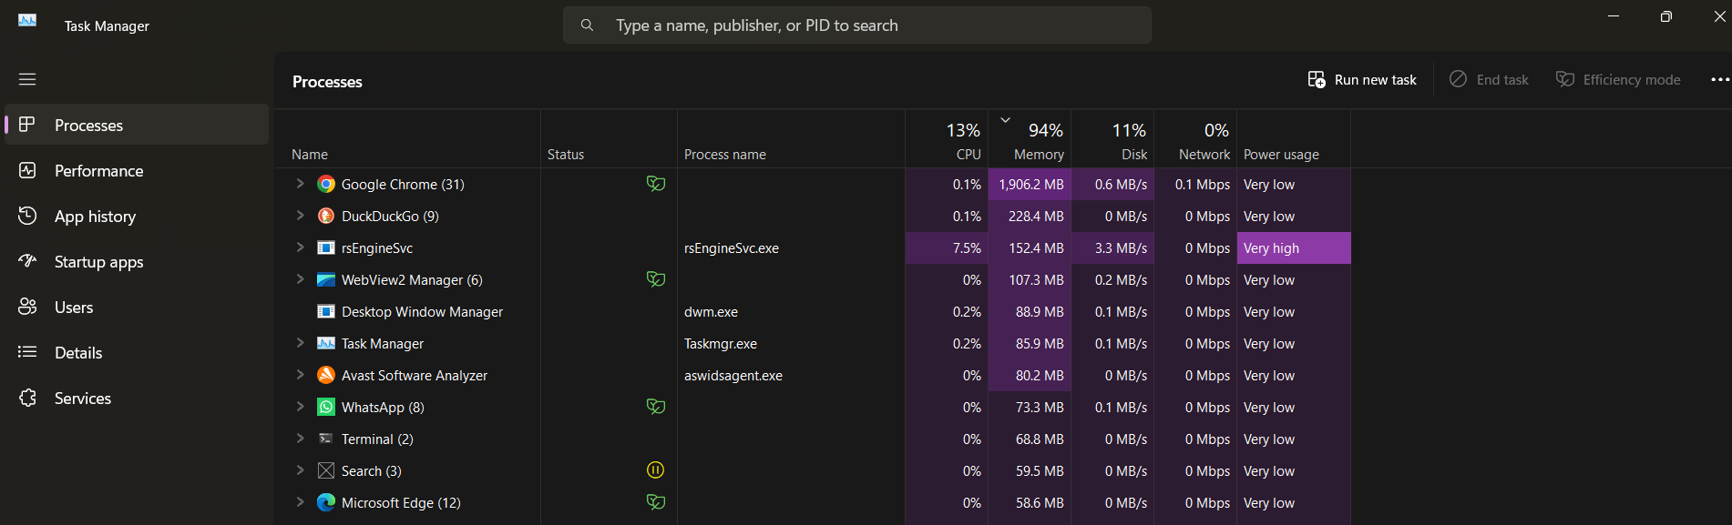

Memory Management
Memory management assigns RAM to running processes while preventing their access to other processes' memory unless authorized. Modern operating systems will simulate Virtual Memory by taking data off applications that are not currently being used and doing so outside of the physical memory. Memory usage is shown in Task Manager's Performance tab for Windows and is available as memory statistics with the free command on Linux.
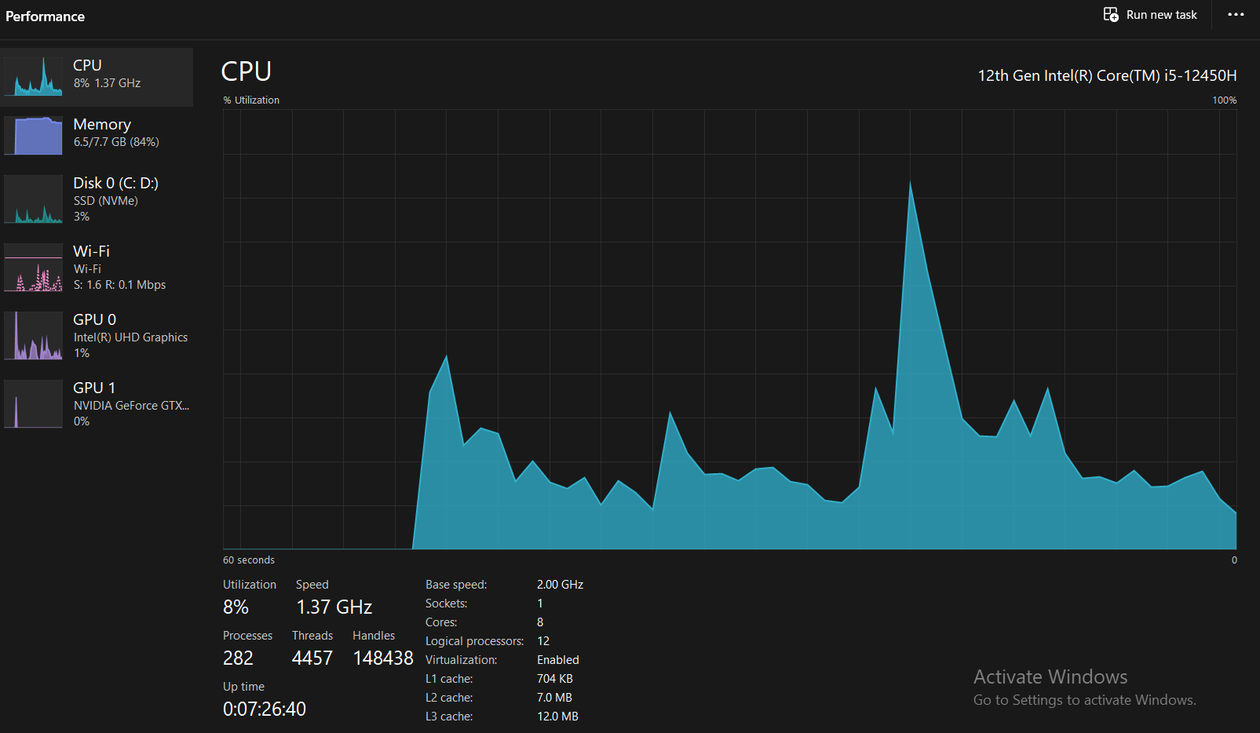

File and Storage Management
A hierarchical system of files is used by operating systems to organize data. NTFS is the main file system in Windows while ext4, XFS, or Btrfs are the most common systems used in Linux. File management involves file creation, deletion, copying, moving, compressing, and securing. Storage management also encompasses disk partitioning, permissions, and file recovery. CLI tools are more flexible than GUI tools, which include Windows File Explorer or Linux file managers.

Device Management
Device drivers are special pieces of software that are designed to communicate between the operating system and hardware devices. Manages printer, keyboard, storage, graphics, and network adaptors; resolves conflicts between them. In Windows, Device Manager enables administrators to install, upgrade, disable or troubleshoot hardware driver configurations.
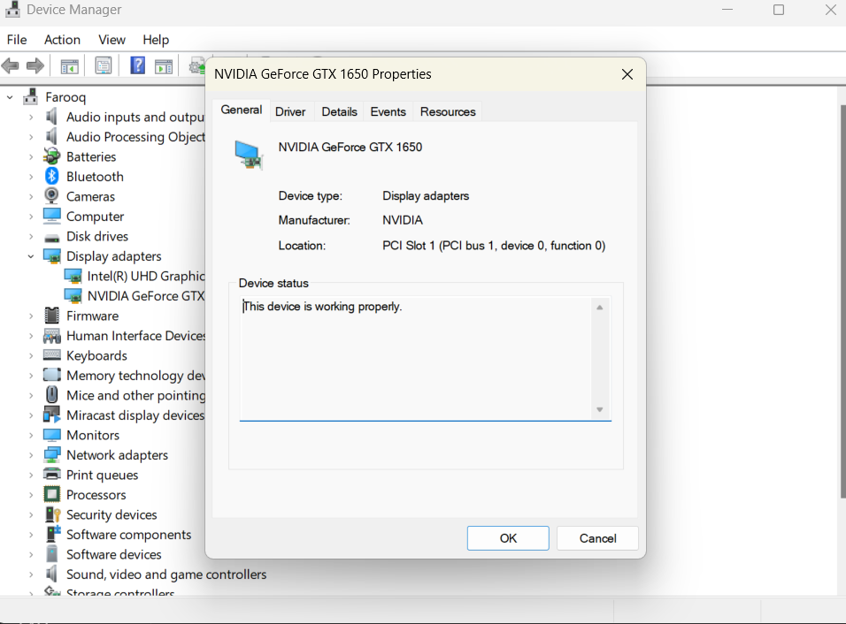

Security and User Management
Security mechanisms identify access users and impose permissions on access to resources on the local file system, applications and the network. These include firewalls, passwords, encryption, Windows Defender, and Linux's discretionary access control, which help to protect systems from "unwanted access" and from being attacked by malware. Access to particular parts of the system is authorised and privileges can be assigned to various user accounts on the system, allowing only certain types of users access to sensitive parts of the system.
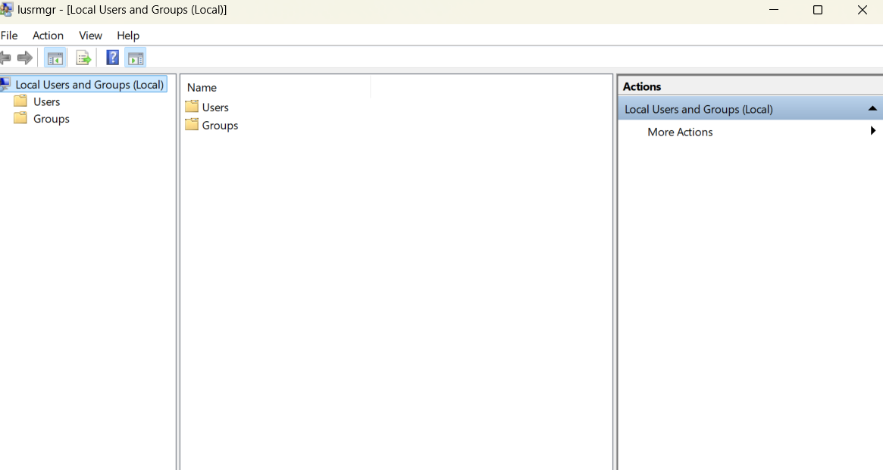

Network Management
Operating systems provide networking services that allow computers to communicate over local and wide area networks. These services consist of TCP/IP configuration, DNS resolution, network monitoring, firewall management and wireless connectivity. Windows comes with an application called Network & Internet Settings, and the Linux operating system has similar applications like ip and ping, as well as command-line applications like ping and ss.
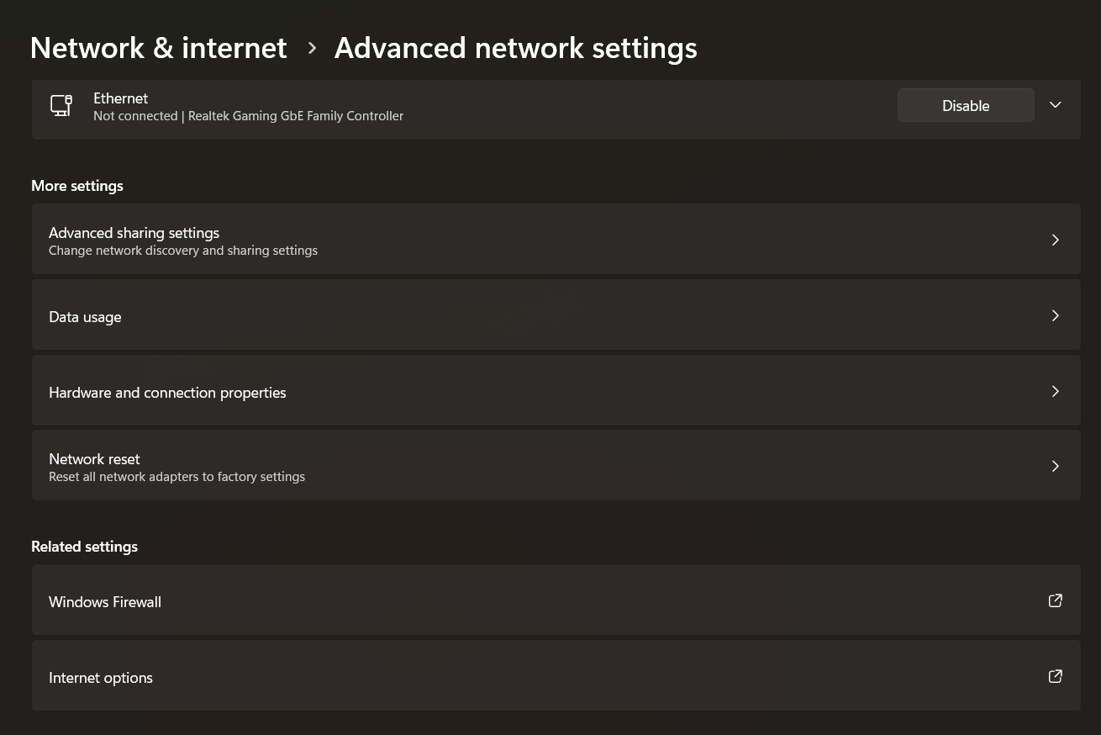
Overall, OS operating systems are frameworks on which all applications run. Process management, memory management, storage management, (hardware) management, users management, and network management leads to reliable system performance, security, and usability, both in a personal computing environment and in enterprise computing.

2. Use of Windows OS CLI Commands
Windows provides both the traditional Command Prompt (Batch) and the more powerful PowerShell environment for system administration. Command-line tools enable administrators to automate repetitive tasks, diagnose problems, and manage system resources more efficiently than graphical interfaces.
Command | Purpose
tasklist | Displays all currently running processes.
taskkill /PID 1234 /F | Terminates a process using its Process ID.
dir | Lists files and folders in the current directory.
mkdir Reports | Creates a new directory.
copy file1.txt D:\Backup\ | Copies files to another location.
ipconfig /all | Displays detailed network configuration including IP address, DNS servers, and MAC address.
ping google.com -n 4 | Tests network connectivity by sending four ICMP packets.
net user | Lists all local user accounts.
net user Student P@ssword123 /add | Creates a new local user account.
schtasks /query | Displays scheduled tasks configured on the system.
schtasks /create /sc daily /tn Backup /tr backup.bat /st 18:00 | Creates a scheduled task to execute daily.
Get-Process (PowerShell) | Displays detailed information about running processes.

Practical Uses
The tasklist and taskkill commands assist with process management by identifying and terminating unresponsive applications. Administrators frequently use these commands when software becomes unresponsive.
The dir, mkdir, and copy commands support file management tasks including directory creation, file organisation, and backups.
Network diagnostics rely heavily on ipconfig and ping. The ipconfig /all command displays IP addresses, DNS settings, and adapter information, while ping verifies whether remote systems are reachable and measures response times.
User administration is simplified through the net user command, allowing administrators to create, modify, or remove local accounts directly from the command line.
Finally, the schtasks utility automates routine maintenance by scheduling scripts, backups, or software updates to execute at predefined intervals without user intervention.
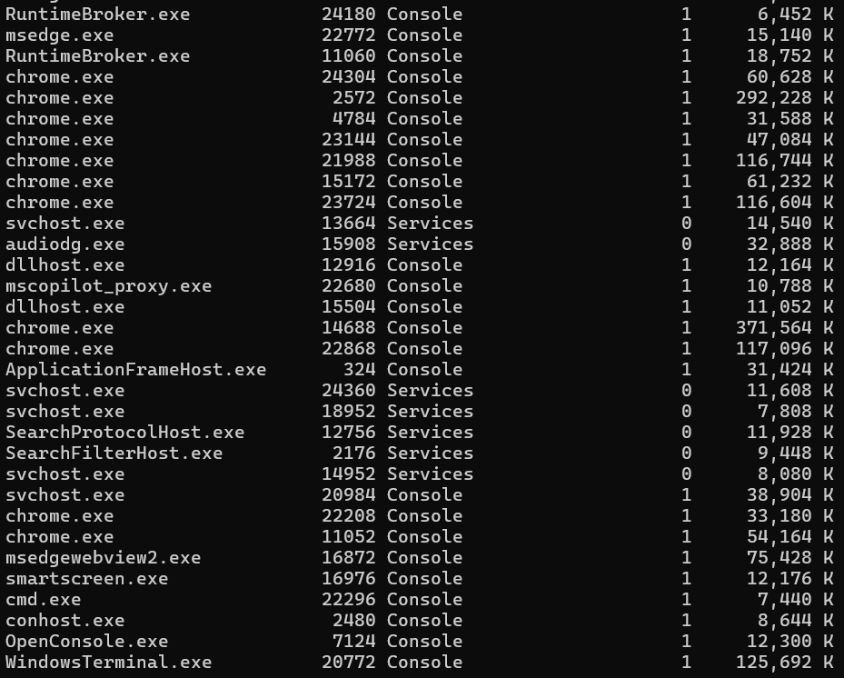
tasklist output.
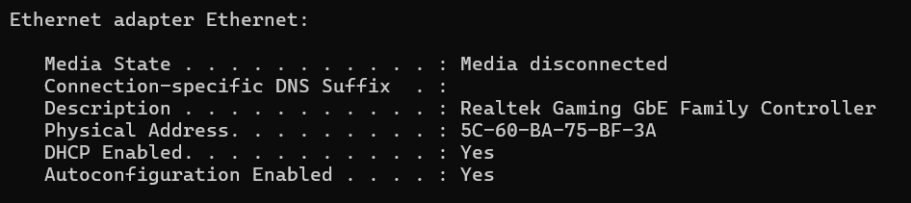
ipconfig /all output.
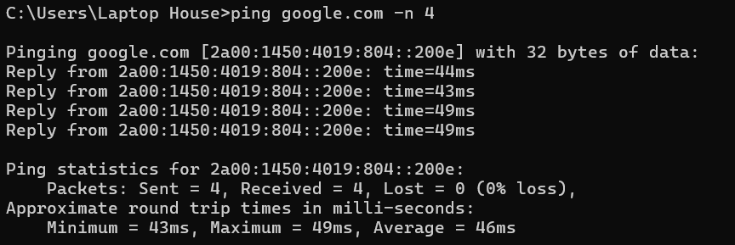
ping google.com -n 4 output.

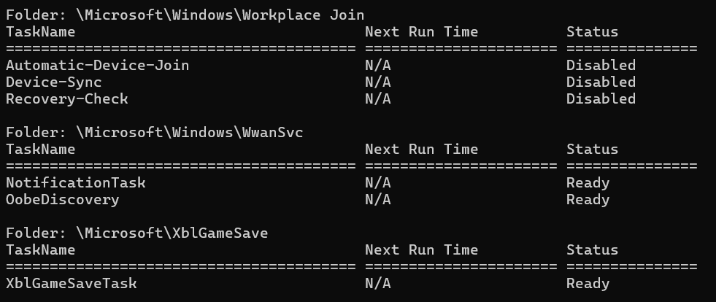
schtasks /query output.
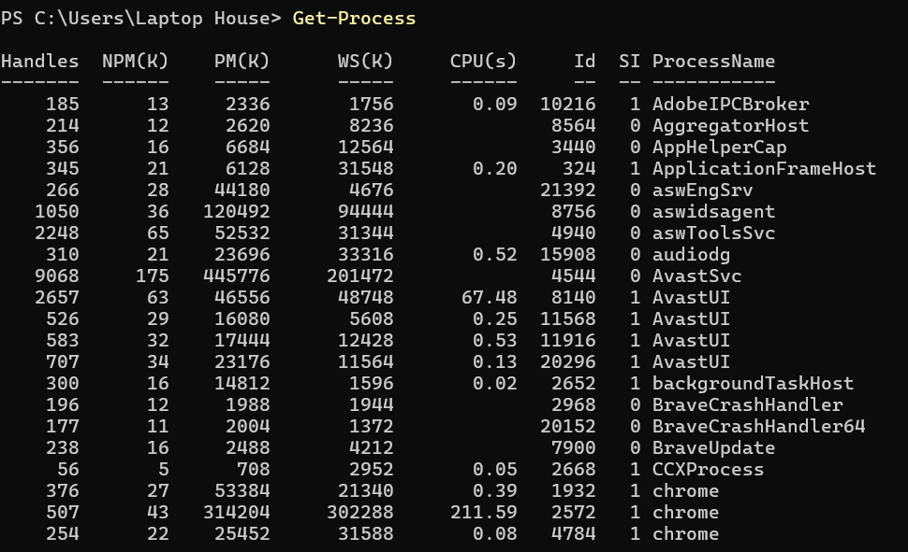
PowerShell Get-Process output.

3. Linux OS CLI Commands
System administration, automation, and troubleshooting can all be conveniently carried out from the Linux command line interface (CLI) accessed from a Bash shell. The CLI is not the same as a graphical interface and can carry out complex tasks in an efficient manner by means of conciseness and simplicity.
Command | Purpose
ps -ef | Displays all running processes.
kill -9 PID | Terminates a process using its Process ID.
ls -la | Lists files and directories with permissions and hidden files.
mkdir project | Creates a new directory.
cp file.txt backup/ | Copies files to another directory.
mv old.txt new.txt | Moves or renames files.
ip addr show | Displays network interface configuration and IP addresses.
ping -c 4 google.com | Tests network connectivity by sending four ICMP packets.
sudo adduser student | Creates a new user account.
crontab -l | Lists scheduled cron jobs for the current user.
df -h | Displays disk usage in a human-readable format.
free -h | Shows memory usage statistics.
These commands are used to perform basic administrative functions. For process management, use of ps -ef and kill commands enables super users to check the status of the processes and to end unresponsive processes. The efficient ways to organize file and directory are: ls, mkdir, cp and mv.
Two commonly used network administration commands are ip addr show for displaying IP configuration and ping for testing and diagnosing network connectivity and communication problems. User management is done with sudo adduser, which adds new users with the appropriate permissions. Task Automation in Linux uses cron – crontab -l lists the tasks that have been scheduled for a particular user. Also, df -h and free -h can be used to keep track of storage space and memory usage, aiding in proactive system maintenance.

4. Use of Windows Batch Scripts
Batch scripting automatically performs repetitive administrative tasks on Windows using commands from Command Prompt. These are examples that will show how variables, user input, and conditional statements, as well as arithmetic operations can be utilized.
Script 1: System Information
@echo off
set /p username=Enter your name:
echo Welcome %username%
echo Computer Name: %COMPUTERNAME%
echo User: %USERNAME%
pause
This script asks the user a question, saves the response in a variable and prints some basic system information. It shows handling of variables and interaction with the user.
Script 2: Number Checker
@echo off
set /p num=Enter a number:
if %num% GTR 50 (
echo Number is greater than 50.
) else (
echo Number is 50 or less.
)
Pause

This script takes user input and makes use of a conditional (IF...ELSE) statement to compare the user input value. This is typical in administrative scripts used for decision making and validation.
These examples show how Batch scripts help automate simple tasks in Windows administration, and also perform them more reliably and consistently.

5. Linux Bash Scripts

The Bash scripting provides Linux system administrators with the ability to use variables, loops, arithmetic logic, and conditional statements to automate tasks in the Linux system.
Script 1: Greeting Script
#!/bin/bash
echo "Enter your name:"
read name
echo "Welcome, $name!"
echo "Today is $(date)"
This script takes input from the user, adds it to a variable and prints out a personalised greeting along with the current date. It shows various uses of pipes and command substitution.
Script 2: Countdown Loop
#!/bin/bash
echo "Enter a number:"
read num
while [ $num -gt 0 ]
do
echo $num
num=$((num-1))
done
echo "Finished!"
Counts the numbers down to zero using the user's input, arithmetic and while loop. Automation is a very common use for control structures, including loops, with tasks like backups, monitoring and log processing.
These Bash scripts are a good example of how Linux shell scripting can be used to automate repetitive administrative tasks and to enhance efficiency and user productivity without introducing human error.

Conclusion
The software that controls computers, their hardware, and software services, including process scheduling, allocation of memory, the management of files, access to hardware, security, and network management, is known as operating systems. This report discussed key operating system functions and illustrated OS (Windows and Linux) administration with the Command Line Interfaces. While both the Bash shell and the PowerShell provide an extensive range of functionality, they each have their own limitations, whereas, PowerShell, Command Prompt, and the Bash shell together give administrators a far more efficient way to manage processes, users, files, networks, and scheduled tasks, than any graphical tool could. The Batch and Bash scripts also showed an example of automating repetitive system administration tasks using variables, accepting user input, making decisions with conditional statements, and looping, just as discussed above. IT professionals need to become fluent in command-line operations of both Linux and Windows to achieve higher productivity, better reliability of systems and greater automation of repetitive administrative tasks—hence this skills development focus.

References
[1] A. Silberschatz, P. B. Galvin, and G. Gagne, Operating System Concepts, 10th ed. Hoboken, NJ, USA: John Wiley & Sons, 2018.
[2] A. S. Tanenbaum and H. Bos, Modern Operating Systems, 5th ed. Harlow, UK: Pearson, 2022.
[3] Microsoft, "Windows Commands," Microsoft Learn. [Online]. Available: https://learn.microsoft.com/windows-server/administration/windows-commands. [Accessed: 12-Jul-2026].
[4] Microsoft, "PowerShell Documentation," Microsoft Learn. [Online]. Available: https://learn.microsoft.com/powershell/. [Accessed: 12-Jul-2026].
[5] Microsoft, "Task Manager in Windows," Microsoft Support. [Online]. Available: https://support.microsoft.com/windows. [Accessed: 12-Jul-2026].
[6] Ubuntu Documentation Team, "Ubuntu Server Guide," Canonical Ltd. [Online]. Available: https://ubuntu.com/server/docs. [Accessed: 12-Jul-2026].
[7] GNU Project, "Bash Reference Manual." [Online]. Available: https://www.gnu.org/software/bash/manual/. [Accessed: 12-Jul-2026].
[8] The Linux Foundation, "Linux Documentation Project." [Online]. Available: https://tldp.org/. [Accessed: 12-Jul-2026]

