University of Wales Trinity Saint David
Certificate in Higher Education: Skills for the workplace
Impact of Virtual Learning Environment
(VLE) on Students
Digital Skills and Research Methods
(BMSW4003_LON)
Lecturer: Terry Walcott
Assignment #2 Term 2
by Antonio Jakimov (1914614) Group #2
CONTENTS:
Introduction…………………………………………………………………p.3
Primary Sources.………………………………………………………….p.3
Question #1…………………………………………………………………p.3
Question #2…………………………………………………………………p.4
Question #3…………………………………………………………………p.4
Question #4…………………………………………………………………p.5
Question #5…………………………………………………………………p.5
Question #6…………………………………………………………………p.6
Question #7…………………………………………………………………p.7
Question #8…………………………………………………………………p.7
Question #9…………………………………………………………………p.9
Question #10………………………………………………………………p.10
Question #11………………………………………………………………p.10
Question #12………………………………………………………………p.11
Question #13………………………………………………………………p.12
Secondary Sources..…………………………………..……………….p.13
Conclusion………………………………………………………………….p.14
List of references………………………………………………………..p.15
Appendix…………………………………………………………………….p.16

Introduction
In this academic report I will include and analyse in great detail the data collected via a questionnaire made by me and provided to my classmates for them to complete. The goal of the assignment is to provide a better understanding on the impacts of virtual learning. It will be mostly based on the collected information from the survey, although there will be examples from other sources such as journals, web sites, articles, published literature and others. Graphs of the provided by my classmates answers will also be attached to the document as well as in the appendix.
Due to the current COVID-19 pandemic the entirety of the second term of Certificate in Higher Education: Skills for the Workplace took place online, thus impacting every student in University of Wales Trinity Saint David. Many other institutes around the world were impacted as well.
Primary Sources:
Question #1
Five different students have partaken in the completion of the survey created by me.
As shown on the graph attached below it is clear that the participants in the survey were all between the ages of 18 and 35. Each of the five classmates has completed the entire questionnaire providing genuine answers and expressing their feelings and understandings towards the topic covered. 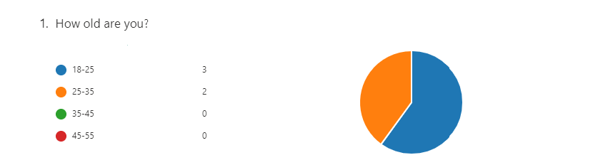
Question #2
Each of the five members of the course has provided an answer to the question where they are from. As it is made clear by the table below there are three participants from Italy and two of them are from Bulgaria. All of the answers are provided anonymously. All of them are Europeans, the study does not provide us with information from students outside of Europe and the United Kingdom.
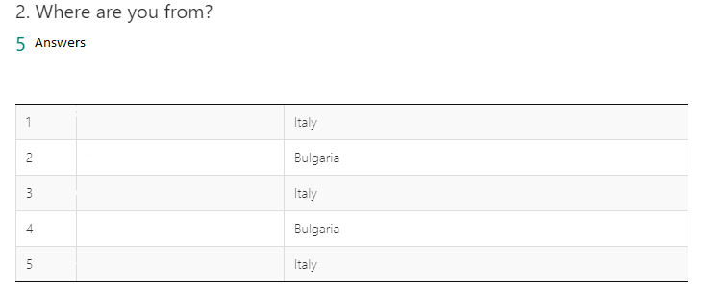

Question #3
From the five people who completed the survey we can see that four are women and one of them is a man.
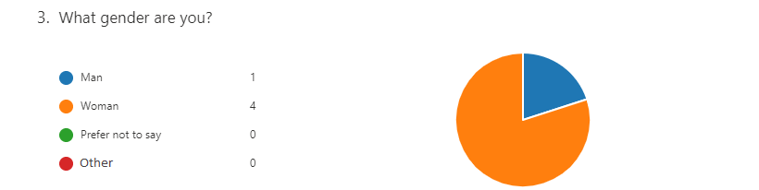

Question #4
In the fourth graph provided below the actual study on the impact of Virtual Learning on students begins. The answers all participants have provided show that majority of the students in the course have not previously partaken in online classes. On the other hand more than a third claim that they have studied virtually before.
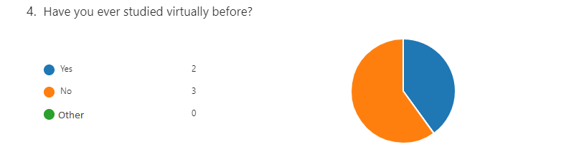
Question #5
When asked to give a rating on the online studies the have been a part of the students gave an average rating of 3.80, which means that none of them are completely satisfied with how virtual learning has impacted them. Although they have given a high rating overall, thus leaving the impression that they have been mostly impacted in a positive way by practicing online learning. It is a good rating in general.
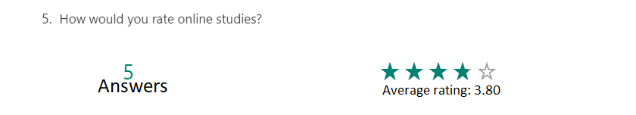
Question #6
When asked if they would rather have online courses or traditional class room ones, most participants have chosen the traditional way. The answer provided as “Other” states that the preferred method by that student is Traditional learning. The answers to this question are a clear example that majority of students who have taken the time to complete the survey would prefer to be physically present in class with the teacher. This could be due to the fact that most of the participants in the study have never had online classes before. This conclusion can be made by comparing question #4 and #6, since the number of people who haven’t been a part of virtual learning before is the same as the number of people who prefer traditional learning over virtual.
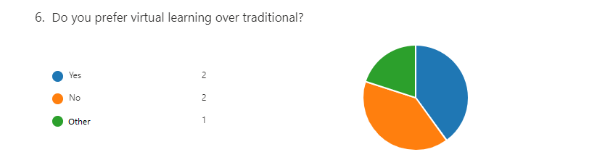
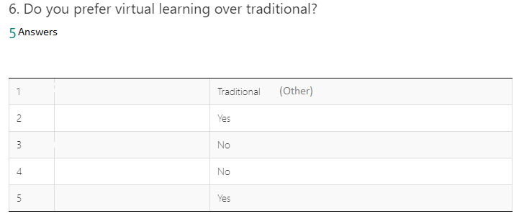

Question #7
The following question provides us with a closer look on the fact that most students who completed the questionnaire find it easier to learn new material trough online teaching. It is however interesting how majority would rather have traditional classes even though it is easier for them to learn virtually. This leads us to believe that they would like to be challenged more by being able to overcome difficulties in a real life environment such as a classroom. It is also very likely that there could be another reason for their preferences and the level of difficulty in learning new material is not why they chose the traditional way of studying. 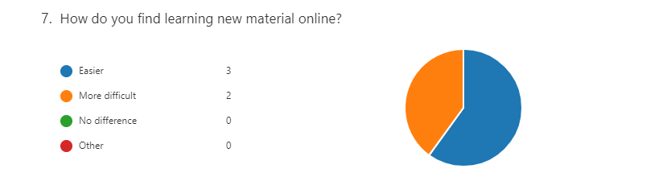

Question #8
When asked what they would change if they could about online classes the students have provided a variety of answers. First, we have communication and right after it the answer states that the change made by the person would be to have the classes be individual. These answers could be interpreted as very similar when analysed in detail. They could both have a common reason. The reason for both these students to provide these answers could be that they felt in a certain way that the communication in an online class is somewhat limited and thus they would prefer to have individual classes. In online courses it is often possible to have difficulties communicating due to many factors. In many cases the students do not use cameras, so aspects of a classroom style of teaching like raising a hand become difficult, although not impossible.
The third answer states hat lecturers need to have a better understanding of Virtual Learning. This could be because many of the lecturers who have been teaching the students who partook in the survey have also never faced the necessity to teach online. Many of them are also not very experienced when it comes to using modern technology to teach and the software used for that, since they have been using more traditional methods their entire career.
The next answer provided states that the student is satisfied with the way Virtual Learning has affected them and would not change anything about it.
The final answer provided to this question is that the person would like to have more lessons, but that could not provide us with enough data to analyse in regards to virtual learning, since the number of classes has remained the same as when the lectures were taking place in the campus of the university.
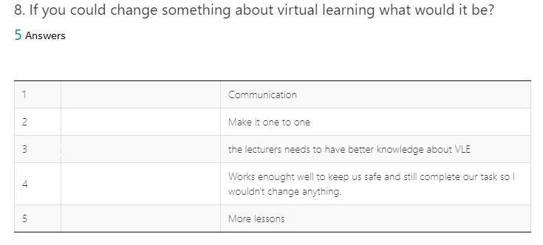
Question #9
For question number 9 the entirety of students who completed the survey have agreed that it is an advantage to be able to study from the comfort of their own homes. This is again in contradiction with the statement that most of them would prefer to study in a traditional way by physically visiting the campus. On the other hand, the answers provided to both question may have entirely different reasoning behind them, that makes the contradiction disappear.
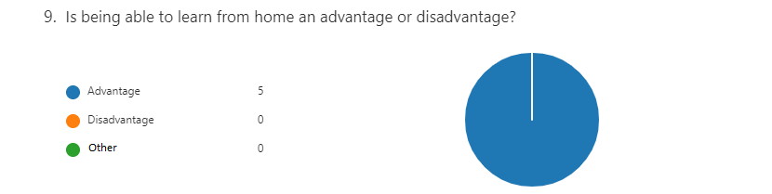
Question #10
Again, we have complete agreement when it comes to answering question number 10. All of the participants in the survey have stated that they are feeling more comfortable to take part in classes when learning online. This could be because they are having difficulty with their social skills and are shy or uncomfortable answering questions in a real-life class. It could also be because they feel more confident when they are at home.
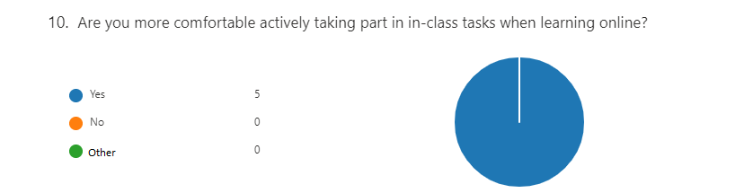
Question #11
Four out of the five students who completed the questionnaire have provided very similar answers to the next question. Their favourite aspect of having online classes is that they manage to save time this way. This is understandable, since travelling to and from the campus of the university is eliminated, which is extremely reducing the time involved in the whole process of being a student. This provides them with the opportunity to focus more on their studies or get more rest during the day. Majority of the students are either running their own businesses or are employed full-time by a company and this is quite an advantage for them.
One of the participants has stated that their favourite aspect is that they can stay home, which could also be interpreted as saving time. Another possible way to understand the statement of this student is that they could be one of the people having issues with their social and interpersonal skills.
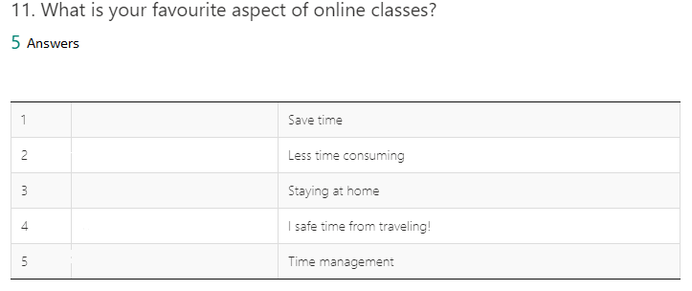
Question #12
The answers for question number 12 may potentially provide us with a better understanding of why most students would prefer to study traditionally by being present in a classroom. When asked how likely it is for them do be distracted during online lectures all of them stated that it is likely to a certain extent, with two out of the five of them answering that it is very likely for that to occur. The other three participants claim that it is somewhat likely that they get distracted.
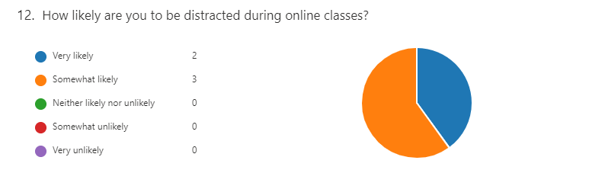
Question #13
The last question from the survey asks the students to provide an answer whether the future standard way of education will remain be Virtual Learning. Most of the students have given “Yes” as their answer, while one of them chose to provide a different one that states that they hope this will not become a standard way of lecturing. This could be due to the fact that this person is having difficulties with online classes or with their social and interpersonal skills the same way it could be the reason for some of the answers provided to the questions above. 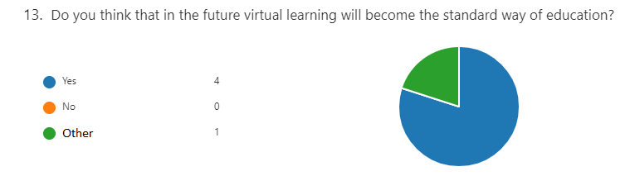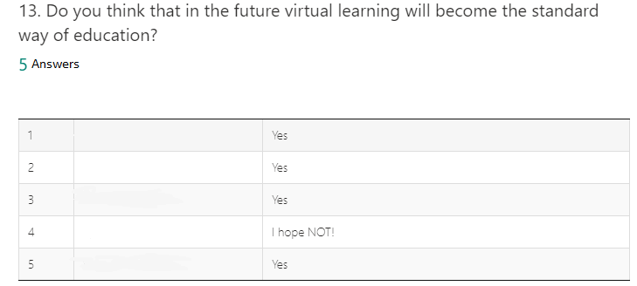

Secondary data sources
Virtual Learning Environments (VLEs) are virtual spaces which lecturers and students are able to use to present and share different resources and partake in activities and interact with each other. These platforms also could be used as a tool to teach an entire online course or to support face-to-face courses. (Mosquera, 2017)
“VLEs provide a means to manage the learning experience, communicate the intended learning experience and facilitate tutors’ and learners’ involvement in the experience. Their main goal is to ease, motivate and provide learning experiences that go beyond the classroom. Authors such as (Peter Grossman, 2013) claim that VLEs boast a wide spectrum of research showing positive impacts across different contexts.” (Mosquera, 2017)
Virtual learning environments (VLEs) have a wide use in education, in a variety of sectors, typically to deliver instructional materials and facilitate communication. (Peter Grossman, 2013)
“This article reports on an online survey into VLE use by 248 second year students at an English Sixth Form College (SFC). The survey investigated the reported impact of using the college’s VLE (Moodle) on learning, and was based on three research questions which investigated: whether the use of a VLE has a positive impact on student learning; whether the use of a VLE in teaching and learning helps develop independent learning; and whether the use of a VLE increases students’ motivation to learn. The statistically significant findings report that the use of Moodle produces improvement in learning and motivation to learn as reported by the student participants. The findings will be of broad interest to teachers as they indicate areas for attention in promoting VLE use to enhance learning.” (Peter Grossman, 2013)
Seemingly virtual learning has improved to a large extent the satisfaction and engagement of students (Eimear Ryan, 2019). Based on research virtual learning is undoubtedly superior to the traditional ways of educating students and has proven to be more effective in many aspects.
Conclusion
In conclusion I would like to express my understanding and overall impact of the Virtual Learning Environment. In general, it is a better way of providing students with knowledge, since the present-day technology allows for the entire process to be easier and more efficient. The lectures are more easily approachable by students with problems in aspects like social skills and communication issues. Boosting the confidence of students will without a doubt show results in more action taken during class and improved learning ability. It is easier to provide class members with necessary materials such as documents, papers, sources, etc.
Not having to travel to and from the university campus will significantly increase productivity for students and will drastically reduce their travel costs. I believe that the future of learning lies in online classes. And overall I believe that it has mostly a positive impact on students and education.

References:
Eimear Ryan, C. P., 2019. Impact of Virtual Learning Environment on Students' Satisfaction, Engagement, Recall, and Retention. [Online]
Available at: https://www.tandfonline.com/doi/full/10.11120/ened.2012.07010011
[Accessed 28 08 2020].
Mosquera, L. H., 2017. Impact of Implementing a Virtual Learning Environment (VLE) in the EFL Classroom. [Online]
Available at: https://www.researchgate.net/publication/320604290_Impact_of_Implementing_a_Virtual_Learning_Environment_VLE_in_the_EFL_Classroom
[Accessed 28 08 2020].
Peter Grossman, J. B., 2013. The Learning Impact of a Virtual. [Online]
Available at: https://insight.cumbria.ac.uk/id/eprint/1455/1/146-574-1-PB.pdf
[Accessed 28 08 2020].

Appendix:

