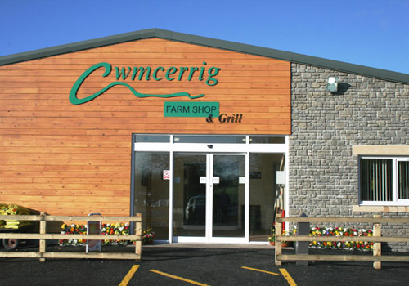  Figure 1  Rural business Output  Rural Enterprise Management | Tutor -Jessica Shore  James Thomas Dexter (1907923)

Contents

Contents: page 1
Introduction: page 2
Rural: page 2-3
Triple Bottom Line: page 3
Cwmcerrig Farmshop and Grill: page 3-6
Challenges, threats and opportunities: page 7
Conclusion: page 7
References: page 8-9

Rural Business Output

Introduction

Focusing on a rural business called Cwmcerrig Farm Shop that is located in South West Wales in a village called Cross Hands, this shop has been able to provide products and services for the local and surrounding communities for many years. This report will be concentrating on examining the main business’ outputs. The UK has plenty of places which could be classed as rural and within these areas of land will see some rural business’ and these businesses can range in what services and products they also offer. Some business’ have been passed down through generations and some of them are new ventures into the world. Any business will face challenges along the way and in rural area it could seem hard to overcome. There are many factors that businesses will have to take into account

Cwmcerrig Farm shop located in Cross Hands sells farming products as well as having a restaurant that caters for their customers and walk ins. This Farm shop was created by the Watkins family who originally have been farming since the 1950’s that then decided in 2008 to open up a shopping facility and then in 2009 built their 8000 square foot building. The business is family run with the brothers over-looking the shop and other family members making up the team. Cwmcerrig farm shops has multiple things to do when on site, during good weather they let their Shetland ponies, Jacob sheep and their Hereford cows out to roam the paddocks, also there is a Tommy the Tractor and Billy the Combine Harvester that children can play on whilst parents chill out making the facility that it more versatile. The farm shop itself sells farming products that range from the obvious meats to drinks and jams, they really do offer a wide variety.

Rural

The definition of rural definitely differs from person to person but also from area to area and this is for many various reasons. The UK government website says that to be classified as rural, the populated area must have below 10,00 residents. Being in the UK there is plenty of land that is not occupied by settlements or by wildlife or animals meaning there are more areas within the UK that have less than the 10,000 residents meaning there are many rural areas and opportunities for business. Another way that rural has been defied by The National Geographic an area where wildlife and a lower density population of people can be found away from cities and towns. Known as the country because of this as people can see and interact with the wildlife around the area and many homes and businesses will be in the same rural areas.

Reference of Business describes rural business as having many different variations depending on the area that one lives and can be characterized on the type of business it is. Rural business aims to market to the local communities or close by populated areas and sometimes to big corporations. Businesses tend to be industrial such as farming and due to being passed down through generations have been able to be well equipped for the products and services, they provide allowing them to be successful. Being rural and having a much lower populated areas means that there is less competition within the areas meaning more sustainable income. With this all being said this doesn’t mean that new business’ will not be able to stay afloat or thrive in these areas. Small business ideas such as removal services, cleaning, services and any ideas that can cater for the local community that the government can’t look after or get to because of transportation issues allows these ideas to become solid part of the community as they are a continuous need. Being rural also means that there will not always be a large number of employees and also a smaller market to sell to. businesses in rural areas can be seen as more determined as they tend to find ways to make things work or struggle if there are no alternatives.

Triple Bottom Line

In today’s world there is a massive push for business to make a difference to climate change concentrating more on creating less of an environmental impact and also creating social benefits at the same time but alongside this make the profits they were originally after.

The triple bottom line is a sustainability accounting method which concentrate on profit, people and planet. Main reason this method is different to traditional ones is because traditional methods did not take into account ecological and social aspects into their framework with money profits being the bottom line. In theory improving any sector will lead to positive benefits for the company overall (Fernandes).

Social

The social bottom line aspect looks at how a business has an impact on human interaction. Companies taking on the bottom-line method look to become more socially responsible; this would indicate that not only stakeholders, but people employed, customers, vendors and also the community or anyone impacted where business is conducted. Human relationships and interactions that allow a company to stay active such as creating fair rotas for employees, offering opportunities and healthcare benefits that lead to a safe work environment.

Environmental

The environmental bottom-line looks at what impact the company is making environmentally and what is in place to help reduce its ecological footprint. The main things that a company would look at to help reduce their impact is to recycle where possible and this is the minimal thing that they can do. Rethinking about packaging products or services to become more sustainable so that things can be used again and again making less consumption and waste. Looking into how they operate the buildings or facilities are they using renewable energy or adopting green policies?

Financial

Financial gains are what most business is set up for and this would be the traditional method as the bottom line would be what profits are made. This bottom line comes with different factors because there are many things that influence the revenue made. Financial bottom line takes into account factors such as job growth, cost of underemployment, establishment and personal income can be seen as a few examples (IBR).

Cwmcerrig Farm Shop and Grill

During the introduction to this paper there was a brief breakdown of Cwmcerrig Farm and the products and services that it provides. This business being Situated in Cross Hands would come under the bracket of rural as the population according to City Population the area has a population of around 5,717 recorded on the 30th June 2019. Well within the 10,000 population mark set by the UK Gov really does make it that much more rural. During 2009 there was a broad selection of shops in the area that helped out the community such as corner shops and some branded retailers. The business originally being a cattle farm for many years meant that there was an already underlying reputation of good service and meats. Starting a farm shop would be a great thing to do as their business had a good reputation and a big source of clientele meaning they would have a base for customers and now being able to open their doors to customers who can buy locally sourced produce and also have a place to take their family.

Cwmcerrig Farm Shop’s triple bottom line

Looking into Cwmcerrig farm shop they do seem to take on the triple bottom line accounting method based on what can be seen from their products and services. Having this triple bottom line can help determine what this business actually outputs are and if they relate to being more characterised as a rural business.

Financial

When trying to look into the financial history of this company there doesn’t seem to be much help on the internet such as Companies House as for some reason you cannot find the business when typed in using different methods. Cwmcerrig is a family run business and there are some information out there about the farm and the farm shop nothing really tells us about how they are doing financially specifically. Due to the amount of produce that they have and being able to distribute across the UK allows them room to have a constant flow of income. This being said all depends on the circumstances and time of year meaning there will be different ways for them to gain revenue.

On the front page of the Cwmcerrig Farm Shops website it states that the company is still open during this coronavirus pandemic with hours being open from 8am to 4pm, this means that with everything going on the company is still able to operate for its customers and create income. In an article on wales online it says that in 2012 attracted around 7,000 people a week, under new conditions can imagine there’s been a major shift in the number of visitors to the store. They also mention how being a family owned business has helped their business as they have been established in the area for quite a while and have a good variety of customers come to their shop.

Running the farm and the 8,000 square foot building will have cost implications as any business would. They would have multiple bills that would have to paid such as water, electric, gas, things such as food for their cattle and also for the packaging of their products and shipping all come into play. The wales online article does say that a total of 21 family members and 40 employees worked at the farm during 2012 again meaning there would be quite a high financial risk employing so many people. An article posted by The Guardian had spoken to british farmers and had found that cost of feed had been going up by £50-£60 per tonne in 2013 causing more impact on any farming company.

One thing that could of caused a financial impact also was the redevelopment of Cross Hands Retail park which would see big retailers setting up from in the same area such as Lidl and the Food Warehouse which also supply meats and fresh produce (Gregory). This being said there were already retailers such as Farmfoods and Aldis in the area and Cwmcerrig was still able to beat the competition.

Social

Looking into the social side of the triple bottom line means that the company in some way would have to provide a social meaning to what they provide, and their website suggest that they try and include everyone by offering multiple things other than takeaway food. On their website under the things to do section it outlines all the things one can do at the facility. During good weather Cwmcerrig allows its animals to roam the paddocks, this gives customers and families somewhere to go and enjoy not just shopping but an experience for the day. For the children as already mentioned there are the Tommy the Tractor and Billy the Combine Harvester attractions that they can play on whilst other family members can enjoy themselves on the terrace. One amazing thing they also offer is hosting school visits helping educate the younger people about food.

Being able to provide a space for community groups to get together allows the facility to be that more diverse and help the community in having a safe place to meet. Being wheelchair and pushchair accessible Cwmcerrigs Facebook page is constantly being posted on keeping over 2,000 people who have liked the page and 3,000 people following up to date with what they are offering. Cwmcerrig having a big workforce is made up from family members and local community members showing they are being socially responsible by employing local people instead of out of the area.

Environmental

Farming has always come under the limelight when it comes to talking about being environmentally friendly and Cwmcerrig has been farming since the 1950’s and their new venture in 2009 would also impact how much of an environmental impact they have. The farming side of things has an impact environmentally from the progresses in which they use to maintain, grow and expand their business using irrigation, feeds and so on. Having cattle means that they will always need feeding and looking after, cows release larger amounts of methane gases than other animals on their farm.
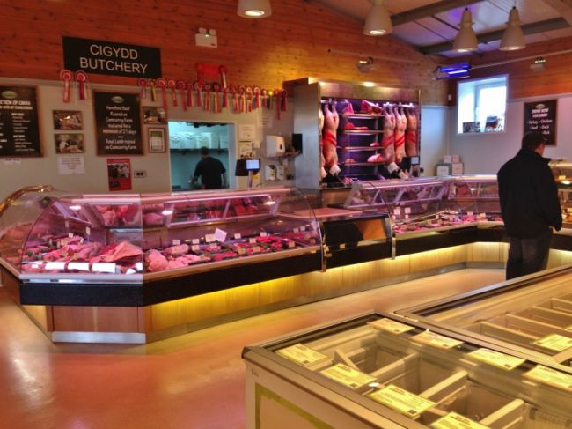
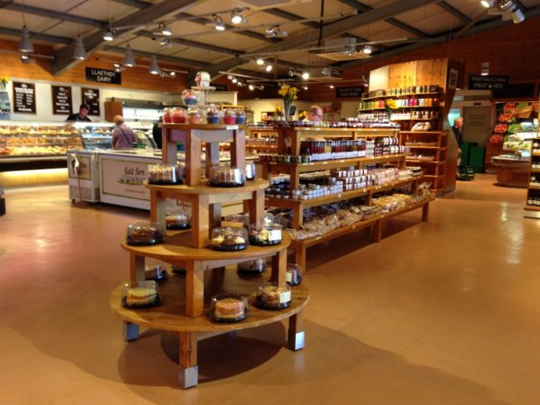
Cwmcerrig seem to have an amazing outlook when it comes to packaging their products, on multiple places on the internet where reviews have been left one can see how they set out their shop to display products. Here are some pictures posted by Stallion Valley showing off the shop layout at Cwmcerrig Farmshop.
Figure 2
Figure 3

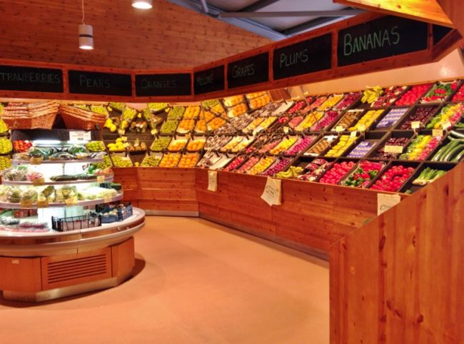
Viewing the photos, they display certain products differently, most of the fruit and vegetables that they display are not in packaging and small variety are in minimal packaging. The meat is on display in a cooling fridge for everyone to see but are protected by the temperature and glass to avoid any meat going off. There is some use for plastic packaging within the shop where necessary but in figure 2 you can see the bottles are made from glass. Packaging things in glass bottles allows it to be easily reused instead of single use plastics that would just be thrown away. This helps even more in decreasing the amount of impact the business has on the environment. Cattle being able to roam the paddocks in good weather also always for less maintenance as the cattle will eat the grass allowing room to spend less on feed and bringing emissions down.
Figure 4

Challenges and Threats

Some of these threats have been discussed during this report but not into much detail. Covid-19 hit the world harder than anyone would of thought forcing a lot of businesses to close whilst some still being able to operate. Luckily in Cwmcerrigs case they are allowed to remain open to the public during lockdowns. During lockdowns people are not able to travel very far so the farm shop would be impacted by the considerably less footfall. Produce not being sold then can be seen as going to waste meaning money can be lost this way too. Cwmcerrig being the working farm it is needs the support of the community and all the delivery services they provide including shipping. The typical welsh weather is not the best so during wetter season families are not able to make the most of outdoor activities. Livestock has a lot of threats as they are also living things so cattle can get disease and would need to be sorted out before it spread causing financial impacts.

Opportunities

Cwmcerrig farm deciding to open up the farm shop and grill in 2009 was a great step forward in expanding their business and providing what they produce to customers. They used to offer door to door service for their local customers which would really help them gain a sense of community and now do some deliveries. Taken up most opportunities it could hard to think of ideas in this pandemic they could increase interest and customers.

During 2020 some farms were losing money from selling milk and came up with the idea of a self-serve milk service which allows customers to socially distance and get milk from their local farmer rather than the supermarket. Llaeth Beynon Dairy is an example of a farm taking to this opportunity and has received a lot of attention even being in the Wales online news-paper from losing milk to selling so much it has hour ques. Buyers from further away have already connected so looking for more business further away can help gain more income.

Conclusion

This report looking at examining Cwmcerrig Farmshop and grill’s business output has been quite interesting, I would say that the business adopts the triple bottom line pretty well, from providing a place people can shop to support their local farmers to being able to provide a place for people to visit. They made a good sense of community from all they have done and in the current climate with a few changes won’t have issues being sustainable.

References

Figure 1, Smiths Retail Design, Cwcerrig Farm Shop & Grill – Entrance, Smithsretaildesign.com, http://www.smithsretaildesign.co.uk/cwmcerrig-farm-shop/cwmcerrig-farm-shop-grill-entrance-large/

The government, official statistics, Defining rural areas using the rural urban classification, 25/06/2015 https://www.gov.uk/government/statistics/defining-rural-areas

The national geographic, Rural Area, national geographic, 2/6/2011 https://www.nationalgeographic.org/encyclopedia/rural-area/

Cwmcerrig farm shop, Who We Are…, Cwemcerrigfarmshop.com http://www.cwmcerrigfarmshop.co.uk/who-are-we/

Reference of business, Rural business, referenceofbusiness.com https://www.referenceforbusiness.com/small/Qu-Sm/Rural-Businesses.html

P Fernandes, What is The triple bottom line, business.com https://www.business.com/articles/triple-bottom-line-defined/

IBR business school, The Triple Bottom Line: What is it and how does it work?, Indiana business review https://www.ibrc.indiana.edu/ibr/2011/spring/article2.html

City Population, Carmarthenshire, citypopulation.com https://www.citypopulation.de/en/uk/wales/W06000010__carmarthenshire/

R misstear, wales online Welshfood month: a Family success story at Cwmcerrig Farm, 26/03/2013 https://www.walesonline.co.uk/news/local-news/welsh-food-month-family-success-2024127

R Gregory, wales 247, New cross hands retail park almost fully let. https://www.wales247.co.uk/new-cross-hands-retail-park-almost-fully-let

Cwmcerrig farmshop and grill, cwmcerrig farmshop and grill, https://www.facebook.com/cwmcerrigfarmshop

J Rayner, the guardian, Britains farming crisis: people don’t realise how tough everything is, theguardian.com https://www.theguardian.com/environment/2013/mar/16/britain-farming-crisis-how-tough

Figure 2, stallion valley, Cwmcerrig Farm Shop and Grill, stallionvalley.com https://www.stallionvalley.com/west-wales/item/486-cwmcerrig-farm-shop-and-grill/

Figure 3, stallion valley, Cwmcerrig Farm Shop and Grill, stallionvalley.com https://www.stallionvalley.com/west-wales/item/486-cwmcerrig-farm-shop-and-grill/

Figure 4, stallion valley, Cwmcerrig Farm Shop and Grill, stallionvalley.com https://www.stallionvalley.com/west-wales/item/486-cwmcerrig-farm-shop-and-grill/

Llaeth Beynon Dairy, llaethbeynondairy.com https://www.llaethbeynondairy.co.uk

B Thomas, wales online, how a llanelli milk farmer went from pouring thousands of gallons down the drain to hour long queues and selling out in hours, https://www.walesonline.co.uk/news/wales-news/llaeth-beynon-dairy-milk-machine-19219374

