A comparison of the marketing methods of two multinational hotel brands

 VS 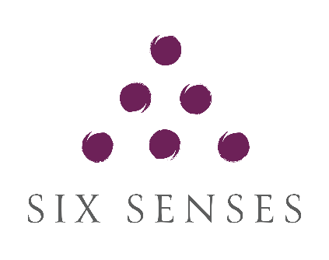

- Name: Mihai Serban
- Student ID number: 2244688
- Module title: Marketing Essentials BMIH4005
- Lecturer’s name: Dale Clarke
- Word Count: 1640

In any business, marketing strategy plays a key role in building a brand, trying to get new customers, and making every effort to maintain the loyalty of the existing ones. Today’s hotel industry is highly competitive and makes no exception regarding the importance of marketing. This essay observes and compares the marketing methods and strategies of two multinational hotel brands, Six Senses and Holiday Inn. Both brands are part of IHG (InterContinental Hotels Group) and are striving to provide quality hospitality services to their guests. The Six Senses, which opened in 1995, manages 19 hotels and resorts and 27 spas in 19 countries and has signed 34 properties into the development pipeline. Six Senses is a luxury hotel and resort brand known for its high-end and exclusive properties with a focus on wellness and sustainability, offering unique and immersive experiences. "We want our places and spaces to help you reconnect and explore what it means to be mentally, physically, spiritually, and emotionally happy." (Neil Jacobs, unknown) In contrast, Holiday Inn, with "a history that can’t be replicated or matched" (Jen Gribble, 2021), is a mid-scale hotel brand that focuses on providing comfortable accommodations and standard amenities to a wide range of travellers. Unlike the Six Senses brand, whose primary targets are affluent and discerning travellers who value unique experiences, wellness, and sustainability, Holiday Inn targets a broader market, including families, business travellers, and tourists with a budget-conscious who are looking for reliable and affordable accommodations with standard amenities. "This hotel had everything we needed for an enjoyable and accessible stay. It was affordable with first-class service and a cosy, upmarket feel. We will be back again." (Emma, 2018).

"A SWOT analysis is a compilation of a company’s strengths, weaknesses, opportunities, and threats, with the primary objective of helping organisations develop a full awareness of all the factors involved in making a business decision." (Skye Schooley, 2023). Six Senses is a luxury property brand that is often situated in picturesque and secluded locations. They offer unique and immersive experiences to guests, providing a sense of exclusivity and natural beauty. Additionally, Six Senses offers wellness and spa programmes with personalised service to attract guests seeking relaxation and rejuvenation. SWOT analysis indicates that Six Senses' strengths are a combination of luxury and exclusivity. Now looking at the weaknesses, the SWOT analysis of Six Senses properties shows that they are relatively expensive compared to other hotel brands, limiting accessibility for budget-conscious travellers. Additionally, they have a limited global presence with a smaller footprint than some larger hotel chains, which can limit options for travellers in some regions. However, this can also be seen as an opportunity for Six Senses to expand its presence in new locations and tap into emerging markets, attracting a wider range of customers. "In 2023, there will be many challenges faced by the hotel industry, which may quickly feel overwhelming to address." (Patrick Landman, 2022). In one of his articles, Patrick Landman believes that some of the threats for a hotel in the coming years will be meeting the needs of the modern guest, hiring the right employee, and the continuous change in consumer demands.
Now, looking at the SWOT analysis for Holiday Inn, we can identify the first strength: global presence. Unlike Six Senses, which had a limited global presence, Holiday Inn has a widespread global presence, with numerous properties in various countries offering convenient accommodations for travellers around the world. "There are few hotel brands as recognisable as Holiday Inn Express. From New York City’s bustling Chelsea neighbourhood to Hong Kong and even the dusty, windswept plains of my humble hometown in Levelland, Texas, the hotel brand can be found dotting maps the world over." (Tanner Saunders, 2021). Holiday Inn is also an easy-to-recognise brand that has established itself as a well-known and trusted name in the hotel industry, which contributes to customer loyalty and brand recognition. Holiday Inn can also be very proud of its consistency, as the brand maintains a consistent standard of quality across its properties and, together with its loyalty programme, IHG Rewards Club, provides incentives for repeat stays and offers benefits such as room upgrades, discounts, and other exclusive perks. One of the weaknesses identified in the article published by the MBA Skool Team is that Holiday Inn is continuing its efforts to enhance its market presence in developing nations. Another one of Holiday Inn’s weaknesses is the intense competition with numerous other hotel brands competing for market share, which may make it challenging for Holiday Inn to stand out in certain locations. As an opportunity, Holiday Inn can look into embracing new technology to enhance guest experiences, such as incorporating mobile check-in and check-out, smart room features, and personalised digital services. As for any other hotel, economic factors (global crises, wars, etc.), increasing costs for operations, and intense competition can be presented as threats for the coming years.
Local governments have a significant impact on the hospitality and tourism industries, with travel bans, changes in government, and taxes being some of the factors that can affect them. Recent examples of this include the situation between Ukraine and Russia, where tourism has taken another hit while still recovering after the COVID pandemic downfall. "According to the Economist Intelligence Unit, the war will affect Europe’s tourism industry in four ways: a loss of Russian and Ukrainian tourists; restrictions on airlines and use of airspace; higher food and fuel costs; and a big hit to traveller confidence and disposable incomes." (Milana Nikolova, 2022). The hotel industry is also directly impacted by changes in the economy. While many hotels, such as Six Senses, cater to luxury travellers with high prices and exceptional service, there is also a preference for budget hotels like Holiday Inn. Additionally, fluctuations in exchange rates can influence travellers from different countries. On the technological side, we can recognise the advancements in technology that enhance guest experiences, such as mobile apps and self-check-in kiosks. The availability of online booking options, whether directly on hotel websites or through third-party applications, has significantly increased hotel reservation rates. Guests from various countries can now effortlessly book a hotel room with a simple click. Moreover, this convenient method also allows them to access all the essential information effortlessly.
Additionally, the feature allowing guests to write reviews has played a crucial role in encouraging hotels to improve their services and prevent any form of discrimination. Increasing focus on sustainability and environmentally friendly practises in the hotel industry is a must in the current climate, and it seems that Six Senses is doing a better job here, claiming to prioritise the elimination of single-use plastic and virgin plastic sourcing through supplier engagement.
The marketing mix consists of product, price, place, and promotion and is a fundamental tool used by organisations to formulate their marketing strategies. Six Senses and Holiday Inn employ distinct approaches to each of these elements. On the product side, Six Senses differentiates itself as a high-end hotel label that provides enriching experiences centred around well-being, environmental consciousness, and a harmonious relationship with the natural world. Their establishments frequently boast rejuvenating spas, eco-friendly initiatives, and distinct lodging options. In contrast, Holiday Inn prioritises cost-effectiveness, convenience, and delivering consistent and cosy lodging options to cater to the needs of travellers. In regards to pricing, Six Senses implements a premium pricing approach to align with its opulent image, appealing to affluent customers in search of unparalleled experiences. Conversely, Holiday Inn employs a mid-range pricing strategy, appealing to a wider range of consumers who prioritise cost-effectiveness and good value. From a place perspective, Six Senses strategically chooses locations that align with its commitment to sustainability and natural surroundings. Their properties are often found in exotic destinations, emphasising a retreat-like experience. In contrast, Holiday Inn focuses on establishing a presence in major cities, business hubs, and popular tourist destinations, ensuring accessibility and convenience for travellers. Six Senses implements an extensive digital marketing approach, utilising social media platforms, collaborating with influencers, and employing content marketing strategies. These methods are employed to showcase their distinctive offerings, with a focus on promoting wellness, sustainability, and luxury through visually captivating and informative content.
Holiday Inn and Six Senses communicate with their target audiences through digital marketing channels. To effectively engage with their respective target groups, both organisations use a variety of marketing communication platforms. According to the competitiveness analysis, there is just a slight difference in website traffic between Six Senses and Holiday Inn. However, as seen in Appendix A, Holiday Inn appears to invest more in acquiring visitors, while Six Senses appears to gain more from organic traffic. According to Appendix B, Holiday Inn appears to do better solely on Facebook, whereas Six Senses looks to perform better on YouTube, Instagram, and Pinterest.

In conclusion, the marketing strategies of Six Senses and Holiday Inn reflect their distinct target markets and brand positioning. Six Senses focuses on luxury, exclusivity, and wellness, appealing to affluent travellers seeking unique experiences. In contrast, Holiday Inn targets a broader market, emphasising comfort, affordability, and convenience for various customer segments.

Both brands face challenges and opportunities in the evolving hospitality market, as revealed through situational analysis using SWOT and PESTEL frameworks. Six Senses benefits from its luxury positioning and sustainability commitment but has limitations in terms of accessibility and global presence. With its global footprint and recognised brand, Holiday Inn needs to enhance its presence in developing nations while dealing with intense competition. To improve their marketing activities, recommendations can be made. Six Senses could expand its presence in new locations and emerging markets to attract a wider customer base. Strengthening partnerships with online travel agencies and influencers can increase their reach and showcase their unique offerings. On the other hand, Holiday Inn should explore the adoption of new technologies to enhance guest experiences and differentiate itself in competitive markets.

References:

Becky Pokora, (2023) - A Quick Guide And Comparison To All 17 IHG Brands Available at:
https://www.forbes.com/advisor/credit-cards/travel-rewards/ihg-brands/ (Accessed on 01 May 2023)

Emerging Europe, (2022) - How Russia's war on Ukraine impacts travel and tourism. Available at:
https://emerging-europe.com/news/how-russias-war-on-ukraine-impacts-travel-and-tourism/#:~:text=According%20to%20the%20Economist%20Intelligence%20Unit%2C%20the%20war,big%20hit%20to%20traveler%20confidence%20and%20disposable%20incomes (Accessed on 01 May 2023)

Emma, (2018) - 5 Reasons Why You’d Love A Stay At Holiday Inn Manchester Available at:
https://www.simplyemma.co.uk/5-reasons-youd-love-holiday-inn-manchester (Accessed on 05 May 2023)

IHG Hotels & Resorts, (2021) - ‘Holiday Inn® brand builds on 70 years of trusted travel and innovation’ Available at:
https://www.ihgplc.com/en/news-and-media/news-releases/2021/holiday-inn-brand-builds-on-70-years-of-trusted-travel-and-innovation (Accessed on 01 May 2023)

Jasper Jolly, (2020) - Covid-hit UK hotels unlikely to recover for four years, says PwC Available at:
https://www.theguardian.com/business/2020/oct/27/covid-hit-uk-hotels-unlikely-to-recover-for-four-years-says-pwc(Accessed on 5 May 2023)

Kiesha Frue, (2019) - PESTLE Analysis for Hotel Industry Available at:
https://pestleanalysis.com/pestle-analysis-for-hotel-industry/ (Accessed on 5 May 2023)

Kyle Peterdy, (2023) - What is a PESTEL Analysis? Available at:
https://corporatefinanceinstitute.com/resources/management/pestel-analysis/ (Accessed on 5 May 2023)

Patrick Landman, (2022) - 10 Solutions to Challenges the Hotel Industry faces in 2023 Available at:
https://www.xotels.com/en/hotel-management/challenges-problems-hotel-industry (Accessed on 01 May 2023)

Patrick Landman, (2022) - Top Hospitality Industry Trends in 2022 Available at:
https://www.hospitalitynet.org/opinion/4109812.html (Accessed on 01 May 2023)

Tanner Saunders (2021) - Holiday Inn Express just opened its 3,000th hotel: How the brand became iconic and what next Available is at:
https://thepointsguy.com/news/3000-holiday-inn-express/ (Accessed on 05 May 2023)

Team 10.3, (2019) - Competitive Analysis of Six Senses Available at:
https://sixthsense513094188.wordpress.com/2019/11/03/competitive-analysis-of-six-senses/?fbclid=IwAR0iUYrviLW2rpTYb_Yxgx2IL1KP2GxCOQJ6c4ZAmERapDeNFByVP8Iuyhk

Unknown Publisher (2020) Holiday Inn SWOT Analysis, Competitors & USP Available at:
https://www.mbaskool.com/brandguide/tourism-and-hospitality/2170-holiday-inn.html?fbclid=IwAR21hLjsHFTlnIxUSE7xgun40L-IRnNaF7EhKg-n6EjittXfzGaxnPE-mCI (Accessed on 10 May 2023)

Unknown Publisher (2022) - Six Senses Sustainability - Plastic Freedom Avaiable at:
https://www.sixsenses.com/en/sustainability/stories/sustainability-impacts-2022

Unknown Publisher (2021) - Learn about the SWOT framework, the process of a SWOT analysis, and its advantages and disadvantages Available at:
https://www.cipd.org/uk/knowledge/factsheets/swot-analysis-factsheet/ (Accessed on 10 May 2023)

Umar Farooq, (2023) - PESTLE Analysis of the Hotel Industry Available at:
https://www.marketingtutor.net/pestle-analysis-of-the-hotel-industry/ (Accessed on 01 May 2023)

Appendices:
https://pro.similarweb.com/#/digitalsuite/websiteanalysis/social/overview/*/999/3m?webSource=Desktop&key=sixsenses.com,holidayinn.com

Appendix A: Images
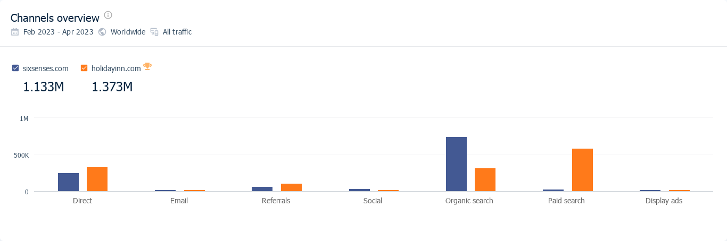
Appendix B: Images


