Study Skills for Electronics

HID Global Apprentice
Student No: 2413111

L4 – Study Skills for Electronics
ACDA4021- 2024-25

Electrical & Electronic Engineering Degree Apprenticeship

Table of Contents

Presentation Skills

Overview of Myself

Screengrabs of PowerPoint

Learning Experienced

Improvements in the future

Research on Skill Sets

Skills Required for Successful Learning

Skills that Employers look for

Self-Evaluation and Action Plan

Self-Evaluation Exercise and Comparison

Main Goals Going Forward

Action Plans

Data Application and Storage

3 Different Places Strategy

Ransomware Research

Enhancing Personal Productivity

E-Portfolio Structure

Conclusion & Evaluation

References

Appendices

Presentation Skills

Overview of Myself
Hello, my name is Thomas Morris, I am currently 20 years old and was born in August of 2004. I currently live in Bridgend and have been living within the Bridgend area for all my life. I went to Brynteg Comprehensive School where I stayed for 7 years from year 7 all the way through to my A levels. After this I took a gap year where I, at the age of 19, went and got my PSV (Passenger Service Vehicle) licence which enabled me to drive service route buses and also coaches, I still currently drive a service bus on a Sunday each week as it keeps my CPC valid, and I do enjoy the work. Alongside this I am also very involved within the sport of football in which I have played since the age of 3, I am also a fully qualified referee registered with the FAW and consistently referee games each weekend. I also Coach at a junior age group within my football club which is Brackla FC and I am currently working towards gaining my FAW football leaders award which will fully qualify me as a coach at junior level within the FAW. Alongside this I work at HID Global as an Apprentice Product Manufacturing Engineer in Cardiff and have currently been there for over 4 months now.

Screengrabs of PowerPoint
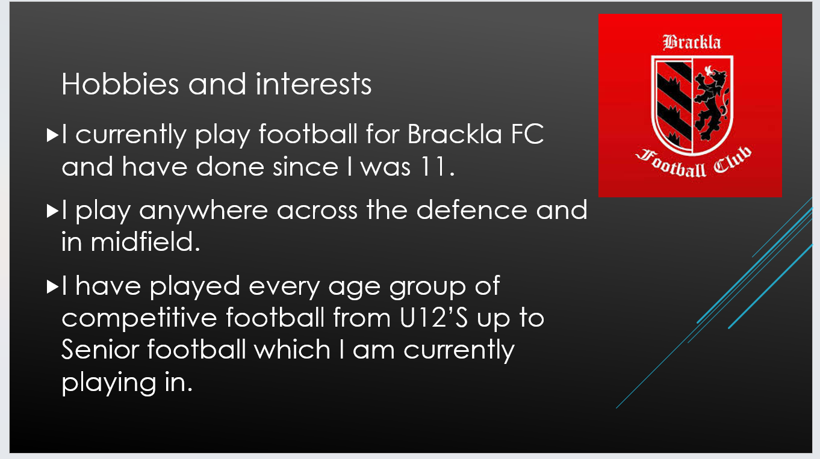
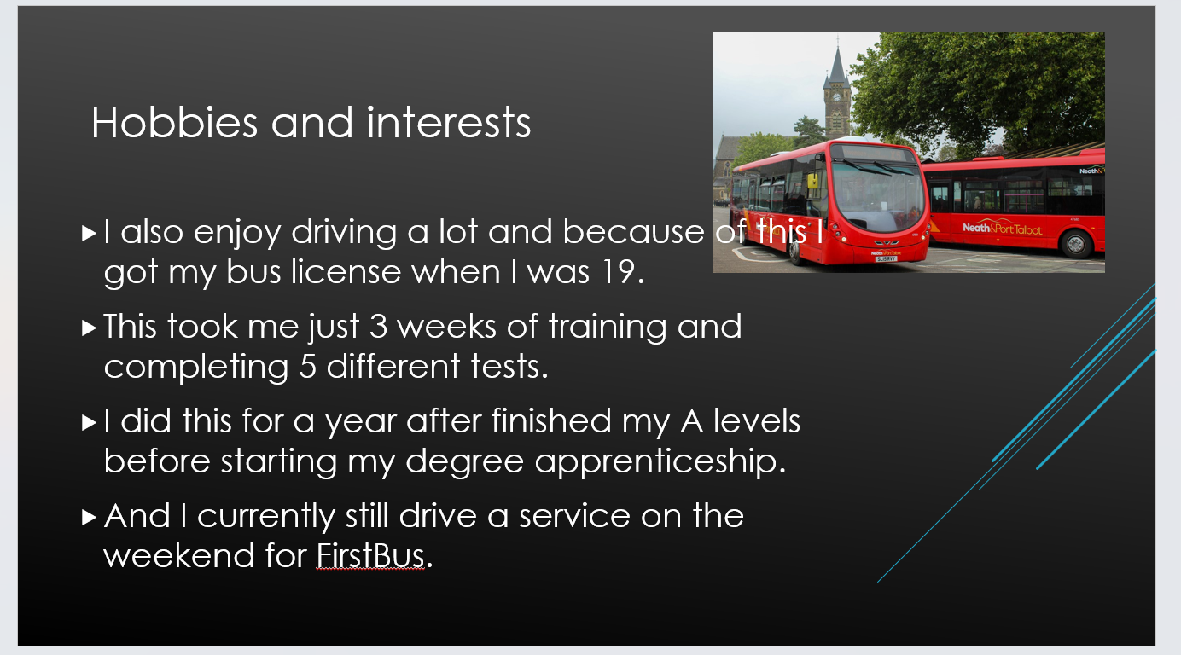
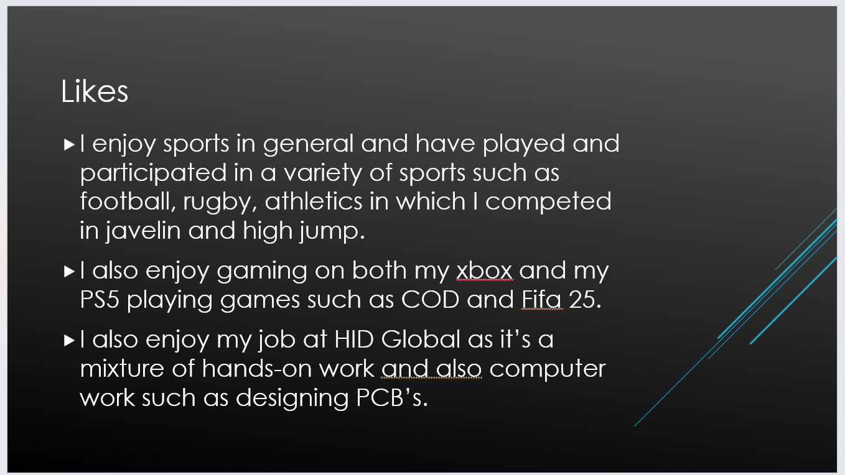
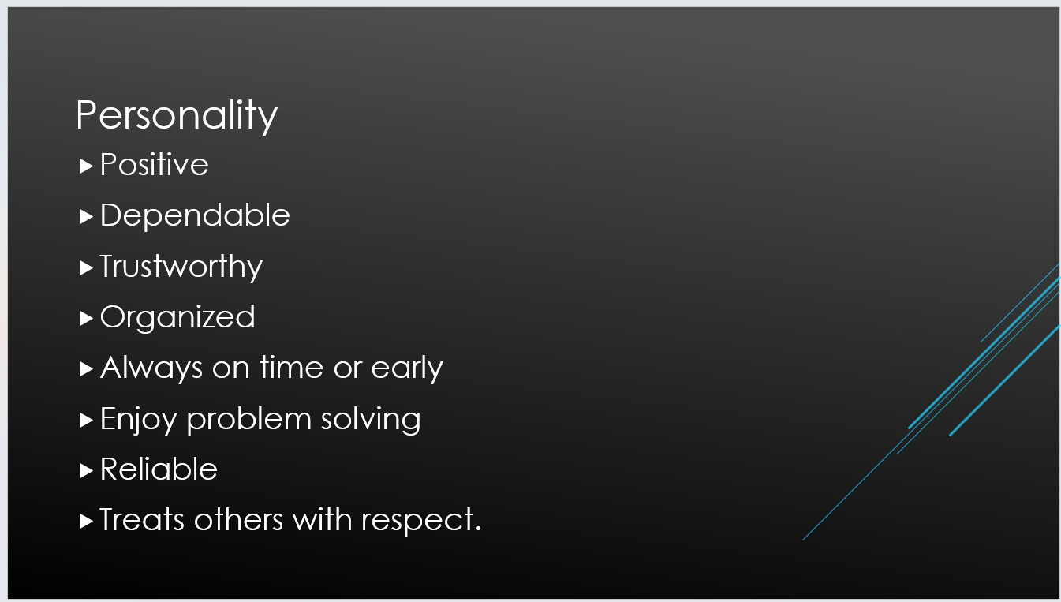

Learning Experienced
When I was producing and delivering a successful presentation, I was able to learn different key points that enabled me to be able to reach my goal of delivering an informative and successful presentation. The first point that I learned out of it was being able to split up key points within my presentation while also not putting too much information on each slide, as doing this would’ve been an overload of information for the people who I was delivering my presentation to and would increase the time that it would take to get through each slide. Leading on from this point, having enough information on the screen so that the people who are watching the presentation should be able to read it was a positive but then also being able to add on to certain points as a presentation shouldn’t just be someone reading off of a screen they should also be able to interact with the audience a bit and the audience have the main attention of the person who is presenting.
Another key factor is adhering to the time limit that was given as part of the assignment, the key point that I was able to take from this was being able to not make the presentation too long but also being able to include every main point that I wanted to address and if there was time left over adding extra in after it. A structure to the presentation was also a key factor as it enables the presentation to flow naturally and each slide leads onto another rather than having everything within a random order, an example of this is by starting with your name and age and then progressing into more detail about yourself after getting the basic information said first.

Improvements in the future
The improvements I would make in the future are to add more content within my presentation as my presentation was about 4 minutes long and the target time was 5 minutes, to be able to get closer to this time while also adding in more information would be to present my presentation in a slow and calm demeanour while also timing myself and doing this multiple times to ensure I add enough information but not too much information at the same time to ensure I’m within the parameters set by the lecturer.

Research on Skill Sets

Skills Required for Successful Learning
Skills required for successful learning as described by [1] their top 2 values which are essential for higher learning are firstly time management, time management as stated by [1] is one of the most important skills that a student must be able to develop, students must be able to use this skill effectively in order to succeed as students are expected to be able to do multiple courses at once while also doing assignments and extracurricular activities, they are expected to do all of this while also having a social life and a part time job on the side and then to be able to complete all the work on time and while doing exams which is the biggest factors for a students grades. Which if they break these tasks down into smaller manageable chunks and build a schedule around their day this will help the student to balance everything a lot easier and more effectively.
Another skill highlighted by [1] is research skills, this skill is essential due to being able to find relevant sources to the topic that you are researching and being able to analyse information from them and draw conclusions as well as being able to use different databases and search engines to gather data.
According to [2] another essential skill is writing skills, these skills are essential as students use this skill every day, as for all degrees the skill for being able to write at a good standard is key for being able to submit coursework assignments as well as lab reports and dissertations. In University you are expected to be able to develop upon a point that you have made to show your understanding of the topic and to do this you require the skill to be able to write in a structured manner.

Skills that Employers look for
According to [3] effective communication is essential for employers when they are looking at the skills that a candidate possesses. Effective communication is referred to as how clearly you can put across your ideas to others around you and your ability to also listen and communicate effectively with others when working together or even being able to explain a problem that you are having.
Another skill that employers look for according to [4] is resilience, this skill is how a person is able to deal with setbacks within different aspects of their life, and how well a person is able to cope under stress when something goes wrong or if there is an unexpected change or problem that occurs within their work. You should be able to show an employer that you are able to react positively and are able to use critical thinking to solve the problem.

Self-Evaluation and Action Plan

Self-Evaluation Exercise and Comparison
The student conducted many different evaluation exercises to ascertain what sort of personality the student had and see the comparison between both results that he got from the test and what he had previously thought before. As shown from the pictures below from the one on the right it shows that the student is realistic and conventional but also very social, this is very similar to what the student originally thought as he is involved in a lot of social clubs and events and having a low artistic percentage is also similar to what the student already thought as he has never been artistic and finds it as something that bores him a great deal as he likes more experimental and investigative lines of work such as fault finding and working out equations to solve a problem.
As shown in the picture on the right it shows the core values and skills of the student as ranked by the test, as expected the student had critical thinking as one of his top skills which is expected as the student greatly enjoys problem solving and being able to think on his feet as shown by the skill of being able to adapt to change and carry out calculations also being within the top 4 skills. The student does need to improve on his ability to advice others as shown in this test and being able to judge and manage risks of health as being the top result is also a surprise as the student is more engineering and science orientated so it was a surprise.

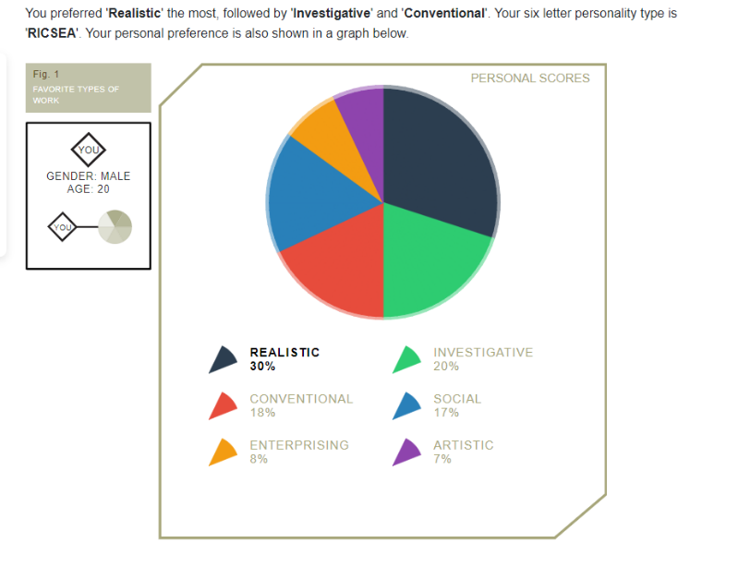
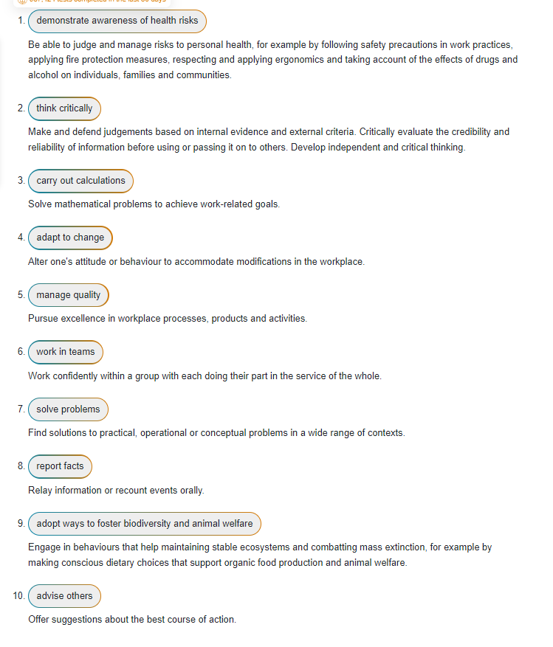

Main Goals Going Forward
The students’ main goals going forward are a mixture of academic, personal and professional goals, my first goal which is academic is to complete my university degree over the next 4 years and gain experience within my workplace, another goal of mine is to finally have my surgery on my leg and get back into fully fit playing condition for my football team. A third goal of mine is to gain more experience within the FAW as a referee and try to rise up the tiers of leagues that I am qualified to referee within. My fourth and last goal that I have is to be able to complete my Lean Six Sigma Green Belt course that I am undertaking within work and get my certification.

Action Plans
Shown below are my action plans for each of my goals and how I will work to ensure that they succeed.
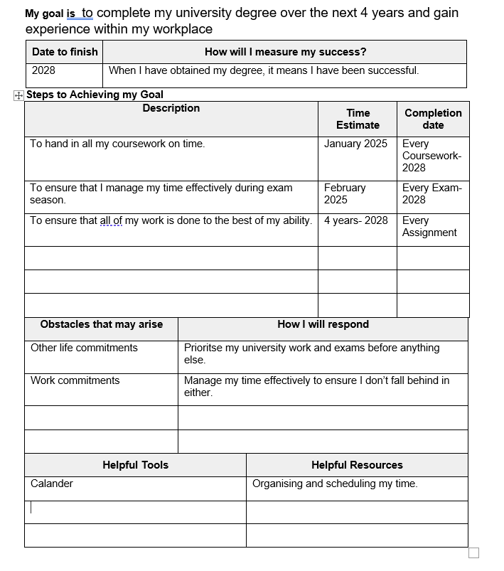
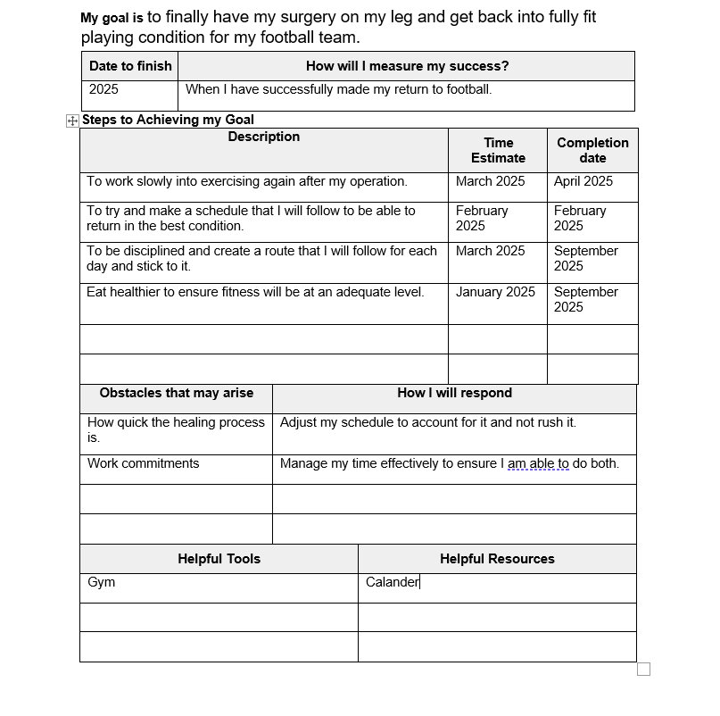
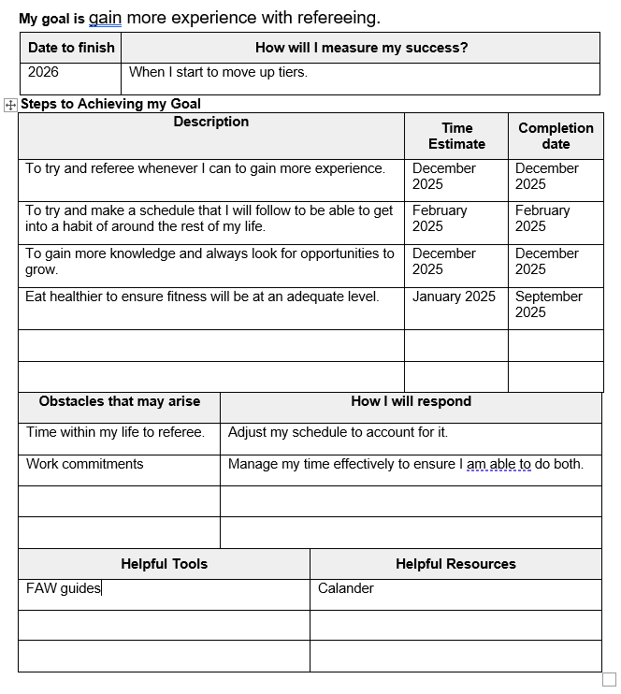

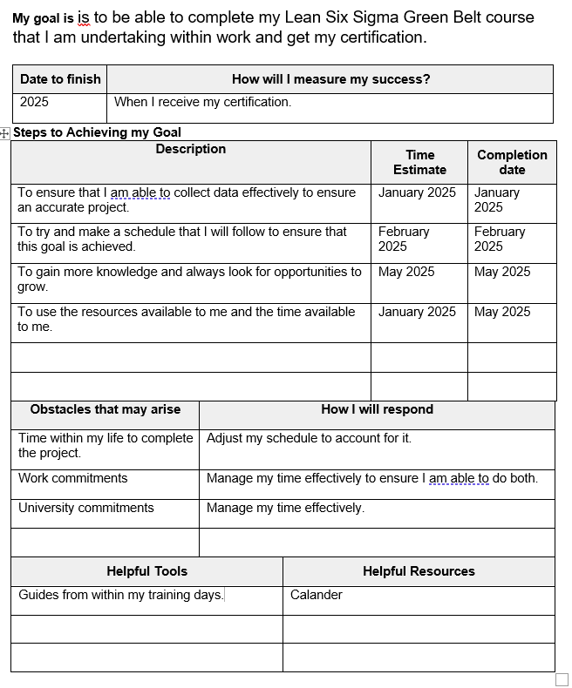

Data Application and Storage

3 Different Places Strategy
As the student has learned about data and storage of that data that we may use within our everyday life, in university or in work, one of the best strategies which will help overcome the risk of losing important data is the 3 different places strategy, this strategy is an idea of if something isn’t saved within three places it is considered that it doesn’t exist. As a student or as someone who works within a workplace, there is always a chance that something could fail. Everything eventually fails such as even if something is saved on a hard disk, a hard disk is mechanical and will eventually wear out and even USB drives have a finite R/W limit within each USB, this shows that it’s not a case of if something fails it’s a case of when it fails.
The 3 different places strategy helps combat this by having the same piece of data saved within 3 different places and saved ideally within 3 different ways. Such as having a document saved on your computer, it will only be safe and secure as long as the computer itself is working, to counter this there are also online drives that you are able to save data onto, these online drives would be the second place of the 3 different places.
These drives are very commonly used these days and are a great way of a secondary backup of the save data. The only flaw with these drives are that if the company that is running the drive and holding the data online has any issues with their servers or the company closes then the data will be lost, this is why it is good to try and have the data stored with a global company such as Microsoft or google as there is very little risk of the company closing and they would have a better and more secure server in which your data would be stored.
The third part of the 3 different places strategy would be to have the data stored onto a USB drive, or even multiple USB drives as this is a portable way of keeping your data secure and could be kept within a different location than where the other two data places are. The downside to a USB drive is that it is easy to lose and also could easily be stolen but that is the point of the 3 different places strategy.

Ransomware Research
Ransomware is a type of malware that will hold a person’s or organisations data/ device hostage by using threats to either destroy or keep the data unless a certain demand is met which is usually within the form of paying someone.
The three different places strategy as explained above would be very useful and effective in this situation, having the data stored in 3 different places would remove any risk to the data being destroyed as even if the person had the device within which the data had originated from they would only be able to delete the data from on that computer of device which would make the threat void as you would still have access to the data within two different places in which the ransomware wouldn’t have effected and would allow time to then reinstate the three different places strategy by loading the data again on another device or in another place.
For the threat of keeping the data the three different places strategy is also effective as them keeping the data wouldn’t make a difference to you as a person or to a company as they would still be in possession of the data as it would’ve been stored within two different places and would make the data stolen by the ransomware useless to the person trying to extract money from a person or company.

Enhancing Personal Productivity
The steps that the student currently has taken to enhance and improve their own productivity is by organising their time within their workplace. They have an electronic diary in which their numerous meetings and training is marked within which enables them to plan out their day efficiently and be able to change things accordingly without having to remember important times and dates when trying to plan their work schedule. As shown below is what has been stated above and has helped greatly to improve efficiency within the workplace and also outside of the workplace. It also allows the student to see if meetings or events have been cancelled without the student having to read through loads of different emails to figure out where and when was the event that has been cancelled and to see where it was moved to.
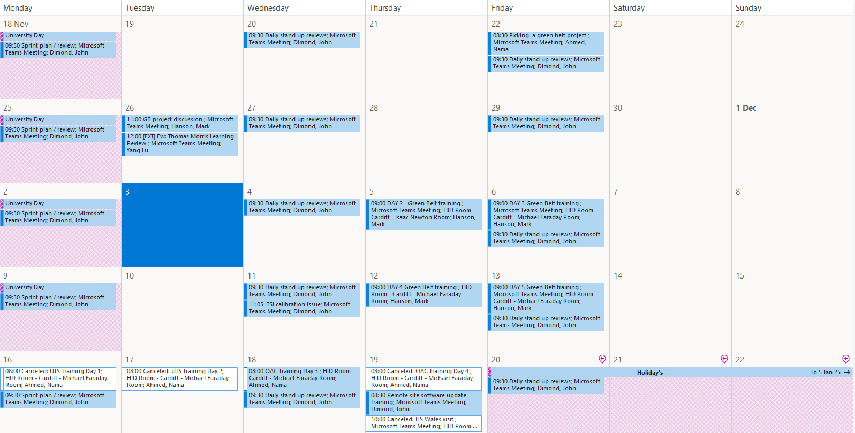

E-Portfolio Structure
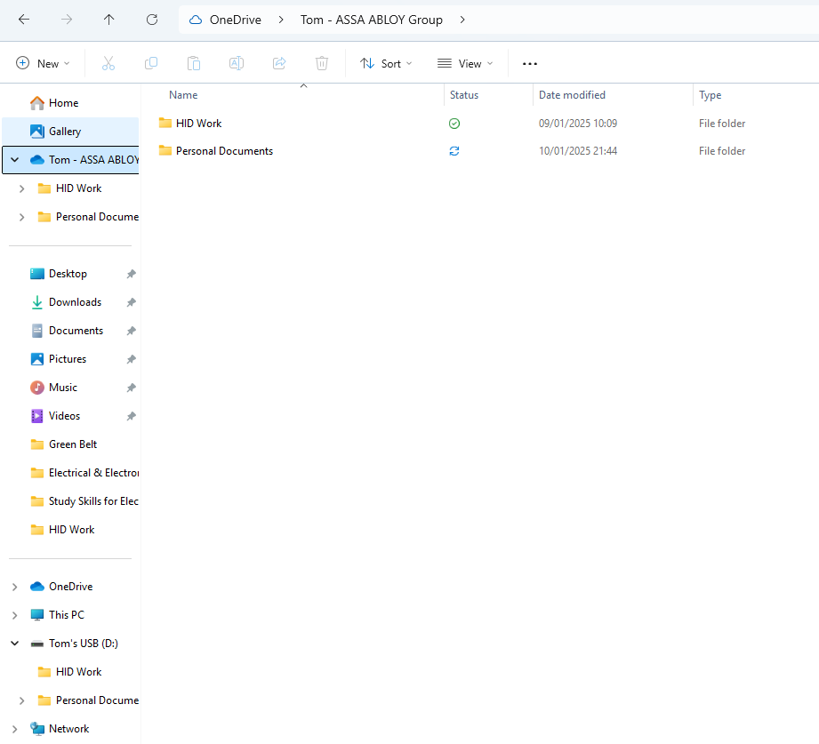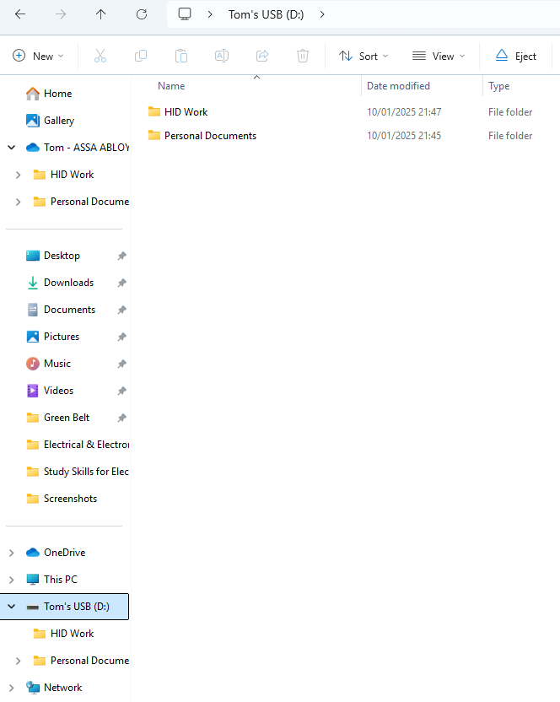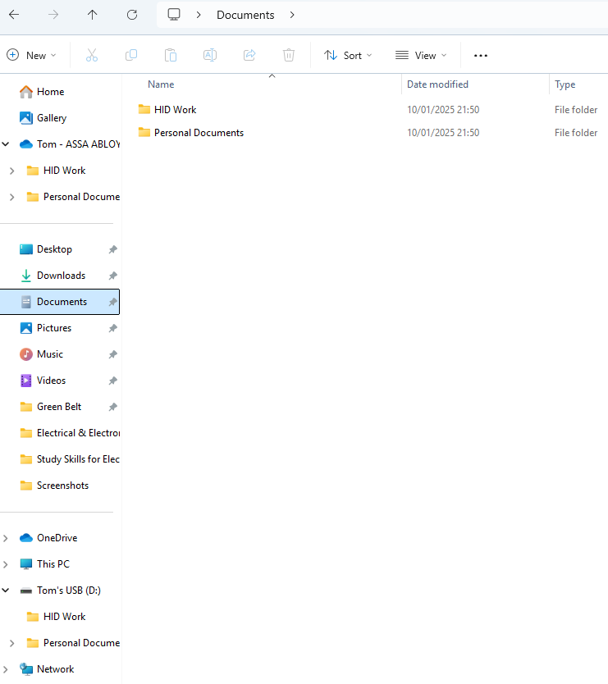

Shown above is the 3 different place method that the student has implemented within their daily life.

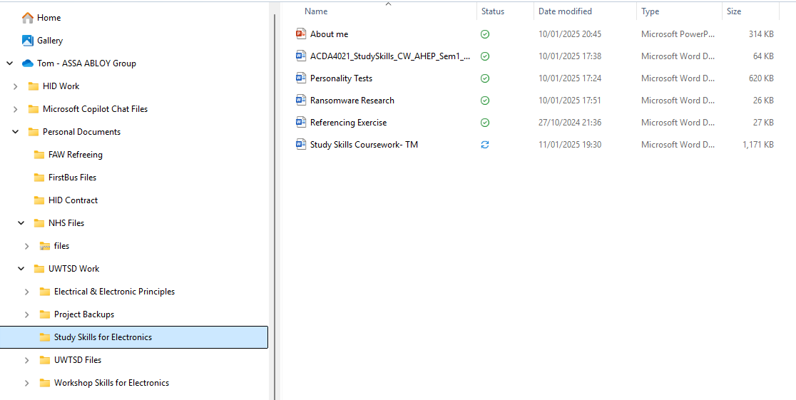
Shown above is an example of the structure that the student has implemented within his daily life being able to split work and university documents and then being able to divide them accordingly making finding and accessing files a lot easier for the student when working.

Conclusion & Evaluation
To conclude the student has learnt a great deal about delivering a presentation effectively and being able to structure and adhere to a time and to a specification and then being able to deliver that presentation effectively to a room of their peers and while also learning to practise the presentation more and timing before presenting it properly to get an idea of how long the presentation will be.
The student has been able to research and successfully identify different skills that would be required of the student through their time within university and the skills that employers would also looks for and give the student an idea on what they should be looking to work toward and grow, the student could conduct further study into this and it would be beneficial to know the different skills to develop upon in a more in depth view.
The student confirmed a lot of his own thoughts about his personality type and career type as he wasn’t surprised by many of the result that he had received but could improve a lot of skills as well if he wants to get to where he wants to be such as advising others to do a task which is a crucial skill if the student wants to progress further than his current role within the work place.
The student learned and displayed in depth the reasoning behind having a way of saving data within 3 different places and he himself also implemented it within his personal and work life so that he will never find himself within that situation but also could improve upon by making the data even more secure and researching different alternatives to a USB as it is very easily lost and can only store a certain amount of data.

References

References

[1] | “Unfresher,” 15 December 2024. [Online]. Available: https://unifresher.co.uk/cities/national/20-of-the-most-important-academic-skills-you-need-for-university/.
[2] | R. Needleman, “UniAdmissions,” 11 December 2024. [Online]. Available: https://www.uniadmissions.co.uk/application-guides/6-essential-skills-for-university-students/.
[3] | R. Swain, “Prospects,” 2023. [Online]. Available: https://www.prospects.ac.uk/careers-advice/applying-for-jobs/what-skills-do-employers-want.
[4] | C. Cheesman, “Freshminds,” 2024. [Online]. Available: https://www.freshminds.co.uk/candidates/skills-hub/top-skills-employers-are-looking-for?source=bing.com.

Appendices

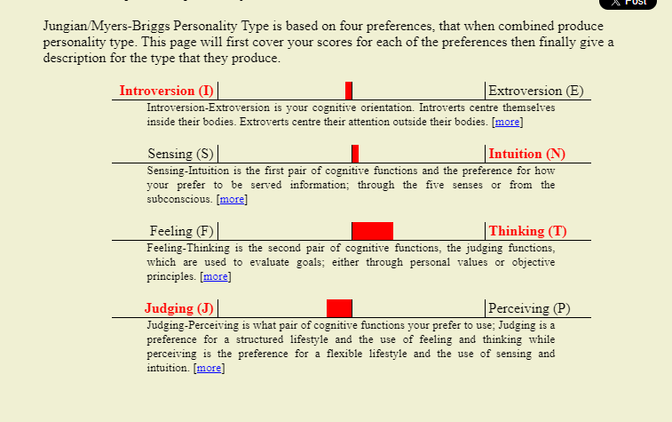
Open Extended Jungian Type Scales

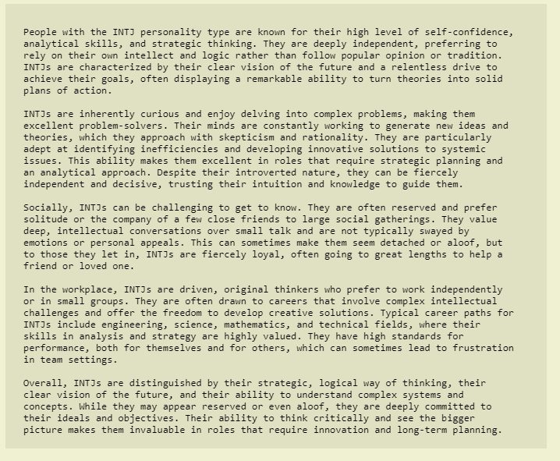

The Big 5
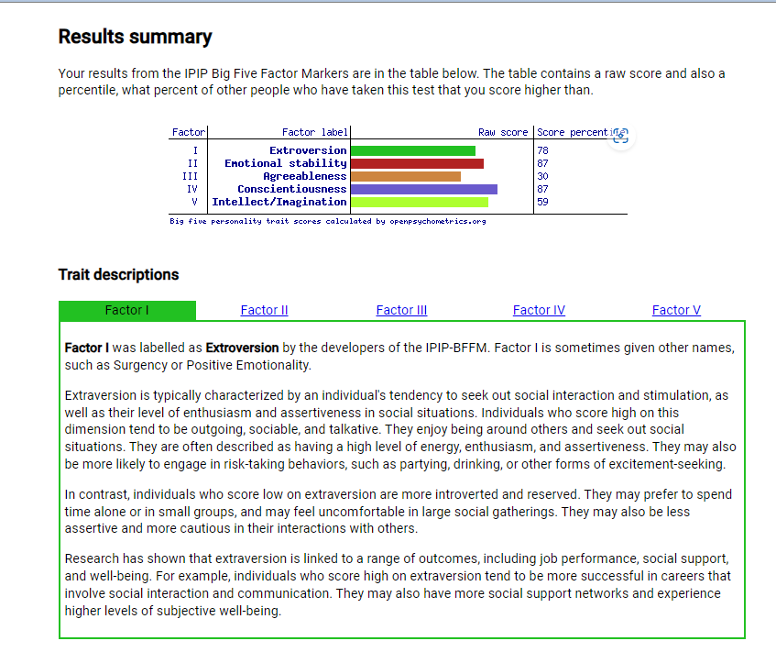

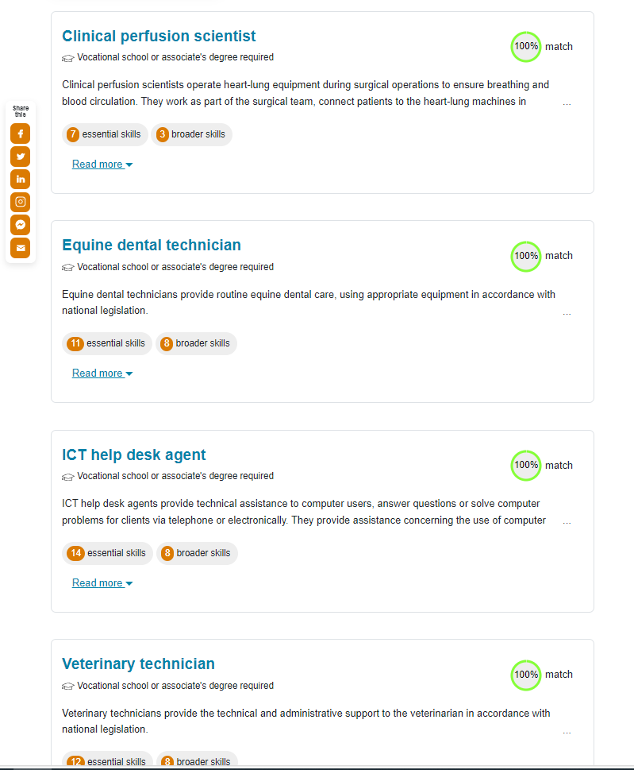
Career Test

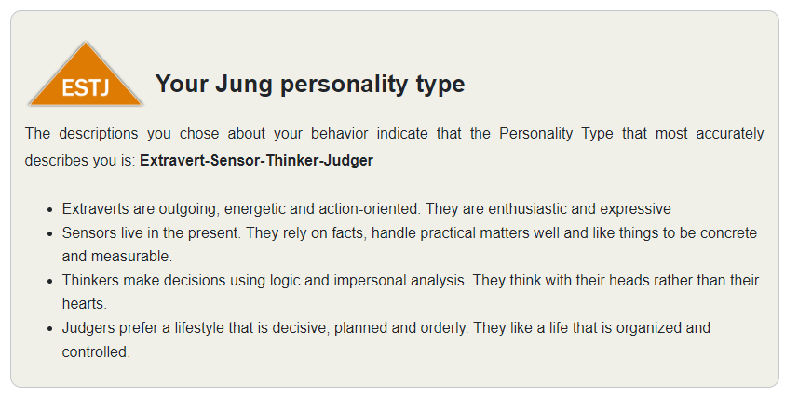
Jung Personality Report


