

Case study of the redevelopment of a process to allow tenants to book a housing repair on-line.

by
Julian Milligan (1904804)

Supervisor: Gaynor Thomas
2nd Marker – Michael Dacey

Project submitted as part of the requirements for the award of
BSc (Hons) Computing Software Engineering

April 2023

DECLARATION

I, Julian Milligan declare that I am the sole author of this Project; that all references cited have been consulted; that I have conducted all work of which this is a record, and that the finished work lies within the prescribed word limits.

This work has not previously been accepted as part of any other degree submission.

Date : 10/07/2023

FORM OF CONSENT

I Julian Milligan hereby consent that my Project, submitted in candidature for the B.Sc.(Hons) Computing (stream) degree, if successful, may be made available for inter-library loan or photocopying (subject to the law of copyright), and that the title and abstract may be made available to outside organisations.

Date : 10/07/2023

Abstract.

The aim of this project is to provide the tenants of Carmarthenshire a seamless experience in booking a housing repair. The current system is left over from a legacy system and is a serval year old. Currently the tenant fills in a form which is emailed to the contact centre where a member of staff transfers the details into a 3rd party package. During this process they must work out a job code which sets the time limit, who will attend and the costings. After it has been entered another team will then allocate a time slot.
This new process will look at combining all this in to one process that will be tenant driven. Once the tenant has submitted some basic information a time and date for visit will be displayed allowing the tenant to choose a date that suits them. They will also have the option to change the date or even cancel the booking.
After speaking with various teams within the council it has been found that the problems of using the existing process have far reaching implications.
- The contact centre waste time with double handling of data.
- The contact centre deal with many call / emails chasing repairs.
- The complaints team deal with many complaints about non visits or having no date for a repair.
- The democratic team deal with complaints from councillors who are acting on behalf of a tenant.

Even though the process will offer a new easier experience for the tenant it is also hoped that the 4 points above can also be addressed. With the project going live fully for tenants after this report will be completed data to see if these objectives can be met will not available but data will be checked to see if the number of hours wasted, and complaints have dropped.

During this report several terms will be used to describe a Granicus form.

Form – A single form with multiple sections used to capture information.
Integration – A system to send information to another system such as Email or to read data from another system such as a Database query.
Process – A few forms together.
Published – the ability to make a process accessible via the internet or intranet.

Table of Contents
Abstract. 3
Terminology used. 5
Table of Figures 6
Introduction. 7
Literature Review. 9
Business case. 9
Research. 11
Development Methodology. 14
Requirements / Design. 14
Requirements. 14
Additional requirements. 14
Design. 15
The form. 18
The Middleware code. 19
Project Plan 21
Development. 22
Testing 43
Test 1. 43
Evaluation. 45
Conclusions and Recommendations. 45
Reflection. 45
Reference. 46
Appendix. 47
Appendix 1 47
Appendix 2 47
Appendix 3 48
Appendix 4 49
Appendix 5 50
Appendix 6 (documents include in extra file) 69

Terminology used.
- CCC – Carmarthenshire County Council.
- CSA – Contact Centre Staff.
- Total – Software used to manage the housing stock.
- Tenant – Member of the public that rents a property from CCC.
- CRM – Customer relationship management.
- API – Application Protocol Interface.
- Form – a basic form to capture information.
- Process – a selection of form in a solution someone can access via a URL.

Table of Figures
Figure 1 Old form repair issue 6
Figure 2 Old form Roof issue 7
Figure 3 Old form date 7
Figure 4 Total guidance on POST 14
Figure 5 Total API Get User details. 15
Figure 6 Basic data flow. 19
Figure 7 Granicus create process. 21
Figure 8 Granicus form design 1. 22
Figure 9 Granicus form design 2. 23
Figure 10 Granicus form design 3. 24
Figure 11 Granicus form design 4. 25
Figure 12 SQL Query ExternalID. 25
Figure 13 SQL SP ExternalID 26
Figure 14 Granicus form design 5. 27
Figure 15 Granicus integration SP ExternalID 1 27
Figure 16 Granicus integration SP ExternalID 2 28
Figure 17Granicus integration SP ExternalID 3 28
Figure 18 Granicus form design 6 29
Figure 19 Granicus form design 7 29
Figure 20 Granicus form design 8 30
Figure 21 Granicus ExternalId test 1 30
Figure 22 Granicus ExternalId test 2 31
Figure 23 .Net code base controller 31
Figure 24 .NET code home controller - checkTenantDetails. 32
Figure 25 .NET code helper bearer token 32
Figure 26 .NET code check cust helper 33
Figure 27 Granicus form design get job code. 34
Figure 28 Granicus Test Assistant Job Codes 35
Figure 29 Granicus Integration rasieSalesOrder 36
Figure 30 Granicus Integration Payload 36
Figure 31 .NET SalesOrderData Model 37
Figure 32 .NET RasieSalesOrder 37
Figure 33 .NET Code RasieSalesOrder Helper 38
Figure 34 .NET Code RasieSalesOrder Helper 38
Figure 35 .Net Code getBookingAvailabilty 39
Figure 36 .NET code bookingAvailability 1 40
Figure 37 .NET code bookingAvailability 2 40
Figure 38 Granicus Test Assistant Dates 41
Figure 39 .Net Code confirm booking. 41
Figure 40 .NET code confirm booking Helper. 42
Figure 41 Granicus confirmation. 43
Figure 42 Total confirmation. 43
Figure 43 Granicus testing missing job code. 43

Introduction.

In late 2018 the council need to retire the existing platform than manged the how members of the public could request a service from the council. A new forms package was purchased and configured called Granicus. There were over 40 forms in the existing system and at the time there was no need to change the way they functioned, so all the forms were replicated into the new system and published for the public to use. As time moved forward some were re-designed after departments submitted an Expression of Interest and a business case to make the process easier for the public and back-office staff.
Most of the existing processes captured basic information and a PDF was emailed to a department / team to deal with. As time moved on some processes were rebuild from the ground up and using API`s data was passed to 3rd systems removing the need for a team to double handle data and enter it manually. Error checking was done on the form to make sure the data enter was clean and accurate.
With the housing repairs from it has several limitations these include

  - A very complex way to diagnose the issue. 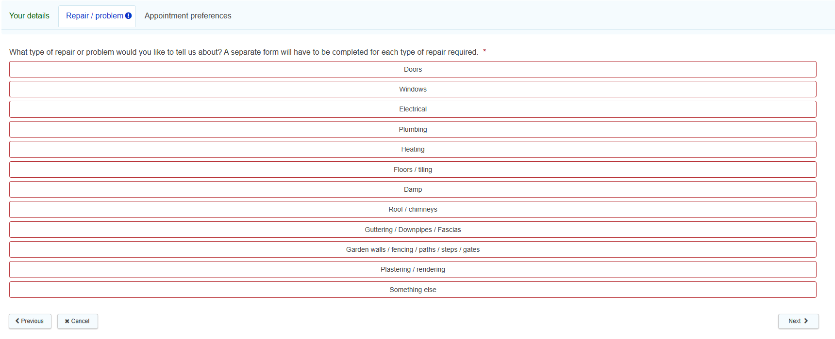
Figure 1 Old form repair issue
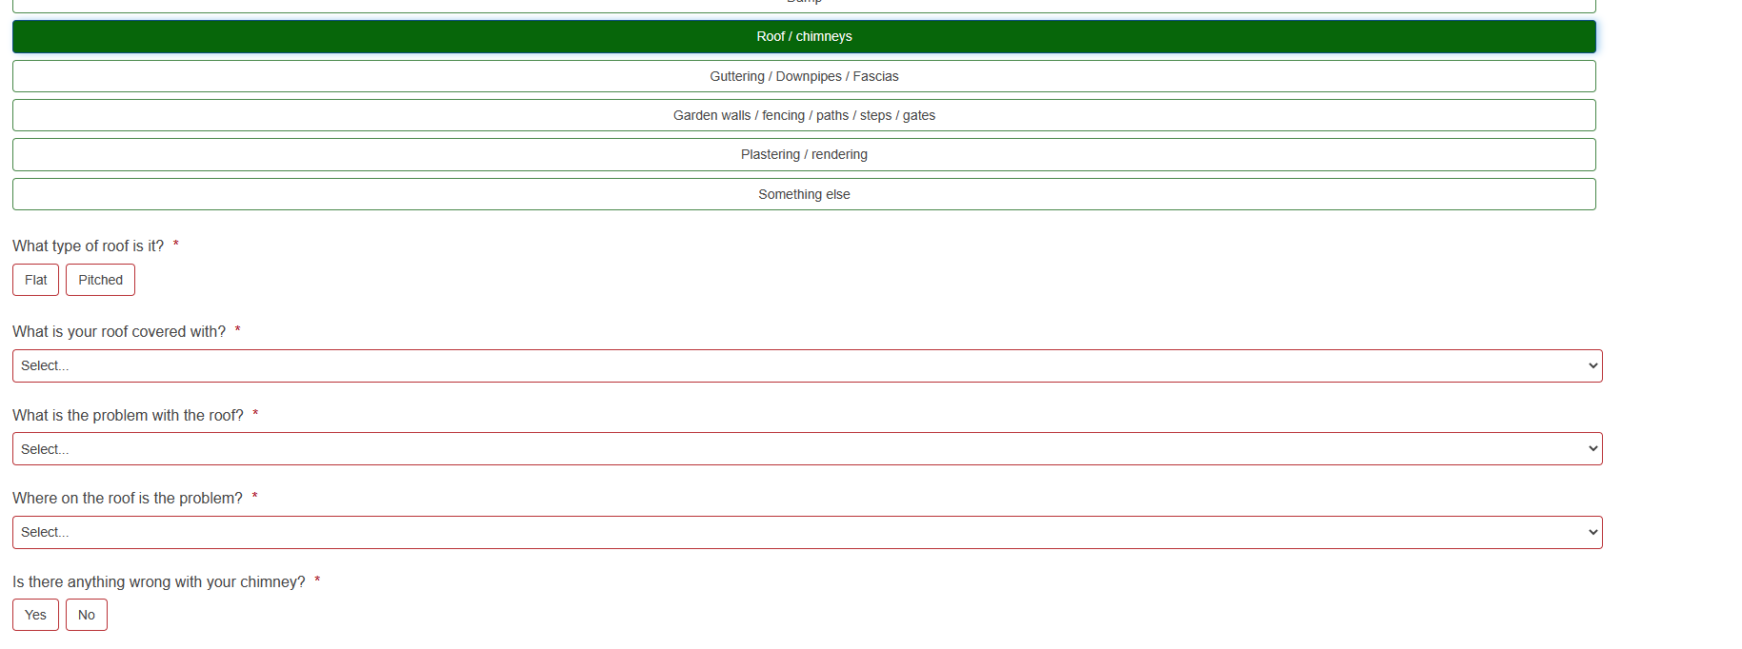
Figure 2 Old form Roof issue
  - The tenant was not able to choose a day for the repair. 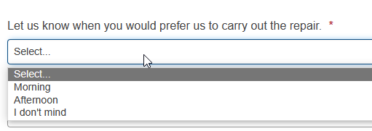
Figure 3 Old form date
  - There was very little feedback as once it had been submitted the case was closed in Granicus which often confused tenants resulting in calls to the contact centre.
  - Sometimes the tenant was not contacted with a date resulting in an engineer arriving to do the repair and no one was home, or it was not convenient.
  - Email system may fail so calls were not raised again resulting in calls to the contact centre.

The current form can be accessed here Request a housing repair - Your details - Section 1 - My Account (gov.wales)

The aim of this project is to provide the tenant with an easy-to-use process / form which provides feedback up until the repair is completed. This will fall under the Chief Executives vision of a single point for requesting a service from the council. If this main aim is archived then hopefully the points 3, 4 and 5 should reduce as well.

The objectives will be.
- A simple way to enter / search for the issue being reported.
- Allow tenants of Garages to also book repairs, as currently this not available to them.
- Allow a tenant to choose what date they would like a visit and which part of the day.
- Based on feedback from the Industrial Based Research report one feature that was requested was the ability to change the contact information.
- Insert the repair details into the Total system using their API`s after the data has been checked.
- Based on the survey results with less than 1% of the old process being completed in Welsh, a push will be made to show the process is available in Welsh.

If these objectives are met, then the reduction on other teams’ workload will be reduced. This will not be classed as an objective as it has not been requested in the main business case which is included in the Literature Review section of this report. However, it will be a welcome outcome if met.

The rest of the report will look at in more detail to why this is needed, how it will do, the design methodology, the development, and the testing of the process.

Literature Review.

Business case.
Project aim and objectives.

The aim of this project is to
- Deliver a faster and easier way for a citizen / staff to book an on-line repair to a building.
- Reduce the time the contact centre staff need to spend dealing with emails and double handling of data.
- Using the 3rd party software provide more accurate reports on housing repairs.

The project will also fall under the aims of the Chief Executive Wendy Walters of Carmarthenshire County Council to make the process for citizens a one stop location to raise an issue or query with the council.

The objective is to use an on-line forms package supplied by a company called Granicus ‘Modern Public Services: Software Empowering Public Sector | Granicus’ and a 3rd party cloud solution that will replace the current on-prem solution called Total with a new version called Total Connect. The cloud version allows the usage of API`s and several other benefits to make the integration between the two packages more seamless.

There is a lot of background work that needs to be completed for the process to be launched. The team in Place and Infrastructure need to setup the new system, provide there are staff to complete the repairs and for inspectors to be able to allocate work. These items will not be covered in this report, but it will take that the work is ongoing and running in parallel with this project and will be in place at the time of launch.

Since the start of this project the scope has changed, and two separate processes needed to be delivered.
- External form to allow tenants to book a repair.
- Internal form to allow council staff to book a repair.

Project Approach.

During the design and development of these processes the developer (Julian Milligan) will work closely with both the teams in Place and Infrastructure and the Contact Centre to ensure the project matches any needs they have.

Quality.

The process will help improve the quality of information being received by the engineer that is due to visit a property. More importantly the quality of service that the Council provides it`s tenants will improve because:

- Tenants will know at the time of booking when someone is coming.
- Be able to change the date via a link sent to them.
- The form will a lot quicker to fill in.
- Able to change the contact details. (Mr Blank may fill in the form but as he is working on the day of the visit, he can supply another person’s details as a contact)
- Contact centre staff free to deal with other items.
- Tenants will be able to see a history of their bookings.
- Tenants will have access to what the engineer reported, and work done.
- It will also send a text message to remind the tenant an engineer is calling the next day. This was a requested feature when a survey was run during The Industrial-Based Research report.

These points will be asked in the final survey and the results are recorded further on in this report.

Costings.

The cost of the new cloud system is around £70,000 per annum and this is covered by Place and Infrastructure.

As for savings this work has yet to be carried out, but some examples of time saving are below:
- CSA staff – saving 10mins per case (on average 28 per day)
  - Week starting 06/03/2023.
  - Monday – 36
  - Tuesday – 32
  - Wednesday – 20
  - Thursday – 36
  - Friday – 18

No case entered on the weekend would have been entered so Saturday 10 and Sunday 5 were added to Monday as this is when they would be processed.

So, on average over 4.5 hours a week could be saved by the new process. There is another process currently live that allows a tenant to ask what is happening to housing repair with this new process the submissions to that process will reduce and again reduce the time CSA need to deal with those queries and queries via direct email.

Resources,

Other than work being done in the background by Place and Infrastructure the development work will be completed solely by the developer.

Key Milestones.

- Confirming the API`s do what is needed.
- Accessing the API`s via middleware solution from Granicus integrations.
- Development of a subform to deal with the booking.
- Development of two processes Internal and External.
- Teams complete testing of both processes.
- Teams confirm the wording in the processes.
- Go-live for Internal process.
- Go-live for External process.
- Feed-back survey for Internal process.
- Feed-back survey for External process.
- Provide results to all involved and decide next steps.

Risk Identification and Management.

There are several risks with a project of this scale, a number are with the other teams so they will not be included in this report. However, there are some general risks with a process going live. As Granicus is a cloud-based system the CCC have no control if there is any down time but there are practices in places for a general outage.

If the platform is down for over an hour, then either Ben Grice (Digital Solutions Manager), Julian Milligan (Senior Application Developer) or Della Mills (Contact Centre Team Leader) will contact the Market and Media team who will place an announcement on social media to advise and a support call raised with Granicus, if the outage is lasting any longer then the support call is escalated as per the Service Level Agreement.

Research.

A few other councils including Wrexham, Pembrokeshire and Bridgend use the Granicus package to capture information from tenants to request a housing repair, however they currently have the same process as Carmarthenshire. A request is made and emailed to another department for the request to be actioned. Speaking to the technical team in Total and they are also not aware of any other councils UK wide that use Granicus connecting to their product via API`s to provide a seamless booking of a Housing repair. Because of this with in the Industrial Based Research report a survey was conducted to see if the existing system had any merit or any failings. The results are as follows.

- Date run 18/06/2022 – 01/09/2022.
- 51 responses.
- None in Welsh.
- 6 people said it was poor.
- 15 said it need improving.
- 7 said it was excellent.
- 23 said it done what was needed.

Granicus start rating system.

- 5 stars – 162
- 4 stars – 10
- 3 stars – 16
- 2 stars – 7
- 1 star – 13

Features they would like to see in a new system.

- Changing of contact details (Mrs A may be book the repair but Mr A will be at home on the day of the visit).
- A text message a day before to remind the tenant of the visit.

The above figure only shows a small snapshot, when the survey ran 174 submissions were made to the housing repair form so only 29% completed the feedback questioner. However, reviewing the complaints that came in around the same time show a different story. Complaints included tenants reporting visits not happening when expected, no date given to the tenant and the housing request not being passed on.

After speaking to Rob Griffiths, the digital team’s leader in Wrexham he faces the same issues as Carmarthenshire County Council. As they use a similar system.

From the information provided in the Business case and further Expression of Interest a few main points are highlighted.

Provide a one stop location for Council tenants to book a repair, manage the job and see any updates on it.

Provide a quick view so CSA can view the status of a job without using licenses for the main Total package.

Provide clean data to the API`s so the job is inserted correctly with no error`s.

Further investigation with other teams showed that this new process will not only benefit the tenants and the housing team but serval other teams within the council. As can be seen in the business case several hours will be saved within the contact centre with regards to entering jobs received via email from the old process. After speaking to Eifion Davis (Contact Centre Manager) and Della Mills (Contact Centre Team Leader) both senior members of the contact centre. It is apparent that entering the call details is only a small piece of the process. Other issues they face are.
- Tenants ringing to change a date.
- Tenants ringing to book an appointment as they can`t use the current process.
- Tenants wanting to know when someone will be out.
- Tenants wanting to know what was done, as they were not home when they visited.
All the above points again take time for the contact centre staff. So as part of the development process they points will be looked to see if they can be reduced. With the launch date of public process for tenants being after the date of report then there will be no follow up data entered.

Another team that was spoken to was Corporate Policy and following a meeting with Llinos Evans (Policy & Involvement Manager) it was noted that the complaints team received many complaints from tenants about housing repairs. Due to the nature of complains they cannot be included in this report however they take up a large amount of time within the team and the officer that deals with complaints within the housing team.

Some housing officers were all so spoken to as they log cases for tenants when they conduct visits to tenants. It was found however that they normally called to the contact centre to speak to a CSA directly so the issue could be raised, entered on to Total and booked while the housing officer was on the phone. This process could sometimes take 10 – 15 mins. When asked why one officer was quoted “Completing the form was complex and as no date for a visit was given it was easier to ring the contact centre”.

As with all the teams spoken too as part of the research for this project it is clear to see that this new project will affect a few teams within the council, and it is hoped that after the public process has gone live follow up interviews are conducted to see if there is an impact in the team either positive or negative. Negative impacts will be looked at and discussed at future development meetings.

Looking at the Business case, survey research and team interviews. Below are the new main objectives for this project.

- A simple, quick, and informative process for tenants.

It is hoped that if this objective is met then the issues other teams mentioned will reduced and the time saved can be used for other projects within the relevant teams. As for the housing officers a demo will be given of the final system to see if it will help them log a call directly from the site while they are in the tenant’s home.

Development Methodology.

The agile methodology will be used to develop this application / process. This will be used because there are several components included in this application. Each time a part is added it will be passed back to Total Team or Customer services to test and then any changes can be made and re-tested. As per the methodology regular meeting will be held to discuss where the project is at and what is needed for the next sprint. The Agile Manifesto was published in February 2001 after 17 software developers came together in Utah and came up with “by doing it and helping other do it” [1]. It has four main values which fall in line with the policies of the development team. They are:

- Individuals over processes and tools
- Working software over comprehensive documentation
- Customer collaboration over contract negotiation
- Responding to change over following a plan

These values will allow the developer to keep in contact with the team that requested the process and make changes as needed if new features are discovered or a feature is needed to help the process become more usable for the public.

C# will be the main language used for the middleware part with JSON being passed to and from the API`s. There is no need for any extra hardware as existing servers will be used for to serve the API`s and existing SQL clusters will be used for any databases.
The software used will be:
Granicus – For form design.
Postman – To test the API`s
Visual Studio 2019 Pro – to develop the Middleware

Requirements / Design.

Requirements.

- A single process to book a housing repair.
- Allow the tenant to choose a date that suits them.
- Allow the tenant to choose a time slot that suits them.
- Confirm property is part of the councils housing stock.
- Insert a job into Total via the provided API.
- Retrieve a job number from the Total system.
- Cancel the booking via the tenant if needed.
- Forms need to be provided in Welsh.
- Provide job updates to contact centre staff.
- Allow contact centre staff to change the date of the visit.

Additional requirements.

- Provide feedback to tenant from engineer.
- Easy method to change / update job codes.
- Allow the booking of repairs to council owned garages.
- Allow the booking of repairs to communal areas.
- Convert the process so it can be used of council buildings.

Design.

There are three main areas of design the Granicus form and process, the middleware application and database table to hold dynamic values and a look up of council properties.

Before any of the work can be started on the design of the form the API`s supplied by Total needed to be checked to see they could check, book, update and cancel a job. To this end Postman was used to build up the API`s with test data.
The Application Programming interface is a method to allow data to be sent to another program normally via a URL on a remote server. The server then processes the data and if needed returns a set of results. The developer does not need to know what language the application on the server is built in as an interoperability language is used to bridge the gap. This is normally provided in the documentation. Within the documentation provided by Total it recommends using either JSON or XML. As per best practice within Carmarthenshire County Council JSON will be used. 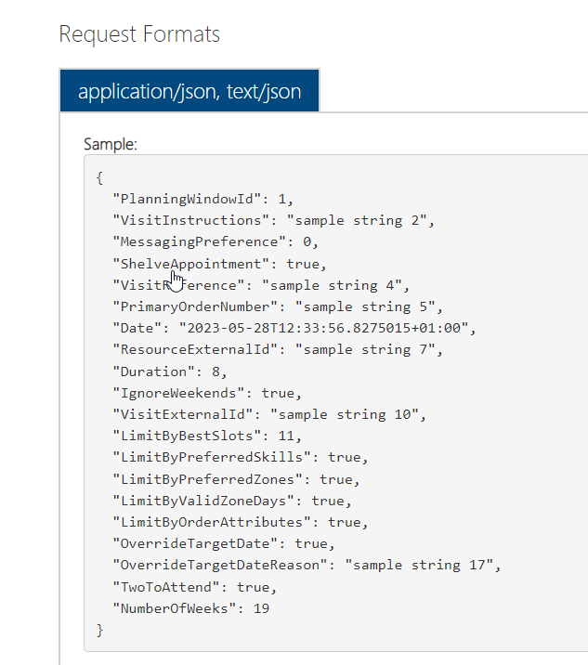
Figure 4 Total guidance on POST

To confirm that the correct data is being returned a test tenant was created with the Total application with the identification JMTest and using the address and name of the developer. To conclude that the API are working and returning the correct results 3 tests will be ran.

- To obtain a Bearer token, as this token will be needed for each request moving forward.
- Get the record details of the test account.
- Submit a Sales Order (repair request) and receive a Job Number back.

Test 1

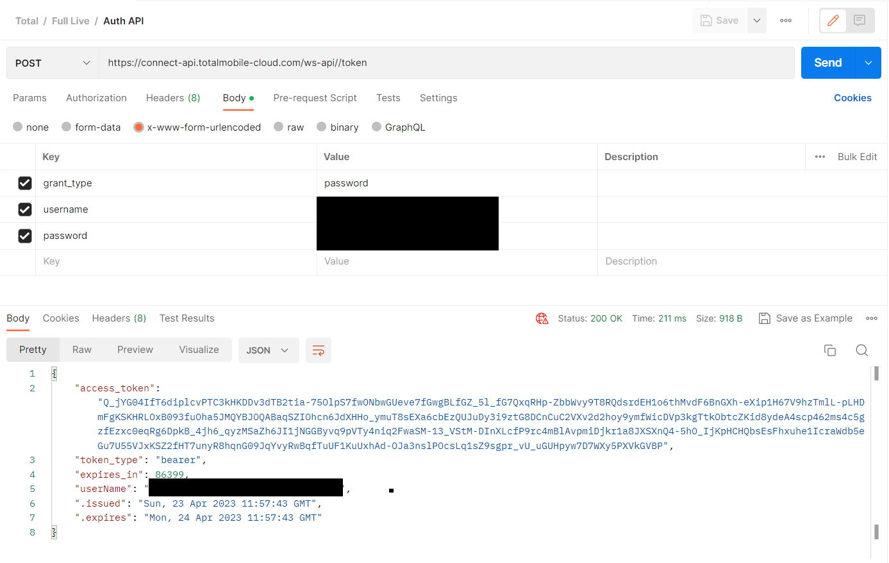
No body JSON was needed for this request as all the details such as Username and Password were included in the Header file. They have been redacted for security reason. As a status of 200 is received and there is also a Bearer Token, issue date and expiry date then it`s safe to say the connection to Total`s API base works. Moving forward the access token will be used. This has been noted for development as it will need to be ran before any other method is called.

Test 2
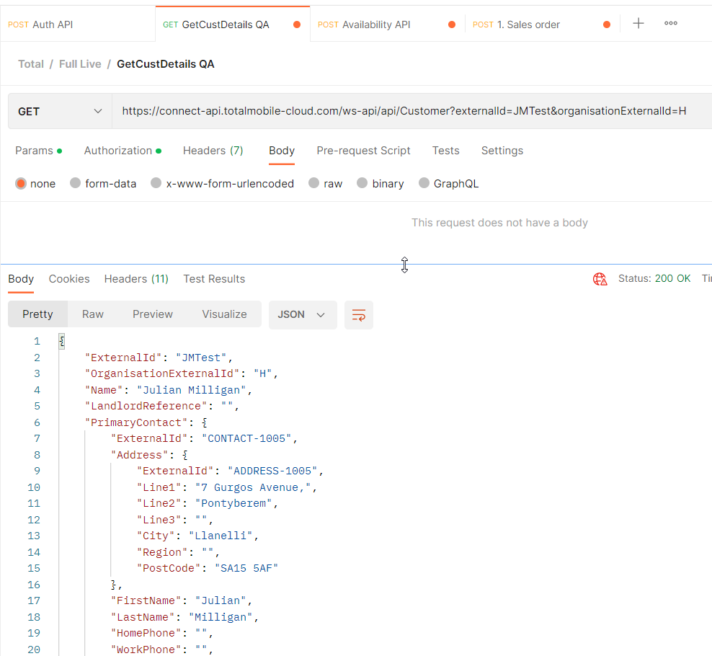
Figure 5 Total API Get User details.
The API`s use a mixture of no body, query string and body JSON. This one uses the query string method to pass information.
The Params tab was used to create and populate two keys.
ExternalID – userID
organisationExternalID – H = Housing / NH = Non-Housing.
The difference between H and NH is H is used for council house stock and NH is used for Council building such as School, Libraries and Offices. These have been setup by the Total to match their working methods.
The Authorization tab was set to the type of Bearer and the access token copied in to empty filed.
The Headers was left as default.
As data was needed to be returned and the system was being queried the request was set as a Get request. As can be seen in the image above the request was successful and returned all the stored information for the ExternalID JMTest.

Test 3

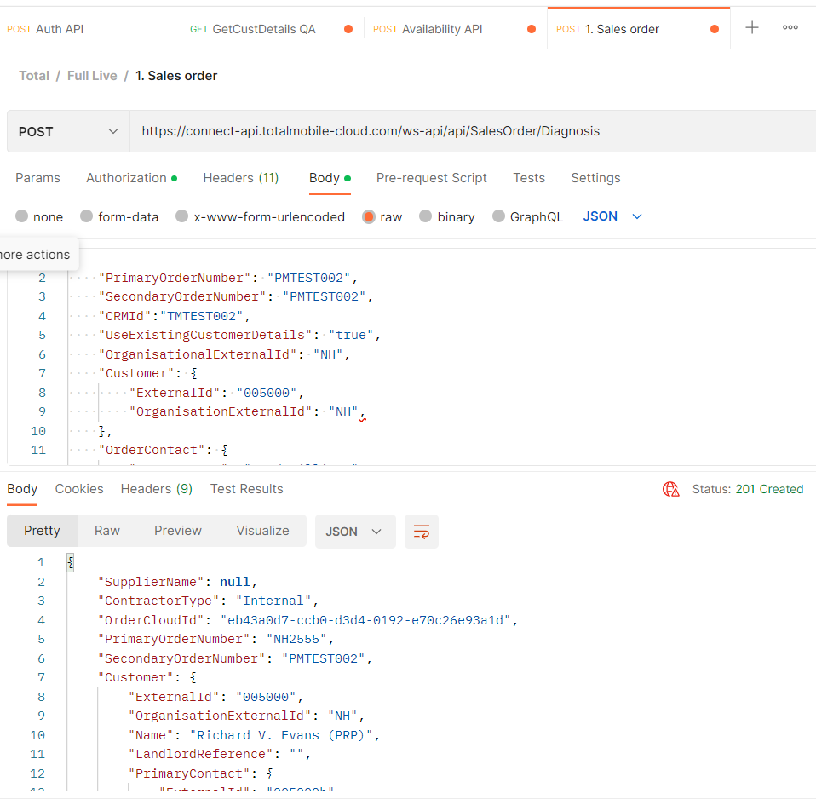

As the organisationExternalID was not fully setup the next test needed to use the NH group and another ExternalID that was setup. Again, the authorization tab was populated with the bearer token. This time the body tab is used, and selection of JSON is supplied to the request, PrimaryOrderNumber / SecondaryOrderNumber are references internal to the council and will be populate with a reference from the Granicus form.
The important section is the Customer section as this holds the ExternalID and organisationExternalID. This time a 201 status is returned to say a record has been created and in the response JSON a PrimaryOrderNumber is supplied. In development this will be used as the primary reference for the job.

Confirming that the API`s work as expected with no firewall issues and finally return a PrimaryOrderNumber, then design work for the rest of the process can continue.

The form.

The form will be built using the inhouse product called Granicus. This is a form design package that allows developers to add integration such as email, database look ups, API calls and text formatting. The existing form was very complex, so the new version needs to be quicker however it also needs to collect or obtain information to raise a sales order in Total.

Information that needs to be captured to raise a sales order –

Detail | Source
Name | Form
Address | Form
ExternalID | Database lookup
PrimaryOrderNumber | Form
JobCode | Database lookup
Booking Date | API data

Job code is mentioned above these have been setup by the team within the council. An example is Non-Housing - Domestic Bathroom - Basin - Loose basin.
The all comprise of four sections the Organisation, contract type, item, and issue. These are used in the Total application for costings, charge backs and assigning the correct trades person. Within this report it will not go into any further depth on the job code except for the trade’s person. When a booking is made the Job code controls what trade is needed and then looks are available dates for the trade and using the ExternalID looks for the one that covers that area.

Using the table above it shows two sections are needed and they align with the best practices within the council.

Section 1

Name and address.

Section 2

Processing of the booking.

The tenant will not know their ExternalID, however the value used by Total team is the same value used in an inhouse database used for rent accounts and is called property ref. An integration will need to be created for this.

As this process will be used for two different process council tenants and council staff the process of booking a repair will be made into a subform with Granicus. This will allow one subform to be used in two different processes and any changes made will replicate to both processes.

The Middleware code.

The Granicus platform can call API, send JSON, and receive JSON which can then displayed on the form. However, it is not possible to securely use the bearer token authentication in the integrations. So, a .Net application will be written to process the data from the Granicus form, call the Total API`s and return any data back to the form. It can also be used to CRUD any databases that maybe needed. A class will be written housing a method for each function of the process with a base class storing variables that maybe used a few times. Helper classes will also be built that will contain the method for processing any data. The version used will be 4.6.1 which is the current version used within the department.

Main Class
- Check tenant details.
- Raise sales order.
- Get booking Availability.
- Confirm booking.
- Booking summary.

Helper classes.
- Bearer token.
- Raise sales order.
- Check customer.
- Email – for error capturing.
- Confirm booking.
- Booking availability.

These will also need to Asynchronous methods to deal with the requests correctly. Entity Framework will also be used for any database connections. One possible table will be for the dates of possible repairs. During testing of the API`s the date returned by the API for bookings was complex and contained several entries that were not relevant like dates for time slots not selected and dates where no engineer was available. To overcome this a database table will be used to filter through the information and correct the formatting needed to display a date correctly in the Granicus form. This is a known issue with Granicus. The Middleware package will be built as a separate solution for this report but will be integrated into the Councils’ main Middleware solution in the future.

In brief the Granicus form will not call any of the Total API`s directly but data will pass through the Middleware solution to it can be made secure, data cleansed, error checking and if there are any errors they are caught, and the development team informed. Even though the Granicus form is hosted in the cloud the Middleware solution and databases are hosted on internal servers. Below is an example of the connections used.

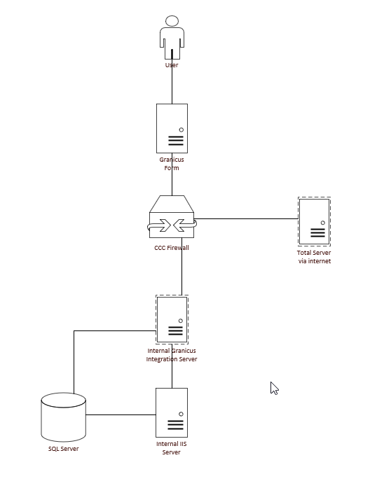
Figure 6 Basic data flow.

The above diagram shows the basic flow. The Granicus server uses a secure connection and there are rules on the CCC firewall to allow data from a set IP address and port number. All Granicus integrations are controlled through a dedicated server this server then communicates with other servers. For this project they will be known as IGIS1, ISS1 SQL1.
So as an example, if the user fills in their details and the process need to look up the ExternalID then the Granicus server will pass the integration request to IGIS1 which then uses the API address in the integration and sends the request to ISS1 which runs a stored procedure on SQL1. The result is then passed back in the reverse path and the information is saved on the form and a successful message displayed to the user. This will be covered more in the development section of this report.

Project Plan

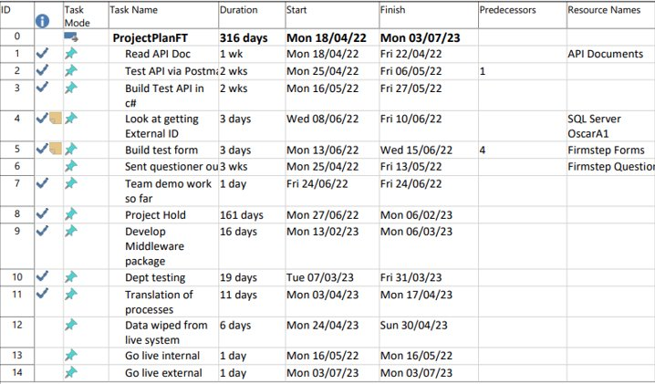

This project has been in development for a long time, there was a long period where nothing was done this is because of external factors that where beyond the control of the developer. These included items such as staffing to administer the new Total system and staff to complete the repairs. It was decided to put the project on hold until all the staffing issues had been resolved. The go live for the External form is still 03/07/2023 however at the time of writing this report the new go live for the internal process is 19/06/2023.

Development.

The first part of the development process will be the form to capture the information. The form design is a cloud-based application that all developers within the council have access to as per a best practice document created within the team this process will be created within the Live environment. If it was an existing process that was being updated, then it would be copied to the Test environment so the live process can remain active while the update was being developed.

To create a new process
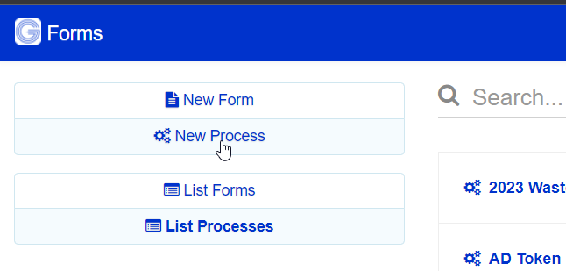Figure 7 Granicus create process.

A Granicus form is made up of several parts.

The Process – this contains all the individual elements.
A stage – This contains the form and it`s action, there are normally multiple stages. For example, Stage1 the request (where the user completes the form) and Stage2 is where the back-office staff process the data.
A form – these live within the stage and has all the input boxes, list, and integrations.
A section – Allows parts of the form to be split.

Once the new process is created a name is given to it again keeping within the best practice. They need to be simple and describe what the process does. This process will be call “Request a property repair”. The stage will be renamed to “Request”. As per the design brief two sections will be created “Your details” and “Repair/Problem” this to help split the form to make it more readable to the user. On the “Your details” section the basic information that needs to be captured is Name and Address. Before this some information needs to be provided to users. These details were copied from the original process, the case reference is also need further along in the process and what type of unit are they requesting a repair for?
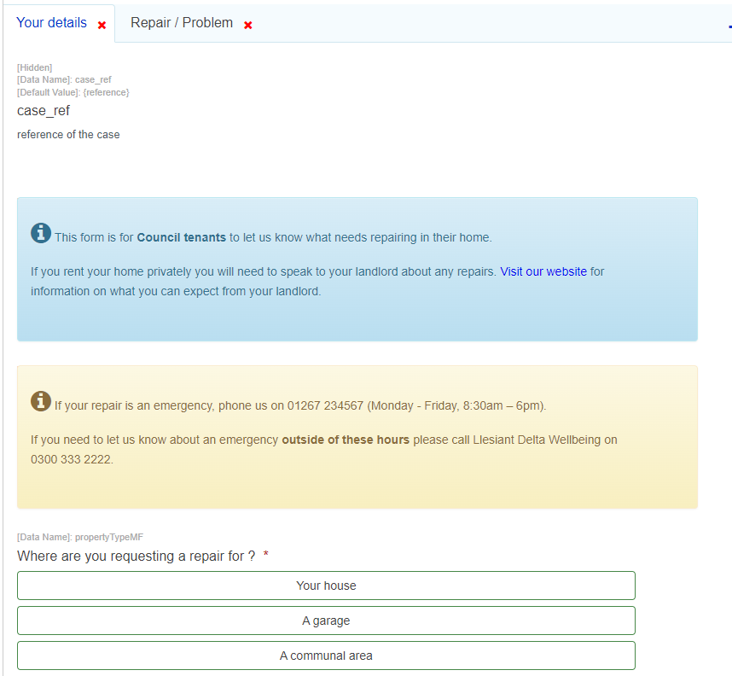
Figure 8 Granicus form design 1.
Figure 8 shows 4 basic elements on the new form case_ref will be used to capture the case reference which will be used later in the process to tie the Granicus Process and the Total request together. Below that are two sections of information for the user. The last part is what type of property the user is requesting a repair for, this is needed as the job codes will be dynamic based on this selection. Also, for a garage or communal area a different approach is needed to obtain the ExternalID.
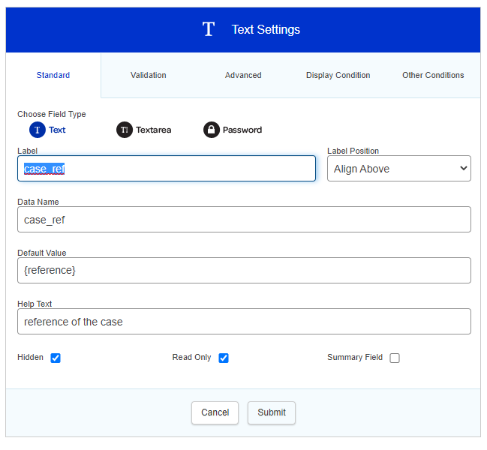
Figure 9 Granicus form design 2.
Figure 9 show the basic properties of a text box, this one is for the case reference, most of the properties follow the elements of a basic HTML text box within a form. Label is what is displayed to the user, Data Name is the value that is referred to when data is needed from the field and Default Value can be text or as shown above it contains a token value. The value {reference} is a default token supplied by Granicus and it provides the case reference of the current case. A token is a data name enclosed in {}.
As this information is not need by the user it has been set to hidden and read only.

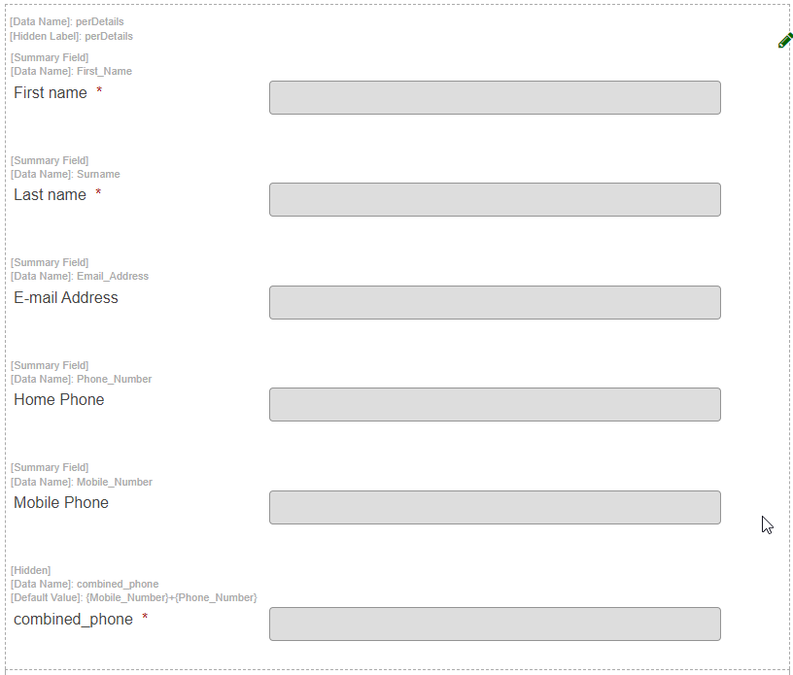
Figure 10 Granicus form design 3.

Figure 10 shows a subform called “CCC Standard Person Details”, standard subforms are used because it provides a constant look to all the process published by developers, it was also agreed with Marketing and Media. The form allows the user to enter a name, email if they wish and a combination of telephone numbers. There is some error capturing to make sure at least one telephone is entered.
If the user selects “Your house” then another subform is displayed asking for their address, it is driven via the post code and will only display Council Rent stock houses. This subform was also created to be used repeatably and uses a database lookup connected to the rent table in a SQL Database. This report will not go into any depth on this as they are standard practices used within the Council. If the user selects “A garage” or “A communal area” a different subform is displayed that will look at a different database source for a list of addresses and is dynamic based on the selection made. This subform will provide an ExternalID as that information is stored with the database table. However, for the option Your house a further lookup is needed.

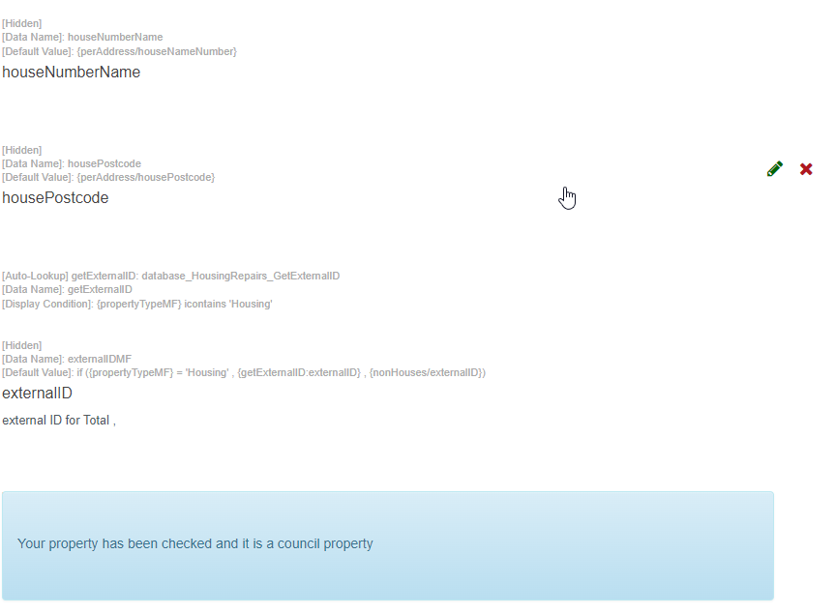
Figure 11 Granicus form design 4.

Figure 11 show the fields needed to obtain the ExternalID for a rented house. This report will show in detail how this integration is created, and any further database integrations will be mentioned but not the same level of description.

Fist a query was written to retrieve only the information that was needed for this process, a test address of 57 Sycamore Way, Carmarthen SA31 3QG was used and will be used as the test address for the rest of the development.

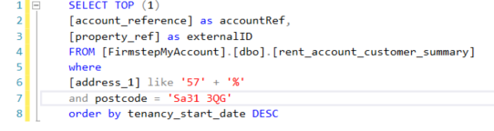

The database FirmstepMyAccount is one of the main admin databases used with Granicus (Firmstep was the name of the platform before a name change in late 2022). There are several tables with Council rent information stored in them these are update every night from the council`s benefit system. The two columns needed are account reference and property reference these as renamed in the query for use further on.

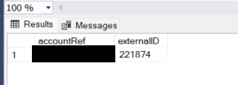
Figure 12 SQL Query ExternalID.
Figure 12 shows the result of the query and confirms the correct information is being provided and in the correct format. This query was tested several times and all results where as expected.
House number | Postcode | ExternalID | Pass / Fail
8 | SA15 3RN | 100379 | Pass
46 | SA15 1RN | 102896 | Pass
47 | SA16 0JY | 154710 | Pass
33 | SA16 0DD | 157683 | Pass
3 | SA15 5AF | 151653 | Pass
46 | SA18 3QH | 153625 | Pass
24 | SA16 0UH | 155013 | Pass

No non rent houses were tested as the subform on the first section will only display rented properties so no non rented houses will be submitted.

Next this query was turned in to a Stored Procedure with variables for postcode and houseNumber so that it can become dynamic.

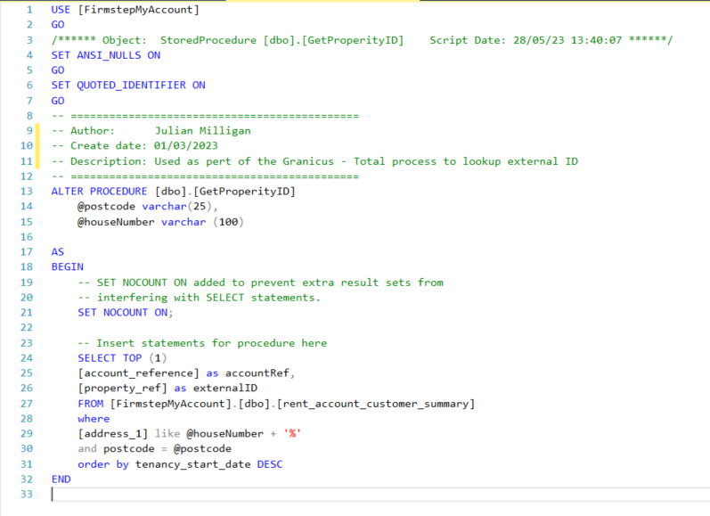
Figure 13 SQL SP ExternalID
This was also tested with the same data as the query and the results matched. Based on the variables declared the SP will need a value for postcode and house number passed to it.
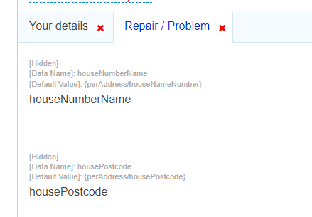
Figure 14 Granicus form design 5.

These are captured at the top of the second section and the default values are pulled from the subform on the first section. In theory the value perAddress/housePostcode could be used but previous experience has shown that this method is not reliable, so new fields are created to make sure they populated with the correct data. The nest phase is to create the integration.

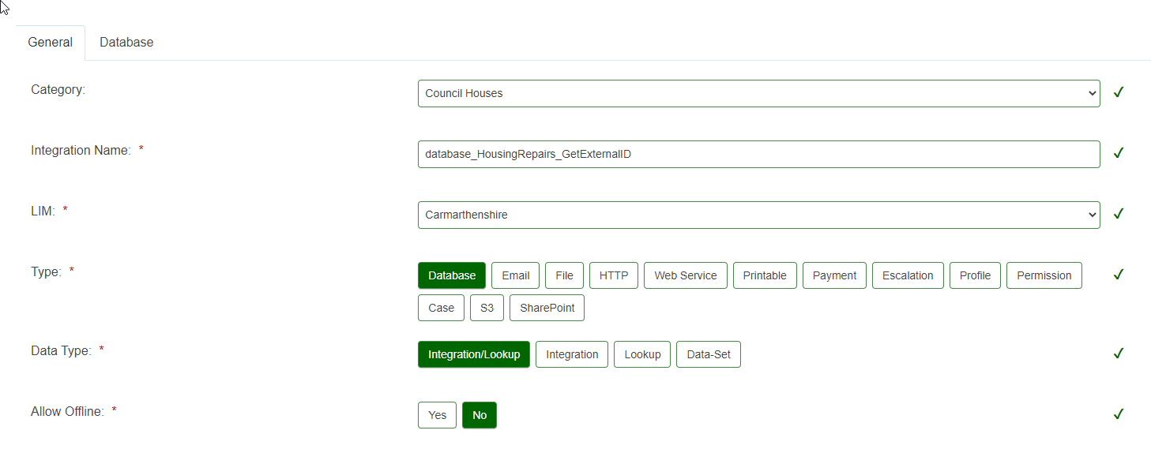
Figure 15 Granicus integration SP ExternalID 1
The above image shows the general fields needed for an integration.
- Category – used to group different integrations to a project.
- Integration name – best practice used, type of integration – group – what it does.
- LIM – this shows if it runs on internal servers or Granicus cloud servers.
- Type – a few different types of integrations can used.
- Data type – Integration/Lookup is used as data needs to be returned.
- Allow offline – this is always set to No as several servers could be used for one process.

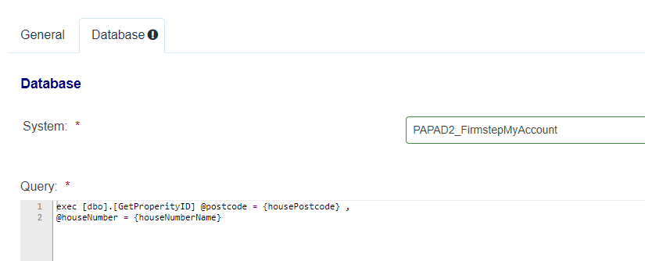
Figure 16 Granicus integration SP ExternalID 2

The System is a pre-defined connector this one points to an SQL server called PAPAD2 and the Table FirmstepMyAccount.

The query is a standard SQL statement the values in {} relate back to the two data names in Figure 14. To test that the integration work the Granicus designer has a build in test assistant.

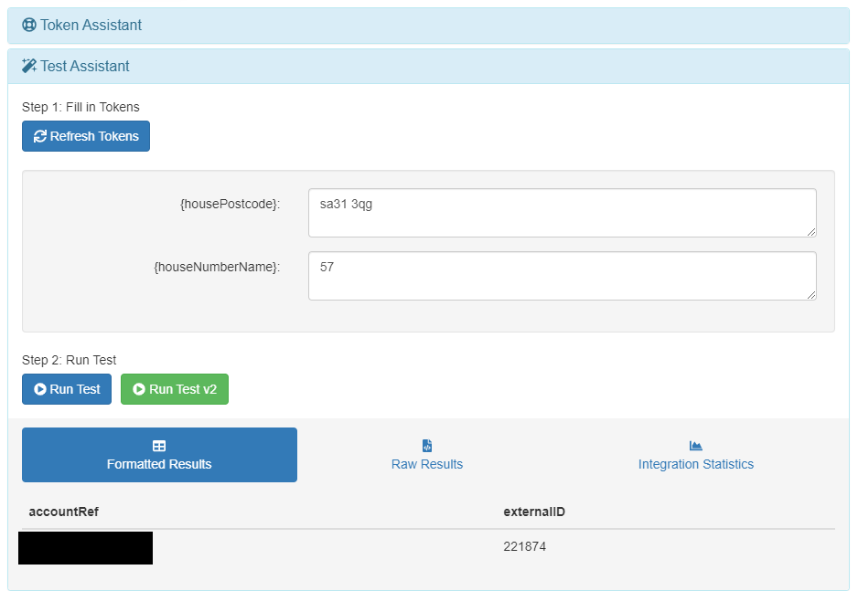
Figure 17Granicus integration SP ExternalID 3
This allows developers to input test data which is then converted to tokens and passed to the SP via SQL exec command. Using the test data an ExternalID and accountRef is returned.

The integration can now be added to the form and the returned data displayed on the screen.

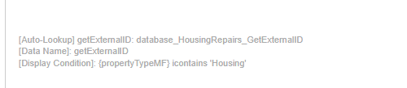
Figure 18 Granicus form design 6
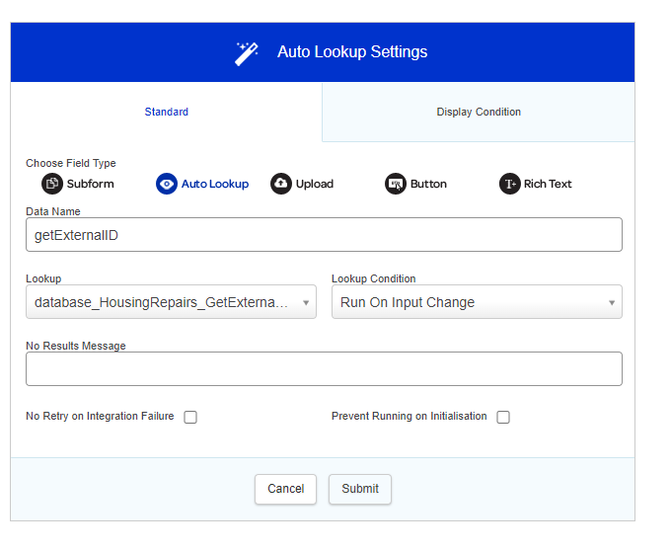
Figure 19 Granicus form design 7
Figure 18 shows the integration on the form and Figure 19 shows the properties. A data Name is provided so it can be access further on, the look up is the name of the integration created in Figure 15 – 17. The lookup condition controls when it should run this is set on input change meaning when the tokens above have values it runs.

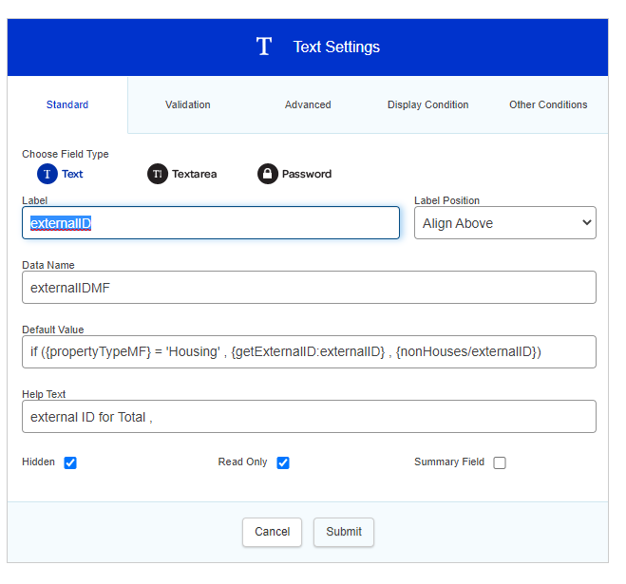
Figure 20 Granicus form design 8
A text box is then added to the form the data Name has MF added to it this is to show that it is the definitive ExternalID and is from the main form (MF). In the default value an if statement is used. The format is if (condition to be checked, true, false). propertyTypeMF refers to the question asked in Figure 8 as only ‘Your house’ or the value Housing needs the data from the integration as the others provide it, so if it`s true then the token value form {getExternalID:externalID} is used. This token is made up of the auto lookup Data Name and the value returned. For testing this was left unhidden.

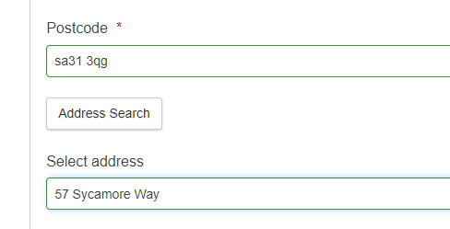
Figure 21 Granicus ExternalId test 1
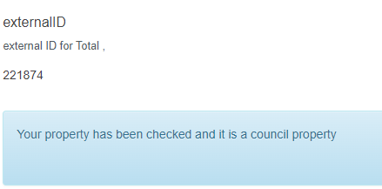
Figure 22 Granicus ExternalId test 2

Figure 21 and Figure 22 show the postcode and the address search and then on the next section the ExternalID being displayed correctly. As this feature is only a small part of the entire process no more testing results will be displayed as the feature was tested above and the results would not be any different. Any further database lookups mentioned in this report will not show as much detail.

Now that the ExternalID is being displayed and is stored in the form building of the main section can continue. Also, as a safety feature a check is needed to confirm that the tenant is in Total, this will use one of the methods created in the middleware solution. The next section will cover how the middleware solution was developed and will cover two methods in detail the Bearer Token and Check cust methods. The Bear Token will be called in each method so this will be created and tested first.

The middleware solution will be developed in Visual Studio Professional 2019. It will use .Net Framework 4.6.1 and Entity Framework V4 and will be constructed using the MVC model. The solution will Visual SVN for version control.

As mentioned previously all methods will be Asynchronous and will public.

A base controller will be created that will contain sensitive information like username and password, it will also hold the base URL for the API call in the solution. It will also hold some other items such json version and will create a new object called emailHelper which will be used to send an email to the development team in case of any errors.

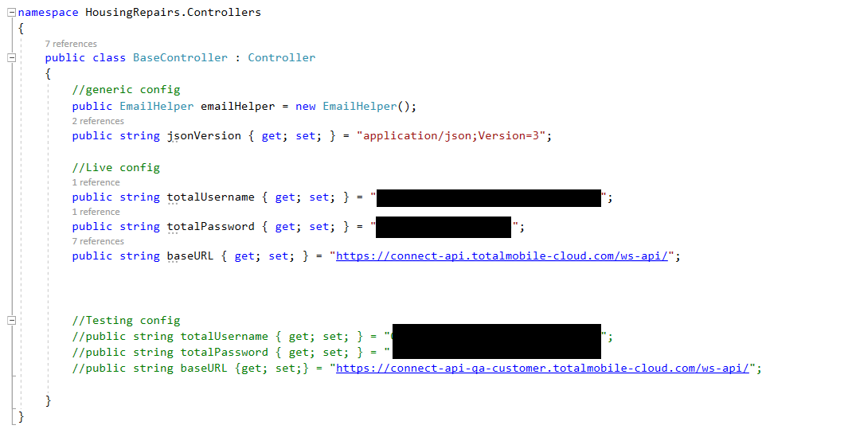
Figure 23 .Net code base controller
Figure 23 shows several public string properties being initialized so they can used elsewhere in the solution. Test settings are also initialized here. The main home controller will then inherit the properties from the base controller as seen on line 15 of Figure 24.
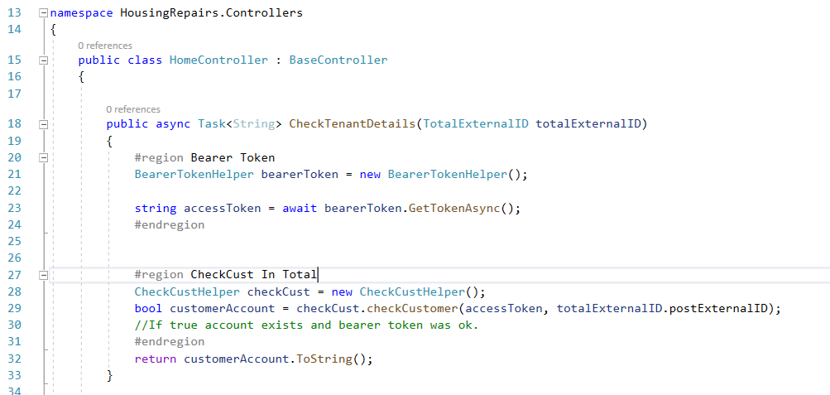
Figure 24 .NET code home controller - checkTenantDetails.

As the bearer token will be used in every method moving forward the process will only be described in detail once. Line 21 creates a new object called bearerToken by use of the helper method BearerTokenHelper. Line 23 waits for the returned data.

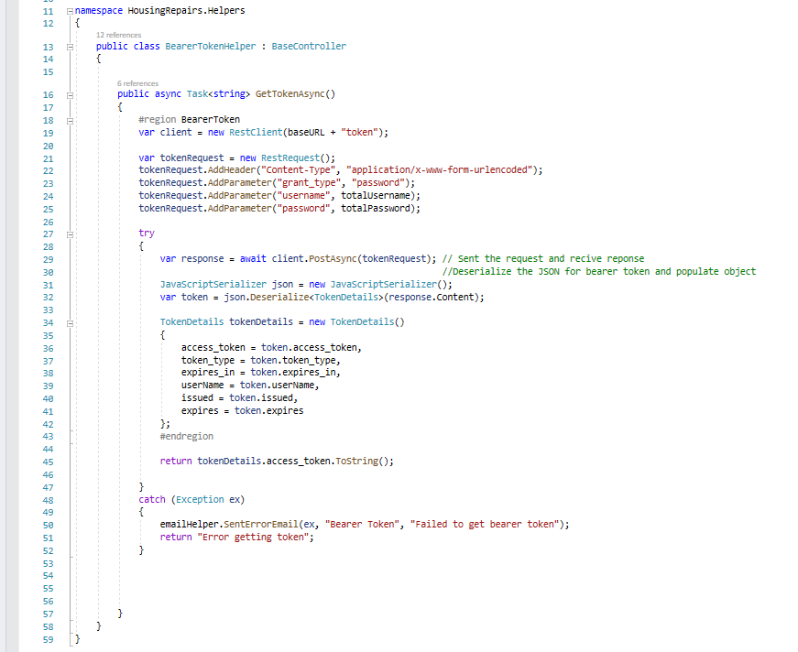
Figure 25 .NET code helper bearer token

Using a build in library called RestSharp a new client object is created on line 19 and passed the baseURL from the base controller and the string ‘token’ is appended to it. A new tokenRequest object is created on line 21 using the same library and various parameters are added to it. These include.
- Line 22 – the content type
- Line 23 – the grant type
- Line 24 – the username
- Line 25 – the password.

These match the parameters in the image for Test 1 when using Postman. A try / catch function is then used to capture any errors that maybe returned. Line 29 creates an async object called response and it passes the tokenRequest object via the client object created on line 19. This will now wait for a response before moving on the next line. The result returned is in the JSON format for this to be used it needs to be dieselized which is controlled via line 31 and 32. A new object is created called tokenDetails which uses the model TokenDetails and in case any data may be needed in future development all fields are assigned. As for now only the access token is needed to its returned from the method on line 45. Line 45 uses the object emailHelper and the function SentErrorEmail to send the caught exception, the area where the error happened and a subject line.

In Figure 24 line 28 creates a new object called checkCust, line 29 creates a bool variable and calls the object and function checkCustomer and passed the accessToken and ExternalID from the object on line 18 which includes data passed to API from an external source.
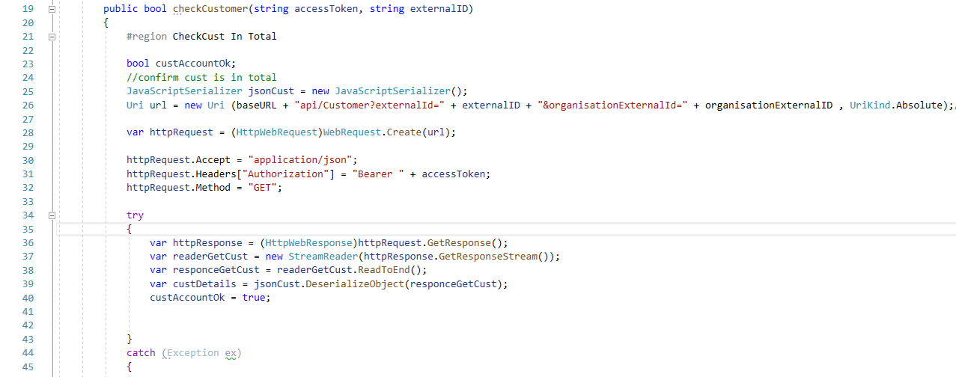
Figure 26 .NET code check cust helper

Line 19 shows the creation of the method and the data passed to it. During testing in Postman if an incorrect ExternalID or one that did not exist was passed to the API then it returned a status code of 500 if it did exist then 200 was returned. Based on this the try / catch was used again and would set the variable created on line 23 to either True or False.

Referring to table created in the design section the first 3 parts have been obtained. As the development processes this table will be reused and expanded.

Detail | Source | Captured | Needed to create sales order
Name | Form | Yes | No
Address | Form | Yes | No
ExternalID | Database lookup | Yes | Yes
PrimaryOrderNumber | Form |  | No
JobCode | Database lookup |  | Yes
Booking Date | API data |  | No

As can be seen from the table only the job code from the user is now needed to create a sales order. A hidden filed has been added to the form this is also needed but not via user input. Total needs to know if it`s a Councils House or a Council building. This is controlled by OrganisationalExternalId. For this process it is set to ‘H’

To raise a Sales order a set number of step must be taken, and the development will follow these steps to make sure that the correct data is provided to next step.
- Obtain External ID.
- Confirm ExternalID exists in Total.
- Obtain a PrimaryOrderNumber from Total.
- Get a job code.
- Obtain dates bases on the Job code.
- Obtain a booking reference.

The next item that needs to be obtained is the Job Code, this uses a select list on the form and a database lookup called ‘database_HousingRepairs_GetDiganositicCodes’ in the name you can see the naming convention used. Type – Process – function, if its language dependant then the language is added to the end CY or EN.

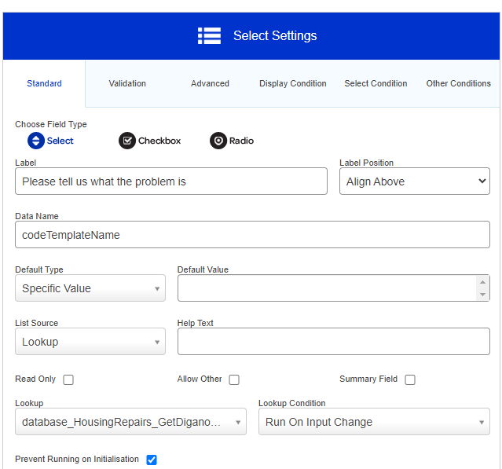
Figure 27 Granicus form design get job code.
Figure 27 show the how the select list is build and the lookup being called on Input Change (when the user clicks on it). This integration runs a simple SQL command to execute a SP and pass two values property type and the form language.
‘EXEC spTotalConnect_GetDiagnosticCodes @propertyType = {propertyType}, @formLanguage = {language}’

PropertyType is used so the SP can be used in the future development of the internal form and the different property types, so a value is needed to identify the correct list of Job codes.
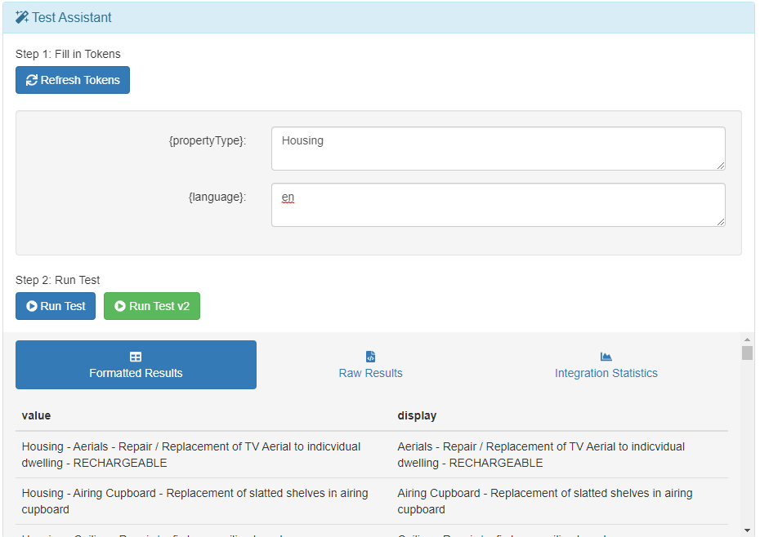
Figure 28 Granicus Test Assistant Job Codes
The above image shows the test assistant in Granicus and the results from the query. The SP takes the language variable that is passed to it and the following code.
ALTER PROCEDURE [dbo].[spTotalConnect_GetDiagnosticCodes]
@propertyType varchar (250),
@formLanguage varchar (10)

AS
BEGIN
-- SET NOCOUNT ON added to prevent extra result sets from
-- interfering with SELECT statements.
SET NOCOUNT ON;

if ( @formLanguage = 'en')
SELECT ValueText as value , DisplayTextEN as display
FROM [dbo].[TotalConnect_DiagnosticCodes]
WHERE DisplayTextEN IS NOT NULL and Active = 1 and PropertyType = @propertyType
Order BY DisplayTextEN ASC
else
SELECT ValueText as value , DisplayTextCY as display
FROM [dbo].[TotalConnect_DiagnosticCodes]
WHERE DisplayTextCY IS NOT NULL and Active = 1 and PropertyType = @propertyType
Order BY DisplayTextCY ASC
END

Not all columns need to be return only the ones that are needed to be displayed and the value to be passed further on in the form. The where clause removes any NULL values and will only return active Job Codes and for the correct Property Type. Future work will include an application where the Total team can CRUD new Job codes. Using the SQL returns a list of the property types currently used.

select distinct PropertyType
from dbo.TotalConnect_DiagnosticCodes

PropertyType
Communal
Garage
Housing
Housing
NonHousing

Once a job code has been selected by the user then the sales order can be raised. This process needs some error checking to over come a known issue in the Granicus platform where a button will not always run. Once the user has pressed the ‘Submit Request’ an integration called ‘http_HousingRepairs_raiseSalesOrder’ is ran.
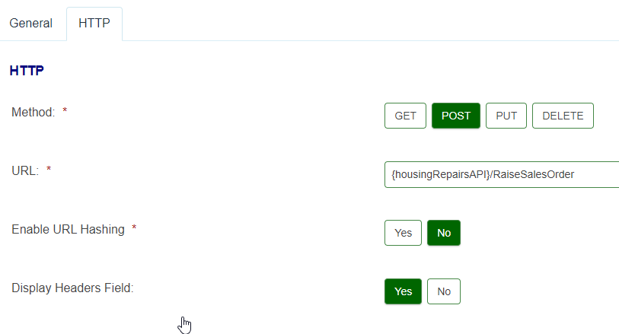
Figure 29 Granicus Integration rasieSalesOrder
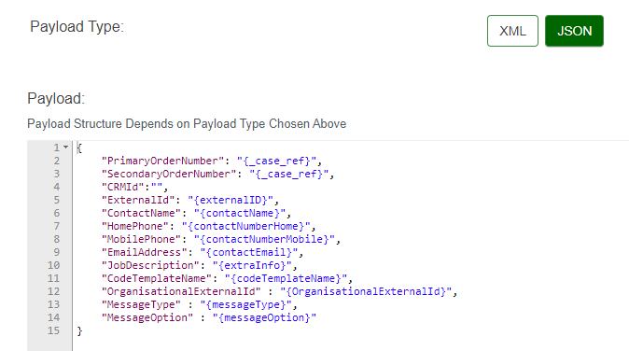
Figure 30 Granicus Integration Payload

Figure 30 shows the payload sent via Granicus to the server running the middleware application. This payload object matches the Model created in the Middleware Application in figure 31.

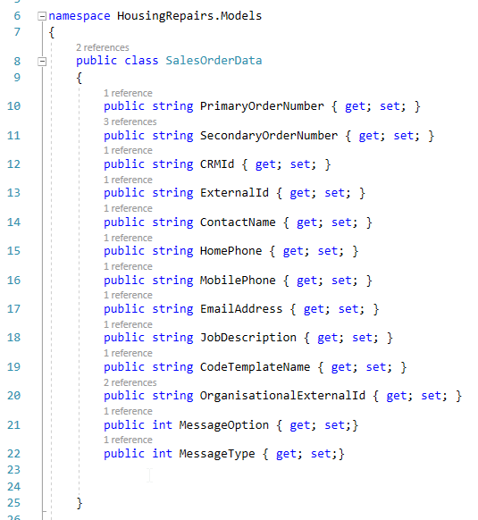
Figure 31 .NET SalesOrderData Model

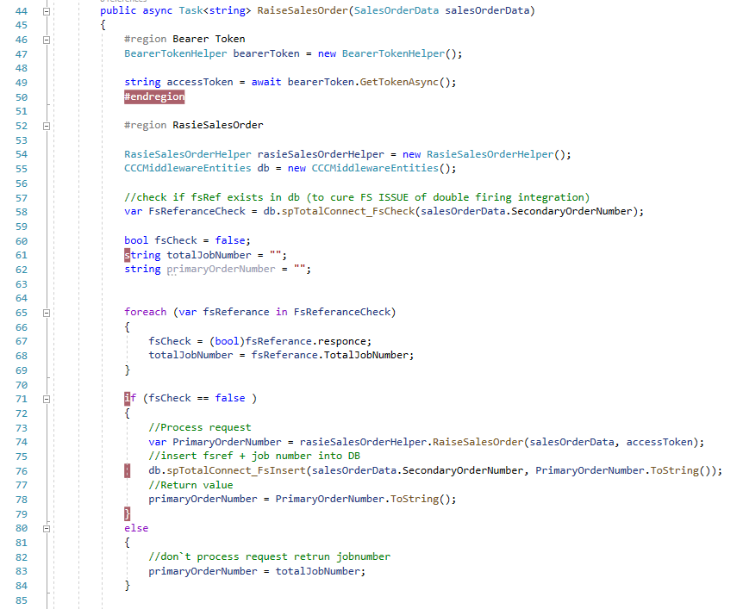
Figure 32 .NET RasieSalesOrder

The bearer token is generated on line 46 – 52, two new objects are then created one for the raise sales order helper and one for the database connection as this is used for error checking. Line 58 checks a database table to see if the Granicus reference number exists in the table, if it does it sets a Bit to 1 and if it does not it sets it to 0. Lines 71 – 79 will then run if it`s set 0 or false, these process the helper and then add an entry into the database so if it`s ran again it will it return true and not process the helper again. Lines 81 – 84 will just return the PrimaryOrderNumber from the database.

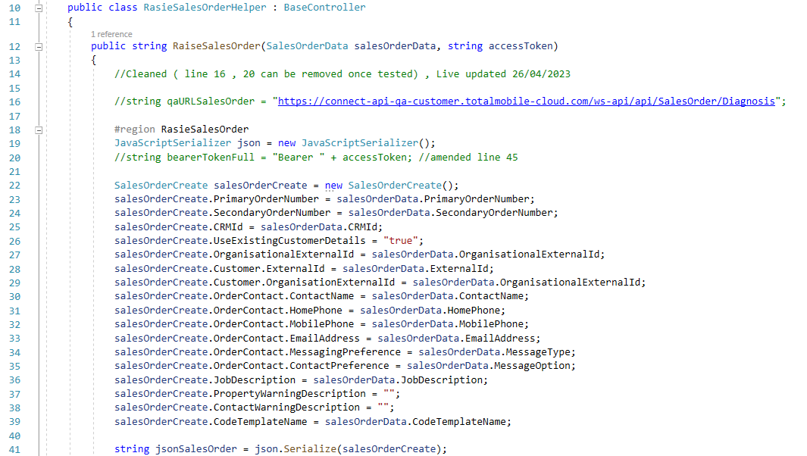
Figure 33 .NET Code RasieSalesOrder Helper
The above image shows the first part of the helper class, constructing the object that needs to be passed as JSON via POST to the Total API. Line 14 show a comment where work was done after the base controller was added and the effect it has on the code. Line 22 is where the new object is created and lines 23 – 39 show the fields being populated with values, line 26 has no value passed from another object as this will always be set to true so it can`t be modified outside the code. Lines 37 and 38 currently do not need values passed but were added in case they were needed in the future. Line 41 then builds the JSON string.

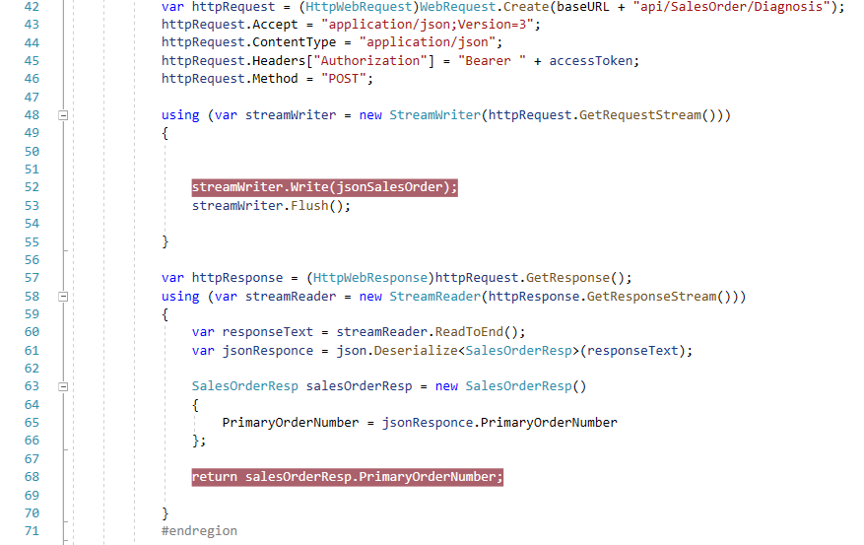
Figure 34 .NET Code RasieSalesOrder Helper
Figure 41 shows the rest of the class, Line 42 amends the baseURL and lines 43 – 46 build the rest of the HTTP Request. The rest of the code transmit the request and waits for a response on line 60 which then populates the SalesOrderResp object which holds the PrimaryOrderNumber. This is then returned via line 68 which is passed to line 78 in Figure 32 and then returned to the Granicus integration and then saved on the form. Once the form has a value the rest of the booking can be completed.

Detail | Source | Captured | Needed to create sales order | Need to create a booking
Name | Form | Yes | No | No
Address | Form | Yes | No | No
ExternalID | Database lookup | Yes | Yes | No
PrimaryOrderNumber | Form | Yes | No | Yes
JobCode | Database lookup | Yes | Yes | No
Booking Date | API data |  | No | Yes

The table that was created earlier in the report now has an extra column added to it and it shows that all data has been captured to create a sales order. The only missing item is the booking date. This is one of the most complex parts of the process so certain parts are assumed.
- A bearer token is passed.
- HTTP Request is used.
- A valid PrimaryOrderNumber is used.

To get a booking date first a list of available dates is needed from the system. For these two items need to be passed PrimaryOrderNumber and planningWindow. The PrimaryOrderNumber is needed because the Total system will then know what trade calendar to look at this is controlled within Total so not much detail will be discussed about this. The planningWindow controls the time of day for the booking. This is selected by the user on the form and the values are: -

All Day - 4
Morning - 5
Afternoon - 6
School run - 7

There are other values, but these are not used in this process. Once the user has selected a value, they press the button ‘Check for dates’ which runs the integration ‘http_HousingRepairs_getAppionmentSlots’ and passes the following JSON payload.
{
"primaryOrderNumber" : "{primaryOrderNumber}",
"planningwindow" : "{planningwindow}",
"fsRef" : "{_case_ref}"
}

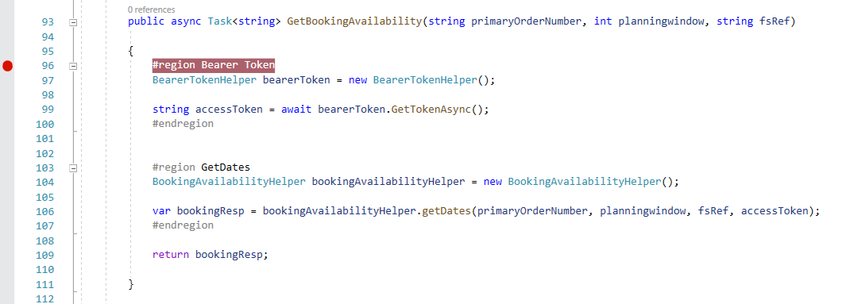
Figure 35 .Net Code getBookingAvailabilty
The main class is very simple and stripped back with all the business logic being done in the helper class. The Model used is attached as Appendix 2. The method used is GET and line 23 creates the url using query string, the number of weeks is set as a static value after discussions which the Total team.
Figure 36 .NET code bookingAvailability 1
This will return 5 weeks’ worth of bookings however this will also include days where there are no slots are available and all planning windows. This data will need to be reduced so only the free dates are returned and with the planning window the user selected.

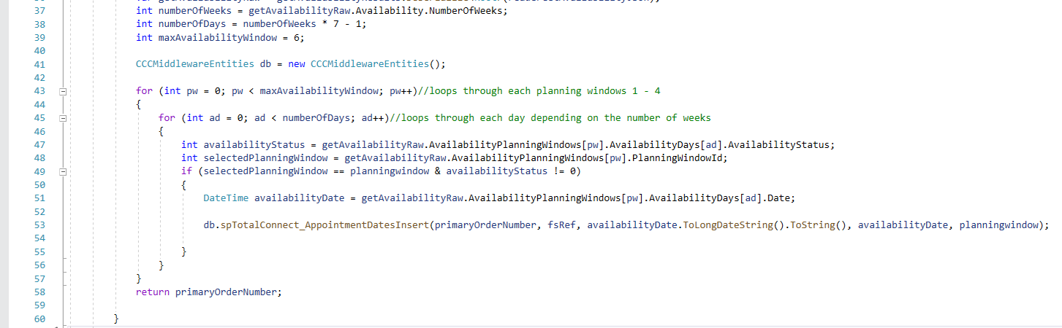
Figure 37 .NET code bookingAvailability 2

To filter out only the dates needed two for loops are used. The first to loop through the planning window and the second loop will only run when the planning window matches with the one selected by the user. The second for loop has an if statement in it to look for dates that have availability, once a date is found it is entered into a database table. The reason for this is twofold. First to capture the details for logging / error checking and the second to deal with the dates formatting used in Granicus and Total. During testing it was found that both Granicus and Total use two different formats for displaying the date and injecting it into the API. The primaryOrderNumber is returned to show the process is complete.
Running the following SQL for Granicus reference TCH460634904 shows the following results and shows the user changing the planning window option.

SELECT *
FROM dbo.TotalConnect_AppointmentDates
WHERE FsRef = 'TCH460634904'

ID PrimaryOrderNumber FsRef DateDisplay DateValue PlanningWindow
46 HR3714 TCH460634904 25 October 2022 2022-10-25 5
47 HR3714 TCH460634904 26 October 2022 2022-10-26 5
48 HR3714 TCH460634904 27 October 2022 2022-10-27 5
49 HR3714 TCH460634904 25 October 2022 2022-10-25 6
50 HR3714 TCH460634904 26 October 2022 2022-10-26 6
51 HR3714 TCH460634904 27 October 2022 2022-10-27 6
52 HR3714 TCH460634904 25 October 2022 2022-10-25 5
53 HR3714 TCH460634904 26 October 2022 2022-10-26 5
54 HR3714 TCH460634904 27 October 2022 2022-10-27 5

The Granicus form can then use the database integration ‘database_HousingRepairs_GetDates to display the dates to the user in the correct format needed for the form. Using the test assistant with the same details from the SQL Query above the following results are returned.

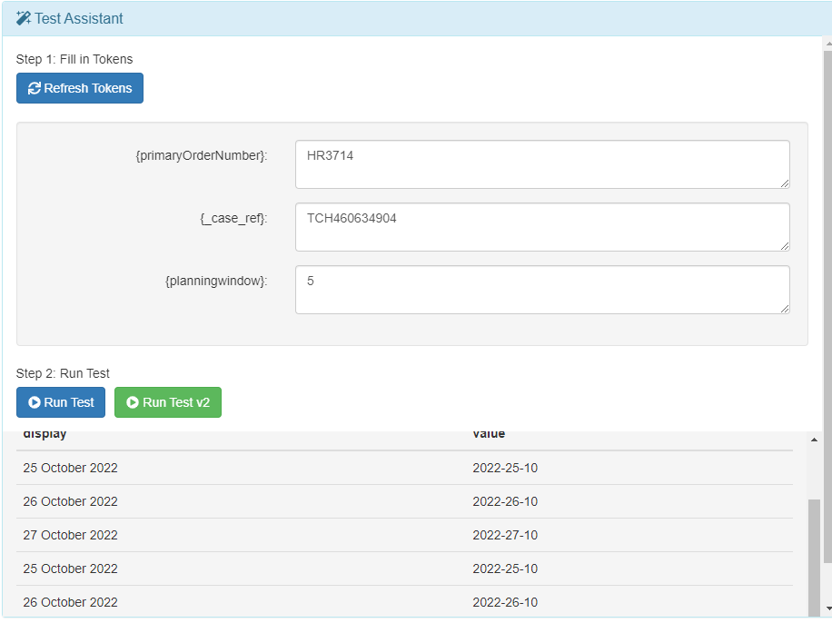
Figure 38 Granicus Test Assistant Dates
The display value is what is seen by the user and the value is what will be passed to the integration.

Detail | Source | Captured | Needed to create sales order | Need to create a booking | Confirm booking
Name | Form | Yes | No | No | No
Address | Form | Yes | No | No | No
ExternalID | Database lookup | Yes | Yes | No | Yes
PrimaryOrderNumber | Form | Yes | No | Yes | Yes
JobCode | Database lookup | Yes | Yes | No | No
Booking Date | API data | Yes | No | Yes | Yes

All items have now been captured to confirm the booking as can be seen in the modified table above.
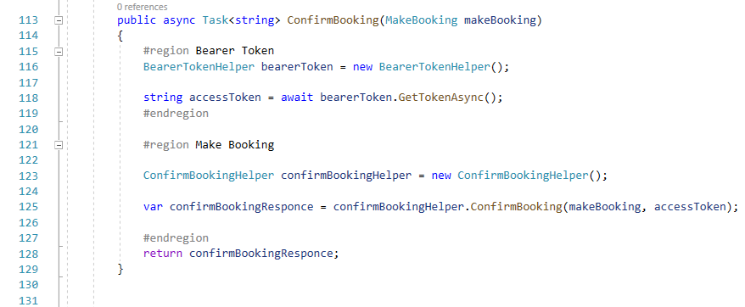
Figure 39 .Net Code confirm booking.
As with previous class in the middleware the main class is very simple with the business logic being done in the helper class. The full code is contained in Appendix 4.

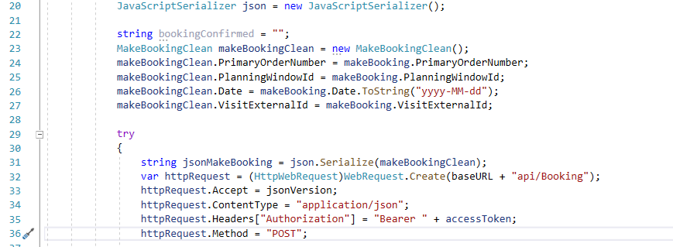
Figure 40 .NET code confirms booking Helper.

Lines 23 – 27 show the object being populated with the incoming model supplied via the Granicus integration ‘http_HousingRepairs_confirmBooking’ and the following JSON payload -
{
"PrimaryOrderNumber": "{primaryOrderNumber}",
"Date" : "{bookingDate}",
"PlanningWindowId" : "{planningwindow}",
"VisitExternalId": "{VisitExternalId}"

}

The form then waits for the response which will be the primaryOrderNumber if this matches then a confirmation message is displayed to the user.

If for any reason no dates or the confirmation is not successful, an error message is displayed to the user showing the PrimaryOrderNumber, but it will be called Job number and asking them to ring the main contact centre for the Council. They will have the ability to enter the Total back-office system and book the visit manually. Any exceptions in the middleware will also be emailed to a group mailbox and passed to the lead developer.

Testing

The process for testing was the same for each feature that was added to the process / code that involved a major function. Such as

- Showing correct address?
- Confirming they are council tenants?
- Do they exist in Total?
- Do all the Job Codes display correctly?
- Is the Job booked correctly?
- Are the correct dates returned?
- Is it confirmed correctly?

The testing took part in two stages, the first would be with the developer testing with local data to make sure the flow would be correct. Each helper within the code would then be tested on and using breakpoints to makes sure the correct data was being returned from the API. Due to the size of this project, it is not possible to cover all the testing on all the features.
However, it will look at a testing phase for cancelling a booking that was done by Shane Williams on 07th November 2022.

Test 1.
Job was successful booked with ref NH3845
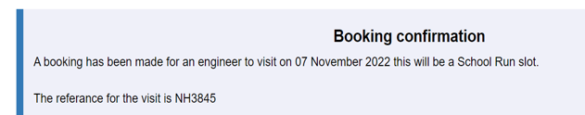
Figure 41 Granicus confirmation.
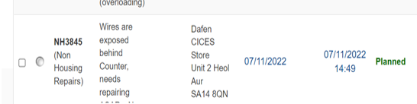
Figure 42 Total confirmation.

The test failed as no email was sent to the user with guidance on how to cancel the visit.
Investigation found that the incorrect trigger had been setup for the email.

Test 2 proved the email was sent after changes were made.
Test 3 moved to test the cancel process in more detail. The email showed that items were missing, these were added and retested.
Test 4 confirmed the email was now working correctly however the same item was missing the job number.
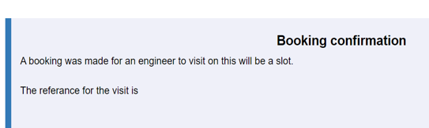
Figure 43 Granicus testing missing job code.

This was because of the way the data was being passed to the next stage, changes were made and tested.

Tests 5 and 6 show the section of the process working as expected. A few cases were submitted by several different members of staff after the issues of test 1 – test 4 were resolved.

This process of testing was used for each major feature of the form.

Evaluation.

The internal version of the process went live as planned on the 19^{th of} June 2023. It was a soft launch with the contact centre using the process when a school rung in with an issue. As expected, there were teething issues however these were not related to the form or middleware package. Text changes were requested, and the Total team were asked to create new job code. Some of the existing job codes did not yet have any dates assigned to them. 21 jobs were raised on the first day and 10 were assigned dates the rest were allocated manually. Della Mills was contacted to ask how the new process is working and the feedback was positive however she did mention the above issue. These will be resolved before schools and other council users have a live link to the form. This process has been one the most complex processes built using the Granicus platform. The platform was designed for users with no coding experience to develop forms quickly and easily. However, as Carmarthenshire County Council have a strong development team, they push what the platform can do, and this is what led to this project being implemented. It is hoped that the work done on this project will reduce the time the contact centre spends on property repairs and are then able to deal with more pressing matter. The same can also be said for the over teams but this will not be measurable at the time of this report. There will be ongoing development to the process such as adding a stage where tenants can see the status of the repair and cancel a booking. Also, the ability for the contact centre staff to change the date of the booking however this will not be needed for most tenants as they will receive a link from the Total system which gives them the option to change the date. The feature will be added so people that do not like using online forms can ring in.

As the focus of this project was to see if a new streamline version of the process could be created that allowed tenants to quickly book an appointment online. Functional the process does match the specification that was laid out in the Expression of Interest at the beginning of this document. However, it is not possible to say if it has had a positive impact on the various departments and reduced the workload.

Conclusions and Recommendations.
There have been some recommendations from the contact centre however these have mainly been text changes, one such change was a warning message that shows if the system is not able to pull back any dates. Currently the message says to ring the contact centre and they will book a visit. After speaking to both teams there will be some operatives that will check for visits that are not booked and they will book them and contact the tenant. So, because of this the text has been updated. On Friday 23rd June 2023 there were errors being shown within the system. On further investigation 3 job codes were causing the booking of a job to fail. No work was done on the weekend however on the following Monday it was confirmed that there was an issue with the setup of the Job codes in Total and they were disabled within the system. A system

Reflection.

This has been one of the most interesting projects I have worked on, and the lessons learnt while doing the degree have helped me. As an example, the use of bearer tokens, even though guidance was given on how to implement it I had the confidence to research how it worked and from that I made the decision that it should not be used directly within the Granicus system as it was in plain text. I would have written a middleware package anyway, but this fact reinforced why it was needed. There has not been a great need for complex database within this project as most of the data that was need already existed in other systems. The job code table was created so in the future codes could be added / changed or deleted by another team via a .Net grid interface. All the job codes could have been added to the form manually, but this would have meant a developer would need to make the changes. The lessons learnt from Cloud-Based Web Services ACCA6024 gave me a sound understanding of Async which is used in this project. We have documentation on how to lay out a Middleware solution but understanding the underlying technology helped in the development and the same for Socket Programming and Concurrency ACCA6028 which expanded on JSON serialization and deserialization along with inheritance which was used late on the project but helped removed several lines of code and made the switch from the test API address to the live address much simpler.

Reference.
[1] O. Hazzan and Y. Dubinsky, “The Agile Manifesto,” 2014, pp. 9–14. doi: 10.1007/978-3-319-10157-6_3.

Appendix.

Appendix 1
List of Granicus integrations used.
- database_HousingRepairs_CountSlots
- database_HousingRepairs_GetBookedDate
- database_HousingRepairs_GetCommunalGarages
- database_HousingRepairs_GetDates
- database_HousingRepairs_GetDiganositicCodes
- database_HousingRepairs_GetExternalID
- email_HousingRepairs_CancelBooking_EN
- email_HousingRepairs_CancelBooking_internal_EN
- http_HousingRepairs_bookingSummary
- http_HousingRepairs_cancelBooking
- http_HousingRepairs_checkTenant
- http_HousingRepairs_confirmBooking
- http_HousingRepairs_getAppionmentSlots
- http_HousingRepairs_raiseSalesOrder
- http_HousingRepairs_raiseSalesOrderJobNumber

Appendix 2
GetAvailbility Model
namespace HousingRepairs.Models
{
// Root myDeserializedClass = JsonConvert.DeserializeObject<Root>(myJsonResponse);
public class Availability
{
public string PrimaryOrderNumber { get; set; }
public DateTime Date { get; set; }
public int Duration { get; set; }
public bool IgnoreWeekends { get; set; }
public string VisitExternalId { get; set; }
public bool LimitByPreferredSkills { get; set; }
public bool LimitByPreferredZones { get; set; }
public bool LimitByValidZoneDays { get; set; }
public bool LimitByOrderAttributes { get; set; }
public bool OverrideTargetDate { get; set; }
public object OverrideTargetDateReason { get; set; }
public bool TwoToAttend { get; set; }
public int NumberOfWeeks { get; set; }
}

public class AvailabilityDay
{
public DateTime Date { get; set; }
public int AvailabilityStatus { get; set; }
public int TravelTime { get; set; }
}

public class AvailabilityPlanningWindow
{
public int PlanningWindowId { get; set; }
public List<AvailabilityDay> AvailabilityDays { get; set; }
}

public class PlanningWindow
{
public int Id { get; set; }
public string Name { get; set; }
public int StartHour { get; set; }
public int StartMinute { get; set; }
public int EndHour { get; set; }
public int EndMinute { get; set; }
}

public class Root
{
public Availability Availability { get; set; }
public List<PlanningWindow> PlanningWindows { get; set; }
public List<AvailabilityPlanningWindow> AvailabilityPlanningWindows { get; set; }
public object Appointments { get; internal set; }
}

}

Appendix 3
BookingAvailabiltyHelper.cs

using HousingRepairs.Helpers;
using HousingRepairs.Models;
using System;
using System.IO;
using System.Net;
using System.Threading.Tasks;
using System.Web.Mvc;
using System.Web.Script.Serialization;
using System.Web.Helpers;
using System.Collections.Generic;
using HousingRepairs.Controllers;

namespace HousingRepairs.Helpers
{
public class BookingAvailabilityHelper : BaseController
{
//public string qaURLGetAvailability = "https://connect-api-qa-customer.totalmobile-cloud.com/ws-api/API/Availability?PrimaryOrderNumber=";

public string getDates (string primaryOrderNumber, int planningwindow, string fsRef , string accessToken)
{
//Cleaned line 29 , 23 , 17 Live updated 26/04/2023

string url = baseURL + "API/Availability?PrimaryOrderNumber=" + primaryOrderNumber + "&NumberOfWeeks=5";

JavaScriptSerializer getAvailabilityResults = new JavaScriptSerializer();

var httpRequest = (HttpWebRequest)WebRequest.Create(url);
httpRequest.Accept = "application/json";
httpRequest.Headers["Authorization"] = "Bearer " + accessToken;
httpRequest.Method = "GET";

var httpResponse = (HttpWebResponse)httpRequest.GetResponse();
var readerGetAvailabilityJson = new StreamReader(httpResponse.GetResponseStream()).ReadToEnd();

var getAvailabilityRaw = getAvailabilityResults.Deserialize<Root>(readerGetAvailabilityJson);
int numberOfWeeks = getAvailabilityRaw.Availability.NumberOfWeeks;
int numberOfDays = numberOfWeeks * 7 - 1;
int maxAvailabilityWindow = 6;

CCCMiddlewareEntities db = new CCCMiddlewareEntities();

for (int pw = 0; pw < maxAvailabilityWindow; pw++)//loops through each planning windows 1 - 4
{
for (int ad = 0; ad < numberOfDays; ad++)//loops through each day depending on the number of weeks
{
int availabilityStatus = getAvailabilityRaw.AvailabilityPlanningWindows[pw].AvailabilityDays[ad].AvailabilityStatus;
int selectedPlanningWindow = getAvailabilityRaw.AvailabilityPlanningWindows[pw].PlanningWindowId;
if (selectedPlanningWindow == planningwindow & availabilityStatus != 0)
{
DateTime availabilityDate = getAvailabilityRaw.AvailabilityPlanningWindows[pw].AvailabilityDays[ad].Date;

db.spTotalConnect_AppointmentDatesInsert(primaryOrderNumber, fsRef, availabilityDate.ToLongDateString().ToString(), availabilityDate, planningwindow);

}
}
}
return primaryOrderNumber;

}

}
}

Appendix 4
Confirm booking helper.
using HousingRepairs.Controllers;
using HousingRepairs.Models;
using System;
using System.IO;
using System.Net;
using System.Threading.Tasks;
using System.Web.Script.Serialization;

namespace HousingRepairs.Helpers
{
public class ConfirmBookingHelper : BaseController // handles booking and rebooking. With rebooking the visit id is passed to change the date.
{
public string ConfirmBooking (MakeBooking makeBooking , string accessToken)
{
//cleaned line 34 ,32 , 33. Line 18 can be removed once tested. Live updated 26/04/2023

#region Make Booking
//string qaURLBooking = "https://connect-api-qa-customer.totalmobile-cloud.com/ws-api/api/Booking";

JavaScriptSerializer json = new JavaScriptSerializer();

string bookingConfirmed = "";
MakeBookingClean makeBookingClean = new MakeBookingClean();
makeBookingClean.PrimaryOrderNumber = makeBooking.PrimaryOrderNumber;
makeBookingClean.PlanningWindowId = makeBooking.PlanningWindowId;
makeBookingClean.Date = makeBooking.Date.ToString("yyyy-MM-dd");
makeBookingClean.VisitExternalId = makeBooking.VisitExternalId;

try
{
string jsonMakeBooking = json.Serialize(makeBookingClean);
var httpRequest = (HttpWebRequest)WebRequest.Create(baseURL + "api/Booking");
httpRequest.Accept = jsonVersion;
httpRequest.ContentType = "application/json";
httpRequest.Headers["Authorization"] = "Bearer " + accessToken;
httpRequest.Method = "POST";

using (var streamWriter = new StreamWriter(httpRequest.GetRequestStream()))
{

streamWriter.Write(jsonMakeBooking);
streamWriter.Flush();

}

var httpResponse = (HttpWebResponse)httpRequest.GetResponse();

bookingConfirmed = makeBooking.PrimaryOrderNumber;

using (var streamReader = new StreamReader(httpResponse.GetResponseStream()))
{
var responseText = streamReader.ReadToEnd();
}

}
catch (Exception ex)
{
return ex.ToString();
emailHelper.SentErrorEmail(ex, "Confirm booking ", "Failed to confirm the booking");

}

return bookingConfirmed;
#endregion

}
}
}

Appendix 5

Screenshots of Cancel Request Test
7/11/2022 Non-Housing Form 1st Test (No Email Received)
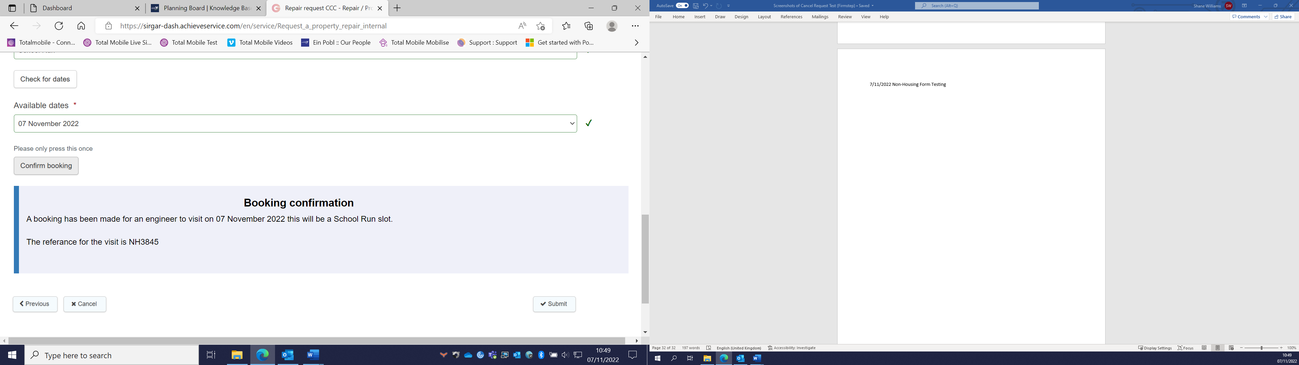

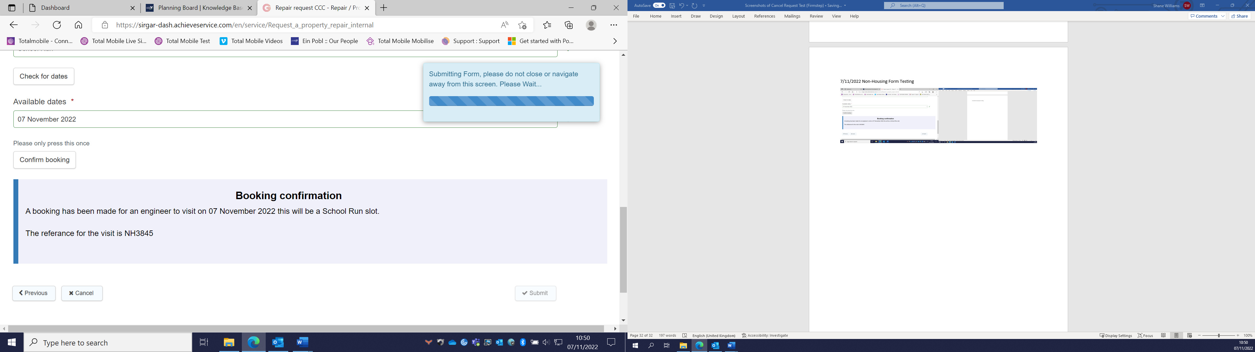

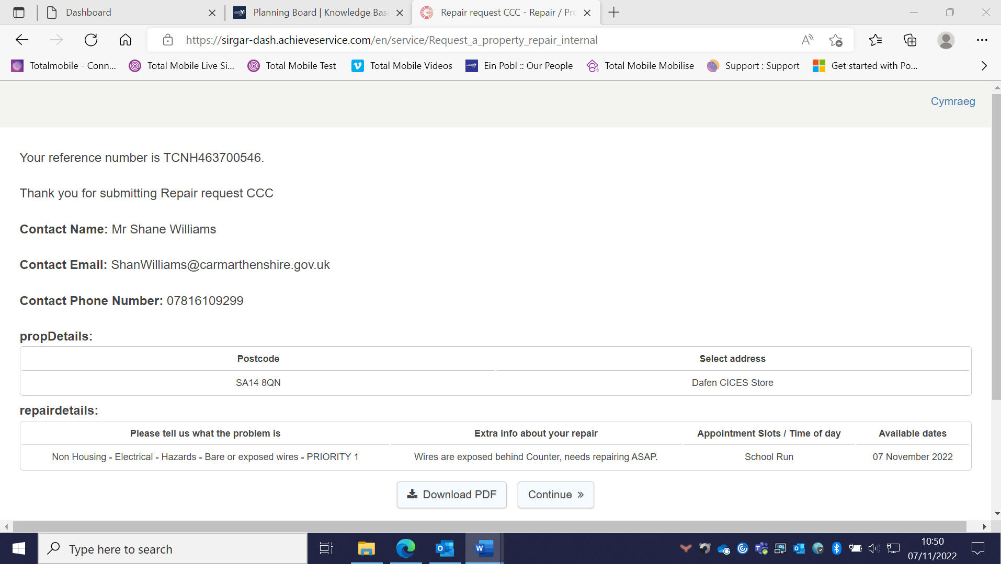

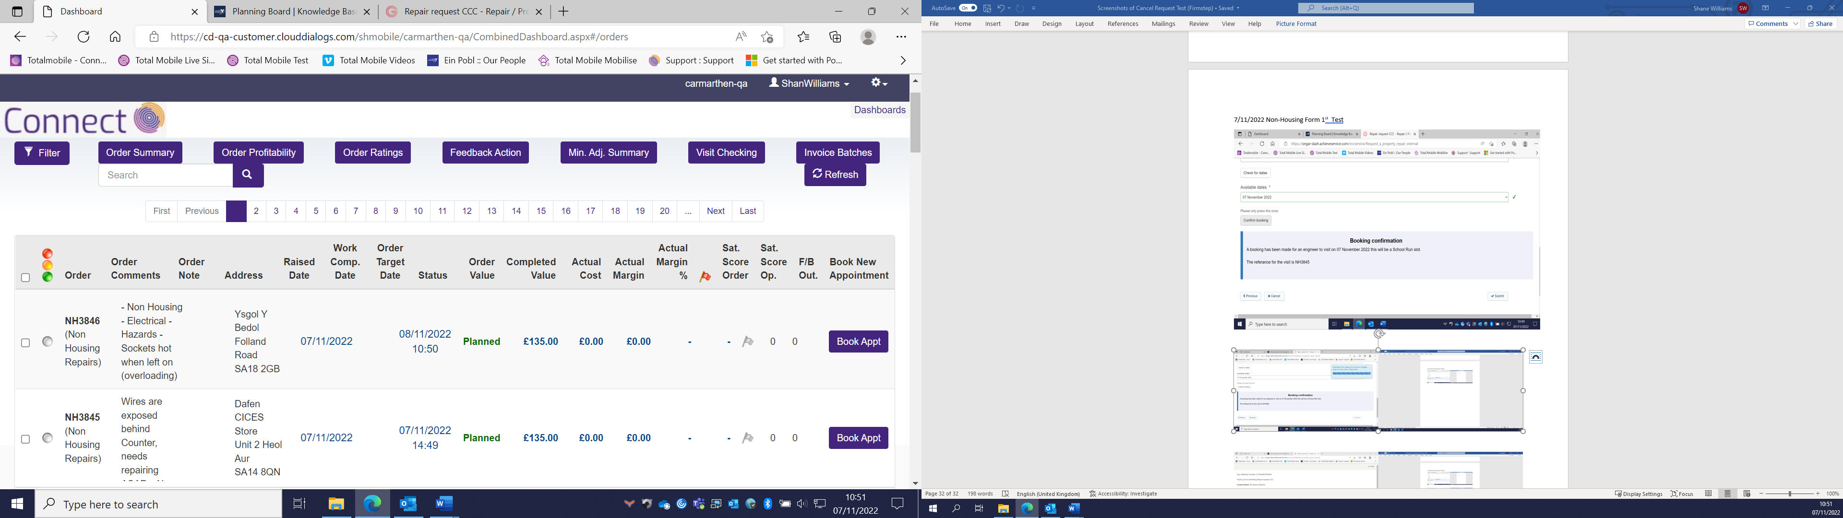
Worked fine but No Cancel Request Email.
Test 2 (Not Working)
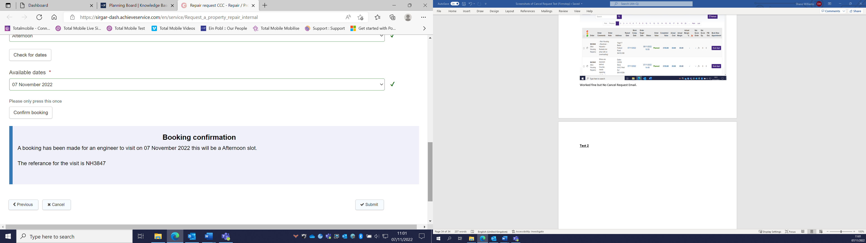

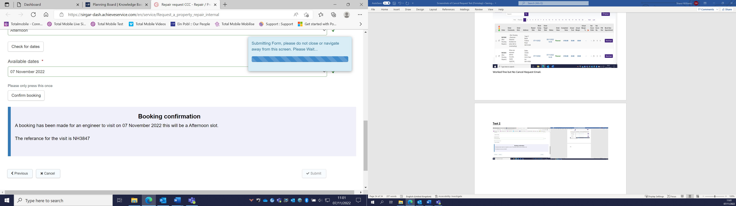

Test 3 (Working but no Visit number)
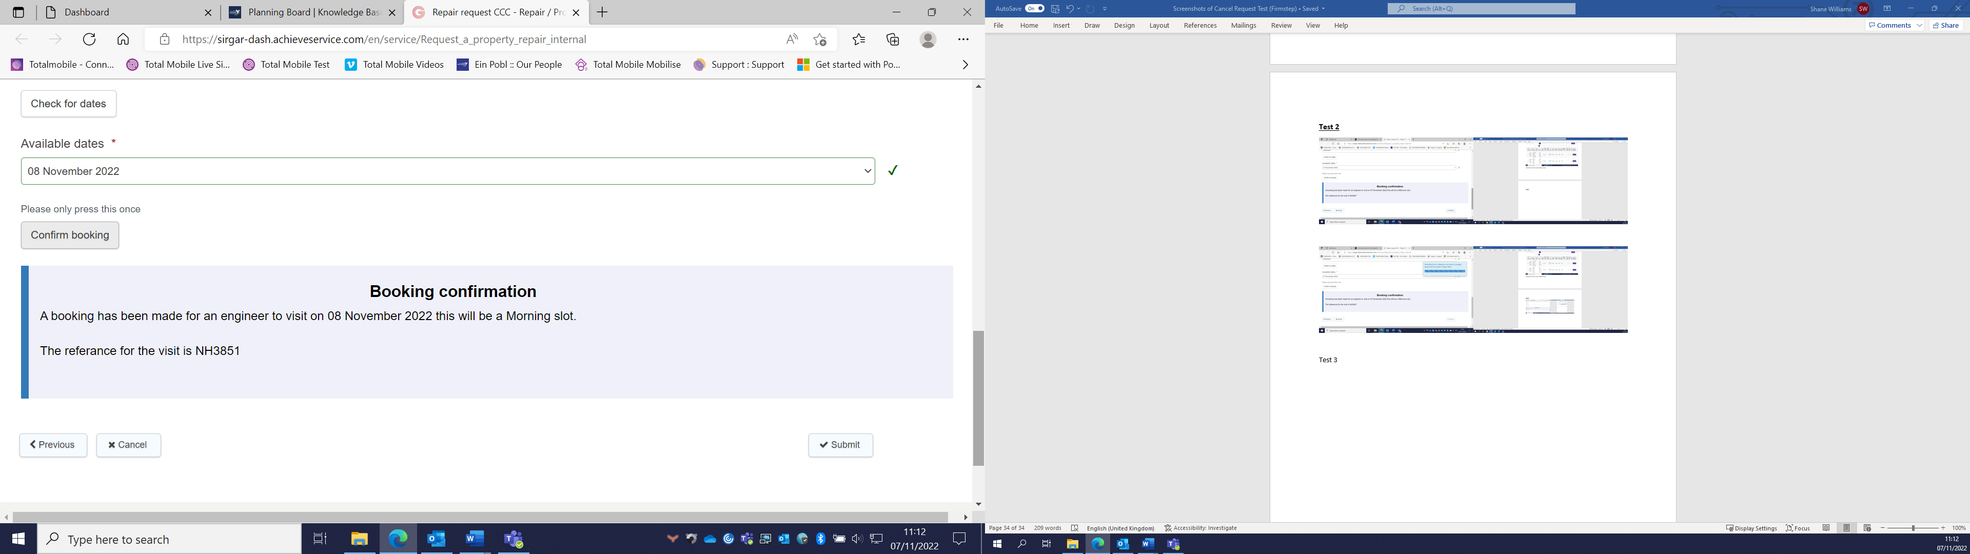

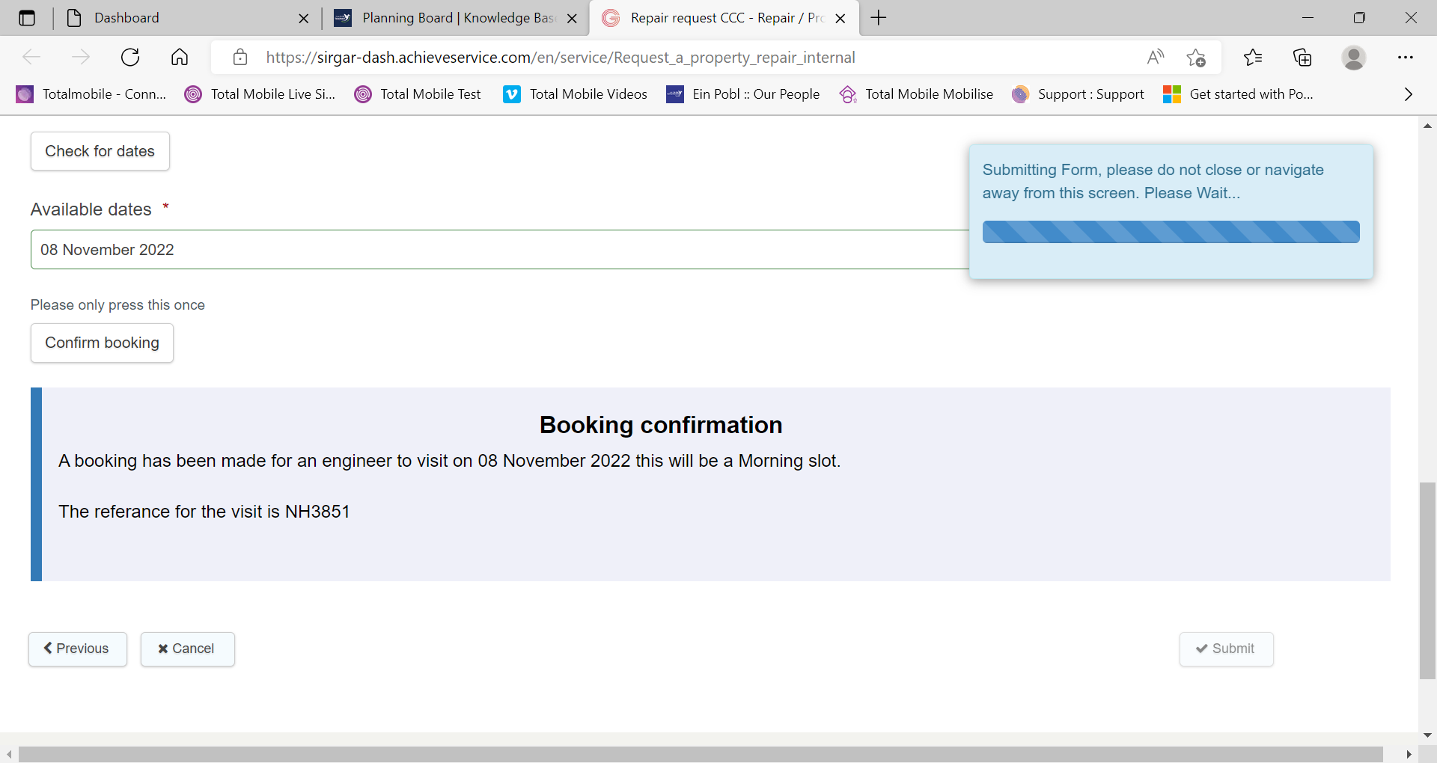

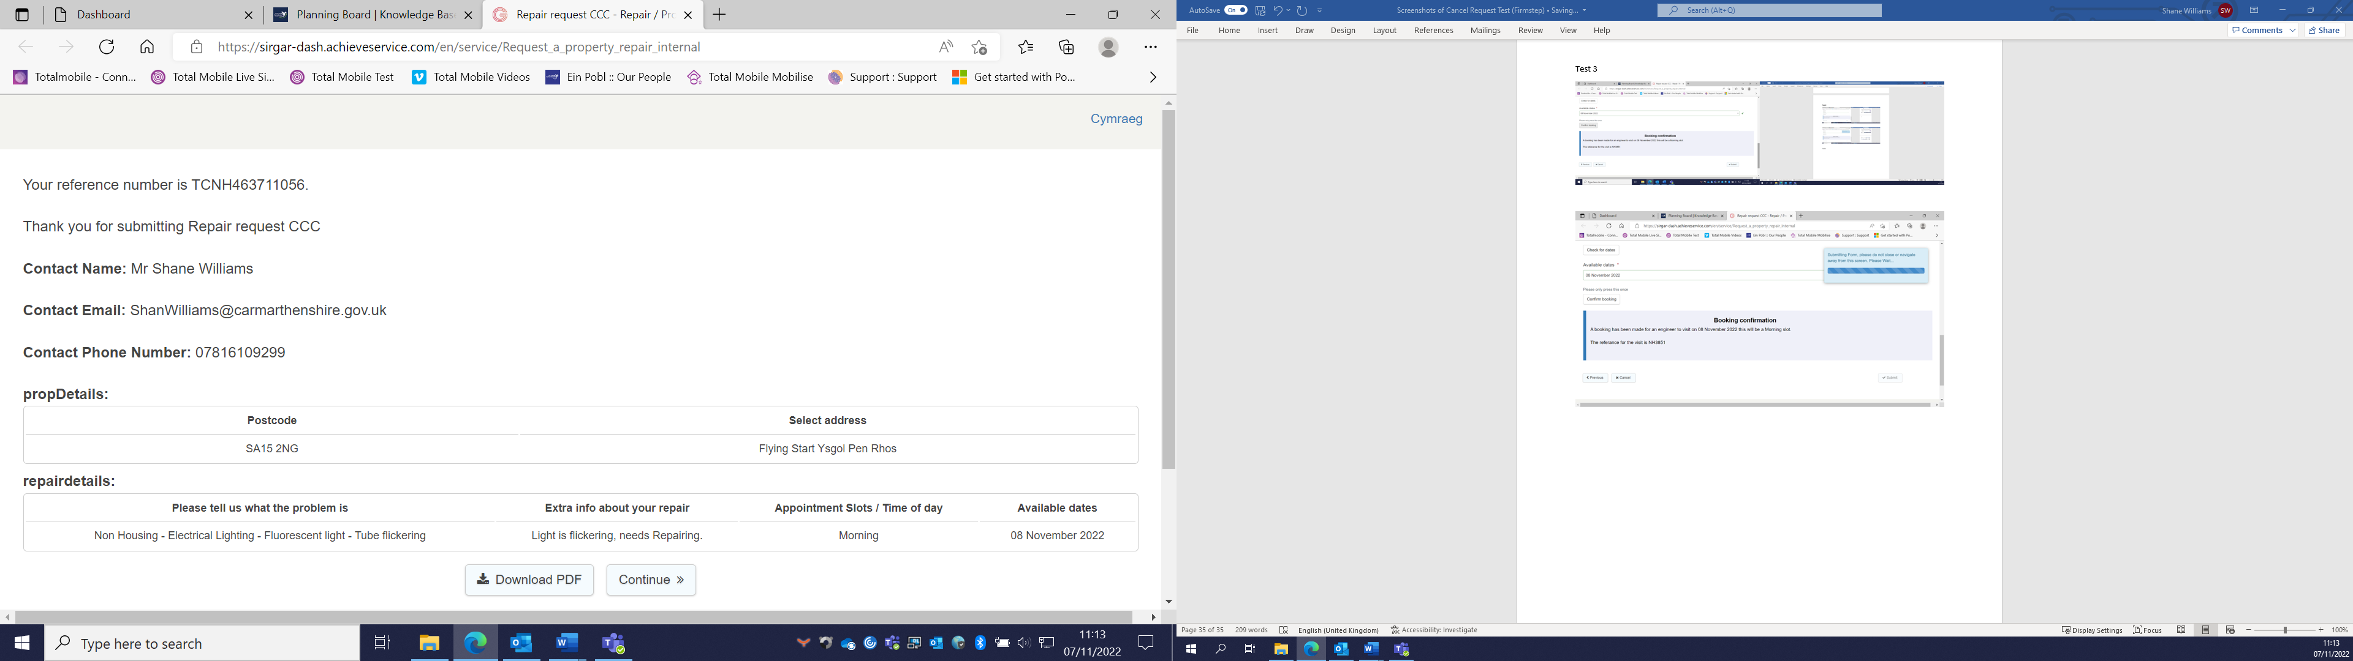

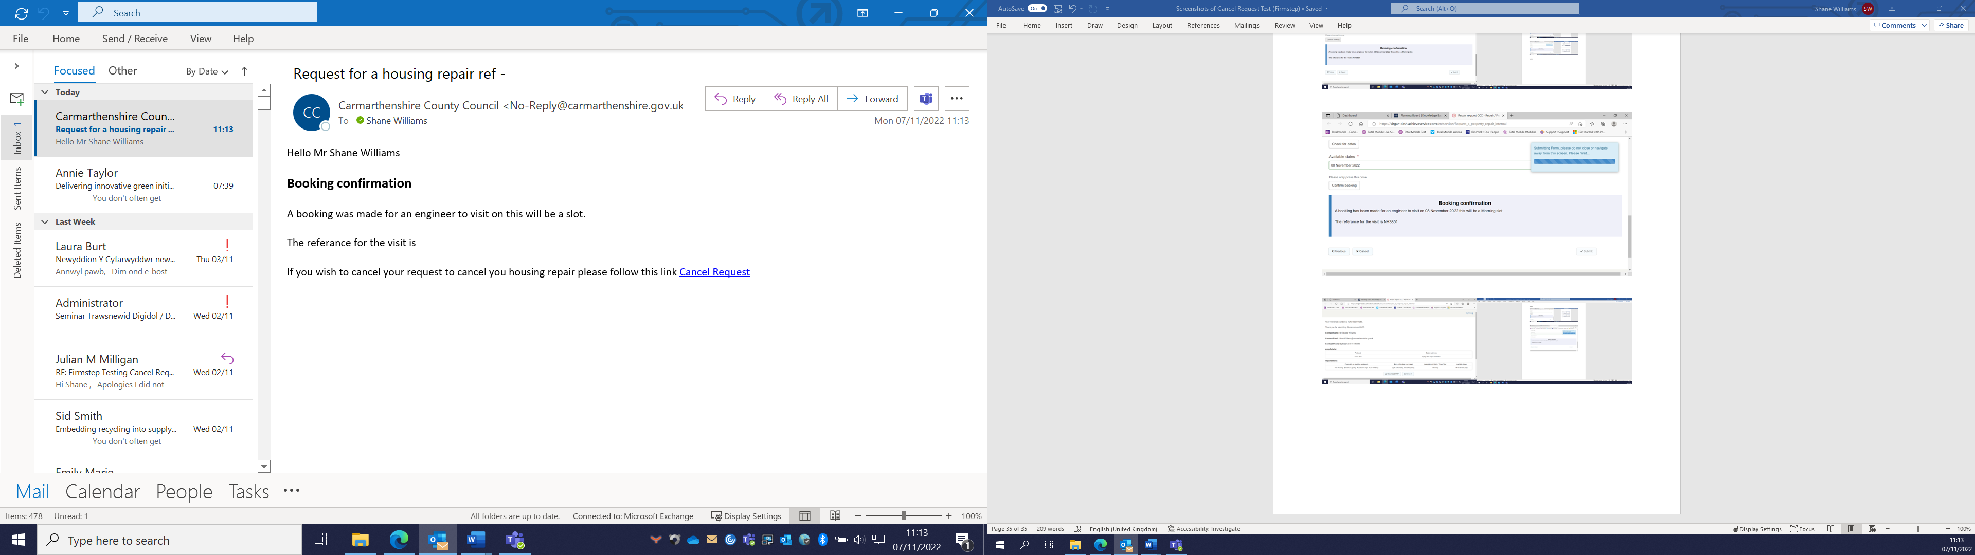

Test 4 (Working but no Visit Number)
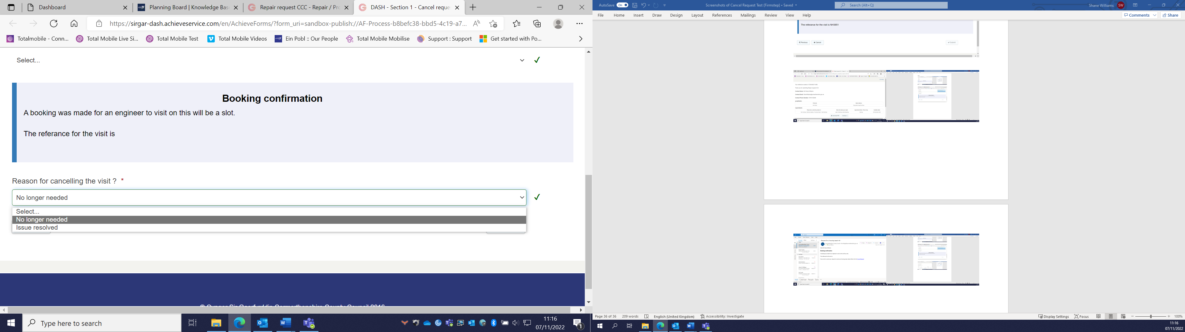

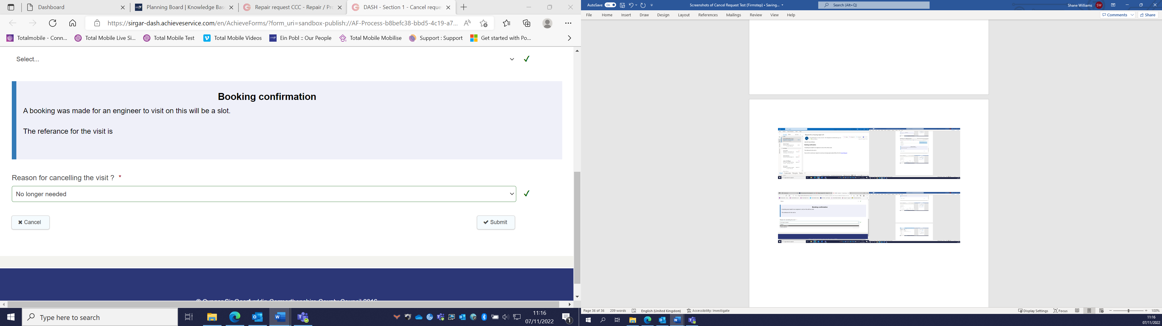

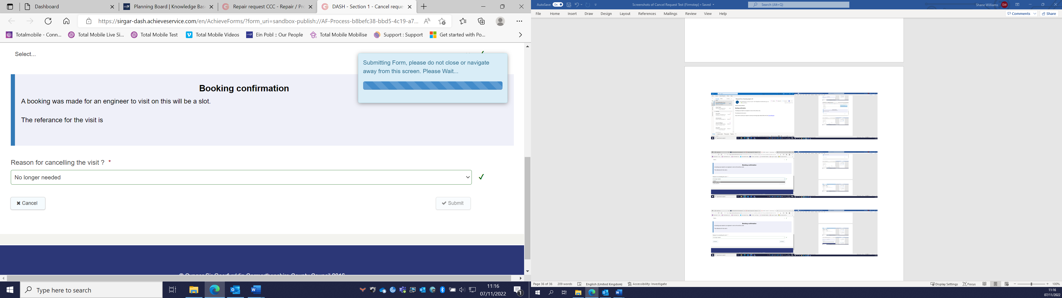

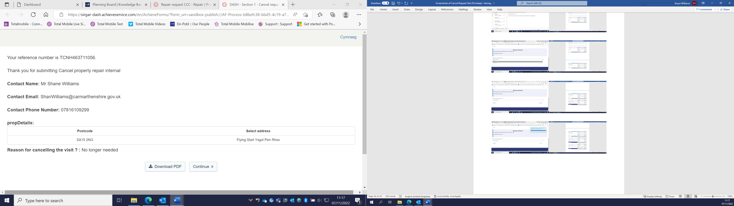
Test 5 (Working)
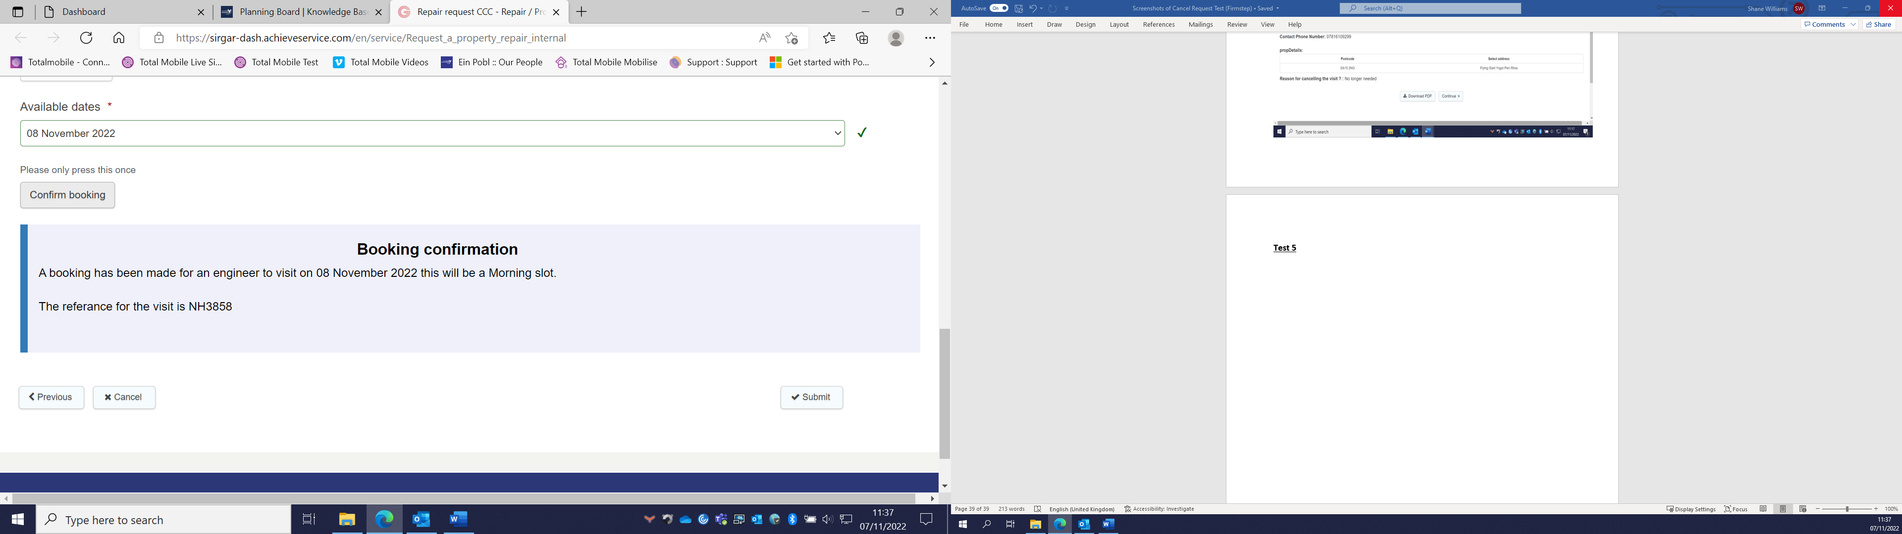
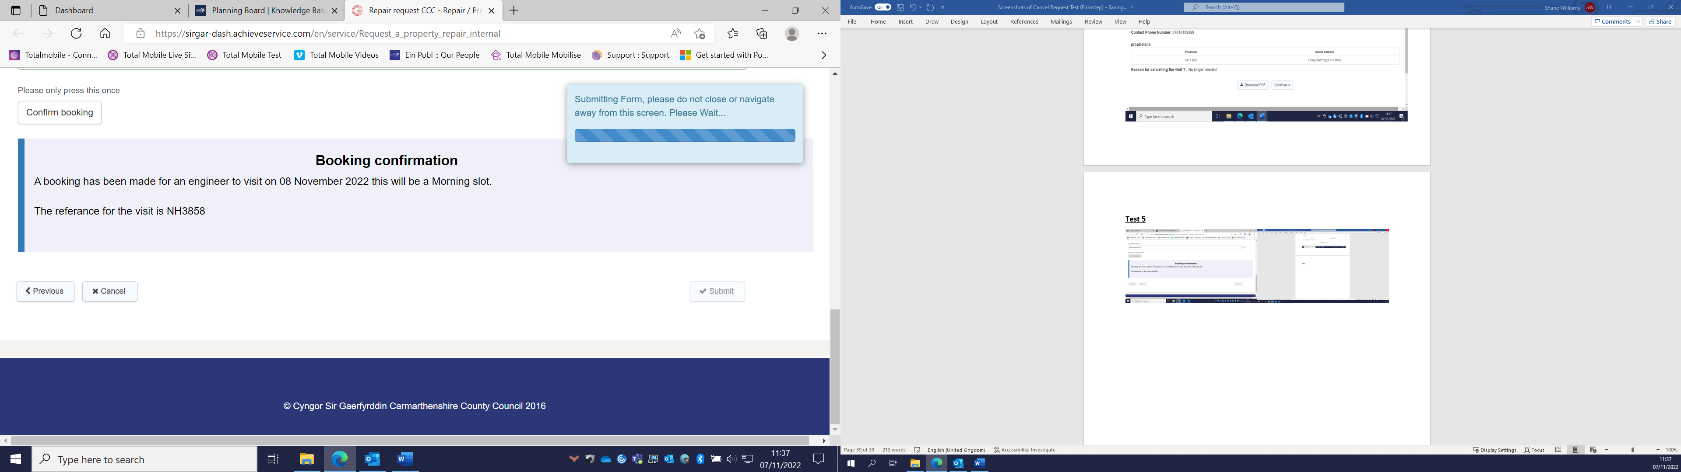

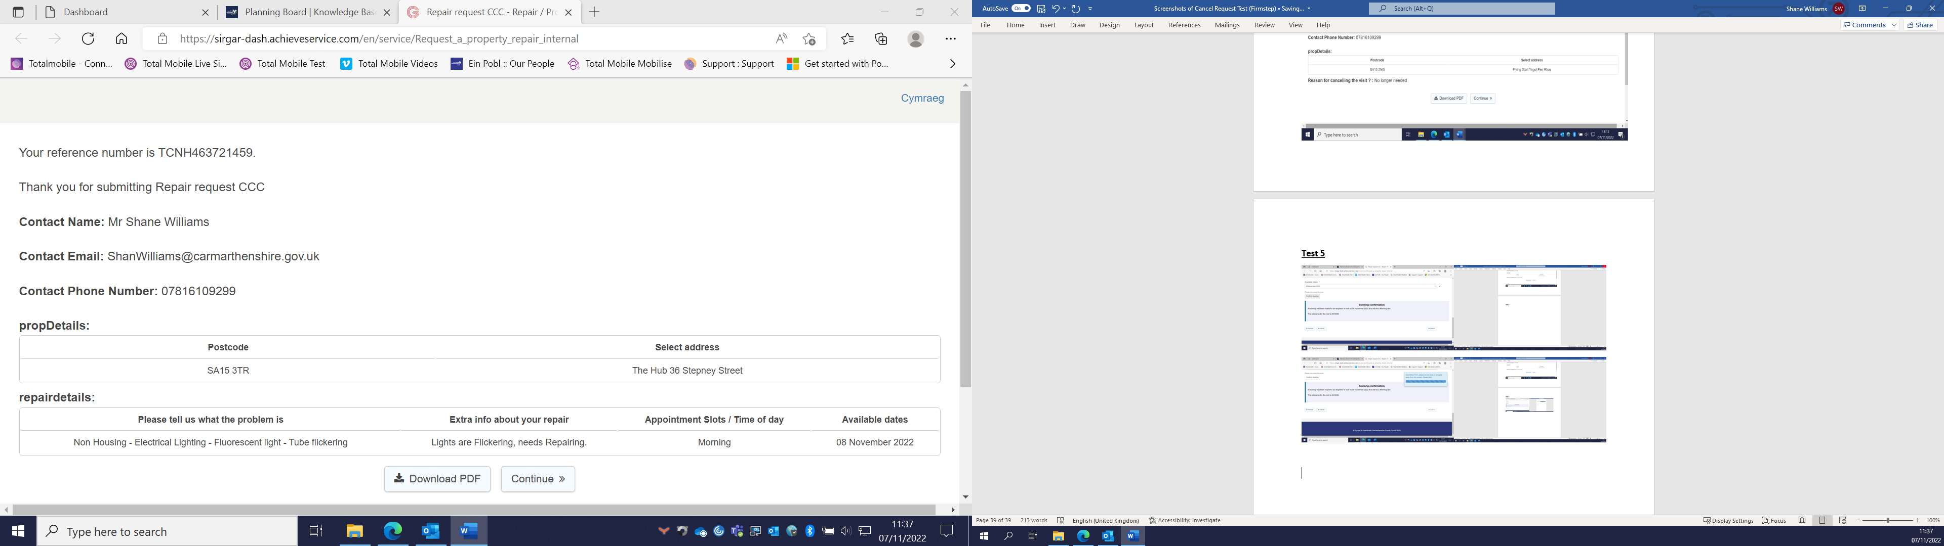

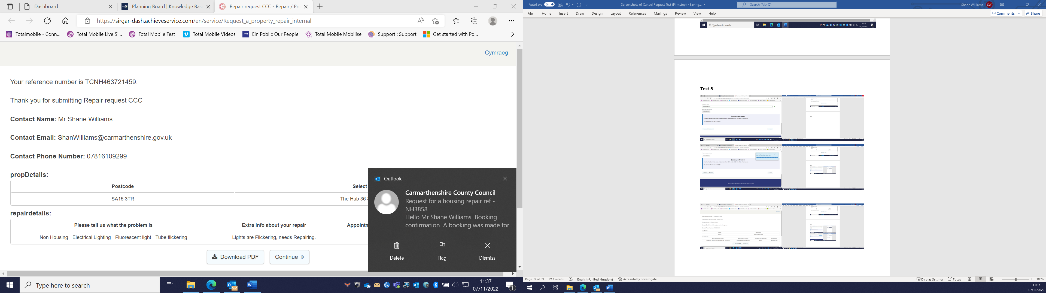
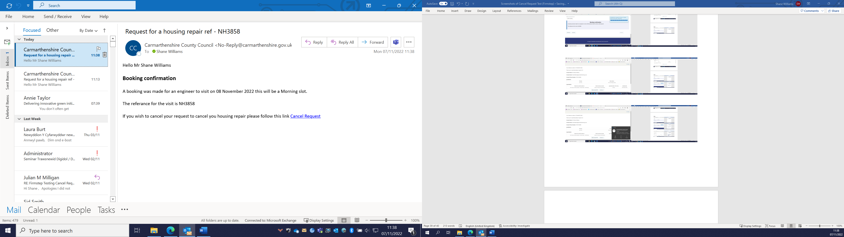

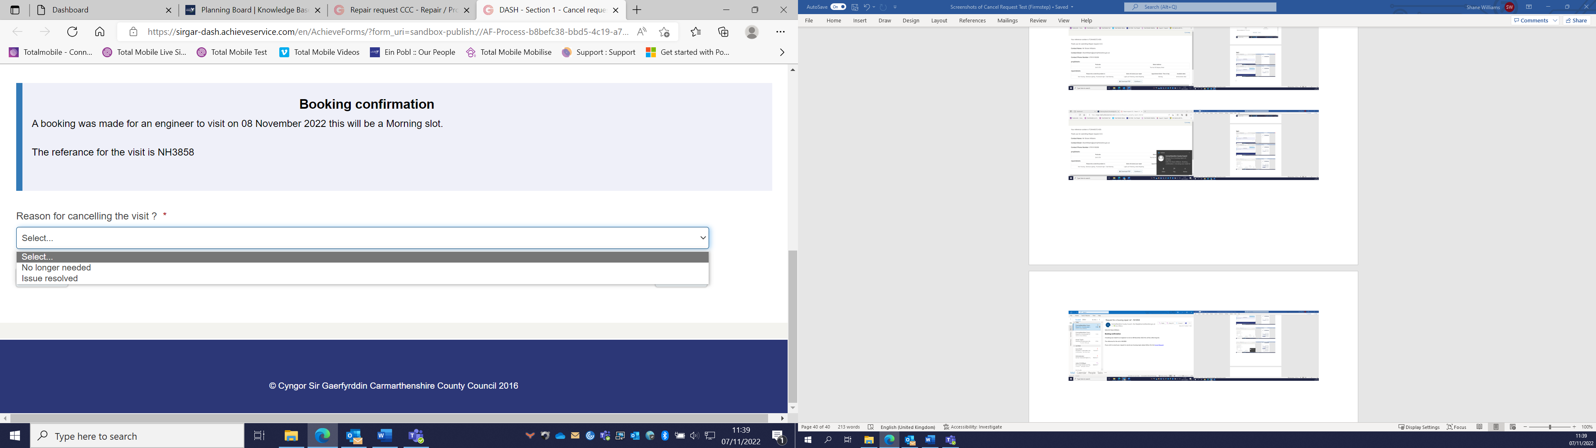

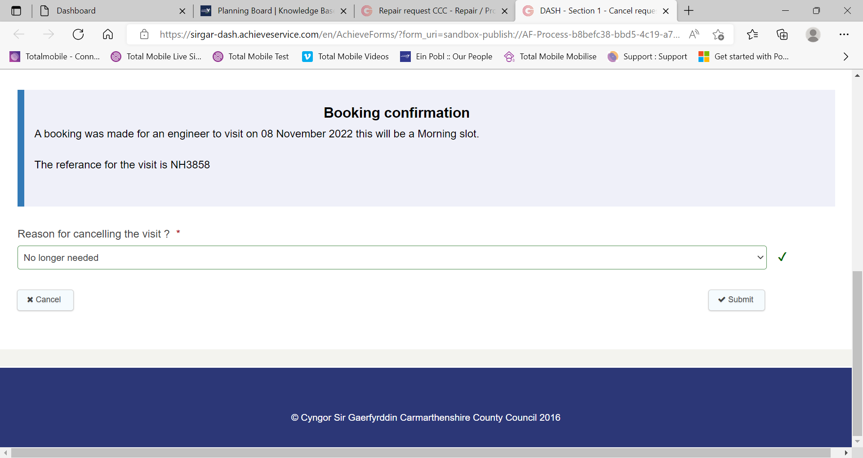

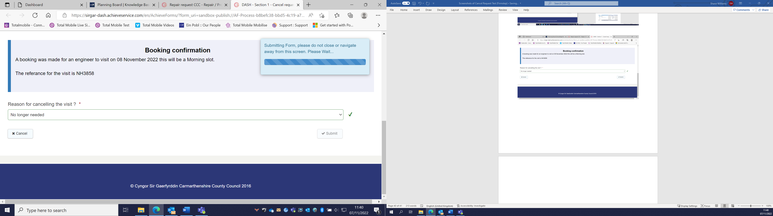

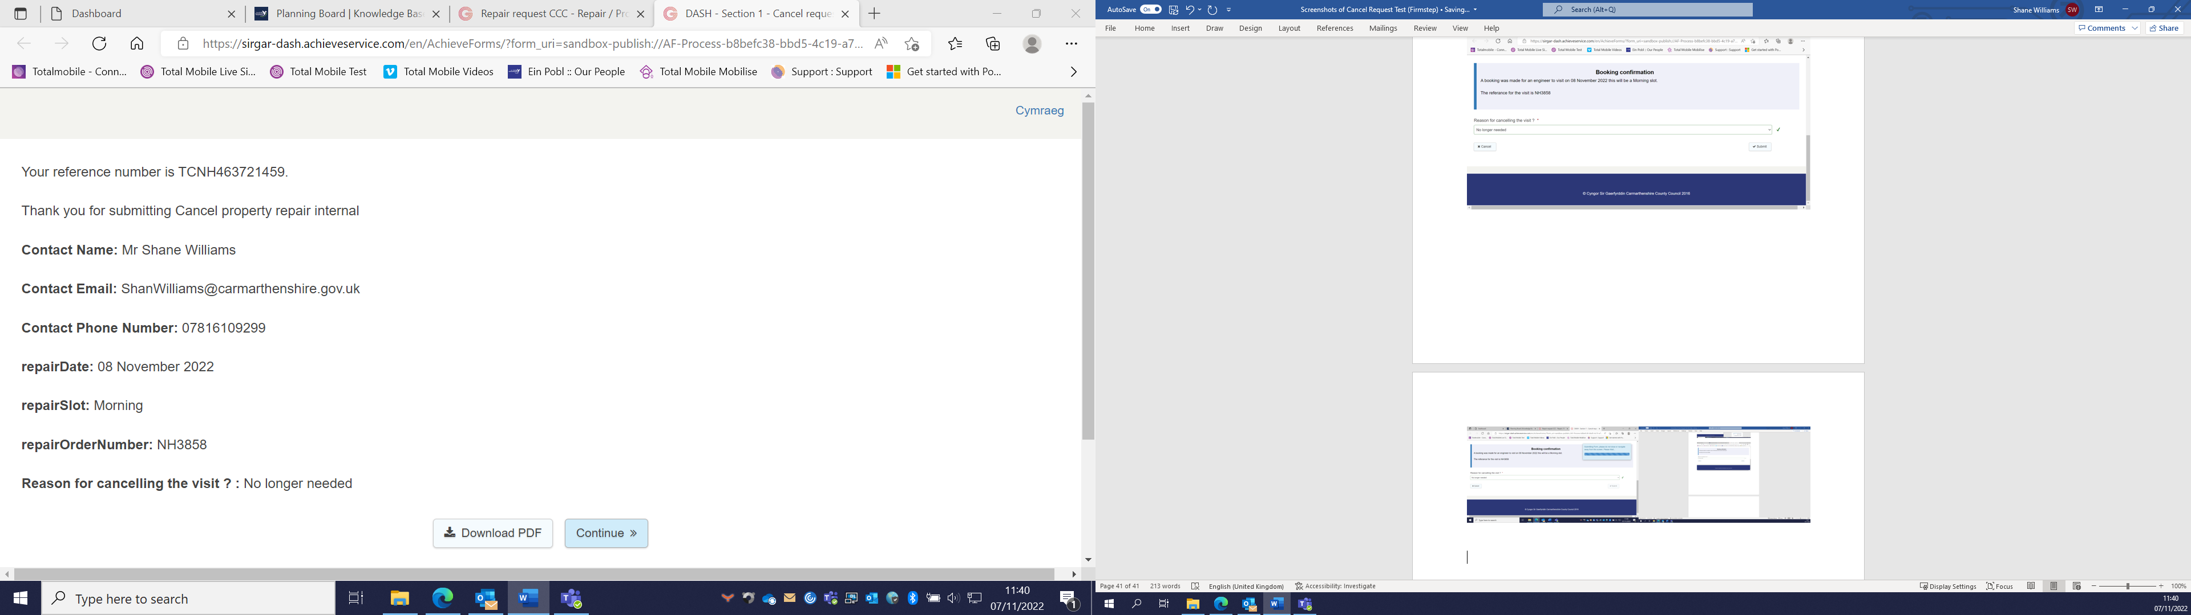

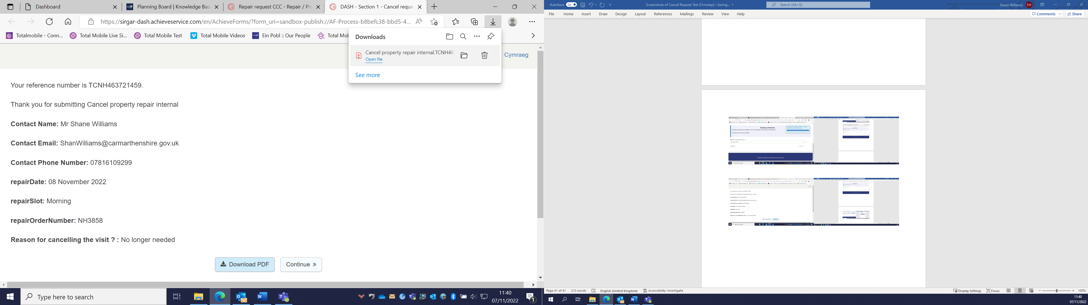

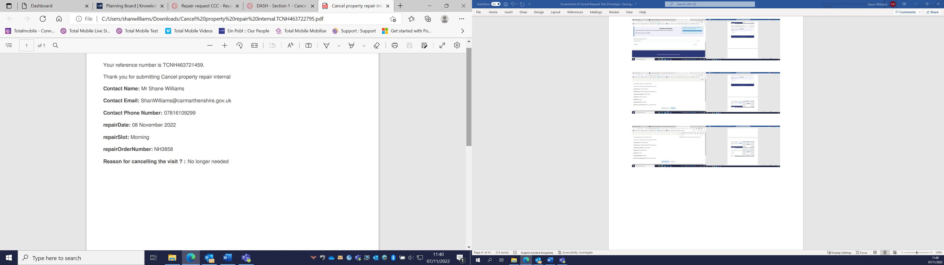

Test 6 (Working)
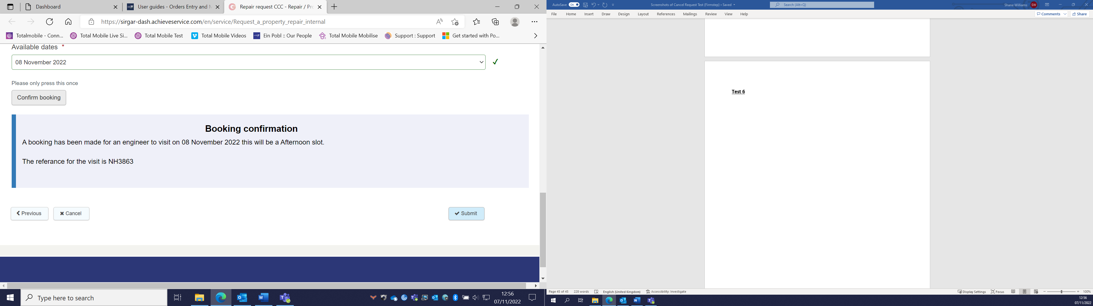

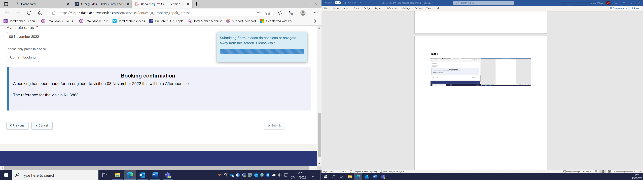

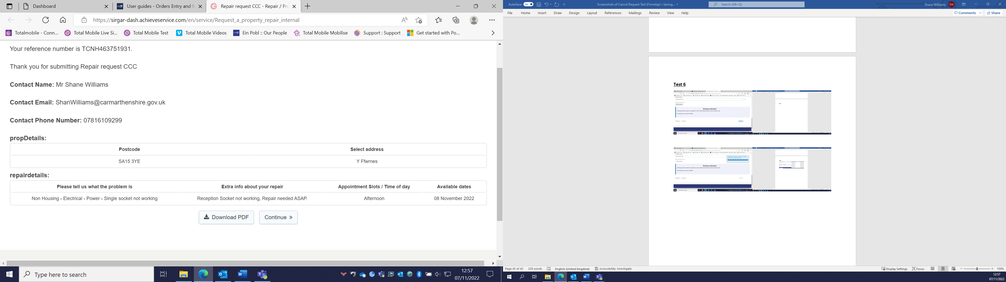

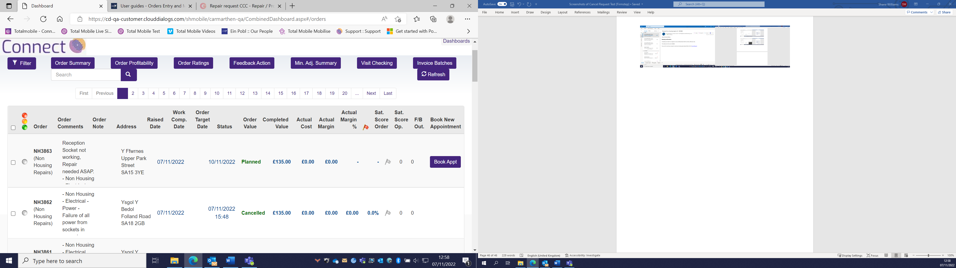

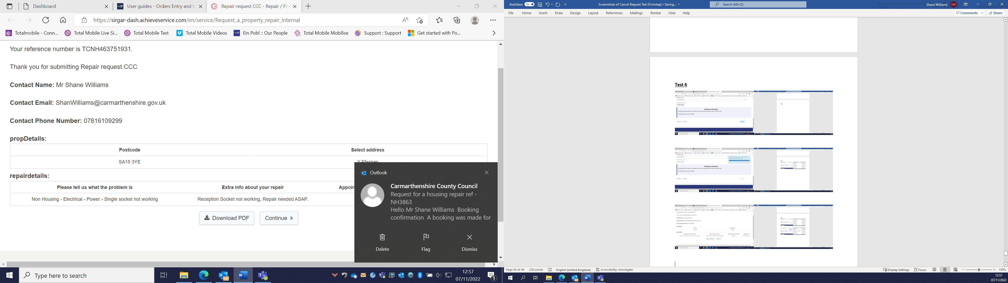

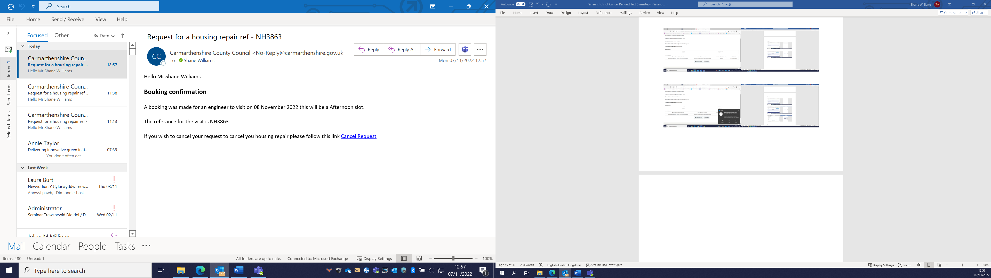

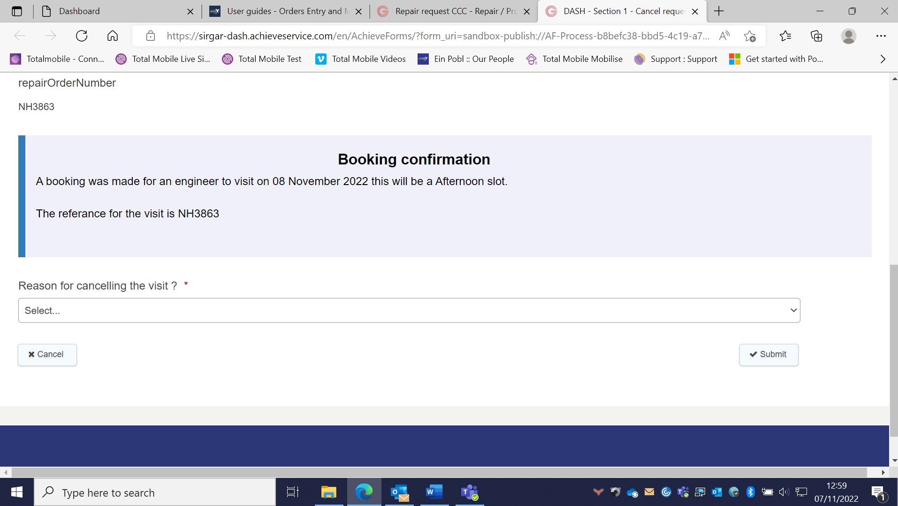

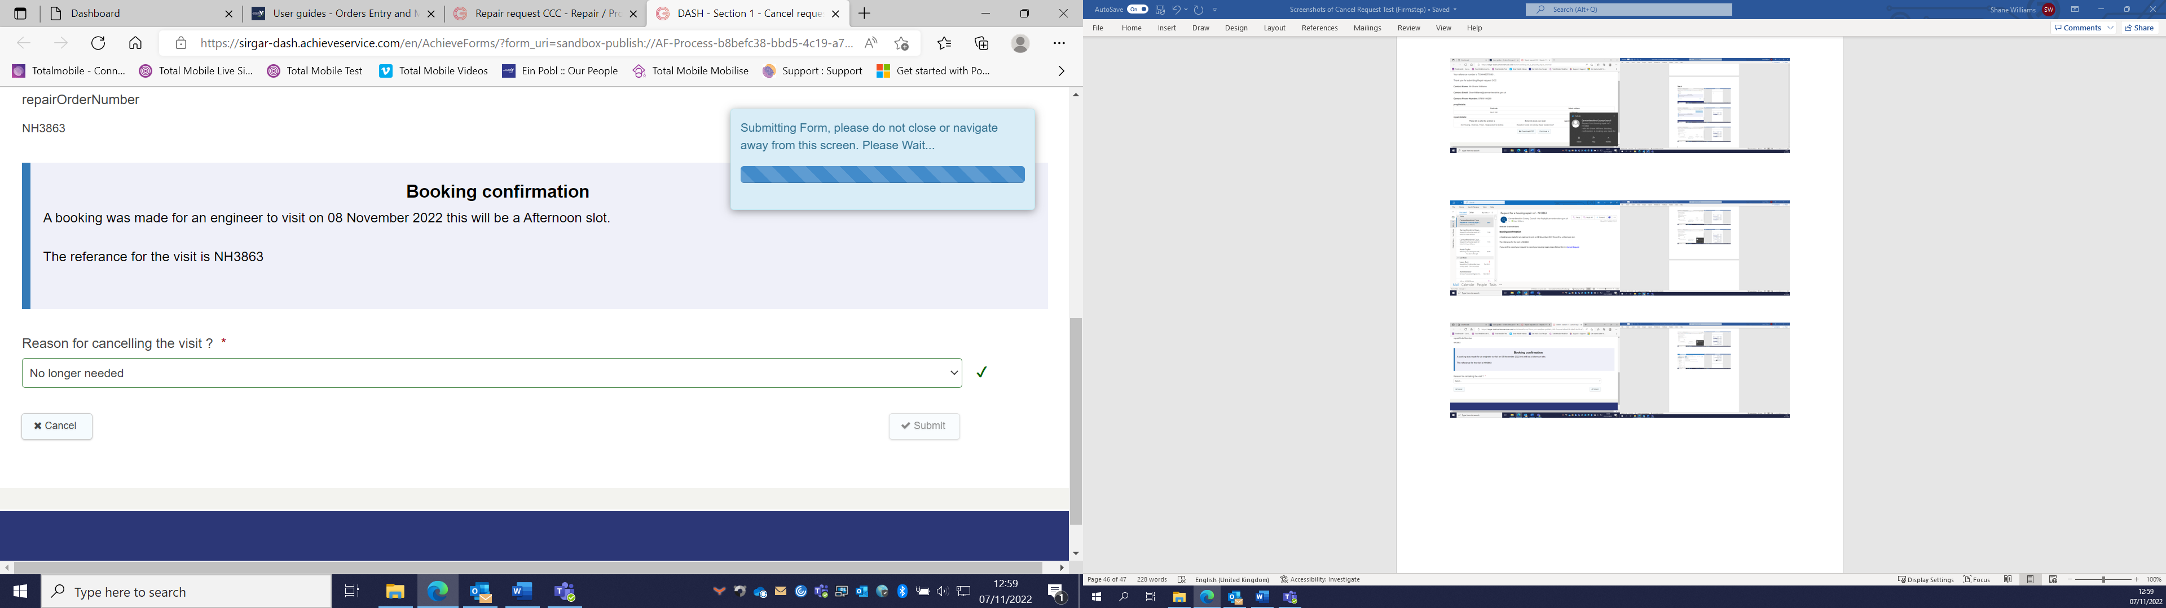

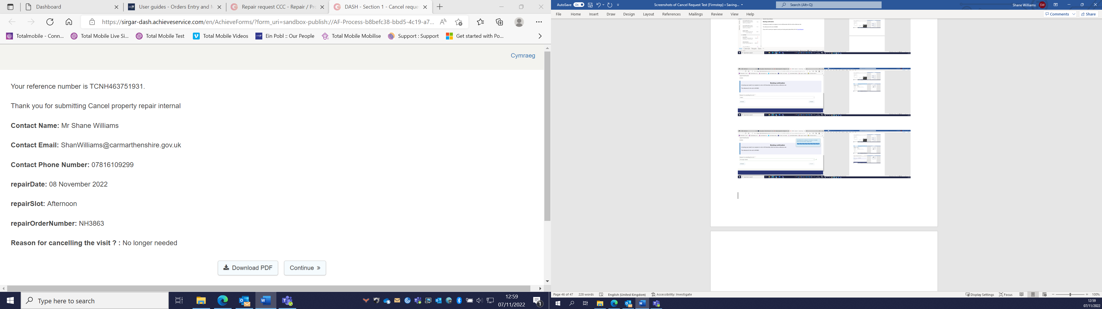

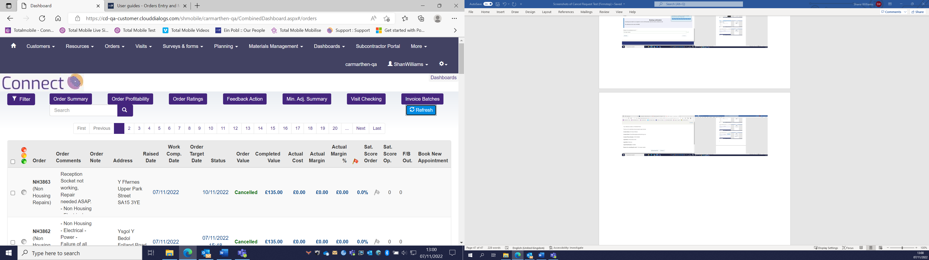

Appendix 6 (documents include in extra file)

- Middleware guidance - CCC_Middleware_guidelines.docx
- Granicus in house best practice - Firmstep guide and best practice.docx
- Final .Net application code - Housing Repair Solution Code.docx
- Demo video of final product – Demo video.mp4
- Non Housing diagnostic codes - non housing diag codes.xlsx

